**Structural health monitoring of Two Storey steel frame Structure using**

**shake table Experimental analysis with accelerometer sensor**

**Mohit*,1, Sachin Kumar Singh*,2, Abhishek Mishra*,3**

**\*,1** M. Tech. Scholar, Department of Civil Engineering, I.E.T., Lucknow, Uttar Pradesh, India.

**\*,2** Asst. Professor, Department of Civil Engineering, I.E.T., Lucknow, Uttar Pradesh, India.

**\*,3** Asst. Professor, Department of Civil Engineering, I.E.T., Lucknow, Uttar Pradesh, India.

**ABSTARCT**

Determining how vibrations affect structures and their behavior has become more important in recent years, both domestically and internationally. Wind, explosions, and earthquakes are examples of external forces that can modify the earth and the buildings it supports. Eigen frequency and other physical characteristics of the G+2 steel frame bolted structure were determined experimentally using a one-dimensional shake table. The Fast Fourier Transform (FFT) of the data received by the accelerometer sensor in LabVIEW software is routinely used to discover these qualities. To determine the different modes and eigen frequencies, according to experimental shake table results and finite element analysis.

**Keywords:** Experimental modal analysis, Shake table, Fast Fourier transform, accelerometer

**INTRODUCTION**

The structural health monitoring (SHM) technology has been used to closely monitor how the civil infrastructure is operating. Various SHM techniques have been created to identify damage in different types of steel structures. To identify structural problems, including cracking in steel gusset plate joints, an intelligent technique was developed [1-2]. Bolt joint cracking and loosening are considered to be two of the most frequent forms of damage to bolted steel frames. Connection stiffness is crucial for steel frames since it influences the structure's overall integrity and dynamic responsiveness. Numerous studies have looked into how bolt loosening affects the mechanical behaviour of steel frames. provided a reduced order numerical model for damage diagnosis upon loss of the frame connecting bolt [3]. He provides a technique based on variations in the intrinsic frequencies of the structure to identify defects, such as the loosening of bolted connections, in space frame construction with L-shaped beams. Shao and associates on the basis of piezoelectric impedance frequency shifting, a bolt looseness detection system was created [4-5]. The exact design and management of bolt axial preloads were made possibly by this technique. Consequences of joint damages in steel frame structure under seismic excitations were investigated. A model that detects changes in model parameters and compare them to a reference state was given as a way to anticipate structural defect in steel frames. The study’s damage detection mechanism can be broken down into the following stages [6-7]. The creation of three- dimensional finite element (FE) model for a steel frame subjected to various damage scenario [8-10]. The extraction of acceleration data under cyclic loading from the FE model. System identification principles served as the foundation for early research on operational and experimental model analysis. Numerous studies have been done on system identification. Assessing how vibrations affect structures and how they behave has grown crucial in recent years, both domestically and internationally [11-12]. Since many historically significant buildings in our nation are situated in systemically active areas, more research is being done on how buildings react to vibrations, particularly after many earthquakes. Currently, researchers utilize genetic algorithms for this purpose. artificial neural networks, fuzzy logic, etc. Many older buildings have experienced significant damage due to design flaws, construction errors, natural disasters, and excessive loads. Given our country's active seismic zones and large population, evaluating such damage is crucial [13]. Structures are continually exposed to vibrations from wind, earthquakes, waves, explosions, and vehicular traffic, which can result in cracks or severe damage. Understanding how a structure behaves under these conditions is essential for its longevity and often requires experimental studies, as analytical models may not entirely capture real-world behaviour. Structural design generally starts with developing analytical models for static and dynamic analyses under various loads [14-15]. however, these models often do not accurately represent actual building behaviour. With advanced technologies, it is now possible to create safer structures and continuously monitor them. To accurately determine dynamic parameters, it is essential to correctly define the structure's parameters.

**METHODOLOGY**

**a). Experimental Setup**

Steel Frame Structure: Construct a scaled model of the steel frame structure to be tested.

Shake Table: Use a shake table to simulate seismic loads. The shake table can replicate various earthquake scenarios by applying controlled vibrations to the structure.

Sensors and Data Acquisition: Install accelerometer sensors on the structure to measure responses during the tests.

**Figure 1** Methodology of experimental model analysis

### 4. Data Analysis

**5. Validation andReporting**

**3.** **Testing Procedure**

Experimental steel frame structure analysis Methodology

### 2. ****Data Acquisition and Control****

### 1.Experimental setup

**b). Data Acquisition and Control**

**LabVIEW**: Utilize LabVIEW software for real-time data acquisition and control. LabVIEW interfaces with the sensors and the shake table, allowing for precise control of the test conditions and real-time monitoring of the structural responses.

**MATLAB**: Use MATLAB for data analysis and visualization. MATLAB can process the raw data collected from the sensors, perform signal processing, and extract meaningful features such as natural frequencies, mode shapes, and damping ratios.

**c). Testing Procedure**

**Baseline Testing**: Conduct initial tests to establish the baseline dynamic properties of the undamaged structure.

**Damage Simulation**: Introduce controlled damage to the structure, such as notches or reduced cross-sectional areas, to simulate real-world damage scenarios.

**Dynamic Testing**: Perform dynamic tests using the shake table under various loading conditions. Record the structural responses using the sensors.

**d). Data Analysis**

**Modal Analysis**: Use MATLAB to perform modal analysis on the collected data. Identify changes in natural frequencies, mode shapes, and damping ratios due to the introduced damage.

**Time-Frequency Analysis**: Apply time-frequency analysis techniques, such as wavelet transforms, to study the transient responses of the structure.

**Damage Detection**: Implement algorithms in MATLAB to detect and quantify the damage based on changes in the dynamic properties. Techniques such as the Fast Fourier Transform (FFT) can be useful.

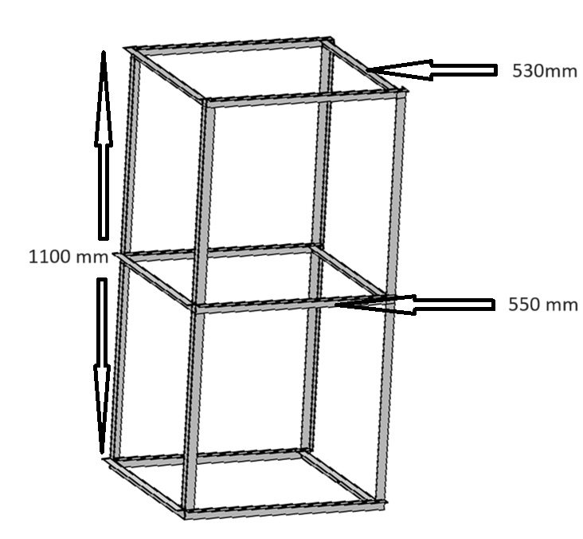

**Figure 2.** Geometry of Steel Frame Structure

**e). Validation and Reporting**

**Validation**: Compare the experimental results with numerical simulations or previous studies to validate the findings.

**Reporting**: Document the methodology, results, and conclusions in a detailed report. Include visualizations such as plots of frequency response functions, mode shapes, and time-history responses.

The steel frame structure height is 1.1m. As shown in Fig 2, a 3D steel frame was built in the laboratory. The height of each floor is 550mm, and the plan of frame structure is 530 mm × 550 mm. The Steel angle structure profile was selected for the columns and beams of the steel frame shown in Table 1, while the Indian Standard Angle (ISA) 24.4 mm x 24.4 mm x 2mm profile was used for the joints. M6 bolts are used in all the column-beam joints.

**III. MODELING AND ANALYSIS**

G+2. Steel frame for a storey the building geometry depicted in Figure 2 is designed which also specifies angles and the heights, widths, and lengths of beams and columns. Steel is available in the Materials section of Table 1 of the Material Library. Explain steel's density, Young's modulus, Poisson's ratio, and other material characteristics. Determine the fixed support of the bottom beam. Utilizing the conversions study, ascertain the mesh size.

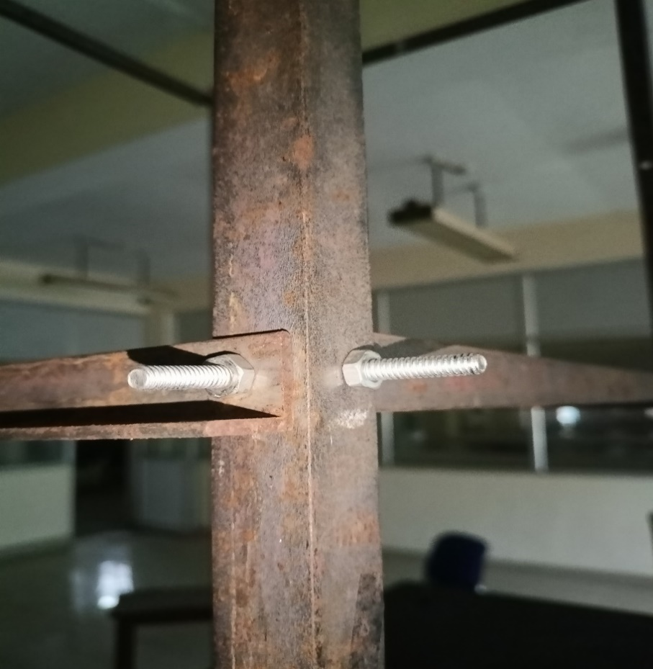

**Figure 3.** STEEL FRAME BOLTED JOINTS

**Theoretical Framework for Bolted Joints**

Bolted joints are commonly used in steel frame structures due to their ease of assembly and disassembly. They consist of bolts, nuts, and washers that connect the steel members. The performance of these joints under dynamic loading is critical for the overall behavior of the structure during an earthquake.

**Load Transfer Mechanism**: Bolted joints transfer loads through friction between the connected plates and shear in the bolts. The effectiveness of load transfer depends on the bolt pretension, the number of bolts, and the quality of the contact surfaces.

**Failure Modes**: Common failure modes include bolt shear, plate bearing, and bolt slip. Understanding these failure modes is essential for designing joints that can withstand seismic loads.

**Design Considerations**: Factors such as bolt diameter, spacing, edge distance, and the type of steel used influence the joint’s performance. Design codes provide guidelines for these parameters to ensure safety and reliability.

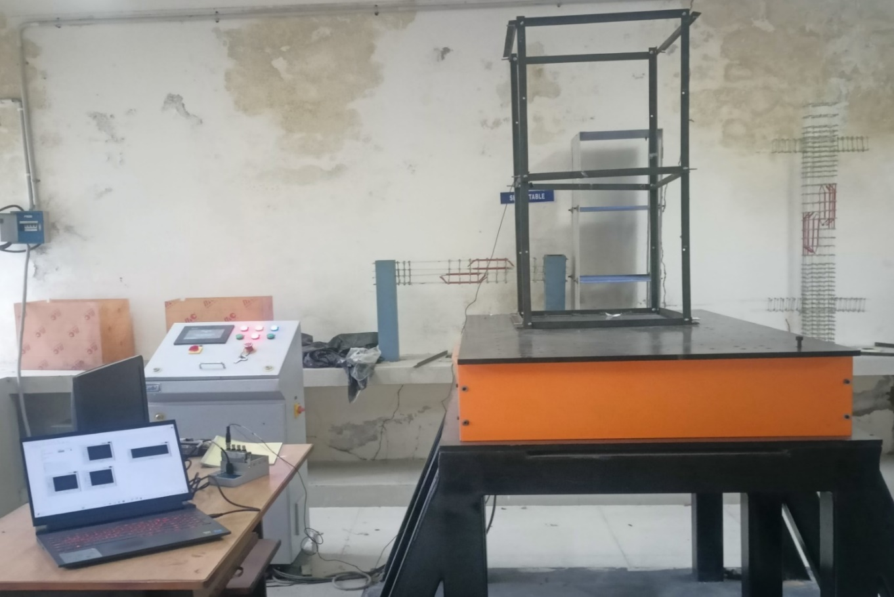

Accelerometer

Server Controller

Bolted Joint

Steel Frame

Shake Table

DAQ

PC

**Figure 4.** Lab Setup

Vibration sensors are extensively used in various products, including automobiles, aircraft, circuit boards, suspension bridges, and buildings, for vibration measurements and to study the dynamic behavior of structure, such as Through defined model analysis. Accelerometers, a type of vibration sensor, are employed to evaluate responses to outside pressures, validate the modal

Table 1 Physical properties of material

|  |  |  |
| --- | --- | --- |
| **Physical Properties** | **Parameter** | **Values(mm)** |
| (Front beam dimension) | Length | 550 |
| Width | 25 |
| Thickness | 2.1 |
| (Side beam dimension) | Length | 530 |
| Width | 25 |
| Thickness | 2.1 |
| (Column dimension) | Length | 1100 |
| Width | 25 |
| Thickness | 2.1 |
| Structural Steel | Young’s Modulus (GPa) | 18 |
| Density (Kg/m3) | 7850 |
| Poisson Ratio | 0.3 |

that simulation programs employ, and forecast reactions in various operational scenarios. Vibration sensor monitoring has emerged as the most widely used method for evaluating the condition of major machinery and building in both the industrial and civil sectors. Vibration trends over time can be used to forecast when deterioration will start and to take corrective action before failure happens. “Predictive maintenance” is the term for this type of ongoing or sporadic observation of a plant’s operational state. an Accelerometer works by measuring the inertia of a mass that is being acceleration. Vibration sensors are extensively used in various products, including automobiles, aircraft, circuit boards, suspension bridges, and buildings, for vibration measurements and to study the dynamic behavior of structure, such as Through defined model analysis. Accelerometers, a type of vibration sensor, are employed to evaluate responses to outside pressures, validate the modal that simulation programs employ, and forecast reactions in various operational scenarios. Vibration sensor monitoring has emerged as the most widely used method for evaluating the condition of major machinery and building in both the industrial and civil sectors.

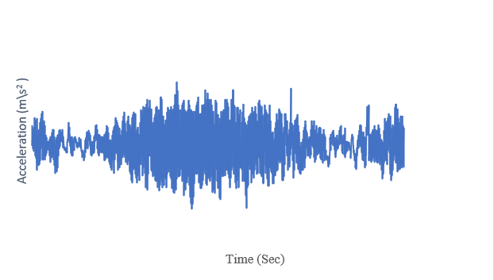

**GRAPHS 1.** Accelerometer Data through shake Table

Vibration trends over time can be used to forecast when deterioration will start and to take corrective action before failure happens. “Predictive maintenance” is the term for this type of ongoing or sporadic observation of a plant’s operational state. an Accelerometer works by measuring the inertia of a mass that is being acceleration. A sensor measures the displacement of the mass with respect to the device’s permanent structures while it is suspended by an elastic element. because of its inertia, the mass accelerates and moves from its rest position according to the acceleration that is Sensed. the displacement is transformed by the sensor into an electrical signal that contemporary measurement equipment can obtain. Various types of sensors have been developed based on this principle. Data obtained from accelerometer sensor with the help of LabVIEW software shown in Graphs.4.1. The obtained mode shape frequency results through FFT analysis shown in Graphs.4.2

**RESULT AND DISSCUSION**

**RESULT OF FFT**

A fixed support was made at the bottom beam of the steel frame structures in Fig. 5's FEM analysis. The influence of rotation in the rigid frame systems was seen throughout the analysis.

Table 2 Eigen Frequency Experimental data

|  |  |  |  |
| --- | --- | --- | --- |
| Mode shape | 1 | 2 | 3 |
| Experimental frequency (Hz) | 13.46 | 22.28 | 22.28 |

The dynamic performance of structures and fundamental dynamic properties are strongly influenced by natural frequencies and vibration modes. Figure 6 illustrates the three natural frequencies that were obtained for the structure, which are 13.46 ,22.28, and 28.75 Hz. A relation between power and frequency

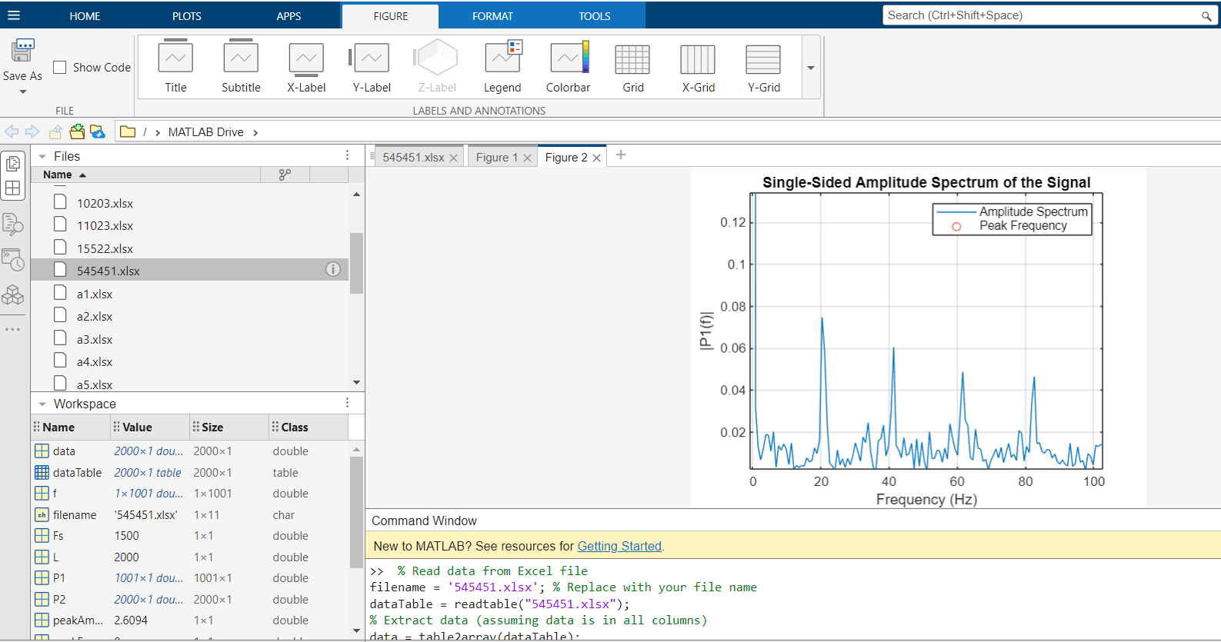

**Figure 2** FFT on MATLAB software

Ambient excitation was used with the accelerometer data that was obtained. As seen in figure 8, two accelerometer sensor one of which was employed as a reference sensor and was always positioned on the beam were used to monitor the ambient vibration in both the X and Y axes.

**CONCLUSION**

The model study of a steel frame building using both analytical and experimental techniques is presented in this paper The results of the study allow for the following deductions. Three natural frequencies were found model of the steel frame building was produced, experimental modal analysis and its dynamic characteristics were ascertained analytically. Data gathered from ground level vibrations was used to test ambient vibration. Enhanced frequency domain decomposition (EFDD) technology was used to find the modal parameter. The following conclusions are drawn from a comparison of the analytical and experimental model analysis results. The first three mode forms, which have frequencies ranging from 13.46 Hz for the first mode and 22.28 Hz for the second, to 28.75 Hz for the third, were analytically derived using the steel frame structure's finite element model.

**REFERENCES**

1) Biranchi Panda and Ming Jen Tan, Experimental study on mix proportion and fresh properties of fly ash based geopolymer for 3D concrete printing, Ceramics International, <https://doi.org/10.1016/j.ceramint.2018.03.031>.

2) Fischer O, Thoma S, Crepaz S. Distributed fiber optic sensing for crack detection in concrete structures. Civil Engineering Design. 2019; 1:97–105, https:// doi.org/10.1002/cend.201900008.

3) Ali Zar · Zahoor Hussain · Muhammad Akbar · Timon Rabczuk · Zhibin Lin · Shuang Li · Bilal Ahmed, Towards vibration‑based damage detection of civil engineering structures: overview, challenges, and future prospects, <https://doi.org/10.1007/s10999-023-09692-3>.

4) Charles R. Farrar and Keith Worden, An introduction to structural health monitoring, (2007) 365, 303–315.doi:10.1098/rsta.2006.1928.

5) Jann N. Yang, Ye Xia and Chin-Hsiung Loh, Damage Identification of Bolt Connections in a Steel Frame. DOI:10.1061/(ASCE)ST.1943-541X.0000831.

6) Hassene Hasni, Amir H. Alavi*, Pengcheng Jiao, Nizar Lajnef, Detection of fatigue cracking in steel bridge girders: A support vector machine approach,17 (2017) 609–622, <http://dx.doi.org/10.1016/j.acme.2016.11.005>.

7) Hu F et al. Experimental study on seismic behavior of high strength steel frames: Global response. Eng Struct (2016), <http://dx.doi.org/10.1016/j.engstruct.2016.11.013>.

8) K. Chilamkuri and V. Kone, Monitoring of varadhi road bridge using accelerometer sensor, Materials Today: Proceedings, <https://doi.org/10.1016/j.matpr.2020.04.159>.

9) Osama Abdeljaber a, Onur Avci a.n, Serkan Kiranyaz b, Moncef Gabbouj c, Daniel J. Inman, Real-time vibration-based structural damage detection using one-dimensional convolutional neural networks, <http://dx.doi.org/10.1016/j.jsv.2016.10.043>.

10) Francisco J. Pallarés a, Michele Betti b, Gianni Bartoli b, Luis Pallarés, Structural health monitoring (SHM) and Nondestructive testing (NDT) of slender masonry structures: A practical review, 0950-0618, <https://doi.org/10.1016/j.conbuildmat.2021.123768>.

11) J.P. Lynch, K.J. Loh, A summary review of wireless sensors and sensor networks for structural health monitoring, The Shock and Vibration Digest, 38 2006, pp. 91–128, <http://dx.doi.org/10.1177/0583102406061499>.

12) C.C. Chiang, J.R. Lee, H.J. Bang, Structural health monitoring for a wind turbine system: a review of damage detection methods, Meas. Sci. Technol. 19 (2008) 122001, <http://dx.doi.org/10.1088/0957-0233/19/12/122001>.

13) S.W. Doebling, R.F. Charles, B.P. Michael, W.S. Daniel, Damage identification and health monitoring of structural and mechanical systems from changes in their vibration characteristics: a literature review, Technical Report. LA–13070-MS; ON: DE96012168; TRN: 96:003834, 1996, <http://dx.doi.org/10.2172/249299>.

14) A.H. Alavi, H. Hasni, N. Lajnef, K. Chatty, F. Faradizer, an intelligent structural damage detection approach based on self-powered wireless sensor data, Autom. Constr. 62 (2016) 24–44, <http://dx.doi.org/10.1016/j.autcon.2015.10.001>.

15) H.N. Li, L. Ren, Z.G. Jia, T.H. Yi, D.S. Li, State-of-the-art in structural health monitoring of large and complex civil infrastructures, J. Civ. Struct. Heal. Monit. 6 (1) (2016) 3–16, <http://dx.doi.org/10.1007/s13349-015-0108-9>.