Office Administration

Rutuja D. Kudale1, Saloni D. Limbhore2, Atharva S. More3, Sarthak J. Shitole4, Prathmesh P. Parthe5 ,

Prof. Megha Garud6

[1][2][3][4][5][6]Computer Engineering, Zeal Polytechnic, Pune, Maharashtra, India.

***Abstract: This survey paper explores the various aspects of office administration within Chartered Accountants (CAs) firms. It highlights the significance of efficient administration for enhancing productivity and client satisfaction. The paper reviews existing literature on office management practices, identifies common challenges faced by CAs, and proposes solutions to streamline operations and improve service delivery. This survey paper investigates the critical role of office administration in Chartered Accountant (CA) firms, emphasizing its impact on operational efficiency and client satisfaction. The paper reviews current practices in administrative workflows, document management, and communication strategies within CA offices.***

**KEYWORDS:** office administration, Chartered Accountants, service delivery, administrative workflows.

# INTRODUCTION:

Office administration plays a critical role in the ef- ficient functioning of organizations, serving as the backbone that supports various operational pro- cesses. In an increasingly dynamic business envi- ronment, effective office management is essential for enhancing productivity, fostering communica- tion, and ensuring smooth workflow. This survey paper aims to explore the key aspects of office ad- ministration, including the evolution of adminis- trative practices, the integration of technology, and the emerging trends shaping the future of office management. Ultimately, this survey serves as a foundation for future research and development in office management strategies, emphasizing the im- portance of adapting to new trends and technolo- gies to meet the evolving needs of the workplace.

# OBJECTIVES:

The primary objective of the CA Office Admin- istration project is to develop an Android-based ap- plication that automates essential administrative tasks for CA firms, streamlining processes for both accountants and office staff. The application aims to reduce manual effort, minimize errors, and en- hance productivity through automation and AI- powered tools. Specific objectives include: Automating Administrative Tasks:

To provide tools like an Automatic Appointment Scheduler, Document Management System, and Task Assignment Tracker that simplify office workflows.

Enhancing Client Service Management:

To offer features such as Automated Invoice Gen- erator, Client Reminder System (for due filings and tax submissions), and Feedback Collection Tools to ensure efficient client interactions and support. Seamless Real-Time Data Management:

To integrate with platforms like cloud storage or databases (e.g., Firebase) to ensure real-time syn- chronization of financial records, deadlines, and communication between staff and clients.

Simplifying Report Generation:

To enable an Automated Report Generator, which formats and compiles financial statements, audit reports, and tax summaries, reducing the manual workload.

Improving Overall Office Productivity:

To streamline repetitive tasks such as filing, in- voicing, and follow-ups using automation, allow- ing staff to focus more on strategic tasks and client engagement.

**Current Market Needs and Problems:** Traditional CA office processes are often time- consuming and prone to human error. Accountants and staff spend countless hours managing appoint- ments, preparing invoices, filing tax returns, and compiling financial reports. This leaves limited time for more valuable client engagement and stra- tegic advisory services.

A study on professional services highlights that ad- ministrative tasks consume approximately 30-40% of work hours, reducing efficiency and client satis- faction. Similarly, clients often face delays in re- ceiving essential reports and reminders, leading to missed deadlines and penalties. Automating these processes can significantly reduce errors and en- hance both operational efficiency and client ser- vice.

# BACKGROUND:

The field of Chartered Accountancy (CA) has wit- nessed rapid modernization, with the integration of technology becoming essential to manage complex financial processes efficiently. With increasing de- mand for automation in office administration, CA firms now rely on software solutions to handle tasks such as client management, invoicing, tax fil- ing, compliance tracking, and financial reporting.

# . LITERATURE SURVEY:

1. **Competency of Office Administration em- ployees in a office:** Abraham, K. G., & Taylor, S.

K. (1996). Firms' use of outside contractors:

Theory and evidence. Journal of Labor Economics, 14,394-424.

# Features:

* + - **Evaluation of Competency:** The study evaluates the competency of forty graduat- ing office administration students by ana- lyzing their skills in administrative work, technical skills, and ethical values using descriptive-comparative research methods.
    - **Program Performance Indicators**: The study uses program performance indicators based on guidelines from the Commission on Higher Education (CHED) to assess the students' preparedness for the industry.
    - **Improvement of Educational Programs:** The research aims to bridge the gap be- tween educational competencies and indus- try needs by recommending improvements to academic programs.
    - **Guidance for Academic Personnel:** The study serves as a reference for academic personnel to develop innovative interven- tions that can enhance the curriculum and better prepare students for industry require- ments.

# Limitations:

* + - **Scope of Respondents:** The study is lim- ited to forty graduating students of a spe- cific state university, which might not re- flect the competency levels of office ad- ministration students in different institu- tions.
    - **Diverse Backgrounds:** The research con- siders only a few variables like family in- come, school academic strand, and type of school graduated, which may not account for all factors influencing the competency of students.
    - **Regional Focus:** The study focuses on the competency of students in the Philippines, which may not be applicable to students or educational institutions in other regions or countries.
    - **Generalization of Findings:** Since the study is conducted in a particular educa- tional setting with a specific group, its find- ings might have limited generalization to other educational contexts or broader pop- ulations.

1. **employee’ Perception and Satisfaction in Of- fice Administration Program:** Agomuo E.E. (1997) in Agomuo, E.E and Isu, C.O. (2002) Sec- retarial Job Tasks required in Modern Business Of- fices in Abia State: Implications for improved Sec- retarial Education. Business Education Journal III (5).

# Features:

* + - **Administrative Support:** Organizing and maintaining files, handling correspond- ence, and managing office supplies.
    - **Communication:** Facilitating communica- tion within the office and with external stakeholders, including scheduling meet- ings and managing phone calls.
    - **Data Management**: Maintaining data- bases, entering data, and ensuring accuracy in records.
    - **Scheduling and Planning:** Coordinating schedules for meetings, events, and travel arrangements.

# Limitations:

* + - **Scope of Authority:** Often limited in deci- sion-making power, requiring approvals for certain actions.
    - **Skill Set Variability:** Proficiency in vari- ous tools and processes can vary, impacting efficiency.
    - **Resource Constraints:** Limited access to resources, including technology and train- ing, can hinder performance.
    - **Workload Management:** High volumes of tasks can lead to burnout or mistakes if not managed effectively.

1. **Office Administration Program: Graduate Employment and Curriculum Relevance:** Da- vis-Blake, A., & Uzzi, B. (1993). Determinants of employment externalization: A study of temporary workers and independent contractors. Administra- tive Science Quarterly, 38, 195-223.

# Features:

* + - **Financial Tasks**: Assisting with budget preparation, invoicing, and expense track- ing.
    - **Customer Service:** Addressing inquiries from clients or customers, providing infor- mation, and resolving issues.
    - **Project Coordination:** Assisting in plan- ning and executing projects, including tracking deadlines and deliverables.
    - **Compliance and Reporting**: Ensuring ad- herence to company policies and preparing reports as required.

# Limitations:

* + - **Adaptability**: Resistance to change or lack of training can limit the ability to adopt new technologies or processes.
    - **Interdepartmental Dependence:** Reli- ance on other departments can delay pro- jects and decision-making.
    - **Time Constraints**: Tight deadlines can af- fect the quality of work and thoroughness of tasks.
    - **Diverse Backgrounds:** The research con- siders only a few variables like family

income, school academic strand, and type of school graduated, which may not ac- count for all factors influencing the compe- tency of students.

# FEATURES:

* + **Comprehensive Literature Review**: A detailed analysis of existing research on of- fice administration practices and trends, providing context and background for the study.
  + **Survey Design and Methodology**: Clear explanation of the survey design, including sampling methods, questionnaire develop- ment, and data collection processes.
  + **Diverse Participant Pool**: Inclusion of a variety of organizations across different in- dustries to ensure a well-rounded perspec- tive on office administration.
  + **Data Analysis Techniques**: Utilization of appropriate statistical methods to analyze survey data, ensuring robustness and valid- ity of findings.
  + **Client Management:** Centralized data- base for storing client information, contact details, and engagement history.
  + **Task Management:** Ability to assign tasks to team members with deadlines and prior- ity levels.

# PROPOSED SYSTEM:

The proposed office administration system aims to streamline operations and enhance productivity through a comprehensive suite of features. Central to this system is a robust document management module that allows for the secure storage and easy retrieval of files, complete with version control and access permissions to protect sensitive infor- mation. Task and project management tools will facilitate the assignment and tracking of tasks, pro- moting collaboration among team members through shared comments and file-sharing capabil- ities. Communication will be improved with an in- tegrated internal messaging system and an an- nouncements board for company-wide updates, while shared calendars will simplify scheduling and room bookings, complete with automated re- minders for meetings and deadlines.

To ensure security, the system will incorporate data encryption, regular backups, and multi-factor authentication, alongside clearly defined user roles—such as admin, manager, and employee—to control access to various features. Integration ca- pabilities with third-party tools like Slack and Google Workspace will enhance functionality, and reporting tools will provide valuable insights into team performance and project status. Ongoing user training and support will be integral to the system's

success, alongside a feedback mechanism to con- tinuously refine the user experience. Overall, this proposed system is designed to foster a more orga- nized, efficient, and collaborative office environ- ment.

1. **SYSTEM ARCHITECTURE:**

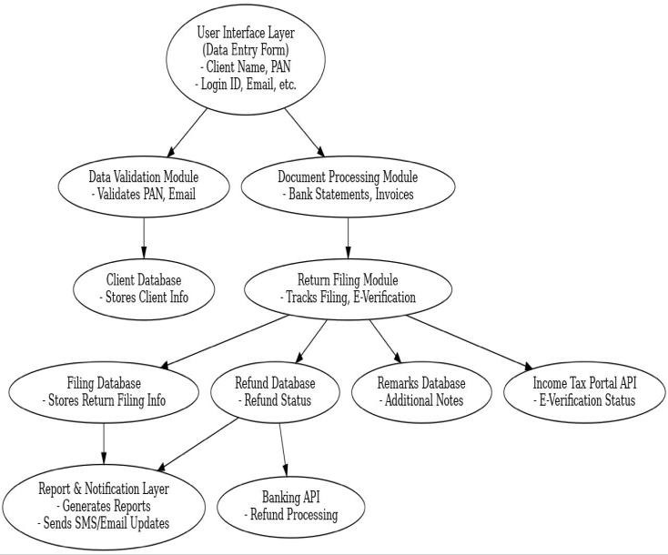

# FLOWCHART :

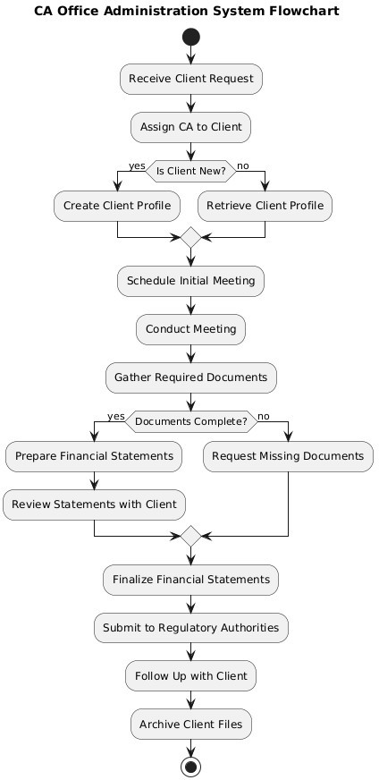

1. **SCOPE:**

In the future, developers interested in enhanc- ing this system can explore integrating technol- ogies like email and SMS functionality directly into the platform, eliminating the need for ex- ternal applications. The Office Admin Hub is designed to save time and money while boost- ing productivity for both users and administra- tive staff. It features predictive capabilities that analyze daily task trends, identify peak work- loads, and forecast the most critical administra- tive needs based on historical data and seasonal patterns. By leveraging this predictive analysis, administrative teams can optimize resource al- location, reduce operational costs, and stream- line processes. Meanwhile, users benefit from a centralized platform where they can easily access information, manage schedules, and

make informed decisions based on availability and priority. This integrated approach ensures a more efficient and responsive office environ- ment for everyone involved.

# CONCLUSION:

Our Office Admin Hub is designed for seam- less management and organization, accessible from any device or browser. With a user- friendly interface and straightforward naviga- tion, it ensures that all users can efficiently manage their tasks without any hassle. You can log in to access essential tools, streamline workflows, and communicate with your team effortlessly. In today's remote work environ- ment, our platform is perfectly suited for pro- fessionals who need to stay organized and con- nected from home or the office. Whether you're using a computer, tablet, or smartphone, the Office Admin Hub provides a smooth and con- venient experience for managing schedules, documents, and communications. With its in- tuitive design, our platform aligns with the in- creasing demand for efficient digital solutions in office administration. It caters to the needs of individuals and teams who prefer to enhance their productivity and collaboration from the comfort of their own spaces. So, if you're look- ing to improve your administrative processes, our user-friendly platform is here to support you every step of the way.

# REFERENCES:

1. Information systems- [Article by: Muham- mad Awais] “Advanced SWOT Analysis of E- Commerce”, IJCSI International Journal of Computer science Issues, Vol 9,Issue 2,No 2,pp. 569-574 (2012).
2. Information systems [Article by: Chou D.C. and Chou A.Y.] “The E-Commerce Revolution, A Guide to the Internet Revolution in Banking” information systems management,pp.51-57 (2000).
3. Information systems- [Article by: Dr. Mitali Gupta] “ Study on impact of office administra- tionsystems [http://ijrar.com/upload_is-](http://ijrar.com/upload_issue/ijrar_issue_20542895.pdf) [sue/ijrar_issue_20542895.pdf](http://ijrar.com/upload_issue/ijrar_issue_20542895.pdf) (2019).