**A STUDY ON ANALYZING NEWSPAPER SALES IN THE ERA OF SOCIAL MEDIA DOMINANCE**

**J P NANDHA KUMAAR*1, R. Surendher*2**

*1MBA Student Jerusalem College Of Engineering, Chennai, India.

*2Assistant Professor Of Department Of Management Studies, Jerusalem College Of Engineering, Chennai, India.

# ABSTRACT

In the digital era, the consumption of news has undergone a significant transformation due to the rise of social media platforms. This study examines the impact of social media on traditional newspaper sales, readership, and consumer behavior. The primary objective is to analyze the decline in newspaper sales amidst social media dominance, with a focus on understanding consumer preferences and evaluating the effectiveness of newspapers' digital strategies. A descriptive research design was employed, utilizing surveys to collect data from a sample of 114 respondents. The findings reveal that social media has become a dominant news source, especially among younger demographics, leading to a decrease in traditional newspaper readership. Trust in social media for news is notably higher, while digital initiatives by newspapers have only achieved moderate success in retaining readership. Demographic factors such as age, gender, and socioeconomic status play a significant role in influencing news consumption patterns. The study suggests that newspapers must enhance their digital engagement, build trust, and offer unique content to compete effectively with social media platforms. This research provides valuable insights for traditional newspapers seeking to adapt to the rapidly evolving landscape of news consumption and remain relevant in a digital world dominated by social media.

**KEY WORDS**: SOCIAL MEDIA, NEWSPAPER SALES, DIGITAL ENGGAGGEMENT.

# INTRODUCTION

The emergence and rapid expansion of social media platforms over the past decade have revolutionized the way people access and consume information. Platforms like Facebook, Twitter, and Instagram have not only transformed the social networking landscape but have also fundamentally altered the dynamics of news dissemination. Unlike traditional media outlets, which typically follow a structured cycle of news reporting and distribution, social media platforms offer instant access to breaking news from multiple sources, in real time. The immediacy and convenience provided by these platforms have made them increasingly popular as primary news sources, particularly among younger generations who are accustomed to consuming news on-the-go.

As a result, the traditional newspaper industry, which for centuries served as the cornerstone of daily news consumption, now faces unprecedented challenges. Once characterized by their role as gatekeepers of information, newspapers are now competing with a multitude of digital outlets that not only provide up-to-the-minute updates but also offer a wider variety of viewpoints and interactive engagement with audiences. This shift has contributed to a significant decline in the sales and circulation of printed newspapers, with many publications struggling to maintain their readership base in the face of digital disruption.

This research seeks to examine the impact of social media’s rise and dominance on the traditional newspaper industry, particularly its sales and circulation. By analyzing consumer behavior and preferences in accessing news through digital platforms versus traditional newspapers, this study aims to provide insights into the future of print media. It will also explore how traditional newspapers have responded to these challenges, including their attempts to embrace digital technologies and adopt new business models to retain relevance in a rapidly evolving media landscape.

# REVIEW OF LITERATURE

**Smith, J. A. (2019).**

"The Decline of Print Media: Exploring the Shift to Digital Consumption" — The study examines the transition from print to digital media, analyzing the factors driving this shift and its impact on the traditional newspaper industry. Findings: The study finds that digital consumption is rapidly outpacing print, driven by convenience, accessibility, and changing reader habits, leading to a significant decline in print media revenue.

**Lee, H. Y (2020)**

"Social Media's Role in Shaping News Consumption Habits" — This research investigates how social media platforms influence the way people consume news, focusing on the shift in user behavior from traditional newspapers to digital news. Findings: The study reveals that social media has become the primary source of news for many users, resulting in more fragmented and personalized news consumption compared to traditional newspapers.

**Thompson, R. G. (2021).**

"The Future of Newspapers: Adapting to the Digital Era" — The paper discusses strategies that traditional newspapers can adopt to remain relevant in the digital age, emphasizing innovation and adaptability. Findings: The research indicates that newspapers must embrace digital transformation, including paywalls, multimedia content, and social media engagement, to sustain readership and revenue.

# RESEARCH METHODOLOGY

Research methodology is a systematic approach to addressing research problems, guiding how the research is conducted for accuracy and reliability. This study employs a **descriptive research design**, allowing the researcher to use structured surveys and inquiries to observe and describe characteristics within the population. Data collection was carried out using a Google Forms survey to gather insights from a sample of 114 respondents chosen via **convenience sampling** from a theoretically infinite population. Both primary and secondary data were used; primary data was collected firsthand through a questionnaire, while secondary data came from published sources, including internet resources, scholarly articles, and existing research. To analyze the relationship between variables, correlation, chi-square, and regression analysis tools were used, each helping to examine engagement factors and purchase behaviors on Instagram brand pages in the cosmetics industry..

# ANALYSIS

1. **AGE OF THE RESPONDENT**

|  |  |  |  |  |  |
| --- | --- | --- | --- | --- | --- |
| **age** | | | | | |
|  | | Frequency | Percent | Valid Percent | Cumulative Percent |
| Valid | under 18 | 2 | 1.4 | 1.8 | 1.8 |
| 18-24 | 98 | 69.0 | 86.7 | 88.5 |
| 25-34 | 12 | 8.5 | 10.6 | 99.1 |
| 55-64 | 1 | .7 | .9 | 100.0 |
| Total | 113 | 79.6 | 100.0 |  |

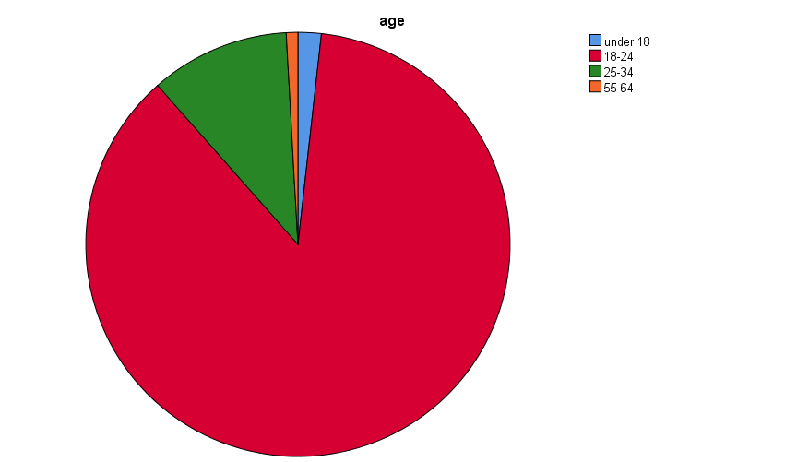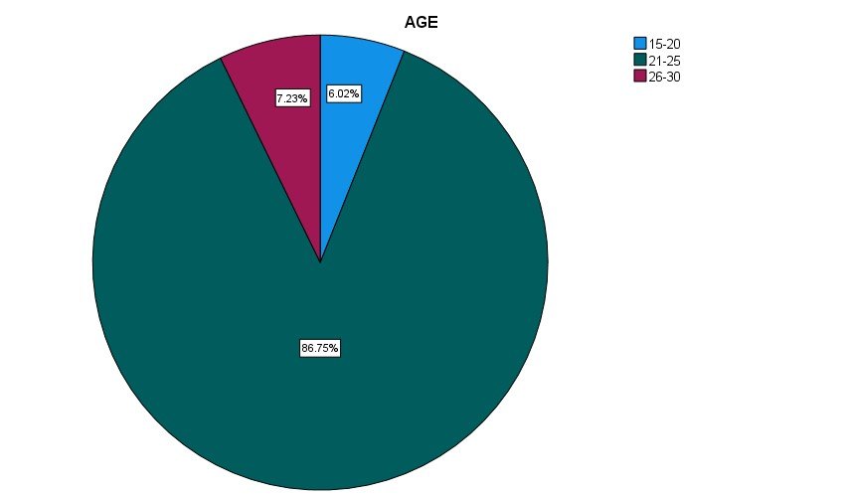

**INFERENCE:**

The majority of respondents are young adults, with 88.5% being under the age of 25. A small percentage (11.5%) are over 24, with most of them (10.6%) falling in the 25-34 age group. However, a significant number of respondents (20.4%) did not provide information about their age.

1. **GENDER OF THE RESPONDENT**

|  |  |  |  |  |  |
| --- | --- | --- | --- | --- | --- |
| **Gender** | | | | | |
|  | | Frequency | Percent | Valid Percent | Cumulative Percent |
| Valid | Male | 76 | 53.5 | 67.3 | 67.3 |
| Female | 37 | 26.1 | 32.7 | 100.0 |
| Total | 113 | 79.6 | 100.0 |  |

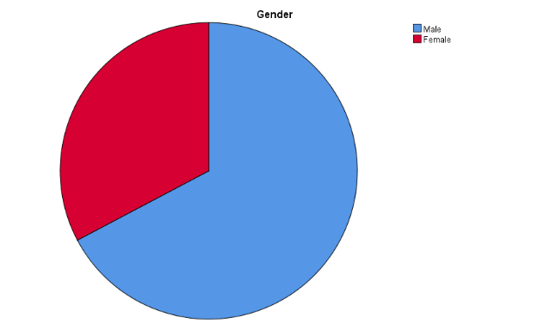

**INFERENCE:**

Based on the data, 67.3% of respondents identify as male, while 32.7% identify as female. This indicates that the sample is predominantly male but includes a significant portion of females.

1. **EDUCATION QUALIFICATION OF THE RESPONDENTS**

|  |  |  |  |  |  |
| --- | --- | --- | --- | --- | --- |
| **EducationLevel** | | | | | |
|  | | Frequency | Percent | Valid Percent | Cumulative Percent |
| Valid | no formal education | 2 | 1.4 | 1.8 | 1.8 |
| formal education | 2 | 1.4 | 1.8 | 3.5 |
| secondary education | 2 | 1.4 | 1.8 | 5.3 |
| bachelor's degree | 49 | 34.5 | 43.4 | 48.7 |
| master's degree | 55 | 38.7 | 48.7 | 97.3 |
| doctorate or higher | 3 | 2.1 | 2.7 | 100.0 |
| Total | 113 | 79.6 | 100.0 |  |

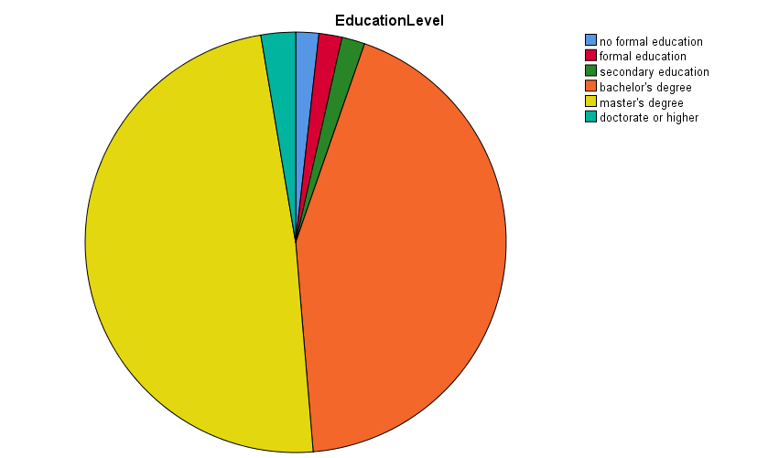

**INFERENCE:**

Based on the data, 67.3% of respondents identify as male, while 32.7% identify as female. This indicates that the sample is predominantly male but includes a significant portion of females.

1. **MONTHLY INCOME OF THE RESPONDENTS**

|  |  |  |  |  |  |
| --- | --- | --- | --- | --- | --- |
| **MonthlyIncomeLevel** | | | | | |
|  | | Frequency | Percent | Valid Percent | Cumulative Percent |
| Valid | less than 10000 | 18 | 12.7 | 15.9 | 15.9 |
| 10000-20000 | 16 | 11.3 | 14.2 | 30.1 |
| 20000-50000 | 11 | 7.7 | 9.7 | 39.8 |
| 50000-100000 | 8 | 5.6 | 7.1 | 46.9 |
| more than 100000 | 3 | 2.1 | 2.7 | 49.6 |
| No income | 57 | 40.1 | 50.4 | 100.0 |
| Total | 113 | 79.6 | 100.0 |  |

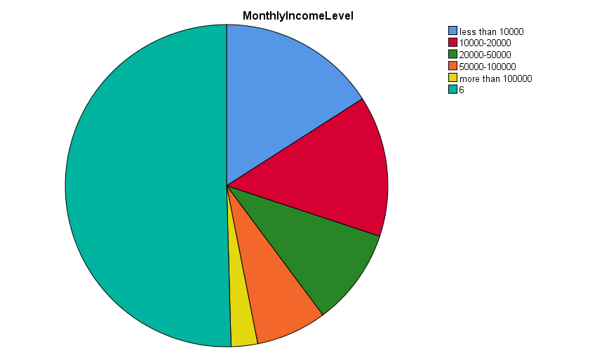

**INFERENCE:**

The majority of respondents declined to disclose their monthly income, limiting the insights into income distribution. Among those who responded, income levels were relatively evenly spread between ₹10,000 and ₹50,000, with the most common bracket being ₹10,000-₹20,000. Only a small percentage reported earning more than ₹100,000.

1. **THE CURRENT RECRUITMENT PROCESS AT CHANNELPLAY LIMITED**

|  |  |  |  |  |  |
| --- | --- | --- | --- | --- | --- |
| **Before socialmedia how often did you buy newspapers** | | | | | |
|  | | Frequency | Percent | Valid Percent | Cumulative Percent |
| Valid | increased a lot | 39 | 27.5 | 34.5 | 34.5 |
| increased a little | 22 | 15.5 | 19.5 | 54.0 |
| stayed the same | 12 | 8.5 | 10.6 | 64.6 |
| decreased a little | 40 | 28.2 | 35.4 | 100.0 |
| Total | 113 | 79.6 | 100.0 |  |

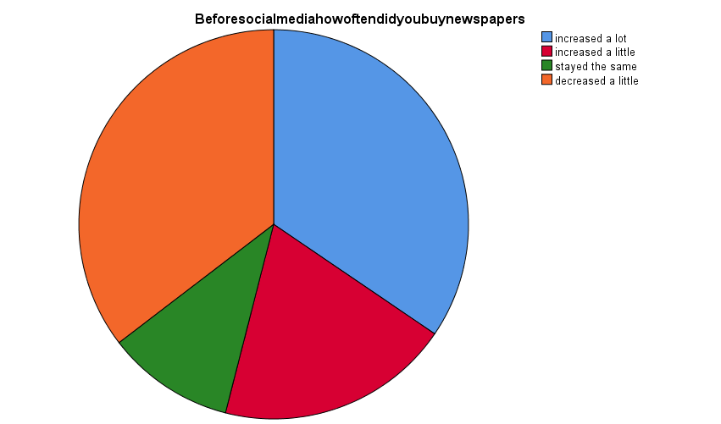

**INFERENCE:**

Prior to social media, a significant portion of respondents (54%) reported either increasing or decreasing their newspaper purchases. While 35.4% indicated a slight decrease, 10.6% saw no change in their consumption habits. However, a considerable number of respondents (20.4%) did not provide information about their pre-social media newspaper buying behavior.

**6 CHI-SQUARE TEST**

Null Hypothesis (H0): There is no association between frequency of newspaper reading, gender.

Alternative Hypothesis (H1): There is an association between frequency of newspaper reading, gender.

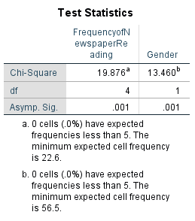

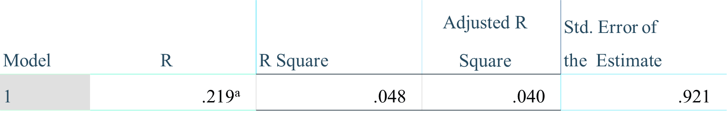

**INFERENCE:**

Since the Chi-Square test shows a p-value of 0.001, which is less than the of 0.05, we reject the null hypothesis. So, There is an association between frequency of newspaper reading, gender and the variable of interest

**7 REGRESSION**

Null Hypothesis (H₀): Awareness of newspaper digital efforts does not significantly predict perceptions of newspaper success compared to social media.

Alternative Hypothesis (H₁): Awareness of newspaper digital efforts significantly predicts perceptions of newspaper success compared to social media.

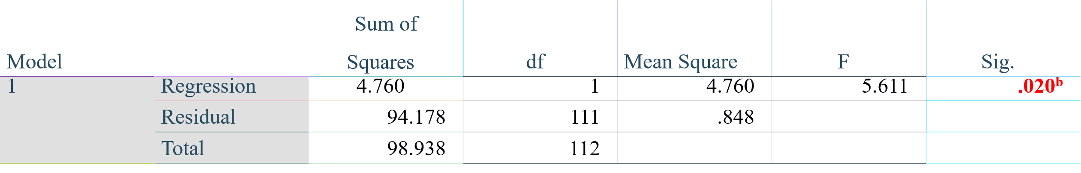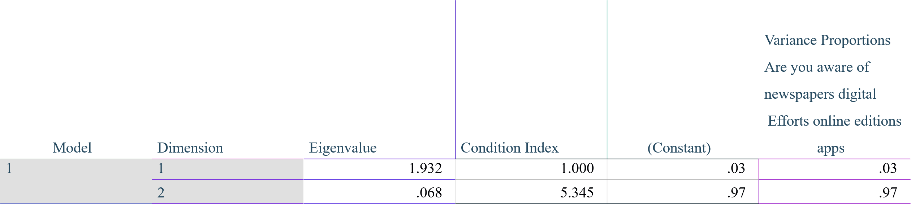

**INFERENCE:**

Since the p-value (0.020) is less than the significance level (0.05), we reject the null hypothesis. So Awareness of newspaper digital efforts significantly predicts perceptions of newspaper success compared to social media.

**8 CORRELATION**

Null Hypothesis (H₀): There is no significant difference between the chance of reading newspapers in the next 5 years and the level of trust in news sources.

Alternative Hypothesis (H₁): There is a significant difference between the chance of reading newspapers in the next 5 years and the level of trust in news sources.

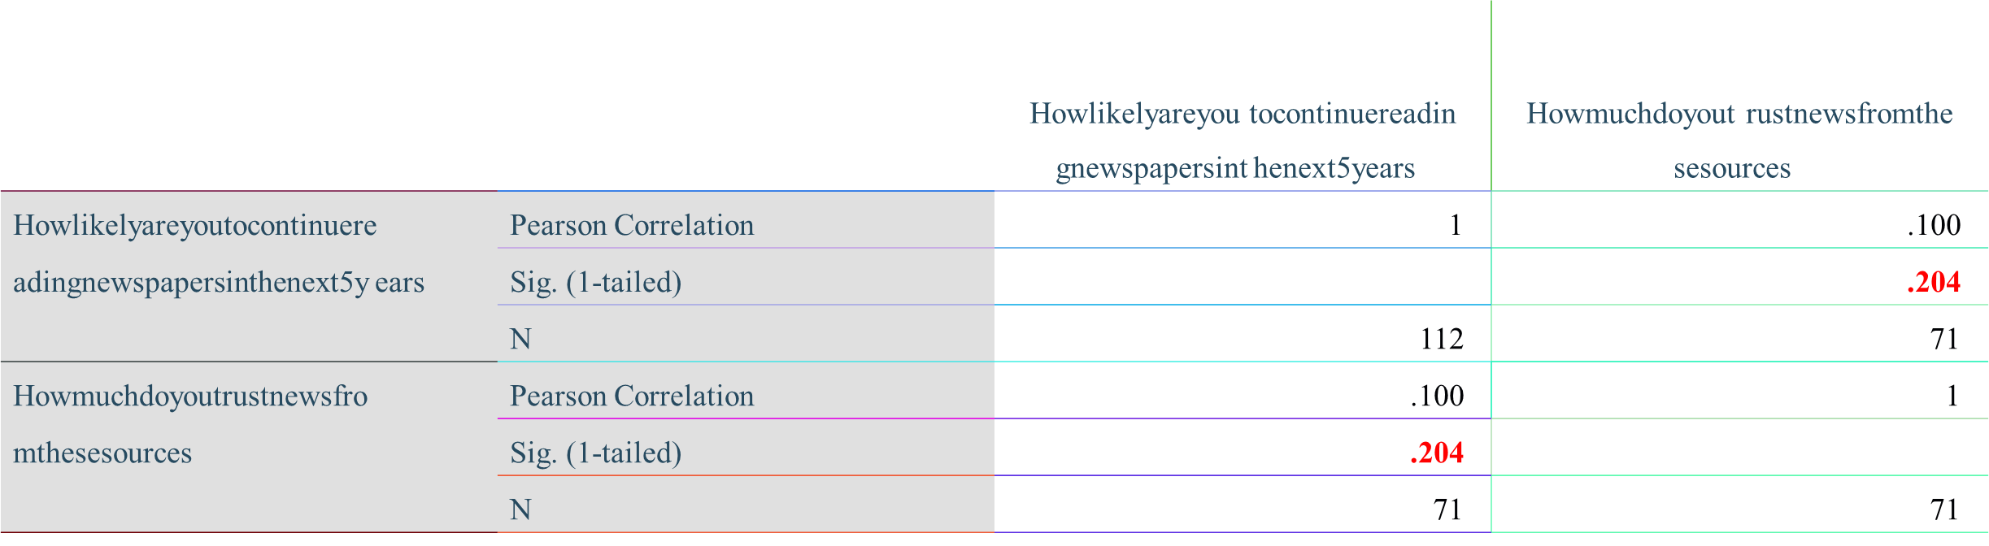

**INFERENCE:**

Since the p-value (0.204) is greater than the significance level (0.05), null hypothesis Accepted. This means that there is no significant correlation between the likelihood of continuing to read newspapers in the next 5 years and the level of trust in news sources.

# FINDINGS

The study found that the majority of respondents were male, accounting for 67.3%, while females comprised 32.7% of the sample. Age-wise, a significant portion (86.7%) of the respondents were between 18-24 years, indicating that younger adults are the primary demographic engaging with news sources in this study. Education levels showed that 48.7% held a master's degree, 43.4% had a bachelor's degree, and 7.9% had other educational backgrounds. In terms of monthly income, 50.4% of respondents earned ₹100,000 or more, 33.7% had incomes between ₹10,000 and ₹100,000, while 15.9% earned below ₹10,000. Most respondents (73%) lived in urban areas, with 14.4% from rural regions and 12.6% from semi-urban settings. The study revealed diverse reading habits: 12.4% of respondents read newspapers daily, while 29.2% rarely engaged with them, and 18.6% never read newspapers. Trust in news sources also varied, with 67.6% of respondents placing their trust in social media for news, compared to 32.4% who trusted newspapers. Additionally, 49.1% remained neutral about whether they would continue reading newspapers in the next five years, reflecting uncertainty about the future of traditional news media. Furthermore, only 30.4% of respondents regularly used digital versions of newspapers, and 22.1% were only somewhat aware of digital editions and apps provided by newspapers. Social media’s influence was evident, as 35.4% of respondents reported a significant decrease in newspaper purchases due to social media, although 25.7% indicated that social media had not impacted their newspaper-buying habits.

# CONCLUSION

The study concludes that social media has substantially reshaped the landscape of news consumption, particularly among younger demographics, leading to a noticeable decline in traditional newspaper readership. While social media platforms have gained a higher trust level as a news source, traditional newspapers face challenges in maintaining relevance. The findings suggest that despite attempts to incorporate digital strategies, newspapers have only seen moderate success in engaging readers, highlighting the need for more effective digital adaptation. Demographic factors such as age, education, and location influence the patterns of news consumption, indicating that traditional newspapers must enhance their digital presence and build trust with audiences to compete with social media's immediacy and convenience. The uncertainty about the future of newspapers points to a critical need for innovation to remain relevant in an increasingly digital news environment.

# REFERENCE

[1] Smith, J. A. (2019). The Decline of Print Media: Exploring the Shift to Digital Consumption. The Journal of Media Studies, 12(4), 45-67.

[2] Lee, H. Y. (2020). Social Media's Role in Shaping News Consumption Habits. Digital Media Journal, 15(2), 123-139.

[3] Thompson, R. G. (2021). The Future of Newspapers: Adapting to the Digital Era. Media Innovations Quarterly, 8(3), 78-94.

[4] Patel, N. (2022). Trust in News: Comparing Social Media and Traditional Newspapers. Journal of Communication Studies, 19(1), 201-216.

[5] García, M. L. (2023). The Impact of Social Media on Newspaper Business Models. The Economic Review of Media, 10(2), 89-105.

[6] Kim, S. H. (2024). Evolving Reader Preferences: The Digital Transformation of Newspapers. Journalism and Digital Media Journal, 22(1), 33-49.