Free Food Donate application

* + 1. **Nandini Moglappa Dhangar, Zeal Polytechnic, Pune, India.**
    2. **Pratiksha Moglappa Dhangar, Zeal Polytechnic, Pune, India.**
    3. **Priti Ambadas Karajkar, Zeal Polytechnic, Pune, India.**
    4. **Kavita Rajeshwar Dhumale, Zeal Polytechnic, Pune, India.**
    5. **Prof. Savita Biradar, Assistant Professor, Zeal Polytechnic, Pune, India.**

**Abstract:** This project presents the development of a free food donation application for Android, aimed at efficiently connecting food donors—such as individuals, restaurants, and grocery stores—with local recipients, including food banks and shelters. The application leverages user-friendly design and real-time data integration to facilitate the easy donation and redistribution of excess food. By utilizing machine learning algorithms, the app analyzes various datasets to optimize the matching process, ensuring that donated food reaches those in need promptly. Key features include user registration, real-time notifications, and an intuitive interface that simplifies the donation process. We also emphasize data preprocessing and normalization to enhance the accuracy of our matching models. The results demonstrate a significant increase in donation efficiency and a reduction in food waste compared to traditional methods. This research underscores the potential of mobile technology to address food insecurity, promote community engagement, and improve access to nutritious food for underserved populations, ultimately fostering a more sustainable food system.

# Introduction:

**According to the United Nations, an estimated 17 percent of total global food production is wasted annually. In 2020, the Global Hunger Index (GHI) ranked India at 94 among 107 countries, which means only 13 countries performed worse than India when it came to meeting their population's food needs. As many people still sleep without eating enough every day, food waste remains a serious cause for concern.**

**This android based Food Waste Management system can assist in collecting the Leftover food from restaurants & hotels to distribute among those in need.**

**The NGO & donors of this system have to register in the app which creates username and respective passwords from which they can easily access the application. This works as basically an android application which includes attractive designs and proper arrangements of images and data.**

**NGO (Non-Governmental organizations) works independent of the government and they are non-profit entities and they are active in social working activities. NGO’s focus on all the issues concerning human rights, social, environmental and advocacy.**

**The "Free Food Donate Application" has been developed to overcome the problem of wastage of food in restaurants or hotels and use that in a fruitful way.**

**This application is supported to eliminate the problems faced by the people who really require food. Moreover, this system is designed for the particular need of the organization and donors to carry out operations in a smooth and effective manner. The application is reduced as much as possible to avoid errors while entering the data. It also provides an error message while entering the data. It also provides an error message while entering invalid data. No formal knowledge is needed for the user to use this system. Thus, by this all it proves it is user-friendly.**

**This android based food waste management system will help restaurants to reduce food waste and will help in feeding the poor and needy people. Thus, it will help NGO’s and donors in better utilization of resources.**

1. **Literature Survey**

**Title: Aahar – Free food donate application (App)**

**Mr. S. Kalidass [1] has proposed a system in the name of Aahar – Food Donation App. Aahar is a Smartphone Android program that provides donors and seekers with a forum to donate and collect food once they have successfully logged into the system.**

**The system consists of three primary donor, volunteer and admin modules. This app will be used as the interface between food doer and the distributor, the paper 'Beyond Food Sharing: Promoting the Elimination of Food Waste With ICTs', released in 2016**

**Title: Web Based Orphanage Fundraising Information System**

Phitsa Mauliana1 & Ricky Firmansyah [2] have proposed a system in the name Web Based Orphanage Fundraising Information System. This research proposes implementation the "Panti" web-based orphanage information system as a means of raising donations. Through this system benefactors will be able to see profiles of orphanages, lists of orphans, orphanage activities, and how to make donations.

**Title: Reduction of food Wastage through android application**

Yumna Sohail [3] have proposed a system in the name Reduction of Food Wastage through Android Application – Make You Smile which published from the International Journal of Scientific & Engineering Research Volume 10, 915 ISSN 2229-5518.This app mainly focus on food wastage in order to develop this app they have used Android Studio and Firebase database including java, xml there are three modules in this namely admin module, user module, driver module which have a feature of GPS tracking system

**Title: Food Wastage Reduction Through Donation**

J Manikandan1, Mr. N Kumar [5] have proposed a system in the name FOOD WASTAGE REDUCTION THROUGH DONATION. It is a Study Of cross platform mobile application, developed to prevent food insecurity, a lack of access to healthy and affordable food. The donor can be either individual, or from hotels and function halls, the recent depression has increased the number of individuals living in conditions of food poverty, especially in developed regions. At the client-side App provides a facility to donate food to the charity for the assistance of hungry people.

**Title: Designing A Mobile Application For Food Wastage Reduction**

If anyone has wasted food, they enter their food quantity details and their address in that application, and then the admin keeps track of the food donator's details. The donor can set up an account, and if they have leftover food, they may login and submit a request to the administrator. The admin also keeps track of the buyer's information (orphanages, destitute persons, etc.). After the admin has reviewed the donor request, he or she will send an alert message with information such as the time to come and collect the food. And the admin collects food from donors through their local agent, which they then distribute to orphanages or impoverished individuals in the area. Admin will receive the meal from the agent and send an alert message to the donor. If a donor needs any information regarding the orphanage, they can submit a request to the administrator, who will gather the information.

**Title: A Food Wastage Reduction Mobile Application**

This app will enable users to register, login, view items, add items, add items to cart, remove an item from the cart, and log out. This app is using the firebase storage and real-time database. Any user in need can see all the food images donated by different users and add it to his or her cart.

**Title: Food Wastage Reduction Web Application:**

A Novel Approach to Curb Hunger and Spread Happiness The purpose of Hunger Free is to free India from hunger. Every day over millions of Indians sleep without getting a meal. This problem can be solved by tackling the food distruction problem that occurs during big Indian weddings, Restaurants, etc. Hunger Free is a platform that provides a solution to this problem by connecting restaurants, various NGOs to the needy. Hunger Free is a web app designed and developed keeping in mind the difficulties NGO’s or restaurants face to reach out to people

1. **Problem Statement**

The objective of this Android application is to address the critical issue of food wastage in restaurants and events by facilitating the donation of leftover food to NGOs. Every day, a significant amount of food is discarded in restaurants, canteens, family gatherings, and various events. This application provides a platform for individuals and organizations to donate surplus food to those in need, including orphanages, old age homes, and other charitable entities.

### **Existing System Overview**

Currently, food donations are often conducted manually, requiring individuals to visit multiple organizations to deliver surplus food. While some websites have emerged to facilitate food donations by allowing users to donate food, funds, or volunteer, they often fall short in several key areas.

### **Drawbacks of the Existing System**

**Lack of GPS Tracking:**  
The existing systems do not incorporate GPS tracking, which can lead to inefficiencies in logistics and food delivery.

**Limited-Interaction:**  
There is minimal direct interaction between donors and NGOs. The process is often mediated by intermediaries, which can hinder transparency and rapport.

**Uncertain-Food-Distribution:**  
Donors lack assurance that their food donations are reaching the intended NGOs, raising concerns about accountability and effective distribution.

1. **Proposed System**

In the proposed system, we have tried to reduce food wastage from various sources by giving leftover food to NGO’s. This is a food donation android application designed to reduce food wastage by donating excess food to poor or needy people. We are preparing and developing the food donation app to connect NGOs with adding Google map location identification for both user and NGO volunteer. Donors will raise a request, in case of any leftover food restaurants have. The NGO then approves the request, collects the food and forwards the donation to the poor and needy people. The leftover food at the restaurant can be given to NGOs at the end of the day. The proposed system is to develop Adding the location facility to our app. The donating user should identify the location of the shared food. The benefit of using this app helps both the restaurant (reducing food wastage), and the needy. We can Keep track of donated food from restaurants. The user can play a role in saving food destruction and helping the needy. The proposed application shall reduce food wastage of needy organizations and peoples. In order to encourage the NGO’s, they will receive a rank, based on their donation. The ranking can be given by the donor based on the delivery of the NGO and also depends upon the quantity of food that the NGO has collected. NGO data can be organized by the system and can generate a report based on the NGO performance of his donations.

**Advantages**

* Food waste will reduce due to proper maintenance.
* Volunteers can directly be associated for faster work.

**Methodology**

**System Architecture**

We developed the waste food donation application app by using the android studio in java. The pages of the application can be developed by using the otlin. Mysql was used for the database related operations

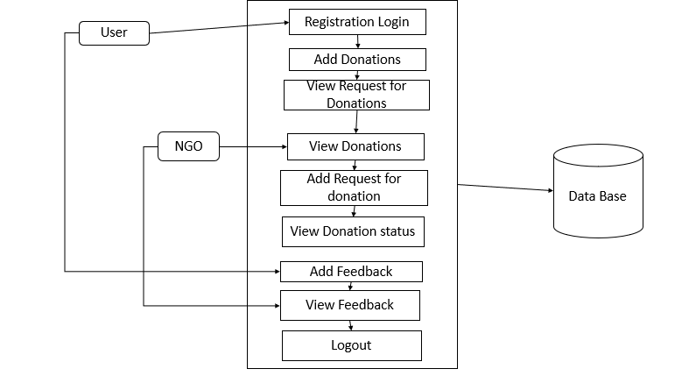

1. **Possible solution**

**Define the Disease of Interest:**

To enhance disease prediction, it’s crucial to specify the disease you are focusing on, such as diabetes or cancer. This targeted approach allows for a more tailored analysis.

**Data Collection:** To Gather relevant datasets from reputable public health sources or platforms like Kaggle. Access to high-quality, diverse datasets is vital for effective machine learning applications.

**Data Preprocessing:**

* **Handle Missing Values:** Address gaps in the dataset through methods such as imputation or removal of incomplete records.
* **Outlier Detection:** Identify and manage outliers to ensure they do not skew results.
* **Normalization:** Scale numerical features to ensure consistency across the dataset.
* **Encoding Categorical Variables:** Convert categorical data into numerical format for model compatibility.

**Feature Selection:** Utilize techniques like correlation matrices or model-based importance scores to identify and retain the most relevant features, enhancing the model's predictive power.

**Algorithm Selection:** Choose an appropriate machine learning algorithm based on the complexity of your data. Options include:

* **Logistic Regression** for binary outcomes
* **Decision Trees** for interpretability
* **Random Forests** for handling non-linear relationships

**Data Splitting:** Divide the dataset into training (80%) and testing (20%) sets to evaluate model performance effectively.

**Model Evaluation:** Implement cross-validation to assess the robustness of the model. Use metrics such as accuracy, precision, recall, and confusion matrices to evaluate performance comprehensively.

**Model Optimization:** Enhance the model's performance through hyper parameter tuning techniques, such as Grid Search, to find the best settings for your algorithms.

**Trends in Healthcare Technology:** The landscape of healthcare technology is rapidly evolving, marked by significant trends such as the proliferation of telemedicine and the integration of artificial intelligence. Investment in health tech start ups focusing on predictive analytics is on the rise, signa ling a shift towards data-driven decision-making in healthcare.

1. **Project and scope**

This is a food donation android application designed to reduce food wastage by donating excess food to poor or needy people. Based on Kotlin and currently under development.

In Africa, especially Kenya, food wastage is a disturbing issue. The streets, garbage bins and landfills have ample proof to prove it. Homes, canteens, restaurants, social and family get-togethers and functions disposes out so much food. Food wastage is not only an indication of hunger or pollution, but also economic problem. The high standard of living has resulted in the wastage of food, clothes etc, because of quick changes in habits and lifestyle. Instead of wasting these things we can put them in use by donating them to various organizations such as orphanages, old age homes, etc. The product is an internet-based android application that basically aims at charity through making donations on excess food that may go to waste. This application is meant to reduce food wastage and also full fill other requirements like clothes, books, utensils, etc. for the needy organizations and people.

Instead of throwing away the same as trash (which usually is the scenario), it can be used to feed the homeless. Also, since the pickup is arranged for by the enterprise, the restaurants/cafes need not worry about it. Benefiters will be both the restaurants/cafés (reducing the carbon footprint and wastage), and the needy. The ultimate objective of this project is to communicate that investments in food wastage reduction is the most logical step in the pursuit of sustainable production and consumption, including food security, climate change and other adverse environmental effects. Public awareness materials and a strategy will be developed to this effect.

We crating some if any query we can crate much better and good.

## **Splash screen**

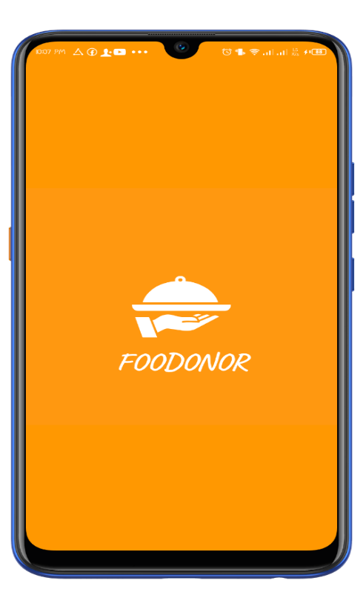

## **Sign in screen**

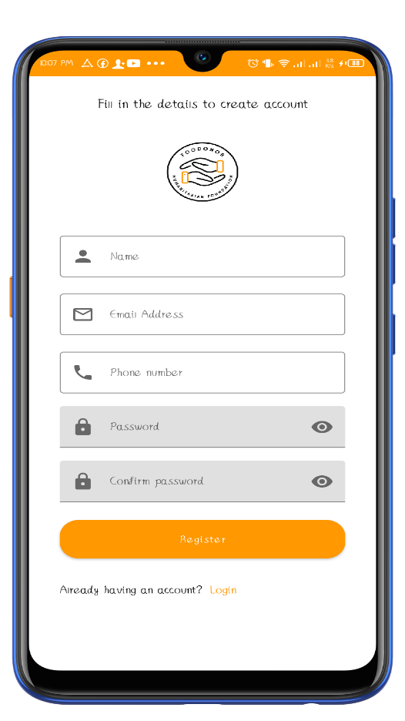

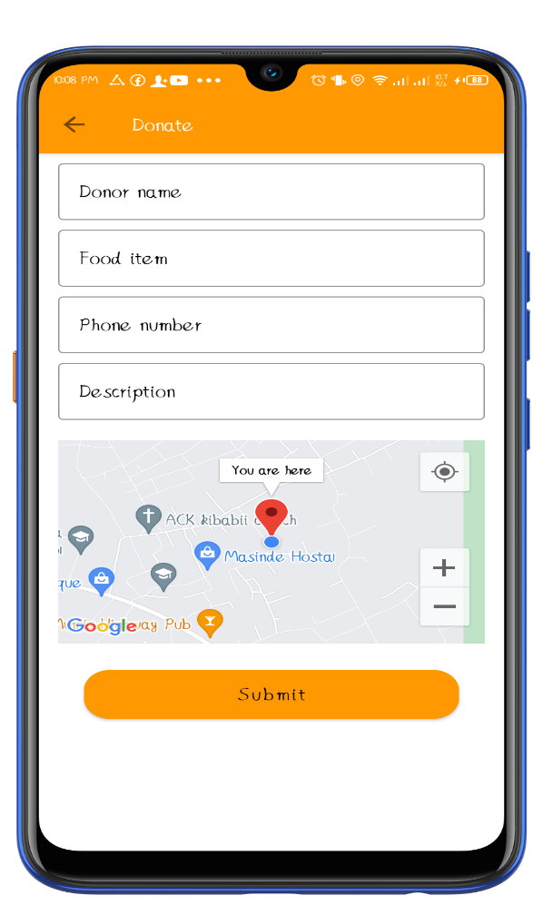

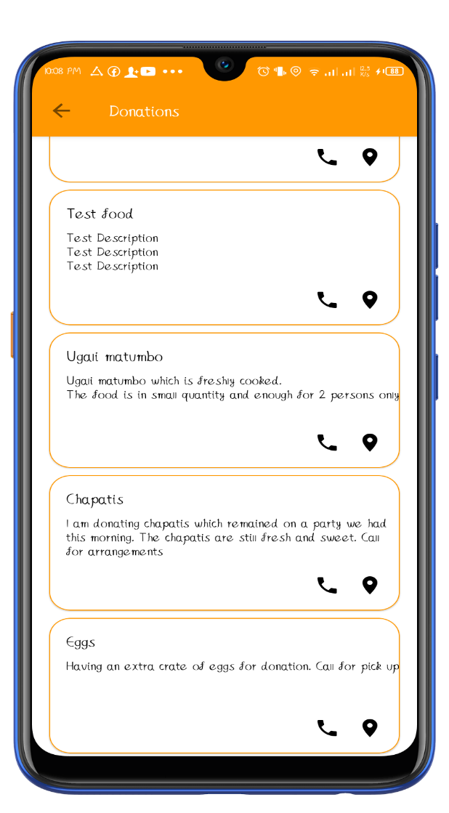

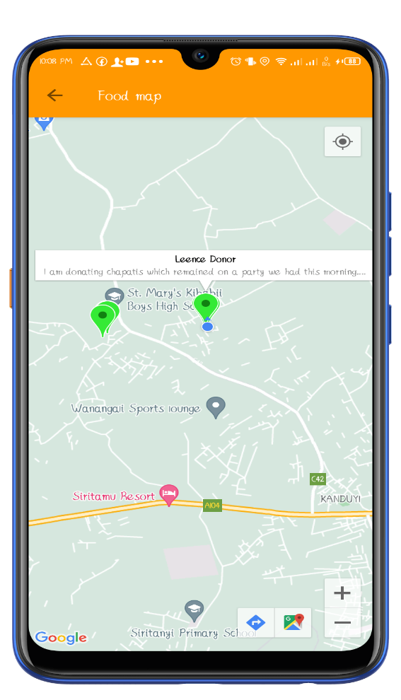

**7. Critical Evaluation**

#### **User Experience (UX)**

**Strengths:**

Intuitive interface design for both donors and NGOs facilitates easy navigation.

Clear call-to-action buttons and straightforward workflows enhance usability.

**Weaknesses:**

If not designed properly, the app may overwhelm users with too many options.

Accessibility features must be prioritized to ensure inclusivity for all users.

#### **Functionality**

**Strengths:**

Essential features like donation requests, real-time location tracking, and NGO ratings provide comprehensive

functionality.

The integration of Google Maps aids in efficient logistics for food pickups.

**Weaknesses:**

Potential technical issues may arise during peak usage times, affecting performance.

Limited offline functionality could hinder users in areas with poor connectivity.

**Performance**

**Strengths:**

Utilizing efficient algorithms for managing requests and notifications can ensure timely updates. Regular maintenance and updates can help optimize performance.

**Weaknesses:**

High-resolution images or poorly optimized code may lead to slower app performance on lower-end devices.

**Security**

**Strengths:**

Implementing secure authentication processes protects user data data encryption for sensitive information, such as user profiles and donation details, enhances security.

**Weaknesses:**

Vulnerabilities could arise if not properly managed, especially regarding location data. Continuous monitoring and updates are necessary to mitigate security risks.

Impact on Community

**Scalability**

**Strengths:**

The app architecture can support scalability to include more features or regions over time. Potential for partnerships with larger organizations for expanded outreach.

**Weaknesses:**

As the user base grown, increased demand on the server may require additional resources it is the so and infrastructure improvements.

Managing larger datasets and user interactions may complicate app performance if not planned adequately.

**Feedback and Improvement**

**Strengths:**

A built-in feedback mechanism allows users to report issues and suggest improvements, fostering continuous development.

Regular updates based on user feedback can enhance user satisfaction and app performance.

**Weaknesses:**

If user feedback is not adequately addressed, it may lead to frustration and decreased usage ensuring timely responses to feedback is crucial for maintaining user trust.

# Significance:

The serve paper for a waste food donation application plays a vital role by establishing a comprehensive framework that ensures legal protection and regulatory compliance for food donors. It outlines operational procedures and safety protocols, which help to minimize risks associated with food handling and distribution. By facilitating collaboration between food donors and nonprofits, it fosters community engagement and enhances partnerships aimed at addressing food insecurity.

Moreover, the serve paper promotes resource efficiency by encouraging the diversion of edible food from landfills, contributing to environmental sustainability. It emphasizes transparency and accountability, allowing organizations to track donations and assess the impact of their efforts. Additionally, it can serve as a training tool, promoting best practices among staff and volunteers involved in food donation initiatives.

Ultimately, the serve paper not only supports the logistical aspects of food donation but also raises awareness about food waste and food insecurity, potentially influencing policy changes that bolster these efforts. Its significance lies in its ability to create a structured, safe, and effective system for food donations, benefiting both donors and those in need.

1. **Conclusion:-**

Our study has look into the problem of food waste that has many serious side effects economically and socially. However, the waste of the food can be prevented or at lowest decreased using political rules and technology. Mobile application technology is helpful for food waste management. The app objective to encourage better food management. Our proposed solution should reduce food waste by facilitating food sharing in group using mobile technology. This work is an first step towards design a better system to reduce daily food waste.

Food waste is one of the issues currently facing the planet as a whole. Necessary steps should be taken to stop food waste, otherwise the people of the world will suffer from food scarcity. If you can save food from being wasted, we can feed the hungry people who has no food to eat. We have built “waste food donate application” which is an android application to reduce food waste age through donation. Any restaurant or individual user who has food surplus, can donate food through our application. Our registered charity organization’s volunteer will collect the food and distribute them to hungry people. We believe that food wastage will be reduced through out project. The surplus food can be donated by our project and also poor or hungry people will get food who have not enough food to eat. So our project can make a hung difference in the society by saving food from being wasted. Our goal is to establish a link between restaurants or individual users who has food surplus and charity organizations who have volunteer to collect organizations who has volunteer to collect the excess food.

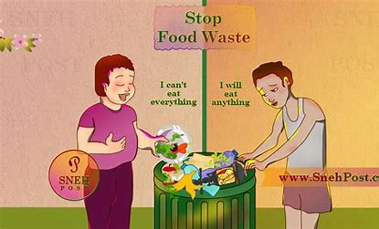

1. **Reference:**

* Vidhi Panchal1, Kajal Kuchekar2, Snehal Tambe3, Availability of food for NGO through Mobile Application:Food For All International Research Journal of Engineering and Technology (IRJET) Mar 2020.
* Ayesha Anzer, Hadeel A. Tabaza, and Wedad Ahmed, Hassan Hajj Diab,”A Food Wastage Reduction Mobile Application” 2018 6th International Conference on Future Internet of Things and Cloud Workshops.
* JManikandan1, Mr N Kumar2,”Food waste reduction through donation” International Research Journal of Engineering and Technology (IRJET) Mar 2020.
* Mrigank Mathur, Ishan Srivastava, Vaishnavi Rai,”Aahar Food donation App” International Journal of Scientific Research & Engineering Trends May-June2021.
* R.Adline Freeda1, M.S.Sahlin Ahamed2,”Mobile Application for Excess Food Donation and Analysis” April 2018, International Journal Of Innovation Research . technology(IJIESET)
* Komal Mandal ,Swati Jadhav, Kruti Lakhani, Food Wastage Reduction through Donation using Modern Technological Approach: Helping Hands International Journal of Advanced Research in Computer Engineering & Technology(IJARCET), April 2016.
* Sasikala P#1,Sentiment Analysis of Online Food Reviews using Customer Ratings 2018.
* Anusha Kailas Kogta,”Cross Platform Application for Canteen Food Ordering System” June 2020.

Anusha Kailas Kogta,”Cross Platform Application for Canteen Food Ordering System” June 2020. Services for Tinnitus Assessment, Therapy and Research, in 4th Intl Con Mobile Services 2015

* Platform Application for Canteen Food Ordering System” June 2020.
* Food Reviews using Customer Ratings 2018.
* (IJARCET), April 2016. Computer Engineering & Technology (IJARCET), April 2016.
* Donation using Modern Technological Approach: Helping Hands International Journal of Advanced Research in Computer Engineering & Technology (IJARCET), April 2016.
* , Food Wastage Reduction through Donation using M Approach: Helping Hands International Journal of Advanced Research in Computer Engineering & Technology (IJARCET), April 2016.

Online Food Reviews using Customer Ratings 2018.

* A Kailas Platform Application for Canteen Food Ordering System” June 2020.
* Mobile Crowd Sensing Services for Tinnitus Assessment, Therapy and Research, in 4th Intl Coon Mobile Services 2015.

## 