Geochemical studies of Groundwater and Surface Water samples from the Kapshi Lake Region in Akola, Maharashtra by using GIS Technique

***Mahesh D. Phalke1*, P. B. Zamarkar2 S.V. Dautpure3 A. D. Fuladi4***

*1,2,4Assistant Professor (Dept. of Geology)*

*3Assistant Professor (Dept. of Chemistry)*

*SSESA’s, Science College, Congress Nagar, Nagpur*

*Corresponding Author:* [*mahesh.phalke@sscnagpur.ac.in*](mailto:mahesh.phalke@sscnagpur.ac.in)

# ABSTRACT:

At the Kapshi Lake, which is close to Akola, India, this study looks into the physicochemical characteristics of both surface and groundwater. pH, TDS, EC, TH, Ca, Mg, Cl, color, and temperature were analyzed for six water samples from bore wells, dug wells, and Kapshi Lake. Finding out how surface and groundwater quality relate to one another and whether or not they are suitable for irrigation and drinking is the main goal. According to the research, anthropogenic activities like industrial discharge, inappropriate waste disposal, and agricultural runoff are the main causes of the various levels of contamination found in the water sources of Kapshi Lake. Natural processes, such as leaching and mineral dissolved also influence the quality of the water. There are noticeable changes in the chemical makeup of samples of surface water and groundwater when compared. While surface water is impacted by evaporation, rainfall, and biological activity, groundwater is typically characterized by higher concentrations of dissolved minerals and salts. In addition, hydrological circumstances and geological formations within the watershed affect the spatial distribution of water quality indicators. Public health and sustainable resource management depend on an understanding of the physicochemical characteristics of the surface and groundwater in Kapshi Lake. Policymakers and local communities can design successful policies for managing water quality by using the useful insights obtained from this study. To enhance the quality of the water in this area, future studies should concentrate on determining the precise causes of contamination and putting mitigating measures in place.

**Keywords:** Groundwater, Runoff, Evaporation, Contamination, Kapshi, Leaching.

**Introduction:**

A multitude of studies have shown that the lack of clean, safe drinking water has a negative influence on public health and linked health problems in underdeveloped nations. 2018's Adimalla N. The geochemistry of the soil that groundwater percolates through before reaching aquifers has a substantial impact on the kind and degree of chemical contamination in groundwater. Zuane (1990). Since it is impossible to stop unwanted substances from dissolving in the waters once, they reach the ground (Johnson 1979; Sastri 1994), information on groundwater quality can be very helpful in understanding the lithology of the region's rocks and the groundwater's movement, recharge, and storage (Walton, 1970), as well as the length of time that water spends in contact with rocks. Groundwater is analyzed in the scientific field of hydrogeochemistry to determine its chemical makeup and how it interacts with the surrounding geological environment. Hydrogeochemistry offers important insights into the quality and suitability of groundwater for various uses, even though it may appear to be a straightforward process of gathering and testing water. Laboratory analysis and field sampling techniques are crucial elements of hydrogeochemical investigations. Hutton (1983) offers a thorough overview of these techniques. To avoid contamination, groundwater samples are usually taken using sterile containers from sources such as lakes, hand pumps, drilled wells, and tube wells. We can ascertain the chemical makeup of the water and pinpoint any possible pollutants by examining samples of groundwater.

**Study Area:**

The village of Kapshi is located in Maharashtra's Akola district. The study region is located in Survey of India Toposheet No. 55D/14 and is between 20°33'47.989"N and 76°57'39.285"E. A total size of 11,2468 square kilometers. The Morna River Basin a tributary to the Kapshi Lake Basin.

Fig. 1 Location Map of the Study Area.

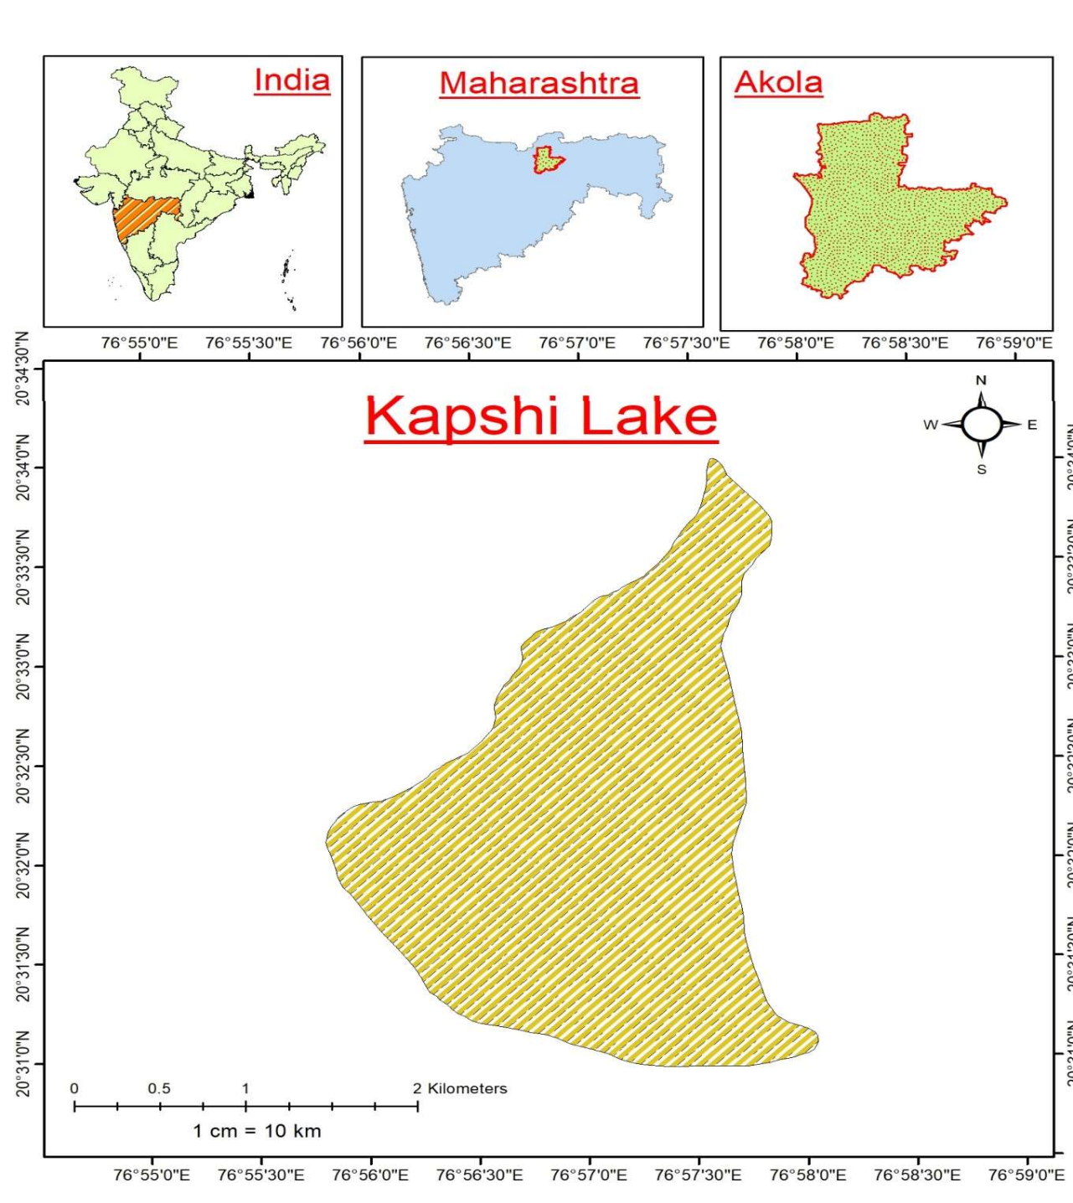

**Methodology:**

Six strategically chosen water samples were taken from a variety of sources, including dug wells, bore wells, and Kapshi Lake, in order to thoroughly evaluate the water quality and its correlation to the environmental parameters in the Kapshi watershed. These sampling sites were picked with care to reflect a range of hydrological conditions and land use types. To reduce the impact of stagnant pipe water, each sampled well had its water discharged for two to three minutes before to sample collection. After that, a variety of physicochemical characteristics, such as pH, TDS, EC, TH, Ca, Mg, Cl, color, and temperature, were examined in the collected water samples. The overall health of the water bodies in the watershed as well as possible sources of contamination were both well-informed by this data. We combined remote sensing methods with Geographic Information Systems (GIS) to improve our comprehension of the spatial correlations between hydogeochemical parameters and environmental conditions. This allowed us to examine the effects of topography, hydrology, and land use on the distribution of water quality indicators in the research area.

**Results and observations:**

Samples were taken from the research area's surface and wells. Table1 and Table 2 display the spot-by-spot data that was noticed following the analysis.

|  |  |  |  |  |
| --- | --- | --- | --- | --- |
| **Sample no.** | **Location** | **Lat** | **Long** | **Well type** |
| **1** | Chikhalgaon | 20.52881056 | 76.9487 | Dug well |
| **2** | Near Kapshi Lake | 20.56674273 | 76.9602 | Surface water (Nala in village) |
| **3** | Kapshi Lake | 20.56642091 | 76.9603 | Surface water in |
|  |  |  |  | lake |
| **4** | Chikhalgaon | 20.53728427 | 76.9407 | Bore well |
| **5** | Chikhalgaon | 20.55827442 | 76.9573 | Dug well |

**Table 1: Water Samples collected from the study area**

**Table 2: Geochemical parameters of water samples collected from the study area**

|  |  |  |  |  |  |
| --- | --- | --- | --- | --- | --- |
| **SR.**  **NO.** | **PARAMETERS** | **SAMPLE 1** | **SAMPLE 2** | **`SAMPLE 3** | **SAMPLE 4** |
| **1)** | **Colour** | Colourless | Colourless | Colourless | Colourless |
| **2)** | **Temperature** | 240c | 230c | 260c | 250c |
| **3)** | **Turbidity** | 1 NTU | 1 NTU | 1 NTU | 4 NTU |
| **4)** | **Ph** | 6.8 | 7.8 | 6.9 | 7.9 |
| **5)** | **Conductivity** | 1080 µmho/cm | 316 µmho/cm | 685  µmho/cm | 450 µmho/cm |
| **6)** | **Total dissolved solids** | 990 mg/lit | 500 mg/lit | 700 mg/lit | 700 mg/lit |
| **7)** | **Dissolve oxygen** | 2.3 mg/l | 7 mg/lit | 8.5 mg/lit | 3.4 mg/lit |
| **8)** | **Total alkalinity** | 472 mg/lit | 275 mg/lit | 293 mg/lit | 462 mg/lit |
| **9)** | **Total hardness** | 462 mg/lit | 213 mg/lit | 702 mg/lit | 825 mg/lit |
| **10)** | **Calcium hardness** | 88.18 mg/lit | 72.16 mg/lit | 259.86  mg/lit | 285.24 mg/lit |

**1)Temperature**:   
The water sample was found to be between 220 and 250 degrees Celsius in temperature. The temperature was discovered to be 250 C at place VI and to be 220 C at spot II, which was the lowest. The temperatures at spots I and IV were determined to be the same, or 230 C, whereas the temperatures at sports III and IV were discovered to be 240 C and 230 C, respectively.  
**2. Colour:**

Throughout the research, it was discovered that the water samples were clear, or colorless.

**3) pH:**

While the pH does not directly affect human health, it can affect how water tastes and show correlations with some other water quality factors (Islam ARMT, Ahmed N, Bodrud-Doza M, Chu R (2017). The water sample's pH was discovered to be between 6.5 and 9. Spot VI had a pH of 9, while spot V had a pH of 6.5. The pH values at spots III and IV were discovered to be 7.9 and 8, respectively. However, it was discovered that the pH at spots I and III was the same, or 6.9.

**Fig.2 Potential of Hydrogen (pH) of concerning temporal variations of the study area.**

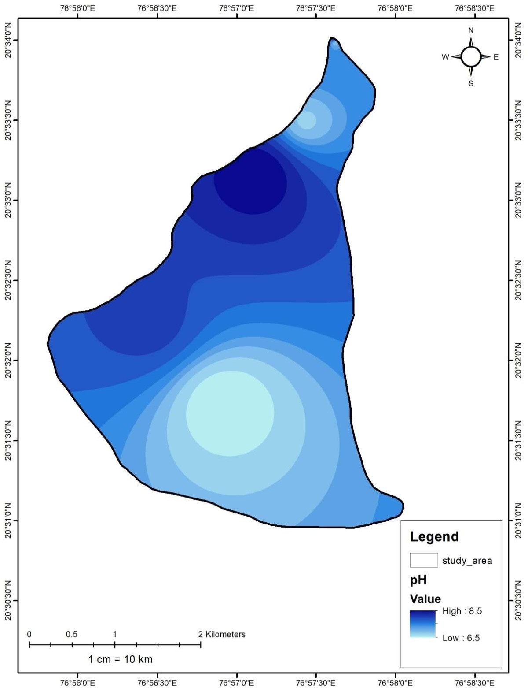

**4. Conductivity:**

Since it increases with temperature and the number of dissolved salts in the water, conductivity in water is particularly important (Panaskar DB, Wagh VM, Pawar RS 2014). The conductivity of the water sample was determined to be between 314 and 1174 µmho/cm, with spot III exhibiting the lowest conductivity at 314 µmho/cm and spot VI exhibiting the highest conductivity at 1174 µmho/cm. At locations I, II, IV, and V, the conductivity was measured at 1096 µmho/cm, 680 µmho/cm, 456 µmho/cm, and 1114 µmho/cm, in that order.

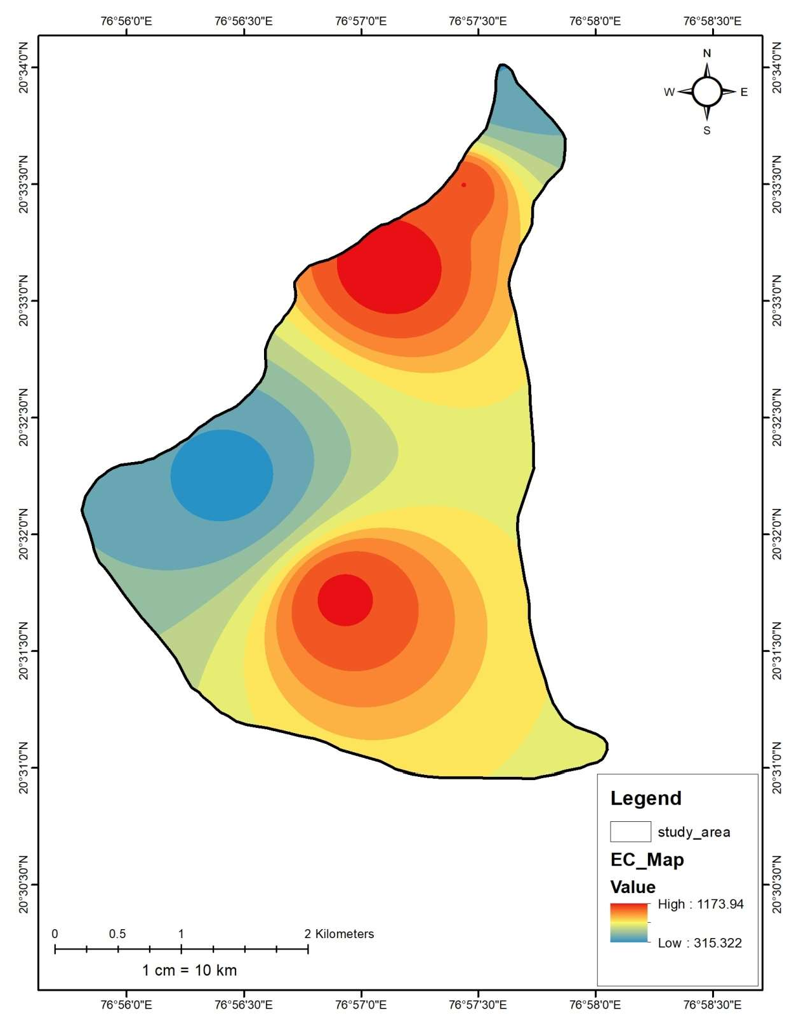

**Fig.3 Electrical Conductivity (EC) of with respect to temporal variations of the study area.**

5**) Total Dissolved Solids (TDS):**

Between 400 and 1000 mg/lit were found to be the total dissolved solids in the water sample. Whereas the total dissolved solid at spot II was 400 mg/l, it was observed that the total dissolved solid at place I was 1000 mg/l. 800 mg/l of total dissolved solid was detected in spots III and V, and 600 mg/l and 900 mg/l, respectively, at spots IV and VI.

**6) Oxygen dissolved:**

In the range of 2.2 mg/l to 8.6 mg/l, dissolved oxygen was discovered in the well water sample. The oxygen content was determined to be at its lowest point (2.2 mg/l) at location I and at its maximum (8.6 mg/l) at spot III. There was 8 mg/l of dissolved oxygen at spots II, IV, and V, 3.6 mg/l, and 4.8 mg/l, in that order.

**7. Chloride:**

There was 76.68 mg/l to 159.04 mg/l of chloride in the water sample. Spot III produced the lowest chloride concentration of 76.68 mg/l, whereas spot VI produced the highest concentration of 159.04 mg/l. At spots I, II, IV, and V, the amounts of chloride were determined to be 110.76 mg/l, 85.2 mg/l, and 122.12 mg/l, in that order.

**8) Total hardness:**

The entire water sample's hardness was determined to be between 216 and 820 mg/l. The total hardness was measured at 464 mg/l, 700 mg/l, 688 mg/l, and 748 mg/l at spots I, III, V, and VI, in that order. The maximum total hardness was obtained at spot-IV (820 mg/l), and the minimum total hardness was found at spot II (216 mg/l).

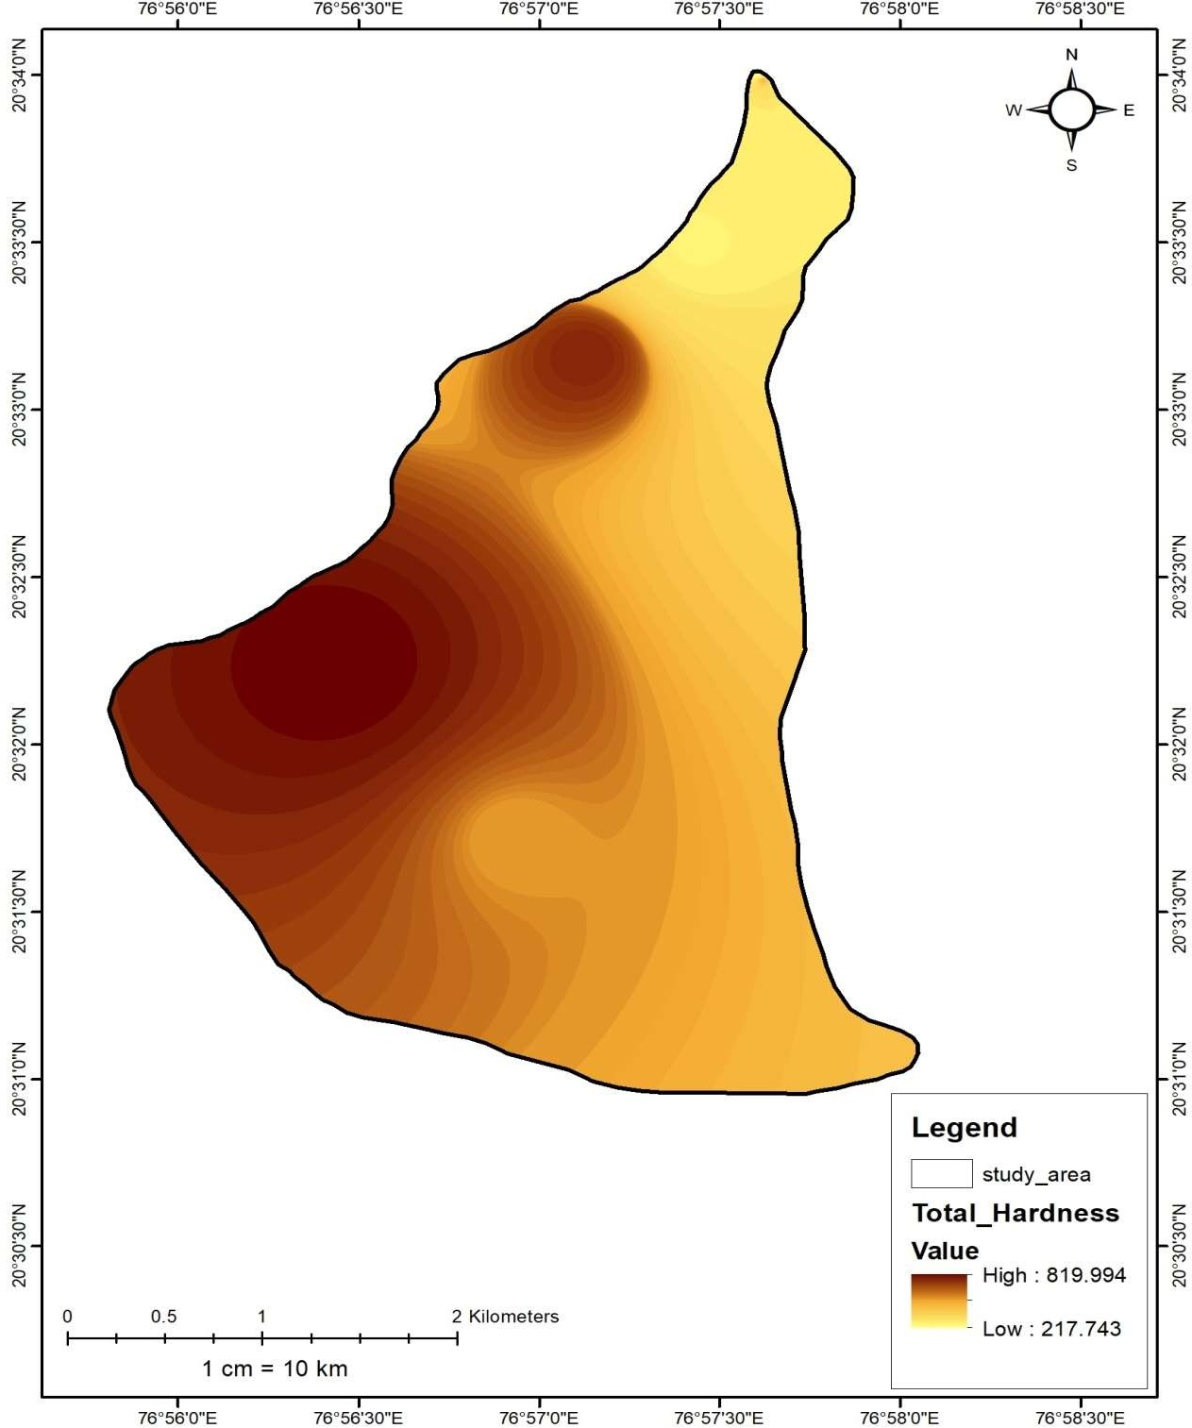

**Fig.4 Total Hardness map concerning temporal variations of the study area.**

**9) Calcium Hardness:**

The water sample's calcium hardness was measured and determined to be between 72.144 to 285.36 mg/l. Higher calcium hardness was measured at spot IV at 285.36 mg/l, while lower calcium hardness was measured at location II at 72.144 mg/l. Calcium hardness was measured at spots I, III, V, and VI, and was determined to be 88.176 mg/l, 72.144 mg/l, 259.79 mg/l, 126.65 mg/l, and 182.76 mg/l, respectively.

**10) Magnesium Hardness:**

The water sample's magnesium hardness was measured and determined to be between 143.856 and 565.24 mg/lit. The highest magnesium hardness of 565.24 mg/lit was discovered at place VI, and the lowest of 143.856 mg/lit was discovered at spot II. It was discovered that the magnesium hardness at spots I, III, IV, and V was, in that order, 375.824 mg/lit, 441 mg/lit, 534.64 mg/lit, and 561.35 mg/lit.

**Conclusions:**

The spatial distribution of water quality measures and their correlation with environmental factors in the Kapshi Lake region can be analyzed with the help of GIS, which is a helpful tool. We can uncover important information about the variables affecting water contamination and locate possible hotspots by combining multiple data layers into a GIS environment. Many significant inferences can be made from the examination of the water quality data. The increasing concentrations of TDS, EC, TH, and other contaminants in the groundwater of the Kapshi Lake area show that the groundwater is prone to contamination. Significant causes of water contamination in the area are anthropogenic activities like industrial discharge, runoff from agriculture, and inappropriate trash disposal. Surface water and groundwater are chemically different, with groundwater being more mineralized than surface water because of its interactions with geological formations. Effective water quality management techniques are crucial for preserving public health and guaranteeing sustainable resource management. This involves pinpointing the precise sources of contamination, putting pollution control measures in place, keeping a close eye on things, and creating thorough strategies for water management. Policymakers and local communities may work toward enhancing the quality of the water and guaranteeing the long-term sustainability of water resources in the Kapshi Lake region by addressing these challenges.

**References:**

1. Adimalla N (2018) Groundwater quality for drinking and irrigation purposes and potential health risks assessment: a case study from semi-arid region of South India. Expo Health 11(2):109–123.
2. Anji Reddy M. (2001) “A Text Book of Remote Sensing & GIS”, 2nd edition, B.S.Publications, Hyderabad.
3. Arnold J. G. Williams, J. R., Nicks, A. D. and Sammons, N. B.(1990) “SWRRB – A Basin Scale Simulation Model for Soil and Water Resources Management”, Texas A&M Press, College Station, TX, 1990
4. Aronoff (1989) “Geographic Information System: A Management Perspective”, WDL Publications, Ottawa Canada.
5. Burrough P.A. (1986) “Principles of Geographic Information Systems for land Resources Assessment”, Clarendon Press, Oxford
6. Demus M.N. (1997) “Fundamentals of Geographic Information Systems”, John Wiley and Sons. Inc.
7. Dwivedi R.S., P. R. Reddy, K. Sreenivas and G. Ravishankar (1988) “The Utility of IRS data for Land Degradation Mapping”, Proceedings, National Seminar, IIRS, Mission and Its Application Potential, Hyderabad
8. Elvis A. Shukla, Jagdish Prasad, M.S.S. Nagraju, Rajeev Srivastav and D.L. Kauraw (2009) “Use of Remote Sensing in Characterization and Management of Dhamni Micro-watershed of Chandrapur District of Maharashtra”, J. Indian Soc. Remote Sensing, March 2009 Vol.37
9. Gosain A. K. and Sandhya Rao (2004) “GIS-based technologies for Watershed Management”, CURRENT SCIENCE, Vol. 87, No. 7
10. Hutton, L.G. (1983) Field Testing of Water in Developing Countries. Water Research Centre, Medmeham, England.
11. Islam ARMT, Ahmed N, Bodrud-Doza M, Chu R (2017) Characterizing groundwater quality ranks for drinking purposes in Sylhet district, Bangladesh, using entropy method, spatial autocorrelation index, and geostatistics. Environ Sci Pollut Res 24(34):26350–26374.
12. Johnson, C. C. (1979). Land application of water-an accident waiting to happen. Groundwater, 17(1), 69–72.
13. Panaskar DB, Wagh VM, Pawar RS (2014) Assessment of groundwater quality for suitability of domestic and irrigation from
14. Nanded Tehsil, Maharashtra, India. SRTMUs J Sci 4(1):71–83
15. Sastri, J. C. V. (1994). Groundwater chemical quality in river basins, Hydrogeochemical modeling. Lecture notes—refresher course, School of Earth Sciences. Bharathidasan University, Tiruchirapalli, Tamil Nadu, India.