**APP FOR SCREW COMPRESSORS & MACHINERY**

**Piyush Halande, Aditya Sheth, Puneesh Tilekar, Siddharth Shahi, Prof. Laxman Lande**

Zeal Polytechnic, Pune, India

DOI: https://www.doi.org/10.58257/IJPREMS36389

**ABSTRACT**

The Maintenance App for Compressors and Machinery is designed to streamline the management of industrial equipment maintenance. It allows users to log maintenance tasks, schedule future activities, and receive notifications to ensure timely servicing. The app features role-based access control, allowing admins and technicians to have different levels of access. A real-time analytics dashboard provides insights into machine performance and maintenance trends, while inventory tracking ensures that spare parts are always available. The app supports secure login with multi-factor authentication (MFA) and password reset functionality. It is compatible with Android, offering a user-friendly interface for managing compressors and machinery maintenance efficiently.

1. **INTRODUCTION**

Industrial machinery, such as compressors, plays a critical role in various sectors like manufacturing, construction, and energy. However, the downtime caused by equipment failure can lead to significant operational and financial losses. Regular and timely maintenance is essential to ensure the continuous and efficient functioning of these machines. Traditional manual maintenance processes, often reliant on paper-based logs or isolated spreadsheets, can lead to missed maintenance tasks, inefficient scheduling, and difficulty in tracking performance over time.

The **Maintenance App for Compressors and Machinery** aims to solve these problems by providing an intuitive digital platform for managing all aspects of machinery maintenance. The app helps users log maintenance activities, track spare parts inventory, and receive notifications for scheduled servicing. With real-time analytics and a role-based user interface, it ensures that maintenance tasks are completed efficiently, minimizing the risk of equipment failure.

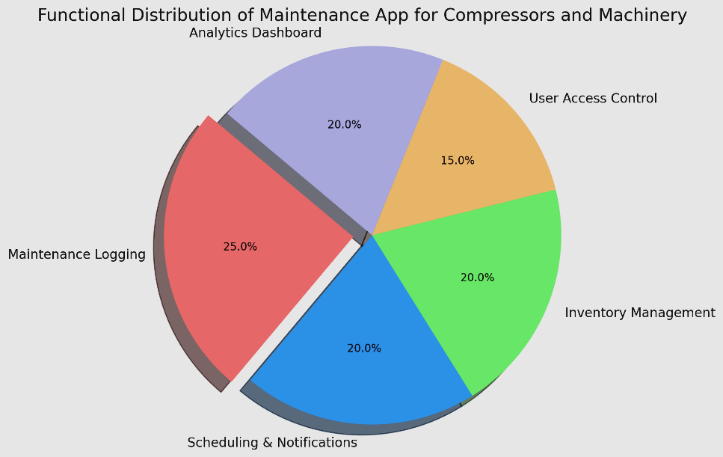

* Maintenance Logging: 25%



* Scheduling & Notifications: 20%
* Inventory Management: 20%
* User Access Control: 15%
* Analytics Dashboard: 20%

1. **LITERATURE SURVEY**

* **Importance of Maintenance in Industrial Machinery**

Effective maintenance is essential for maximizing the lifespan and efficiency of compressors. Transitioning from reactive to preventive maintenance can significantly reduce downtime and operational costs. Systematic approaches enhance overall equipment effectiveness.

* **Role of Mobile Applications in Maintenance Management**

Mobile applications enhance maintenance management by providing real-time data access. They improve communication between technicians and management, facilitating logging and tracking of maintenance activities. This leads to increased efficiency and reduced response times.

* **User-Centered Design in Maintenance Applications**

User experience is crucial for the success of maintenance apps. Intuitive interfaces and clear navigation enhance user satisfaction and engagement. Incorporating user feedback in design increases the likelihood of effective usage.

* **Impact of Data Analytics on Maintenance Efficiency**

Data analytics in maintenance apps provide insights into equipment performance. Monitoring key performance indicators promotes condition-based maintenance strategies. This data-driven approach enhances decision-making regarding maintenance schedules.

* **Future Research Directions**

Future studies should explore AR and VR advancements for training and troubleshooting. Understanding user behavior and engagement can optimize app features. Research focusing on overcoming existing challenges will enhance mobile maintenance applications.

1. **METHODOLOGY**

**1.** **Requirement Analysis**

* Objective: Understand the needs of the industry and the specific requirements for maintaining compressors and other machinery.
* Process:
  + Conduct interviews with potential users (maintenance technicians, engineers, etc.).
  + Identify key features such as logging, notifications, inventory tracking, and analytics.
  + Establish system requirements such as security protocols, platform compatibility (iOS, Android), and integration with existing tools (e.g., databases, cloud storage).

**2.** **System Design**

* Objective: Translate the requirements into a clear design framework for the app.
* Process:
  + UI/UX Design: Develop wireframes and mockups of the app’s user interface, ensuring intuitive navigation and easy access to core functions (maintenance logs, notifications, analytics).
  + Database Design: Design a relational database to store maintenance records, equipment details, user roles, and parts inventory. Ensure scalability for future expansions.
  + Security Architecture: Design the security framework, including password encryption, session management, and role-based access control.

**3.** **Development**

* Objective: Build the app using appropriate technologies for cross-platform compatibility and seamless performance.
* Process:
  + Frontend Development: Create the app’s user interface based on the approved UI/UX designs using frameworks like React Native for cross-platform compatibility.
  + Backend Development: Develop the backend services to handle authentication, notifications, and data storage. Use cloud-based services for scalability and real-time updates.
  + Core Feature Implementation:
    - Maintenance logging module.
    - Scheduling system with real-time notifications.
    - Role-based access control (admin, technician).
    - Inventory management system.

**4. Integration of Features**

* Objective: Ensure that all features are seamlessly integrated and work together.
* Process:
  + Integrate the login system with multi-factor authentication (MFA).
  + Implement email and push notifications for maintenance schedules.
  + Ensure inventory updates are tied to maintenance logs and are reflected in real-time.
  + Link the analytics dashboard to the database to provide insights on equipment performance and maintenance trends.

**5. Testing**

* Objective: Ensure the app works flawlessly across different devices and scenarios.
* Process:
  + Unit Testing: Test individual components such as the login system, notification system, and database connectivity.
  + Functional Testing: Validate the app's core functionalities (logging, notifications, inventory management).
  + Cross-Platform Testing: Test the app on both Android and iOS devices to ensure consistent performance.
  + Security Testing: Test the security protocols, including encryption, authentication, and role-based access, to ensure data protection.

**6. Deployment**

* Objective: Launch the app and make it accessible to end users.
* Process:
  + Deploy the app on both the Apple App Store and Google Play Store.
  + Set up backend services on a cloud platform for scalability.
  + Ensure that user data is securely stored and accessible for real-time operations.

**7. Post-Launch Monitoring and Updates**

* Objective: Continuously monitor the app for issues and make improvements based on user feedback.
* Process:
  + Monitor user activity and system performance to identify any issues or potential improvements.
  + Roll out updates based on user feedback and evolving maintenance needs, including potential features like web version integration and expanded analytics.

1. **CONCLUSION**

The development and implementation of a mobile application for maintaining compressors and machinery represent a significant advancement in industrial maintenance practices, offering numerous benefits such as improved efficiency, reduced downtime, and cost savings. By facilitating proactive maintenance strategies, the app encourages users to adopt preventive approaches that enhance overall equipment effectiveness. User-centered design principles are critical to the app’s success, ensuring it meets technicians' needs and fosters higher engagement rates. The inclusion of data analytics empowers users to make informed decisions based on real-time insights, optimizing maintenance schedules and extending equipment lifespan. Case studies demonstrate the practical advantages of mobile applications, with notable reductions in emergency repairs and improved task completion rates. However, challenges such as data privacy concerns, integration with existing systems, and resistance to change among personnel must be addressed. Future research should enhance the app’s capabilities, incorporating advanced technologies like augmented reality and virtual reality for training purposes. Ultimately, this mobile maintenance app has the potential to transform maintenance practices across various industrial sectors, leading to improved operational reliability and significant cost reductions, making it essential for maintaining competitiveness and operational excellence in an evolving industry landscape.

1. **REFERENCES**
2. https://www.aims.org.au/articles/asset-maintenance-management
3. https://www.lean.org/lexicon/total-productive-maintenance Project-Report-docx
4. https://www.techtarget.com/search/query?q=mobile+technology+for+asset+maintenance
5. https://www.ibm.com/blogs/internet-of-things/iot-predictive-maintenance/
6. https://www.machinerylubrication.com/Read/33719/mobile-maintenance-solutions