Online Blood Report System

1.Prachi Dhumal , Zeal Polytechnic, Pune, India.

2.Rohit Jori , Zeal Polytechnic, Pune, India.

3.Shravani Kadam , Zeal Polytechnic, Pune, India.

4.Nikita Gulage , Zeal Polytechnic, Pune, India.

5.Prof. Megha Garud , Professor, Zeal Polytechnic, Pune, India

***Abstract:* *The Online Blood Report System is a web-based platform designed to streamline the process of generating, accessing, and managing medical blood test reports. This system provides a secure and user friendly interface for patients, doctors, and laboratory staff, enabling them to efficiently handle blood test data and report distribution. Patients can conveniently view their test results online, while healthcare professionals can upload and analyze these results in real-time. The system offers features like automated report generation, secure data storage, quick search functionality, and role-based access control to maintain confidentiality. By digitizing the blood test reporting process, the system aims to reduce manual errors, enhance data accuracy, and improve patient-doctor communication, ultimately leading to more efficient healthcare delivery.***

# Introduction:

# An Online Blood Report System is a web-based platform designed to streamline and simplify the process of accessing, managing, and sharing blood test results for patients and healthcare providers. The system enables patients to view their blood reports online, download them, and track their health progress over time without needing to visit the laboratory or hospital in person. In the era of digital transformation, healthcare services have evolved significantly, leveraging technology to enhance patient care and improve the efficiency of medical processes. One such innovative advancement is the Online Blood Report System, a platform that allows healthcare providers, laboratories, and patients to interact digitally. This system enables the secure and efficient generation, management, and distribution of blood test reports, making it easier for patients to access their medical information anytime and anywhere. This survey paper explores the features, benefits, and challenges associated with online blood report systems. By examining user experiences and system functionalities, we aim to provide a comprehensive overview of how these platforms contribute to better health management and patient engagement. Furthermore, we will analyze the implications of data security, accessibility, and the overall impact on healthcare delivery.

# Literature Survey:

Online blood report systems are digital platforms designed to manage and distribute patients' blood test results via the internet, allowing for remote access by both patients and healthcare providers. The main goals include improving the efficiency of healthcare services, enhancing the accuracy of diagnostics, reducing the waiting time for results, and providing secure access to medical information. According to studies, integrating these systems with existing healthcare infrastructures like hospitals, clinics, and laboratories has been a key focus. Researchers have noted that the interoperability of these platforms plays a critical role in their success. Literature shows a growing trend in developing mobile apps that integrate with online blood report systems. This shift helps in enhancing accessibility and allows users to receive notifications and updates about their reports in real-time.Studies have emphasized the importance of data security and patient confidentiality in online blood report systems. Encryption techniques and data protection laws like HIPAA (Health Insurance Portability and Accountability Act) are often implemented to ensure the secure handling of sensitive medical information

# Proposed system:

# The proposed online blood report system aims to streamline the process of accessing and managing blood test results through a user-friendly digital platform. By integrating secure web-based interfaces and mobile applications, the system will allow patients to effortlessly view their test results anytime and anywhere, reducing the waiting time typically associated with traditional methods. The system will also enable healthcare providers to efficiently manage patient data, enhance communication, and ensure accurate reporting through automated data entry and retrieval processes. Additionally, robust security measures will be implemented to safeguard sensitive medical information, ensuring patient confidentiality and compliance with healthcare regulations. This innovative solution not only enhances patient engagement and satisfaction but also contributes to more efficient healthcare delivery overall.

# 4. Problem statement:

# In traditional healthcare systems, patients and medical practitioners face significant challenges in accessing, sharing, and managing blood test reports. The current reliance on manual or semi-digital processes leads to delays in diagnosis, inefficiencies in data handling, and limited patient access to personal health information. Additionally, issues related to data security, privacy, and integration with existing hospital information systems hinder the effective use of blood report data for timely medical intervention and personalized care.There is a critical need for an efficient, secure, and user-friendly online blood report system that enables real-time access to blood test results for both patients and healthcare providers. Such a system should ensure data accuracy, improve accessibility, facilitate interoperability with other health systems, and uphold stringent security standards to protect sensitive medical information. Addressing these needs could transform patient care by speeding up diagnostic processes, empowering patients with access to their health data, and enhancing the overall efficiency and quality of healthcare services .

# Project and Scope:

# The project’s scope includes designing the system architecture, developing core functionalities, implementing security measures, and testing for usability and performance. User Registration and Authentication Design a secure registration system for patients, doctors, and healthcare administrators. Use two-factor authentication and encrypted login protocols to protect user data.

# Future Scope

The online blood report systems is expansive and holds the potential to revolutionize the way healthcare services are delivered and managed. As technology continues to advance, these systems are expected to become more intelligent, secure, and integrated with other health information platforms. Artificial Intelligence (AI) and Machine Learning (ML) are set to play a critical role in the evolution of online blood report systems by enabling predictive analytics and providing insights into patient health trends based on blood test results. This could lead to personalized healthcare, where patients receive customized health recommendations and treatment plans, enhancing early diagnosis and prevention of diseases. The integration of blockchain technology is another promising development, aiming to provide a more secure, transparent, and tamper-proof method for managing patient data, which would significantly reduce the risks of data breaches and unauthorized access.

**Objective**

# The Online Blood Report System is to provide patients and healthcare professionals with a convenient and efficient platform for accessing, managing, and analyzing blood test reports. The system aims to streamline the process of report generation, minimize errors, and ensure timely availability of accurate diagnostic information. It also seeks to enhance patient engagement by enabling secure access to their medical records, thereby improving communication between patients and healthcare providers while maintaining data privacy and confidentiality.

# Critical Evaluation:

# The Online Blood Report System offers significant benefits in terms of accessibility and streamlined healthcare management, but it also presents critical challenges that require careful evaluation. Ensuring data security and privacy is paramount, as the system deals with sensitive patient information. Another challenge lies in user accessibility; while the system aims to offer convenient online access, patients with limited tech skills or poor internet connectivity may struggle, highlighting the need for a user-friendly design and possibly an offline mode. Additionally, system reliability is crucial, as downtime could delay urgent medical decisions, emphasizing the need for strong backup systems and a resilient infrastructure. Interoperability with other healthcare systems is also critical without seamless integration, the flow of patient information between hospitals, labs, and doctors could be hindered, reducing the system's effectiveness. Moreover, accuracy in report data is essential to avoid misdiagnosis, requiring stringent data entry validation and restricted access to authorized personnel only. Finally, scalability is a key consideration as usage increases, and the system must be designed to handle larger traffic and data loads without compromising performance. Addressing these challenges will make the Online Blood Report System a more secure, reliable, and inclusive tool, supporting improved healthcare outcomes.

# Significance:

The Online Blood Report System holds significant value in modern healthcare by enhancing efficiency, accessibility, and accuracy in managing blood test reports. It provides instant access to test results, enabling patients to review their health information from any location, which can be particularly helpful in emergencies. For doctors, timely access to reports allows for faster, more informed decision-making, facilitating prompt medical interventions when necessary. Labs benefit from a streamlined process of storing and sharing reports, reducing paperwork and minimizing the chance of lost or misplaced records. The system also promotes data accuracy, as digital records are less prone to human error compared to manual entries. Furthermore, it contributes to patient empowerment, allowing individuals to track their health history over time and take proactive steps toward better health. By creating a centralized, secure, and easily accessible platform, the Online Blood Report System supports a more connected and patient-centered approach to healthcare, aligning with the growing shift toward digital health solutions.

* **Use case diagram for Admin**

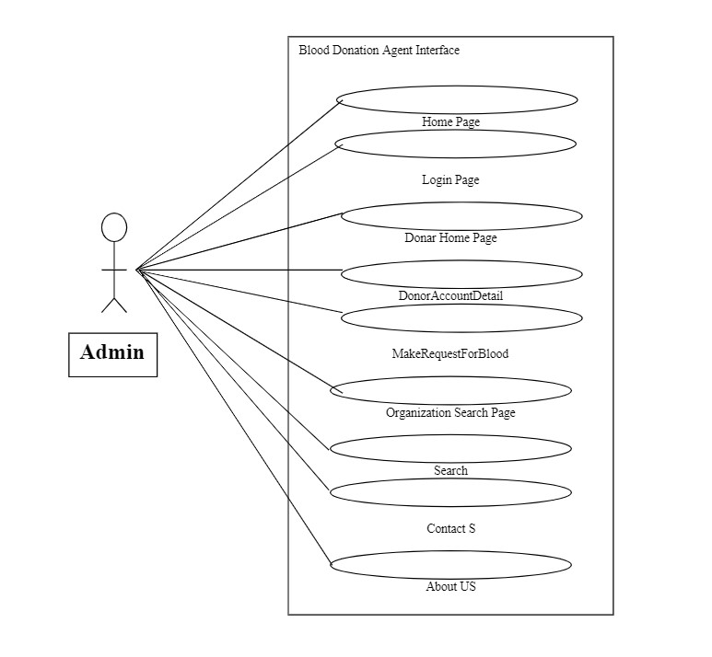

1. **Conclusion:**

Online blood report systems represent a significant advancement in the healthcare sector, providing a faster, more efficient, and user-friendly way to access blood test results. These systems improve patient care by reducing the time needed to obtain diagnostic information and minimizing errors associated with manual data handling. They enhance accessibility, particularly in remote areas, and contribute to better decision-making for both healthcare professionals and patients. However, despite the benefits, challenges such as data security, technical limitations, and user adoption must be addressed to ensure the widespread success of these platforms. Future innovations like AI and blockchain technology hold great promise for overcoming these hurdles and further transforming online blood report systems into even more secure, accurate, and personalized healthcare solutions. Continuous research and development in this area will play a crucial role in refining these systems to meet the evolving needs of the healthcare industry.

1. **References:**

Here are some references that you might find useful for a literature review on the topic of online blood report systems. These references focus on digital health records, laboratory information systems, and healthcare informatics, which are closely related to online blood report systems:

1. Ha yrinen, K. Saranto K., & Nyka nen, P. (2008). "Definition, structure, content, use, and impacts of electronic health records: A review of the research literature." International Journal of Medical Informatics, 77(5), 291-304. o The review focuses on the role of electronic health records (EHRs), discussing their structure and use in improving the accessibility and accuracy of patient data, which is crucial for online blood report systems.

2. Kuperman, G. J., & Gibson, R. F. (2003). "Computer Physician Order Entry: Benefits, Costs, and Issues." Annals of Internal Medicine, 139(1), 31-39. o This paper discusses computer-based order systems, which are integral to managing online blood report systems in laboratories and healthcare facilities.

3. Gupta, S., & Kataria, S. (2016). "Analysis of various security issues and challenges in Online Health Information Systems (OHIS)." Procedia Computer Science, 78, 140-145. o This article discusses security concerns and challenges related to online health information systems, emphasizing the need for secure handling of data in online blood report systems.