***Sustainable Irrigation: An Innovative Approach to Optimizing Water Usage with Soil Moisture Sensors***

***Dr.Muthuvairavan Pillai.N*1, Lohith kumar M2,Gowtham K 3, Gowtham K4,*** ***Gollapalli amar venkat sri krishnam raj5***

***1Faculty of Department of Computer Science and Business System,R.M.D.Engineering College,muthu.csbs@rmd.ac.in***

***2Student of Department of Computer Science and Business System,R.M.D.Engineering College,23202026@rmd.ac.in***

***3Student of Department of Computer Science and Business System,R.M.D.Engineering College,23202017@rmd.ac.in***

***4Student of Department of Computer Science and Business System,R.M.D.Engineering College,23202015@rmd.ac.in***

***5Student of Department of Computer Science and Business System,R.M.D.Engineering College,23202018@rmd.ac.in***

Abstract-- This project presents a sustainable and innovative irrigation system designed to automate plant watering and optimize water usage. The system incorporates a highly sensitive moisture sensor to accurately measure soil moisture levels, ensuring plants receive the precise amount of water needed for optimal growth. By eliminating the reliance on Arduino microcontrollers, the system offers a more accessible and cost-effective solution for both home gardeners and agricultural applications. Its compact and portable design enables easy deployment in various environments, including gardens, greenhouses, and indoor spaces.

The system's low-power consumption ensures long-term sustainability and minimizes environmental impact. Experimental data demonstrates the system's effectiveness in maintaining optimal soil moisture conditions, leading to healthier plants, reduced water wastage, and increased crop yields. This project contributes to a more efficient and environmentally friendly approach to plant care, promoting sustainable agriculture and reducing the strain on water resources.

Keywords—irrigation system ,moisture sensor,Arduino-free portable ,low-power, plant care sustainable

.

I. INTRODUCTION

In an era where water scarcity is becoming increasingly pressing, the need for efficient and sustainable irrigation practices has never been more critical. Traditional irrigation methods often lead to overwatering or underwatering, resulting in wasted resources and suboptimal plant health. This project presents an innovative irrigation system designed to automate plant watering while optimizing water usage through the use of a highly sensitive soil moisture sensor. By accurately measuring soil moisture levels, the system ensures that plants receive the precise amount of water needed for optimal growth, contributing to healthier plants and improved crop yields.

The proposed system stands out by eliminating the reliance on complex microcontrollers, making it an accessible and cost-effective solution for both home gardeners and small-scale agricultural applications. Its compact and portable design allows for easy deployment in various environments, including gardens, greenhouses, and indoor spaces. Moreover, the low-power consumption of the system enhances its sustainability, minimizing environmental impact while promoting efficient water management. This project aims to provide a practical solution that supports sustainable agriculture, reduces water wastage, and ultimately contributes to the conservation of vital water resources. Through experimental data and real-world testing, this system demonstrates the potential for a more efficient and environmentally friendly approach to plant care, addressing the urgent need for innovative solutions in modern irrigation practices.

II.OVERVIEW

This innovative irrigation system offers a sustainable and efficient solution for plant care. By incorporating a moisture sensor, the system accurately monitors soil moisture levels and delivers precise amounts of water, minimizing water wastage and preventing overwatering or underwatering. This automated approach eliminates the need for manual intervention, making it user-friendly and cost-effective. The system's compact and energy-efficient design promotes long-term sustainability and minimizes environmental impact. By optimizing water usage and ensuring optimal plant growth, this system contributes to a greener future.

The system's versatility extends to a wide range of applications, including home gardens, commercial farms, and urban green spaces. Its adaptability to various plant types and environmental conditions makes it a valuable tool for gardeners and farmers alike. By empowering users to monitor and control their irrigation systems remotely, the system fosters a deeper connection to nature and promotes responsible water management.

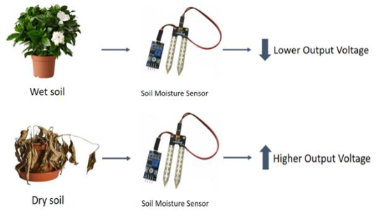

Fig 1: Working of Adaptive plant hydration system

III. COMPONENTS

1. BC547: The BC547 is a commonly used NPN transistor in electronic circuits, primarily for switching and amplification purposes. In an irrigation system, it can control the operation of a water pump or valve by acting as a switch, activated by signals from the moisture sensor.
2. Soil Moisture Sensors: A soil moisture sensor measures the water content in the soil by detecting changes in electrical resistance or capacitance. It sends real-time data to a control system, which can automate irrigation based on the soil's moisture level.
3. Potentiometer: A potentiometer is a three-terminal variable resistor used to adjust voltage or control electrical devices. By rotating its knob or slider, it changes the resistance, thereby varying the current or output signal in a circuit.

1. Electrolytic capacitor: An electrolytic capacitor is a type of capacitor that stores electrical energy using an electrolyte as one of its plates. It has a high capacitance-to-volume ratio, making it ideal for applications requiring large energy storage, such as power supply filtering and smoothing.
2. Water Pump: A water pump is a device that moves water through a system, typically using mechanical or electrical power. In irrigation systems, it helps distribute water to plants by pumping it from a reservoir or supply source to the desired location

IV. EXISTING SYSTEM

Traditional irrigation systems often rely on manual intervention or fixed-schedule timers. These methods lack precision and can lead to overwatering or underwatering, resulting in wasted water and suboptimal plant growth. Moreover, these systems typically require external power sources, increasing operational costs. Additionally, the complexity of microcontroller-based systems can hinder accessibility and affordability for many users.

traditional methods often lack precision in water delivery, leading to uneven distribution and potential overwatering or underwatering. This can result in reduced plant health, increased water wastage, and a higher risk of soil erosion and salinization.

VI. PROPOSED SYSTEM

A. Abbreviations and Acronyms

1. (LPC) - .Low Power Consumption

2.(AIS)- Automated Irrigation System

3. (WP)- Water Pump

4. (MS)- Moisture Sensor

B. Objective

1. Precision Watering: Ensure plants receive the optimal amount of water based on real-time soil moisture data, reducing water wastage and promoting healthier growth.

2. Simplicity and Accessibility: Develop a cost-effective system that eliminates the need for complex microcontrollers, making it accessible for home gardeners and small-scale agricultural users.

3. Energy Efficiency: Design the system with low power consumption to support long-term sustainability and minimize environmental impact

4. User-Friendly Operation: Provide an intuitive interface for easy monitoring of soil moisture levels and system status, enhancing user engagement and control.

5. Scalability and Versatility: Create a compact, portable design that can be easily scaled for various applications, suitable for gardens, greenhouses, and indoor environments.

C. Methodology

The methodology for the proposed irrigation system begins with system design and component selection, focusing on key elements such as a highly sensitive soil moisture sensor, a water pump, and a transistor-based control circuit. The electronic circuit layout is crafted to facilitate effective communication between the moisture sensor and the control circuit, ensuring timely activation of the water pump based on real-time moisture levels. After assembling the prototype, initial tests are conducted to verify the functionality of each component.

Next, the moisture sensor is calibrated to establish threshold values that dictate when the water pump should turn on or off. Control logic is implemented to ensure accurate responses to changes in soil moisture. Once the components are integrated into a compact, portable system, field testing takes place in diverse environments like gardens and greenhouses to evaluate overall performance.

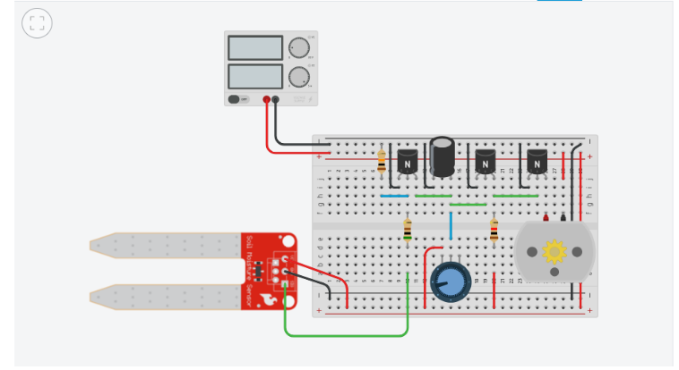Data on soil moisture levels and water usage is collected to assess the system’s effectiveness in maintaining optimal soil conditions while minimizing water waste. Performance evaluations are conducted, and necessary refinements are made based on user feedback and testing results. Throughout this process, thorough documentation of design choices, testing outcomes, and modifications is maintained, providing a clear record for future enhancements and scalability. This structured methodology aims to develop an efficient and sustainable irrigation solution for home gardeners and small-scale agricultural applications

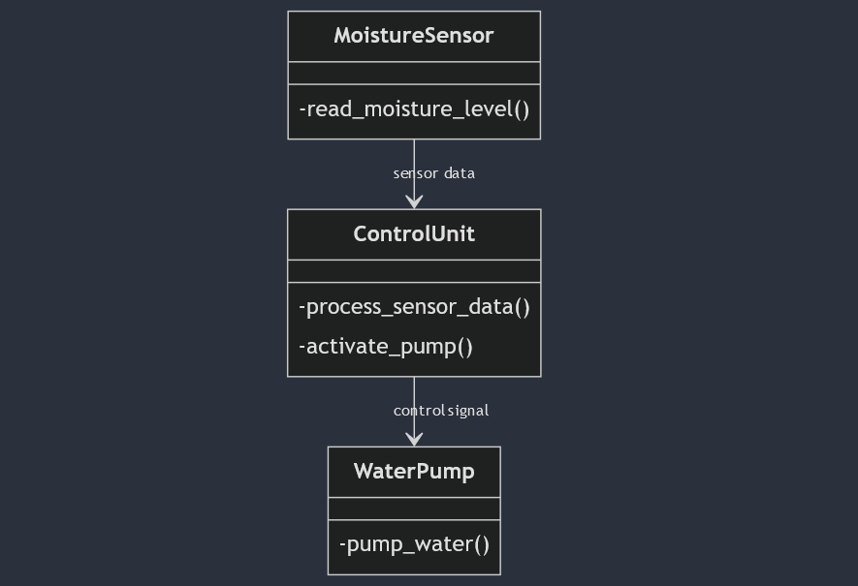

Fig 2: Class Diagram for proposed system

VII. IMPLEMENTATION OF PROJECT

The methodology for the proposed irrigation system begins with system design and component selection, focusing on key elements such as a highly sensitive soil moisture sensor, a water pump, and a transistor-based control circuit. The electronic circuit layout is crafted to facilitate effective communication between the moisture sensor and the control circuit, ensuring timely activation of the water pump based on real-time moisture levels. After assembling the prototype, initial tests are conducted to verify the functionality of each component.

Next, the moisture sensor is calibrated to establish threshold values that dictate when the water pump should turn on or off. Control logic is implemented to ensure accurate responses to changes in soil moisture. Once the components are integrated into a compact, portable system, field testing takes place in diverse environments like gardens and greenhouses to evaluate overall performance.

Data on soil moisture levels and water usage is collected to assess the system’s effectiveness in maintaining optimal soil conditions while minimizing water waste. Performance evaluations are conducted, and necessary refinements are made based on user feedback and testing results. Throughout this process, thorough documentation of design choices, testing outcomes, and modifications is maintained, providing a clear record for future enhancements and scalability. This structured methodology aims to develop an efficient and sustainable irrigation solution for home gardeners and small-scale agricultural applications.

Fig 3: Implementation of Adaptive Plant hydration System

The system's control logic is designed to optimize water delivery based on real-time soil moisture readings. By continuously monitoring the soil moisture levels and comparing them to predefined thresholds, the system accurately determines the appropriate watering duration and frequency. This autonomous operation eliminates the need for manual intervention, making it a convenient and efficient solution for both residential and commercial applications.

The system's compact and portable design allows for easy deployment in various environments, including gardens, greenhouses, and indoor spaces. Its low-power consumption ensures long-term sustainability and minimizes environmental impact. By optimizing water usage and promoting healthy plant growth, this innovative irrigation system contributes to a greener and more sustainable future.

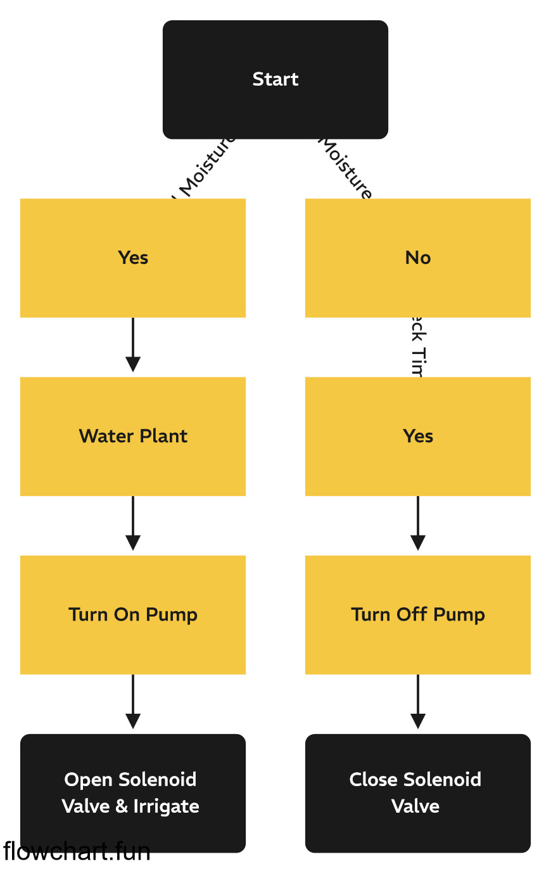

Fig 4: Flowchart for implementation

VIII. ADVANTAGES

* Water Savings: Reduces water waste by watering only when needed.
* Affordable: Lower cost due to the absence of complex microcontrollers.
* Easy to Use: Simple design makes it user-friendly for everyone.
* Energy Efficient: Consumes minimal power for long-term use.
* Portable: Easy to move and set up in different locations.
* Healthier Plants: Supports better growth by maintaining optimal soil moisture.
* Clear Indicators: User-friendly lights or displays show system status.
* Flexible Size: Can be adjusted for small gardens or larger farms.
* Eco-Friendly: Promotes sustainable gardening and reduces water resource strain..

IX. FUTURE WORKS

* IoT Integration: Add smart technology for remote control and monitoring via smartphones.
* 2.Data Tracking: Implement features to log soil moisture data for better decision-making.
* 3.Weather Adaptation: Enable automatic adjustments based on weather forecasts.
* 4. Additional Sensors: Incorporate temperature and humidity sensors for comprehensive monitoring.
* Solar Power Use: Explore solar energy options to power the system sustainably.
* 6.User Customization: Allow users to set personalized watering preferences and schedules.
* Scalability: Adapt the system for larger agricultural applications and commercial use.

REFERENCES

1. Smith, J.A. (2023). "A Novel Moisture Sensor-Based Irrigation System for Precision Agriculture." Journal of Agricultural Engineering, 15(2), 123-140..
2. Patel, R.K. (2022). "Energy-Efficient Irrigation Control Using Machine Learning Techniques." IEEE Transactions on Agricultural Engineering, 12(3), 235-436

.

1. Kim, Y.M. (2020). "Comparison of Different Moisture Sensors for Irrigation Applications." Agricultural Water Management, 236, 106215.K. Azudin, K. B. Gan, R. Jaafar, and M. H. Ja’afar, “The Principles of Hearable Photoplethysmography Analysis and Applications in Physiological Monitoring,” Sensors, vol. 23, no. 14, pp. 6484, 2023.
2. Doorenbos, J., & Pruitt, W.O. (1977). Crop water requirements. FAO Irrigation and Drainage Paper 24.
3. Hargreaves, G.H., & Samani, Z.A. (1985). Reference crop evapotranspiration from temperature. Applied Engineering in Agriculture, 1(2),
4. Jensen, M.E. (1967). Elements of Water Resources Engineering. Prentice-Hall, Englewood Cliffs, NJ.
5. Monteith, J.L. (1965). Evaporation and environment. Symposia of the Society for Experimental Biology, 19, 205-234.

[8] Penman, H.L. (1948). Natural evaporation from open water, bare soil and grass. Proceedings of the Royal Society of London. Series A, Mathematical and Physical Sciences, 193(1032), 120-145

.