**PHOTO-ESSAY OF CULTURAL, ETHNOVETERINARY AND OTHER HERBAL PRACTICES OF SOME WEED SPECIES IN KATSINA STATE**

**1Musa, M., 2Garba, M.G. and 2*Gaddafi, S.**

1Department of agronomy, Federal University Dutsin-Ma, Katsina State, Nigeria

2Department of Animal Science, Federal University Dutsin-Ma, Katsina State, Nigeria

*Correspondent Author Phone Number: +2347067212353; Email: sanigaddafi4@gmail.com

**Abstract**

This paper was designed specifically to highlight some cultural, ethnoveteriary and other herbal practices of some weed species in Katsina State, Nigeria through photo-essay approach. Information on socio-cultural uses of some weeds are presented in photographs such as broom, livestock feed, fencing materials, roofing, cap, mat, basket, housing decoration, bee hives and others. Table 1 and 2 explain cultural and medicinal uses of some weeds species. Therefore this paper highlighted that not all weeds are considered undesirable because of their numerous uses. It is therefore concluded that weeds have great potentials on socio-cultural, aesthetics and medicinal activities in both human and animals. Scientist are therefore recommended to extensively explore multiple benefits of weeds and its way of utilizations.

Key Words: Photo-essay, Weed, cultural and Ethnoveterinary

**Introduction**

Photographs can serve as a tool to draw the attention of scientists and animal production researchers to issues relevant to various socio-cultural, medicinal and other benefits of weeds and grass (Gaddafi *et al.,* 2019). Moreover, photographs are noted as useful tool because they convey complex information and in the case of a photo-essay, the photographs are not disjuncted from research context information (Musa, *et al.,* 2012).

Being weed any plant growing where it is not wanted or interfering with the objectives of humans (Maroyi, 2013) most people are usually regarded weeds as undesirable and targeted for eradications. However, weeds are useful to human beings and animals as food, raw materials, traditional medicines and other social benefits. Weeds are useful to human beings in a variety of ways such as food (Maroyi 2011), erosion control, medicines, aesthetic value, shelter, supplying of organic matter and mineral nutrients to the soil.

**Materials and Methods**

Photographs were taken in Dutsin-Ma Katsina State Nigeria All photographs were taken using a Itel phone version A70 model itel A665L digital camera with Rear Camera 13M DUAL Camera. The grasses photographs presented here were selected to provide visual insight into some cultural and medicinal benefits of weeds Other than image resizing, the photographs have not been substantially modified.

**Uses of Weeds**

Beyond biodiversity values, agro-ecological values and being part of wild nature, the colonising power of plants has been harnessed extensively by societies for a variety of uses, over millennia. The beneficial uses include exploitation as food, medicines, raw materials for industry, animal fodder, and for improvement of water resources and landscape health. There is much to be gained by re-iterating these values, as discussed below, to demonstrate that ‘living with weeds’ is not incongruous with sustainable agriculture, healthy environments and lifestyles, which are attuned with nature.

**Weeds as Source of food**: There has been renewed or increasing interest in consuming some edible weeds as vegetable worldwide. These may be due to their nutritional role and/or health benefits. Many weeds are edible, serving as traditional food every day for people all over the world, as discussed in many publications (Lee *et al.* 2007, Abeysekera and Herath 2007, Bakar 2007, Maneechote 2007, Morita 2007, Varshney and Sushilkumar 2009). More importantly, some are true culinary delights in Asian cooking. In Katsina among the top three edible weeds are *Cassia tora,* *Amaranthus spp.* and *leptadhenia hastata*. Leaves and young shoots are the most commonly used parts of the weeds. Wild edible weeds are important as dietary supplements, providing trace elements, vitamins and minerals.

**Ethnomedical and ethnopharmaceutical uses of weeds:** There is increasing evidences supporting that weeds are relatively high in bioactive ingredient and secondary metabolites and are thus likely to hold promise for drug discovery (Ekwealor et al., 2019). Weed species form a substantially higher proportion of source plants in pharmacopoeias than would be expected from their proportion in the general flora (Stepp 2004, Stepp and Moerman 2001, Voeks 2004). The possible reasons are related to the life cycle of most (annual) weeds being ephemeral, successional, or *r*-selected species. The opportunistic, short-lived species appear to rely heavily on qualitative toxic chemical defensesto deter herbivores, rather than quantitative compounds (Coley *et al*. 1985). These are secondary metabolites, which accumulate on leaves, shoots, flowers and fruits. They are glycosides, alkaloids, and terpenoids, which are all low molecular weight, often toxic at small doses, and highly biologically active. As a result, a large variety of weeds are used in traditional medicine and pharmaceutical industry as sources of therapeutic compounds. Many have healing effects, which include diuretic, choleretic, anti-inflammatory, antioxidative, anti-carcinogenic, analgesic, anti-hyperglycemic, anti-coagulatory and pre-biotic effects, and are used in the treatment of a wide variety of diseases. Among the best examples of weeds commercially important in western medicine are: *Digitalis purpurea* L. (Foxglove) from which digitalin, a group of cardiac-active glycosides is extracted;and *Catharanthus roseus* (L.) G.Don (Madagascar Periwinkle) from which an anti-cancer alkaloid vincistrine, is extracted. The lists compiled by Bakar (2007), Abeysekera and Herath (2007), Maneechote (2007) and others, demonstratethe medicinal values of a large number of weed species, commonly usedin the Asian-Pacific region in traditional medicine, including Ayurveda and Chinese medicine.

**Weeds as raw materials for paper-making and other industrial products:** For producing straw hats, ``Bolga`` bags, hats, fans, hay for cattle. Guinea grass is very flexible and can be manipulated into useful products such as window blinds, sleeping mat, bags and ceiling panel among others.

A large variety of colonising species, particularly grasses, are suitable for extraction of high quality lingo-cellulose fibre and other materials. Examples are: *Spartina alternifolia* Loisel. (Cord Grass), *Erianthusarun dinaceus* ( Retz.) Jeswiet (wild sugarcane), *Saccharum arundinaceum* Retz. (Hardy Sugarcane), *Saccharum spontaneum* L. (kans grass), *Phragmites australis* Steud. (common reed), and *Miscanthus sacchariflorus* (Maxim.) Hack. (amur silver grass)*.* In addition, the stems of *Chromolaena odorata* (L.) King and H.E. Robbins. (siam weed) and *Ageratum aadenophora* (Spreng.) King and H.E. Robbins. (crofton weed), which contain large amounts of cellulose, are also used for fibre board manufacture in China (Kim *et al.* 2007). The large biomass produced by water hyacinth is also popular as raw material for paper and pulp industry in several countries.

**Weeds as Livestock Feed:** Most weeds are delicious, palatable and acceptable quality for animal feed if they are grazed for cut when young. Many fast-growing species, annuals and perennials, legumes and grasses, which produce abundant biomass, provide the fodder required for rearing of animals, such as cattle, goats, pigs, sheep and even horses, ducks and geese.

**Weedy residues as compost and mulches:** The biomass of almost any weed can be composted, as most breakdown quickly; these may not serve as good mulches. On the other hand, biomass of some weeds, which breakdown slower, can be useful mulches. The large sized grasses, *Panicum maximum* Jacq. (Guinea grass), *Imperata cylindrica* ( L.) Beauv. (cogon grass);

**Weeds as raw material for bio-fuels:** Given the large biomass that colonising species can produce, there are significant environmental benefits in utilizing this biomass directly for burning as fuel (primary biofuels), or used as raw material for fermenting to produce bio-diesel, ethanol and methane (secondary biofuels). The possibilities have been demonstrated in China, India, USA and other countries. Examples are *Jatropha curcas* L., *Thlapsi arvense* L., *Arundo donax* L. (giant reed) and others. There is also considerable interest in using the biomass of shrub weeds and medium-sized trees, which have colonised large areas as biofuels. Water hyacinth continues to be of considerable interest, for the combined uses of both phytoremediation of polluted water, and fermentation to produce biogas (Singhal and Rai 2003).

**Other uses of weeds:** Several studies have demonstrated that a wide variety of colonising plants are used in landscaping; stabilization of slopes and banks and roadsides. Others are important as ornamental plants, handicrafts, and for building human shelters (bricks and roof thatching), as well as for green roofs (Lee *et al*. 2007). In addition, several weeds are important as sources of natural, plant-based dyes, and many yield strong allelochemicals, which may be used as biological insecticides (Minggen 2007, Sondhia and Varshney 2009) . Some provide useful ingredients of cosmetic products, such as soaps, perfumes, creams and hair oils.

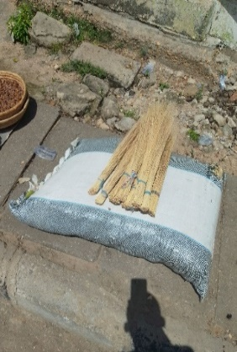 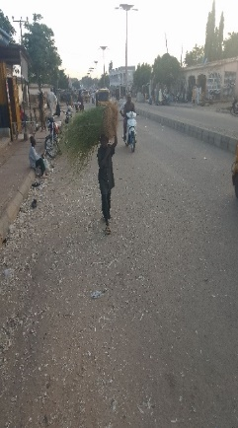 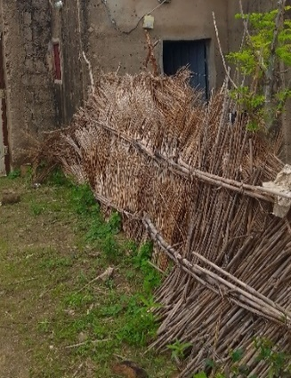

Grasses as livestock feed

Hat made up of guinea grass

Weeds used for fencing

Brooms made from grasses

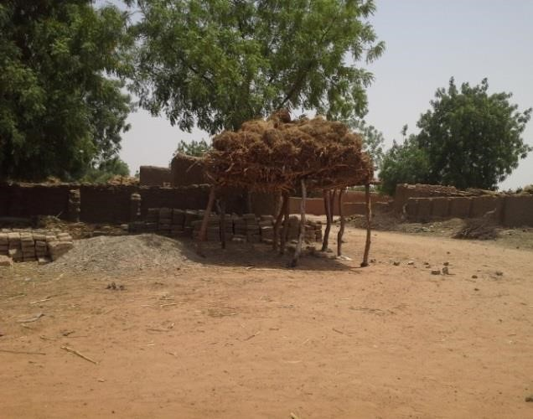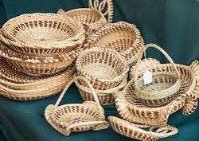 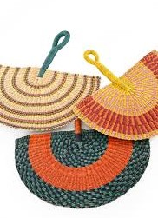 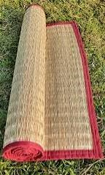

Grasses preserved as animal feed

Gamba grass mat

Hand pan made from grasses

Basket made up of grasses

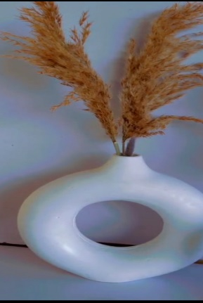 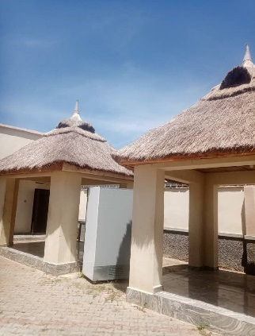 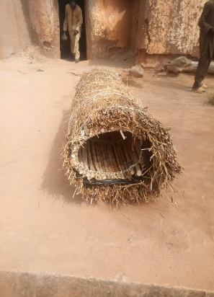 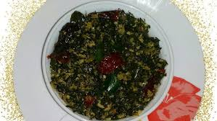

Cooked senna tora for eating

Grasses used for bee hive construction

Thatch used for shade roofing

Weed used as ornamental purposes

**Table 1: Cultural practices of some weed species in Katsina state**

|  |  |  |
| --- | --- | --- |
| Weed | Part used | Purpose/utilization |
| *Pennisetum pedicellatum*  (Pennisetum) | Whole plant | Whole plant are used in soil mixture for earthern blocks making and wall plaster in Hausa land. |
| *Guiera senegalensis* | Leaves | Leaves are used for cultural bathing for a period of four weeks after parturition for a cultural bathing called “*wankan Jego*” in Hausa. |
| *Andropogan gayanus* (Gamba grass) | The stem and leaves | Both stem and leaves are used for house roofing and animal shade roofing. |
| *Striga senegalensis* (Witchweed) | Leaves and flower | Leaves and flower were squeeze and applied on skin for rashes treatment. |
| *Cenchrus ciliaris* (Buffel grass) | Whole plant | Helps in controlling soil erosion and soil disintegration |
| *Hyparrhenia rufa* (Jaragua grass) | Stem and leaf | Stem and leaves are used for fencing and basket sewing. |
| Senna tora | Leaves | Leaves are cook and eat as vegetables. |
| *Panicum maximum* (Guinea grass) | Whole plant | Control erosion, mulching, broom making, folk medicine, and seed as food grain for cage birds. |
| *Eragrostis tremula* (Love grass) | Stem | Stems are used as broom |
| *Senna occidentalis* (Coffee senna) | Stem | Use as fuel |
| *Cyperus corymbosus* | stems | Stems are utilized for mats and screens |

Source: Field survey, 2024

**Table 2: Some weeds with ethnoveterinary activities**

|  |  |  |  |
| --- | --- | --- | --- |
| Disease condition | Plant/weed | Application | References |
| Mastitis | *Curcuma longa* (Turmeric) | Applying curcuma longa on udder have found to treat mastitis | Marandure, (2016); Mann et al., (2003) |
| Salmonellosis | *Tapinanthus dodoneifolius* (Goat weed) | Infusion or decoction is given to birds | Sofowora, (1993); Iwu,(1993) |
| Helminthosis | *Vernonia amygdalina* | The power mix with salt and infusion is given | Saganuwan, and Gulumbe, (2007) |
| Foot and mouth diseases | *Acacia nilotica* (Locust bean) | Dried bark and seeds are pounded and infusion was used to wash affected parts | Marandure, (2016) |
| Tympany | *Linus usitalissimum* (Linseed) | Orally administered | Sofowora, (1993) |
| Newcastle disease | *Cannabis indica* (Hemp plant) | The leaves are soaked in drinking water | Mann, et al., (2003) |
| Abortion | *Desmodium velutinum* (Velvet leaf) | Decoction with potash given to animals | Marandure, (2016) |
| Constipation | *Newbouldia laevis* (Boundary plant) | Leaves are squeezed and given to animals | Sofowora, (1993) |
| Bacterial and fungal infection | *Telfaria occidentalis* (Fluted pumpkin) | Decoction powdered is administrated | Dalzid, (1996) |
| Ecto parasite infestation | *Euphorbia hirta* *L.* (Asthma plant) | Juice squeezed from the leaves are applied on the body for ecto-parasite control | Marandure, (2016) |
| Tick infestation | *Senna occidentalis* (Coffee senna) | Pound fresh leaves in water and filtrate applied as a topical spray | Ekwealor, (2019) |

**Conclusion**

It was concluded that weeds have great potentials on socio-cultural, aesthetics and medicinal activities in both human and animals. This paper highlighted some weeds are used for roofing, mats making, mulching, fencing, basket and used for other aesthetics purposes. Scientist are therefore recommended to extensively explore multiple benefits of weeds and its way of utilizations.

**Acknowledgement**

We sincerely appreciate the sponsorship of Institute Based Grant (IBR) Tetfund of Federal University Dutsin-Ma for the completion of this study.

**References**

Abeysekera A and Herath S. (2007). Utilization of weeds in Sri Lanka, pp. 123-137. In: *Utility of Weeds and Their Relatives as Resources*, (Eds. Kim KU, Shin DH and Lee IJ). Kyungpook National University, Daegu, Korea.

Bakar B.B. (2007). Utilization of weeds and their relatives: Malaysian perspectives, pp. 57-106. In: *Utility of Weeds and their Relatives as Resources*, (Eds. Kim KU, Shin DH and Lee IJ), Kyungpook National University, Daegu, Korea.

Coley P.D, Bryant J.P and Chapin F.S. (1985). Resource availability and plant anti herbivore defence. *Science* **230**: 895899.

Dalzid, J.K. (1996). Local treatment of ear mite infestation in a colony of rabbits in the mild hills of western Nepal. *Veterinary Review,* 1996, 11:30-45

Ekwealor, K.U., Echereme, C.B., Ofobeze, T.N. and Okereke, C.N. (2019). Economic importance of weeds: A Review. *Asian Plant Research Journal,* 3(2):1-11

Fatope, M.O., Takeda, Y., Yamashita, M., Okabe, H., Yamanchi, T. (1990). New *cucurbitane* triterpenoids from *momordica charantia.* *Journal of Natural Products,* 53:1491-1492.

Gaddafi, S., Babba, H.U., Ajibola, O.O., Alkali, M.M. and Jazuli, M.B. (2019). A Photo-Essay on egg shell integrity defects in Livestock Teaching and Research Farm, Federal University Dutsin-Ma, Katsina State. Nigerian Association of Animal Health and Husbandry Technologists (NAAHHT) 32nd Annual Scientific conference and General meeting. Awka, Anambra state, 2019. 55-58

Iwu, M.M. (1993). Handbook of Afrian Medicinal Plants. CRC Press, Boca, R.agin, F.I. 1993,

Lee I.Y, Park J.E, Shin D.H, Lee I.J and Kim K.U. (2007). Utility of Weeds and their Relatives as Resources in Korea. pp. 213222. In: *Utility of Weeds and Their Relatives as Resources*, ( Eds. Kim KU, Shin DH and Lee IJ). Kyungpook National University, Daegu, Korea

Mann, A., Gbate, M., Umar, A. (2003). Medicinal and economic plants of nupeland. Jude evans Books and Publication, Bida Nigeria. 2003; 3-276pp.

Maneechote C. (2007). Utilization of Weeds and their Relatives as Resources in Thailand, pp. 107-121. In: *Utility of Weeds and Their Relatives as Resources.* (Eds. Kim KU, Shin DH and Lee IJ). Kyungpook National University, Daegu, Korea.

Marandure, T. (2016). Concepts and key issues of etho-veteriary medicine in Africa: A review of its application in Zimbabwe. *African Journal of Agricultural Research,* 11:1836-1841.

Minggen W. (2007). Weed resources and their utility in Mount Changbai area of China. pp. 197-211. In: *Utility of Weeds and their Relatives as Resources*, (Eds. Kim KU, Shin DH and Lee IJ) Kyungpook National University, Daegu, Korea.

Morita H. (2007). Edible wild plants including weed species, mainly used as vegetable in Japan. pp. 169-180. In: *Utility of Weeds and their Relatives as Resources*, (Eds. Kim KU, Shin DH and Lee IJ). Kyungpook National University, Daegu, Korea

Musa, M.Z., Eisa, M.O. and Majed, A. (2012). A photo-Essay on dromedary camels in sudan. *3rd*

*ISOCARD International Conference,* 346-348.

Kim K.U, Shin D.H and Lee I.J. (2007).*Utility of Weeds and Their Relatives as Resources*, Kyungpook National University, Daegu, Korea. 222 p.435p

Saganuwan, A.S. and Gulumbe, M.L. (2007). Screening of *Vernonia amygdalina* for in vitro antimicrobial activities and phytochemical constituents. *Journal of Medical and Pharmaceutical Sciences,* 3:32-42,

Salihu, T., Adenubi, O.T., Mbaoji, C.O., Ojogbo, I.A. and Abdullahi, M. (2020). A review of ethnoveterinary Botanical used for tick control in Wukari, Taraba State, North Eastern Nigeria. *Egyptian Journal of Veterinary Science,* 51(3):421-437

Singhal V. and Rai J.P.N. (2003). Biogas production from water hyacinth and channel grass used for phytoremediation of industrial effluents. *Bioresource Technology* 86: 221-225.

Sofowora, A. (1993). Medicinal plants and traditional medicine in Africa. John Willey and Sons, New York; 1993.

Stepp J.R. (2004). The role of weeds as sources of pharmaceuticals. *Journal of Ethnopharmacology* 92: 163-166.

Stepp J.R. and Moerman D.E. (2001). The importance of weeds in ethnopharmacology. *Journal of Ethnopharmacology* **75**: 25-31.

Sondhia S and Varshney J. (2009). Weeds as source of biopesticides. pp. 15-16. In: *Proceedings of National Consultation on Weed Utilization*, (Eds. Varshney JG and Sushilkumar) 20-21 October 2009, Directorate of Weed Science Research, Jabalpur (Madhya Pradesh), India.).

Varshney JG and Sushilkumar (Eds.). 2009. Proceedings of National Consultation on Weed Utilization, 20-21 October, 2009 , Directorate of Weed Science Research, Jabalpur Madhya Pradesh, India. 59 p.

Voeks RA 2004. Disturbance pharmacopoeias: medicine and myth from the humid tropics, *Annals of the Association of American Geographers* **94**(4): 868-888.