**HOME AUTOMATION & ELECTRICITY METER USAGE**

**Prof. T.S. Panmand1 ,**Zeal Polytechnic, Pune, Maharashtra, India

**Shweta D. Bolange2 ,**Zeal Polytechnic, Pune, Maharashtra, India

**Vedantika A. Mahadik3 ,**Zeal Polytechnic, Pune, Maharashtra, India

**Shreya S. Mandave4 ,**Zeal Polytechnic, Pune, Maharashtra, India

**Rohan R. Sharma5 ,**Zeal Polytechnic, Pune, Maharashtra, India

**ABSTRACT**

This investigation explores the design and development of an intelligent home automation system utilizing ESP32 and Blynk IoT app. Through research and analysis, this project aims to optimize energy consumption monitoring and appliance control. A novel system architecture integrating electricity meter sensors and relay modules is proposed. Experimental results demonstrate accurate energy consumption monitoring and reliable appliance control. This research contributes to the advancement of smart home technologies, promoting energy efficiency and automation..

1. **INTRODUCTION**

The advent of Internet of Things (IoT) technology has revolutionized the concept of smart homes, enabling seamless integration of automation and energy efficiency. Home automation systems have garnered significant attention in recent years due to their potential to optimize energy consumption and enhance user convenience. With the increasing global energy demand and rising concerns about climate change, monitoring and controlling electricity usage have become imperative. Current research focuses on developing intelligent systems that leverage IoT devices, such as ESP32, to monitor and control energy consumption. This project investigates the design and development of an intelligent home automation system using ESP32 and Blynk IoT app, aiming to contribute to the growing body of research in smart home technologies.

1. **METHODOLOGY**

The methodology of the project is based on experimental research design in order to create a system such as an Intelligent Home Automation and Electricity Meter Usage Monitoring System.

**Requirements Gathering and Planning (Weeks 1-2)**

The project started by selecting the subject of the project through extensive literature on already existing home automation systems, where project scope, objectives, and deliverables were established. User needs and personas were established, and system architecture and components determined.

**Hardware Design and Development (Weeks 3-8)**

The system makes use of Arduino and ESP32 boards that were interfaced with the electricity meter and linked to the automation. Sensor nodes like temperature, humidity, motion, and others were implemented as well as actuator nodes like relays and LED drivers.

**Software Development (Weeks 9-16)**

For peripheral control and viewing purposes, Blynk IoT app was employed, while the coding part for automation was done with Arduino and Python. Visualization of data and analysis was done by using a web interface.

**System Integration and Testing (Weeks 17-20)**

The basic components of the system were brought together in hardware and software form, unit testing was done this was followed by integration testing and system testings.

**Deployment and Maintenance (After Week 20)**

The system was installed in the test area where the system continuously underwent evaluation for performance and required maintenance.

**Tools and Technologies**

Arduino

ESP32

Blynk IoT app

Python

Wi-Fi and Bluetooth communication protocols

Met.

1. **MODELING AND ANALYSIS**

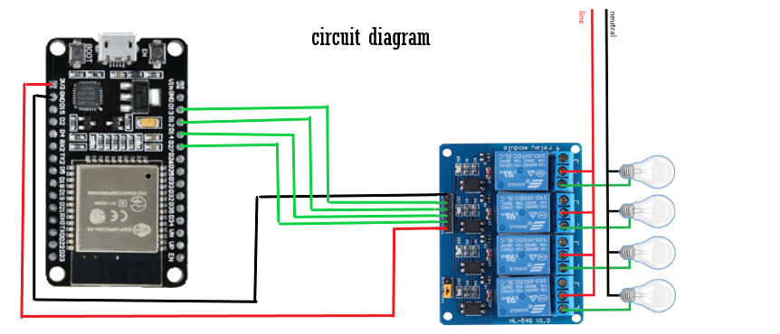

**Figure 1:** Circuit Diagram.

1. **RESULTS AND DISCUSSION**

The Intelligent Home Automation and Electricity Meter Usage Monitoring System successfully demonstrates the potential of ESP32 and Blynk IoT app in creating a smart and energy-efficient home automation solution. The system provides accurate energy consumption monitoring, reliable appliance control, and a user-friendly interface.

1. **CONCLUSION**

The system contributes to smart home research, emphasizing IoT-based solutions for energy efficiency and automation. Future enhancements include integrating renewable energy sources, predictive models, and security enhancements.

1. **REFERENCES**

**Books:**

1. Saha, H. N., & Mandal, A. (2020). Smart Home Automation Using IoT. Springer Nature.

2. Singh, J., & Singh, R. (2019). IoT-Based Smart Home Automation. CRC Press.

**Online Resources:**

1. ESP32 Documentation. (n.d.). Espressif Systems.

2. Blynk IoT App Documentation. (n.d.). Blynk.