# Virtual Dressing Room

# Prof.Megha Garud*1 Vivek Dumber*2 ,

# Shambhuraje Jagtap*3,Sahil Tagunde *4, Parth Waikar *5,

*1,2,3,4,5Computer Engineering, Zeal Polytechnic , Zeal Institute,

Pune, Maharashtra, India.



# ABSTRACT

A virtual dressing room is a modern technology that allows people to try on clothes digitally, without physically wearing them. This innovative concept has become increasingly popular with online shopping, as it helps customers see how outfits will look on them before making a purchase. Using augmented reality (AR) and artificial intelligence (AI), virtual dressing rooms create a personalized shopping experience. Customers can upload their photos or create digital avatars that reflect their body shape and size, enabling them to visualize how different styles, colors, and fits would look on them. This not only makes shopping more convenient but also reduces the number of returns, as shoppers can make better choices about what will suit them. Additionally, virtual dressing rooms can provide personalized recommendations based on user preferences, making it easier for shoppers to discover new styles. The technology is continually improving, with advanced algorithms offering realistic representations of how clothes fit and move. Furthermore, virtual dressing rooms promote inclusivity by catering to diverse body types and personal styles, ensuring everyone can find outfits that fit and flatter them. As retailers adopt this technology, it promises to enhance the online shopping experience, making it more enjoyable and efficient. In essence, virtual dressing rooms are transforming the way people shop for clothes, blending technology and fashion to create a seamless experience.

**Keywords**: Augmented Reality (AR), Personalization, Inclusivity, Convenience.



# INTRODUCTION

The virtual dressing room is an exciting advancement in shopping technology that allows customers to try on clothes digitally. With the rise of online shopping, this tool has become increasingly popular, helping shoppers visualize how garments will look on them without needing to go to a store. Using augmented reality (AR) and artificial intelligence (AI), virtual dressing rooms enable users to upload their photos or create digital avatars that represent their body shape and size. This interactive experience not only makes shopping more convenient but also reduces the likelihood of returns, as customers can make informed choices about what fits and suits them best. Additionally, virtual dressing rooms promote inclusivity by catering to a variety of body types and personal styles. As this technology evolves, it promises to transform the online shopping experience, making it more engaging and enjoyable for everyone

# OBJECTIVE

The objective of a virtual dressing room is to improve online shopping by allowing customers to try on clothes digitally. This technology helps users see how garments fit and look on them, reducing returns due to sizing or style issues. It also aims to promote inclusivity by accommodating various body shapes and sizes. Additionally, virtual dressing rooms provide personalized recommendations based on user preferences, creating a convenient and enjoyable shopping experience that blends technology with fashion. Another key goal is to personalize the shopping experience, offering tailored recommendations based on user preferences and past purchases. Ultimately, the objective is to create a convenient, engaging, and satisfying shopping environment that combines the best of technology and fashion.

# LITERATURE REVIEW

**Prof. Puneeth, Ullas , Sri Dharshan (2022),** This is a system design in In real-time to develop an application known as Virtual Visualization of Cloth Fitting that allow the user tries virtually with any cloth, get properly fit his/her body measurement which helps easy way out on online shopping without feel left anything. The system features functionalities like perfect body part selection, image scaling etc based on big data for advanced processing such as blending and torso detection which is done suitable to state of the art fashion. Its primary goal is to find an accurate body extraction in noisy images. For the first part, we use a novel segmentation method dominated by colors to extract the torso for resizing and fitting of clothing onto an user.[1].

**Limitation**:The proposed virtual dressing system faces several challenges that could impact its overall performance. One major issue is the potential for inaccuracies in body measurement extraction, as different poses and angles can distort the fit. Complicated backgrounds may make body extraction more difficult, while variations in lighting could interfere with accurate color detection and segmentation. The system may also have difficulty accommodating the wide range of human body shapes, leading to poor fit outcomes for some users. Additionally, real-time processing demands, especially when dealing with high-resolution images, could negatively affect system performance. If the user interface is not intuitive, usability might suffer, making navigation more difficult for users. Another concern is the system's ability to accurately represent the various textures and designs of different clothing materials in the virtual environment. Reliance on tools like OpenCV and NumPy introduces the risk of disruptions if these libraries encounter issues. Privacy concerns regarding the uploading of personal images may also deter potential users. Finally, the system's limited training dataset could fail to generalize effectively across diverse populations, further limiting its efficacy. [1].

**In [2] RNS Institute of Technology “Bengaluru”(2014),** Research is conducted to overcome the barriers of regular shop purchase and online clothing system problems by employing virtual trial room implemented with Augmented reality (AR)and artificial intelligence(AI). With this, the company can do away with physical fitting rooms and it enhances a shopper's online experience by giving them an alternative to literally testing out how clothes look.occreateElementID(8990,sd*,sd). It is based on Python algorithms for machine learning and deep learning, with tools including OpenCV for image processing (used to extract hand data from the web camera) and MediaPipe API which handles hand tracking. The app combines anthropometric data generation, cloth realistic modeling and intuitive body motion based GUI to provide users with a more engaging experience than just trying on clothes. The procedure comprises image capture, pre-processing of the images, extracting features from the processed images and populating a database to achieve photo-realistic fitting and sizing. This is the idea behind a virtual trial room, which personalizes and makes for an immersive shopping experience by adjusting cloth models dynamically to user's body.

**Limitation** :Virtual trial rooms face several challenges that could hinder their overall effectiveness. For one, accurate body measurements may be affected by differences in user posture and varying camera angles. Moreover, because the technology relies heavily on augmented reality and AI, it might not perform smoothly on low-end devices. Another issue lies in its difficulty accommodating a wide range of body types, which could restrict its usefulness for certain users. Lastly, concerns about data privacy—particularly regarding the storage of personal measurements—could discourage people from fully embracing the system. .[2].

**Aladdin Masri, Muhannad Al-Jabi (2019),** In this paper, Aladdin Masri, Muhannad Al-Jabi (2019), author proposes virtual dressing room application with the help of Microsoft Kinect sensor. Authors approach is mainly based on extraction of the user from video stream, alignment of models and also skin color detection. Author used modules for locations of the joints for positioning, scaling, and rotating for aligning the 2D cloth models with the user. We then apply skin colour detection on video to handle the unwanted occlusions of the user and the model. Then the model is overlaid on the user in real-time. Problem is just the Alignment of the user and the cloth models with precise position, scale, rotation and ordering. One of the important steps of the problem is the detection of the user and the body parts. In literature, various approaches are suggested that include body part detection, skeletal tracking, and posture estimation and superimposing it onto a virtual environment in the user interface. The project is developed in the real time, C# programming environment for Kinect hacking application. Also, Kinect driver's middleware is used for some basic functions and for the tracking process along with Microsoft Kinect [3].

**Limitation** : There are many limitations of virtual dressing room applications that may hinder its effectiveness. For example, the measurement taken by the body can be done in a particular posture of the user and thus the calibration of the Kinect may not effectively put on the garment on the user. Other drawbacks are the necessity of hardware or software. Here it is the Kinect and thus the system will only work with users with this technology. Besides, user interaction may need to be learned after some period of usage and therefore may not be intuitive with all customers. Apart from that, the differences in garment physics and mechanics are probably not well captured, which would impact the overall feel of the virtual try-on experience. Collection and storage of personal body measurements may evoke privacy concerns among users who might thus shy away from the application. Lastly, issues such as latency or processing may ntervene with the user experience, and frustration may result. [3].

**Prof. T.Suba Nachiyar , C.Carolin Gifta (2022)** The virtual fitting room platform aims to improve the online and in-store shopping experience by letting people try on garments virtually, alleviate time and accessibility issues that accompany traditional fitting rooms. This solution allows the user to upload pictures, enter body measurements, and watch how they would look in the garment using a 3D model with full rotation for an almost realistic view of the apparel from all sides. It entails features, such as a voice assistant that guides the user through a process, an accuracy matcher to predict a range of fit levels, and various categories of clothing. This method provide a 3D user-friendly experience because it has eliminated some of the problems often encountered while using. [4] .

**Limitation** :The virtual fitting room system presents several limitations that may affect user experience. Firstly, the reliance on accurate body measurements can lead to discrepancies if users input incorrect data, compromising fit accuracy. Additionally, the requirement for clear and properly aligned photos can be challenging for users, potentially resulting in unsatisfactory visualizations. The voice assistant feature, while helpful, may not always accurately interpret user commands, causing frustration. Moreover, the system's performance may be hindered by technical issues such as software bugs or connectivity problems. Users may also experience a lack of tactile feedback, missing the physical sensation of trying on garments. Lastly, the application may not cater to all body types, limiting inclusivity in the virtual try-on experience. [4] .

# PROPOSED SYSTEM

The proposed system for virtual dressing rooms enhances the online shopping experience through the use of augmented reality (AR) and machine learning. Users can upload their own measurements and photos, allowing the system to create realistic 3D avatars that accurately represent their bodies. The virtual dressing room offers a wide range of clothing items that allow customers to mix and match their avatars.

Key features include a user-friendly interface that makes it easy to navigate and select, as well as real-time adjustments, which let users see how sizes and styles look after them The system uses advanced algorithms to suggest personalized clothing combinations based on user preferences and trends .

Additionally, social sharing options allow users to invite friends to provide feedback, enhancing the shopping experience. By combining customer reviews and ratings, the system ensures informed purchasing decisions. This innovative approach not only reduces return rates but also increases customer satisfaction and engagement, making online shopping more interactive and enjoyable Ultimately, Virtual Dressing Room aims to provide differences between physical and digital stores in how consumers buy clothes online Provides flexibility.

# ARCHITECTURE DIAGRAM

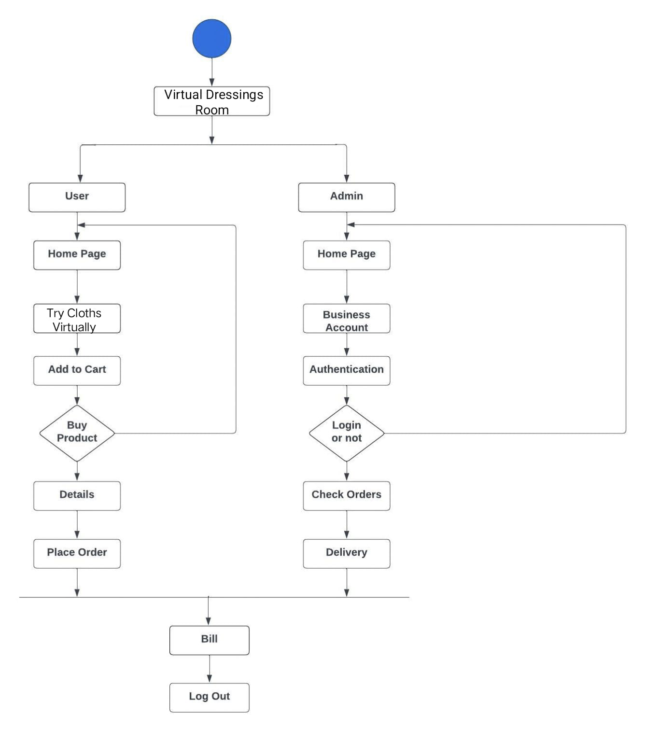

(Figure 1: Architecture diagram of Virtual Dressing Room )

# USE-CASE DIAGRAM OF USER

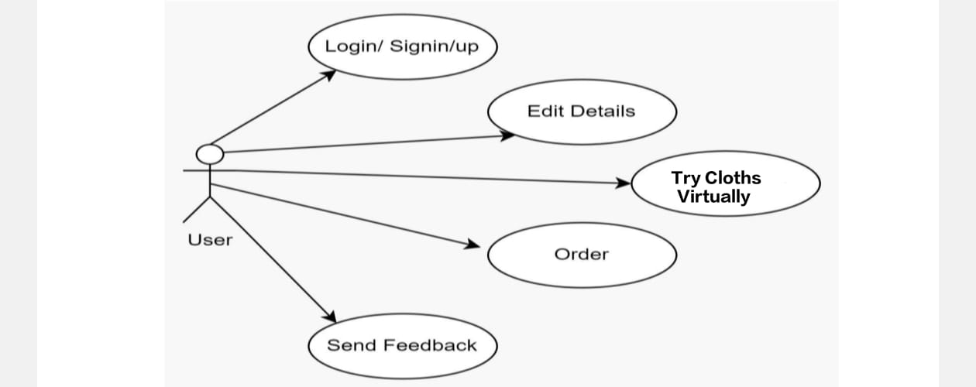

(Figure2: Use-case diagram for user)

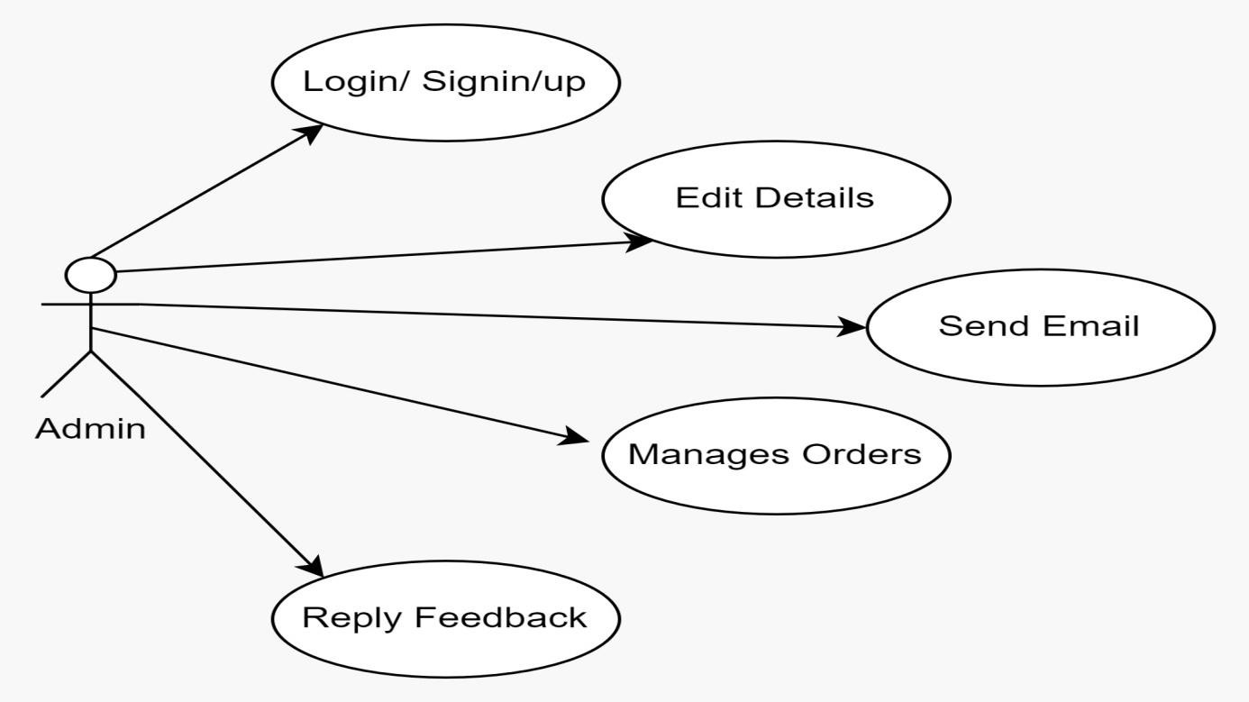

# USE-CASE DIAGRAM OF ADMIN

(Figure3: Use-case diagram for Admin)

# FUTURE SCOPE

The future where virtual dressing room systems will be has great potential for innovation and efficiency. A big breakthrough could be the integration of advanced AI technology, enabling more personalized recommendations by analyzing user behavior and preferences over time This could include virtual stylists speaking naturally functionality empowers, enabling users to interact and receive personalized advice in real time.

Additionally, incorporating multi-sensory experiences such as tactile text can mimic the feel of clothes, enhancing the authenticity of accessories If the platform is extended into adding augmented reality shopping experiences in the physical stores could be a hybrid model, allowing users to try on clothes naturally before the purchase

Additionally, partnerships with fashion brands and designers allow access to exclusive collections that can only be accessed through physical dressing rooms, thus engaging users in which consumer goods are produced integrity Sustainable goods, such as repeatedly used clothing. As you can imagine, styles can enhance the imaginative customer experience.

# CONCLUSION

In conclusion, the virtual dressing room represents a revolution in the online shopping experience, blending technology and fashion to meet the demands of today’s consumers Using augmented reality and machine learning, design this enables users to visualize clothes in individual avatars, greatly increasing fitting accuracy, payback rate Minimizing and the interactive nature of the platform does not seem to provide them with use not only engages but also encourages informed purchasing decisions through personalized recommendations and social engagement features

As technology improves, future developments, such as multi-sensory experiences and sustainable fashion designs, promise to further enhance the user journey By differentiating flesh controlling between the floor and the digital retail space, the virtual interior not only facilitates but meets modern standards of personalization and sustainability Ultimately, this new solution is set to redefine how consumer.

# REFERENCES

* Prof. Puneeth , Ullas M, Tamanna Firdous, Sudarshan BG, Sri Dharshan, (A NOVEL APPROACH OF VIRTUAL VISUALIZATION OF CLOTH FITTING) College Of Engineering Mandya, India.Maharaja Institute Of Technology Mysore, Karnataka, India.Visvesvaraya Technological University, Belagavi, India. e-ISSN: 2582-5208 (2022) [1].
* Dayasagar A S, Kushal S, Sudeep Gowda C K, Sudharshan L, Jagadeesh B N RNS Institute of Technology Bengaluru (Virtual Trial Room Application). ISSN: 2456-3315 (2014) [2].
* Aladdin Masri, Muhannad Al-Jabi, “Virtual Dressing Room Application”, 978-

1-5386-7942-5/19/$31.00 ©2019IEEE. [3]

* R.Subhiksha, C.Carolin Gifta, Prof: T.Suba Nachiyar Department of Computer Science and Engineering, Velammal College of Engineering and Technology (A Proposed Hedonic model for Virtual Fitting room) ISSN 2582-7421 (2022) [4].