A STUDY ON THE CONSUMER PERCEPTION ON GREEN BANKING

# ArunjunaiRani R1, Sivakanni S2

1PG Student Department of MBA Jerusalem College of Engineering Chennai, India.

2Assistant Professor Department Of MBA, Jerusalem College of Engineering, Chennai, India.

# ABSTRACT

The research project entitled study on customer perception on green banking is an attempt to understand customer perception of green banking, aiming to understand how these perceptions influence customer satisfaction and loyalty. A structured questionnaire with closed-ended questions was administered to 105 banking customers using convenience sampling. The descriptive research design helped analyze customer characteristics and attitudes toward green banking practices. Primary data was collected through questionnaire, supplemented by relevant secondary literature. Statistical analyses, including simple percentage analysis and hypothesis testing (Chi-square, correlation and ANOVA), were employed to interpret the data, which was presented through various charts and diagrams. The findings reveal key factors affecting customer perceptions, such as environmental responsibility and awareness of green products, offering valuable insights for banks to enhance their green initiatives and strengthen customer engagement. Overall, the study provides actionable recommendations for banking institutions to improve their green banking strategies and promote sustainable practices.

# INTRODUCTION

As environmental sustainability becomes a pressing global concern, consumer perception of green banking is crucial for financial institutions looking to align their services with eco-conscious values. Understanding how consumers view green banking initiatives allows banks to tailor their offerings, ensuring they resonate with an increasingly aware customer base.

Consumers today are more informed about the environmental impacts of their choices, leading them to favor banks that demonstrate a commitment to sustainability. This awareness presents a competitive advantage for institutions that can effectively communicate their green initiatives, enhancing brand loyalty and attracting new customers.Moreover, consumer perceptions influence banking behaviors; individuals are more likely to choose banks that align with their values. By recognizing the importance of trust and transparency, banks can address potential skepticism surrounding their sustainability claims, fostering deeper relationships with clients. Additionally, as regulatory pressures regarding environmental practices intensify, banks must stay attuned to consumer sentiment to ensure compliance while meeting evolving expectations. Feedback from consumers can provide valuable insights, guiding the development and refinement of green products and services. Ultimately, as consumers increasingly prioritize social responsibility, understanding their perceptions becomes essential for banks aiming to contribute meaningfully to sustainability. By doing so, financial institutions not only enhance their market position but also play a vital role in promoting environmentally responsible practices in the broader community.

Keywords: customer perception, satisfaction, sustainable banking.

# REVIEW OF LITERATURE

Subhashish Dey(2022) in this study the author says that , the whole world is concerned about the change or disturbance of the environment. Even the government is taking huge steps to cope up with the changing environment. Apart from the government, as a premier institution of the country, banks also play a major role in the economy. AS a responsibility towards society banks are also bringing up innovative ideas to contribute towards a better environment. Green Banking is considered one the major revolution by the banking sector. In this paper, a survey was conducted with the aim to identify the perception of the bank customer’s towards green banking services offered by selected commercial banks in the regions of Assam and West Bengal. For this research a primary survey was conducted with the help of questionnaire and some statistical tools are used to analyze the data collected. Rekha Rai (2019) This study review customers perception on Green Banking Practices. This study highlights the growing concerns of green banking initiatives, environment perspective of green banking and exploration of type of banking activities initiated to protect the environment. It assesses the factors influencing customer expectation and usage of green banking products and the benefits of green banking practices for users by the help of analysis of customers experience (positive and negative attitude) towards banking services. The systematic exploration of reality has revealed that the concept of green banking has been accepted as one of the emerging issue in banking and financial institution and there is low level of awareness of green banking practices among general banking consumers. The major perceived problems is fear of information security and time saving has been observed to be the most immediate benefit of using green banking services. However, the issue needs be extensively studied in the national context of Nepal. Dr. Amita Charan et al(2019) this paper is intended to study the status of green banking practices in India and to identify the consumer’s perception towards green banking. Sustainable development goals and climate change are now prominent issues in order to save our planet from unnatural industrial development and human interventions. Sustainability issues and corporate reporting are discussed worldwide in different segments and industries. This is a primary study is intended to find out the status of current green banking practices, awareness among customer and customer’s perception towards green banking practices in India. Dr.K. Nithya Kala,(2020) the study says that in Coimbatore City the launch of green initiative has brought a revolutionary change in the banking sector and has moved financially ahead of green initiatives. The data for the present study were collected from 143 bankers of both public and private sector banks using simple random sampling. Correlation and regression analysis were used to analyze the results of the study. The results of the study suggest that Environmental Training, Energy Efficient Practices and Green Projects have significant Impact on Bank’s Environmental Performance. Ali and Parveen (2019) in their study focused the types of green behaviors among the Islamic bankers and the impact of these behaviors on the growth of ‘Green Banking’ in Malaysia. The data were collected from 55 Islamic bankers through a self-administered survey questionnaire. The data were analyzed using percentage analysis, descriptive statistics and stepwise multiple regression. The regression analysis revealed that Islamic banker’s green behavior has a significant and positive impact on the growth and development of ‘Green Banking’.

# 3.RESEARCH METHODOLOGY

This research employs a combination of primary and secondary data sources. Primary data is gathered through a well- structured questionnaire, utilizing a convenience sampling method to select 105 participants. Secondary data is sourced from a variety of reference materials, such as books, journals, research articles, magazines, and websites. The main goals of the study are twofold: first, to analyze how consumers perception on Green Banking. Secondary Objective is to understand the level of awareness on Green Banking among the banking customers with respect to the selected demographic variables and to identify the expectations of customers in using Green Banking services.

# 4. ANALYSIS

**Percentage analysis**

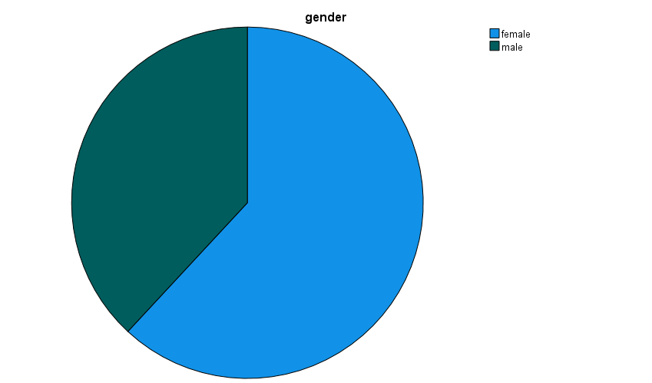

**Figure 1-Gender of respondents**

|  |  |  |  |  |  |
| --- | --- | --- | --- | --- | --- |
| **gender** | | | | | |
|  | | Frequency | Percent | Valid Percent | Cumulative Percent |
| Valid | female | 65 | 61.9 | 61.9 | 61.9 |
| male | 40 | 38.1 | 38.1 | 100.0 |
| Total | 105 | 100.0 | 100.0 |  |

**Table1**-Gender of the Respondent

Inference: From the survey, there are 105 respondents ,38.1% of whom are men and 61.9% of them are women.

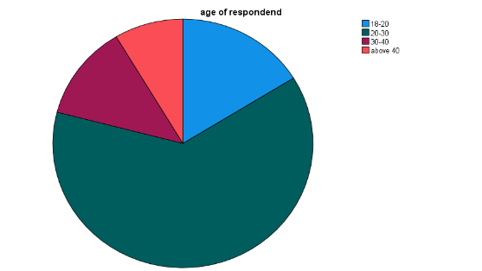

**Figure 2**- Age of respondent

|  |  |  |  |  |  |
| --- | --- | --- | --- | --- | --- |
| **age of respondent** | | | | | |
|  | | Frequency | Percent | Valid Percent | Cumulative Percent |
| Valid | 18-20 | 17 | 16.2 | 16.2 | 16.2 |
| 20-30 | 66 | 62.9 | 62.9 | 79.0 |
| 30-40 | 13 | 12.4 | 12.4 | 91.4 |
| above 40 | 9 | 8.6 | 8.6 | 100.0 |
| Total | 105 | 100.0 | 100.0 |  |

**Figure 2**- Age of respondent

INFERENCE-From the survey there are 105 respondents ,38.1% of whom are men and 61.9% of them are women.

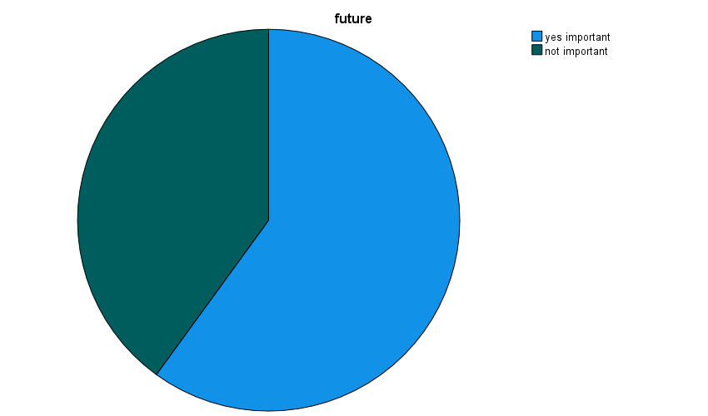

**Figure 3**-Future of Green Banking

|  |  |  |  |  |  |
| --- | --- | --- | --- | --- | --- |
| **future** | | | | | |
|  | | Frequency | Percent | Valid Percent | Cumulative Percent |
| Valid | yes important | 63 | 60.0 | 60.0 | 60.0 |
| not important | 42 | 40.0 | 40.0 | 100.0 |
| Total | 105 | 100.0 | 100.0 |  |

,

**Table 3**-Future of Green Banking

INFERENCE-From the survey, it is observed that out of 105 respondents 60% customers says that Green Banking will become more important in the future .40% says that green banking will not be important in future.

Figure 4- What are the barriers for adopting green banking

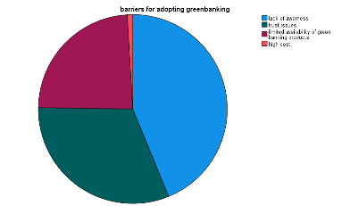

**Table 4**- Barrier for adopting green banking

**INFERENCE-**From the survey, it is observed that out of 105 respondents 43.8%. Have lack of awareness,31.4% has trust issues,23.8% says that they have limited availability of resources,1% says that due to high cost. Majority says that they lack awareness on green banking.

**Figure 5-** Choose a bank that is certified as environmentally friendly

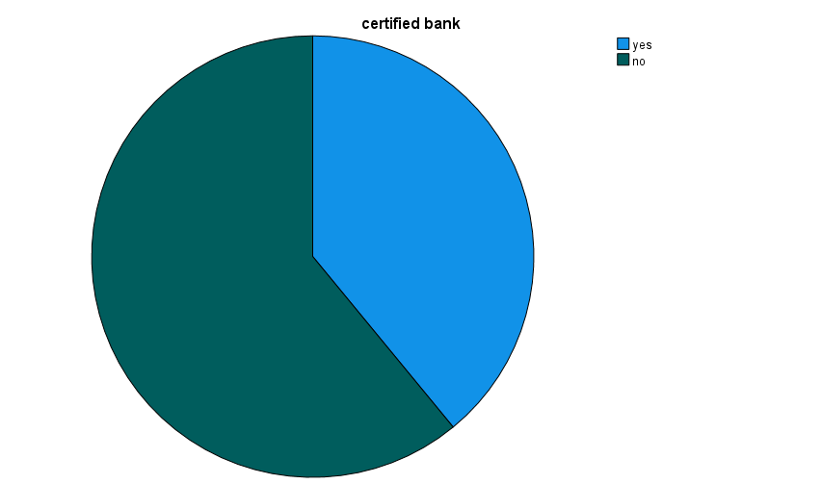

|  |  |  |  |  |  |
| --- | --- | --- | --- | --- | --- |
| **barriers for adopting green banking** | | | | | |
|  | | Frequency | Percent | Valid Percent | Cumulative Percent |
| Valid | lack of awarness | 46 | 43.8 | 43.8 | 43.8 |
| trust issues | 33 | 31.4 | 31.4 | 75.2 |
| limited availability of green banking products | 25 | 23.8 | 23.8 | 99.0 |
| high cost | 1 | 1.0 | 1.0 | 100.0 |
| Total | 105 | 100.0 | 100.0 |  |

|  |  |  |  |  |  |
| --- | --- | --- | --- | --- | --- |
| **certified bank** | | | | | |
|  | | Frequency | Percent | Valid Percent | Cumulative Percent |
| Valid | yes | 41 | 39.0 | 39.0 | 39.0 |
| no | 64 | 61.0 | 61.0 | 100.0 |
| Total | 105 | 100.0 | 100.0 |  |

**Table 5-** Choose a bank that is certified as environmentally friendly

**Correlation analysis**

Correlation is a statistical method used to measure the strength and direction of a relationship between two or more variables. In business research, it's a valuable tool for understanding how different factors or variables are connected.

To find out the relationship between education qualification and green banking knowledge.

Ho- There is no significant relationship between education qualification and green banking knowledge.

H1- There is a significant relationship between education qualification and green banking knowledge.

|  |  |  |  |
| --- | --- | --- | --- |
| **Correlations** | | | |
|  | | education | comes to your mind when you hear green bankinggreenbanking |
| education | Pearson Correlation | 1 | -.051 |
| Sig. (2-tailed) |  | .604 |
| N | 105 | 105 |
| comes to your mind when you hear green bankinggreenbanking | Pearson Correlation | -.051 | 1 |
| Sig. (2-tailed) | .604 |  |
| N | 105 | 105 |

# Table 6 -correlation

Inference-From the above table it is interpreted that the analysis indicates a p-value of 0.604, which exceeds the significance level of 0.05. Consequently, we accept the null hypothesis. This finding suggests that there is no significant relationship between education qualification and knowledge of green banking.

**CHI SQUARE ANALYSIS**

Chi-square is a statistical test used to examine the differences between categorical variables from a random sample in order to judge the goodness of fit between expected and observed results.

To find out the association between the age of respondent and its importance in future.

**Ho**- There is no significant association between age of respondent and its importance in future.

**H1**- There is a significant association between age of respondent and its importance in future.

**Table 7**-Chisquare analysis

|  |  |  |
| --- | --- | --- |
| **Test Statistics** | | |
|  | age of respondent | future |
| Chi-Square | 81.476a | 4.200b |
| df | 3 | 1 |
| Asymp. Sig. | .000 | .040 |
| a. 0 cells (0.0%) have expected frequencies less than 5. The minimum expected cell frequency is 26.3. | | |
| b. 0 cells (0.0%) have expected frequencies less than 5. The minimum expected cell frequency is 52.5. | | |

**Inference:** From the above table, we find that the significant value is .000, which is less than table value 0.05, so the Null hypothesis is rejected and Alternative hypothesis is accepted. This outcome indicates that there is a significant association between the age of respondents and their perception of its importance for the future.

**ANOVA**

ANOVA, or Analysis of Variance, is a statistical method employed to determine if there are significant differences among the means of three or more groups. It helps to assess whether variations observed in the data are the result of genuine differences between the groups or if they could be attributed to random fluctuations. ANOVA is particularly useful when comparing means across multiple groups, and it aids in identifying which groups, if any, exhibit statistically significant distinctions in their average values. This method allows for a more comprehensive understanding of data by examining variance both within and between groups.

To find out the association between perceived barriers to adopt green banking among different age groups.

Ho-There is no significant differences in the mean perceived barriers to adopting green banking among different age groups.

H1-There is a significant difference in the mean perceived barriers to adopting green banking among different age groups.

|  |  |  |  |  |  |
| --- | --- | --- | --- | --- | --- |
| **ANOVA** | | | | | |
| barriers for adopting green banking | | | | | |
|  | Sum of Squares | df | Mean Square | F | Sig. |
| Between Groups | 1.193 | 3 | .398 | .571 | .636 |
| Within Groups | 70.369 | 101 | .697 |  |  |
| Total | 71.562 | 104 |  |  |  |

Inference-From the above table it is found that the statistical results indicate a significance level (p-value) of 0.636. Since this p-value is greater than the established significance threshold of 0.05. This suggests that there are no significant differences in the mean perceived barriers to adopting green banking across the various age groups studied.

**5.FINDINGS**

The study on customer perceptions of green banking highlights several important findings. Firstly, it reveals that there is no significant relationship between education levels and knowledge of green banking, indicating that awareness may not be strongly influenced by formal education. In contrast, a significant association is found between age and the perception of the future importance of green banking, with younger respondents (ages 20-30) more likely to see it as critical. The survey data also shows that a notable correlation exists between positive perceptions of green banking and the willingness to choose certified environmentally friendly banks. This suggests that improving public perception could enhance adoption rates. However, there are variations in perceived barriers to adopting green banking across different age groups, pointing to specific concerns that require targeted strategies. Demographically, the survey revealed that 61.9% of respondents are female, and the majority (62.9%) fall within the 20-30 age range. Awareness barriers were prevalent, with 43.8% of respondents lacking knowledge about green banking, 31.4% expressing trust issues, and 23.8% citing limited resource availability. Notably, only 1% mentioned high costs as a barrier. Looking to the future, 60% of respondents believe that green banking will become increasingly important, although 40% disagree. Additionally, 39% prefer environmentally friendly banks, while a larger segment (61%) prioritizes fees and services over environmental certifications. Statistical analysis, including a Chi-Square Test, confirmed significant associations between age and the perceived importance of green banking, as well as between positive perceptions and the willingness to choose certified banks. However, One-Way ANOVA indicated no significant differences in perceived barriers across age groups. Overall, these findings underscore the need for banks to tailor their marketing and educational efforts to effectively engage diverse customer segments and promote green banking initiatives.

# 6.SUGGESTIONS

To enhance the adoption of green banking, several strategic initiatives can be implemented. First and foremost, increasing awareness among users is essential. Banks should launch comprehensive marketing campaigns that not only educate the public about the benefits and functionalities of green banking but also highlight success stories from other customers. Engaging content, such as videos and infographics, can make complex concepts more accessible. The Reserve Bank of India (RBI) could play a pivotal role by enforcing stricter regulations and guidelines that require banks to prioritize green banking initiatives. This could include incentives for banks that demonstrate a commitment to sustainability, thereby making green banking products more secure and user-friendly. Enhancing security features is crucial for instilling confidence in users. Banks should invest in robust cybersecurity measures and clearly communicate these to customers, making it easier and safer for them to engage with green banking products. Additionally, providing educational resources—such as workshops and webinars—can empower the general public to utilize green banking features effectively while also teaching them how to protect themselves from potential fraud. Establishing help desks in all bank branches can offer immediate support and guidance, fostering a sense of trust and reliability. Moreover, banks could consider creating a dedicated green banking helpline, staffed by knowledgeable representatives who can answer questions and assist with any concerns related to green banking products. To further encourage adoption, banks could implement incentive programs, such as lower fees or rewards for customers who choose green banking options. This not only makes green banking more appealing but also reinforces a culture of sustainability among customers. Overall, promoting green banking is vital for developing a sustainable financial framework that benefits both the environment and society. By focusing on education, security, and support, these initiatives can significantly contribute to the successful implementation of green banking, making it a more attractive option for a wider audience.

# 7.CONCLUSION

In conclusion, boosting the adoption of green banking is crucial for creating a sustainable financial ecosystem. This study on customer perceptions highlights that increasing awareness, enhancing security measures, and strengthening regulations are vital for building consumer confidence. By providing educational resources and establishing support systems, banks can empower users to engage effectively with green banking products. Furthermore, the findings suggest that incentivizing eco-friendly banking choices can encourage broader participation. Collectively, these strategies promote a culture of sustainability, ultimately leading to a more responsible and resilient financial sector.

# 8. REFERENCE

[1] Akhila K H, DR. G Nedumarana (2024) a study on the impact of green banking practices on customer satisfaction among indian commercial banks ISSN:1539-1590 | E-ISSN:2573-7104 Vol. 6 No. 1 .

[2] Ahmad, F., Zayed, N.M. and Harun, A. (2013). Factors Behind the Adoption of Green Banking by Bangladeshi Commercial Banks. ASA University Review, 7(1), 241- 255.

[3] Gračanac A. (2009) p. 245, Global Banking, Educons University Role of Bank of Indonesia to support Green Investment (2011) p. 6, Edi Setijawan..

[4] Herath H.M.A.K (2019) Impact of Green Banking Initiatives on Customer Satisfaction: A Conceptual Model of Customer Satisfaction on Green Banking IOSR Journal of Business and Management (IOSR-JBM) e-ISSN: 2278-487X, p-ISSN: 2319-7668. Volume 21, Issue 1. Ser. III (January. 2019), PP 24-35 www.iosrjournals.org

.