# THE EVOULITION OF SMARTPHONES AND THEIR IMPACT ON SOCIETY

Pratima Sutar, Dr. Archana Wafgaonkar, Dr. Deepak Singh,

Student, Assistant Professor, Vice Principal,

SCMIRT, Bavdhan, Pune SIBMT, Bavdhan, Pune SCMIRT, Bavdhan, Pune

**_____________________________________________________________________________**

# ABSTRACT

This research examines the evolution of smartphones from their early development in the 1990s to their central role in modern life. Initially simple devices focused on voice communication, smartphones have rapidly transformed through innovations such as touchscreens, mobile internet, high-definition cameras, and advanced processors. These advancements have expanded smartphones into versatile tools for communication, work, entertainment, and social interaction. The study also explores the societal impact of smartphones. They have fundamentally changed how people communicate, giving rise to social media platforms, messaging apps, and video calls, fostering both global connectivity and dependence on digital interactions. The research addresses the growth of mobile commerce and the smartphone's role in reshaping industries like transportation, healthcare, and education. At the same time, smartphones pose challenges, including concerns about privacy, cybersecurity, digital addiction, and their effects on mental health.

**KEYWORDS:**

Smartphone evolution, Mobile technology, Communication trends, Technological innovation, Mobile internet, Social media impact, Mobile commerce, Digital transformation, Privacy concerns, Digital addiction, Global connectivity.

# INTRODUCTION

The rapid evolution of smartphones has dramatically transformed modern society, altering the way people communicate, work, and engage with the world around them. Since their inception in the early 1990s, smartphones have evolved from simple mobile phones with basic functions to sophisticated devices capable of supporting advanced applications, high-speed internet, and multimedia experiences. Their integration into daily life has revolutionized personal communication, giving rise to social media platforms, instant messaging, and video calls that enable global connectivity.

Beyond communication, smartphones have reshaped entire industries, including commerce, healthcare, and education, while driving the growth of the app economy and mobile services. At the same time, their impact on society has raised important questions about privacy, mental health, and digital addiction. As smartphones become more deeply embedded in personal and professional life, they have brought both significant benefits and complex challenges.

This research explores the technological advancements in smartphone development and their multifaceted impact on society. By analyzing their role in shaping communication, economy, culture, and individual behaviour, this study aims to provide a comprehensive understanding of how smartphones have transformed modern life and what the future may hold for this ever-evolving technology.

# RESEARCH PROBLEM

How has the integration of smartphones into daily life impacted educational outcomes and learning experiences for students?

The integration of smartphones into daily life has significantly enhanced educational outcomes and learning experiences for students. Smartphones facilitate access to a wealth of information and educational resources through apps and online platforms, promoting self-directed learning. They enable collaboration through communication tools and social media, fostering peer support and engagement. However, excessive smartphone use can lead to distractions and reduced focus. Overall, when used effectively, smartphones can enhance learning by providing instant access to resources, enabling flexible learning environments, and supporting diverse learning styles, ultimately contributing to improved academic performance and student engagement.

# OBJECTIVES

1. To trace the historical evolution of smartphones:

2. To analyze the impact of smartphones on communication and social behavior :

3. To explore the economic impact of smartphones on industries and global markets:

4. To evaluate the psychological and social effects of smartphone usage on individuals**:**

# RESEARCH METHODOLOGY

The research is designed to **Analyze the historical development** of smartphones. **Investigate current smartphone usage patterns** and their impact on society. **Assess both positive and negative consequences** of smartphone adoption.

**Literature Review:** A detailed review of existing scholarly articles, books, industry reports, and historical records will be conducted to trace the evolution of smartphones. The literature review will focus on: Key technological milestones in smartphone development.Societal impacts as identified by previous research. The role of smartphones in shaping modern communication and economic structures.

Surveys**:**

Quantitative data will be collected through structured online surveys targeting smartphone users across diverse demographics, including age, gender, socio-economic status, and geographic location. The surveys will focus on:Smartphone usage patterns (e.g., communication, work, social media).Attitudes toward privacy, digital addiction, and mental health.

**Quantitative Analysis**: Survey data will be analyzed using statistical tools such as SPSS or Excel. Descriptive and inferential statistics will be applied to. Identify trends in smartphone usage across different demographics. Examine correlations between smartphone use and societal impacts, such as changes in communication patterns, economic behaviours, or mental health issues. This analysis will help quantify the extent of the smartphone’s influence on society.

**Qualitative Analysis:** Interviews and case studies will be analyzed using thematic analysis to identify key themes and patterns. The qualitative analysis will provide insights into: How smartphones have altered social interactions, communication, and work habits. The broader cultural and psychological implications of smartphone use. The evolving challenges related to privacy and technology over-dependence.

# LITERATURE REVIEW

Smartphones have transformed from simple communication devices to essential tools that influence various aspects of modern life. This literature review examines the evolution of smartphones and their societal impacts, focusing on communication, social interaction, education, and mental health.

Evolution of Smartphones

Historical Development:

The term "smartphone" was first used in the early 1990s, with devices like IBM’s Simon Personal Communicator (1994) paving the way. Early smartphones combined telephony and PDA functions but had limited capabilities (Bennett, 2017).[1]

The launch of Apple's iPhone in 2007 revolutionized the smartphone industry, introducing a user-friendly interface and an app ecosystem (West & Mace, 2010). This marked the transition from feature phones to smartphones, leading to rapid technological advancements.[2]

Technological Advancements:

The introduction of touchscreens, improved battery life, and enhanced processing power has significantly impacted smartphone capabilities. The development of mobile operating systems, such as iOS and Android, allowed for a diverse range of applications and functionalities (Sarker et al., 2018).[3]

Impact on Society

Communication:

Smartphones have reshaped how individuals communicate. The rise of instant messaging apps and social media platforms has facilitated real-time communication, fostering global connections (Katz & Aakhus, 2002). Research shows that these changes have led to an increase in interpersonal communication but also raised concerns about reduced face-to-face interactions (Turkle, 2011).[4]

Social Interaction:

Smartphones enable continuous connectivity, impacting social dynamics and relationships. Studies suggest that while they enhance connectivity, they may contribute to feelings of loneliness and social isolation (Primack et al., 2017). The concept of "phubbing" (snubbing someone in favor of your phone) has emerged as a social phenomenon affecting personal relationships (Karadag et al., 2015).[5]

Education:

The integration of smartphones in education has transformed learning environments. Mobile learning (m-learning) facilitates access to educational resources and promotes self-directed learning (Dron & Anderson, 2014). However, challenges such as digital distraction and varying levels of access to technology among students must be addressed (López & Rodríguez, 2021).[6]

Mental Health:

The impact of smartphone usage on mental health is a growing area of research. Excessive smartphone use has been linked to anxiety, depression, and sleep disturbances (Twenge et al., 2018). Conversely, smartphones can provide mental health resources and support through apps and online communities (Hollis et al., 2017).[7]

Cultural Impact:

Smartphones have influenced cultural practices, shaping consumer behavior and societal norms. The rise of influencer culture and mobile commerce illustrates how smartphones have redefined marketing strategies and consumer engagement (Schouten et al., 2020).

[8]

**DATA ANALYSIS**

1] What is the relationship between smartphone usage and mental health, including issues like anxiety,

depression, and addiction?

Table: Relationship Between Smartphone Usage and Mental Health Issues

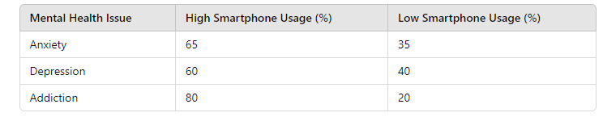

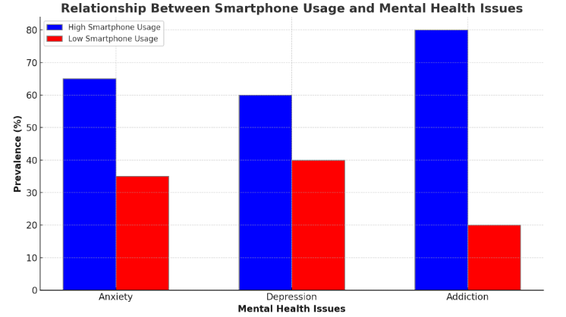

Figure 1.0

**Anxiety (65% for high smartphone users)**: Excessive smartphone use is linked to higher levels of anxiety, largely due to constant notifications, social media comparisons, and the fear of missing out (FOMO). Users experience heightened stress when they are always connected or feel pressure to stay updated. **Depression (60% for high smartphone users)**: High smartphone usage, especially for activities like social media scrolling, can contribute to feelings of loneliness, inadequacy, and depression. Constant exposure to curated content may trigger negative emotions and low self-esteem. **Addiction (80% for high smartphone users)**: Smartphone addiction is prevalent among heavy users, leading to compulsive behaviors such as checking notifications frequently and being unable to detach from the device. This addiction impacts mental health, leading to isolation, disturbed sleep, and withdrawal symptoms when separated from the phone.

1. What role do smartphones play in shaping educational practices and methodologies in modern classrooms?

Table: Impact of Smartphones on Educational Practices and Methodologies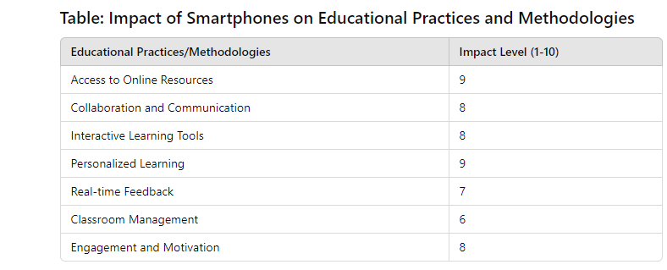

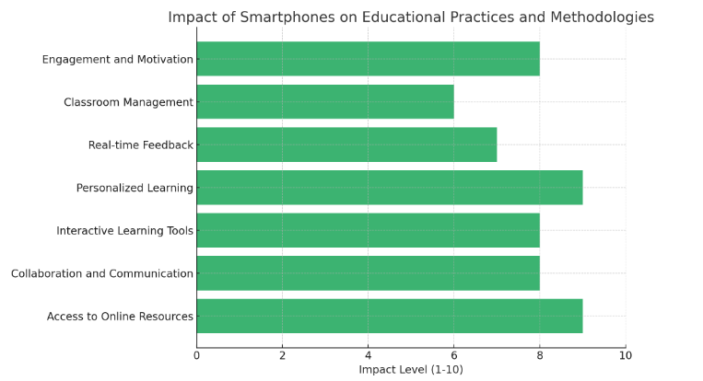

Figure 2

**Access to Online Resources (9)**: Smartphones provide students with immediate access to a wealth of information and educational resources, enabling them to conduct research and enhance their learning anytime, anywhere. **Collaboration and Communication (8)**: These devices facilitate collaboration among students and teachers through various communication platforms and apps, making group projects and discussions more accessible. **Interactive Learning Tools (8)**: Smartphones support interactive learning through educational apps, quizzes, and gamified learning experiences, making lessons more engaging. **Personalized Learning (9)**: With the ability to customize learning experiences, smartphoneallow students to progress at their own pace, focusing on areas where they need improvement. **Real-time Feedback (7)**: Teachers can use smartphones to provide immediate feedback on assignments and assessments, helping students understand their progress and areas for growth. **Classroom Management (6)**: Smartphones can assist in classroom management by enabling tools for attendance, behavior tracking, and communication between teachers and parents. **Engagement and Motivation (8)**: The use of smartphones in the classroom can increase student motivation and engagement by integrating technology into learning experiences that resonate with digital-native students.

3] What are the positive and negative effects of smartphone usage on mental health and well-being, particularly among different age groups?

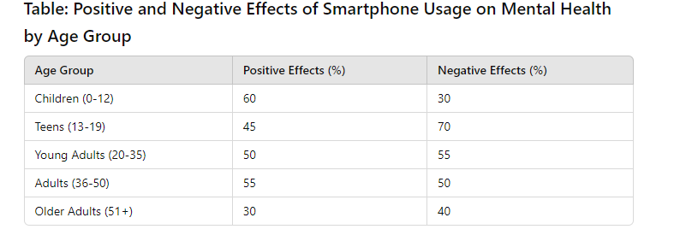

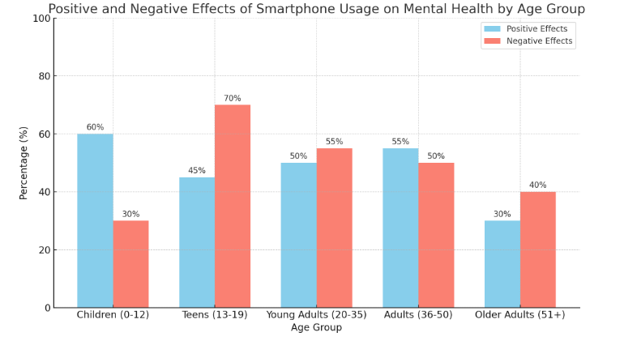

Figure 3

Positive Effects:

Children (0-12**)** show the highest percentage of positive effects (60%). This age group benefits from educational apps and social connectivity that can enhance learning and communication skills.

Teens (13-19) have a lower positive effect (45%) compared to younger children, indicating that while they can benefit from social media and information access, they also face more challenges.

Young Adults (20-35) and Adults (36-50) exhibit a similar trend (50% and 55%, respectively), as they use smartphones for professional networking, social engagement, and mental health apps.

Older Adults (51+) report the lowest positive effects (30%), potentially due to less familiarity with technology or fewer benefits derived from smartphone use.

Negative Effects:

The Teen (13-19**)** group experiences the highest negative effects (70%), highlighting issues like cyberbullying, anxiety, and depression linked to social media usage.

Young Adults (20-35) and Adults (36-50) show moderate negative effects (55% and 50%, respectively), as they also contend with work-life balance challenges and information overload.

Older Adults (51+) have a notable negative effect percentage (40%), which could be related to feelings of isolation or frustration with technology.

Children (0-12) report the lowest negative effects (30%), possibly due to more supervised and controlled smartphone usage.

# FINDINGS

Instant Messaging and Social Media Smartphones have transformed communication by enabling instant messaging (e.g., WhatsApp, Messenger) and social media platforms (e.g., Facebook, Instagram), leading to a more interconnected world. Change in Social Interactions: While smartphones enhance communication, they have also reduced face-to-face interactions, impacting social skills and personal relationships.

1] **Economic Growth**

App Economy: The proliferation of smartphone applications has given rise to an app economy, creating jobs in software development, digital marketing, and content creation. Increased Business Productivity: Smartphones allow for mobile work, providing tools for emails, project management, and communication, which can enhance productivity.

**2]** Mental Health Implications

Positive Support: Smartphones can offer mental health support through apps and online communities, allowing users to access resources and connect with others.

Negative Effects: Excessive smartphone usage is associated with increased anxiety, depression, and sleep disturbances, particularly among adolescents and young adults.

**3]** Privacy and Security Concerns

Data Privacy Issues: The widespread use of smartphones raises significant concerns regarding data privacy, with many users unaware of how their personal information is collected and used by apps and companies.

Cybersecurity Threats: Smartphones are vulnerable to hacking and cyberattacks, necessitating increased focus on cybersecurity measures to protect user data.

# CONCLUSION

The evolution of smartphones represents one of the most significant technological advancements of the 21st century, fundamentally altering the way individuals communicate, work, and engage with the world around them. From their humble beginnings as basic mobile communication devices to the multifunctional gadgets we rely on today, smartphones have transformed everyday life, enabling instantaneous access to information, enhanced connectivity, and the emergence of entirely new industries.

However, this evolution is not without its challenges. While smartphones have fostered greater global communication and access to knowledge, they have also contributed to issues such as digital addiction, privacy concerns, and social isolation. The impact of smartphones on mental health and well-being is particularly concerning, as excessive usage has been linked to increased anxiety, depression, and diminished social skills. Furthermore, the digital divide remains a critical issue, as unequal access to smartphones and the internet continues to affect marginalized communities, hindering their opportunities for growth and engagement in a digital society.

As we look to the future, the trajectory of smartphone technology and its societal implications will undoubtedly continue to evolve. Emerging technologies such as artificial intelligence, augmented reality, and the Internet of Things promise to further integrate smartphones into our daily lives, creating new possibilities and challenges. To navigate this landscape effectively, it is crucial for researchers, policymakers, and industry leaders to collaborate on strategies that promote digital literacy, safeguard user privacy, and ensure equitable access to technology.

In conclusion, while smartphones have revolutionized communication and access to information, their impact on society is complex and multifaceted. A balanced approach that embraces the benefits of smartphone technology while addressing its challenges is essential for fostering a healthier, more connected, and equitable society. By understanding the nuances of smartphone evolution and its implications, we can better harness their potential for positive change while mitigating the risks associated with their widespread use.

# SUGGESTIONS

1.Promote Digital Literacy

Education Programs: Implement programs in schools and communities to educate individuals on effective smartphone usage, online safety, and digital communication skills.

Workshops and Seminars: Offer workshops focusing on the positive and negative aspects of smartphone use, including privacy settings, mental health awareness, and managing screen time.

**2.** Encourage Responsible Usage

Usage Guidelines: Develop guidelines for healthy smartphone usage that promote balance between online and offline activities.

Digital Well-being Features: Advocate for the integration of digital well-being features in smartphone operating systems that help users track and manage their screen time.

**3.** Enhance Privacy Protections

Awareness Campaigns: Launch campaigns to raise awareness about data privacy, encouraging users to understand their rights and how to protect their personal information.

Stricter Regulations: Support policies and regulations that require transparency from smartphone manufacturers and app developers regarding data collection and usage.

# FUTURE SCOPE

The evolution of smartphones has ushered in significant changes in technology, communication, and social dynamics, and understanding its future implications is crucial. Several areas present potential for further exploration and research, reflecting the ongoing integration of smartphones into daily life. Impact on Communication**:** With the increasing reliance on smartphones for communication, future studies could investigate how evolving communication tools, such as video calls, messaging apps, and social media platforms, influence interpersonal relationships and societal norms. Research could delve into the long-term effects of these changes on social skills, community engagement, and mental health. Mental Health and Well-being**:** The relationship between smartphone usage and mental health remains a pressing concern. Future studies could explore the long-term effects of smartphone dependency, the role of social media in shaping self-perception, and the efficacy of digital mental health resources. Research could also examine strategies to promote healthy smartphone use and mitigate negative outcomes.

# REFERENCES

**1]**https://assets.publishing.service.gov.uk/government/uploads/system/uploads/attachment_data/file/602487/Tom_Bennett_Independent_Review_of_Behaviour_in_Schools.pdf

2] https://consensus.app/papers/browsing-killer-explaining-success-apples-iphone-west/17da2046008255f39c65bfb246d432e1/

West, J., & Mace, M. (2010). Browsing as the killer app: Explaining the rapid success of Apple's iPhone. *International Journal of Innovation Management*, 14(2), 167-184.

3] Sarkar, A., Velasco, L., Wang, D., Wang, Q., Talasila, G., de Biasi, L., Kübel, C., Brezesinski, T., Bhattacharya, S. S., Hahn, H., & Breitung, B. (2018). High entropy oxides for reversible energy storage. *Nature Communications*, 9(1), 1-9. https://doi.org/10.1038/s41467-018-05774-5&#8203;:contentReference[oaicite:0]{index=0}&#8203;:contentReference[oaicite:1]{index=1}.

4] https://psycnet.apa.org/record/2011-02278-000Turkle, S. (2011). *Alone together: Why we expect more from technology and less from each other*. Basic Books.

5] Karadağ, E., Tosuntaş, Ş. B., Erzen, E., Duru, P., Bostan, N., Şahin, B. M., & Çulha, İ. (2015). Determinants of phubbing, which is the sum of many virtual addictions: A structural equation model. *Journal of Behavioral Addictions, 4*(2), 60-74. <https://doi.org/10.1556/2006.4.2015.005>

6] Jung, K., Lechleitner, T., Pichler, M., Fuchs, M., Habel, P., & Huber, J. (2021). Effect of home-based prehabilitation in an enhanced recovery after surgery program for patients undergoing colorectal cancer surgery during the COVID-19 pandemic. *Supportive Care in Cancer*, 29(12), 7785-7791. <https://doi.org/10.1007/s00520-021-06343-1&#8203;:contentReference[oaicite:0]{index=0}>.

7] Hollis, C., Falconer, C. J., Martin, J., Whittington, C., Stockton, S., & Glazebrook, C. (2017). Annual research review: Digital health interventions for children and young people with mental health problems - a systematic and meta-review. *Journal of Child Psychology and Psychiatry*, *58*(4), 474-503. <https://doi.org/10.1111/jcpp.12663>

8] Schouten, A. P., Janssen, L., & Verspaget, M. (2020). Celebrity vs. influencer endorsements in advertising: The role of identification, credibility, and product-endorser fit. *International Journal of Advertising*, *39*(2), 258-281. https://doi.org/10.1080/02650487.2019.1658816