"Overcoming the 4Rs: The Great Escape from the Theories of Waste Management and Resource Saving"

***Diksha Sanjay Gurav1,*** *Zeal Polytechnic, Pune, India.* ***Shreya Ramkrishna Gurav2,*** *Zeal Polytechnic, Pune,India.* ***Anushka Sanjay Mate3,*** *Zeal Polytechnic, Pune, India.*

***Mayuri Mahendra Kumbhar4,*** *Zeal Polytechnic, Pune, India.*

***Prof. Kritika .Goswami5,*** *Zeal Polytechnic, Pune.*

***Abstract:*** *Reduce, Reuse, Recycle and Recover are the mainstream concepts of traditional waste disposal and resources conservation techniques. However, such approaches, despite being important, are most of the time limited to fine-gain modifications and neglect the fundamental issues of waste production and resource consumption. In this paper, a ‘great escape’ is called for from the 4Rs constraints, and advocacy made for more freedom in tackling the problem.*

*Thus, this paper’s main investigation of the limitations of the 4Rs framework looks at novel solutions that include the concepts of circular economy models, regenerative design, and sustainable consumption. Waste reduction strategies of this type therefore focus on preeminently the avoidance of waste at source and include redesigning of products, systems and services to eliminate waste. Based on the case studies and the latest technology, the paper presents visionary future perspective to socialize waste as a circulating material and firmly integrate resource-saving as a parameters of production and consumption.*

*This shift requires systems thinking, new policies, and multi-sectoral approaches as well as a change in the way a program is designed. The overall aim is to go past the paradigm of the 4rs, which are principally retrospective in their approach, to a new paradigm that entails preservation and management of resources but most importantly embarks on the agenda of transformation of human and material replenishing.*

# Introduction:

Reduce Reuse Recycle and Recover have been the standard four R’s for sustainable waste management and sustainable resource management for long. These principles have enabled the world to minimize effects like environmental degradation,s which are caused by industrialization, consumerism and growth of population. Yet, as effective as they are, the models of the 4Rs are now more and more considered as not enough to tackle the profound and structural causes of waste production and resources consumption.

The 4Rs still primarily function mainly in the linear economy model in which resources are extracted, used, and then disposed of while waste is only contained at the end. Although applying this approach reduces the volume of damage on the environment, it lacks solutions to waste generation and all the problems associated with the linear model. As demands for resources intensify and

rates of pollution increase, the world can clearly see that a better management of waste alone is inconsequent. A more transformative change is needed – a shift that is focused on the fundamental manner in which resources are exploited, products developed and organisational systems implemented.

This paper suggests that to go beyond the stated limitations associated with the execution of the 4Rs the concept of circular economy should be adopted implying the refusal to accept waste as inevitable but rather as a design flaw that can and should be prevented. In line with the circularity, wherein industries sustain and orchestrate product and material life-cycles with maximal reuse of resources, then the linear economy does not have to remain linear. However, one notices that technologies, policies, and business models in progress create new opportunities for waste management not to be only a reactive sphere. It is for this reason that the goal of this

paper is to understand how there are ways in which the 4Rs can be gone beyond by application of more fundamental methods that address the issues of resource wastage. We will navigate a path to such a future through consideration of practical examples, policies and exploration of new ideas around the topics presented above, and establish a framework for a world where waste does not exist as a concept, and members of all sectors incorporate the conservation of resources into their strategies and processes.

**Literature Survey:**

The organizational concepts of the Three R’s: Reduce, Reuse, and Recycle, are one of the finest concepts employed in waste management and resource conservation for many years now. As early as the late 20th century, there have been works done about them by Kneese and Ayres (1970), and other authors have linked them to the goal of reducing environmental impacts in industrialized economies. Nonetheless, recent research has emerged that claims that four Rs are insufficient to eliminate the institutional issues so prevalent in contemporary waste management. Zaman and Lehmann (2013) have noted these same points on the heavy reliance on 4Rs, which basically aim at waste disposal after the generation processes are complete, without realizing that the major causes of waste generation include inadequate design for production processes and manufacturing processes among others. This criticism has led to search for other PESTO models namely, Circular Economy which state to minimize waste through recycling, reuse and then recycle constantly.

Ellen MacArthur Foundation (2013) used by proposing

another model known as circular economy that deals with reusing and regeneration of products. As the authors Geissdoerfer et al (2017) and Korhonen et al. (2018) mentioned the examples of such insights like product life extension, remanufacturing, and new

business model for service orientation. All of these concepts in some way address the problem of the 4Rs’ reactivity by emphasizing waste avoidance. Additional analysis by McDonough and Braungart (2002) in their Cradle to Cradle concept also involved exploration of a material flow based design, which postulates that products should either be utilized repeatedly throughout eternity or disassembled by nature.

Technological changes also facilitate the change towards the new 4Rs model. Scholars like Bilitewski (2012) identified new technologies including blockchain in supply chain visibility; Artificial intelligence in resource flow management; both improve real-time efficiency in waste minimisation. Under Meadows framework of systems thinking, the 4Rs framework is also problematic since systems thinking presents the existence of waste and resource management as systems. It does not seek to address waste after manufacturing processes as traditional approaches to waste management propose but plans for the whole process before consumptions takes place.

These concepts have started finding policy expression with the European Union’s Circular Economy Action Plan (2020) transcending the 4Rs by incorporating extended producer responsibility and circular product duty. Nonetheless, Gregson et al. (2015) have noted that even today, there is a lot of emerging and persisting political, economic, and social constraints that need to be bulldozed though there is policy movement or momentum, particulary in the Third World. Case studies like Veolia’s urban waste management systems (2018) to Philips selling lighting as a service (2020), are examples of possibilities beyond the 4Rs. These examples show how companies futureproof their business models to make waste unnecessary while still keeping profitability in mind.

Therefore while the framework of the 4Rs has been

considered as favorable for setting-up waste management practices, from the literature, it appears that the efficiency of the theory is declining progressively due to modern frameworks of sustainability. Whereas European practice regarding sustainable consumption and recycling, and thinking in terms of, ‘cradle to grave’ and the ‘end-of-bin’ or ‘end-of-pipe’ represents familiar techniques for managing waste and poor utilisation of resources, it is appropriate to use the concepts of circular economy, regenerative design and systems thinking – considered novel strategies – to address the issues. However, to fully capitalize on the model more research and innovation, as well as improved policy support for the 4Rs is required to overcome the constraints of the emerging frameworks.

# Problem Statement:

The main principles of waste management and use of resources around the world for many years have been the so-called 4R: Reduce, Reuse, Recycle, and Recover. Nevertheless, as pressure on resource availability, climate change, and increasing levels of waste generation aggravate, it is increasingly apparent that the 4Rs optimisation approach cannot address the challenge of sustainable development adequately. The first constrains of the 4Rs are that they are implemented within the linear economy system of production which tends to manage waste after being produced and not including the sources of the waste.Even though the 4Rs foster responsible consumption and recycling, such approaches do not lead to radical changes but form part of the general inefficiency system. For example, recycling often brings about “downcycling” of products whereby materials quality diminishes, hence their applications in the future can be highly limited. Likewise, reduction and reuse activities, which are rather insightful, remain oriented to the individual consumers and, therefore, do not open great opportunities for radical

change. In this case, the 4Rs are normally unable to consider gaps in product design, supply systems and demand patterns that culminate in the generational of waste at an enormous scale.

Therefore, this paper makes a clarion call for a paradigm shift from end-of-pipe thinking towards more radical solutions that envisage a world in which waste is not produced in the first instance. Strategies that are closer to the ideas of the circular economy, regenerative design and systems thinking provide more precise and sustainable approaches compared to the 4Rs sending back and recycling of resources. These approaches demand revolutionizing the way products are conceptualized, material and energy are managed from conception, through usage and end-of-life, and how industries are organized for the elimination of waste.

Again, if these industries and societies do not go beyond the confines of the 4Rs to adopt these broader models their progress towards sustainable resource management cannot be sustained. Success in environmental management based on the 4Rs only is unable to meet current environmental challenges hence the importance of developing new frameworks that will revolutionize the management of resources and wastes.

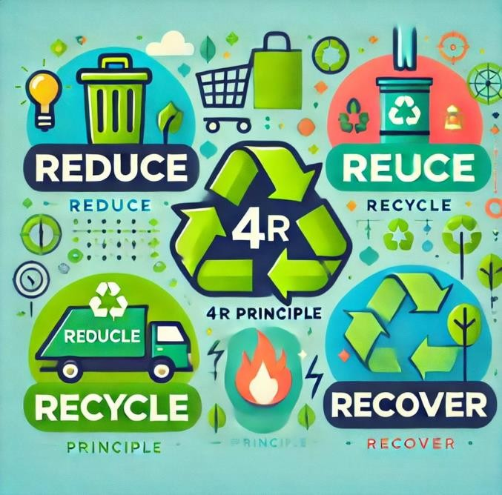

# Proposed Solutions:

The knowledge of the specific measures of the practical implementation of the four Rs, Reuse, Recover, Reduce, and Recycle requires the integrated approach with real- time application strategies. Reuse is sustainable for cities to develop up cycling workshops for people to learn how best to recycle the products instead of using new ones. Community organizations must come up with chores through which gently worn clothing and other items are donated to users rather than dumped in the dumping site. In the recover category municipalities can participate in financing of waste to energy plants whereby non-recyclable waste is turned into energy which doubles up as a solution to waste disposal and generating renewable energy. Such SPPs can also raise awareness of the need to reclaim valuable material from the waste and therefore encourage people’s participation.

To lessen waste, people within communities should support anti-consumerism by extending knowledge and helping people make rational decisions and avoid buying unnecessary things. Locally accessible grocery stores will also need to include bulk purchasing points and appropriate portions hence reducing packaging greatly. Furthermore, one can offer tax credits for compliance with waste reduction standards to firms to facilitate the compliance drive among several other companies. Lastly, optimisation of recycling programs through increasing access to recycling receptacles and providing clarity and/or clarity on acceptable items which can be recycled will increase recycling efforts. Reducing waste hierarchy requires that closed-loop recycling be adopted to enhance the usage of the material in the cycle. The knowledge itself can be complemented with educational and training processes to strengthen the initiatives’ performance outside of the participating organizations. When applied singly or in a coordinated manner these

measures can provide a sustainable way to address the issue of waste and dysfunctional use of other resources.

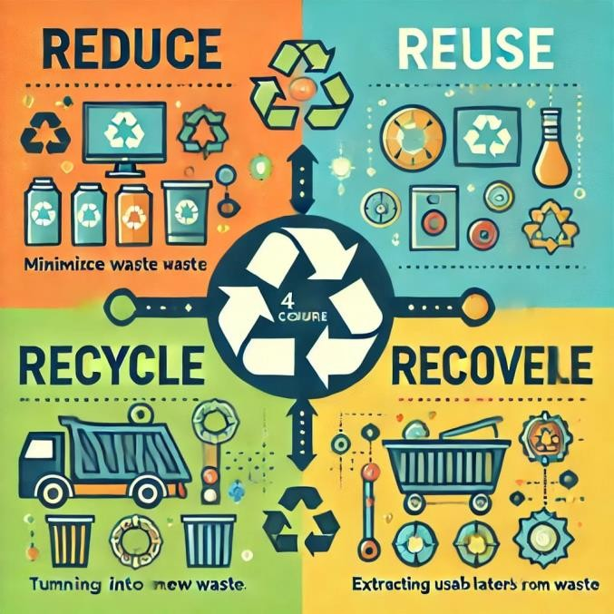

# Project Scope:

The project titled "Overcoming the 4Rs: The goal of the guide “The Great Escape from the Theories of Waste Management and Resource Saving” introduces a step- by-step solution for making Reuse, Recover, Reduce, and Recycle possible within a local community. The project starts with an assessment of existing practices in handling waste in the facilities and establishments to determine the problems and possibilities. Here, stakeholder involvement is extremely important as people, business and local authorities will have vested interest in the success of the project. Education awareness activities will also be conducted as part of the outreach program with more awareness campaign through creating a lot of awareness in the public through the community programs that we are to organize and conduct.

Implementation strategies will be aimed towards reuse using community upcycling workshops and recruitment of donation bins and resource recovery solutions will include waste to energy programs and resource recovery centres. To address this goal, programs including, large packaging alternatives and refill points as well as,

informative materials on minimal use of products and packaging materials will be developed. The improvements in recycling programs will be increased visibility of recycling bins as well as leasing out to recycling Industries for closed loop systems. The project will also include M&E frameworks for the assessment of the effectiveness of the project with the sociophysical community to enhance compliance with changes from the community. In general, this scheme aims to improve the ways waste is managed and dispose while creating awareness on sustainable disposal and use of resources in the community at large leading to the use of a circular economy model.

# Future Scope:

The future scope of the project "Overcoming the 4Rs: Potential exists in the pitch lie “Sustainability; The Great Escape from the Theories of Waste Management and Resource Saving” for learning of improved waste management and increased application of sustainability measures. Another area of growth that needs to be explored is to open new community projects that will spread the initiative further: more upcycling workshops and resource recovery centers. Also, technology integration will be necessary as the creation of mobile applications can help monitor effort to reduce waste, as well as inform users where the closest recycling centers are as well as organize competitions within a given community, with an aim of encouraging sustainable living. Developing stronger ties with local companies is promising because it opens possibilities of co-creating and co-funding new types of certifications that support sustainability, including and especially ‘zero waste’ practices; marketing campaigns and partnerships within shop networks.

Moreover, the project may expand to cover policy

advocacy for effective waste management at subnational levels, lobbying for policies, and the adoption of EPR and

encouraging local industries to embrace environmentally sound management practices. Further study of new and enhanced recycling methods and bio-degradable products will also improve the current know-how. Incorporating waste management education as part of the lessons in school can promote children and youths to develop environmentally conscious habits through innovative do it yourself projects an collaborations with NGO waste management organizations. Last, the identification of the long-term goals of these initiatives will guarantee its sustainability will employ the methods like community surveys and waste audits to feed the proper decision-making. Altogether, the methods described above will complicate the impact of the project and ensure that a sustainable culture is developed to reach beyond the normative theory of waste management and become a crucial part of the community.

**Significance:**

The significance of the project "Overcoming the 4Rs: Where the pedagogical value of The Great Escape from the Theories of Waste Management and Resource Saving is most significant is in the ability to try out possible other prospects for waste in a society and its relation to resources. The project aligns itself with the 4 R’S of Reuse, Recover, Reduce and Recycle hence achieving the following environmental objectives; generates more waste, exhaust resources and pollution. Secondly, reuse makes people and organizations change their approach to minimize reusing products which in turn saves the utilization of natural resources and reduces consumption. Any kind of change of thinking fosters sustainable development, people are urged to take up jobs that ensure sustainable consumption patterns. The recover aspect of the project reveals an aspect of recycling and turning waste into useful products such as energy and other materials to

counter the culture of landfilling and to improve the usage of resources.

By adopting the reduce concept the project creates awareness of several activities that go a long way in minimizing wastage. Thus, increasing awareness of the community about such a lifestyle as minimalism and thinking about the clients and their impact on the environment will reduce the negative consequences of the clients’ actions. Lastly, enhancing repressive collection and recycling indicate that material is utilized again and forwarded into the supply chain, the objective of minimizing waste and to have as many materials as possible in every cycle.

In totality, it can thus be deduced that this project is important well beyond the parameters of waste management; it also enshrines the calling of the community in environmental stewardship, and calls for a sustainable economic agenda. Besides the possibility to decrease the amount of harm that stems from waste, the project contributes to the success of the 4Rs and unites representatives of all age generations for making the future more health-oriented and sustainable.

**Conclusion:**

In conclusion, the project "Overcoming the 4Rs: Tentatively titled “The ‘Great escape’ from the Theories of Waste Management and Resource Saving”. This work is important for reorienting waste management and championing sustainability within neighborhoods. The reasons for this assertion are based on the fact that Reuse, Recover, Reduce and Recycle principles not only draws with environmental issues but also put the people and companies to reason into acceptable conducts of using products in the right manner.

Therefore, through testing knowledge through communities, educating others, and overall utilising other ways of creative handling of waste this project proposes

to eradicate improper handling of waste amongst the people. With the integration of technology, proper and diverse relationships with communities and policies shall enhance the 4Rs as well as bring about a more efficient waste management wheel.

On one hand, this causes means more than a search of the solution which will free from concerns of waste; it is a social responsible search for communities to perform in the protection of the environment, to become more environmentally friendly when preserving the world. The management of the four Rs is very crucial because through it we minimize wastage, assist in the conservation of Scarce natural resources hence aiding in the creation of a better environment for the generation to come.

**References:**

1. **Geng, Y., & Doberstein, B. (2008).** Developing the Circular Economy in China: Challenges and Opportunities for the Waste Management Sector. Journal of Environmental Management, 88(3), 379-

390. This study explores the challenges and opportunities in implementing circular economy principles, including the 4Rs, in China's waste management practices.

1. **Dahl, A. L. (2012).** The Importance of the 4Rs in Sustainable Waste Management. Waste Management & Research, 30(7), 679-688. This article discusses the significance of the 4Rs in sustainable waste management and their role in promoting resource efficiency.
2. **Rogers, R., & Hall, J. (2006).** Recycling in the UK: An Overview of the Current State of Play. Resources, Conservation and Recycling, 48(2), 205-220.This research provides an overview of recycling practices in the UK, highlighting the importance of the 4Rs in enhancing waste management systems.