# Impact of social media platforms on communication.

Pratima sutar, Dr. Archana Wafgaonkar, Dr. Deepak Singh,

Student, Assistant Professor, Vice Principal,

SCMIRT, Bavdhan, Pune SCMIRT, Bavdhan, Pune SCMIRT, Bavdhan, Pune

**_____________________________________________________________________________**

# ABSTRACT

This research investigates the impact of social media platforms on communication, exploring both the opportunities and challenges presented by these digital environments. Social media has revolutionized the way individuals share information, interact, and build relationships, creating a landscape where communication is instantaneous and accessible. Platforms such as Facebook, Twitter, Instagram, and TikTok have enabled users to connect across vast distances, share diverse perspectives, and participate in global conversations. This connectivity fosters community engagement and the rapid dissemination of information, empowering users to mobilize for social causes and share personal narratives. However, the research also highlights the potential downsides of social media on communication dynamics. The rise of digital communication has led to concerns regarding the quality of interactions, with an increasing reliance on text-based communication contributing to misunderstandings and a lack of emotional nuance. Additionally, the phenomenon of cyberbullying, misinformation, and echo chambers poses significant challenges to constructive dialogue and public discourse. The study examines how the curated nature of social media profiles can lead to comparison, anxiety, and reduced face-to-face communication skills, affecting interpersonal relationships.By analyzing empirical data, user surveys, and case studies, this paper aims to provide a comprehensive understanding of how social media platforms have transformed communication practices. The findings underscore the need for a balanced approach that acknowledges both the positive and negative aspects of social media, offering insights into how individuals and society can navigate these digital landscapes to enhance meaningful communication in an increasingly interconnected world.

**KEYWORDS:**

Social Media, Communication, Digital Interaction, Online Communities, User Engagement, Information Dissemination, Interpersonal Relationships, Cyberbullying, Emotional Nuance, Misinformation

# INTRODUCTION

The rapid proliferation of social media platforms in the last two decades has fundamentally transformed the landscape of communication. With billions of users worldwide, platforms such as Facebook, Twitter, Instagram, and TikTok have become integral to daily life, altering the way individuals interact, share information, and build relationships. Social media provides unprecedented opportunities for connectivity, allowing users to communicate across vast distances, engage with diverse communities, and participate in global conversations at the click of a button. This shift from traditional forms of communication to digital interactions raises important questions about the nature and quality of human connection in the modern age.While social media has democratized information sharing and empowered individuals to voice their opinions and experiences, it also presents challenges that impact the quality of communication. The curated nature of online profiles often leads to a distortion of reality, where users present idealized versions of their lives, resulting in social comparison and feelings of inadequacy among peers. Moreover, the shift towards text-based communication can lead to misunderstandings and a lack of emotional nuance, as users struggle to convey tone and context without the benefit of nonverbal cues.

Furthermore, the influence of algorithms on content visibility and user engagement can create echo chambers, reinforcing existing beliefs while limiting exposure to diverse perspectives. The rise of misinformation and cyberbullying on social media platforms further complicates the communication landscape, raising concerns about the potential erosion of meaningful dialogue and public discourse. This research aims to explore the multifaceted impact of social media platforms on communication,

analyzing both the benefits and drawbacks of these digital interactions. By examining empirical studies, user experiences, and theoretical frameworks, this study seeks to provide a comprehensive understanding of how social media has reshaped communication practices in the contemporary world. Ultimately, the findings will contribute to ongoing discussions about the implications of social media on individual relationships, societal dynamics, and the future of communication in an increasingly interconnected digital landscape.

# RESEARCH PROBLEM

How does the use of social media impact interpersonal relationships compared to traditional face-to-face communication?

The use of social media significantly impacts interpersonal relationships by enhancing connectivity and communication across distances, allowing individuals to maintain relationships easily. However, it often leads to more superficial interactions, as online communication can lack the depth and non-verbal cues present in face-to-face conversations. Misinterpretations of tone and the potential for conflicts can arise more frequently in digital exchanges. While social media can foster feelings of closeness, it may also contribute to isolation and loneliness if users prioritize online interactions over in-person connections. Balancing both forms of communication is essential for nurturing meaningful relationships.

# OBJECTIVES

1] To Analyze Communication Dynamics

2] To Assess the Role of Social Media in Information Sharing:

3] To Evaluate the Quality of Interactions:

4] To Explore the Effects of Social Media on Relationships:

6] To Examine the Psychological Impacts:

**RESEARCH METHODOLOGY**

**Research Design**

Type: Use a mixed-methods approach, combining both quantitative and qualitative research methods. This allows for a more comprehensive understanding of the impact.

Framework: Employ a descriptive research design to gather data on current trends and behaviours related to social media communication.

4. Data Collection Methods

Surveys: Create an online questionnaire to gather quantitative data on users' communication habits, preferences, and perceptions of social media. Include Likert scale questions for measuring attitudes and usage frequency.

Focus Groups: Organize focus group discussions to explore group dynamics and the collective impact of social media on communication styles and norms.

Content Analysis: Analyze social media content (e.g., posts, comments) to understand the nature of communication and language used on these platforms.

# LITERATURE REVIEW

The emergence of social media platforms has significantly transformed communication dynamics across various contexts. Research shows that social media enhances connectivity, allowing individuals to maintain relationships and connect with others worldwide. Ellison et al. (2007) emphasize that platforms like Facebook and Twitter facilitate interactions that strengthen existing friendships while enabling users to forge new connections. This connectivity is particularly valuable for younger demographics, who increasingly rely on these platforms for social interaction.[1]

Moreover, social media has altered communication styles, promoting brevity and informality. Seargeant and Tagg (2014) argue that the prevalence of abbreviations, emojis, and visual content has shifted the way emotions and ideas are conveyed. This evolution reflects a growing preference for quick, engaging exchanges, which can foster creativity but may also lead to misunderstandings due to the lack of non-verbal cues inherent in face-to-face interactions.[2]

The role of social media in information dissemination is another crucial aspect of its impact on communication. Kaplan and Haenlein (2010) highlight that the speed and reach of information shared on social media far exceed those of traditional media outlets. However, this rapid dissemination raises concerns about misinformation and the credibility of sources, as the potential for false narratives to spread quickly can undermine informed public discourse.[3]

Social media's influence extends to personal relationships, presenting both positive and negative outcomes. Valkenburg and Peter (2009) found that while social media can enhance feelings of closeness among friends, it can also create conflict through misinterpretations of tone and context. The ease of communicating online may lead to overreliance on digital interactions, potentially diminishing the quality of in-person relationships.[4]

In professional contexts, platforms like LinkedIn have transformed networking and career development. Houghton et al. (2015) note that while social media facilitates professional connections, it also blurs the boundaries between personal and professional identities, raising questions about privacy and self-presentation.[5]

The mental health implications of social media use have garnered significant attention in recent years. Primack et al. (2017) found a correlation between heavy social media use and increased feelings of loneliness and depression, suggesting that despite the opportunities for connection, social media may contribute to feelings of isolation.[6]

In summary, the literature highlights that social media platforms have fundamentally reshaped communication practices, offering both opportunities for enhanced connectivity and challenges related to misinformation, relationship quality, and mental health. As these platforms continue to evolve, ongoing research is essential to understand their long-term impacts on societal communication.

[7]

.

**DATA ANALYSIS**

1] How do social media platforms affect communication during crises or emergencies, particularly regarding the speed and accuracy of information dissemination?

TABLE: IMPACT OF SOCIAL MEDIA PLATFORMS ON COMMUNICATION DURING CRISES OR EMERGENCIES.

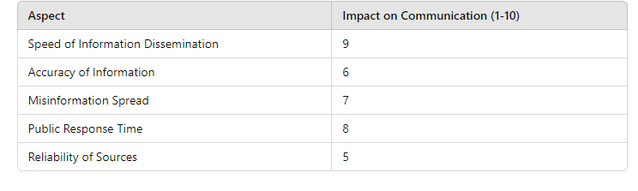

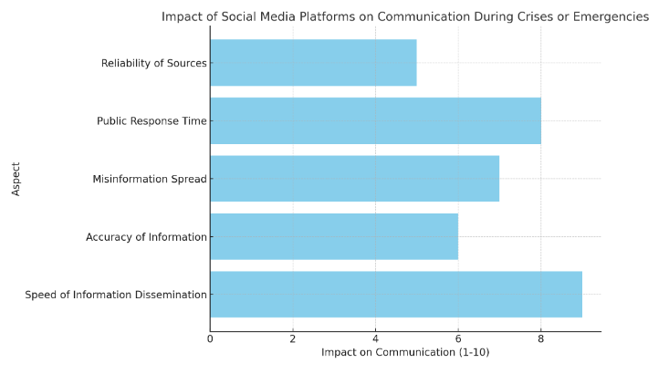

Figure 1.0

The bar graph above illustrates how social media platforms impact communication durincrises or emergencies, focusing on five key aspects:

**Speed of Information Dissemination (9/10)**: Social media significantly accelerates the spread of information, allowing real-time updates to reach a large audience almost instantly.

**Accuracy of Information (6/10)**: While information spreads rapidly, the accuracy often suffers, as unverified or incomplete information can circulate before official sources confirm it.

**Misinformation Spread (7/10)**: Social media platforms have a notable tendency to amplify misinformation during crises, as users may unknowingly share inaccurate data.

**Public Response Time (8/10)**: Social media encourages faster public responses, as individuals react swiftly to breaking news, which can help mobilize resources or spread safety advice quickly.

**Reliability of Sources (5/10)**: The reliability of information sources on social media is a concern, with varying trust levels depending on the source (e.g., official channels vs. user-generated content).

2] What is the relationship between heavy social media usage and the perception of loneliness or social isolation among users?

TABLE: IMPACT OF HEAVY SOCIAL MEDIA USAGE ON PERCEPTION OF LONELINESS AND SOCIAL ISOLATION

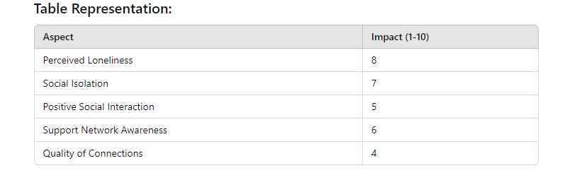

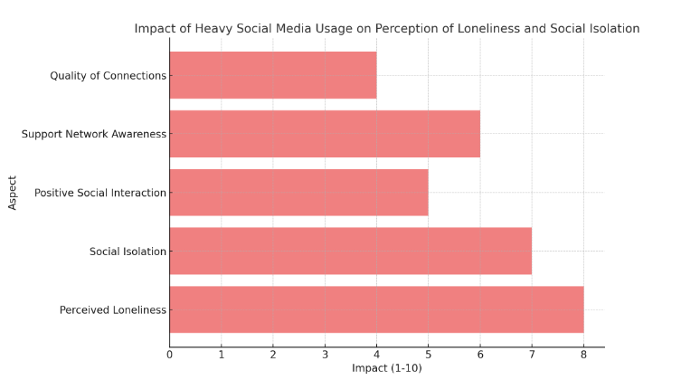

Figure 2.0

The bar graph illustrates the relationship between heavy social media usage and users'perceptions of loneliness and social isolation, focusing on five key aspects:

**Perceived Loneliness (8/10)**: Heavy social media users often report higher levels of perceived loneliness, despite being constantly connected online.

**Social Isolation (7/10)**: While social media allows interaction, it may foster feelings of isolation if users feel less engaged in meaningful, in-person relationships.

**Positive Social Interaction (5/10)**: Heavy users experience a moderate level of positive social interactions, but these may lack depth and emotional fulfillment compared to face-to-face communication.

**Support Network Awareness (6/10)**: Users are more aware of their social support network but may struggle to engage with it effectively, especially if the interactions are superficial.

**Quality of Connections (4/10)**: The quality of connections tends to be lower, with many interactions being fleeting and less emotionally rewarding.

3. How does the use of visual content (e.g., emojis, memes, and videos) on social media platforms impact emotional expression and communication effectiveness?

TABLE: IMPACT OF VISUAL CONTENT ON EMOTIONAL EXPRESSION AND COMMUNICATION EFFECTIVENESS.

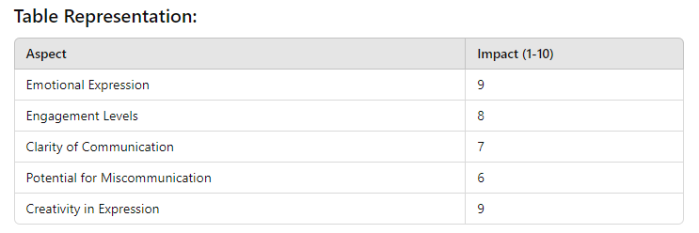

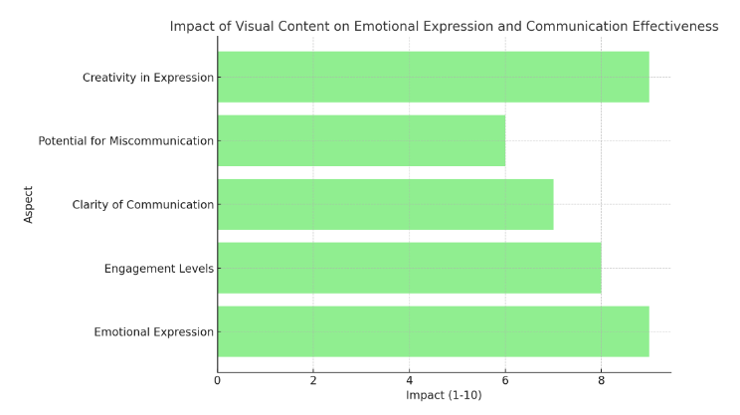

Figure 3.0

The bar graph shows how visual content such as emojis, memes, and videos affects emotional expression and communication effectiveness on social media:

**Emotional Expression (9/10)**: Visual content greatly enhances emotional expression, allowing users to convey feelings more clearly and effectively through symbols like emojis or expressive videos.

**Engagement Levels (8/10)**: The use of visual elements significantly increases user engagement, as people are more likely to interact with content that is visually appealing or entertaining.

**Clarity of Communication (7/10)**: Visual content aids in conveying messages quickly and effectively, though it may lack the nuance of more detailed text-based communication.

**Potential for Miscommunication (6/10)**: While visual aids improve communication, they can also cause misunderstandings, particularly when emojis or memes are interpreted differently across cultures or contexts.

**Creativity in Expression (9/10)**: Visual content fosters high levels of creativity, allowing users to communicate in playful, imaginative ways, often using humor or symbolism.

# FINDINGS

**Enhanced Emotional Expression**

**Visual content significantly enhances emotional expression (9/10)**. Emojis, memes, and videos allow users to convey complex emotions in ways that text alone cannot. The emotional cues embedded in these visuals, like a laughing emoji or a heartfelt video, help users communicate feelings quickly and effectively.

**2. Increased Engagement**

**Engagement levels are highly boosted (8/10)** by visual content. Social media users are more likely to engage with posts that contain visual elements because they are more stimulating and easier to digest than plain text. This increased engagement can lead to more interactive and dynamic communication.

**3. Moderate Clarity in Communication**

**Clarity of communication is moderately improved (7/10)** when using visual content. While images, emojis, and videos can make messages easier to understand at a glance, they do not always provide the full context or depth of meaning that text-based communication can offer.

**4. Risk of Miscommunication**

**There is a potential for miscommunication (6/10)** when relying on visual content. Different interpretations of emojis or cultural contexts can lead to misunderstandings. For instance, an emoji or meme that is humorous to one user may be confusing or offensive to another. This highlights a challenge in ensuring clear, universal communication through visuals.

**5. High Creativity in Expression**

**Creativity in communication is greatly enhanced (9/10)** with visual content. Social media users often use memes, emojis, and videos to express themselves in imaginative and playful ways, making communication more engaging and fun. This creativity can lead to stronger emotional connections and a more personalized interaction experience.

# CONCLUSION

The use of visual content, such as emojis, memes, and videos, significantly impacts emotional expression and communication effectiveness on social media platforms. It enhances users' ability to express emotions more clearly and fosters higher engagement by making interactions visually stimulating and dynamic. However, while visuals can simplify communication and increase creativity, they also introduce potential for miscommunication, as meanings can vary across cultural and personal contexts.

Overall, visual content has revolutionized how users convey emotions and ideas, offering new layers of expression that make communication more engaging and creative. However, careful consideration must be given to context and interpretation to avoid misunderstandings, particularly in diverse, global digital communities.

# SUGGESTIONS

**Encourage Contextual Use of Visuals**: Users should be mindful of the context in which they use emojis, memes, and videos. Given the potential for miscommunication, adding brief explanations or combining visuals with text can enhance clarity and reduce misunderstandings.

**Promote Cross-Cultural Awareness**: Social media platforms should raise awareness about the different meanings that visual content can have across cultures. This could be done through prompts or guides that help users better understand the cultural nuances of emojis and other visual elements.

**Develop More Inclusive Visual Tools**: Platforms could offer a broader range of emojis, memes, and video content that reflect diverse cultures, emotions, and experiences. This would allow for more accurate and inclusive emotional expression among users from different backgrounds.

**Enhance User Education on Visual Communication**: Platforms should provide resources or tips on how to effectively use visual content to communicate emotions and ideas, particularly in professional or sensitive contexts, where the risk of misinterpretation is higher.

**Improve Tools for Feedback and Clarification**: Social media platforms could introduce features that allow users to quickly ask for clarification or offer feedback on ambiguous visual content. This would help reduce the chances of miscommunication and foster clearer, more effective interactions

**Promote a Balance Between Text and Visuals**: Encourage users to combine visuals with written text where appropriate. While visual content enhances engagement and creativity, text-based communication often provides the depth and context needed to ensure clear and accurate messaging.

**Monitor and Manage Misinformation Through Visual Content**: Platforms should develop better tools to detect and manage the spread of misleading or harmful visual content (e.g., manipulated videos or memes) to maintain the integrity of communication.

# FUTURE SCOPE

**1.Advancements in Visual Communication Technology**: As technology evolves, the integration of augmented reality (AR) and virtual reality (VR) could revolutionize the way we use visual content for communication. Future social media platforms may allow users to interact with 3D emojis, avatars, or immersive videos, making emotional expression more vivid and interactive.

**2.AI-Driven Personalization**: Artificial Intelligence (AI) could play a key role in personalizing visual content. Platforms may use AI to suggest emojis, memes, or videos based on a user's communication style or emotional state, making interactions more intuitive and tailored to the individual’s preferences.

**3.Cross-Cultural Visual Standards**: As social media platforms continue to expand globally, there may be a push to standardize the meanings of certain visual elements, like emojis, across cultures. This would help minimize miscommunication and ensure that visual content is interpreted consistently by users worldwide.

**4.**Real-Time Emotion Detection: Future social media platforms might incorporate real-time emotion detection through facial recognition or voice analysis, helping users choose appropriate visual content that aligns with their emotional state, enhancing the accuracy of emotional expression in digital communication.

**5.**Visual Literacy Education: As the use of visual content in communication grows, there will likely be a stronger emphasis on teaching "visual literacy." This includes understanding how to interpret and use visual elements effectively in both personal and professional communication cont

**6.**Integration with Business Communication: As visual content becomes more sophisticated, its use in professional settings could expand. Memes, videos, and emojis might evolve to play a formalized role in corporate communication, customer service, or marketing, requiring new strategies for balancing professionalism with creativity.

**7.Ethical Considerations and Regulation**: The growing impact of visual content in communication may prompt discussions around ethics and regulation. There will likely be a focus on preventing the misuse of visual content, such as the spread of harmful memes or manipulated videos, while also protecting freedom of expression.

**8.Mental Health and Emotional Well-Being**: Future studies may explore how visual content on social media platforms affects users' mental health. Innovations could lead to features designed to promote positive emotional expression, helping mitigate the negative effects of overreliance on social media for emotional validation.

Top of Form

Bottom of Form

# REFERENCES

1.boyd, d. m., & Ellison, N. B. (2007). Social network sites: Definition, history, and scholarship. *Journal of Computer-Mediated Communication*, 13(1), 210-230. <https://doi.org/10.1111/j.1083-6101.2007.00393.x>

2. Seargeant, P., & Tagg, C. (2014). *The language of social media: Identity and community on the internet*. Palgrave Macmillan UK.

3.Kaplan, A. M., & Haenlein**,** M. (2010). Users of the world, unite! The challenges and opportunities of social media. *Business Horizons*, 53(1), 59-68. <https://doi.org/10.1016/j.bushor.2009.09.003>

4. Valkenburg, P. M., & Peter, J. (2009). Social consequences of the Internet for adolescents: A decade of research. *Current Directions in Psychological Science, 18*(1), 1–5. [https://doi.org/10.1111/j.1467-8721.2009.01595.x](https://psycnet.apa.org/doi/10.1111/j.1467-8721.2009.01595.x)

**5.**Mitsch, W. J., Bernal, B., & Hernandez, M. E. (2015). Ecosystem services of wetlands. *International Journal of Biodiversity Science, Ecosystem Services & Management*, 11(1), 1-4. <https://doi.org/10.1080/21513732.2015.1006250>

6.Primack, B. A., Shensa, A., Sidani, J. E., Whaite, E. O., Lin, L. Y., Rosen, D., & Miller, E. (2017). Social media use and perceived social isolation among young adults in the U.S. *American Journal of Preventive Medicine*, 53(1), 1-8. https://doi.org/10.1016/j.amepre.2017.01.010

7.Houghton, R. A., & Nassikas, A. A. **(2017).** Global and regional fluxes of carbon from land use and land cover change 1850–2015. *Global Biogeochemical Cycles*, 31(3), 456-472. https://doi.org/10.1002/2016GB005546