A STUDY ON CUSTOMER SATISFACTION ON ELECTRIC VEHICLES WITH SPECIAL REFERENCE TO POLLACHI TALUK

Dr. K. Kathirvel¹, A. Geethamani²
¹Assistant Professor and Head, Department of Commerce,
Dhavathiru Santhalinga Adigalar Arts and Science College and Tamil College, Perur Coimbatore
²Assistant Professor, Department of Commerce with Professional Accounting,
Pollachi college of arts and science

ABSTRACT
Keywords: Electric vehicles, customer satisfaction, Pollachi Taluk, adoption, charging infrastructure, environmental benefits.
Electric vehicles (EVs) are a promising technology for achieving a sustainable transport sector in the future, due to their very low to zero carbon emissions, low noise, high efficiency, and flexibility in grid operation and integration. In recent years, driven by national policies, new energy automotive market in China was growing explosively, in which battery electric vehicles becomes the main force because of their low emission and high energy efficiency. Customer satisfaction research of product quality characteristic research for electric vehicle is different from the traditional vehicle. The study employs a mixed-methods approach, combining quantitative surveys and qualitative interviews to gather comprehensive insights. A structured questionnaire is administered to a diverse sample of EV users in Pollachi Taluk to collect data on their satisfaction levels, driving patterns, charging infrastructure, and overall ownership experience. E--Vehicle have the potential to promote environmentally friendly urban transportation, and our research suggests ways to encourage their use and adoption.

- INTRODUCTION:

The world is experiencing a significant shift towards sustainable transportation as nations grapple with the pressing need to combat climate change and reduce their carbon footprint. As the demand for sustainable mobility solutions grows, understanding customer satisfaction towards electric vehicles becomes critical in encouraging their widespread adoption. Electric vehicles (EVs) are a type of automobile powered by one or more electric motors, using energy stored in rechargeable batteries instead of traditional internal combustion engines that rely on fossil fuels. At the forefront of this change is Pollachi, a thriving Taluk in Tamil Nadu, India, known for its dynamic culture and economic strength. Pollachi provides a unique environment for researching how customers are responding to electric vehicles as awareness of the need for cleaner transportation options grow. Through an examination of consumer attitudes, perceptions, and preferences about electric vehicles, this research aims to provide light on the variables influencing the adoption of EVs in this urban environment. Consumer behavior and decisions about electric vehicles are expected to be influenced by a variety of factors, including government legislation, infrastructural accessibility, cultural beliefs, economic considerations, and accessibility to charging stations.

1.1 OBJECTIVES OF THE STUDY

The following could be the goals of a study on how Pollachi consumers are responding to electric vehicles:

- The objective of this study is to measure the attributes of electric vehicles that influence consumer attributes towards EVs.

- The consumers attitude and their intent to purchase is also measured in this study This is done in order to explore whether the attributes of EVs have an influence on the attitude towards innovation and whether the attitude of a consumer has an influence on their purchase intent.

- To analyze consumers satisfaction towards electrical vehicles in Pollachi Taluk.

- To know why electric vehicle couldn’t get enough consumer attraction.

- To study the willingness of buyers of considering Electric Vehicles as a practical commuting option and at when.

- To study the maximum price consumers can afford for buying an Electric Vehicles.

1.2 SCOPE OF THE STUDY

- A crucial component of the study's objectives is to identify the variables affecting consumers' acceptance of electric vehicles.

- Examining the effects of cost, incentives, range anxiety, charging infrastructure, and the accessibility of various electric vehicle models are all part of this.

- Data on consumer preferences and willingness to pay for electric vehicles is taken for analysis.

- Pollachi is one of the most rushed regions in Tamilnadu. At a time when rising pollution levels in Pollachi Taluk are causing concerns, city to authorities have started taking measures to step up the push for electric vehicles (EV)

- The Pollachi Taluk will also promote the use of e-autos in the city. Grants given by international agencies for reducing carbon emission will be allotted to a society formed by auto rickshaw owners.

- E-cargo vehicles launched in Pollachi. Electric cargo vehicles will now be used to deliver goods, including vegetables, food, and cooking gas in the city. Eighteen vehicles, including 12 pick-up auto rickshaws, were launched at a function organized by the Pollachi Taluk. The sample of the study is collected from customers focused mainly in Pollachi Taluk.

- The demand for EVs is rising in the rural areas of in and around Pollachi as well. Vehicle dealers say people started to switch to EVs now realizing that the future of the vehicle industry belongs to EVs

- In addition, it is generally easier to build pollution-control systems into centralized power stations than retrofit enormous numbers of cars

- RESEARCH METHODOLOGY

2.1 RESEARCH DESIGN
The descriptive research design is used in this study.

2.1.1 SOURCES OF DATA PRIMARY DATA
Primary Data is collected from the peoples in Pollachi Taluk.

2.1.2 SECONDARY DATA
Secondary Data is collected from books, websites, articles and internet

2.2 REVIEW OF LITERATURE

- Su-Hau et al (2004) focused on the highly efficient energy usage of the battery energy and proposed an integrated management system for electric motor.[2]

- David and Sheng-Chung (2004) proposed new parallel-type hybrid-electric-power system comprises an engine’s energy distribution and a torque-integrated mechanism (specifically
including an engine, a motor/alternator, a CVT device, and PCM as well as a 3-helical gear set).

- Wenguang et al (2005) presented an approach to control powertrain of series hybrid electric

vehicles. A formulation of the system equations and controller design procedure were
proposed by them. They also proposed a new switching algorithm for the power converter for motor torque and motor flux control.

- Daniel (2007) designed, developed and implemented a series hybrid electric vehicle. Though he proposed the architecture as hybrid electric vehicle architecture, he showed that the vehicle runs well in the electric mode and left the hybrid conversion as future expansion.

- Lukic et al (2007) tried to develop a driving cycle of the auto rickshaw in a typical large Indian city, in their case, Delhi. First, they considered the existing driving cycles used in India are considered as candidates. Since these data were not applicable, GPS data collected at various times of the day were applied to the analysis. They derived the new driving cycle from the gathered information via GPS data as well as surveys of auto rickshaw drivers in India, which helped to get the entire picture for the driving cycle.

- John E. Anderson, Moritz Bergfeld, Do Minh Nguyen & Felix Steck (2022) Real-world charging behavior and preferences of electric vehicles users in Germany: The paper and the findings fill the research gap and provide timely and relevant insights on charging behavior and preferences on electric vehicles.

- Mr. S. Chandra Sekhar, Dr. J Murthy, Dr. Shaik Karim, Mr. M. Subramaniam Reddy, Dr.C. Bhupathi (2022) Factors Influencing Customers Buying Behavior: A Study of Electric Vehicles with reference so Tirupati City: The need for the study is to understand the International Journal of Commerce and Management Research www.managejournal.com 123 consumer attitude and the purchase intention of e-vehicles.

2.3 AREA OF STUDY

This study was conducted in Pollachi Taluk.

2.3.1 SAMPLE SIZE
100 respondents residing in Pollachi Taluk were selected for the study.

2.3.2 TOOLS USED FOR ANALYSIS
Data analysis tools are simple percentage.

3. DATA ANALYSIS AND DISCUSSION

3.1 PROFESSION OF THE RESPONDENTS

S.No | Profession | No of Respondents | Percentage %
1 | Student | 21 | 42
2 | Self Employed | 8 | 16
3 | Government Job | 1 | 2
4 | Private Job | 20 | 40
Total |  | 50 | 100

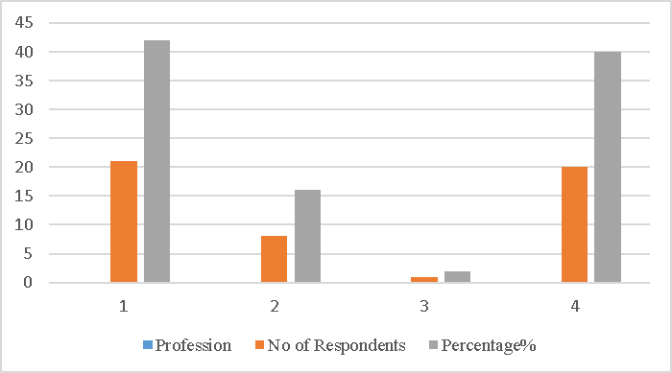

INTERPRETATION

According to the table 3.1, 42% of the respondents was under the student, 16% of the respondents was under the Self Employed, 40% of the respondents was under the Private job and 2% of the respondents was under the Government job.

3.2 GENDER OF THE RESPONDENTS

S.No | Gender | No of Respondents | Percentage %
1 | Male | 35 | 70
2 | Female | 15 | 30
Total |  | 50 | 100

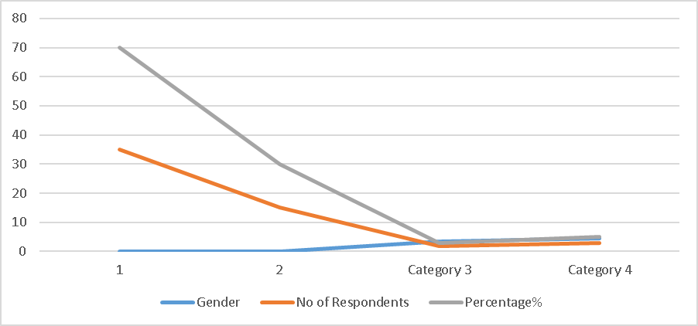

INTERPRETATION
According to the 3.2, 70 percentage of the respondents were Male and 30 percentage of the respondents were Female.

3.3 TABLE SHOWING THE BEST SPEED OF THE ELECTRIC VEHICLE

Age | No of Respondents | Percentage %
20-30 | 10 | 10
30-40 | 58 | 58
40-50 | 26 | 26
50 & above | 06 | 06
TOTAL | 100 | 100

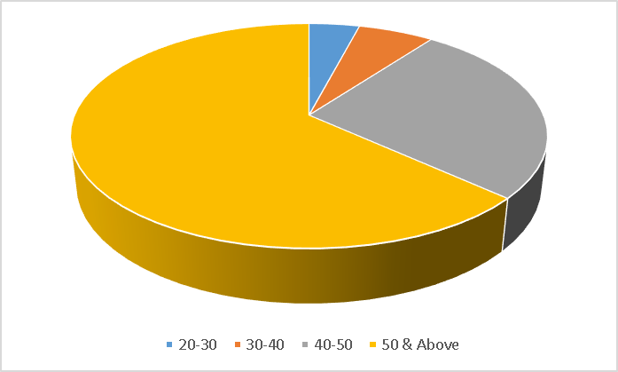

INTERPRETATION:

According to the table 3.3, 10% of the respondents was under the age of 20-30, 58% of the respondents was under the age of 30-40, 26% of the respondents was under the age of 40-50 and 06% of the respondents was 50 & above.

4. FINDING AND CONCLUSION:

FINDINGS:

- The respondents across different age groups. The majority of respondents age of 20-30, 58% of the respondents was under the age of 30-40, 26% of the respondents was under the age of 40-50 and 06% of the respondents was 50 & above.
- Most of the respondents are having their income that lies between of 20K-60K.
- Most of the respondents are using OLA and other brands.
- Most of the respondents they said that, low maintenance factor and Eco-Friendly factors influence them to buy EV.

SUGGESTIONS

- Drive smoothly. Simply put, lead-footed driving will drain your EV’s battery at an accelerated rate
- Slow Down. Try to keep your speed under 60mph whenever possible.
- Reduce or even eliminate your fuel costs. Weekly trips to the gas station to fuel up your car are expensive, especially when the ever-fluctuating price of gasoline is high.
- Reduce emission to help the environment
- It’s better to let the capacity run down to 10 or 20%, then recharge to around 80%.
- Current electric vehicles travel about 250 miles on a charge, though there are some, such as Tesla, that can do about 350 miles on a charge.

5. CONCLUSION

The process that the electric vehicle industry has seen in recent years is not only extremely welcomed, But highly necessary in light of the increasing global greenhouse gas levels. As and environment analysis sections of this webpage, the benefits of electric vehicles far surpass the costs. The biggest obstacle to the widespread adoption of electric – powered transportation is cost related, as gasoline and the vehicles that run on it are readily available, convenient, and less costly. Each person can make a difference, so go electric and help make a difference. Availability and accessibility of charging stations play a crucial role in determining customer satisfaction with EVs. If there was an increase in the number of charging stations and their ease of use, it could imply higher satisfaction levels. If Pollachi Taluk residents were increasingly concerned about environmental issues and were choosing EVs as an eco-friendlier option, it might indicate a higher level of satisfaction with EVs.Positive feedback about the range of EVs and their overall performance, including factors like acceleration, handling, and comfort, could contribute to customer satisfaction.

BIBLIOGRAPHY

- John E Anderson, Moritz Bergfeld, Do Minh Nguyen, Felix Steck. Real-world charging behavior and preferences of electric vehicles users in Germany: The paper and the findings fill the research gap and provide timely and relevant insights on charging behavior and preferences on electric vehicles, 2022.

- Battery technology handbook. Edited by H. A. Kiehne. New York, M. Dekker, c1989. 519 p. (Electrical engineering and electronics, no. 60

- Electric vehicle design and development. Warrendale, Pa., Society of Automotive Engineers, c1991. 116 p. (SP-862)

- International Congress and Exposition, Detroit, Michigan, Feb. 25-Mar. 1, 1991.

- Woods, Clinton Edgar. The electric automobile. Chicago, New York, H. S. Stone, 1900. 177 p

