**Morphometric analysis of the Hatni River Basin Drainage system and its Sub Basins, Western Part of Madhya Pradesh.**

**Tarun Rathore1**

1Research Scholar, School of Studies in Earth Science, Vikram University, Ujjain, Madhya Pradesh

**ABSTRACT**

The Narmada River valley and its surrounding area are tectonically active. Three large zone of fracture like the Rakhabdev, Jaisalmer-Barwani, and Dhar lineaments are mainly inclined toward The Narmada Valley. A morphometric analysis was done of Hatni River Basin drainage characteristics to using digital elevation data (DEM) and other maps. Hatni River Basin was divided into fifty-eight sub- basins (Sb1-Sb58). Lower-order streams dominate the Hatni River Basin, with the drainage pattern primarily shaped by relief and structural features. The basin's morphometry highlights the significant influence of climate on its drainage characteristics. and the significance of morphometric analysis on the hydrologic characteristic is discussed. Different Lineament (Rakhabdev, Jaisalmer-Barwani NW-SE) significantly mainly affect the drainage characteristics. The tectonic influence on the evolution of the Hatni River Basin is indicated by the unusual behaviour of the different parameters.

**Keywords:** DEM, Rakhabdev Lineament, Jaisalmer Barwani Lineament, Dhar Lineament, GIS, Tectonics, Morphometry Analysis, Drainage Basin

* **INTRODUCTION**

One of the key challenges in hydrology is linking a drainage basin's hydrological characteristics with its morphology, soils, and vegetation, which is a complex task. Factors like geological structure are difficult to quantify, while soils and morphology require multiple quantitative factors for analysis. Remote sensing is a practical approach for morphometric studies, offering a broad view of large areas through satellite imagery, making it highly effective in drainage basin analysis (Horton, 1932; Lillesand et al., 2015; Zhou et al., 2017). This method is more efficient than traditional data processing due to advances in spatial information technology and remote sensing, GIS, and GPS offer powerful tools to address most land and water resource planning and management issues. The present study aims at using open-source GIS technology and ISRO remote sensing data to compute different parameters of morphometric characteristics of the Hatni River Basin. The pattern of drainage system is clearly indicated Hatni River Basin area are tectonically structure controlled.

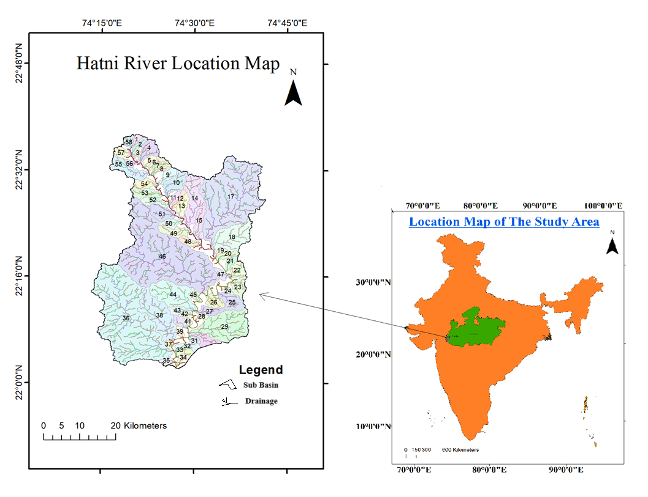

**Figure 1:** Pycnometer Test Procedure.

* **METHODOLOGY**

The methodology for morphometric analysis using remote sensing data and GIS involves several key steps that facilitate the assessment of landform characteristics. Initially, high-resolution satellite imagery and Digital Elevation Models (DEMs, 30 m) are acquired from sources such as Landsat or Sentinel satellites, Cartosat providing crucial topographic information (Lillesand et al., 2015). Topographic information data toposheet no. 46J/2, 46J/3, 46J/4, 46J/6, 46J/7, 46J/8,46J/10, 46J/11 and 46J/12 are obtained from the Survey of India (SOI) government online mapping platform. After data acquisition, preprocessing steps like geometric corrections are applied to ensure accuracy, followed by smoothing DEMs to eliminate noise. Subsequently, morphometric parameters such as slope, aspect, and contour lines are extracted from the DEM, allowing for detailed terrain analysis (Zhou et al., 2017; Vishwanath, 1963-1964; Brierley, 2005; Easterbrook, 1999). GIS software like QGIS, Google Earth Pro, and ArcMap (10.5) is then utilized to integrate various data layers, performing spatial analyses to compute morphometric indices like the Relief Ratio and Circularity Ratio. Visualization tools enable the creation of informative maps and 3D models, enhancing data interpretation. Finally, results are contextualized within geological and environmental frameworks, culminating in a comprehensive report of methodologies and findings. This integrated approach not only deepens the understanding of landforms but also aids in applications related to hydrology, tectonic, urban planning, and environmental management.

Study area: Hatni River Basin is situated in Northen part of lower Narmada River. Approx 2008 Squar Km. area are covered by Hatni River Basin with 58 Sub Basin in different sizes on the location of (22 40 0 N, 74 10 0 E and 22 00 0 N, 74 45 0 E).

Geology: The study area is important for different branches in geology like Tectonics, Paleobiology, Structure Geology, Sedimentology, Mining Gelogy etc. Major lineaments are easily identified like Rakhabdev, Jaisalmer-Barwani, and Dhar lineaments to Hatni River is structure controlled and Narmada Rift Zone are significant to important in active tectonic study. The region is part of the southeastern extension of the Archaean formations of Rajasthan, which are unconformably overlain by Cretaceous sedimentary deposits. Most of the area covered by Sheet 46 J/7 consists of granites, along with rocks like dolomitic marble and granulites. The area included in Sheet 46 J/11 is dominated by chlorite and other schists, granites, associated gneisses, and sedimentary formations (Bagh beds) and southern part of basin are covered by daccan trap. Gneisses, dolomitic marbles and chlorite schist-occurring in the area show strike of N.65° W - S 65°E. The schists show vertical dips and the foliation planes in the gneisses, wherever developed, are almost vertical. The dolomitic marbles forming parallel bands, show dips varying from 25°-30° towards N.E. and at places they are vertical. The dolomtic rabbles are folded into minor anticlines with, minor plunges in NNW/SSE. directions. West of Kusalwai (22°15'30":74°26'00") a vein of pegmatite of 2 - 3 m. wide is seen to be crushed. The vein trends in NE – SW direction and is vertical. The surface of the outcrop is fractured and rods of quartz are noted along the fracture planes. The gneisses in the area are foliated and are crushed at the contact of the intrusive granite. At places they are highly friable and crumple into powder (Vishwanath, 1963-1964; Thornbury, 1969; Strahler, 1952).

|  |  |  |
| --- | --- | --- |
| Table 1 Succession of Hatni River Basin after [4] | | |
| Eon/ Period | Formation | Rock Type |
| Cretaceous | Bagh Beds | Calcareous and gritty  sandstones and calcareous  shales (containing fossils at  places). |
| Archaeans |  | Conglomerates |
| Dolerite |
| Migmatites |
| Quartz veins. |
| Pegmatite. |
| Amphibolite |
| Garnetiferous granulite |
| Chlorite schist |
| Dolomitic marbles |
| Gneisses with, intrusive  granites. |

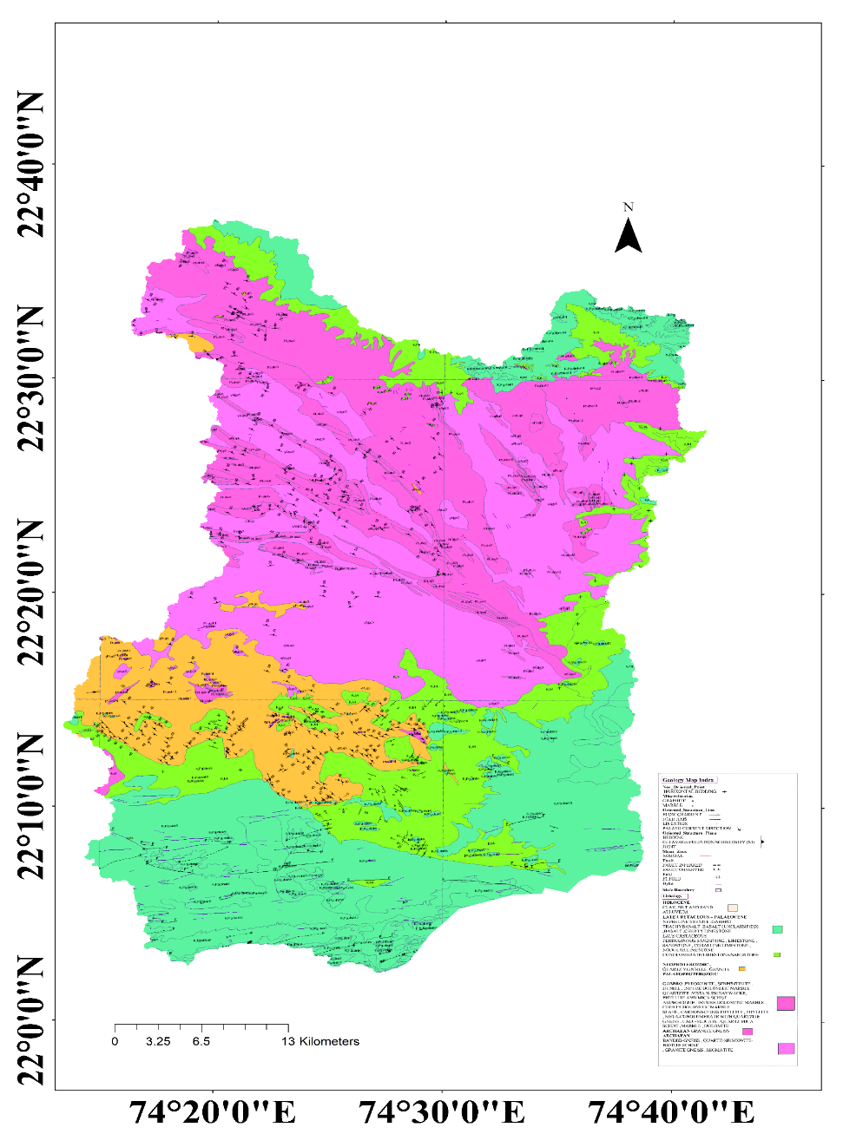

**Figure 2:** Hatni River Basin Area Geology

Topographic maps from the Survey of India (1:50,000 scale) and digital elevation data from Cartosat were utilized for delineating the drainage pattern of the Hatni River Basin. The analysis followed methodologies by (Horton, 1945; Strahler, 1964). The morphometric parameters were classified into three categories: relief aspects linear and areal (Table 1).

1. **RESULTS AND DISCUSSION**

**4.1 Sub Drainage Pattern:** A drainage pattern refers to the spatial arrangement of rivers, streams, and their tributaries as they flow across a landscape. These patterns are shaped by topography, geology, and structural features such as faults, folds, and rock types. Drainage patterns can provide key insights into the underlying geological structures of a region. For example, dendritic patterns, resembling tree branches, these forms develop in areas characterized by consistent rock types and gentle slopes, allowing water to flow freely in various directions.In contrast, rectangular patterns are influenced by faulted or fractured rock, causing streams to follow the fault lines in right-angle turns (Brierley, 2005; Hack, 2010; Melton, 1957; Montgomery, 1988]. The relationship between drainage patterns and geological structures is significant. Structural features often direct water flow, creating specific patterns. Radial drainage patterns generally form around volcanic cones or domes, with streams flowing outward from a central elevated area (Easterbrook, 1999; Morisawa, 1985; Strahler, 1957; Horton, 1945). Trellis patterns develop in areas of folded terrain with alternating resistant and non-resistant rock layers, such as in mountainous regions. These streams align along valleys formed by softer rock and are intercepted by short tributaries draining from the resistant ridges (Thornbury, 1969; Montgomery, 1988; Hack, 1973).

The Hatni River Basin shows how many kinds of drainage systems have developed. The following describes the typical drainage patterns found in the region.

Table 2

|  |  |  |  |
| --- | --- | --- | --- |
| Drainage Pattern | Description | Significance | Reference |
| Sub Dendritic | Tree-like, branching pattern; formed on homogenous materials. | The streams that follow have horizontally extending tributaries. the uniformly constituted rocks with minimal structural control. | (Strahler, 1952) |
| Trellis | Parallel main streams with short tributaries; occurs in folded topography. | Reflects geological structure; useful for understanding tectonic activity. | (Raghunath, 1987) |
| Radial | Streams radiate outward from a central point, such as a volcano. | Indicates volcanic or dome-like structures; important for hazard assessment. | (Hack, 1957) |
| Rectangular | Features right-angle bends; develops in jointed or fractured rock. | Suggests structural control of the landscape; significant for understanding geological history. | (Melton, 1957 |
| Annular | Circular pattern formed around a dome or basin. | Indicates erosion around a central uplift; useful for reconstructing geological history. | (Montgomery, 1988) |
| Sub Parallel | Streams run parallel to each other, often on steep slopes. | Suggests rapid erosion and active geological processes; important for slope stability assessments. | (Morisawa, 1985) |

* **Sub-dendritic pattern**: The initial pattern of the lower-order streams in the Hatni River Basin is sub-dendritic, as illustrated in (Fig. 3B). But higher-order streams flow in a straight course with compressed meanders. The streams that follow have horizontally extending tributaries. the uniformly constituted rocks with minimal structural control (Schumm, 1956; Gregory et al. 1968; Phillips et al., 1987). The sub dendritic pattern is consistent with the lithological characteristics of the Hatni River Basin Basin and suggests the underlying homogenous resistant rock with a mild slope. (Fig. 2) and slope map (Fig. 4).
* **Subparallel pattern**: The Hatni River Basin's regional slope runs north-south. Where the slope is gentle, the higher order streams in Fig. 3A exhibit a subparallel pattern with straight course, contorted, and compressed meander streams, respectively. When streams run in a parallel fracture zone on a gentle slope, sub-parallel drainage patterns can occur. Fracture control is further supported by the higher-order streams' straight paths (; Gregory et al. 1968; Phillips et al., 1987).
* **Trellis pattern:** The trellis pattern in the Hatni River Basin is depicted in Fig. 3F and 3E, where Fig. 3F aligns with the trends of the Rakhabdev and Jaisalmer-Barwani lineaments. These lineaments act as main channels, with smaller drainages converging and flowing through the depression they create.
* **Angulate pattern:** The region is defined by multiple fracture sets that influence the drainage patterns. As the drainage aligns with successive fractures, it ultimately forms an angular pattern (Fig. 3D). Rectangular patterns: Rectangular drainage patterns are significant and occur in areas where the bedrock is highly jointed or faulted. (3C and 3D) This pattern is common in areas where there are extensive tectonic activities, and it helps in identifying regions of structural weakness. These areas can be prone to earthquakes, landslides, and other geological hazards. The rectangular drainage pattern provides valuable information about the geological structure of an area. It points to the presence of fractured or faulted rock systems beneath the surface, indicating tectonic activity or the existence of hard rocks like basalt, granite or gneiss.
* **Radial pattern:** Radial drainage pattern is a significant type of pattern that typically occurs around a central elevated point, such as a mountain, volcanic cone, or dome (3C and 3E). In this pattern, streams radiate outward from the centre, resembling the spokes of a wheel. This unique pattern provides insights into the geological structure and evolution of the landscape. In morphometry, this pattern suggests a young geological feature or a region that has undergone tectonic uplift. The pattern is often associated with landscapes that are undergoing rapid changes.

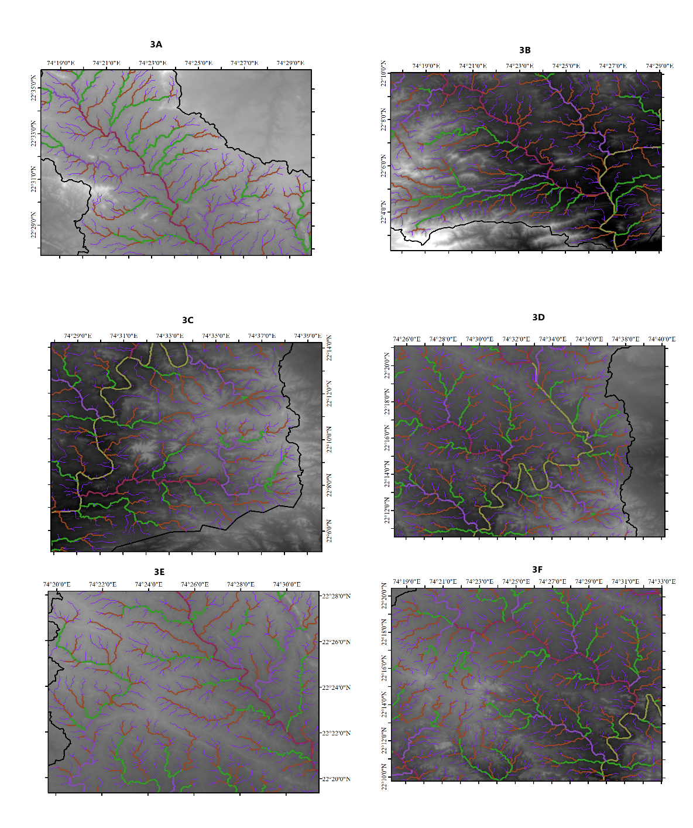

Fig 3 3A Sub Parallel, 3B Sub Dendritic, 3C Rectangular, 3D Angular,3E Radial, 3F Trellis

* 1. **Stream order (SU)**

In geomorphometric analysis of a drainage basin, the ordering of the drainage system is a fundamental step. The stream ordering method developed by Strahler (Strahler, 1957; Reddy et al., 2004; Yadav et al., 2014; Gregory et al., 1973) is commonly applied for this purpose. Stream order defines both the size and position of streams within the drainage network. The smallest and least branched streams are classified as first-order streams. When two first-order streams merge, they form a second-order stream; similarly, two second-order streams combine to create a third-order stream, with this pattern continuing for higher orders. Horton’s first law of stream numbers (Strahler, 1964; Schumm, 1963; Mesa, 2006) states that there is an inverse geometric relationship between stream order. This means that as the stream order increases, the number of streams decreases. When this relationship is represented on a semi-logarithmic graph, it typically appears as a straight line. In the Hatni River Basin, the highest stream order reaches 6, while the maximum stream order for sub-basins ranges from 2 to 5 (Table 3A, 3B, 3C, 3D).

* 1. **Bifurcation ratio (RB)**

The bifurcation ratio (RB) measures the branching pattern of a river network and is calculated by the ratio of the number of streams of a specific order (NU) to the number of streams in the subsequent higher order (NU+1). RB offers valuable insights into the complexity of the terrain. For flat landscapes, RB values are generally ≤ 2, while rolling plains typically have RB values between 2 and 3. Values ranging from 3 to 4 indicate a transition from rolling plains to hilly, dissected terrain, and RB values exceeding 4 suggest mountainous or highly dissected regions (Horton, 1945; Clark et al., 2004; Srinivasa, 2011). Strahler (Strahler, 1957; Singh, 1964-1965] notes that RB is a "useful, dimensionless, and highly stable measure" that usually shows a limited range of variation across various regions or environments, except where geological structures have a strong influence on drainage patterns. The Rb of Hatni River Basin is 5.07 and that of the sub-basins varies between 2.25 (Sb 11) and 10 (Sb 39) (Table 3A,3C), Sub basins between stream orders suggest the influence of geology, relief on drainage branching and structural control. due to highly dissected topography higher values possible.

Table 3 (A)

|  |  |  |  |  |  |  |  |  |  |  |  |  |  |  |  |
| --- | --- | --- | --- | --- | --- | --- | --- | --- | --- | --- | --- | --- | --- | --- | --- |
| Parameters | Sb1 | Sb2 | Sb3 | Sb4 | Sb5 | Sb6 | Sb7 | Sb8 | Sb9 | Sb10 | Sb11 | Sb12 | Sb13 | Sb14 | Sb15 |
| Nu | 3 | 3 | 2 | 4 | 3 | 3 | 3 | 3 | 3 | 4 | 3 | 2 | 4 | 4 | 3 |
| P | 11.64 | 15.83 | 10.32 | 23.68 | 15.67 | 15.67 | 17.01 | 13.77 | 17.95 | 29.93 | 13.22 | 17.11 | 19.94 | 47.79 | 25.64 |
| Lb | 4.38 | 6.32 | 4.01 | 7.51 | 4.47 | 5.66 | 6.07 | 5.43 | 6.52 | 9.15 | 5.09 | 6.66 | 7.29 | 14.61 | 9.89 |
| N1 | 7 | 12 | 5 | 33 | 8 | 11 | 9 | 8 | 13 | 44 | 5 | 9 | 26 | 86 | 28 |
| N2 | 2 | 3 | 1 | 9 | 2 | 3 | 2 | 2 | 3 | 8 | 2 | 1 | 5 | 18 | 6 |
| N3 | 1 | 1 | - | 2 | 1 | 1 | 1 | 1 | 1 | 3 | 1 | - | 2 | 4 | 1 |
| N4 | - | - | - | 1 | - | - | - | - | - | 1 | - | - | 1 | 1 | - |
| N5 | - | - | - | - | - | - | - | - | - | - | - | - | - | - | - |
| N6 | - | - | - | - | - | - | - | - | - | - | - | - | - | - | - |
| NT | 10 | 16 | 6 | 45 | 11 | 15 | 12 | 11 | 17 | 56 | 8 | 10 | 34 | 109 | 35 |
| T1 mean stream length | 0.84 | 0.38 | 0.30 | 0.52 | 0.61 | 0.45 | 3.94 | 0.41 | 01.00 | 0.54 | 1.44 | 0.50 | 0.49 | 0.56 | 0.63 |
| T2 | 0.51 | 0.79 | 3.24 | 1.11 | 1.73 | 0.48 | 3.07 | 1.27 | 1.96 | 1.30 | 0.47 | 6.12 | 0.60 | 1.34 | 0.69 |
| T3 | 2.28 | 4.71 | - | 5.71 | 2.38 | 4.75 | 1.50 | 3.39 | 3.80 | 1.88 | 2.41 | - | 0.14 | 2.88 | 7.9 |
| T4 | - | - | - | 0.52 | - | - | - | - | - | 7.31 | - | - | 4.02 | 11.57 | - |
| T5 | - | - | - | - | - | - | - | - | - | - | - | - | - | - | - |
| T6 |  | - | - | - |  | - | - | - | - | - | - | - | - | - | - |
| LT1 | 5.90 | 4.62 | 1.52 | 17.45 | 4.93 | 5.01 | 3.79 | 3.34 | 13.04 | 24.15 | 7.22 | 4.58 | 12.91 | 48.26 | 17.71 |
| LT2 | 1.02 | 2.38 | 3.24 | 10.01 | 3.47 | 1.44 | 3.32 | 2.55 | 5.88 | 10.45 | 0.95 | 6.12 | 3.04 | 24.28 | 4.14 |
| LT3 | 2.28 | 4.71 | - | 11.43 | 2.38 | 4.75 | 5.10 | 3.39 | 3.80 | 5.65 | 2.41 | - | 0.28 | 11.54 | 7.91 |
| LT4 | - | - | - | 0.52 | - | - | - | - | - | 7.31 | - | - | 4.02 | 11.57 |  |
| LT5 | - | - | - | - | - | - | - | - | - | - | - | - | - | - |  |
| LT6 | - | - | - | - | - | - | - | - | - | - | - | - | - | - |  |
| LT | 9.20 | 11.71 | 4.76 | 39.41 | 10.78 | 11.20 | 12.21 | 9.28 | 22.72 | 47.56 | 10.68 | 10.70 | 20.25 | 95.65 | 29.77 |
| Rb1-2 | 3.5 | 4 | 5 | 3.66 | 4 | 3.66 | 4.5 | 4 | 4.33 | 5.5 | 2.5 | 9 | 5.2 | 4.7 | 4.6 |
| Rb2-3 | 2 | 3 | - | 4.5 | 2 | 3 | 2 | 2 | 3 | 2.66 | 2 | - | 2.5 | 4.5 | 6 |
| Rb3-4 | - | - | - | 2 | - | - | - | - | - | 3 | - | - | 2 | 4 | 5.33 |
| Rb4-5 | - | - | - | - | - | - | - | - | - | - | - | - | - | - | - |
| Rb5-6 | - | - | - | - | - | - | - | - | - | - | - | - | - | - | - |
| Rb | 2.75 | 3.90 | 5 | 3.38 | 3 | 3.33 | 3.25 | 3 | 3.66 | 3.72 | 2.25 | 9 | 3.23 | 4.42 | 5.33 |
| Rl2-1 | 0.60 | 2.06 | 10.63 | 2.10 | 2.81 | 1.06 | 3.94 | 3.05 | 2.25 | 2.38 | 0.33 | 12.01 | 1.22 | 2.40 | 1.09 |
| Rl3-2 | 0.47 | 5.92 | - | 5.13 | 1.36 | 9.82 | 3.07 | 2.65 | 0.48 | 1.44 | 5.05 | - | 0.23 | 2.13 | 11.45 |
| Rl4-3 | - | - | - | 0.09 | - | - |  |  | 1.02 | 3.88 | - | - | 28.22 | 4.00 | - |
| Rl5-4 | - | - | - | - | - | - | - | - | - | - | - | - | - | - | - |
| Rl6-5 | - | - | - | - | - | - | - | - | - | - | - | - | - | - |  |
| Rl | 2.54 | 3.99 | 10.63 | 2.44 | 2.09 | 5.44 | 3.50 | 2.85 | 2.03 | 2.76 | 2.69 | 12.01 | 9.89 | 2.85 | 6.27 |

Table 3 (B)

|  |  |  |  |  |  |  |  |  |  |  |  |  |  |  |  |
| --- | --- | --- | --- | --- | --- | --- | --- | --- | --- | --- | --- | --- | --- | --- | --- |
| Parameters | Sb16 | Sb17 | Sb18 | Sb19 | Sb20 | Sb21 | Sb22 | Sb23 | Sb24 | Sb25 | Sb26 | Sb27 | Sb28 | Sb29 | Sb30 |
| Nu | 2 | 5 | 4 | 2 | 3 | 3 | 4 | 3 | 3 | 4 | 3 | 3 | 2 | 5 | 3 |
| P | 7.00 | 94.29 | 46.05 | 12.08 | 18.29 | 15.50 | 18.77 | 22.60 | 9.38 | 25.59 | 18.82 | 22.83 | 10.58 | 52.91 | 25.68 |
| Lb | 2.14 | 26.09 | 14.33 | 4.01 | 6.14 | 5.34 | 4.96 | 5.82 | 3.26 | 8.55 | 6.15 | 8.55 | 4.03 | 17.55 | 9.16 |
| N1 | 4 | 406 | 95 | 3 | 15 | 12 | 23 | 27 | 7 | 58 | 23 | 20 | 5 | 148 | 20 |
| N2 | 1 | 99 | 14 | 1 | 2 | 3 | 5 | 6 | 2 | 10 | 4 | 4 | 1 | 29 | 4 |
| N3 | - | 18 | 2 | - | 1 | 1 | 2 | 1 | 1 | 2 | 1 | 1 | - | 7 | 1 |
| N4 | - | 5 | 1 | - | - | - | 1 | - | - | 1 | - | - | - | 1 | - |
| N5 | - | 1 | - | - | - | - | - | - | - | - | - | - | - | - | - |
| N6 | - | - | - | - | - | - | - | - | - | - | - | - | - | - | - |
| NT | 5 | 529 | 112 | 4 | 18 | 16 | 31 | 34 | 10 | 71 | 28 | 25 | 6 | 185 | 25 |
| T1 mean stream length | 0.65 | 0.56 | 0.61 | 1.53 | 0.59 | 0.58 | 0.52 | 0.63 | 0.39 | 0.38 | 0.38 | 0.64 | 0.52 | 0.61 | 0.69 |
| T2 | 1.94 | 1.17 | 2.35 | 2.18 | 2.07 | 0.87 | 1.29 | 1.70 | 1.42 | 1.31 | 2.81 | 1.58 | 3.72 | 1.23 | 1.88 |
| T3 | - | 3.82 | 3.28 | - | 2.57 | 3.12 | 3.17 | 3.38 | 0.52 | 0.42 | 3.19 | 5.56 | - | 3.38 | 7.03 |
| T4 | - | 1.35 | 9.41 | - | - | - | 0.62 | - | - | 6.98 | - | - | - | 19.67 | - |
| T5 | - | 5.05 | - | - | - | - | - | - | - | - | - | - | - | - | - |
| T6 | - | - | - | - | - | - | - | - | - | - | - | - | - | - | - |
| LT1 | 2.62 | 230.94 | 58.12 | 4.60 | 8.89 | 6.99 | 12.11 | 17.01 | 2.78 | 22.28 | 8.78 | 12.86 | 2.60 | 90.72 | 13.82 |
| LT2 | 1.94 | 116.03 | 33.00 | 2.18 | 4.15 | 2.62 | 6.46 | 10.21 | 2.84 | 13.16 | 11.24 | 6.35 | 3.72 | 35.84 | 7.52 |
| LT3 | - | 68.92 | 6.56 | - | 2.57 | 3.12 | 6.35 | 3.38 | 0.52 | 0.85 | 3.19 | 5.56 | - | 23.72 | 7.03 |
| LT4 | - | 25.62 | 9.41 | - | - | - | 0.62 | - | - | 6.98 | - | - | - | 19.67 | - |
| LT5 | - | 26.22 | - | - | - | - | - | - | - | - | - | - | - | - | - |
| LT6 | - | - | - | - | - | - | - | - | - | - | - | - | - | - | - |
| LT | 4.56 | 468.03 | 107.19 | 6.79 | 15.62 | 12.74 | 25.56 | 30.61 | 6.16 | 43.29 | 23.22 | 24.78 | 6.33 | 169.97 | 28.38 |
| Rb1-2 | 4 | 4.10 | 6.78 | 3 | 7.5 | 4 | 4.6 | 4.5 | 3.5 | 5.8 | 5.75 | 5 | 5 | 5.1 | 5 |
| Rb2-3 | - | 5.5 | 7 | - | 2 | 3 | 2.5 | 6 | 2 | 5 | 4 | 4 | - | 4.14 | 4 |
| Rb3-4 | - | 3.6 | 2 | - | - | - | 2 | - | - | 2 | - | - | - | 7.00 | - |
| Rb4-5 | - | 5 | - | - | - | - | - | - | - | - | - | - | - | - | - |
| Rb5-6 | - | - | - | - | - | - | - | - | - | - | - | - | - | - | - |
| Rb | 4 | 4.55 | 5.26 | 3 | 4.25 | 3.5 | 3.03 | 5.25 | 2.75 | 4.26 | 4.87 | 4.5 | 5 | 5.41 | 4.5 |
| Rl2-1 | 2.96 | 2.06 | 3.85 | 1.42 | 3.50 | 1.49 | 2.45 | 2.70 | 3.56 | 3.42 | 7.36 | 2.46 | 7.14 | 2.01 | 2.72 |
| Rl3-2 | - | 3.26 | 1.39 | - | 1.24 | 3.57 | 2.45 | 1.99 | 0.37 | 0.32 | 1.13 | 3.50 | - | 2.74 | 3.73 |
| Rl4-3 | - | 1.35 | 2.86 | - | - | - | 0.19 | - | - | 16.42 | - | - | - | 5.80 | - |
| Rl5-4 | - | 5.05 | - | - | - | - | - | - | - | - | - | - | - | - | - |
| Rl6-5 | - | - | - | - | - | - | - | - | - | - | - | - | - | - | - |
| Rl | 2.96 | 2.93 | 2.70 | 1.42 | 2.37 | 2.53 | 1.70 | 2.34 | 1.96 | 6.72 | 2.13 | 2.98 | 7.14 | 3.52 | 3.22 |

Table 3 (C)

|  |  |  |  |  |  |  |  |  |  |  |  |  |  |  |  |
| --- | --- | --- | --- | --- | --- | --- | --- | --- | --- | --- | --- | --- | --- | --- | --- |
| Parameters | Sb31 | Sb32 | Sb33 | Sb34 | Sb35 | Sb36 | Sb37 | Sb38 | Sb39 | Sb40 | Sb41 | Sb42 | Sb43 | Sb44 | Sb45 |
| Nu | 3 | 3 | 3 | 3 | 2 | 5 | 3 | 4 | 2 | 3 | 2 | 3 | 3 | 4 | 3 |
| P | 10.05 | 21.50 | 14.75 | 12.22 | 10.93 | 113.64 | 8.23 | 57.25 | 11.87 | 16.22 | 9.66 | 11.54 | 18.83 | 46.15 | 12.54 |
| Lb | 3.65 | 7.14 | 5.12 | 4.76 | 4.35 | 31.37 | 2.61 | 16.59 | 3.38 | 5.65 | 3.01 | 4.09 | 7.19 | 14.10 | 4.16 |
| N1 | 8 | 13 | 13 | 6 | 6 | 520 | 7 | 122 | 10 | 16 | 6 | 7 | 17 | 99 | 7 |
| N2 | 3 | 2 | 4 | 2 | 1 | 120 | 2 | 26 | 1 | 3 | 1 | 2 | 4 | 22 | 2 |
| N3 | 1 | 1 | 1- | 1 | - | 27 | 1 | 3 | - | 1 | - | 1 | 1 | 4 | 1 |
| N4 | - | - | - | - | - | 6 | - | 1 | - | - | - | - | - | 1 | - |
| N5 | - | - | - | - | - | 1 | - | - | - | - | - | - | - | - | - |
| N6 | - | - | - | - | - | - | - | - | - | - | - | - | - | - | - |
| NT | 12 | 16 | 18 | 9 | 7 | 674 | 10 | 152 | 11 | 20 | 7 | 10 | 22 | 126 | 10 |
| T1 mean stream length | 0.40 | 0.78 | 0.74 | 0.47 | 0.66 | 0.56 | 0.69 | 0.61 | 0.42 | 068 | 0.39 | 0.66 | 00.45 | 0.63 | 0.46 |
| T2 | 0.54 | 1.52 | 1.24 | 1.37 | 2.75 | 1.35 | 1.66 | 1.72 | 3.44 | 0.63 | 2.98 | 1.68 | 1.13 | 1.28 | 1.86 |
| T3 | 2.39 | 3.62 | 3.60 | 2.95 | - | 3.11 | 0.00 | 4.11 | - | 4.45 | - | 0.62 | 5.33 | 3.80 | 1.96 |
| T4 | - | - | - | - | - | 7.51 | - | 9.62 | - | - | - | - | - | 10.30 | - |
| T5 | - | - | - | - | - | 28.11 | - | - | - | - | - | - | - | - | - |
| T6 |  | - | - | - | - | - | - | - | - | - | - | - | - | - | - |
| LT1 | 3.22 | 10.22 | 9.67 | 2.82 | 4.01 | 294.56 | 4.85 | 74.68 | 4.29 | 11.01 | 2.38 | 4.68 | 7.69 | 62.60 | 3.27 |
| LT2 | 1.63 | 3.10 | 4.99 | 2.74 | 2.75 | 162.30 | 3.32 | 44.76 | 3.44 | 1.91 | 2.98 | 3.36 | 4.54 | 28.21 | 3.73 |
| LT3 | 2.39 | 5.62 | 3.60 | 2.95 | - | 84.06 | 0.001 | 12.34 | - | 4.45 | - | 0.62 | 5.33 | 15.23 | 1.96 |
| LT4 | - | - | - | - | - | 45.09 | - | 9.62 | - | - | - | - | - | 10.30 | - |
| LT5 | - | - | - | - | - | 28.11 | - | - | - | - | - | - | - | - | - |
| LT6 | - | - | - | - | - | - | - | - | - | - | - | - | - | - | - |
| LT | 7.25 | 18.94 | 18.27 | 8.52 | 6.77 | 614.13 | 8.18 | 141.41 | 7.73 | 17.38 | 5.36 | 8.68 | 17.56 | 116.35 | 8.97 |
| Rb1-2 | 2.66 | 6.5 | 3.25 | 3 | 6 | 4.33 | 3.5 | 4.69 | 10 | 5.33 | 6 | 3.5 | 4.25 | 4.5 | 3.5 |
| Rb2-3 | 3 | 2 | 4 | 2 | - | 4.44 | 2 | 8.66 | - | 3 | - | 2 | 4 | 5.5 | 2 |
| Rb3-4 | - | - | - | - | - | 4.5 | - | 3 | - | - | - | - | - | 4 | 2.75 |
| Rb4-5 | - | - | - | - | - | 6 | - | - | - | - | - | - | - | - | - |
| Rb5-6 | - | - | - | - | - | - | - | - | - | - | - | - | - | - | - |
| Rb | 2.83 | 4.25 | 3.62 | 2.5 | 6 | 4.81 | 2.75 | 5.45 | 10 | 4.16 | 6 | 2.75 | 4.12 | 4.66 | 2.75 |
| Rl2-1 | 1.35 | 1.97 | 1.67 | 2.91 | 4.11 | 2.38 | 2.39 | 2.81 | 8.01 | 0.92 | 7.51 | 2.51 | 2.51 | 2.02 | 3.98 |
| Rl3-2 | 4.39 | 3.62 | 2.89 | 2.15 | - | 2.30 | 0.0007 | 2.38 | - | 6.95 | - | 0.37 | 4.69 | 2.97 | 1.05 |
| Rl4-3 | - | - | - | - | - | 2.41 | - | 2.33 | - | - | - | - | - | 2.70 | - |
| Rl5-4 | - | - | - |  | - | 3.74 | - | - | - | - | - | - | - | - | - |
| Rl6-5 | - | - | - | - | - | - | - | - | - | - | - | - | - | - | - |
| Rl | 2.87 | 2.79 | 2.28 | 2.53 | 4.11 | 2.71 | 1.19 | 2.51 | 8.01 | 3.94 | 7.51 | 1.44 | 3.60 | 2.56 | 2.51 |

Table 3 (D)

|  |  |  |  |  |  |  |  |  |  |  |  |  |  |  |
| --- | --- | --- | --- | --- | --- | --- | --- | --- | --- | --- | --- | --- | --- | --- |
| Parameters | Sb46 | Sb47 | Sb48 | Sb49 | Sb50 | Sb51 | Sb52 | Sb53 | Sb54 | Sb55 | Sb56 | Sb57 | Sb58 | Hatni Basin |
| Nu | 5 | 3 | 3 | 3 | 3 | 3 | 3 | 3 | 3 | 4 | 2 | 4 | 3 | 6 |
| P | 117.65 | 17.69 | 17.69 | 26.44 | 18.42 | 22.20 | 21.60 | 25.16 | 18.43 | 34.81 | 10.25 | 15.69 | 13.19 | 290.67 |
| Lb | 32.79 | 6.51 | 6.51 | 9.09 | 6.52 | 7.21 | 8.24 | 8.93 | 6.34 | 10.97 | 3.64 | 4.98 | 3.79 | 67.75 |
| N1 | 553 | 18 | 18 | 30 | 18 | 39 | 26 | 27 | 22 | 52 | 6 | 18 | 11 | 3285 |
| N2 | 114 | 3 | 3 | 4 | 3 | 7 | 4 | 8 | 5 | 13 | 1 | 4 | 4 | 687 |
| N3 | 23 | 1 | 1 | 1 | 1 | 1 | 1 | 1 | 1 | 2 | - | 2 | 1 | 145 |
| N4 | 7 | - | - | - | - | - | - | - | - | 1 | - | 1 | - | 30 |
| N5 | 1 | - | - | - | - | - | - | - | - | - | - | - | - | 4 |
| N6 | - | - | - | - | - | - | - | - | - | - | - | - | - | 1 |
| NT | 698 | 22 | 22 | 35 | 22 | 47 | 31 | 36 | 28 | 68 | 7 | 25 | 16 | 4152 |
| T1 mean stream length | 0.60 | 0.53 | 0.53 | 0.53 | 0.57 | 00.54 | 0.41 | 0.58 | 0.64 | 0.53 | 1.14 | 0.52 | 0.43 | 0.52 |
| T2 | 1.32 | 1.01 | 1.01 | 2.75 | 1.73 | 1.66 | 0.71 | 1.08 | 1.34 | 0.58 | 1.88 | 0.97 | 1.14 | 1.3 |
| T3 | 3.25 | 5.19 | 5.19 | 3.97 | 3.59 | 6.25 | 7.04 | 6.97 | 5.31 | 3.60 | - | 1.28 | 2.08 | 3.3 |
| T4 | 5.49 | - | - | - | - | - | - | - | - | 8.66 | - | 2.37 | - | 6.47 |
| T5 | 27.09 | - | - | - | - | - | - | - | - | - | - | - | - | 32.05 |
| T6 | - | - | - | - | - | - | - | - | - | - | - | - | - | 65.05 |
| LT1 | 336.42 | 9.65 | 9.65 | 16.14 | 10.32 | 21.37 | 10.73 | 15.77 | 14.09 | 28.04 | 6.89 | 9.44 | 4.83 | 1716.84 |
| LT2 | 151.41 | 3.03 | 3.03 | 11.00 | 5.19 | 11.67 | 2.85 | 8.69 | 6.72 | 7.63 | 1.88 | 3.90 | 4.57 | 895.65 |
| LT3 | 74.79 | 5.19 | 5.19 | 3.97 | 3.59 | 6.25 | 7.04 | 6.97 | 5.31 | 7.20 | - | 2.57 | 2.08 | 478.89 |
| LT4 | 38.47 | - | - | - | - | - | - | - | - | 8.66 | - | 2.37 | - | 193.96 |
| LT5 | 27.05 | - | - | - | - | - | - | - | - | - | - | - | - | 128.21 |
| LT6 | - | - | - | - | - | - | - | - | - | - | - | - | - | 65.05 |
| LT | 628.17 | 17.88 | 17.88 | 31.12 | 19.11 | 39.30 | 20.63 | 31.44 | 26.13 | 51.56 | 8.78 | 18.31 | 11.50 | 3478.49 |
| Rb1-2 | 4.85 | 6 | 6 | 7.5 | 6 | 5.57 | 6.5 | 3.37 | 4.4 | 4 | 6 | 4.5 | 2.75 | 4.78 |
| Rb2-3 | 4.95 | 3 | 3 | 4 | 3 | 7 | 4 | 8 | 5 | 6.5 | - | 2 | 4 | 4.74 |
| Rb3-4 | 3.28 | - | - | - | - | - | - | - | - | 2 | - | - | - | 4.83 |
| Rb4-5 | 7 | - | - | - | - | - | - | - | - | - | - | - | - | 7.5 |
| Rb5-6 | - | - | - | - | - | - | - | - | - | - | - | - | - | 4 |
| Rb | 5.02 | 4.5 | 4.5 | 5.75 | 4.5 | 6.28 | 5.25 | 5.68 | 4.7 | 4.1 | 6 | 2.83 | 2.60 | 5.17 |
| Rl2-1 | 2.18 | 1.88 | 1.8 | 5.11 | 3.02 | 3.04 | 1.73 | 1.86 | 2.09 | 1.08 | 1.64 | 1.86 | 1.82 | 0.52 |
| Rl3-2 | 2.44 | 5.13 | 5.13 | 1.44 | 2.07 | 3.75 | 9.85 | 6.41 | 3.95 | 6.13 | - | 1.31 | - | 0.54 |
| Rl4-3 | 1.68 | - | - | - | - | - | - | - | - | 2.40 | - | 1.84 | - | 0.41 |
| Rl5-4 | 4.92 | - | - | - | - | - | - | - | - | - | - | - | - | 0.66 |
| Rl6-5 | - | - | - | - | - | - | - | - | - | - | - | - | - | 0.51 |
| Rl | 2.81 | 3.51 | 3.51 | 3.27 | 2.54 | 3.39 | 5.79 | 4.13 | 3.02 | 3.20 | 1.64 | 1.67 | 2.21 | 2.63 |

**4.4 Stream length (Lu)**

The total length of streams (Lt) in Hatni River Basin is 3478.3 km and that of the sub-basins varies from 4.56 km (Sb 16) to 628.17 km (Sb 46) (Table 3A,3D). Generally, the mean length of streams (Lt) in sub-basins increases with the stream order. Consequently, deviations from this overall trend in some sub-basins indicate the influence of lithology and relief.

* 1. **Length of main channel (SL)**

SL refers to the distance from the basin mouth to the source of the longest stream at the drainage divide (Hack, 1973). The length of the Hatni River is 116.09 km.

* 1. **Length of Basin (Lb)**

There are varying perspectives on how to measure basin length. According to Schumm (Schumm, 1956), basin length is defined as "the longest dimension of the basin parallel to the principal drainage line." In contrast, Gregory and Walling (Gregory et al., 1968) describe basin length as "the longest distance within a basin, with one end being at the mouth of the main stream." In this study, basin length is measured following Gregory and Walling’s (Gregory et al., 1968) definition, which emphasizes the longest continuous length from the basin's source to its outlet.

Length of basin (Lb) is a measure of geometrical size and shape of a drainage basin. Hatni River Basin. has a Lb of 66.40 km and that of the sub-basins ranges between 2.14 km (Sb 16) and 32.79 km (Sb 46) (Table 3B,3D) (Fig4.2).

**4..7 Perimeter (P)**

The perimeter (P) is a crucial factor in basin analysis (Phillips et al., 1987) defines the perimeter of a drainage basin as "the horizontal projection of its water divide, which outlines the basin’s area on a map The water divide is the line that connects the highest points between two drainage basins, effectively separating their surface runoff. This boundary outlines the entire catchment area that is drained by the river network, serving as the boundary for hydrological and geomorphological studies. The P of Hatni River Basin is 290.66 km and it varies between 7.00 km (Sb 16) and 117.65 km (Sb 46) for the sub-basins (Table 3B,3D) (Fig 4).

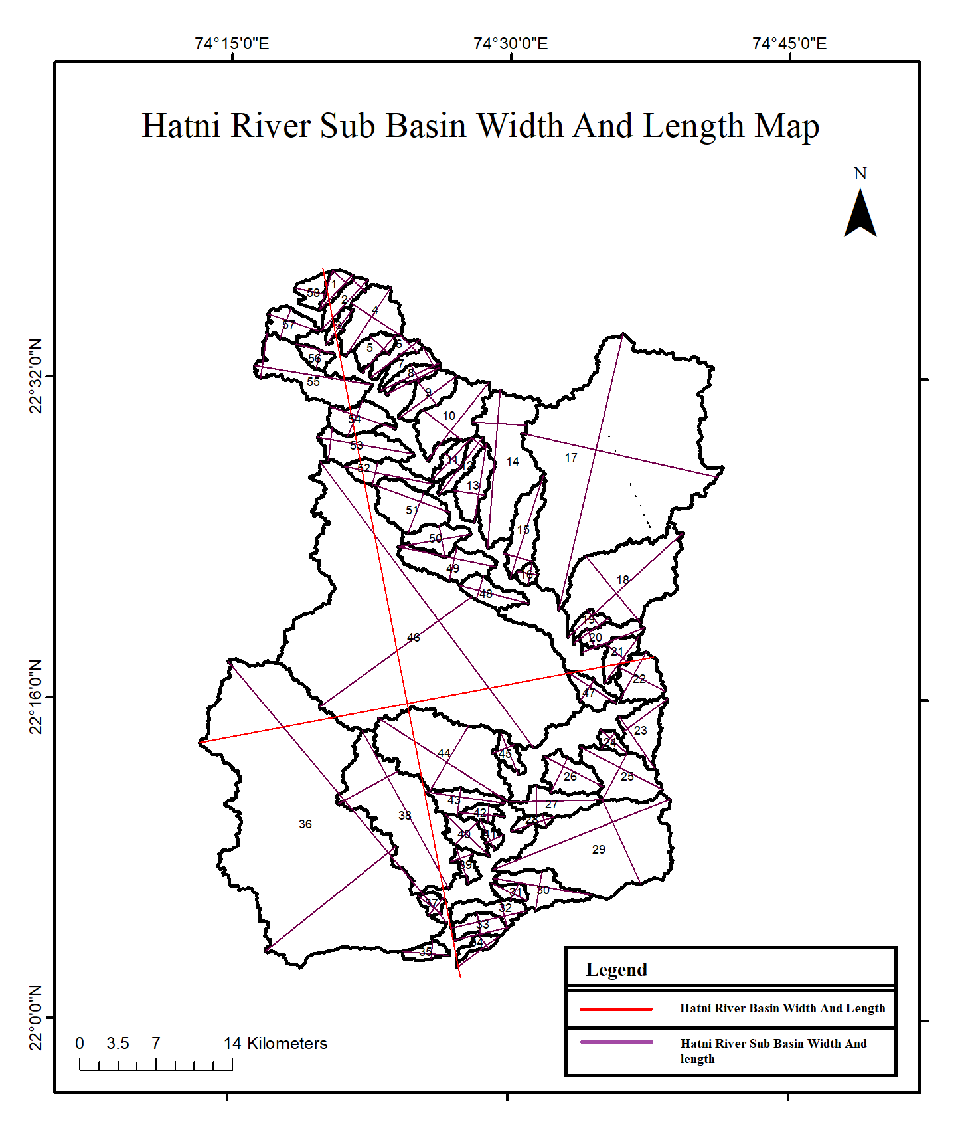

Fig4 Hatni River Basin and Sub Basin Length and Width

Slope plays a crucial role in understanding flow dynamics within a landscape (Verma et al., 2006; Verma, 1993). The mean slope provides a qualitative indication of flow velocity, with steeper slopes suggesting faster flow and gentler slopes indicating slower movement in the area. The rate at which a landscape is shaped or eroded is directly proportional to the velocity of flow, meaning steeper terrains are likely to experience more rapid erosion and landscape carving.

.Hatni Basin Slope Direction is N-S

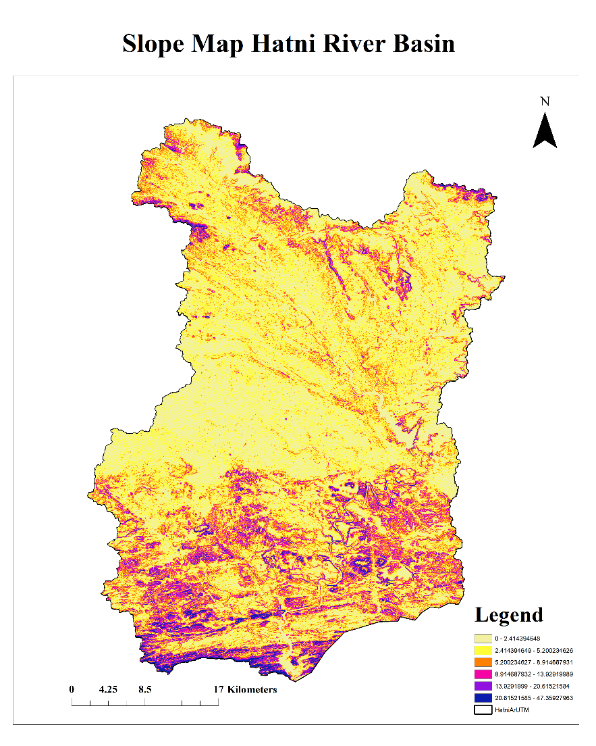

Fig 5 Slope Map Hatni River Basin

* 1. **Relief ratio (RR)**

Analysts utilize a metric called the relief ratio (RR) to assess the relief characteristics of a basin. This ratio is determined by dividing the total relief of the basin by its length. Mathematically, the relief ratio is expressed as RR=BL\BL​, where RR represents the relief and BL denotes the length of the basin. The relief ratio is a dimensionless value that reveals a strong positive correlation with stream gradient, the slope angle of the terrain, and drainage density (Schumm, 1956; Verma, 1993; Rathore et al., 2024).

The relief ratio of the sub basin arevaprox 0.1, characterizing mountainous configuration of the terrain (Schumm 1963). Rr is a dimensionless height-length ratio between R and Lb (Schumm, 1956). The Rr of Hatni River Basin is 0.009, and it’s sub basin value between 0.006 (Sb 4) and 0.2 (Sb 14). Rr values (Rr > 0.20), indicating steep terrain configuration (Table 4).

* 1. **Constant of channel maintenance (CM)**

CM is defined as the reciprocal of drainage density and represents the area, in square kilometers, required to sustain one kilometer of drainage channel. This makes CM an essential metric for evaluating drainage systems. (Phillips et al., 1987). In the Hatni River Basin, the value of CM is 0.58, while the sub-basins exhibit values ranging from 0.43 (Sb 37) to 0.72 (Sb 3) (Table 4).

**4.10 Length of overland flow (Lg**)

The length of overland flow (Lg) is defined as the distance water travels across the ground before it starts to gather in a defined channel. The length of Lg is closely connected to the length of sheet flow, with both processes supported by a shallow layer of surface retention (Melton, 1957; Verma et al., 2006; Rathore et al., 2024). The Lg of Hatni River Basin is 0.29 and that of the sub-basins vary from 0.21 (Sb 37) to 0.36 (Sb3). The low Lg values of the Hatni River Basin and its sub-basins suggest that they are in a late youth to early mature stage of development (Table 4).

* 1. **Drainage density (DD)**

Drainage density is a frequently utilized morphometric parameter for analyzing different environmental variables.

It is a measure of the degree of fluvial dissection and depends on a number of factors like topography, lithology, climate, petroology and vegetation (Nag, 1998). According to (Horton, 1932), it is a measurement of the length of streams per unit area. Drainage density provides a numerical measurement of landscape dissection and run-off potential (Reddy et al., 2004; Yadav, 2014). The Dd of Hatni River Basin is 1.73 and that of the sub-basins ranges between 1.38 (Sb3) and 2.31 (Sb 37) (Table 4).

* 1. **Form factor (FF)**

Horton [15] proposed this parameter to predict the flow intensity of a basin in a defined area. It shows an inverse relationship with square of the axial length and a direct relation with peak discharge (Gregoryet al., 1973; Singh, 1964-1965; Rathore et al., 2024). The form factor of Hatni River Basin is 0.46 and the sub basins range between 0.14 (Sb 12) and 0.62 (Sb 16) (Table 4). The sub basin3. They have peak flows for longer duration. Sab basin 12 has the highest form factor and the highest peak discharge in the sub basin.

* 1. **Stream frequency (Fs)**

The drainage frequency of the basin can be defined as the total number of streams (Nμ) per unit area (A). The Hatni river basin as a whole has a stream frequency of 2.07per km2, which denotes moderate denudational activity and moderate surface stratum permeability. In the study region its sub basin Fs value between 0.91 /km2 (Sb 19) and 2.88/km2 (Sb 31). Sb-31 has the highest Fs value (2.88) whereas Sb 19 lowest stream frequency (Table 4). According to (Yadav et al., 2014) these areas are characterized by steep slopes, less vegetation, and reduced rock permeability, all of which promote higher runoff, high denudation activities, and high relief conditions. The region with the lowest Fs score 0.91 Sb 19 has a soft surface with high permeability and features of flat terrain. The stream frequency parameter is influenced by the basin's lithology and serves as an indicator of the drainage network's texture (Horton, 1945). The Fs of Hatni River Basin is 2.07 /km2

* 1. **Circularity ratio (Rc)**

Circulatory ratio is influenced by the lithology of the basin, stream frequency and gradient of various orders (Strahler, 1964). The Rc is the ratio of A to area of a circle with same P as that of the basin (Miller, 1953). The Rc of Hatni River Basin is 0.30, while that of the sub-basins ranges between 0.27 (Sb 32) and 0.73 (Sb 16) (Table 4). The lower Rc values of most of the sub-basins also indicates the elongated shape.

* 1. **Elongation ratio (Re)**

The Re of Hatni River Basin is 0.76 and it’s sub-basins ranges from 0.43 (Sb 12) to 0.89 (Sb 16) (Table 4). According to (Strahler, 1964), SB12 belong to oval shaped (0.90 > Re > 0.80); Hatni River Basin to less elongated (0.80 > Re > 0.70) and the rest are highly elongated (Re < 0.70) basins.

Table 4

|  |  |  |  |  |  |  |  |  |
| --- | --- | --- | --- | --- | --- | --- | --- | --- |
| Parameters | A | Ff | Re | Rc | Fs | Dd | C | Lg |
| SB 1 | 5.03 | 0.26 | 0.58 | 0.47 | 1.99 | 1.83 | 0.55 | 0.27 |
| SB 2 | 7.72 | 0.19 | 0.5 | 0.39 | 2.07 | 1.52 | 0.66 | 0.33 |
| SB 3 | 3.44 | 0.21 | 0.52 | 0.41 | 1.75 | 1.39 | 0.72 | 0.36 |
| SB 4 | 21.96 | 0.39 | 0.7 | 0.49 | 2.05 | 1.8 | 0.56 | 0.28 |
| SB 5 | 6.77 | 0.34 | 0.66 | 0.35 | 1.62 | 1.59 | 0.63 | 0.31 |
| SB 6 | 6.77 | 0.21 | 0.52 | 0.35 | 2.21 | 1.66 | 0.6 | 0.3 |
| SB 7 | 6.66 | 0.18 | 0.48 | 0.29 | 1.8 | 1.84 | 0.54 | 0.27 |
| SB 8 | 5.47 | 0.19 | 0.49 | 0.36 | 2.01 | 1.7 | 0.59 | 0.29 |
| SB 9 | 11.98 | 0.28 | 0.6 | 0.47 | 1.42 | 1.9 | 0.53 | 0.26 |
| SB 10 | 27.41 | 0.33 | 0.65 | 0.38 | 2.04 | 1.74 | 0.58 | 0.29 |
| SB 11 | 6.19 | 0.24 | 0.55 | 0.45 | 1.29 | 1.71 | 0.58 | 0.29 |
| SB 12 | 6.59 | 0.15 | 0.43 | 0.28 | 1.52 | 1.63 | 0.62 | 0.31 |
| SB 13 | 13.65 | 0.26 | 0.57 | 0.43 | 2.49 | 1.48 | 0.67 | 0.34 |
| SB 14 | 53.77 | 0.25 | 0.57 | 0.3 | 2.03 | 1.78 | 0.56 | 0.28 |
| SB 16 | 2.88 | 0.63 | 0.89 | 0.74 | 1.73 | 1.58 | 0.63 | 0.32 |
| SB 17 | 260.85 | 0.38 | 0.7 | 0.37 | 2.03 | 1.79 | 0.56 | 0.28 |
| SB 18 | 61.41 | 0.3 | 0.62 | 0.36 | 1.82 | 1.74 | 0.57 | 0.29 |
| SB 19 | 4.37 | 0.27 | 0.59 | 0.38 | 0.92 | 1.55 | 0.64 | 0.32 |
| SB 20 | 8.52 | 0.23 | 0.54 | 0.32 | 2.11 | 1.83 | 0.55 | 0.27 |
| SB 21 | 8.15 | 0.29 | 0.6 | 0.43 | 1.96 | 1.56 | 0.64 | 0.32 |
| SB 22 | 15.03 | 0.61 | 0.88 | 0.54 | 2.06 | 1.7 | 0.59 | 0.29 |
| SB 23 | 16.29 | 0.48 | 0.78 | 0.4 | 2.09 | 1.88 | 0.53 | 0.27 |
| SB 24 | 3.7 | 0.35 | 0.66 | 0.53 | 2.7 | 1.66 | 0.6 | 0.3 |
| SB 25 | 25.16 | 0.34 | 0.66 | 0.48 | 2.82 | 1.72 | 0.58 | 0.29 |
| SB 26 | 14.51 | 0.38 | 0.7 | 0.51 | 1.93 | 1.6 | 0.62 | 0.31 |
| SB 27 | 14.42 | 0.2 | 0.5 | 0.35 | 1.73 | 1.72 | 0.58 | 0.29 |
| SB 28 | 3.47 | 0.21 | 0.52 | 0.39 | 1.73 | 1.82 | 0.55 | 0.27 |
| SB 29 | 93.42 | 0.3 | 0.62 | 0.42 | 1.98 | 1.82 | 0.55 | 0.27 |
| SB 31 | 4.15 | 0.31 | 0.63 | 0.52 | 2.89 | 1.75 | 0.57 | 0.29 |
| SB 32 | 10.17 | 0.2 | 0.5 | 0.28 | 1.57 | 1.86 | 0.54 | 0.27 |
| SB 33 | 8.14 | 0.31 | 0.63 | 0.47 | 2.21 | 2.25 | 0.45 | 0.22 |
| SB 34 | 3.87 | 0.17 | 0.47 | 0.33 | 2.33 | 2.2 | 0.45 | 0.23 |
| SB 35 | 4.8 | 0.25 | 0.57 | 0.5 | 1.46 | 1.41 | 0.71 | 0.35 |
| SB 36 | 334.88 | 0.34 | 0.66 | 0.33 | 2.01 | 1.83 | 0.55 | 0.27 |
| SB 37 | 3.54 | 0.52 | 0.81 | 0.65 | 2.83 | 2.32 | 0.43 | 0.22 |
| SB 38 | 77.48 | 0.28 | 0.6 | 0.3 | 1.96 | 1.83 | 0.55 | 0.27 |
| SB 39 | 4.68 | 0.41 | 0.72 | 0.42 | 2.35 | 1.65 | 0.61 | 0.3 |
| SB 40 | 9.61 | 0.3 | 0.62 | 0.46 | 2.08 | 1.81 | 0.55 | 0.28 |
| SB 41 | 3.34 | 0.37 | 0.68 | 0.45 | 2.09 | 1.61 | 0.62 | 0.31 |
| SB 42 | 4.26 | 0.25 | 0.57 | 0.4 | 2.35 | 2.04 | 0.49 | 0.25 |
| SB 43 | 10.36 | 0.2 | 0.5 | 0.37 | 2.12 | 1.7 | 0.59 | 0.29 |
| SB 44 | 67.2 | 0.34 | 0.66 | 0.4 | 1.88 | 1.73 | 0.58 | 0.29 |
| SB 46 | 356.96 | 0.33 | 0.65 | 0.32 | 1.96 | 1.76 | 0.57 | 0.28 |
| SB 47 | 10.36 | 0.24 | 0.56 | 0.42 | 2.12 | 1.73 | 0.58 | 0.29 |
| SB 48 | 10.36 | 0.24 | 0.56 | 0.42 | 2.12 | 1.73 | 0.58 | 0.29 |
| SB 49 | 18.17 | 0.22 | 0.53 | 0.33 | 1.93 | 1.71 | 0.58 | 0.29 |
| SB 50 | 11.48 | 0.27 | 0.59 | 0.43 | 1.92 | 1.67 | 0.6 | 0.3 |
| SB 51 | 22.34 | 0.43 | 0.74 | 0.57 | 2.1 | 1.76 | 0.57 | 0.28 |
| SB 52 | 12.5 | 0.18 | 0.48 | 0.34 | 2.48 | 1.65 | 0.61 | 0.3 |
| SB 53 | 18.98 | 0.24 | 0.55 | 0.38 | 1.9 | 1.66 | 0.6 | 0.3 |
| SB 54 | 13.1 | 0.32 | 0.64 | 0.48 | 2.14 | 2 | 0.5 | 0.25 |
| SB 55 | 29.62 | 0.25 | 0.56 | 0.31 | 2.3 | 1.74 | 0.57 | 0.29 |
| SB 56 | 4.46 | 0.34 | 0.65 | 0.53 | 1.57 | 1.97 | 0.51 | 0.25 |
| SB 57 | 10.15 | 0.41 | 0.72 | 0.52 | 2.46 | 1.8 | 0.55 | 0.28 |
| SB 58 | 6.52 | 0.45 | 0.76 | 0.47 | 2.45 | 1.76 | 0.57 | 0.28 |
| Hatni Basin | 2008.91 | 0.46 | 0.76 | 0.3 | 2.06 | 1.73 | 0.58 | 0.29 |

* 1. **Basin relief (R)**

The R of Hatni River Basin is 685 m and it’s sub-basins ranges between 180 m (Sb 34) and 683 m (Sb 36) (Table 5)

* 1. **Relief ratio (Rr)**

The relief ratio of the sub basin arevaprox 0.1, characterizing mountainous configuration of the terrain (Schumm, 1963). Rr is a dimensionless height-length ratio between R and Lb (Schumm, 1956). The Rr of Hatni River Basin is 0.009, and it’s sub basin value between 0.006 (Sb 4) and 0.2 (Sb 14). Rr values (Rr > 0.20), indicating steep terrain configuration (Table 5).

* 1. **Ruggedness Number (Rn)**

The Rn of hatni River Basin is 1.06 and it’s the sub-basins ranges between 0.06 (Sb 3) and 1.12 (Sb 36) (Table 5) . The high Rn of Hatni River Basin and all most of the sub-basins indicate low soil erosion susceptibility.

Table 5

|  |  |  |  |
| --- | --- | --- | --- |
| Parameters | R | Rr | Rn |
| SB 1 | 80 | 0.02 | 0.15 |
| SB 2 | 99 | 0.02 | 0.15 |
| SB 3 | 49 | 0.01 | 0.07 |
| SB 4 | 100 | 0.01 | 0.18 |
| SB 5 | 121 | 0.03 | 0.19 |
| SB 6 | 137 | 0.02 | 0.23 |
| SB 7 | 97 | 0.02 | 0.18 |
| SB 8 | 98 | 0.02 | 0.17 |
| SB 9 | 80 | 0.01 | 0.15 |
| SB 10 | 124 | 0.01 | 0.22 |
| SB 11 | 71 | 0.01 | 0.12 |
| SB 12 | 94 | 0.01 | 0.15 |
| SB 13 | 77 | 0.01 | 0.11 |
| SB 14 | 196 | 0.01 | 0.35 |
| SB 15 | 85 | 0.01 | 0.14 |
| SB 16 | 231 | 0.11 | 0.37 |
| SB 17 | 275 | 0.01 | 0.49 |
| SB 18 | 127 | 0.01 | 0.22 |
| SB 19 | 54 | 0.01 | 0.08 |
| SB 20 | 66 | 0.01 | 0.12 |
| SB 21 | 49 | 0.01 | 0.08 |
| SB 22 | 105 | 0.02 | 0.18 |
| SB 23 | 133 | 0.02 | 0.25 |
| SB 24 | 107 | 0.03 | 0.18 |
| SB 25 | 205 | 0.02 | 0.35 |
| SB 26 | 169 | 0.03 | 0.27 |
| SB 27 | 193 | 0.02 | 0.33 |
| SB 28 | 198 | 0.05 | 0.36 |
| SB 29 | 311 | 0.02 | 0.57 |
| SB 30 | 203 | 0.02 | 0.36 |
| SB 31 | 102 | 0.03 | 0.18 |
| SB 32 | 180 | 0.03 | 0.34 |
| SB 33 | 190 | 0.04 | 0.43 |
| SB 34 | 110 | 0.02 | 0.24 |
| SB 35 | 327 | 0.08 | 0.46 |
| SB 36 | 613 | 0.02 | 1.12 |
| SB 37 | 184 | 0.07 | 0.43 |
| SB 38 | 234 | 0.01 | 0.43 |
| SB 39 | 117 | 0.03 | 0.19 |
| SB 40 | 208 | 0.04 | 0.38 |
| SB 41 | 150 | 0.05 | 0.24 |
| SB 42 | 149 | 0.04 | 0.3 |
| SB 43 | 180 | 0.03 | 0.31 |
| SB 44 | 230 | 0.02 | 0.4 |
| SB 45 | 157 | 0.04 | 0.26 |
| SB 46 | 232 | 0.01 | 0.41 |
| SB 47 | 74 | 0.01 | 0.13 |
| SB 48 | 74 | 0.01 | 0.13 |
| SB 49 | 88 | 0.01 | 0.15 |
| SB 50 | 70 | 0.01 | 0.12 |
| SB 51 | 73 | 0.01 | 0.13 |
| SB 52 | 80 | 0.01 | 0.13 |
| SB 53 | 136 | 0.02 | 0.23 |
| SB 54 | 120 | 0.02 | 0.24 |
| SB 55 | 195 | 0.02 | 0.34 |
| SB 56 | 63 | 0.02 | 0.12 |
| SB 57 | 103 | 0.02 | 0.19 |
| SB 58 | 59 | 0.02 | 0.1 |
| Hatni Basin | 685 | 0.009 | 1.06 |

* 1. **Discussion**

This study explores the use of CARTOSAT Digital Elevation Model (DEM) for morphometric analysis, particularly in mountainous areas. The analysis focused on the Hatni River Basin and its minimum second-order tributaries to examine the spatial variability of morphometric parameters and their hydrological implications. The drainage patterns and the linear arrangement of stream courses within the Hatni River Basin indicate a structural influence on the drainage network. First-order streams comprise approximately 79% of the total stream count in the basin, with a higher number of first-order streams observed across all sub-basins. This prevalence suggests the presence of structural weaknesses in the basin, primarily manifested as lineaments (Mesa, 2006). Overall, this indicates that the development of the sub-basins primarily adheres to the principles of erosion operating on homogeneous geological materials with consistent weathering and erosion characteristics. Variations in stream orders across the sub-basins can be attributed to irregular sub-basin development, local topographic differences, and the influence of localized geological disturbances. Generally, the bifurcation ratio of lower-order streams is higher, suggesting significant dissection in these areas. The bifurcation ratio of the sub-basins, exceeding 3, indicates structural disturbances likely caused by the proximity of a major fault. (Clark et al., 2004). The stream frequency across all sub-basins is moderate, suggesting a corresponding level of runoff. Figure 4 illustrates the regression trend between drainage density and stream frequency, which reveals a positive linear correlation (Horton, 1932). The elongation ratio further indicates significant relief within the Hatni River Basin. The elongation ratio (Rc) for the sub-basins varies from 0.28 (Sb 32) to 0.74 (Sb 16). Notably, one sub-basin exhibits high values of both elongation ratio (Re = 0.89) and Rc (0.74), potentially indicating differential erosion and displacement within the sub-basin. The form factor for the elongated basins ranges from 0.15 (Sb 12) to 0.63 (Sb 16) (Strahler, 1964). All sub-basins fit into this category. Sub-basin 16 has a higher form factor (0.63) compared to other elongated shapes, consistent with their elongation and circulatory ratios. This increased form factor in sub-basin 16 (Table 4) indicates enhanced drainage development and structural control within these sub-basins. It has been noted that the relationship follows the order: elongation ratio > circulatory ratio > form factor (Srinivasa et al., 2011) except for the Hatni River Basin 58, which underscores the significance of structural control. Figure 6 illustrates the variations in shape parameters. The bifurcation ratio (Table 3A,3B,3C,3D) ranges from around 2 in flat or gently rolling drainage basins to between 3 and 4 in mountainous or highly dissected basins. As anticipated, the bifurcation ratio tends to be higher in hilly, well-dissected drainage basins than in rolling ones. Furthermore, it will be demonstrated that the length of overland flow is one of the most significant independent variables affecting both the hydrologic and physiographic development of drainage basins.

1. **CONCLUSION**

Morphometric analysis of the Hatni River Basin highlights the significance of terrain analysis and its impact on river basin management. Precambrian rocks cover much of the basin, making it difficult to see underlying geological formations. The Hatni River Basin's morphometric analysis highlights the significance of morphometric studies in terrain analysis and river basin management. The Archaean meta-sediments include quartzites, calciphyres, dolomitic marbles, chlorite schists, garnetiferous talc chlorite schists, and graphite schists. Precambrian rocks cover much of the basin, making it difficult to see underlying geological formations. The Archaean meta-sediments are represented by Quartzites, calcites, and dolomitic rocks Chlorite schists can be garnetiferous (e.g., Talc, Graphite) (Singh, 1964-1965). The basin shows two distinct landscapes, its Northern Western part shows structure control type of drainage and its Northern eastern part shows parallel to subparallel drainage pattern (Fig. 2). The geometry of the Hatni river basin implies headward extension because terrain and structure influence the prevailing form of drainage development and stream bifurcation simultaneously. This heavily dissected Hatni river basin has a higher degree of drainage integration, and so the analytical results hint to a late youth to early mature stage of geomorphological evolution. The upstream part of Hatni River Basin is well drained and the downstream is very badly to moderately drained and topography configuration plays a key influence in shaping the spatial variance. The basin's less elongated shape, combined with highly elongated sub-basins, reduces the risk of flood flows and makes flood management easier. The classification of the 4th and 5th order mostly sub basins are highly elongated The Elongation ratio of Hatni river Sub Basin are Show most of Sub Basin is Highly Elongated (Oval Shaped 3 Sub Basin, Less Elongated 6 Sub Basin, Highly Elobgated 49 Sub Basin) and Hatni River Basin are structure control basin.

1. **REFERENCES**
2. Horton, R. E. (1932). Drainage-basin characteristics. *Transactions American Geophysical Union*, *13*, 350-361.
3. Lillesand, T., Kiefer, R. W., & Chipman, J. (2015). *Remote sensing and image interpretation* (7th ed.). John Wiley & Sons.
4. Zhou, W., Wang, H., & Zhang, Y. (2017). Morphometric analysis of watersheds using remote sensing and GIS techniques. *Applied Geography*, *81*, 65-74.
5. Vishwanath, M. N. (1963-1964). Geological Survey of India (GSI). Retrieved from <http://www.gis.gov.in>
6. Brierley, G. J., & Fryirs, K. A. (2005). *Geomorphology and river management: Applications of the river styles framework*. Blackwell Publishing.
7. Easterbrook, D. J. (1999). *Surface processes and landforms* (2nd ed.). Prentice Hall.
8. Thornbury, W. D. (1969). *Principles of geomorphology* (2nd ed.). John Wiley & Sons.
9. Strahler, A. N. (1952). Hypsometric (area-altitude) analysis of erosional topography. *Geological Society of America Bulletin*, *63*(11), 1117-1142.
10. Raghunath, H. M. (1987). *Hydrology: Principles, analysis, and design*. New Age International.
11. Hack, J. T. (1957). Studies of longitudinal stream profiles in Virginia. *U.S. Geological Survey Professional Paper*, *294-B*, 45-97.
12. Melton, M. A. (1957). An analysis of remnant topography in Virginia. *Geological Society of America Bulletin*, *68*(1), 1-32.
13. Montgomery, D. R., & Dietrich, W. E. (1988). Where do channels begin? *Science*, *246*(4920), 1000-1003.
14. Morisawa, M. (1985). *Rivers: Form and process in alluvial channels*. John Wiley & Sons.
15. Strahler, A. N. (1957). Quantitative analysis of watershed geomorphology. *Eos Transactions American Geophysical Union*, *38*(6), 913-920.
16. Horton, R. E. (1945). Erosional development of streams and their drainage basins; hydrophysical approach to quantitative morphology. *Geological Society of America Bulletin*, *56*(3), 275-370.
17. Hack, J. T. (1973). Stream-profile analysis and stream-gradient index. *Journal of Research of the United States Geological Survey*, *1*(4), 421-429.
18. Schumm, S. A. (1956). Evolution of drainage systems and slopes in badlands at Perth Amboy, New Jersey. *Geological Society of America Bulletin*, *67*(5), 597-646.
19. Gregory, K. J., & Walling, D. E. (1968). The variation of drainage density within a catchment. *International Association of Scientific Hydrology Bulletin*, *13*(2), 61-68.
20. Phillips, L. F., & Schumm, S. A. (1987). Effect of regional slope on drainage networks. *Geology*, *15*(9), 813-816.
21. Reddy, M. M., Reddy, S. R., & Reddy, P. K. (2004). Drainage density and its relationship with geomorphological parameters in the southwestern part of the Godavari River Basin, India. *Journal of Earth System Science*, *113*(5), 789-797.
22. Yadav, A., Kaur, M., & Jha, A. (2014). Drainage density analysis and its influence on land use/land cover: A case study of Bahraich District, Uttar Pradesh, India. *International Journal of Geomatics and Geosciences*, *5*(2), 207-218.
23. Gregory, K. J., & Walling, D. E. (1973). Axial length and drainage density of rivers in England and Wales. *Geomorphology*, *1*(2), 89-95.
24. Strahler, A. N. (1964). Quantitative geomorphology of drainage basins. In V. T. Chow (Ed.), *Handbook of applied hydrology* (pp. 4.1-4.40). McGraw-Hill.
25. Schumm, S. A. (1963). Geomorphology and river management. *American Geophysical Union, Water Resources Monograph*, *3*, 1-104.
26. Mesa, J. (2006). Stream morphology and sediment transport in a mountain river: A case study in the Sierra de Guadarrama, Spain. *Geomorphology*, *76*(1-2), 32-42.
27. Clark, J. S., Slayback, D., Kelsey, R., et al. (2004). The influence of land use on watershed hydrology and water quality: A study of the southeastern United States. *Journal of the American Water Resources Association*, *40*(2), 423-437.
28. Srinivasa, K., & Nagesh, S. (2011). Morphometric analysis of a watershed using remote sensing and GIS techniques. *International Journal of Geomatics and Geosciences*, *1*(2), 176-188.
29. Singh, M. (1964-1965). Geological Survey of India (GSI). Retrieved from <http://www.gis.gov.in>
30. Verma, P. K., & Bhagat, S. N. (2006). Relation between lineaments and tectonics in parts of the Vindhyan Basin, Madhya Pradesh. *Journal of the Indian Society of Remote Sensing*, *34*(2), 203-207.
31. Verma, P. K. (1991). Remote sensing of the lineament patterns associated with the Great Boundary Fault of Rajasthan. *Journal of the Indian Society of Remote Sensing*, *19*(4), 253-262.
32. Verma, P. K. (1993). Tectonic inferences from the statistical treatment of the remote sensing lineament fabric data associated with the Great Boundary Fault of Rajasthan, India. *Journal of the Indian Society of Remote Sensing*, *21*(2), 67-74.
33. Rathore, A. K., Khan, S., & Verma, P. K. (2024). Integrated Python and GIS approach for geomorphometric investigation of Man River Basin, Western Madhya Pradesh, India. *Energy Nexus*, *16*, 100328. https://doi.org/10.1016/j.nexus.2024.100328
34. Nag, S. (1998). Morphometric analysis using remote sensing techniques in the Chaka sub-basin, Purulia district, West Bengal. *Journal of the Indian Society of Remote Sensing*, *26*, 69–76. https://doi.org/10.1007/BF03007341.