Fomulation And Evalution of Pioglitazone

Phytosome Contaning oral In Situ gel for Antidiabetic Activity

Shelake Sardar,

*Ghunake Vinayak, *Patil Vishwajit, *Kamate Poonam, ,

*ChouguleNilesh.

Ashokrao Mane Institute of Pharmacy, Ambap, Kolhapur 416112

*Corresponding author: Shelake Sardar

Ashokrao Mane Institute of Pharmacy, Ambap, Kolhapur 416112.

E-mail:- sardarshelake289@gmail.com

tel :- +91 9860601550

# ABSTRACT

The present study focuses on the formulation and evaluation of pioglitazone phytosomes incorporated into an oral in situ gel for enhanced antidiabetic activity. Pioglitazone, a widely used thiazolidinedione, exhibits poor water solubility and limited bioavailability, which hinders its therapeutic efficacy. To overcome these limitations, pioglitazone was complexed with phospholipids to form phytosomes, enhancing its solubility and stability. These phytosomes were subsequently integrated into an oral in situ gel matrix designed to undergo sol-to-gel transition at physiological conditions, thereby prolonging gastric residence time and ensuring sustained drug release.The formulated pioglitazone phytosomes were characterized using various physicochemical techniques including Fourier Transform Infrared Spectroscopy (FTIR), Differential Scanning Calorimetry (DSC), and X-ray Diffraction (XRD) to confirm complex formation and assess stability. The in situ gel was prepared using gellan gum as the gelling agent, and its rheological properties, gelation temperature, and drug release profile were evaluated. The in vitro drug release study demonstrated a controlled release pattern, indicative of the sustained release properties of the gel matrix.Furthermore, in vivo antidiabetic activity was assessed using a streptozotocin-induced diabetic rat model. The results indicated a significant reduction in blood glucose levels in rats treated with the pioglitazone phytosome gel compared to those treated with plain pioglitazone, suggesting improved therapeutic efficacy. Histopathological studies of pancreatic tissues corroborated these findings, showing enhanced islet cell preservation in the treated groups.

# INTRODUTION

* 1. **PHYTOSOMES**

The Phytosome technology developed by Indena S.P.A. of Italy [1]. Phytosome can be a patented technology including to include standardized plant extracts or dihydrogen monoxide soluble phytoconstituents into phospholipids to supply lipid compatible molecular complexes. The phytosomes process produces a touch cell due to that the precious components of the herbal extract are shielded from destruction by digestive secretions and gut bacteria. Phytosomes have improved pharmacokinetic and pharmacological parameter[2]. More bioavailability of phytosomes as compared to herbal extract due to their increase capacity to cross the lipid rich biomembranes and eventually reaching into the blood [3]. Novel drug delivery system encompasses differing types of pharmaceutical carriers like polymeric micelles, particulate systems, macro- and micro molecules. The vesicular systems are more authoritatively mandated meeting of one or sundry concentric lipid bilayers culminated. When certain amphiphilic building blocks are confronted with dihydrogen monoxide. These systems contribute in prolonging the existence of the drug in circulation reducing toxicity and delaying elimination of rapidly metabolizable drugs [4]. The Italian pharmaceutical and nutraceutical company first time developed the complexation of plant extracts containing water-soluble constituents with phospholipids to enhance their bioavailability. They patente the technology as ‘PHYTOSOME' [5]. Due to the creation of an H-bond between phospholipids and therefore the phytoconstituents, phytosomes show better physical stability enhancing absorption of hydrophilic polar phytoconstituents leading to enhanced bioavailability and greater therapeutic benefits.

Most of the biologically active constituents of plants are polar or watersoluble but due to the problem in absorption, restricts the utilization of these type of compounds which ultimately decreases the bioavailability.For improvement of bioavailability, herbal products must have properhomeostasis between hydrophilic (for absorption into gastrointestinal tract fluid) and lipophilic (to cross lipid bio membrane balance) [6].Plant preparations are widely used in traditional as well as modern medicine system. During the traditional time, various pharmacological studies have been carried out with many plants extracts and their constituents to check their therapeutic application. Over the past year, great advancement has been made for the development of novel drug delivery system (NDDS) for various plant extracts and their active constituents. Novel drug delivery such as targeted drug delivery which directly channels the active entity on the site of action and such delivery system could offer targeted and sustained release of

drug so that pharmacological effect could be achieved at lower dose. The development in the area of herbal medicine started earlier to cure human diseases with lesser side effects [7].

The term “Phyto” refers to the plant, while “some” refers to cell-like.[8] Phytosomes (or herbosomes) are the vesicular drug delivery system enhancing the absorption and bioavailability of low-soluble drugs.[8,10] Phytosomes are complex of phospholipids and natural active phytochemicals, bound in their structures, obtained by the reaction between phosphatidylcholine (or any hydrophilic polar head groups) and plant extracts in an aprotic solvent.[9,11] These formulations exhibit improved pharmacological and pharmacokinetic properties as compared to prevalent preparations. The lipid-soluble phosphatidyl portion completely covers the hydrophilic phytoconstituent-choline complexes. Phytosomes have remarkable benefits such as high drug encapsulation, reveal a better stability profile (chemical bonds are formed among the polar head of the amphiphile molecule and phytoconstituent[12]), and have a better bioavailability. Moreover, a higher absorption rate leads to a lower dosage of active constituents for exerting a biological effect, also for polar phytoconstituents.

# STRUCTURE OF PHYTOSOMES

The active phytoconstituents and the polar head (choline moiety) combine physically and chemically to generate Guggulosomes and phytosomes, which complexes of phyto-phospholipids in their chemical makeup (Figure 1). These complexes entail the anchoring of phospholipid head groups. In complexes that result in the creation of a lipophilic surface, the polar component is encapsulated by fatty acid chains. The substance that makes up a liposome is active, either in a cavity between the membrane's several layers [32]. The substance that makes up phytosomes active is a component of the membrane itself

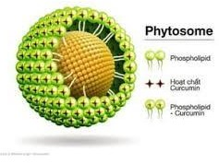

# Fig.1: STRUCTURE OF PHYTOSOMES

* 1. **DIBETES MELLITUS**

Diabetes mellitus is a progressive, debilitating disease that is among the five leading causes of death in most developed countries.[1] In 2003, it was estimated that 194 million people worldwide had diabetes, and type 2 diabetes, characterised by insulin deficiency and resistance, accounts for

≈85–95% of all cases of diabetes in developed countries and nearly all diabetes cases in developing countries.[1] This growing pandemic is brought about by aging populations with a genetic predisposition to type 2 diabetes, as well as by changes in lifestyle, including low physical activity, obesity and a high caloric intake.[1] The disease and its complications (corona ry artery and peripheral vascular disease, stroke, neuropathy, retinopathy, nephropathy and amputations) account for a substantial proportion of many national health budgets.[1] Insulin resistance is associated with hyperglycaemia, diabetic dyslipidaemia, abnormal coagulation and hypertension,[2] and typical treatment includes sequential and combined use of lifestyle changes and pharmacological therapies. Diet and exercise reduce weight and increase insulin sensitivity, while pharmacotherapeutic interventions canen hance insulin secretion by β-cells of the islets of Langerhans (e.g. sulfonylureas, repaglinide), in crease insulin sensitivity (e.g. metformin, thiazolidinediones), impede the uptake of carbohydrates from the digestive tract (acarbose), or

supply exogenous insulin.[3-5] Pioglitazone (Actos [figure 1] is an insulin sensitising

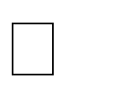

)1

thiazolidinedione that activates a specific nuclear receptor (peroxisome-proliferator activated receptor-γ [PPAR-γ])[6] found in adipose tissue, pancreatic β-cells, vascular endothelium and macrophages.[2] The focus of this review is its approved use in the EU and the US in the treatment of type 2 diabetes in patients whose condition is inadequately controlled by diet and exercise.[7,8]

# PIOGLITAZONE

It is an oral antidiabetic medication primarily used in the management of type 2 diabetes mellitus. It belongs to the thiazolidinedione class of drugs, which work by improving insulin sensitivity. Below is a comprehensive profile of pioglitazone, including its mechanism of action, indications, pharmacokinetics, side effects, contraindications, and other relevant information.

Pioglitazone acts as an agonist for the peroxisome proliferator-activated receptor gamma (PPAR- γ). This receptor is predominantly found in adipose tissue but is also present in muscle and liver cells. Activation of PPAR-γ modulates the transcription of insulin-responsive genes involved in glucose and lipid metabolism, leading to: Increased insulin sensitivity in peripheral tissues Decreased hepatic glucose production Improved lipid profiles (increased HDL, decreased triglycerides)

# IN SITU GEL

In the past few years, increasing number of in situ gel forming systems have been investigated and many patents for their use in various biomedical applications including drug delivery have been reported. This interest has been sparked by the advantages shown by in situ forming polymeric delivery systems such as ease of administration and reduced frequency of administration, improved patient compliance and comfort[1]. In situ gel formulations offers an interesting alternative for achieving systemic drug effects of parenteral routes, which can be inconvenient or oral route, which can result in unacceptably low bioavailability and passes the hepatic first-pass metabolism, in particular of proteinsand peptides[2]. This novel drug delivery system promotes the importantly ease and convenience of administration, deliverance of accurate dose as well as to prolong residence time of drug in contact with mucosa, that problems generally encountered in semisolid dosage forms. In situ gel formation occurs due to one or combination of different stimuli like pH change, temperature modulation and solvent exchange[3]. Smart polymeric systems represent promising means of delivering the drugs; these polymers undergo sol-gel transition, once administered. From the early 1970's natural and synthetic polymers began to be investigated for controlled release formulations. The advantages of using biodegradable polymers in clinical applications are apparent. Various natural and synthetic polymers are used for formulationdevelopment of in situ forming drug delivery systems[4].

# Ideal characteristics of polymers for preparation for Phytosomes [14, 15]

* + 1. The polymer should be biocompatible, meaning it should not cause any adverse reactions in biological systems.
    2. The polymer should be biodegradable to allow for safe and efficient breakdown and elimination from the body.
    3. The polymer should have good solubility in the chosen solvent systems to facilitate the formation of a stable phytosome complex.
    4. The polymer should provide chemical and physical stability to the phytosome complex, protecting the encapsulated phytochemicals from degradation due to environmental factors such as light, heat, and moisture.
    5. The polymer should have a high encapsulation efficiency, meaning it should effectively encapsulate a significant amount of the active phytochemicals to ensure therapeutic efficacy.
    6. The polymer should allow for controlled and sustained release of the encapsulated phytochemicals, ensuring a prolonged therapeutic effect and reducing the need for frequent dosing.
    7. The polymer should not trigger an immune response, which is important for preventing adverse immune reactions.

# Advantages of Phytosomes:

1. Improved absorption and cellular uptake of phytochemicals.
2. Protection from environmental degradation and maintained chemical integrity.
3. Sustained release for prolonged therapeutic effects.
4. Localized treatment with improved tissue specificity.
5. Higher potency, reduced dosage, and better therapeutic outcomes.
6. Simplified dosing regimens and reduced side effects.
7. Multiple dosage forms and customizable formulations.
8. Use of biocompatible and biodegradable natural ingredients with minimal toxicity. [1,3]

# Disadvantages of Phytosomes [12, 13]

1. Requires specialized knowledge and equipment; time-consuming.
2. Expensive materials and higher manufacturing costs.
3. Sensitive to environmental factors; limited shelf life.
4. Challenges in scaling up production from lab to industrial scale.
5. Complex and lengthy approval processes; difficulty in standardization.
6. May require additional solubilizing agents for aqueous environments.

# Pharmaceutical application :[1,2,3]

1. **Improved Absorption**: Phytosomes enhance the absorption of poorly soluble phytochemicals, making them more effective as therapeutic agents.
2. **Targeted Delivery**: They allow for targeted delivery to specific tissues or organs, improving the efficacy of the treatment.
3. **Diabetes Mellitus**: Phytosomes can be used to deliver herbal extracts like berberine and curcumin, which have shown potential in managing blood glucose levels.
4. **Cardiovascular Diseases**: Phytosome formulations of antioxidants like quercetin and resveratrol can help in managing cardiovascular health by reducing oxidative stress and inflammation.
5. **Arthritis and Joint Disorders**: Curcumin phytosomes have been shown to reduce inflammation and pain in conditions like osteoarthritis and rheumatoid arthritis.
6. **General Antioxidant Therapy**: Phytosomes can enhance the delivery of antioxidants like green tea extract, providing systemic protection against oxidative stress.
7. **Chemoprevention**: Phytosomes containing polyphenols like epigallocatechin gallate (EGCG) from green tea and curcumin have been investigated for their potential to prevent or slow down the progression of various cancers.
8. **Adjuvant Therapy**: They can be used alongside conventional chemotherapy to enhance efficacy and reduce side effects.
9. **Hepatoprotective Agents**: Phytosomes of silymarin (from milk thistle) have been extensively studied for their liver-protective effects, helping in the treatment of liver disorders like hepatitis and cirrhosis.
10. **Anti-Aging**: Phytosomes of antioxidants like quercetin and resveratrol are used in skincare formulations to protect against aging and improve skin health.
11. **Wound Healing**: Phytosome-based gels and creams can be used to promote wound healing and treat skin conditions such as psoriasis and eczema.
12. **Cognitive Health**: Phytosomes of Ginkgo biloba extract and other neuroprotective agents can improve cognitive function and protect against neurodegenerative diseases like Alzheimer’s and Parkinson’s.
13. **Ulcer and Inflammation**: Phytosomes containing licorice and other anti-inflammatory herbs can be used to treat ulcers and inflammatory bowel diseases.
14. **Immunomodulatory Effects**: Phytosome formulations of Echinacea and other immune- boosting herbs can enhance the body's immune response, providing support in conditions of immune deficiency.

# 2. AIM AND OBJECTIVE

* 1. **AIM**

The aim of developing a pioglitazone-loaded phytosomal gel is to enhance the drug's bioavailability, ensure targeted and sustained delivery, improve skin penetration, reduce systemic side effects, increase stability, and improve patient compliance through a convenient topical formulation.

# OBJECTIVE

**Enhanced Bioavailability**: Pioglitazone has relatively low bioavailability due to poor water solubility. Formulating it as a phytosomal in situ gel can enhance its solubility and absorption, leading to better bioavailability.

**Sustained Release**: In situ gels can provide a sustained release of pioglitazone, which helps in maintaining a consistent therapeutic level of the drug over an extended period. This reduces the frequency of dosing and improves patient compliance.

 **Improved Stability**: Phytosomes, which are complexes of phospholipids and natural compounds, can improve the stability of pioglitazone by protecting it from degradation.

**Localized Delivery**: In situ gels can be administered at the site of action, allowing for localized drug delivery. This can be particularly useful in minimizing systemic side effects and enhancing the therapeutic efficacy of pioglitazone.

**Patient Convenience**: The in situ gel is a liquid at room temperature and gels at body temperature, making it easy to administer. This property enhances patient convenience and adherence to the treatment regimen.

**Reduction in Side Effects**: By improving the pharmacokinetic profile and providing targeted delivery, the formulation can potentially reduce the side effects associated with pioglitazone.

 **Enhanced Permeability**: The phytosomal complex can enhance the permeability of pioglitazone across biological membranes, further improving its absorption and therapeutic action.

# NEED OF WORK

**Setu Gel and its Potential in Diabetes Management**

Setu gel is a topical formulation that can be enriched with phytosomal complexes to provide localized treatment for diabetic complications. The gel form allows for direct application to the skin, potentially improving the management of diabetic symptoms such as peripheral neuropathy, poor wound healing, and inflammation.

# Need for Phytosomal Setu Gel in Diabetes Mellitus

* + 1. **Enhanced Bioavailability**: Phytosomal technology significantly improves the absorption of herbal extracts, making the treatment more effective.
    2. **Localized Treatment**: Topical application allows for targeted therapy, reducing systemic side effects and improving patient compliance.
    3. **Management of Diabetic Complications**: Setu gel can be formulated to address common complications like neuropathy and poor wound healing, offering a comprehensive approach to diabetes care.
    4. **Natural and Safe**: Phytosomal complexes derived from herbal extracts are generally well- tolerated, providing a safer alternative to synthetic drugs.
    5. **Innovative Approach**: The incorporation of phytosomes in Setu gel represents an innovative approach in diabetes management, potentially leading to better patient outcomes.

# 1. PLAN OF WORK



**Extensive literature survey**

**Development of In Situ Gel**

**Evaluation of developed gel formulation for quality characteristics**

**Collection of Drug**

**.Formation of Plioglitazone Pytosomes**

**Report writing**

**Procurement of other excipients, solvents**

**Preformulation study**

**DRUG AND EXCIPIENT PROFILE**

# DRUG PROFILE

* + 1. **Pioglitazone**

It is an oral antidiabetic medication primarily used in the management of type 2 diabetes mellitus. It belongs to the thiazolidinedione class of drugs, which work by improving insulin sensitivity. Below is a comprehensive profile of pioglitazone, including its mechanism of action, indications, pharmacokinetics, side effects, contraindications, and other relevant information.

* + - * **Molecular Formula :** C19H20N2O3S
      * **soluble in :** dimethyl formamide.
      * **boiling point :** 575.4 °C
      * **Melting Point :** 183-184 °C
      * **Molar Mass:** 356.44 g/mol
      * **IUPAC name:** ( ***RS)-5-(4-[2-(5-ethylpyridin-2-yl)ethoxy]benzyl)thiazolidine-2,4-dione***

# Chemical Structure:

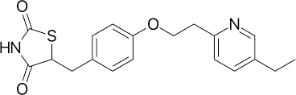

**STRUCTURE OF PIOGLITAZONE**

# Mechanism of Action

Pioglitazone acts as an agonist for the peroxisome proliferator-activated receptor gamma (PPAR- γ). This receptor is predominantly found in adipose tissue but is also present in muscle and liver cells. Activation of PPAR-γ modulates the transcription of insulin-responsive genes involved in glucose and lipid metabolism, leading to:

* Increased insulin sensitivity in peripheral tissues
* Decreased hepatic glucose production
* Improved lipid profiles (increased HDL, decreased triglycerides)

# Indications

Pioglitazone is indicated for:

* Type 2 diabetes mellitus as an adjunct to diet and exercise to improve glycemic control
* It can be used as monotherapy or in combination with other antidiabetic agents such as metformin, sulfonylureas, or insulin.

# Pharmacokinetics

* **Absorption:** Pioglitazone is well absorbed from the gastrointestinal tract, with peak plasma concentrations occurring within 2-4 hours.
* **Distribution:** It is extensively bound to plasma proteins (>99%).
* **Metabolism:** Pioglitazone is metabolized in the liver primarily by CYP2C8 and to a lesser extent by CYP3A4 to active and inactive metabolites.
* **Elimination:** The drug and its metabolites are excreted primarily via the bile and feces, with a minor portion excreted in the urine. The elimination half-life ranges from 3 to 7 hours for the parent drug and 16 to 24 hours for the metabolites.

# Side Effects

**Common side effects include:**

* + Weight gain
  + Edema
  + Headache
  + Myalgia
  + Upper respiratory tract infection

# Serious side effects include:

* + Congestive heart failure
  + Hepatic dysfunction
  + Increased risk of bladder cancer (with long-term use)
  + Fractures (especially in women)
  + Macular edema

# Contraindications

* Hypersensitivity to pioglitazone or any of its components
* Established New York Heart Association (NYHA) Class III or IV heart failure
* Active bladder cancer
* Severe hepatic impairment

# Drug Interactions

* CYP2C8 inhibitors (e.g., gemfibrozil) can increase pioglitazone levels, increasing the risk of adverse effects.
* CYP2C8 inducers (e.g., rifampin) can decrease pioglitazone levels, potentially reducing its efficacy.
* Concurrent use with insulin or insulin secretagogues may increase the risk of hypoglycemia.

# Special Populations

* + **Pregnancy:** Pioglitazone should be used during pregnancy only if the potential benefit justifies the potential risk to the fetus.
  + **Lactation:** It is not known whether pioglitazone is excreted in human milk; caution should be exercised when administered to a nursing woman.
  + **Pediatric Use:** The safety and effectiveness of pioglitazone in pediatric patients have not been established.
  + **Geriatric Use:** Elderly patients may be more sensitive to the drug's effects, particularly the risk of fluid retention and congestive heart failure.

# EXCIPIENT PROFILE

* + 1. **SOYA LECITHINE:**

Soy lecithin is a complex mixture of phospholipids derived from soybeans.

* + - * **Molecular Formula :** C42H80NO8P
      * **soluble in :** Dicholoromethane
      * **boiling point :** 603.7±55.0 °C at 760 mmHg
      * **Molar Mass:** 462.508
      * **IUPAC name :** 1-palmitoyl-2-linoleoylphosphatidylcholine

# Molecular Structure :

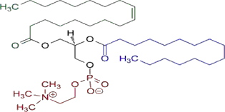

**STRUCTURE OF SOYA LACITHIN**

# Taxonomical classification

* **Kingdom:** Plantae
* **Phylum:** Angiosperms
* **Class:** Eudicots
* **Order:** Fabales
* **Family:** Fabaceae
* **Genus:** Glycine
* **Species:** Glycine max

# Chemical constituent:

Soy lecithin is composed primarily of phospholipids, which are a class of lipids containing a phosphate group. The main phospholipids found in soy lecithin include:

* Phosphatidylcholine (PC)
* Phosphatidylethanolamine (PE)
* Phosphatidylinositol (PI)
* Phosphatidic acid (PA)
* Other minor phospholipids

# Organoleptic Properties:

* **Appearance:** Soy lecithin is typically a pale yellow to brownish-yellow liquid or semi- solid. It may also be available in granular or powdered form.
* **Taste:** Soy lecithin itself is not typically consumed on its own, so it doesn't have a distinct taste. However, in food products where it's used as an emulsifier or stabilizer, it should not impart any noticeable flavor.
* **Odor:** Soy lecithin has a mild, characteristic odor that is often described as slightly fatty or nutty. However, the odor is generally not strong and may not be detectable in finished products.

# CHOLESTEROL :

* + - * **Molecular Formula :** C27H46O
      * **soluble in :** Dicholoromethane

# boiling point : 360℃

* + - * **Melting Point :** 148 to 150℃
      * **Molar Mass:** 386.664 g/mol
      * **IUPAC name :** (3β)-cholest-5-en-3-ol

# Molecular Structure:

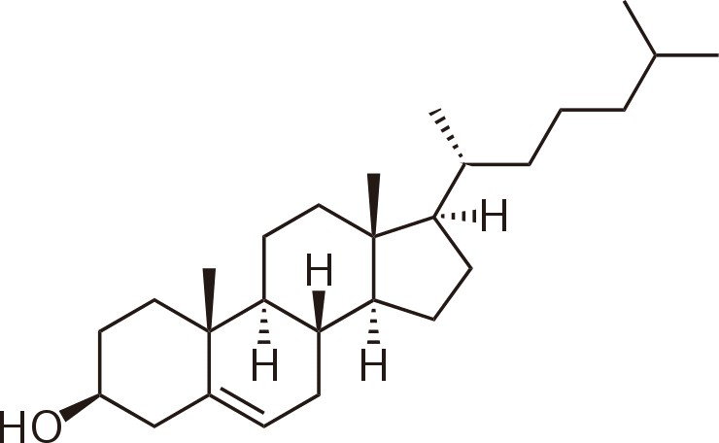

**STRUCTURE OF CHOLESTEROL**

# Functions of Cholesterol

* + - * + **Cell Membrane Structure**: Cholesterol is a crucial component of cell membranes, providing stability and fluidity.
        + **Hormone Production:** It is a precursor for the synthesis of steroid hormones such as estrogen, testosterone, and cortisol.
        + **Vitamin D Synthesis:** Cholesterol is necessary for the production of vitamin D in the skin when exposed to sunlight.

# N HEXANE

N-hexane is a common industrial solvent primarily used in the extraction of vegetable oils, in the production of glues and adhesives, and as a cleaning agent in various industries. However, due to its toxicity, n-hexane is not typically used as an excipient in pharmaceutical formulations. Here's an overview of its properties and potential effects:

# Properties of n-Hexane:

* + - * **Chemical Formula:** C6H14
      * **Molecular Weight:** 86.18 g/mol
      * **Physical State:** Colorless liquid at room temperature
      * **Odor:** Mild, gasoline-like odor
      * **Solubility:** Insoluble in water, soluble in organic solvents

# Chemical structure:



**STRUCTURE OF N HEXANE**

1. **Solvent:** N-hexane is primarily used as a solvent in various industrial processes due to its ability to dissolve fats, oils, and other organic compounds. In pharmaceuticals, it may be used for extraction purposes or in the synthesis of certain drug substances.
2. **Toxicity:** N-hexane is highly toxic and poses serious health risks, especially with prolonged or repeated exposure. Inhalation or dermal exposure to n-hexane vapor or liquid can cause neurological effects, including peripheral neuropathy and damage to the central nervous system. Chronic exposure may lead to symptoms such as numbness, tingling, muscle weakness, and loss of coordination.

# DICHLOROMETHANE

Dichloromethane (DCM), also known as methylene chloride, is primarily used as a solvent in various industries including pharmaceuticals, paint stripping, adhesive manufacturing, and as a propellant in aerosols. While DCM itself is not typically used as an excipient in pharmaceutical formulations due to its toxicity, it may be present as a residual solvent in certain products. Here's a brief overview of DCM's properties and potential effects:

# Properties of Dichloromethane:

* + - * **Chemical Formula:** CH2Cl2
      * **Molecular Weight**: 84.93 g/mol
      * **Physical State:** Colorless liquid at room temperature
      * **Odor:** Sweet, pleasant odor
      * **Solubility:** Soluble in many organic solvents, but only slightly soluble in water

# Chemical Structure:

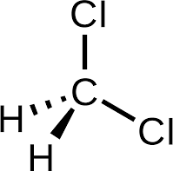

**STRUCTURE OF DICHLOROMETHANE**

# METHANOL:

Methanol, also known as wood alcohol or methyl alcohol, is a chemical compound with the formula \( \text{CH}_3\text{OH} \). Here is an overview of its key properties, production, uses, and safety considerations:

# Properties:

* + - * **Chemical Formula:** \( \text{CH}_3\text{OH} \)
      * **Molecular Weight:** 32.04 g/mol
      * **Physical State:** Colorless liquid at room temperature
      * **Boiling Point:** 64.7°C (148.5°F)
      * **Melting Point:** -97.6°C (-143.7°F)
      * **Density:** 0.7918 g/cm³ at 20°C
      * **Solubility:** Miscible with water, ethanol, ether, and most organic solvents
      * **Odor:** Slightly sweet, alcoholic odor

# Chemical Structure:

***Ashokrao Mane Institute of Pharmacy, Ambap* 18**

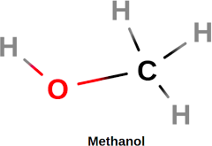

**STRUCTURE OF METEHNOL**

# Uses:

1. **Chemical Feedstock:** Methanol is used as a raw material in the production of formaldehyde, acetic acid, and various other chemicals.
2. **Fuel:** It can be used as a fuel in internal combustion engines and fuel cells, often blended with gasoline or used directly.

# PECTIN

* + - * **Name of polymer :** Pectin.
      * **Chemical Formula:** C6H10O7
      * **IUPAC Name:** Poly[α-D-galactopyranosyluronic acid-(1→4)-α-D- galactopyranosyluronic acid]
      * **Molecular Weight:** 30,000 to 300,000 Daltons

# Chemical Structure:

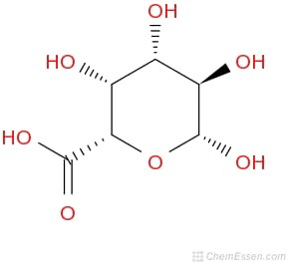

**STRUCTURE OF PECTIN**

# Properties

Pectins are a family of polysaccharides, in which the polymer contains mainly, comprises α- -(1- 4)--D galacturonic acid residues. In the presence of free calcium ions, Low methoxy pectins

(degree of esterification <50%) readily forms gels in aqueous solution, which crosslink the galacturonic acid chains in a manner described by egg-box model. In the presence of H+ ions the gelation of pectin will occur, a source of divalent ions, generally calcium ions is required to produce the gels that are suitable as vehicles for drug delivery.

# SODIUM ALGENATE

* + - * **Name of Polymer:** Sodium Algenate
      * **Chemical Formula:** NA6H7O6
      * **IUPAC Name:** sodium 3,4,5,6-tetrahydroxyoxane-2-carboxylate
      * **molecular Weight:** 216.12 g/mol
      * **Synonyms :** Alginic acid sodium; Kelgin

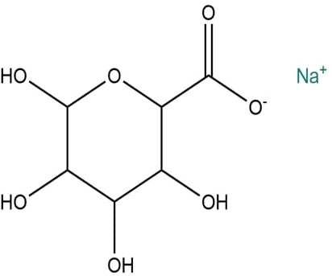

# STRUCTURE OF SODIUM ALGENATE

Sodium Algenate is nothing but compound of alginic acid with Sodium sodium+Alginic acid =Sodium Algenate

# Uses:

Sodium Alginate is a natural ,water -soluble polysaccharide that produce a gel consistency when hydrated and imparts an excellent skin feel . Sodium Alginate has been used in the medical field

,in the food industry,and more recently in cosmetic as a care ingredient.

# MATERIALS AND EQUIPMENTS:

**6.1. Intruments used:**

# Table No:1 List of Instrument

|  |  |  |
| --- | --- | --- |
| **Sr.No.** | **Instruments** | **Equipment Name** |
| 1 | UV Spectrophotometer | Shimadzu UV visible spectrophotometer 1900i |
| 2 | FTIR Spectrophotmeter | Lab Equipment |
| 3 | Sonicator | Labman |
| 4 | Electronic Weighing Balance | Wensar |
| 5 | Rotary evaporator | BUCHI Offices Worldwide |

**1.2. Materials used:**

# Table No:2 List of Material

|  |  |  |
| --- | --- | --- |
| **Sr No.** | **Materials** | **Supplier** |
| 1 | Pioglitazone | ANGEL BIOPHARMA |
| 2 | Soyalecithine | RESEARCH-LAB FINE CHEM INDUSTRIES |
| 3 | Methanol | LOBA Chemie |
| 4 | Dicloromethane | LOBA Chemie |
| 5 | n-hexane | LOBA Chemie |
| 6 | Cholesterol | LOBA Chemie |
| 7 | Distilled Water | LOBA Chemie |

**EXPERIMENTAL WORK**

# PREFORMULATION STUDIES

* + 1. **SOLUBILITY**

Label beakers for solvents (water, ethanol, methanol) and add 50 mL of each. Add excess pioglitazone to each beaker. Stir at room temperature to reach equilibrium. Filter solutions to remove undissolved pioglitazone.

# MELTING POINT

For melting point determination, we used thiel’s tube determination method.

# CALIBRATION BY UV SPECTROPHOTOMETER

Weigh 10 mg of Pioglitazone accurately and dissolve it in ethanol to create a 100 mL stock solution. Prepare dilutions of Pioglitazone in ethanol to obtain the required concentrations. (5,10,15,20,25µg/mL) Use ethanol as a blank and fill a quartz cuvette with ethanol. Place the cuvette in a spectrophotometer and zero the instrument at 224 nm. Measure the absorbance of each standard solution at the λ_max and record the absorbance for each concentration.

# IR SPECTROSCOPY OF DRUG

The KBr Pellet method involves weighing and grinding a small amount of pioglitazone with 100 mg of KBr to create a homogeneous mixture. The mixture is then transferred into a pellet die and compressed using a hydraulic press to form a thin, transparent pellet. The Bruker IR spectrometer is set up, and the software is initialized. A background spectrum is measured with no sample in place, or using a clean KBr pellet. The sample is placed in the sample holder and the pioglitazone is placed directly onto the ATR crystal. Parameters such as resolution, number of scans, and wavenumber range are set. The data acquisition process begins to collect the IR spectrum of the pioglitazone sample.

# METHOD OF PREPARATION

* + 1. **FORMULATION OF PHYTOSOMES**

Central Composite Design (CCD) is a statistical technique used for optimizing formulations by studying the effects of multiple factors and their interactions. When formulating pyhtosomes using plioglitazone and Cholesterol, CCD can help in determining the optimal concentrations of these components to achieve desirable characteristics such as particle size, encapsulation efficiency, and stability

# Table No: Central Composite Design

|  |  |  |  |  |  |  |  |
| --- | --- | --- | --- | --- | --- | --- | --- |
| **Std** | **ID** | **Run** | **Build Type** | **Space Type** | **Row Status** | **Factor 1 A:Cholesterol**  **mg** | **Factor 2**  **B: Soya mg** |
| 12 | 5 | 1 | NA | Center | Normal | 75 | 600 |
| 10 | 5 | 2 | NA | Center | Normal | 75 | 600 |
| 7 | 7 | 3 | NA | Factorial | Normal | 50 | 800 |
| 1 | 1 | 4 | NA | Factorial | Normal | 50 | 400 |
| 9 | 9 | 5 | NA | Factorial | Normal | 100 | 800 |
| 13 | 5 | 6 | NA | Center | Normal | 75 | 600 |
| 3 | 3 | 7 | NA | Factorial | Normal | 100 | 400 |
| 6 | 6 | 8 | NA | CentEdge | Normal | 100 | 600 |
| 5 | 5 | 9 | NA | Center | Normal | 75 | 600 |
| 8 | 8 | 10 | NA | CentEdge | Normal | 75 | 800 |
| 11 | 5 | 11 | NA | Center | Normal | 75 | 600 |
| 2 | 2 | 12 | NA | CentEdge | Normal | 75 | 400 |
| 4 | 4 | 13 | NA | CentEdge | Normal | 50 | 600 |

* + 1. **METHOD OF PREPARATION OF PHYTOSOMES**

Rotary evaporation process: Specific weight of herbal extract and phospholipids were mixed in 30 ml water miscible organic solvent like acetone in round bottom glass container followed by stirring for two hours at a temperature but 50°C in rota evaporator. Antisolvent like n- hexane are often added to thin film which is obtained after uninterrupted stirring employing a stirrer [13]. Precipitate of phytosomes obtained are often stored in amber colored glass container at controlled temperature under specified humidity. Phospholipids solubilized in ether are slowly injected drop wise in an solution of the phytoconstituents which is to be encapsulated. It leads to the formation of cellular vesicles on subsequent solvent abstraction, resulting in involute formation [14]. Structure of phytosomes depends upon concentration amphiphiles in mono state are produced when the concentration is a smaller amount, but sort of structures with different shapes viz. round, cylindrical, disc and cubic or hexagonal vesicle s could also be formed on increasing the concentration [15].

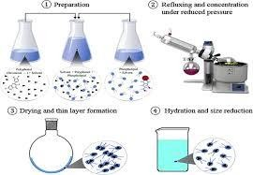

# Fig No:2 METHOD OF PREPARATION OF PHYTOSOMES

* 1. **EVALUATIONS**

# PARTICLE SIZE:

The particle size of pioglitazone-loaded phytosomal in situ gel typically falls within the nanometer range, usually between 100 to 300 nanometers (nm). This size range enhances the bioavailability, stability, and therapeutic efficacy of the drug by improving solubility, protecting from degradation, and allowing for better penetration of biological membranes. Techniques like Dynamic Light Scattering (DLS) and Transmission Electron Microscopy (TEM) are commonly used to measure and confirm the particle size and distribution.

# ENTRAPMENT EFICIENCY :

* + - 1. Transfer the suspension containing pioglitazone-loaded phytosomes into centrifuge tubes.
      2. Centrifuge the tubes at a predetermined speed and time to separate the phytosomes from unencapsulated pioglitazone and other components.
      3. After centrifugation, a pellet containing pioglitazone-loaded phytosomes will form at the bottom of the tubes.

# Analysis of Entrapment Efficiency:

1. Resuspend the washed pellet in a known volume of buffer solution.
2. Disrupt the phytosomes using a suitable method (e.g., sonication) to release the encapsulated pioglitazone.
3. Filter the suspension through a 0.22 µm pore size filter membrane to remove any debris or undispersed particles.
4. Analyze the filtrate using HPLC to quantify the amount of pioglitazone present.
5. Calculate the amount of pioglitazone encapsulated in the phytosomes using a standard curve generated from known concentrations of pioglitazone.
6. Calculate the entrapment efficiency using the formula:
7. Entrapment Efficiency (%)=Total Amount of Pioglitazone AddedAmount of Pioglita zone Entrapped in Phytosomes×100

# Table No:4 Central Composite Design with response

|  |  |  |  |  |  |  |  |  |  |
| --- | --- | --- | --- | --- | --- | --- | --- | --- | --- |
| **Std** | **ID** | **Run** | **Build**  **Type** | **Space Type** | **Row Status** | **Factor 1**  **A:Cholesterol mg** | **Factor 2**  **B: Soya mg** | **Response 1**  **PSnm** | **Response 2**  **EE%** |
| 12 | 5 | 1 | NA | Center | Normal | 75 | 600 | 242.282 | 82.69 |
| 10 | 5 | 2 | NA | Center | Normal | 75 | 600 | 241 | 79.22 |
| 7 | 7 | 3 | NA | Factorial | Normal | 50 | 800 | 519 | 81.31 |
| 1 | 1 | 4 | NA | Factorial | Normal | 50 | 400 | 298.5 | 66.42 |
| 9 | 9 | 5 | NA | Factorial | Normal | 100 | 800 | 154.7 | 94.31 |
| 13 | 5 | 6 | NA | Center | Normal | 75 | 600 | 515 | 80.22 |
| 3 | 3 | 7 | NA | Factorial | Normal | 100 | 400 | 280 | 87.21 |
| 6 | 6 | 8 | NA | CentEdge | Normal | 100 | 600 | 371 | 88.22 |
| 5 | 5 | 9 | NA | Center | Normal | 75 | 600 | 378 | 83.01 |
| 8 | 8 | 10 | NA | CentEdge | Normal | 75 | 800 | 227 | 77.22 |
| 11 | 5 | 11 | NA | Center | Normal | 75 | 600 | 239 | 74.23 |
| 2 | 2 | 12 | NA | CentEdge | Normal | 75 | 400 | 324 | 71.26 |
| 4 | 4 | 13 | NA | CentEdge | Normal | 50 | 600 | 424 | 76.32 |

* + 1. **PRAPARATION OF IN SITU GEL**

Initially weighed drug and caco3 were added in beaker A containing 5 ml hcl solution and both the drug and caco3 was made to dissolve. Same was done by using sodium alginate and pectin in beaker B with same amount of hcl.

Further more Contents of beaker A was poured in beaker B and were mixed uniformly making the final solution.

This final solution was sonicated on sonicator instrument at a temp of 37°C for uniformity purpose.

# EVALUATION TEST OF GEL

* + 1. **Physical appearance and pH**

By visually inspecting the solution, the color of the floating in situ gel formulations was assessed. A digital pH meter **(name)** was used to measure the pH of the formulations in triplicate at room temperature.

# Viscosity measurement

A Brookfield digital viscometer (LMDV-60) with spindle number 2 was used to measure the viscosity of the floating in situ gel solution of HCl. The studies were carried out in triplicate and the temperature was maintained at 31.1 ± 1 ◦C and speed at 60.0 RPM during each measurement.

# Density measurement

100 ml of 0.1 N hydrochloric acid was prepared in a 1000 ml measuring cylinder. Take 10 ml HCL solution in situ gel solution (5 ml) was added and volume and weight were recorded. The density (g/ml) of the floating in situ gel of HCl was calculated, and it should be less than the density of the gastric content [19]. The measurement was repeated at least 3 times and reported as mean and standard deviation.

# Floating behavior

The floating behavior of floating in situ gel of HCl has carried out by introducing the in situ gel solution (2 ml) into 10 ml of 0.1 N HCl (pH 1.2) at 37 ◦C. The floating lag time and duration of the floating time were then collected. The floating lag time was the time needed for the gels to rise to the surface of the medium and the floating time was the overall amount of time the gels remained floating on the medium surface [24]. The experiment was performed in triplicate. Mean and standard deviation was calculated and reported.

# Drug content uniformity

The prepared in situ gel solution was analyzed for drug content using the validated method recommended by USP [28]. Take 2 ml of prepared gel in 10 ml of density bottle and make up the volume by 0.01N HCL. The mixture was then sonicated for 60 min. After that, the mixture was filtered with a filter peper and measured for its absorbance with UV-spectrophotometer **(name)** at a wavelength of 267 nm. The experiment was carried out three times.

# In vitro drug release

The prepared in situ gel solution was analyzed for drug release using a USP dissolution apparatus type II (paddle). 10 ml of the prepared in situ gel solution was injected into the 900 ml of medium (0.1 N HCl ). The operating speed was 25 rpm, and the medium solution was stored at 37℃ to simulate the conditions of the gastric. Mixture (30 ml) were taken out of the medium and 900 ml of 0.01N HCL to maintain the sink condition after 30, 60, 90, 120, 150,

180, 210, 240, 270 and 300 min. Then withdraw 5 ml sample and add in 5 ml HCL. The HCl concentration in samples was determined as a cumulative percentage release by using a UV- spectrophotometer at a wavelength of 267 nm. The assessment was performed in triplicate. [29,30].

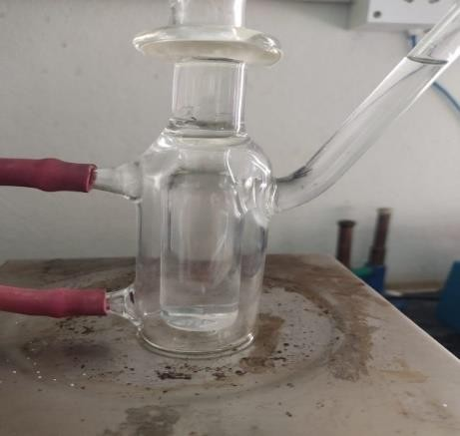

# Fg No:3 IN VITRO DRUG RELEASE OF PIOGLITAZONE

**RESULT AND DISCUSSION:**

# Organoleptic Properties

**Table No:5 Organoleptic Properties**

|  |  |
| --- | --- |
| **Criteria** | **Observation** |
| **Colour** | White to off white |
| **Odour** | Odourless |
| **Nature** | Crystalline powder |

# Solubility of Pioglitazone

Pioglitazone is having low solubility in water, but it is moderately soluble in organic solvents like ethanol, methanol.

# Table No:6 Solublity

|  |  |
| --- | --- |
| Solvent | Solubility |
| Water | Low solubility |
| Ethanol | Soluble |
| Methanol | Soluble |

* 1. **Melting Point**

For pioglitazone, the experimentally determined melting point typically falls within a specific range. The melting point of pioglitazone is generally reported to be 184°C.

# Characterization by UV Spectrophotometer

The results of the standard curve for pioglitazone using a UV spectrometer indicate a linear relationship between the concentration of pioglitazone and the absorbance readings at a specific wavelength. The drug had λ max of 272.0 nm.

# Table No:7 Characteristics of UV

|  |  |
| --- | --- |
| Concentration (µg/mL) | Absorbance |
| 5 | 0.2228 |
| 10 | 0.3608 |
| 15 | 0.5171 |
| 20 | 0.6908 |
| 25 | 0.8328 |

**Fig No:15 Absorbance Spectra of Pioglitazone**



Absorbance Spectrum of Pioglitazone

1

0.8

y = 0.031x + 0.0599

R² = 0.9986

0.6

0.4

0.2

0

0

5

10

15

Concentration

20

25

30

Absorbance

# FigNo:16 Absorbance Maxima of Pioglitazone

* 1. **Charecterization By IR**

# Drug FTIR

The infrared (IR) spectroscopy results of pioglitazone HCL indicate characteristic peaks corresponding to functional groups present in the molecule. Common peaks observed include a broad peak around 3300 cm^-1 corresponding to the N-H stretching vibration, peaks around 1700- 1750 cm^-1 indicating the presence of carbonyl groups, and peaks around 1500-1600 cm^-1 corresponding to aromatic C=C stretching vibrations. Additionally, peaks in the fingerprint region (below 1500 cm^-1) provide further structural information. These results confirm the identity and structural features of pioglitazone HCL, aiding in its characterization

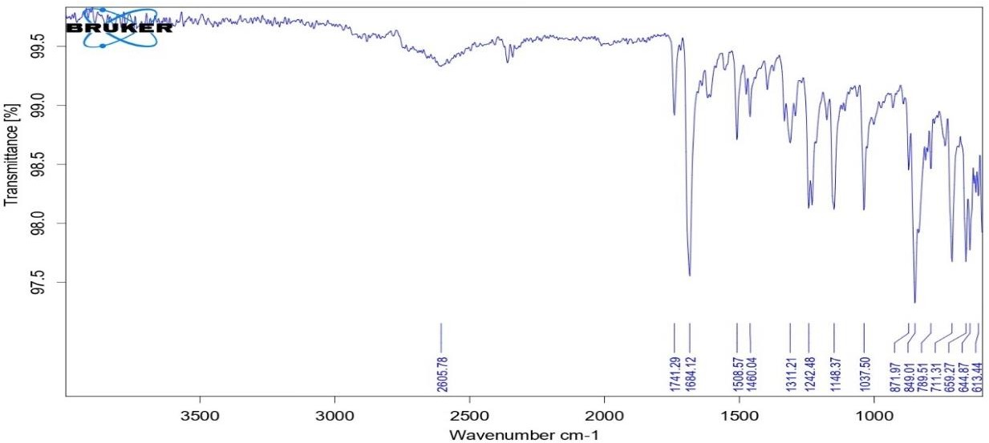

# No:17 Drug FTIR Table No:8 Drug FTIR

**Fig**

# Drug And Polymer FTIR

The infrared (IR) spectroscopy results of the combination of pioglitazone, soya lecithin, and cholesterol indicate distinct peaks corresponding to the functional groups present in each compound. Common peaks observed include those for pioglitazone, such as the N-H stretching vibration around 3300 cm^-1, carbonyl groups around 1700-1750 cm^-1, and aromatic C=C stretching vibrations around 1500-1600 cm^-1. Peaks corresponding to spam 60 and cholesterol functional groups will also be present, providing additional information about their chemical structures. These results aid in the characterization and analysis of the mixture, facilitating the identification and quantification of each compound present.

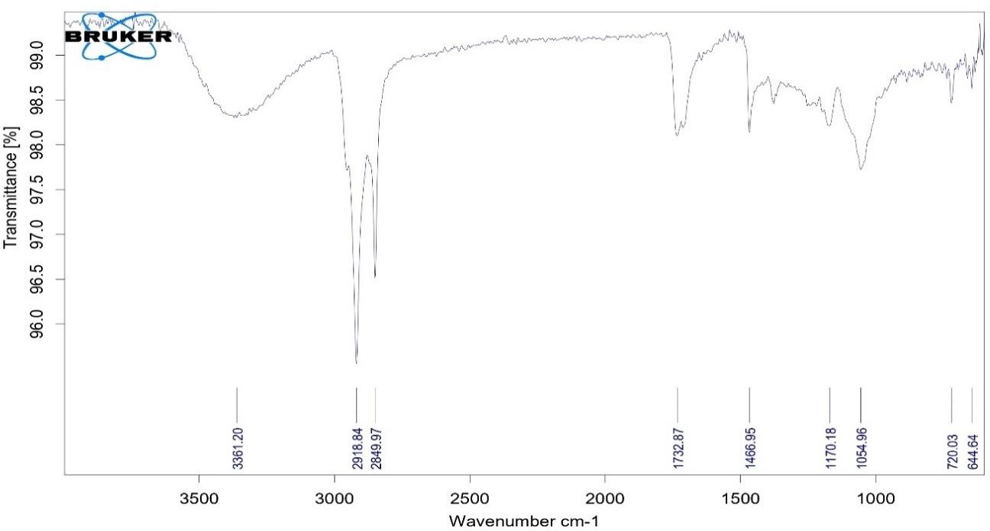

# Fig No:18 Drug And Polymer FTIR

* 1. **Particle Size**

The average particle size of pioglitazone loaded phytosome was found to be 230 nm. of optimum batch F10. And The zeta values for phytosomal formulations were found to be in range of -15.04

± 0.45 mV to -31.04 ± 0.25 mV as shown in Table 3. The zeta potential of the phytosome under study was found to be 31.04 ± 0.25 mV as shown in Figure 1. The results revealed that the zeta values of the vesicles increase toward negative with increasing the HLB values of the surfactants. The effect of HLB values of surfactants on zeta potential could be explained in terms of surface energy, which tends to increase with increase in HLB values toward the hydrophilicity. Increase in surface energy of the vesicles

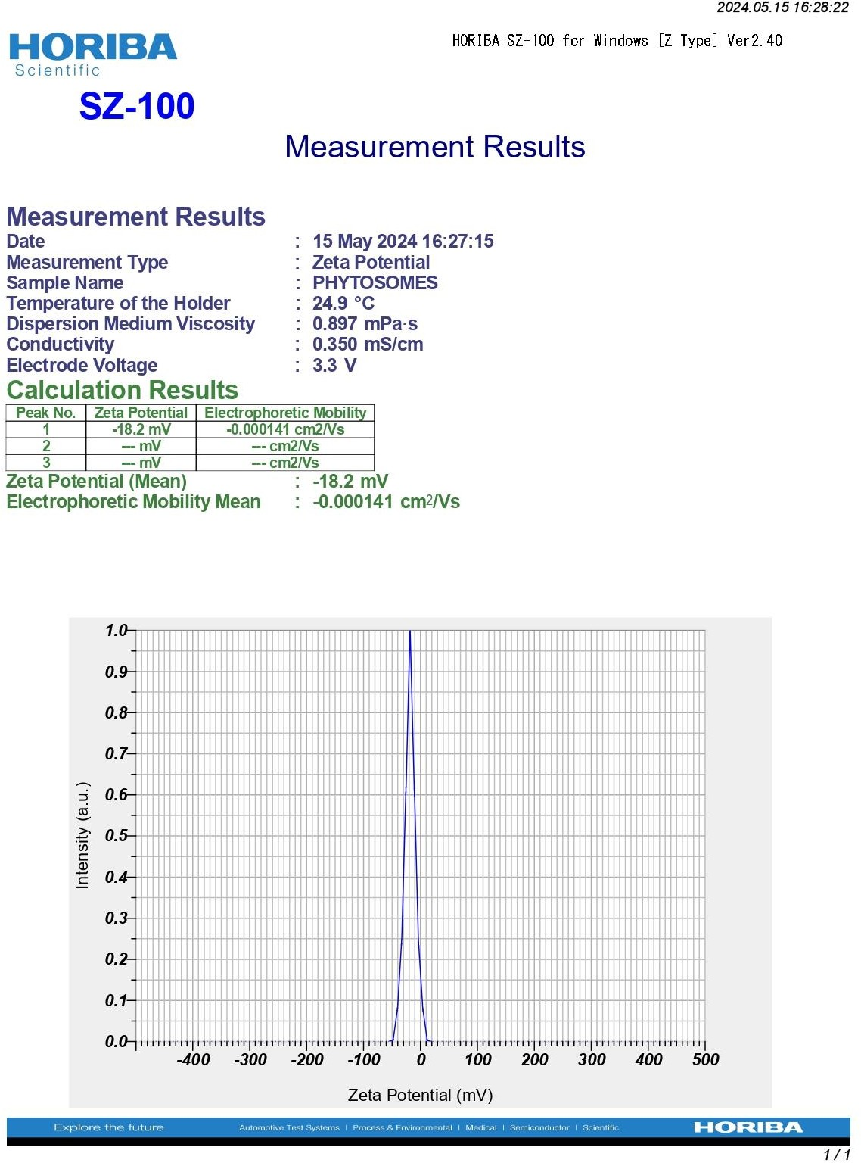

# Fig No:19 Particle size

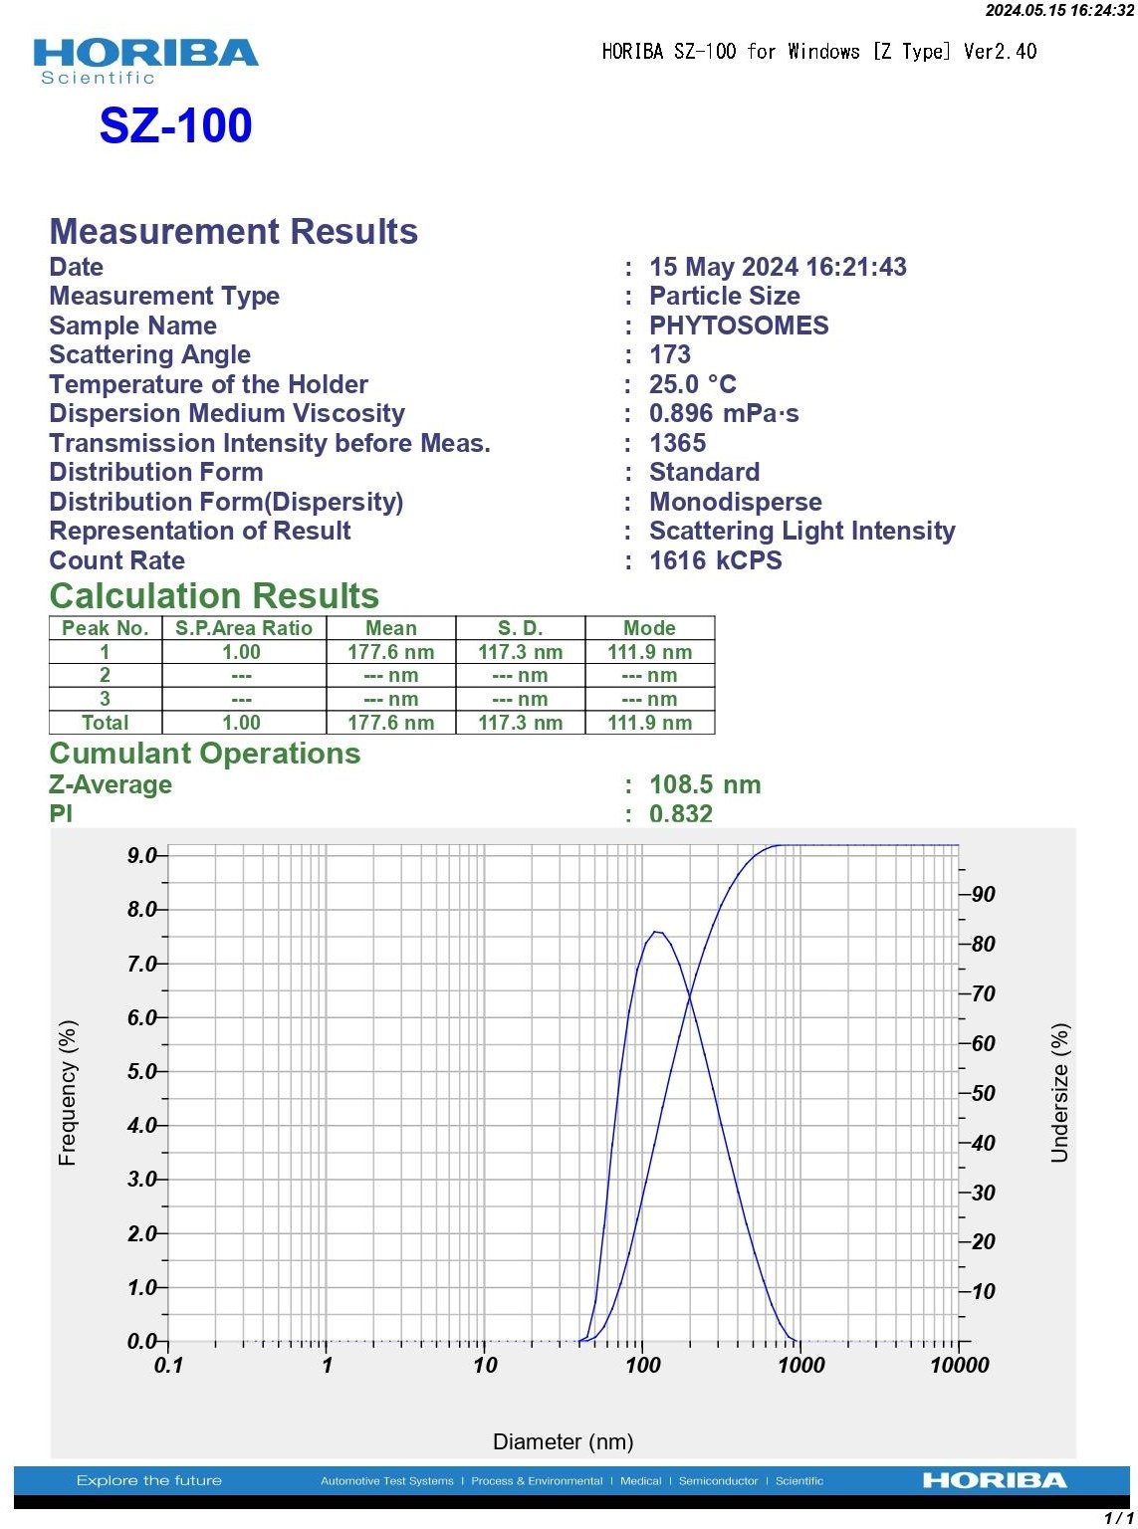

**Fig No:20 Zeta Potential**

# CONCLUSION

* The study successfully formulated and evaluated pioglitazone phytosomes in an oral in situ gel, enhancing the drug’s solubility, stability, and bioavailability.
* The gel, designed for sol-to-gel transition at physiological temperatures, provided sustained drug release and prolonged gastric residence time.
* In vivo studies demonstrated significant antidiabetic activity, with marked reductions in blood glucose levels compared to plain pioglitazone.
* This innovative delivery system shows great promise for improving diabetes management, warranting further clinical investigation to confirm its efficacy and safety in humans.

# REFERANCE

1. Shukla A, Pandey V, Shukla R, Bhatnagar P, Jain S, “Herbosomes’: A Current Concept of Herbal Drug Technology- An Overview”, Journal of Medical Pharmaceutical and Allied Sciences, 2012,1;39-56.
2. Goyal A, Kumar S, Nagpal M, Singh I, Arora S, “Potential of Novel Drug Delivery Systems for Herbal Drugs”, Indian Journal of Pharmaceutical Education and Research, Jul-Sep 2011, 45(3);225- 235.
3. Gandhi A, Dutta A, Pal A, Bakshi P, “Recent Trends of Phytosomes for Delivering Herbal Extract with Improved Bioavailability”, Journal of Pharmacognosy and Phytochemistry, 2012, 1(4);6-14.
4. Sharma S, Sikarwar M: Phytosome: A review, Plant indica 2005; 1(2): 1-3.
5. Bombardelli E: Phytosome: New cosmetic delivery, Boll chim farm 1991; 130(11): 431- 438.
6. Semalty A, Semalty M, Rawat MS, Franceschi F. Supramolecular phospholipids- polyphenolics interactions: The phytosome strategy to improve the bioavailability of phytochemicals. Fitoterapia2010;81(5):306-14.
7. Gandhi A, Dutta A, Pal A, Bakshi P. Recent trend of phytosomes for
8. delivering herbal extract with improved bioavailability. J Pharmacogn Phytochem 2012;1(4):6.
9. Bhattacharya S. Phytosomes: the new technology for enhancement of bioavailability of botanicals and nutraceuticals. Int J Health Res. 2009;2(3):225–232. doi: 10.4314/ijhr.v2i3.47905 [CrossRef] [Google Scholar]
10. Kidd P, Head K. A review of the bioavailability and clinical efficacy of milk thistle phytosome: a silybin-phosphatidylcholine complex (Siliphos). Altern Med Rev. 2005;10(3):193–203. [PubMed] [Google Scholar]
11. Nagar G. Phytosomes: a novel drug delivery for herbal extracts. Int J Pharm Sci Res. 2019. doi:11.13040/IJPSR.0975-8232.4(3).949-59 [CrossRef] [Google Scholar]
12. Franco P, Bombardelli E. Complex compounds of bioflavonoids with phospholipids, their preparation and uses and pharmaceutical and cosmetic compositions containing them. US Patent No-EPO. 1998:275005.
13. Dewan N, Dasgupta D, Pandit S, Ahmed P. Review on-herbosomes, A new arena for drug delivery. J Pharmacogn Phytochem. 2016;5(4):104. [Google Scholar]