**Potential Benefits of Pedalium murex in Reproductive Health**

**An Ethnopharmacological Perspective**

**Dr. Sanjay Kumar Acharya1 Dr. Suman Lata Tripathi2**

**Department of Botany, Govt. Dungar College, Bikaner**

**Abstract**

Pedalium murex commonly known as "large caltrops," is a medicinal plant used in traditional systems like Ayurveda and Siddha for its therapeutic properties, particularly in reproductive health. This review explores the ethnopharmacological potential of *Pedalium murex* in addressing various reproductive health issues, drawing on historical and contemporary knowledge. The plant's rich phytochemical profile, including flavonoids, glycosides, saponins, and tannins, contributes to its medicinal properties, making it a valuable resource in natural therapies for both male and female reproductive disorders.

In traditional medicine, *Pedalium murex* has been widely used as an aphrodisiac, to treat infertility, and to manage sexual dysfunctions. It has shown potential in enhancing libido, improving sperm quality and motility, and addressing erectile dysfunction in men. For women, the plant has been traditionally used to regulate menstruation, manage leucorrhea, and improve fertility. The anti-inflammatory and antioxidant properties of *Pedalium murex* are believed to support reproductive health by reducing oxidative stress and inflammation, both of which are implicated in reproductive disorders.

Scientific studies have corroborated many of these traditional claims, with research indicating that *Pedalium murex* extracts may improve sperm parameters and enhance reproductive hormone regulation. Additionally, its diuretic and antimicrobial properties make it useful in managing urinary tract infections, which can affect reproductive health. However, while preliminary findings are promising, further pharmacological and clinical studies are necessary to fully validate its efficacy and establish standardized therapeutic dosages.

In conclusion, *Pedalium murex* represents a promising natural remedy for reproductive health, offering a holistic approach that integrates traditional knowledge with modern pharmacological insights. Its potential as a safe, effective treatment for reproductive disorders warrants more comprehensive research to explore its full therapeutic scope.

**Keywords:** Medicinal plant**,** Ayurveda, Ethnopharmacological potential, flavonoids, glycosides, saponins, and tannins.

**Introduction**

Reproductive health is a critical component of overall well-being, affecting both men and women across various stages of life. In traditional medicine, plants with medicinal properties have played an essential role in managing reproductive health issues, offering natural remedies that often have fewer side effects compared to modern pharmaceutical drugs. One such plant with significant Ethnomedicinal value is *Pedalium murex* Linn, commonly known as "large caltrops." Widely distributed in tropical regions, including India, this plant has long been revered in Ayurveda, Siddha, and folk medicine for its potential benefits in treating reproductive disorders.

*Pedalium murex* has a rich phytochemical composition, containing bioactive compounds such as flavonoids, saponins, glycosides, and tannins. These compounds have been associated with various pharmacological activities, including antioxidant, anti-inflammatory, diuretic, and antimicrobial properties, making the plant a valuable therapeutic agent. In traditional systems, *Pedalium murex* has been used to address a wide range of reproductive health problems, including sexual dysfunction, infertility, and menstrual irregularities.

For men, the plant is known for its aphrodisiac properties, helping to enhance libido and improve sperm quality and motility. It has also been used to manage conditions such as erectile dysfunction and urinary tract infections, both of which can impact male reproductive health. For women, *Pedalium murex* has traditionally been used to regulate menstruation, alleviate symptoms of leucorrhea, and promote fertility.

This ethnopharmacological perspective seeks to explore the historical uses of *Pedalium murex* in reproductive health and examine the scientific evidence supporting its efficacy. By bridging traditional knowledge with modern research, we aim to highlight the plant’s potential as a natural, holistic treatment for reproductive health issues, underscoring the need for further clinical validation.

**Aim of the Study**

The aim of this study is to explore and evaluate the potential benefits of *Pedalium murex* in reproductive health from an ethnopharmacological perspective. Specifically, the study seeks to investigate the traditional uses of *Pedalium murex* in treating reproductive disorders, such as sexual dysfunction, infertility, and menstrual irregularities, while examining its pharmacological properties, including aphrodisiac, anti-inflammatory, and antioxidant activities. By integrating traditional knowledge with modern scientific findings, the study aims to provide a comprehensive understanding of *Pedalium murex* as a natural remedy for reproductive health, and to highlight its potential for future clinical applications in both male and female reproductive health management. The primary aim of this study is to analyze the ethnopharmacological applications of *Pedalium murex* in improving reproductive health, with a focus on both male and female reproductive disorders. This study aims to examine the traditional knowledge surrounding its use, assess the bioactive compounds responsible for its therapeutic effects, and evaluate existing scientific evidence on its role in managing conditions such as infertility, sexual dysfunction, and menstrual irregularities. This study aims to investigate the therapeutic potential of *Pedalium murex* in reproductive health by exploring its traditional medicinal uses in ethnobotanical practices. The study will focus on assessing the pharmacological properties that contribute to its reproductive health benefits, such as its aphrodisiac, hormone-regulating, and anti-inflammatory effects. Additionally, it will aim to provide insights into the plant's potential as a complementary treatment in modern reproductive health therapies. The objective of this study is to critically assess the role of *Pedalium murex* in reproductive health management from an ethnopharmacological standpoint. By investigating its historical applications in traditional medicine, the study aims to identify the mechanisms through which *Pedalium murex* exerts its effects on fertility, sexual function, and menstrual health. Additionally, the study seeks to bridge the gap between traditional knowledge and modern pharmacological research to validate its clinical relevance.

**Review of Literature**

Early accounts of the medicinal uses of *Pedalium murex* date back to classical Indian references. Chopra et al. (1956) (2) in their *Glossary of Indian Medicinal Plants*, detail the plant's use in treating reproductive and urinary disorders. Similarly, Nadkarni (1976) (4) in *Indian Materia Medica*, highlights its effectiveness in enhancing sexual function, treating leucorrhea, and acting as a diuretic to support reproductive health. These historical texts underscore the plant's longstanding value in Indian traditional medicine.

Sharma et al. (2002) (8) further elaborate on the plant’s uses in Ayurveda, emphasizing its role in balancing the body's doshas (humors), which is critical for maintaining reproductive health in both genders. Their research in the *Database on Medicinal Plants Used in Ayurveda* also documents its applications in promoting fertility and regulating menstrual cycles, which is consistent with traditional practices.

Pharmacognostic studies, such as those by Kokate et al. (2010) (3) provide a detailed chemical analysis of *Pedalium murex*, revealing the presence of flavonoids, saponins, and tannins. These compounds are known for their antioxidant, anti-inflammatory, and antimicrobial properties, which contribute to the plant’s ability to protect reproductive tissues from oxidative damage and infections.

Balamurugan et al. (2014) (1) examined the aphrodisiac and spermatogenic effects of *Pedalium murex* in male rats and found that the plant extract significantly enhanced libido, sperm count, and motility. Their findings suggest that the plant's bioactive compounds, particularly its flavonoids, contribute to improving male reproductive health by reducing oxidative stress and supporting hormonal balance.

Several studies focus specifically on the effects of *Pedalium murex* in male fertility. Pawar et al. (2012) (5) discuss its ability to enhance sperm quality, particularly in cases of alcohol-induced infertility. The study suggests that the plant’s antioxidant properties play a crucial role in reversing oxidative damage to sperm cells and improving overall reproductive outcomes.

Sharma et al. (2013) (9) also highlight *Pedalium murex*’s role as an aphrodisiac in their study published in the *Asian Journal of Pharmaceutical and Clinical Research*. They found that the plant improved spermatogenesis and restored sperm viability in experimental models. This further supports its use as a therapeutic agent in male reproductive health disorders.

In addition to its benefits for male fertility, *Pedalium murex* has shown promise in treating female reproductive health issues. Shukla and Tiwari (2016) (7) in their ethnobotanical study, documented its use by rural communities in Madhya Pradesh for managing menstrual disorders and enhancing fertility. The plant's anti-inflammatory and antimicrobial properties make it suitable for treating conditions like leucorrhea and infections that affect female fertility.

Rao and Singh (2013) (6) also explored the use of *Pedalium murex* in treating menstrual irregularities and promoting ovulation in women. Their study, published in the *Ayurveda Research and Treatment Journal*, highlights the plant’s ability to support hormonal regulation, which is critical for reproductive health.

**Classification and Morphology of Pedalium murex**

Kingdom: Plantae

Phylum: Angiosperms

Order: Lamiales

Family: Pedaliaceae (Sesame family)

Genus: *Pedalium*

Species: *Pedalium murex* L.

This classification places *Pedalium murex* within the Pedaliaceae family, which is known for its small group of flowering plants, including the more commonly known sesame (*Sesamum indicum*). *Pedalium murex* is a valuable plant in traditional medicine due to its diverse pharmacological properties. Species:  *Pedalium murex* L.

*Pedalium murex*, commonly known as "large caltrops" or "gokhru," is a herbaceous plant with distinct morphological characteristics:

|  |  |
| --- | --- |
| **Roots** | The plant has a taproot system, with slender, fibrous roots that penetrate deep into the soil, aiding its growth in dry, sandy environments. |
| **Stem** | The stems are soft, succulent, and branched, with a light green color. They are covered with fine glandular hairs, which give them a sticky texture when touched. |
| **Leaves** | The leaves are simple, alternate, and oblong or ovate in shape. They are 3–7 cm long and have a somewhat fleshy texture. The margins of the leaves are serrated or toothed. The leaves are also covered in glandular hairs, which give them a sticky or slightly rough feel. |
| **Flowers** | The flowers of *Pedalium murex* are yellow and tubular, solitary or paired in the axils of the leaves. They have a funnel-shaped corolla, about 1–2 cm long, with five lobes, resembling a small trumpet. The flowers are hermaphroditic, containing both male (stamens) and female (pistil) reproductive organs. |
| **Fruits** | The fruit is a small, woody, four-angled capsule, usually around 1–1.5 cm in diameter, with sharp spines or thorns on its surface. The capsules contain seeds and are easily dispersed by clinging to animal fur or human clothing. |
| **Seeds** | The seeds are small, oval, and smooth, typically brown or reddish-brown in color. Each fruit contains several seeds. |

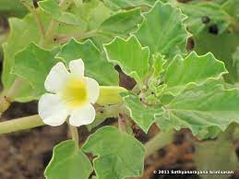 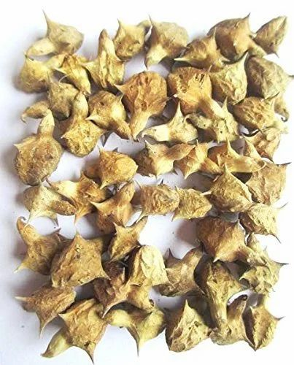 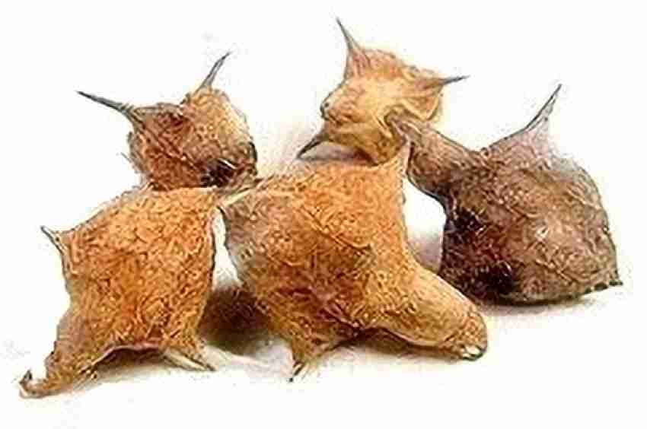

**Bioactive Compounds Found in Pedalium murex**

*Pedalium murex* contains a variety of bioactive compounds that contribute to its medicinal properties. These compounds are primarily responsible for its therapeutic effects, including anti-inflammatory, antioxidant, aphrodisiac, and diuretic activities. Some of the key bioactive compounds found in *Pedalium murex* are:

|  |  |
| --- | --- |
| **Flavonoids** | These compounds are known for their antioxidant and anti-inflammatory properties. In *Pedalium murex*, flavonoids help in neutralizing free radicals and reducing oxidative stress, which is beneficial for overall health and reproductive wellness. |
| **Saponins** | Saponins are known for their role in immune modulation and their ability to act as natural diuretics. In *Pedalium murex*, saponins also contribute to its aphrodisiac properties, supporting sexual health by improving libido and enhancing reproductive function. |
| **Glycosides** | Glycosides have multiple therapeutic properties, including antioxidant and antimicrobial activities. These compounds play a role in protecting against infections and promoting reproductive health by supporting hormonal balance. |
| **Tannins** | Tannins in *Pedalium murex* possess astringent and antimicrobial properties. They contribute to wound healing, improve tissue integrity, and are useful in treating various reproductive health disorders, including leucorrhea and urinary tract infections. |
| **Sterols** | Phytosterols, such as sitosterol, found in *Pedalium murex* are essential for their role in regulating cholesterol levels and maintaining hormonal balance, which can aid in reproductive health. |
| **Mucilage** | The mucilage content in *Pedalium murex* acts as a soothing agent, especially for the mucous membranes of the urinary and reproductive systems, making it effective in treating conditions like urinary tract infections and reproductive tract inflammation. |

These bioactive compounds collectively contribute to the medicinal benefits of *Pedalium murex*, particularly in reproductive health, making it a valuable plant in both traditional and modern herbal medicine.

**Role of Pedalium murex in Male Fertility**

*Pedalium murex* has long been used in traditional medicine for its beneficial effects on male fertility. Its rich phytochemical composition, including flavonoids, saponins, and sterols, contributes to its role in improving reproductive health in men. The mechanisms by which *Pedalium murex* supports male fertility are diverse and primarily involve the following aspects:

|  |  |
| --- | --- |
| **Aphrodisiac Properties** | *Pedalium murex* is known for its aphrodisiac effects, which help improve sexual desire and performance. The bioactive compounds, particularly saponins, help enhance libido by stimulating androgen production, which plays a crucial role in sexual drive and reproductive function. |
| **Improvement in Sperm Quality** | Studies have shown that *Pedalium murex* can improve sperm quality by enhancing sperm motility, count, and viability. This is largely attributed to its antioxidant properties, which help protect sperm cells from oxidative damage. Oxidative stress is a major factor in male infertility, leading to reduced sperm function. The flavonoids and sterols in *Pedalium murex* act as potent antioxidants, neutralizing free radicals and supporting healthier sperm. |
| **Hormonal Balance** | *Pedalium murex* has been observed to have a positive effect on reproductive hormone levels, particularly testosterone. Testosterone is critical for maintaining libido, spermatogenesis (sperm production), and overall sexual health. By supporting the natural regulation of testosterone, *Pedalium murex* helps enhance male reproductive function. |
| **Anti-inflammatory and Antimicrobial Effects** | Chronic inflammation and infections, particularly in the reproductive and urinary tracts, can impair fertility. The anti-inflammatory and antimicrobial properties of *Pedalium murex* help alleviate such conditions, promoting better reproductive health by reducing inflammation and eliminating microbial infections that can impact fertility. |
| **Support for Erectile Function** | *Pedalium murex* has been used traditionally to address erectile dysfunction. Its vasodilatory properties, likely stemming from its flavonoid content, help improve blood flow to the reproductive organs, enhancing erectile function and improving sexual performance. |

In summary, *Pedalium murex* plays a multifaceted role in enhancing male fertility by improving sperm quality, boosting libido, regulating hormonal balance, and addressing issues like erectile dysfunction and reproductive tract infections. These effects make it a promising natural remedy for male infertility, especially when combined with a healthy lifestyle and proper medical care.

**Role of Pedalium murex in Female Fertility**

*Pedalium murex*, a medicinal plant with a long history of use in traditional medicine, is known for its positive effects on female fertility. Its bioactive compounds, including flavonoids, saponins, and glycosides, contribute to various therapeutic actions that support reproductive health in women. The following mechanisms highlight how *Pedalium murex* helps in enhancing female fertility:

|  |  |
| --- | --- |
| **Regulation of Menstrual Cycle** | *Pedalium murex* has been traditionally used to regulate menstrual cycles and manage conditions like amenorrhea (absence of menstruation) and dysmenorrhea (painful periods). The plant’s ability to balance hormones plays a key role in normalizing menstrual cycles, which is crucial for regular ovulation and overall fertility. Hormonal imbalances are a leading cause of infertility in women, and by promoting hormonal balance, *Pedalium murex* supports reproductive health. |
| **Enhancement of Ovulation** | *Pedalium murex* is believed to support ovulation, a critical process for female fertility. Its influence on reproductive hormones, particularly estrogen, may help stimulate ovulation, increasing the chances of conception. The plant’s natural compounds also contribute to the proper functioning of the ovaries, improving the likelihood of successful egg release. |
| **Anti-inflammatory and Antioxidant Effects** | Inflammation and oxidative stress can impair reproductive function and reduce fertility in women. *Pedalium murex* contains flavonoids and tannins that exhibit strong antioxidant and anti-inflammatory properties, which help protect the reproductive organs from damage. These properties also help alleviate conditions like endometriosis and pelvic inflammatory disease, which are common causes of infertility in women. |
| **Treatment of Leucorrhea and Vaginal Infections** | Leucorrhea, a condition characterized by abnormal vaginal discharge, can affect female fertility. *Pedalium murex* has been used in traditional medicine to treat leucorrhea and vaginal infections due to its antimicrobial and astringent properties. By addressing these infections, the plant helps maintain the health of the reproductive tract, improving fertility outcomes. |
| **Uterine Tonic** | *Pedalium murex* is often referred to as a uterine tonic in traditional medicine. It is believed to strengthen the uterine muscles and enhance the overall health of the uterus, creating a conducive environment for conception and pregnancy. A healthy uterus is essential for successful implantation of a fertilized egg and the maintenance of a healthy pregnancy. |
| **Support for Fertility through Hydration and Mucus Production** | The mucilage content in *Pedalium murex* has a hydrating and soothing effect on mucous membranes, including those of the reproductive tract. Adequate production of cervical mucus is essential for sperm motility and survival, facilitating the journey of sperm to the egg. By supporting cervical mucus production, *Pedalium murex* may enhance fertility in women. |

**Conclusion**

*Pedalium murex* holds significant potential in improving reproductive health, as evidenced by its long history of use in traditional medicine systems such as Ayurveda and Siddha. Its diverse bioactive compounds, including flavonoids, saponins, glycosides, and tannins, contribute to its therapeutic effects, particularly in addressing male and female fertility issues. For men, *Pedalium murex* supports sexual health by enhancing libido, improving sperm quality, and managing erectile dysfunction. For women, it regulates menstrual cycles, promotes ovulation, and treats conditions like leucorrhea and vaginal infections, all of which are vital for reproductive success.

The plant’s antioxidant, anti-inflammatory, antimicrobial, and hormone-balancing properties create a holistic approach to reproductive health, offering a natural remedy with fewer side effects compared to conventional treatments. While traditional uses of *Pedalium murex* are well-documented and supported by initial scientific studies, further research is needed to confirm its efficacy, establish standardized dosages, and explore its full potential in modern reproductive therapies.

In summary, *Pedalium murex* offers a promising natural solution for enhancing reproductive health in both men and women, bridging the gap between ethnopharmacological knowledge and contemporary medical research. Its wide-ranging benefits underscore the importance of further investigation into its role as a complementary treatment in reproductive health management.

**References**

|  |  |
| --- | --- |
| 1 | Balamurugan K., Selvan N. and Vijayakumar S. (2014) Journalof Pharmaceutical and Biological Sciences. |
| 2 | Chopra, R.N., Nayar, S.L., and Chopra, I.C. (1956)Glossary of Indian Medicinal Plants, Council of Scientific & Industrial Research (CSIR), India. |
| 3 | Kokate, C.K., Purohit, A.P., and Gokhale, S.B. (2010)Pharmacognosy, Nirali Prakashan. |
| 4 | Nadkarni, K.M. (1976)Indian Materia Medica, Popular Prakashan, Mumbai. |
| 5 | Pawar, S.S., Bhandari, M.B., and Bhise, S.B. (2012) |
| 6 | Rao, G.M.M. and Singh, M.P. (2013)Ayurveda Research and Treatment Journal. |
| 7 | Shukla, S. and Tiwari, P. (2016)Indian Journal of Traditional Knowledge. |
| 8 | Sharma, P.C., Yelne, M.B., and Dennis, T.J. (2002)Database on Medicinal Plants Used in Ayurveda, Central Council for Research in Ayurveda and Siddha (CCRAS), New Delhi. |
| 9 | Sharma, V., Thakur, M., and Chauhan, N.S. (2013)Asian Journal of Pharmaceutical and Clinical Research. |
| 10 | Varier, P.S. (2005)Indian Medicinal Plants: A Compendium of 500 Species, Orient Longman. |