**REAL ESTATE MANAGEMENT SYSTEM USING SALESFORCE**

**Prof. Pratush Jadoun1, Sofiyan. R. Pathan2, Amar. W. Pakhare3, Chetan. B. Patil4, Kunal. K. Shinde5**

2,3,4,5BE Scholar, Dhole Patil College of Engineering, Pune, India.

1Professor, DPCOE, Savitribai Phule Pune University, Pune, India

**ABSTRACT**

In today’s fast-paced real estate market, efficient management of property listings, client inquiries, and sales processes is critical to maintaining competitiveness. This paper presents a cloud-based real estate management system built on Salesforce Cloud, designed to automate and streamline key operations for real estate firms. The system allows clients to browse properties, submit inquiries, and receive real-time notifications via email and WhatsApp. Automated workflows manage the creation, assignment, and tracking of leads, facilitating timely follow-ups and improving lead conversion rates. The solution also includes an admin dashboard for monitoring vital metrics such as lead generation, active clients, and property availability. Leveraging Salesforce’s CRM capabilities, this project demonstrates how cloud computing can enhance real estate operations through scalable, efficient, and integrated processes. Future plans can also include the integration of AI Chabot, which could make client support even better.

**Keywords:** Cloud Computing, Salesforce, Real Estate, CRM, Lead Management, Workflow Automation.

1. **INTRODUCTION**

Digital technologies have greatly revolutionized the real estate industry. Managing property listings, client inquiries, and lead conversions have become increasingly complex as businesses expand. Traditionally, real estate firms rely on manual processes for handling these operations, which can be time-consuming and prone to human error. Efficient CRM solutions have become the need of the hour, especially in competitive markets, where follow-up and smooth client interaction at the right time is important. Cloud computing, offering on-demand computing resources via the internet, provides a scalable and efficient platform for modernizing real estate operations. Salesforce Cloud is the most up-to-date cloud-based CRM that would help in streamlining real estate firms' operation, minimizing time-consuming tedious work, and improving communication with clients.

By integrating workflows for lead management, client communication via email and WhatsApp, and comprehensive admin dashboards for tracking key performance indicators (KPIs), Salesforce helps businesses stay agile and competitive.

This paper presents a cloud-based real estate management system developed using Salesforce Cloud. The system automates the workflow from client inquiry submission to lead conversion and sales closure. This will enable the administrators to track metrics on lead generation, conversion, availability of property, and so on in real-time. By leveraging Salesforce’s robust CRM capabilities, this project demonstrates how cloud-based systems can revolutionize real estate management.

1. **REQUIREMENTS FOR REAL ESTATE MANAGEMENT SYSTEM USING SALESFORCE**

The Real Estate Management System built using Salesforce Cloud must meet several key requirements to ensure smooth operation and scalability:

**2.1 Cloud-Based Infrastructure**

The system must be hosted on a cloud platform, allowing for scalability, flexibility, and remote accessibility. Salesforce Cloud was chosen for its ability to provide real-time access to CRM data from anywhere, which is essential for real estate agents working across multiple locations.

**2.2 Client Communication Integration**

The system must be integrated with multiple communication channels, including email and WhatsApp, to ensure timely and efficient communication with clients. Upon lead creation, automated emails and WhatsApp messages should be sent to clients to acknowledge inquiries and initiate follow-ups.

**2.3 Sales Rep Assignment and Follow-Up:**

The system must assign leads to sales representatives based on predefined criteria (e.g., location or property type). Once assigned, the sales rep should be notified of the new lead and able to update the lead status as they follow up with the client, ensuring a smooth workflow.

**2.4 Lead Conversion and Opportunity Management:**

The system must support seamless lead conversion, turning interested leads into opportunities. The sales rep should be able to manage the opportunity through its lifecycle, from initial discussion to deal closure, ensuring that no potential sales are missed.

**2.5 Admin Dashboard for Tracking and Reporting:**

Real-time KPI monitoring and tracking at the admin level must be established with an admin dashboard. This should illustrate metrics such as how many leads have been generated, the number of active clients, conversion rates, and whether the property is available. This enables admins to make informed decisions and streamline processes.

**2.6 Scalability:**

The system must be scalable to accommodate the growing number of clients, leads, and properties as the business expands. Salesforce’s cloud infrastructure ensures that the system can handle increasing amounts of data and users without compromising performance.

**2.7 Security and Data Privacy:**

The system must adhere to strict security standards to protect sensitive client data. Salesforce Cloud’s built-in security features, such as role-based access control and encryption, ensure that client information is stored and handled securely.

1. **OBJECTIVE**

This project focuses on developing a full-fledged, cloud-based real estate management system that would enable the automation and streamlining of the handling of property listings, client inquiry processes, and converting leads into some tangible result. In simpler words, it's making the real estate business less manual, hence more efficient.

**3.1 Real Estate Management:** It involves tasks such as listing properties, handling client inquiries, distributing leads to sales reps, and tracking conversions. These tasks are long-winding and often prone to errors in the manual task of handling them.

**3.2 Salesforce Cloud:** A leading CRM platform, Salesforce Cloud offers a powerful way to automate these processes. It allows businesses to create leads automatically, track interactions with clients, and provide an organized workflow for sales reps to follow up with potential buyers.

1. **LITERATURE REVIEW**

The real estate industry has employed technology to streamline operations and help make better decisions with improved customer management. Traditionally, contact with clients and prospects was the main applications of CRM systems. With an increase in the volume of data and transaction complexity, manual systems and simple CRMs cannot easily meet the scales required for that efficiency in automation.

1. **ARCHITECTURE**

The Real Estate Management System built on Salesforce Cloud leverages the platform's extensive CRM capabilities to automate workflows, manage leads, and improve the flow of communication between clients and sales representative. The architecture is designed to provide a scalable, efficient, and user-friendly interface for real estate businesses. Below is a breakdown of the system's architecture:

**5.1 Client-Side Interface (Frontend):** The client-side interface is designed for property browsing and inquiry submission. This part of the system is responsible for:

**1. Property Listing Page:** A web-based platform where clients can browse available properties. The front end is built using modern web technologies and is integrated with Salesforce APIs to fetch real-time property data.

**2. Property Details Page:** Once the property is selected, clients are redirected to the page with detailed information of that particular property; it shows price, description, and location.

**3. Inquiry Submission:** The client can submit an inquiry through a form on the property details page. The form data is sent to Salesforce via API integration, creating a new lead in the system.

**5.2 Salesforce CRM (Backend):** Salesforce is the core of the system, managing leads, automating workflows, and storing data. The key components of the Salesforce CRM backend include:

**1. Lead Management:** When an inquiry is made, Salesforce generates a new Lead record marked as "Inactive". There are automation rules that permit Salesforce to become part of the right sales rep regarding the preset criteria, such as area or the type of property.

**2. Workflow Automation:** Workflow rules are established to trigger automated actions based on certain conditions:

a. An acknowledgment email and a WhatsApp message are automatically sent to the client confirming the inquiry.

b. The correspondent sales rep is sent alerts, reminding them of the need to make contact with the customer.

c. Lead status updates (e.g., "Contacted," "Qualified," "Converted") are managed by the sales representative and automatically tracked in Salesforce.

**3. Lead Conversion:** If the client shows interest in the property, the sales representative updates the lead status, converting it into an Opportunity. Salesforce’s opportunity management features allow the sales team to track and manage potential deals until closure.

**4. Communication Integration:** Salesforce Cloud is integrated with third-party services to enhance communication with clients. The system supports:

a. Email Integration: Salesforce’s built-in email templates are used to send acknowledgment and follow-up emails automatically.

b. WhatsApp Integration: Through third-party integrations, Salesforce can also send real-time WhatsApp notifications to clients, enhancing the speed and effectiveness of communication.

c. Future Integration with AI Chatbots: An AI-powered chatbot can be integrated into the system to handle basic client inquiries, guide users through property listings, and answer frequently asked questions.

**5. Security and Role-Based Access Control:** Salesforce is known to have strong securities that protect its very sensitive data. The usage of role-based access control (RBAC) ensures minimizing the presence of unwanted or uninvited access to specific data and even certain features.

a. Sales Representatives: Have access only to the leads and opportunities assigned to them.

b. Admins: Have full access to all data, including performance metrics, lead tracking, and property management.

c. Clients: Can only access public-facing property data and submit inquiries via the website.

**6. Scalability and Cloud Integration:** The system is designed to scale as the business grows. The pay-as-you-go model of Salesforce Cloud empowers the system to manage the increase in data volumes, such as more listings of properties, inquiries, and sales. Salesforce’s cloud infrastructure ensures high availability and uptime while offering seamless updates and maintenance.

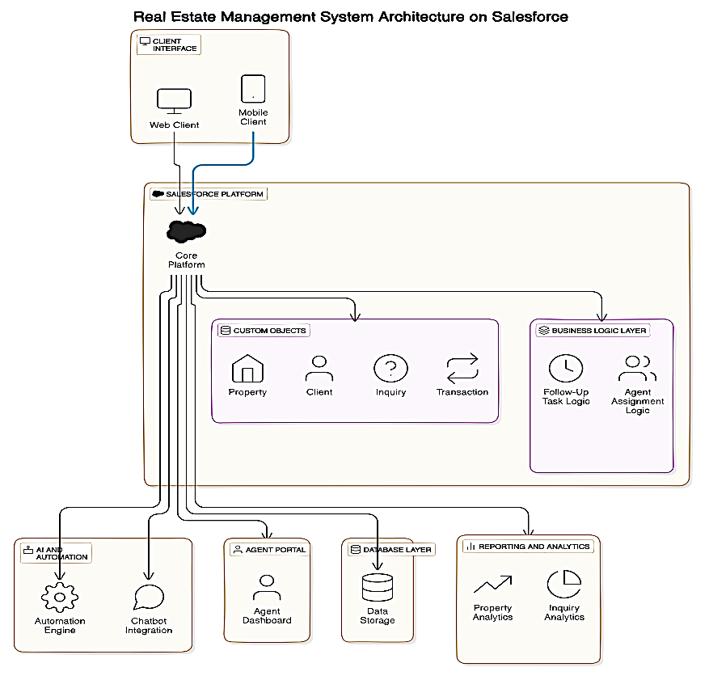

**Figure 1:** Architecture of Real Estate Management System using Salesforce

**5.3 Goals:** Our main objective might seem a bit technical, but it's pretty straightforward. Let's break it down into digestible parts:

**1. Streamlining Operations:** Managing real estate listings, client inquiries, and lead tracking can often be complex and time-consuming. By automating these processes with Salesforce Cloud, real estate firms can significantly streamline their operations. This reduces the load of administrative work on the staff and enhances the general productivity. As a result, sales reps can focus more on closing deals rather than handling manual tasks, leading to higher productivity across the board.

**2. Enhancing Client Experience:** One of the primary goals of this project is to enhance the client experience by making property browsing, inquiries, and follow-up communication smooth and effortless. By integrating communication tools like email and WhatsApp for real-time updates, clients stay informed at every stage of the process. A positive client experience translates into higher client retention and referral rates, building long-term relationships with customers.

**3. Improving Lead Conversion Rates:** With automated lead management workflows, sales reps receive timely notifications and can follow up with clients quickly. The faster a lead is contacted and nurtured, the more likely it is to convert into a sale. By automating lead assignments and tracking, the system helps sales reps stay organized, improving lead conversion rates and maximizing sales opportunities.

**4. Scalability for Business Growth:** The admin dashboard provides real-time details of KPIs such as lead generation, conversion rates, and property availability. These insights help decision-makers optimize their strategies based on accurate data, whether it's reallocating resources, adjusting marketing tactics, or identifying new growth opportunities.

1. **EXISTING RESEARCH**

There is a growing body of research on automation systems built on Salesforce. Some of the notable projects include:

**6.1 PYRAMID REAL ESTATE MANAGEMENT:** PYRAMID Real Estate is a modern real estate company. The organization began with only four full-time agents, namely Sanjay, Mansi, Vishal, and Deepak. It has subsequently grown to include dozens of full-time agents in various regional locations across the country. The commission gained on the purchase and sale of properties is paid to the agents who work for PYRAMID [2].

**6.2 CUSTOM APPLICATION DEVELOPMENT IN CLOUD ENVIRONMENT:** Reliable hardware and software resources along with reduced maintenance costs and security worries have forced many infrastructure managers and companies to switch to cloud computing in recent times. The cloud services are running the world at a good pace. The paper presents two cloud services: salesforce.com [3].

1. **CONCLUSION**

With Salesforce Cloud, the developed Real Estate Management System is strongly scalable and efficient in terms of automating the detailed and complex workflows involved in real estate operations management. By integrating client inquiries, lead management, automated follow-ups, and real-time analytics, the system optimizes sales processes and enhances both client and sales team experiences. With the use of very advanced tools in Salesforce's CRM, real estate firms can optimize operations, increase conversion rates for leads, and make decisive data-driven decisions easily [6].

Furthermore, the project’s flexible and scalable architecture positions it for future growth and technological advancements. It can be maintained up-to-date with AI powered insights, mobile apps, block-chain for secure transactions, virtual property tours, and the list goes on in real estate business.

Summing up, this system, quite aside from streamlining the real estate sales process, gives a competitive advantage in addition to boosting efficiency, increasing client engagement, and driving greater profitability. The project represents a forward-thinking approach to real estate management, leveraging modern cloud technologies to meet the ever-growing demands of the industry.

1. **REFERENCES**
2. Rakesh Kumar, Yougeshwary Sharma, Sonu Agarwal, Pragya, Bhanu, Bhushan Parashar. "Extremely effective CRM Solution Using Salesforce"; JETIR, Volume 1 Issue. 5, pg.278-282 ISSN-2349-5162.Ganesh Kumar and P.Vasanth Sena, “Novel Artificial Neural Networks and Logistic Approach for Detecting Credit Card Deceit,” International Journal of Computer Science and Network Security, Vol. 15, issue 9, Sep. 2015, pp. 222-234.
3. Preeti Karmore, Awantika Nagpure, Ayushree Kamde, Bhairavi Kumbhare, Monika Kohale, Lata Malviya, Meghana Lohakare. "PYRAMID REAL ESTATE MANAGEMENT USING SALESFORCE"; IRJMETS, Volume:04/Issue:06/June-2022, pg.2669-2675, e-ISSN: 2582-5208.
4. Radhika Gupta, Sahil Verma, Kavita Janjua. "Custom Application Development in Cloud Environment: Using Salesforce"; IEEE, 30-31 August 2018, pg.23-27, DOI: 10.1109/ICCS.2018.00010.
5. Rakesh Kumar, Extremely effective CRM Solution Using Salesforce, Volume 1 Issue 5 JETIR (ISSN2349-5162).
6. J. Patel and C. Science, “Salesforce.com: A Cloud Service Provider”.
7. <https://www.salesforce.com/in/learning-centre/crm/what-is-crm>
8. <https://www.salesforce.com/in/what-is-salesforce/>
9. <https://www.salesforce.com/in/saas>
10. <https://appexchane.salesforce.com/>
11. https://trailhead.salesforce.com/