**Housing Portal Using Blockchain : A Review**

Prof. Archana Priyadarshni , Abhishek Sonawane, Prathamesh Chatare, Hrishikesh Patil,

Pranav Chaudhari

1Student, Department of Computer Science Engineering, Dhole Patil College of Engineering, Savitribai Phule Pune University, Pune, Maharashtra, India.

2Principal of Dhole Patil College of Engineering, Savitribai Phule Pune University, Pune, Maharashtra, India.

Mail for corresponding Author: patilarjun415@gmail.com

# Abstract

***The real estate industry is plagued by issues such as fraud, lack of transparency, and inefficiencies in property transactions. This research paper explores the integration of blockchain technology into housing portals to address these challenges. Blockchain, with its decentralized and immutable nature, offers a promising solution to enhance security, transparency, and efficiency in real estate transactions. This study proposes a blockchainbased housing portal that leverages smart contracts for secure and automated transactions, decentralized storage for property listings, and blockchain-based identity verification for user authentication. The proposed system aims to reduce fraud, ensure data integrity, and streamline the property transaction process. A prototype of the housing portal is developed and tested to demonstrate its feasibility and effectiveness. The results indicate that blockchain technology can significantly improve the reliability and trustworthiness of housing portals. Future work will focus on scaling the solution, integrating advanced technologies like AI and IoT, and exploring market adoption strategies.***

# I. INTRODUCTION

**Background**: Blockchain technology has revolutionized various industries by providing a decentralized and secure way to handle transactions and data. In the real estate sector, traditional housing portals often face issues like fraud, lack of transparency, and inefficiencies.

**Problem Statement**: Current housing portals struggle with trust issues, data security, and transaction transparency. These challenges can be mitigated by leveraging blockchain technology.

**Objective**: The aim is to develop a housing portal that uses blockchain to enhance security, transparency, and efficiency in real estate transactions.

**II. PROBLEM STATEMENT**

Enhancing Transparency and Security in Real Estate Transactions through a Blockchain-Based Housing Portal

The real estate industry often faces issues like lack of transparency, fraud, and slow transaction processes. Traditional property transactions involve many intermediaries, which can increase costs and cause delays. This project aims to create a blockchain-based housing portal to tackle these problems. By using blockchain technology, we can make property transactions more transparent, secure, and efficient. This new platform will benefit buyers, sellers, and real estate agents by providing a more reliable and user-friendly experience.

# III. OBJECTIVE

1. Develop a blockchain-based housing portal to ensure secure and transparent property transactions.
2. Reduce the need for intermediaries, cutting down on transaction costs and time.
3. Create a tamper-proof record of property ownership and transaction history.
4. Use smart contracts to automate and enforce transaction agreements.
5. Assess the feasibility and scalability of the solution in real-world scenarios.

# IV. LITERATURE REVIEW

**Blockchain Technology**: Blockchain is a distributed ledger technology that ensures data integrity and security through cryptographic methods. Key features include immutability, decentralization, and transparency. **Current Housing Portals**: Analyze existing housing portals like Zillow, Realtor.com, and MagicBricks, highlighting their strengths and weaknesses. **Blockchain in Real Estate**: Review case studies and research papers on blockchain applications in real estate, such as Propy and Ubitquity, which have successfully implemented blockchain for property transactions.

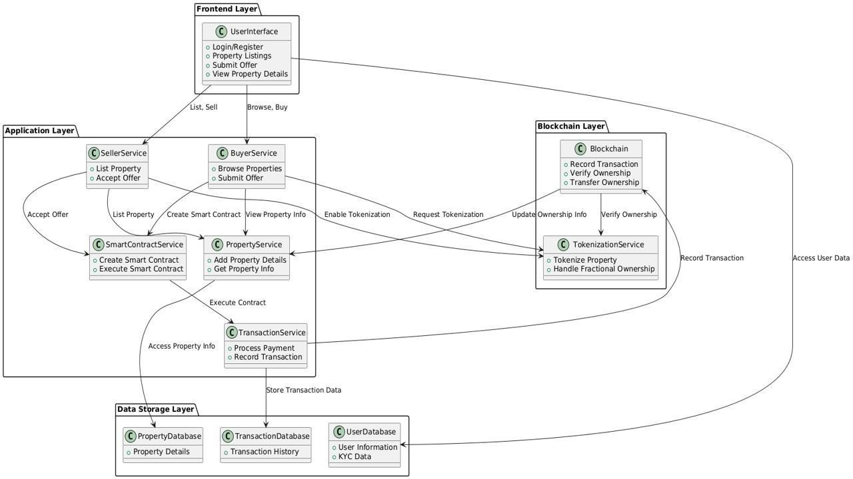

Fig. 1 Overview Of System Architecture Diagram

# 1.FRONTEND LAYER

• USER INTERFACE: This Is Where Users Interact With The System. It Includes Features Like Login/Register, Property Listings, Submitting Offers, And Viewing Property Details.

# 2. APPLICATION LAYER

* SELLER SERVICE**:** Manages Property Listings, Allowing Sellers To List Properties And Accept Offers**.**
* BUYER SERVICE**:** Enables Buyers To Browse Properties, Submit Offers, And View

Property Details.

* SMART CONTRACT SERVICE**:** Handles The Creation And Execution Of Smart

Contracts For Property Transactions.

* PROPERTY SERVICE: Manages Property Information And Details.
* TOKENIZATION SERVICE: Facilitates The Tokenization Of Properties, Allowing Fractional Ownership.
* TRANSACTION SERVICE: Processes Payments And Records Transactions.

# 3. BLOCKCHAIN LAYER

• BLOCKCHAIN: The Core Of The System, Ensuring Secure And Transparent Transactions. It Records Transactions, Verifies Ownership, And Transfers Ownership Through Smart Contracts.

# 4. DATA STORAGE LAYER

* PROPERTY DATABASE: Stores Property Details And Information.
* TRANSACTION DATABASE: Keeps A Record Of All Transactions.
* USER DATABASE: Contains User Information And Kyc (Know Your Customer) Data.

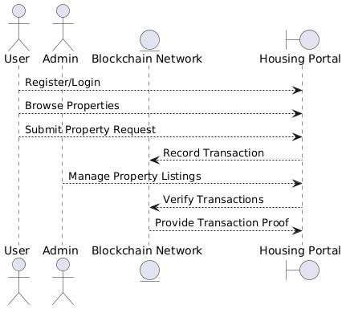

Fig.2 Data Flow Diagram

The diagram illustrates a blockchain-based housing portal system. It shows the interaction between users, an admin, and the blockchain network. Key actions include registering/logging in, browsing properties, submitting property requests, managing property listings, verifying transactions, and providing transaction proof. The flowchart emphasizes how blockchain technology enhances security and transparency in real estate transactions by ensuring that all actions are securely recorded and verified on the blockchain. This system aims to streamline property transactions and reduce fraud.

# V. PROPOSED OUTCOME

The proposed outcome of Housing Portal Using Blockchain Technology as follows:

1. **More Transparency:** With blockchain, every property transaction will be recorded in a way that can’t be altered. This means buyers, sellers, and agents can trust that the information they see is accurate and reliable.
2. **Better Security:** Blockchain’s decentralized system will make it much harder for fraudsters to tamper with property records. Each transaction will be securely encrypted and verified, ensuring that only authorized people can access and change the records.
3. **Lower Costs and Faster Transactions:** By cutting out the middlemen, we can make the transaction process quicker and cheaper. Smart contracts will handle things like payments and contract enforcement automatically, reducing delays and mistakes.
4. **Improved User Experience:** The portal will be easy to use, making it simpler for people to buy, sell, and manage properties. Users will get real-time updates and notifications, making the whole process more convenient.

**VI. Conclusion**

The integration of blockchain technology into housing portals presents a transformative approach to addressing the longstanding issues of fraud, lack of transparency, and inefficiencies in real estate transactions. By leveraging the decentralized and immutable nature of blockchain, the proposed system enhances security, ensures data integrity, and streamlines the transaction process. The implementation of smart contracts automates and secures property transactions, reducing the need for intermediaries and minimizing the risk of fraud. Decentralized storage solutions further protect user data and property information, fostering trust among users. The prototype developed and tested in this study demonstrates the feasibility and effectiveness of a blockchainbased housing portal. Future research should focus on scaling the solution, integrating advanced technologies such as AI and IoT, and exploring strategies for market adoption.

# VII. References

1.Books

[Ammar Jreisat](https://link.springer.com/book/10.1007/978-981-99-8533-3#author-1-0)[, Mehdi Mili (](https://link.springer.com/book/10.1007/978-981-99-8533-3#author-1-1)2024) Blockchain in Real State: This book provides an overview of the latest developments in real estate blockchain technology and its applications. It explores blockchain technologies in all industries, cryptocurrencies’ effect on the payment system, money transfers and currency exchange, investment, venture capital, etc.

2.Research Papers

Qingshui Xue1*, Zongyang Hou1, HaifengMa1, Haozhi Zhu2, Xingzhong Ju2, Yue Sun2 (2021) “Housing rental system based on blockchain Technology”

3.web resources

How Blockchain Technology is Changing Real Estate (2020) Retrieved from [ https://www.investopedia.com].