A STUDY OF BRAID GROUPS IN TWO DIMENSIONAl MANIFOLD

1C.Srinivasulu,2D.Yasoda,3G.Swarnakala

1Assistant Professor, Department of Mathematics, Annamacharya Institution of Technology and Sciences,Tirupati-517520

2Assistant Professor, Department of Mathematics, Annamacharya Institution of Technology and Sciences ,Tirupati-517520

3Assistant Professor, Department of Mathematics, Annamacharya Institution of Technology and Sciences ,Tirupati-517520

**Abstract**

Braid groups, which arise in the study of topology, particularly in the context of two-dimensional manifolds, provide a rich framework for understanding the complexities of intertwining and linking structures. This paper explores the mathematical properties of braid groups and their applications in two-dimensional topology, focusing on their relationship with surface knots, homotopy theory, and geometric representations. We investigate the algebraic structure of braid groups, emphasizing their generators, relations, and the role of the Artin presentation. Additionally, we analyze how braid groups can be utilized to classify and differentiate between various types of surface embeddings and their associated invariants. The interplay between braid groups and other topological constructs, such as mapping class groups and fundamental groups, is also examined. Our findings highlight the significance of braid groups in both theoretical and applied topology, offering insights into knot theory and the study of three-manifolds through the lens of their two-dimensional counterparts.

**1. Introduction**

Braid groups have long fascinated mathematicians due to their intricate structure and deep connections to various fields of topology, algebra, and geometry. Originally conceptualized in the context of braiding strands of hair, these groups have evolved into powerful tools for studying the properties of two-dimensional manifolds. A braid on 𝑛

n strands can be visualized as a collection of curves that intertwine in space, leading to a rich tapestry of mathematical relationships and classifications.

In two-dimensional topology, braid groups serve as a bridge between geometric intuition and algebraic rigor. They can be defined as the group of isotopy classes of braids, where the operations correspond to concatenating braids. The study of these groups not only reveals the behavior of braids themselves but also illuminates the properties of surfaces onto which these braids can be projected or embedded.

The significance of braid groups extends beyond mere abstract algebra; they have crucial implications in various branches of mathematics, including knot theory, where they are used to analyze and classify knots and links. Moreover, braid groups are intimately related to the mapping class groups of surfaces, offering insights into how surfaces can be deformed and manipulated.

This paper aims to explore the role of braid groups in two-dimensional topology, focusing on their algebraic structures, geometric interpretations, and connections to other topological concepts. By examining the foundational aspects of braid theory and its applications, we seek to elucidate the importance of these groups in understanding the complexity and richness of two-dimensional manifolds. Through this exploration, we highlight the interplay between algebra and topology that braid groups embody, paving the way for further research in both theoretical and applied contexts.

**Keywords**

1. Braid group
2. 2- Dimensional Manifolds
3. Knot Theory and braid

4. Represent of Braid group and Etc..

1. **Braid Group**

A beautiful connection between topology and algebra is through Artin’s braid groups. For each positive integer n one considers n strings in 3-space which are monotone in one direction, and disjoint, but possibly intertwined, and begin and end at specified points in two parallel planes. The product of braids is concatenation, as illustrated in Figure 1. Two braids are equivalent if one deforms to the other through a one-parameter family of braids, with endpoints fixed at all times. The identity in the n-strand braid group Bn is represented by a braid with no crossings – the strands can be taken as straight lines.

According to Artin [2] for each n ≥ 2, Bn has generators σ1,...,σn−1, in which σi is the simple braid in which all the strands are straight, except that the strand labelled i crosses over the strand labelled i+1. These generators are subject to the relations σiσj = σjσi if |i − j| > 1 and σiσjσi = σjσiσj when |i − j| = 1.

Each n-strand braid has an associated permutation of the set {1,...,n} which records how the strands connect the endpoints of the various strands. In other words, there is a homomorphism Bn → Sn, where Sn denotes the symmetric group on n elements, in which σi is sent to the simple permutation interchanging i and i + 1. This homomorphism is surjective – it is easy to see that any permutation of {1,...,n} can be realized by infinitely many braids (if n > 1).

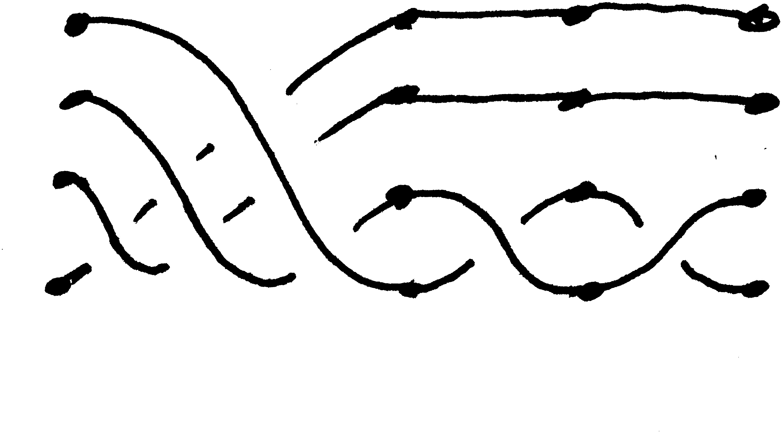

1. **Two-dimensional Manifold**

A two-dimensional manifold is a topological space that locally resembles Euclidean two-dimensional space (commonly known as the plane). In other words, a two-dimensional manifold is a space where every point has a neighbourhood that is homomorphic to a region in the plane. Formally, a topological space M is considered a two-dimensional manifold if, for every point x in M, there exists an open neighbourhood U(x)and a homeomorphism (a continuous bijection with a continuous inverse) between U and an open subset of the Euclidean plane R2. Two-dimensional manifolds are often referred to as surfaces, and they come in various forms, including spheres, tori, projective planes, and more complex surfaces.

**Definition**

The open disk, denoted as D, which consists of all points in R^2 (the two-dimensional Euclidean space) with a distance less than one from the origin, can be shown to be homeomorphic to R2. This homeomorphism can be established using a specific function, denoted as f, which maps points from the open disk to points in R2.

The homeomorphism function f is defined as follows: $f\left(x\right)=\frac{x}{1-|\left|x\right||}$ where ||x|| represents the Euclidean norm or the distance of point x from the origin.

It is noteworthy that this homeomorphism demonstrates that every open disk, regardless of its size or location within R2, can be considered homomorphic to the entire plane R2. This result is a fundamental concept in topology, highlighting the remarkable flexibility and uniformity of topological spaces.

Let us consider the 2-dimensional analogue. The following is classical.

**Theorem 3.1**

Homeo(I2,∂I2) is torsion-free. I believe it is an open question whether Homeo(I2,∂I2) is left-orderable.

**Theorem 3.2** (Calegari-Rolfsen)

PL(I2,∂I2) is locally-indicable, and therefore left-orderable.

Here is an outline of the proof. Consider a nontrivial subgroup H of PL(I2,∂I2) generated by the finite set h1,...,hk of functions. The fixed point set fix(hi) of each generator is a finite polyhedron in I2 containing ∂I2, and the same may be said of the global fixed point set). Now we choose a point p which is on the frontier of fix(H); we can arrange that p has a neighbourhood which can be identified with R2 = {(x,y)} in such a way that all the functions are the identity on the x-axis and act linearly on the upper half plane. We then map H nontrivially to the “germs” of functions of H at p which according to the following lemma is a locally indicable group. It follows that H is indicable.

1. **Knot theory**

Knot theory is an appealing subject because the objects studied are familiar in everyday physical space. Although the subject matter of knot theory is familiar to everyone and its problems are easily stated, arising not only in many branches of mathematics but also in such diverse fields as biology, chemistry, and physics, it is often unclear how to apply mathematical techniques even to the most basic problems. We proceed to present these mathematical techniques.

**Knots**

The intuitive notion of a knot is that of a knotted loop of rope. This notion leads naturally to the definition of a knot as a continuous simple closed curve in R3. Such a curve consists of a continuous function f : [0,1] → R3 with f(0) = f(1) and with f(x) = f(y) implying one of three possibilities:

1. x = y

2. x = 0 and y = 1

3. x = 1 and y = 0

Unfortunately, this definition admits pathological or so called wild knots into our studies. The remedies are either to introduce the concept of differentiability or to use polygonal curves instead of differentiable ones in the definition. The simplest definitions in knot theory are based on the latter approach.

**Definition (knot)**

A knot is a simple closed polygonal curve in R3.

The ordered set (p1,p2,...,pn) defines a knot; the knot being the union of the line segments [p1,p2],[p2,p3],...,[pn−1,pn], and [pn,p1].

**Definition (vertices)**

If the ordered set (p1,p2,...,pn) defines a knot and no proper ordered subset defines the same knot, the elements of the set, pi, are called the vertices of the knot.

Projections of a knot to the plane allow the representation of a knot as a knot diagram. Certain knot projections are better than others as in some projections too much information is lost.

1. **Knot and Braids**

We will present a very brief review of the theory of knots and an interesting application of the braid ordering to knot theory.

There is a close connection between the braid groups and the theory of knots and links. By a knot we mean an embedding of a circle in 2-dimensional space R3. This models the idea of a knotted rope, but we assume the ends of the rope are attached to each other, preventing the knot from being untied by simply pulling the rope through itself. Two knots are considered equivalent if there is an isotopy (continuous family of homeomorphisms) of R3 which at the end takes one knot to the other. One can add knots K1 and K2 by tying them in distant parts of the rope, thus forming the connected sum K1]K2.

The sum is easily seen to be commutative and associative, up to equivalence.

Thus the set of (equivalence classes of) knots forms an abelian semigroup, with

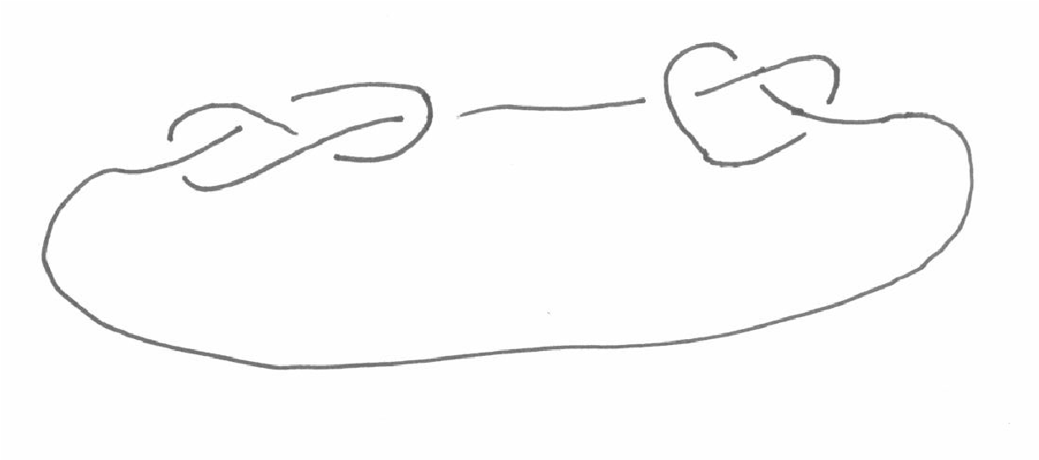

unit the trivial knot, or unknot, which is a curve equivalent to a round circle in space. There is a prime decomposition theorem: any knot K can be written K ∼= K1]···]Kp where each Ki is prime, i.e. not expressible as a sum of two nontrivial knots. Moreover, in this decomposition the terms are unique up to order. Finally, it is a theorem that there are no inverses: if K1]K2 is equivalent to the unknot, then so are both K1 and K2. This is one reason that braids are convenient in the study of knots, as the braids do form groups: every braid has an inverse – namely its mirror image in a plane perpendicular to the direction in which the strands are monotone.

If β is a braid, its closure βˆ is a knot (or disjoint union of knots, called a link) formed by connecting the ends

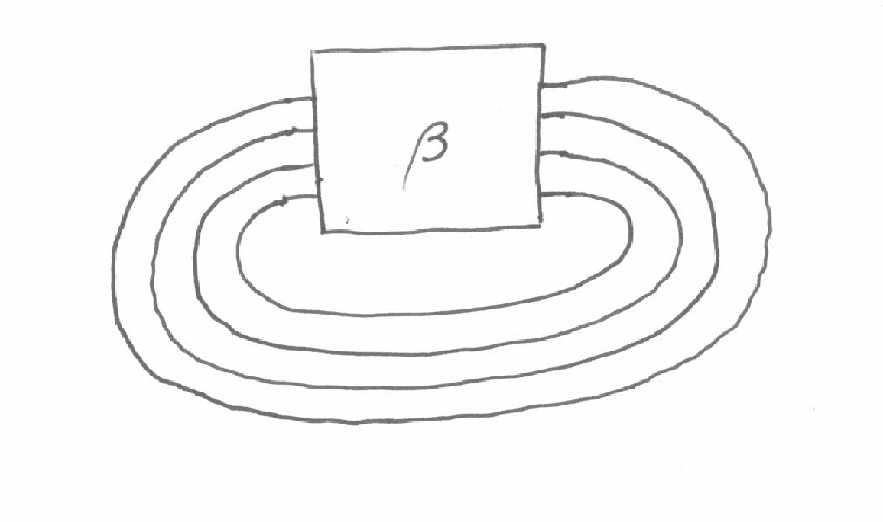

**Braid groups of manifolds**

To see what all this has to do with braid groups, think about the fundamental groups of the configuration spaces Fn and Cn.

The following result (due to Joan Birman[1]) suggests that the only really interesting cases of this question arise when M is a 2-manifold

**Theorem**

Let M be a closed, smooth m-manifold. Then, for each k ∈ Z, the inclusion map

i : Fn(M) ,→ YM induces a homomorphism

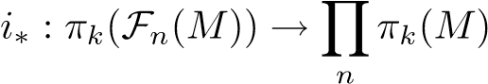

which is surjective if dimM > k and an isomorphism if dimM > k + 1.

This means that, unless M is a 2-manifold, the fundamental group of Fn(M) is just a direct product of n copies of the fundamental group of the manifold M itself.

**The braid group of the 2-manifold** S2

The braid group of the 2-manifold is similar to the braid group of the Euclidean plane, except that the points move on S2 instead. An S2-braid may be depicted geometrically as a braid between two concentric spheres.

The group Bn(S2) is generated by the same generators σi and relations as Bn(E2), but with one additional relation:

(iii) σ1σ2 ...σn−1σn−1 ...σ2σ1 = 1

This requirement says, geometrically, that the braid formed by taking the first string round behind all of the other strings and back in front of them, back to its starting position, is equivalent to the trivial braid.

By considering the geometric depiction of an S2-braid described above, we see that this is true, since the loop may be pushed off the inner sphere without tangling with any of the other strings.

As before, we can construct a fundamental exact sequence for Bn(S2):

0 −→ An(S2) −→ PBi n(S2) −→ PBj n−1(S2) −→ 0

The remark at the end of the previous subsection suggests that the braid groups of the 2-sphere and the projective plane might have some strange properties not shared by the braid groups of arbitrary 2-manifolds. This is further suggested by the following:

**Theorem (Newwirth)**

If M is either E2 or any compact 2-manifold except P2 or S2 then neither Bn(M) nor PBn(M) have any nontrivial elements of finite order.

So, is Bn(Sn) torsion-free? Or can we find a nontrivial element of finite order?

**Theorem (Fadell/Newwirth 1962)**

The word σ1σ2 ...σn−1 has order 2n in Bn(S2).

This can be seen geometrically, with a little imagination. The word σ1σ2 ...σn−1 corresponds to taking the first string over all the others to the nth position. If we do this n times, then each of the strings ends up back where it started, making a pure braid. If we then do the same thing a further n times (making 2n in total), each string winds round the remaining n − 1 strings twice. We may then utilise a move known as the ‘Dirac string trick’ (qv [5] for a series of diagrams depicting this operation) to untangle all n strings, resulting in a trivial braid.

What are some of these groups Bn(S2) like? Notice that Bn(E2) is infinite for n > 1, but the previous theorem suggests that this might not necessarily be the case for the braid groups of the 2-sphere.

|  |  |
| --- | --- |
| In fact |  |
| PB2(S2) | = 0 |
| B2(S2) | = Z2 |
| PB3(S2) | = Z2 |
| B3(S2) | is a ZS-metacyclic group of order 12 |

1. **Representations of braid groups**

we provide a brief overview of Fox’ free differential calculus, show how it may be used to construct matrix representations of automorphism groups of Fn, and then look at two examples, namely Burau and Gassner’s representations of, respectively, Bn and PBn

**Free differential calculus**

Let Fn be a free group of rank n, with basis {x1,...,xn}, and let φ be a homomorphism acting on Fn, with denoting the image of Fn under φ.

Now let denote the integral group ring of: an element of is a sum Pagg, where ag ∈ Z and, with addition and multiplication defined by

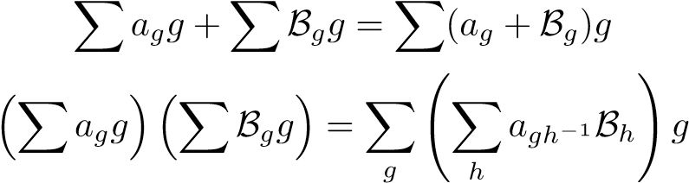

A homomorphism ψ : Fnφ → Fnψφ induces a ring homomorphism ψ : ZFnφ → ZFnψφ. Later we will consider the cases where ψ is the abelianiser a or the trivialiser t. There is a well-defined mapping

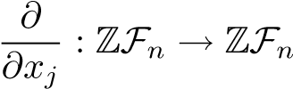

1. **CONCLUSION**

Braid groups play a pivotal role in the study of two-dimensional topology, providing a framework that intertwines algebraic and geometric perspectives. Their rich structure not only facilitates the classification of braids but also serves as a critical tool in understanding surface embeddings, knot theory, and the mapping class groups of surfaces. Throughout this exploration, we have seen how braid groups encapsulate the complexities of intertwining strands and reveal deeper insights into the properties of two-dimensional manifolds.

The connections established between braid groups and other topological constructs underscore their importance in contemporary mathematical research. As we continue to investigate the applications of braid groups, particularly in fields such as quantum computing and molecular biology, it is clear that their influence extends far beyond traditional topology. Future research may focus on developing new invariants derived from braid groups, exploring their relationships with higher-dimensional manifolds, or applying braid theory to solve complex problems in various scientific domains.

**REFERENCES**

1. Patrick Dehornoy. Braid groups and left distributive operations. Trans. Amer. Math. Soc., 345(1):115–150, 1994.
2. Patrick Dehornoy, Ivan Dynnikov, Dale Rolfsen, and Bert Wiest. Ordering braids, volume 148 of Mathematical Surveys and Monographs. American Mathematical Society, Providence, RI, 2008.
3. T. V. Dubrovina and N. I. Dubrovin. On braid groups. Mat. Sb., 192(5):53–64, 2001.
4. Michael Falk and Richard Randell. Pure braid groups and products of free groups. In Braids (Santa Cruz, CA, 1986), volume 78 of Contemp. Math., pages 217–228. Amer. Math. Soc., Providence, RI, 1988.
5. R. Fenn, M. T. Greene, D. Rolfsen, C. Rourke, and B. Wiest. Ordering the braid groups. Pacific J. Math., 191(1):49–74, 1999.
6. L. Fuchs. Partially ordered algebraic systems. Pergamon Press, Oxford, 1963.
7. David Gabai, Robert Meyerhoff, and Peter Milley. Mom technology and volumes of hyperbolic 3-manifolds. Comment. Math. Helv., 86(1):145–188, 2011.
   1. M. W. Glass. Partially ordered groups, volume 7 of Series in Algebra. World Scientific Publishing Co. Inc., River Edge, NJ, 1999.
8. O. H¨older. Die Axiome der Quantitat und die Lehre vom Mass. Ber. Verh. Sachs. Ges. Wiss. Leipzig Math. Phys. Cl., 53:1–64, 1901.
9. James Howie and Hamish Short. The band-sum problem. J. London Math. Soc. (2),
10. 31(3):571–576, 1985.
11. Tetsuya Ito. Braid ordering and knot genus. J. Knot Theory Ramifications, 20(9):1311–1323, 2011.
12. V. F. R. Jones. Hecke algebra representations of braid groups and link polynomials. Ann. of Math. (2), 126(2):335–388, 1987.
13. Djun Maximilian Kim and Dale Rolfsen. An ordering for groups of pure braids and fibre-type hyperplane arrangements. Canad. J. Math., 55(4):822–838, 2003.
14. Valeri˘ı M. Kopytov and Nikola˘ı Ya. Medvedev. Right-ordered groups. Siberian School of Algebra and Logic. Consultants Bureau, New York, 1996.
15. F. W. Levi. Contributions to the theory of ordered groups. Proc. Indian Acad. Sci., Sect. A., 17:199–201, 1943.
16. Peter A. Linnell. The space of left orders of a group is either finite or uncountable. Bull. Lond. Math. Soc., 43(1):200–202, 2011.

Top of Form