A Study On The Impact of Cryptocurrency in Online Gaming and Virtual Economies.

Mansi Ganotra

**ABSTRACT** The rise of cryptocurrency has significantly influenced the online gaming industry and the development of virtual economies. This paper explores the intersection between cryptocurrency and online gaming, with a particular focus on how decentralised digital currencies such as Bitcoin, Ethereum, and game-specific tokens are influencing virtual market places, in-game economies and player interactions. This study focuses on the impacts of using cryptocurrencies in gaming, including blockchain-based games and platforms, through analysing different case studies. This paper also delves into the challanges and possibilities that come with the integration of digital currencies in online gaming, such as regulatory concerns, security issues and chances for financial speculation. Through an interdisciplinary approach, this research seeks to offer a comprehensive understanding of how cryptocurrency is transforming online gaming ecosystems and their implications for the future of virtual economies.

**KEYWORDS** Cryptocurrency, Play-to-earn (P2E), Blockchain technology, Decentralisation, Non-fungible tokens(NFTs),Virtual economies, Tokenized assets, Virtual marketplaces, Metaverse, Decentralised Finance (DeFi)

**1.INTRODUCTION**

**1.1 BACKGROUND**

The integration of Cryptocurrency into gaming industry has swiftly gained momentum as game developing companies strive to capitalise on the benefits offered by digital currencies. This convergence has given rise to a new frontier in digital economies, altering the way gamers interact with virtual environments and the structure of these ecosystems. Cryptocurrencies such as Bitcoin, Ethereum, and various game specific tokens are being more widely adopted into gaming platforms, enabling players to buy, sell and trade digital assets that were previously impossible. This has resulted in the rise of decentralised, player-driven economies where virtual assets have real-world value, and transactions are conducted securely without the involvement of intermediaries. The concept of virtual economies in gaming is not new. For a long time, gamers have traded in game currencies and items, both directly within the game’s and through external platforms. However, the advent of blockchain technology and cryptocurrency has significantly transformed the gaming landscape by introducing the concept of true ownership of virtual assets, tokenization, secure and transparent transactions. Non- fungible tokens (NFTs) and decentralised finance platforms have played crucial role in this evolution, enabling players to not just engage in virtual economies but also to earn and invest in them.

**1.2 OBJECTIVES**

The main aim of this research paper is to delve into how cryptocurrency influences gaming and virtual economies.To achieve this aim, the following objectives have been set:

* *To Analyse the Integration of Cryptocurrency*: This research seeks to examine the different ways cryptocurrencies are incorporated into gaming platforms, focusing on payment methods and their role in-game transactions.
* *To Assess Economic Effects*: This study will look into how the adoption of cryptocurrency affects in-game economies, including aspects such as price stability, inflation rates, and overall market dynamics within virtual spaces and how cryptocurrency is transforming in-game economies and transactions.
* *To Evaluate Player Interaction and effect on developers*: This study aims to understand how the integration of Cryptocurrency influences player behaviour, specifically in terms of spending patterns, trading practices, and investment strategies related to virtual assets. It also focuses on the effect of this integration on game developers and publishers.
* *To Study Benefits and Risks:* The objectives include assessing both benefits and potential risks associated with using cryptocurrency in gaming, with focus on security concerns ,market volatility, and their influence on game design.
* *To Examine Regulatory Implications:* This research will analyse the rules and regulations related to cryptocurrency in games, highlighting the challenges and opportunities for both developers and players.
* *To Study Crypto Gaming Markets*: This study will delve into the data points, trends, market segmentation and factors contributing to the exponential growth of this sector.
* *To Investigate Future Trends*: Finally, the research aims to evaluate the future of cryptocurrency in gaming virtual economies, considering emerging technologies and devolving player expectations.

By addressing these objectives, this study intends to provide a comprehensive understanding of the complex impact of cryptocurrency in the gaming industry and its wider implications for virtual economies

**2.THE ROLE OF CRYPTO IN ONLINE GAMING**

**2.1 INTEGRATION OF CRYPTOCURRENCY IN GAMING**

The rise of cryptocurrencies has been one of the most transformative developments in the global financial landscape over the past decade. Originating with the launch of Bitcoin in 2009, cryptocurrencies have evolved from niche digital assets into widely recognized financial instruments. These decentralised, blockchain based currencies allow peer-to-peer transactions without the need for intermediaries like banks, enabling greater financial autonomy and transparency. As of 2024, there are thousands of cryptocurrencies in circulation, with Bitcoin, Ethereum, and Binance Coin among the most well-known. Blockchain, the underlying technology behind cryptocurrencies, ensures the security, transparency, and immutability of transactions, making it an appealing solution for various industries.[19] The gaming industry, one of the fastest growing sectors globally, has found cryptocurrencies and blockchain technologies particularly attractive. Virtual economies have long existed in gaming, with in-game currencies, assets, and marketplaces becoming integral parts of many games. However, these systems have traditionally been controlled by developers and publishers, with limited value outside the gaming environment.

Cryptocurrencies present an opportunity to redefine virtual economies within gaming by enabling true digital ownership, decentralised marketplaces, and the potential for real-world value exchange. Blockchain technology is reshaping the way players interact with in-game economies, offering the possibility of earning and exchanging digital assets that hold real-world financial value. In this context, cryptocurrency has the potential to empower players, reduce transaction fees, and create more secure and transparent economic systems in games. From play-to-earn models to the rise of NFTs (Non-Fungible Tokens), cryptocurrencies are not only changing how players engage with games but also how they participate in virtual economies. Because they allow for real-world value exchange, decentralised marketplaces, and actual digital ownership, cryptocurrencies provide a chance to completely reshape virtual economies in the game industry. Players’ interactions with in-game economies are being transformed by blockchain technology, which makes it possible to acquire and trade digital goods with actual monetary worth. Cryptocurrency has the ability to empower participants in this situation, lower transaction costs, and establish more open and safe economic systems in online gaming.[14]

**2.2 NFTs AND DIGITAL OWNERSHIP**

NFTs are unique digital assets recorded on a blockchain that verify ownership and authenticity. Unlike cryptocurrencies like Bitcoin, Ethereum NFTs are distinct assets that can not be duplicated or exchanged on a one to one basis.[14] NFTs are used to to represent in game assets like skins, weapons, land and characters, providing players genuine ownership of these items. Since blockchain protects this ownership, in game assets can be transferred, exchanged or sold outside of the game ecosystem, often for real world currency or alternative cryptocurrencies.

NFTs can represent:

* *Skins*: Players can own unique cosmetic items like attire or accessories for their in game avatars.
* *Weapons*: NFTs can signify rare or customised weapons which players can buy sell or even lease to others.
* *Land:* Players in virtual worlds can own parcels of land (digital real estate), which they can buy sell or rent out.
* *Characters*: NFTs can embody fully playable or collectible characters, some of which may possess unique attributes.

**2.2.1 CASE STUDIES OF NFT INTEGRATED GAMES**

*1.Decentraland*

Decentraland is a decentralised virtual land where users can buy, sell or even develop virtual lands as NFTs. The game is built on Ethereum blockchain platform and employs MANA cryptocurrency for transactions within the game. Players can buy parcels of virtual land, which are represented as NFTs and can use them to build structures, create experiences and rent out their land to others.

* *Virtual reality estate*: Since virtual land is limited in Decentraland, players have total ownership of their purchased land and represent by NFTs. These parcels can be traded on other marketplaces.
* *Monetisation*: Gamers can develop their virtual lands to host events , creating games or establish virtual storefronts. Some players lease their land to others, generating potential revenue streams .
* *Interoperability*: Assets created or possess within Decentraland can be utilised potentially in other games or virtual worlds , enhancing the appeal of owning NFTs.

*2. Axis Infinity*

Axis infinity is one of the most popular blockchain based games that seamlessly incorporates NFTs along with play to earn model. Players can collect breed or combat digital creatures known as ”Axies”,each represented as an NFT. On the Axie marketplace players can purchase, sell or trade these Axies using cryptocurrency (Axis infinity Shards or AXS and Smooth Love potion )for their exchanges*.*

* *Ownership*: Players posses genuine ownership of their Axies who are free to exchange them for cryptocurrencies or sell them to other players.
* *Play to Earn*: Players earn cryptocurrency through gameplay, which can be exchanged for real world money, fostering a dynamic virtual economy.
* *NFTs and breeding*: Axies can breed to produce new, unique NFTs which may be sold or utilised within the game. Each Axie possess unique traits and varying levels of rarity, making some NFTs more valuable than others.[3]

*3.The Sandbox*

Constructed on Ethereum blockchain, Sandbox is another virtual world that allows players to purchase and sell land, create gaming experiences and trade in-game assets, all of which are represented as NFTs .The game is based on user generated content, which allows players to create and monetize their own games, structures and assets.

* *User created NFTs*: With a tool known as Voxedit, players can create custom assets that can subsequently be tokenized as NFTs and sold in The Sandbox marketplaces.
* *P2E model*: Similar to Axie Infinity,The Sandbox features a play to Earn model, permitting players to earn cryptocurrency through gameplay and development of land.
* *Virtual reality estate*: Players can acquire land as NFTs and either develop virtual experiences or lease it to others. The value of the land is subject to fluctuations based on demand and its geographical positioning within the virtual world.

**2.3 SMART CONTRACTS AND IN-GAME ECONOMIES**

Smart contracts are self executing contracts with their terms encoded directly into software, operation blockchain platforms like Ethereum. Within the gaming sector, these contracts are used to automate and secure transactions, guaranteeing that trading and transfer of in-game assets are conducted in a transparent manner.

* *Securing in game transactions:* Upon the fulfillment of specified conditions, smart contracts make sure that in game transactions involving NFTs and cryptocurrency are completed automatically. For instance, when a player opts to sell a weapon or cosmetic item for cryptocurrency, a smart contract can facilitate the transfer of ownership and funds without the need of an intermediary. This helps in ensuring: [11]
* *Secure payments*: Transactions are permanent and transparent, recorded on the blockchain for public access. The potential for fraud is minimised as smart contracts execute automatically based on predetermined terms, eliminating the need of trust among players. For example, In Axis infinity Smart contracts manage the breeding and sales of Axies. The smart contract makes sure that the required SLP(Smooth Love potion) is paid when two players decide to breed their Axies, and the new Axie is automatically generated and sent to the players as an NFT. [11]
* *Enabling Player driven Markets*: Smart contracts are instrumental in enabling decentralised player driven Blockchain based games leverage smart contracts to enable peer-to-peer trading of NFTs and cryptocurrencies, in contrast to conventional gaming marketplaces where the developer controls item trading and sets the regulations. This eliminates the necessity for a centralised marketplace, giving players full control over this assets and transactions, enables the development of value in the real world since players may swap items for cryptocurrencies which can then be redeemed for fiat money. For instance,In Decentraland, players can trade virtual land and items on decentralised platforms like OpenSea. These transactions are regulated by Smart contracts, ensuring a secure trading environment.
* *Royalties and Revenue sharing*: Smart contracts can also be programmed to automatically allocate royalties to creators upon the resale of their NFTs.This guarantees that content creators or game developers are consistently compensated for a portion of the future sales of their in game assets. For example, a creator who design a custom skin or weapon in The Sandbox is entitled to a percentage of each subsequent sale of their NFT , even following the initial transaction.This not only incentivises the creation of high quality digital assets but also ensures that creators receive equitable remuneration of their efforts. [14]
* *Automated Rewards and Staking*: Furthermore, Smart contracts can also be used to automate reward systems in play to Earn games. Players can stake their tokens and earn interest or earn cryptocurrencies based on their game play, all under the stipulations established within the smart contract. As an example, within The Sandbox players can stake SAND tokens (the game’s native cryptocurrency)in specific areas within the game and earn rewards.Smart contracts handle the distribution of these reward, taking into account staking duration and other specified conditions, making the process smooth and transparent. Furthermore, cryptocurrencies offer participants the opportunity to fully own their in-game assets in a manner that traditional systems fail to provide. Through the use of non-fungible tokens (NFTs), participants can exchange or sell unique digital items, including skins, weapons, or land, across decentralised marketplaces. The inherent scarcity and uniqueness of these digital assets frequently lead to an increase in their value over time, thereby allowing participants to profit from their investments.

**3. IMPACT ON VIRTUAL ECONOMIES**

**3.1 ECONOMIC MODELS AND CURRENCY SYSTEMS**

**3.1.1 CRYPTOCURRENCY AS IN-GAME CURRENCY VS TRADITIONAL GAME CURRENCY**

* *Ownership and Control*: Players can enjoy true ownership of an in-game item using cryptocurrency. When a player buys an in game item or currency using crypto currency they posses complete over that assured which can be stored inside the digital wallet and can be transferred to other platform or marketplace. This is possible through blockchain technology and tokenization, which allows every asset and currency to be sorted as the blockchain and can be independently traded of the game developer (or allowing) for independent trading outside the game environment. On the other hand, traditional in game currencies are under the control of the game devlopers (such as in golds in World of Warcraft or V-banks in Foretnite ) these currencies are available for purchases or earning by players, but their application is generally confined to itself. Players do not posses true ownership of there currencies and such currencies cannot be transferred or traded internally. They can lose their assets if the game developer shuts down or completely shifts.
* *Decntralisation vs Centralisation:* Cryptocurrencies are operated on decentralised network, indicating that no single entity or organisation controls the currency. Tran-  sition and asset ownership are authenticated through distributed ledger (the blockchain) enhancing transparency and imperviousness to manipulation. This decen- tralisation aligns with the idea of player autonomy, which permits players to conduct transactions and hold assets without requiring approval from the game developers. In contrast traditional in game currencies are centralised and entirely regulated by the game developer or publisher. The developer has the power to modify the currency, alter the value of currency and restrict access to certain items or assets. Players are wholly reliant on the game company to sustain and manage the virtual economy. [12]

 3.2 *ECONOMIC BENEFITS AND RISKS FOR PLAYERS*

*Cryptocurrency can empower players in the following ways:*

* *P2E opportunities* **:** Cryptocurrencies have enabled the Play to Earn model ,where players can earn digital tokens or assets by simply playing the game.These assets can be exchanged for other cryptocurrencies or real money on external platforms, offering players the chance to earn a legitimate income from their gaming efforts.
* *Asset Value Growth*: Since blockchain-based assets (NFTs,tokens) can be scarce or limited in supply, their values can increase over time. Rare in -game items or characters can become highly coveted , and their value can skyrocket in secondary markets. This presents an opportunity for players to invest in virtual assets with the potential for long- term financial returns . [15]
* *Ownership and Autonomy*: NFTs and cryptocurrencies provide players with complete ownership and autonomy over their virtual assets.They can trade, sell, or use them in different games without being restricted by a game developer’s policies.This sense of ownership fosters a deeper connection to the game and empowers players to make real economic decisions. [15]
* *Global Accessibility*: Cryptocurrencies make virtual economies accessible to players around the world, including those in unbanked regions .With just an internet connection and a crypto wallet, players can participates in the global market ,buying and selling assets without the need for conventional banking. [10]
* *Reward for Skill and Investment:* In a crypto-powered game economy ,highly skilled and dedicated players can reap significant financial rewards. Those who excel in game-play, strategy, or who manage to secure rare items can profit greatly ,turning gaming into a financial rewarding venture.

*Risks faced by players*

* *Vulnerability to Fraud and Scams*: The decentralised often anonymous nature of cryptocurrency transactions can expose players to scams, frauds, or Unscrupulous developers might create fraudulent games or token schemes, while players could lose assets through hacked wallets, phishing attacks ,or fake marketplaces.
* *Security Risks:* It’s crucial for players to be careful about the storage of their digital assets. Crypto wallets and exchanges can be hacked , and if security protocols are not followed, players can lose their earnings or in-game assets. Unlike in traditional games where assets can be recovered from the game developer, in a decentralised system, lost assets are typically irrecoverable.
* *Reliance on Game ’s Success:* The value of in-game assets and currencies is often tied to the popularity and success of the game itself. Should a game lose its player base, be discounted, or become obsolete, the value of its associated cryptocurrency or assets could plummet, leaving players with worthless items. [15] [17]
* *Regulatory risks and Volatility Concerns:* The worth of cryptocurrency is subject to significant fluctuations, indicating that the value  of the tokens or assets acquired  in a game can vary greatly. Additonaly, in some countries, crypto assets may be banned or highly regulated. Players could face legal issues or barriers when attempting to convert their in game profits into real money, depending on the laws of their jurisdiction. [13]

**3.3EFFECT ON DEVELOPERS AND PUBLISHERS** *Benefits for developers and publishers*:

* *Lower transaction fees*: Cryptocurrencies diminish the dependency on conventional payment processors such as banks or credit card companies,,which usually charge transaction fees. Particularly, for micro transactions cryptocurrency transactions can be cheaper, allowing developers to retain more revenue . [19]
* *Global Access*: Cryptocurrency facilitates easy access to global markets without the necessity for currency conversions or different or dealing with different banking regulations. This enables individuals from countries with limited access to traditional banking services to participate in the gaming economy.
* *Instant  payments:*Traditional payment systems are prone to delays specially in international transactions. Cryptocurrencies enables faster, often instantaneous transactions.l, improving cash flow for developers and reducing chargebacks or fraudulent payments.
* *Decentralised Asset Ownership*: Through blockchain, developers are able to establish decentralised economies where players can own in-game assets ,such as NFTs.This created secondary market for these places, benefiting both developers  through  royalty payments and players by increasing the value of their in game purchases.
* *Expanded Monetization Possibilities*: The tokenization of in game money and assets opens up new revenue streams for game developers. This includes selling digital assets , token based game models (like P2E),and using tokens for governance within games.

*Enhanced Transparency and Security*: By providing transparent ledger of transactions, blockchain technology lowers the possibility of fraud and boosts confidence between players and developers. [19]

*Challanges for developers and publishers:*

* *Legal and Regulatory challenges*: Cryptocurrency remain subject to regulatory ambiguity in many countries, and the gaming business may face varying legal requirements based on jurisdiction. This encompasses compliance with anti-money laundering (AML) and KYC regulations.
* *Security Risks:* Managing cryptocurrencies present security risks , including protecting wallets and preventing should a game or platform be compromised, the assets of players could be at risk, potentially leading to repercussions for developers and publishers. It is also possible to take advantage of flaws or vulnerabilities in smart contracts to manipulate game economies of lose money. [13][17]
* *Volatility of Cryptocurrencies:*The fluctuating value of cryptocurrency can cause uncertainty into pricing for both players and developers. In-game currency might become less valuable overnight, frustrating players ,pr conversely, experiencing an overvaluation, which may complicate the balance of game and economy. [16]
* *Environmental Concerns*: Due to their high energy consumption, many cryptocurrencies, especially those that rely on proof of work (like Bitcoin) have a significant environmental impact .This issue has emerged as a concern for both gamers and developers who prioritise environmental sustainability.
* *Integration and Scalability issues:* Blockchain technology is still evolving, and not all platforms can manage speed and size needed for popular games. Challenges such as network congestion, slow transaction speeds ,and Scalability limitation hamper the smooth functioning of crypto-based gaming economies.[3]

4**MARKET ANALYSIS**

**4.1MARKET SEGMENTATION OF CRYPTO-GAMING INDUSTRY**

The crypto gaming market is diverse and can be analysed through various segmentation categories, including game type, platform, and region. Understanding these segments is crucial for stakeholders to identify trends, opportunities, and challenges within the industry.

1.BY GAME TYPE

*A*.*Role-Playing Games (RPGs)*

* *Market Share*: RPGs account for approximately 50% of the crypto gaming market, making them the largest segment.
* *Characteristics*: RPGs offer immersive experiences where players assume the roles of fictional characters within a narrative-driven environment. Blockchain integration allows for the ownership of in-game assets, characters, and items, enhancing player engagement and providing real economic value. Players can earn rewards through gameplay, such as tokens and NFTs, which can be traded or sold in secondary markets. [1]

*Examples*: Titles like Axie Infinity, Gods Unchained, and The Sandbox exemplify how RPGs incorporate blockchain mechanics to enhance gameplay.

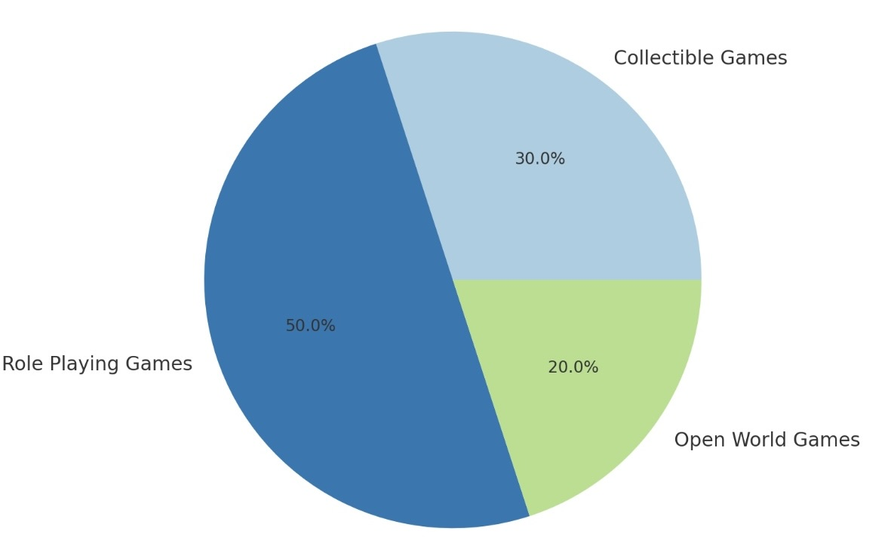

Fig1.Game Type Distribution in Blockchain Gaming Market.

*B.Collectible Games*

* *Market Share*: This segment constitutes about 30% of the mar- ket.
* *Characteristics:* Collectible games focus on acquiring, trading, and showcasing unique digital assets. Players engage in buying, breeding, and trading in-game assets, with the value often determined by rarity and demand. The ownership of these assets is secured through blockchain technology. [1]

*Examples:* Axie Infinity not only qualifies as an RPG but also as a collectible game due to its in-game assets like Axies, which can be collected, bred, and sold.[6]

*C*.*Open World Game*

* Marke*t Share: Rep*resenting around 20% of the market, open world games allow players to explore expansive virtual environments. [1]]
* *Characteristics:*These games provide players with the freedom to roam, interact with others, and create their own experiences within a decentralized environment. Blockchain technology ensures that assets within the game, such as land and items, are owned by the players, allowing for trading and monetization.

*Examples:* Decentraland and The Sandbox are prime examples, where users can buy, sell, and develop virtual land and assets.

2.BY PLATFORM

*A*.*Ethereum (ETH)*

* *Dominance:* Ethereum is the leading platform for crypto gaming, powering a wide array of popular games.
* *Advantages*: Extensive developer ecosystem: Ethereum’s mature ecosystem allows developers to create and deploy complex smart contracts, enabling innovative game mechanics. High level of security and decentralisation, making it a preferred choice for many developers.

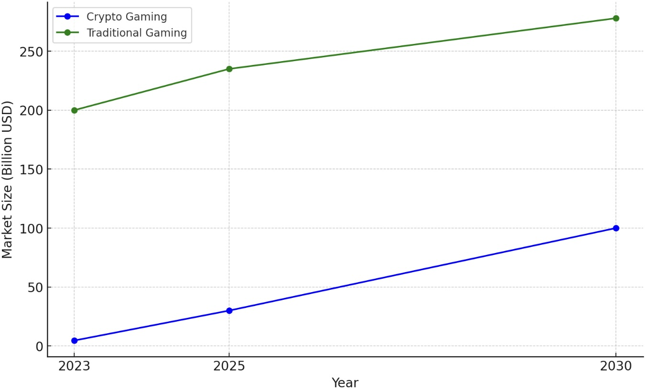

Fig3.Projected Market Size of Crypto gaming vs Traditional Gaming(2023-2030)

*Examples:* Games like Axie Infinity, Gods Unchained, and Decentraland leverage the Ethereum blockchain for their functionalities.

*B.BNB Chain*

* *Emerging Platform:* BNB Chain is gaining popularity due to its lower transaction fees and faster processing times compared to Ethereum.
* *Growth Factors*: Lower costs encourage smaller developers to enter the market, expanding the variety of games available. Strong backing from Binance, one of the largest cryptocurrency exchanges, aids in promoting and supporting game development on its platform.

*Examples*: Games like PancakeSwap and others that are starting to integrate gaming features.

*C.Polygon*

* *Rising Adoption:* Polygon is recognized for its scalability solutions and lower transaction costs.
* *Characteristics*: Designed to enhance Ethereum’s capabilities, Polygon supports the development of fast and secure dApps (decentralized applications) without compromising on security. Its growing popularity among developers indicates a shift toward multi-chain ecosystems in gaming.

*Examples*: Aavegotchi and Zed Run are notable titles utilizing the Polygon network for their game functionalities.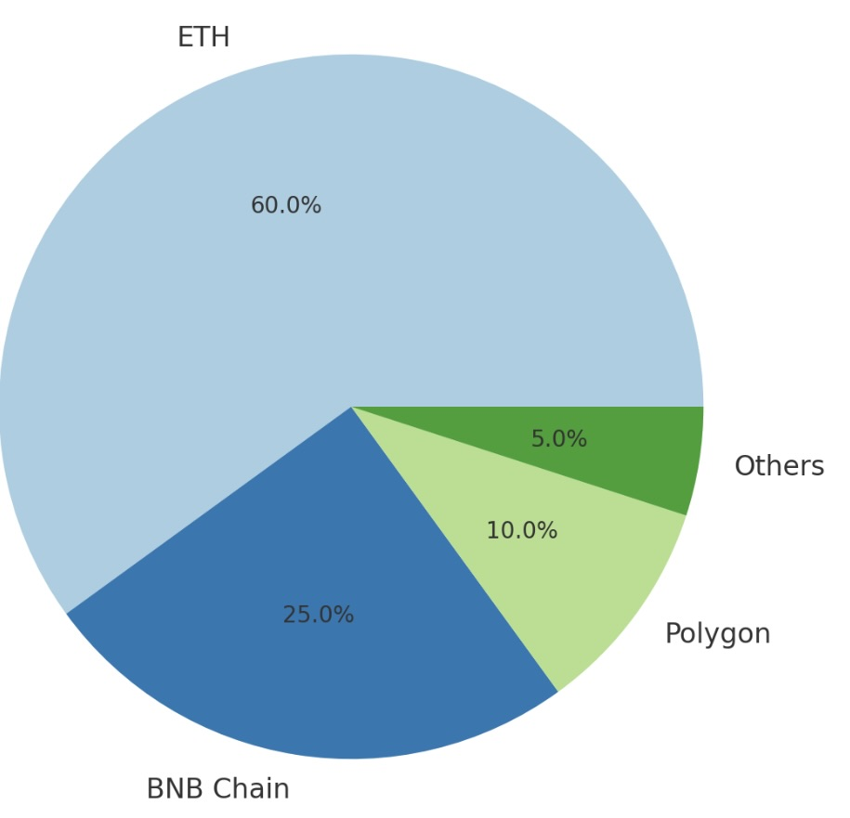

Fig2.Platform Distribution In Blockchain Gaming market.

3.BY REGION

*A*.*Asia Pacific* Dominance: The Asia Pacific region is expected to lead the market due to high rates of crypto adoption and significant investments in blockchain infrastructure. [1]

*Characteristics*: Countries like China, Japan, and South Korea are at the forefront of blockchain gaming development, with a large and engaged gaming population. Local regulations increasingly favor blockchain initiatives, encouraging innovation and adoption. [1]

*Market Drivers*: Increased smartphone penetration and internet access facilitate easier entry into crypto gaming for users in this region. North America and Europe

*Significant Markets*: These regions are experiencing growth driven by investments and advancements in blockchain regulations.

*B*.North America

Characteristics: North America boasts a well-established gaming industry and a high number of blockchain gaming startups. European countries are exploring regulatory frameworks that support blockchain technology, attracting investments and fostering innovation.

*Market Drivers:* The established gaming culture and tech-savvy population in these regions contribute to the increasing interest in blockchain games. [1]

C.*Latin America*

*Rapid Growth:* Latin America is emerging as a rapidly growing market, benefitting from the economic opportunities offered by P2E (Play-to-Earn) games.

*Characteristics:*High levels of interest in cryptocurrencies and blockchain technology have led to a surge in participation in P2E games. Many players in the region view blockchain gaming as a way to generate income and improve their financial situations.

*Market Drivers:* The region’s young population and increasing access to mobile technology facilitate the adoption of blockchain gaming. Conclusion The crypto gaming market’s segmentation by game type, platform, and region high- lights the diverse opportunities and challenges within the industry. As technologies evolve and players’ preferences shift, understanding these segments is essential for stakeholders to strategise effectively and capitalise on growth trends in this rapidly changing landscape.[1][2]

**4.2 MARKET SIZE**

Below, we delve deeper into the data points, trends, and factors contributing to the exponential growth of this sector.

1. *Market Size*

* *Current Market Size* (2023): In 2023, the global crypto gaming market was valued at approximately $4.6 billion. This value represents the combined earnings from in-game purchases, token trading, NFT transactions, and associated activities like DeFi applications within gaming. This valuation is the result of the growing number of blockchain-based games and the increasing player base engaged in these ecosystems. Major titles such as Axie Infinity, Decentraland, and The Sandbox have attracted millions of users, driving demand for in-game assets and cryptocurrencies. [1]
* *Projected Market Size for 2025 and 2030*

*2025 Projection:* By 2025, the market size is expected to grow to $30 billion. This projection is based on current growth rates, increased mainstream adoption, techno- logical advancements, and the expansion of metaverse-based gaming environments.[1]

*2030 Projection*: Looking further ahead, the market could potentially reach $100 billion by 2030. This would include not only direct revenue from gaming but also the secondary market for NFTs, the integration of DeFi in games, and the rise of virtual economies within gaming platforms.[1]

*Factors Driving Market Growth*:

* *Increased Adoption of Blockchain Technology* : Blockchain is the underlying technology of crypto gaming, enabling decentralised ownership, tokenization, and interoperability between different gaming ecosystems. More efficient blockchains (e.g., Ethereum 2.0, Solana, and Binance Smart Chain)  are  lowering  entry  barriers, making it easier for game developers  to  integrate  crypto  economies  into  their platforms.
* *Growing Player Base:* As  more  players  engage  in  P2E  games and metaverse-based ecosystems, demand for in-game  tokens  and  assets  continues to rise. Younger  demographics and crypto enthusiasts are particularly driving   this trend.
* *Ecosystem Expansion*: The crypto gaming ecosystem is expanding with cross-platform integrations, NFT marketplaces, and DeFi protocols within gaming platforms, contributing to the sector’s value.

2. *Compound Annual Growth Rate (CAGR) of Crypto Gaming (2023–2030*)

The crypto gaming market is projected to grow at a CAGR of 20–30% between 2023 and 2030. This growth rate is considerably higher than that of the traditional gam-  ing industry, which is expected to grow at a CAGR of 8–12% over the same period. [1]

*Drivers of High CAGR in Crypto Gaming:*

* *Play-to-Earn (P2E) Model:* P2E has been a game-changer for the crypto gaming industry, transforming players from passive consumers to active participants in virtual economies. In traditional gaming, players typically pay to access premium content or items, whereas in P2E models, they earn tokens and NFTs through game- play that can be traded for real-world value. Axie Infinity, for example, has proven the viability of the P2E model, where players earn the in-game token Smooth Love Potion (SLP), which can be exchanged for cryptocurrencies or fiat. This model has spurred interest, particularly in developing countries where players can supplement their income.[ 5]]
* *Global Accessibility:* Crypto gaming is borderless, allowing anyone with internet access to participate. The low barriers to entry have been particularly beneficial in regions like Southeast Asia, where P2E games are highly popular, creating communities of players and entrepreneurs engaged in virtual economies.
* *Expansion of the Metaverse:* The growth of metaverse-based games (like Decentraland and The Sandbox) is contributing to market growth, with these platforms providing virtual spaces where users can socialise, trade assets, and participate in decentralised governance. The growing interest in virtual real estate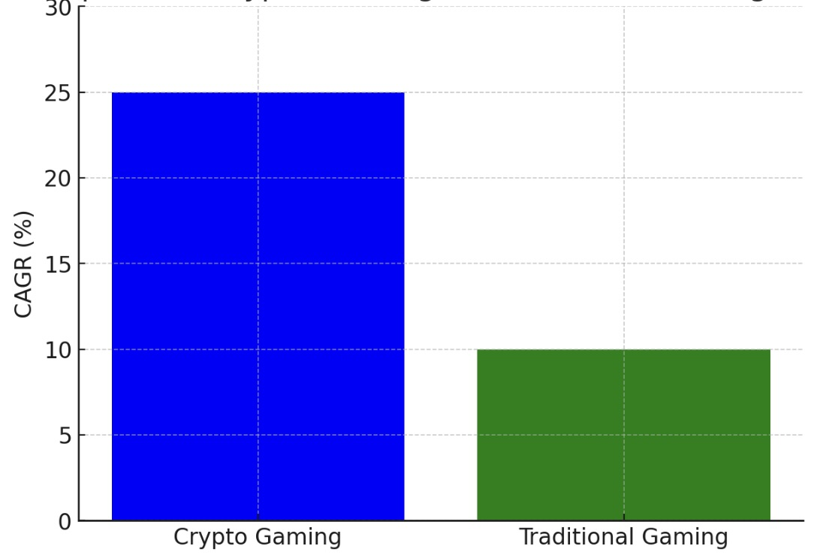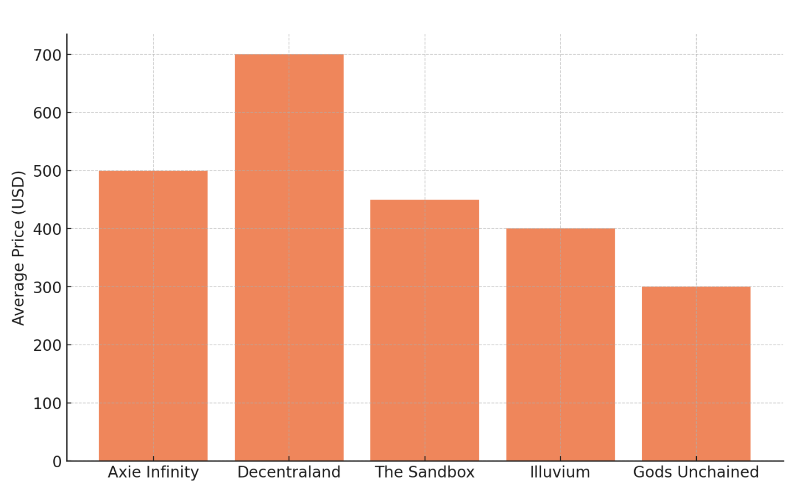 Fig4CAGR Comparison of Crypto Gaming vs Traditional Gaming(2023-2030)

(digital land) and immersive experiences is pushing market valuations upwards.

* *NFT Integration*: NFTs are a critical driver of the crypto gaming economy. In-game items and assets that players can truly own,  sell,  and  trade  have fundamentally changed how people interact with games. As more games adopt NFT-based economies, the market value of these digital assets is expected to grow, pushing the overall market size higher.
* *Secondary Markets and Speculation:* The crypto gaming market benefits from the highly liquid secondary market for NFTs and tokens. Players and investors speculate on in-game assets, further driving demand. This speculative behaviour is amplified in games with scarce or unique assets, where high resale values attract collectors and traders.

*Comparison with Traditional Gaming*

Traditional Gaming Market Growth Traditional gaming, which still relies on centralised control of in-game assets and   the pay-to-play (P2P) or free-to-play (F2P) models, is expected to grow at a CAGR  of 8–12%. Traditional gaming has a massive market size (over $200 billion globally), and its growth is driven by mobile gaming, console releases, and increased internet penetration. However, its growth is slower compared to crypto gaming due to the absence of financial incentives for players and the limited integration of decentralised technologies.

*Differences in Growth Potential*:

* *Ownership and Monetization:* In traditional gaming, players do not truly own in- game assets, nor can they monetize their gameplay to the same extent as in crypto gaming. This limits the market dynamics to content purchases and micro-transactions controlled by the game developers or publishers. Crypto gaming, on the other hand, gives players control  over  their  in-game assets through NFTs and tokenized economies. This decentralised ownership model unlocks new revenue streams for both players and developers, leading to a more vibrant economy that is attractive to new players.
* *Integration of Blockchain and Cryptocurrency*: The integration of blockchain technology allows for decentralised governance, interoperability between games, and true asset ownership, providing more flexible and profitable ecosystems. Traditional gaming companies are beginning to experiment with blockchain integration (e.g., Ubisoft), but they lag behind native crypto games in terms of adoption and innovation.
* *Player Incentives*: The P2E model of crypto gaming directly rewards players, creating an additional financial incentive to participate. In contrast, traditional gaming focuses on entertainment and in-game achievements without offering real-world value. The ability to earn money while playing in crypto games has widened the appeal to a broader audience, particularly in regions with lower incomes.

Fig5. AveragePrice By Popular gaming Collections(in USD)

* *Ecosystem and Financialization*: The financialization of gaming through DeFi elements (staking, liquidity provision, yield farming) has introduced new growth drivers for the crypto gaming market. Traditional gaming companies are less likely to incorporate decentralised finance elements into their games, leaving crypto gaming with a competitive edge in terms of financial innovation.

3.*Trends in Crypto Gaming Blockchain*

* *Advancements:* The launch of Ethereum 2.0 and other layer-2 scaling solutions such as Polygon and Immutable X will resolve many of the scaling and transaction fee issues currently facing blockchain games. These advancements will enable faster and cheaper trans- actions, making blockchain gaming more accessible to the mainstream.
* *Reduced Gas Fees and Increased Efficiency*:Gas fees, the cost of conducting trans- actions on blockchain networks, have been a major obstacle in crypto gaming, particularly on Ethereum. With Ethereum 2.0 and Layer-2 solutions, these costs will be significantly reduced, enabling seamless in-game transactions and asset trading without incurring high costs.
* *Expansion of DeFi and NFTs*:The integration of decentralised finance (DeFi) into gaming is expected to grow, enabling players to earn returns on their in-game assets through mechanisms like staking, yield farming, and liquidity provision. This adds an additional layer of financial incentives for players, making crypto gaming an attractive option for both gamers and investors. The use of NFTs will continue to expand, offering new use cases beyond in-game assets. NFTs can represent governance rights, access to exclusive content, or proof of participation in events, further driving adoption within gaming ecosystems.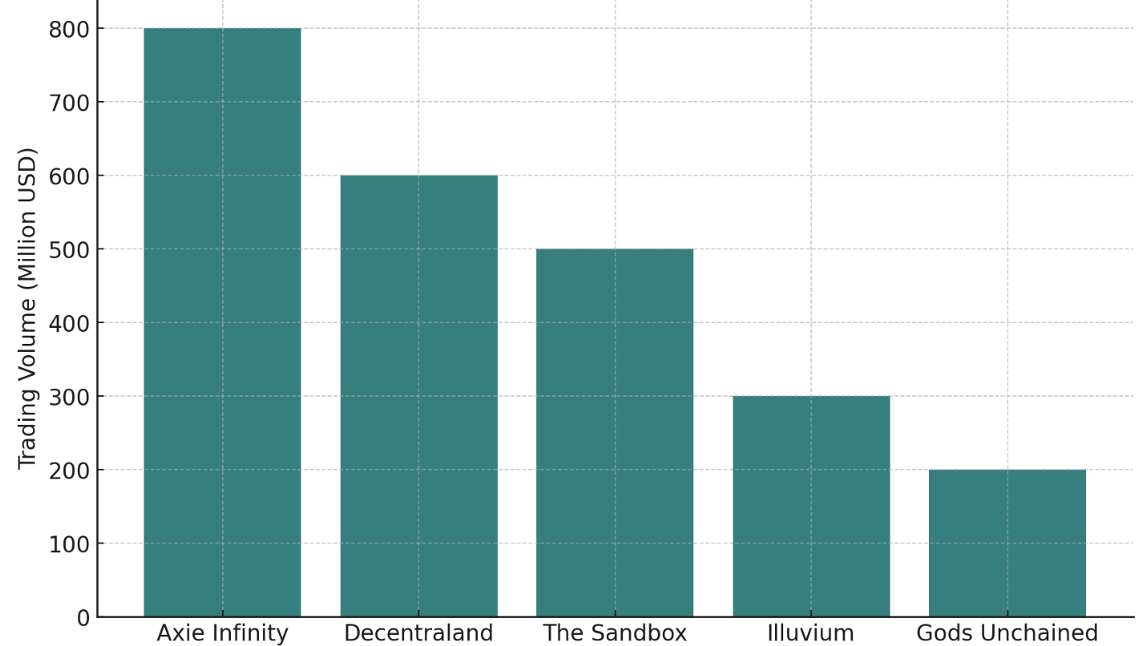

Fig6.NFT Trading Volume BY Popular gaming Collections(in USD

* *The Symbiotic Relationship between NFTs and DeFi in Gaming*: NFTs represent in-game assets such as characters, items, skins, or virtual real estate, and give players true ownership. Players can trade, sell, or lend their assets, creating an economy of digital goods that holds real- world value. DeFi (Decentralised Finance) adds another layer of financial complexity to crypto games. Players can stake their in-game tokens, participate in liquidity pools, or earn interest on their holdings, allowing them to generate passive income from their virtual assets. This integration allows players to monetize their game time in new ways, making the virtual economy more vibrant and complex. In games like Illuvium and Gods Unchained, players can earn tokens that have DeFi functionalities, creating additional streams of value within the game ecosystem. [2]

**5.*FUTURE SCOPE***

*A. The Evolution of Play-to-earn  models:*

Play-to-Earn (P2E) games have gained tremendous popularity, providing players with opportunities to earn cryptocurrency or tokenized assets by participating in game- play.he  P2E model is transforming gaming from a purely entertainment activity to a potential source of income, particularly in developing countries.

Here’s how P2E is evolving and examples of successful ecosystems:

* *Rewarding Participation and Skill:* Unlike traditional games where players spend money to purchase in-game assets, P2E games allow players to earn assets by invest- ing time and skill. Players are rewarded in tokens or NFTs, which have real-world value. This shift allows gamers to monetize their in-game achievements, leveling the playing field between time investment and financial returns.
* *Community-Driven Economies:* P2E models are often built on decentralized, community-driven economies where players can participate in governance through decentralized autonomous organizations (DAOs). Players can vote on game updates, economic policies, and distribution of rewards, further engaging them in the ecosystem.
* *Sustainable Economies:* As P2E models evolve, developers are working to create more sustainable ecosystems by balancing token supply with demand. This includes measures such as burning tokens or introducing in-game sinks to stabilise the value of rewards and prevent inflation.

*B.Cross -Platform Virtual Economies:*

Cross-platform digital gaming economies are the future of the gaming industry, allow- ing assets, currencies, and digital tokens to be utilized across various games and platforms. Cryptocurrencies play a crucial role in this by establishing a uniform system for ownership, exchange, and compatibility. Here’s how cryptocurrency enables cross-platform economies:

* *Interoperability Through Blockchain:* Cryptocurrencies and NFTs are stored on pub- lic blockchains, which are decentralised and accessible across different games. Players can transfer their assets from one game to another, provided both games support the same blockchain standard (e.g., Ethereum or Binance Smart Chain). This breaks down the silos that exist in traditional gaming economies, where items are usually locked to a single platform. [7]
* *Cross-Game Economies:* With the use of NFTs and interchangeable tokens, players can apply assets from one game to another. For instance, a piece of clothing bought in a game such as The Sandbox could be used in another game that supports     the same NFT standards. This provides a seamless experience for players, allowing them to carry their investments and accomplishments across various games, thereby enhancing the value of digital assets.
* *Unified Currencies Across Games*: Cryptocurrencies like $SAND, $AXS, or $MANA act as native currencies within specific game ecosystems but can also be traded  across platforms and converted into other cryptocurrencies or fiat.  This  creates  fluid, interconnected economies where players are no longer tied to a single game’s economy and can fluidly move value across platforms.
* *Economic Opportunities for Developers:* Multi-platform economies also present new avenues for game developers to generate revenue. By creating assets that are interopenable, developers can appeal to a broader audience of players who appreciate assets that maintain their value across different games. Developers can also collaborate to create economies that are shared across multiple titles.

*C. Metaverse Integration*: Cryptocurrencies are seen as a foundational element for building the metaverse-a col- lective immersive digital realms where individuals engage with avatars, craft digital creations, and participate in virtual financial systems.The vision of the metaverse is to create fully interconnected digital spaces with decentralised ownership and governance, where cryptocurrencies and blockchain technology play a central role.

*The Role of Cryptocurrencies in the Metaverse*:

* *Digital ownership via NFTs:* NFTs are revolutionary for establishing verifiable ownership of digital assests.In the metaverse,these assets include - Virtual Real Estate,Avatars and customizations,
* *In -game items* *Interoperability and Cross-World Economies :*The metaverse’s potential lies in its interconnectedness.
* *Seamless Transactions:* Cryptocurrencies act as a universal medium of exchange, allowing users to transact across different platforms effortlessly.
* *Asset Portability:* Users can transfer assets between various virtual worlds, enhancing the value of their digital possessions and creating a more unified digital economy.
* *Collaborative Experiences*: Interoperability fosters collaborative projects, such as joint events or shared experiences, where users can utilise their assets across multiple environments .Decentralised Governance via Decentralized Autonomous Organizations (DAOs) empower users within the metaverse.
* *Community Decision-Making:* Members with tokens have the power to approve plans, guaranteeing that leadership mirrors what the community wants and requires.
* *Resource Allocation*: Decentralised Autonomous Organizations can oversee common assets, such as digital property investment funds, influenced by the community’s suggestions.
* *Sustainability of Platforms:* This model encourages active participation, making the metaverse more resilient and responsive to its users.
* *Economic Opportunities for Users:* The metaverse offers abundant opportunities for business ventures.
* *Development and Distribution of Digital Products:* Individuals can create and sell digital items, ranging from apparel to complete experiences, making money directly through cryptocurrency.
* *Offering Services:* Professions can be turned into a source of income in the meta- verse, with individuals providing services like education, design, or entertainment.
* *Digital Enterprises:* Business owners can build and grow enterprises in the meta- verse, leveraging its worldwide accessibility and varied audience. Examples of Crypto-Driven Metaverse Platforms:
* T*he Sandbox Metaverse:* Players can purchase land, develop experiences, and monetize their creations in *The Sandbox*. The $SAND token serves as the primary currency, enabling transactions, staking, and governance within the ecosystem.
* *Decentraland:* A fully decentralised virtual world where users can buy, develop, and trade virtual land using the $MANA cryptocurrency. Decentraland also offers a wide range of NFT-based goods, such as avatars, accessories, and virtual art, that can be sold or traded.
* *Meta (Facebook’s Vision):* Although still in development, Meta’s vision of the metaverse includes integrating cryptocurrencies and NFTs to create interoperable virtual economies where users can build, trade, and monetize digital assets across platforms.

As the metaverse evolves, cryptocurrencies will be foundational in creating a vibrant, decentralised economy. This integration not only enhances user experiences but also democratises access to digital ownership and opportunities, fostering an inclusive virtual community where creativity and collaboration thrive.

**6.DISCUSSION** **ON FINDINGS**

The crypto gaming market is on a rapid growth trajectory, with market size projected to increase from $4.6 billion in 2023 to potentially $100 billion by 2030. This growth is driven by blockchain advancements, the P2E model, NFT integration, and the fusion of DeFi elements within games. With a CAGR of 20–30%, crypto gaming is outpacing traditional gaming in terms of innovation and revenue potential.To begin with, cryptocurrency provides players with a decentralised approach to transactions, removing the necessity for middlemen like banks or game developers. This change empowers players, allowing them to engage in direct trading of virtual items with lower transaction costs and greater visibility.However, the decentralised nature of cryptocurrency also presents regulatory challenges, as governments and regulatory bodies struggle to keep pace with the rapid evolution of digital assets in virtual economies.Future policies could shape the role of cryptocurrency in gaming platforms, potentially restricting or expanding its use.Another notable impact of cryptocurrencies on online gaming is the rise of the Play-to-Earn (P2E) model, where players can earn crypto tokens and other blockchain-based assets as rewards for gameplay.This has blurred the distinction between gaming for fun and gaming for profit, attract-  ing new players into the community who might not have been interested in gaming before. While this opens up avenues for earning and even job opportunities, it also raises questions about the sustainability of these models and the possible exploitation of players in countries where these rewards can be a major source of income. Furthermore, the ownership of in-game assets through blockchain and non-fungible tokens (NFTs) has led to a paradigm shift in how players perceive value in virtual economies. Unlike traditional games, where assets are confined within proprietary ecosystems, blockchain technology enables the ownership and trade of in-game assets across multiple platforms.This could lead to the creation of a powerful secondary market for digital assets, but also increases the risk of fraud, market manipulation, and volatility.As a result, developers and publishers must balance innovation with consumer protection to ensure these new systems are fair and secure Lastly, the adoption of cryptocurrency has enhanced community-driven gaming ecosystems .Decentralised autonomous organizations (DAOs) allow players to have a say in the governance of games and virtual worlds, creating a more inclusive and democratic atmosphere. However, this could also lead to power imbalances if a few large token holders have too much influence over the decision-making processes.This fosters a more inclusive and democratic environment but may also create power imbalances if large token holders exert disproportionate influence over decision-making processes. In conclusion, cryptocurrencies have brought great opportunities for online gaming and the virtual economy, but they have also brought challenges that require careful consideration.Regulatory frameworks, sustainability, security, and fairness are key areas for future research to ensure that the integration of cryptocurrencies remains beneficial for all stakeholders. The incorporation of cryptocurrency into the realms of online gaming and virtual economies marks a major shift in the functioning of digital ecosystems, offering both opportunities and challanges. Cryptocurrency facilitates decentralised ownership, enabling players to trade and monetize virtual assets in ways  that were not feasible under the old gaming frameworks.This democratisation of virtual economies has been further amplified by the emergence of play-to -earn models and digital assets secured on blockchain, turning gaming from a mere pastime into a possible avenue for earning for many players. However these innovations come with their own set of challenges.The decentralised nature of cryptocurrency raises regulatory concerns, particularly related to fraud, market manipulation ,and the need for legal control.The volatility of cryptocurrency markets also introduces financial risk for both players and game developers.Additionally, while blockchain technology has made the ownership of digital assets clearer and easier to transfer, it also brings about challenges concerning security, sustainability, and ensuring everyone has fair access. 

**7. CONCLUSION**

The integration of cryptocurrencies into online games and virtual economies has had multifaceted impacts, changing the dynamics of virtual asset ownership, monetization, and community engagement.To sum up, the introduction of digital currencies in online gaming and virtual  economies has the  potential  to  reshape  the  digital  landscape  creating  new  ways for economic engagement and involvement.However, to realise it’s full potential, stakeholders—ranging from developers to regulators—must address the risks and uncertainties that accompany this technological shift.Striking a balance between innovation and regulation, ensuring the security of these systems, and promoting fairness  in access will be key in determining how successfully digital currencies can change the landscape of online gaming and virtual economies.

**8.REFERENCES**

[1]Fortune Business Insights. (2024, September 23). Blockchain Gaming Market Size, Share & COVID-19 Impact Analysis, By Game Type (Role Playing Games (RPG), Multiplayer Games, and Collectible Games), By Technology (Web-based, Android, and iOS), and Regional Forecast, 2023-2030 [Report ID: FBI108683]. <https://www.fortunebusinessinsights.com/blockchain-gaming-market-108683>

[2] Sivula, A., Shamsuzzoha, A., & Helo, P. (2021). Requirements for Blockchain Technology in Supply Chain Management: An Exploratory Case Study. <http://doi.org/10.31387/oscm0440284>Fortune Business Insights. (2024, September 23). Blockchain Gaming Market Size, Share & COVID-19 Impact Analysis, By Game Type (Role Playing Games (RPG), Multiplayer Games, and Collectible Games), By Technology (Web-(RPG), Multiplayer Games, and Collectible Games), By Technology (Web-based, Android, and iOS), and Regional Forecast, 2023-2030 [Report ID: FBI108683]. <https://www.fortunebusinessinsights.com/blockchain-gaming-market-108683>

[3] Robertson, A. (2022, April 8). Axie Infinity’s financial mess started long before its $600 million hack. The Verge. <https://www.theverge.com/2022/4/8/23015468/axie-infinity-blockchain-nft-play-to-earn-game-economics-hack>

[4] Brustein, J. (2022, June 10). A billion-dollar crypto gaming startup promised riches and delivered disaster. Bloomberg. <https://www.bloomberg.com/news/features/2022-06-10/axie-infinity-axs-crypto-game-promised-nft-riches-gave-ruin>

[5] Roth, E. (2022, June 28). Axie Infinity NFT game reopens transactions months after $625 million theft. The Verge. <https://www.theverge.com/2022/6/28/23186368/axie-infinity-nft-game-transactions-625-million-theft>

[6] Lawler, R. (2022, April 7). After $600 million crypto heist, Axie Infinity team raises $150 million and launches another NFT game. The Verge. <https://www.theverge.com/2022/4/7/23013134/axie-infinity-ronin-network-crypto-theft-origin-launch>

[7] Kruppa, M. (2021, August 25). Crypto’s hottest game is facing an economic maelstrom. Financial Times. <https://www.ft.com/content/b0c49d6f-a06a-4def-8469-45ad009ac13c>

[8] Gawron, M., & Strzelecki, A. (2021). Consumers' Adoption and Use of E-Currencies in Virtual Markets in the Context of an Online Game. Journal of Theoretical and Applied Electronic Commerce Research, 16(5), 1266-1279. <https://doi.org/10.3390/jtaer1605>

[9] da Silva, I. R. R., & Omar, N. (2021). Real and Virtual Token Economy Applied to Games: A Comparative Study Between Cryptocurrencies. In K. Arai (Ed.), Intelligent Computing (Lecture Notes in Networks and Systems, Vol. 284, pp. 869-880). Springer, Cham. <https://doi.org/10.1007/978-3-030-80126-7_61>

[10]Servando, K., & Sayson, I. (2021, August 25). This video game is turning the pandemic jobless into crypto traders. Bloomberg. <https://www.bloomberg.com/news/articles/2021-08-25/axie-infinity-how-game-is-turning-pandemic-jobless-into-crypto-nft-traders>

[11] Shen, X., Jiang, S., & Zhang, L. (2021). Mining bytecode features of smart contracts to detect Ponzi scheme on blockchain. Computer Modeling in Engineering & Sciences, 127, 1069-1085.

[12] Agarwal, J. D., Agarwal, M., Agarwal, A., & Agarwal, Y. (2020). Economics of Cryptocurrencies: Artificial Intelligence, Blockchain, and Digital Currency. In A. K. Gupta (Ed.), Handbook of Cryptocurrencies and Blockchain Technologies (pp. 313-342). Springer International Publishing. <https://doi.org/10.1142/9789811220470_0013>

[13] Min, T., & Cai, W. (2019). A security case study for blockchain games. In 2019 IEEE Games, Entertainment, Media Conference (GEM) (pp. 1-8). IEEE

[14] Attaran, M., & Gunasekaran, A. (2019). Blockchain for Gaming. Cham: Springer International Publishing. <https://doi.org/10.1007/978-3-030-27798-7_12>

[15] Yuen, H. Y., Wu, F., Cai, W., Chan, H. C., Yan, Q., & Leung, V. C. (2019). Proof-of-play: A novel consensus model for blockchain-based peer-to-peer gaming system. In Proceedings of the 2019 ACM International Symposium on Blockchain and Secure Critical Infrastructure (BSCI ’19) (pp. 19-28). Association for Computing Machinery. <https://doi.org/10.1145/3327960.3332386>

[16] Kaal, W. A., & Calcaterra, C. (2017). Crypto transaction dispute resolution. The Business Lawyer, 73(1), 109-152. JSTOR

[17] Wohn, D. (2014). Spending real money: Purchasing patterns of virtual goods in an online social game. In Proceedings of the CHI 2014 (pp. 3359-3368). ACM Press.

[18] Ducheneaut, N., Yee, N., Nickell, E., & Moore, R. (2007). The life and death of online gaming communities: A look at guilds in World of Warcraft. In Proceedings of the 2007 International Conference on Human Factors in Computing Systems (CHI '07) (pp. 839-848). ACM Press.

[19] Narayanan, A., Bonneau, J., Felten, E., Miller, A., & Goldfeder, S. (2006). Bitcoin and cryptocurrency technologies: A comprehensive introduction. Princeton University Press.