**THE EFFECT OF GLOBALIZATION ON INTERNATIONAL MARKET DYNAMICS**

Vijay Kumar Agarwal1 Dr. Mohan Lal Dhaka2

1Research Scholar 2Research Guide

Department of Management

NIILM University, Kaithal (Haryana)

**Abstract**

Globalization, the intricate web of interconnectedness among nations, has redefined the landscape of international business. Its impact is profound, shaping economic, social, and cultural dimensions worldwide. In the realm of international business, globalization has facilitated unprecedented opportunities for expansion, enabling companies to tap into new markets and access a diverse range of resources. However, it also presents challenges, as businesses navigate through varying regulatory frameworks, cultural nuances, and geopolitical tensions. The rise of global supply chains has heightened competition while fostering innovation and efficiency. Yet, it has also exposed vulnerabilities to disruptions, as seen in recent times with the pandemic. In essence, globalization is a double-edged sword for international business, offering immense potential for growth while demanding adaptability and resilience in an ever-evolving global landscape.

**Keywords:** Global supply chains, Economic integration, Trade liberalization.

**Introduction**

Globalization expands local and nationalistic viewpoints of a connected global market that allows cross-border currencies, commodities, and services. As tariffs, import restrictions, and export fees are abolished, "globalization" may decrease the world. A suffering economy would suffer from globalization, but the free market would not. Correct globalization will generate a more equitable society where rich and poor share prosperity. It may also impact the global system that oppresses the poor and elevates the privileged.

Social and economic "globalization." is formed by national markets and global networks. "Globalization" was in 1930's "Towards New Education." Post-Cold War economic integration was dubbed "globalization." Globalized political economy depends on shifting assets and products. Power moves from the state to the supranational state under globalization. Direct foreign investments and portfolio investments in multinationals encourage globalization.

Countries and people trade products and services internationally. International companies trade. Investments, sales, transportation, and private and/or governmental activities between nations and territories are international business. International businesses focus on worldwide resources, economic prospects, and risks. That is, "What is Malaysia's import, export, and trade balance in international trade?" Businesses trade products, services, and money internationally. Trade accounts for a major portion of GDP in many nations.

Governments share political economy authority. Relational and absolute power exist. State power may be soft or harsh. Hard power coerces, whereas soft power influences via culture, values, and beliefs. Markets value efficiency, human behavior, and self-interest. Society, part of the global political economy, includes ideas, history, and culture. Due to their differing aims and techniques, state, market, and society sometimes collide. International political economy is driven by interdependence and the reality that changes in one of these three sectors usually affect the others. "International migration" is crossing countries for better work, living conditions, education, public amenities, and longevity.

Power and money exchange agreements form the global political economy. These agreements control international power, money, and commerce. Negotiations in international political economics may take several forms. Some agreements are signed, authorized, and maintained; others are understandings, standards, or suggestions. Some international political economics agreements demonstrate rational power the ability to influence another's conduct. The environmental effects of trade policies on natural resources are hard to quantify, although research shows both positive and negative effects. This study seeks to understand globalization and trade.

**Literature Review**

Liberalization, economic integration, unconstrained capital and investment flows, labor force mobilization, and information flow are globalization. International businesses purchase and sell products and services between nations. Only large companies with overseas operations are international.

Global enterprises from every country dominate the global economy owing to widespread commerce. International business, "based on the self-selected social characteristics of the common commitment to the product category, brand, or consumer activity grouping," is a consuming subculture. The world shrinks as economies, businesses, and technology encourage travel. International business law is growing more important technological, political, legal, dynamic socio-cultural, and technical challenges dominate international economic and ecological conditions.

Globalization is an irreversible force established by governments and organizations to promote free commerce, ideas, people, and products for economic and social unity. Bridges between the past, present, and future are "globalization". It discusses social system expansion and inter-social complexity. People, companies, and governments from other nations interact in globalization. Information technology enables global commerce and investment. Globalization fosters international collaboration.

Globalization integrates internationally. Creating a global social and economic network is "globalization". International business emphasizes worldwide resources and an organization's aims for global business possibilities and risks. International commerce comprises all public and private economic exchanges between countries. Any business between two or more nations across a border is international commerce. International business entails cross-border cooperation and research synthesis into larger frameworks.

Globalization enhanced information technology, reducing disasters and aiding rescue efforts. Thus, we must evaluate if globalization has promoted peace and growth. International commerce, investment, labor, products, services, and money were freed by globalization. In many nations, labor is plentiful but money is scarce. Trade and investment globally are affected by globalization to solve economic growth's capital deficit. Trading and investing are restricted. To enhance trade and investment, countries must integrate.

Globalization creates global business possibilities and risks. Globalization connects markets, thus worldwide enterprises require a strong marketing mix. Foreign corporations compete even if local enterprises don't desire globalization. Over the last 30 years, economic progress has decreased global poverty. The globalization recession increased the wealth divide. Globalization also challenges national and international sustainability. Foreign direct investment and export-import commerce dominate international business. Next steps will include subsidiaries and joint ventures. Global business comprises franchises and licenses.

**Globalisation and Its Impact on International Business**

1. **Globalization**

Globalization includes trade, migration, technology transfer, and information exchange. A nation must sign bilateral, regional, or multilateral trade agreements to eliminate trade barriers. This might boost global commerce and industry. Trade agreements increase financial, information, and product mobility. Due to changing labor market manufacturing costs, globalization entails emigration and immigration of prospective workers. Global commerce and technology distribution enterprises need technology since new manufacturing techniques and alternatives spread quickly.

The globalization process included five stages. First, social globalization became a key topic as our forefathers grew and brought diverse immigrants. Second, political globalization may have driven our predecessors to build small-scale, rural, urban, and communal life. Several worldwide political regimes will result. Globalization of culture ranks third. Politically established nations are influenced by global technology and culture. Cultural, religious, and English examples. Economics globalization ranks fourth. The 1757 revolution boosted economic globalization. Sixth: integrative globalization. Integration of globalization in 21st century. Free-flowing capital and products are replacing independent economies in many nations.

Integrating economies will also benefit. Business operations gain from new goods released in less than a year. To boost its image among customers and businessmen, the corporation may grow abroad. Organizations may evaluate new funding, technology, and sources. Positive influence builds brand identity overseas. It will spend less since it will target the same customer categories in all markets with the same product idea and approach. Globalization benefits consumers, governments, and businesses. Customers may now compare and buy similar things globally with better, cheaper, and wider options. Economic developments have been affected by globalization. It also weakens communism and promotes democracy. Globalization has improved living conditions in industrialized and poor nations.

Globalization has several effects on businesses expanding globally. First, political stability boosts business and FDI. Thus, a nation with uncertain politics gains less. Second, bureaucracy may inhibit multinationals' business. Forex changes hurt third. Currency exchange rates are the price of one currency in terms of another. Foreign companies may struggle with exchange rate fluctuations. Corruption may hinder international trade and investment. State administration needs money for services. Globalization has led to trade agreements to lower tariff and non-tariff barriers. However, many nations increasingly defend their industries, hurting multinational corporations. Nontariff goods trade would be hampered by custom import permits. Industrial piracy is ubiquitous and undermines expensive R&D, putting enterprises at risk. Businesses need protection from government action to make their goods hard to copy. Growing international enterprises will compete vigorously. A company competes internationally with multinationals and locals. International corporations are tougher to manage than domestic ones owing to various norms, cultures, beliefs, customer behavior, and attitudes. Environmental, human rights, and international laws must be addressed since oversight may fail companies. Multinational companies with several sites often face management blunders, which create substantial financial losses.

1. **Impact of Globalization on International Business**

The market is more competitive owing to globalization. Market, manufacturing technology, quality, pricing, and product/service expenses are competing factors. A cheap, high-quality product or service may become worldwide. Market share will rise for their company.

Globalization has helped developing nations utilize technology. Rich nations may invest in poor nations owing to globalization. Industrialized nations export industry, agriculture, and other advances to undeveloped ones. Poor and emerging nations' economy will benefit.

Globalization expands opportunity for everybody. People benefit from resource and industrial progress. Companies are expanding, providing jobs, and individuals are traveling overseas to earn money. Immigration boosts social and economic advancement. Every nation should welcome international investment because it strengthens industrial and local economies. Outside investors invest extensively in several sectors. Industries invest in R&D to improve technologies and boost output.

Manufacturing and service organizations are judged by survival and profitability. Service organizations value relationships over profit and assess performance by client happiness. Industrial companies prioritize profit but are judged by product quality.

Globalization has reduced trade and investment constraints. International commerce happens when a corporation sells abroad. Corporations engage in overseas firms via FDI. Import taxes on manufactured products and services increase trade obstacles. Tariffs shield indigenous businesses from international competition. Globalization has eased commerce and investment, bringing nations closer. All nations have benefited from easier trade and investment.

1. **Malaysia’s Total Export Based on Country in 2016**

This section compares Malaysia's 2016 short-term exports to international trade. The dispute is based on Malaysia's Department of Statistics statistics. Globalization has raised questions about Malaysia's primary business partners. Products and services exported from one country to another are called exports. Exports help a country sustain its cash flow because they have a competitive edge, learn how to sell in other markets, generate jobs, enhance inhabitants' quality of life, and bring in higher income. The export graph shows Malaysia's 2016 export value of RM785, 934.8 billion. Malaysia's 2016 exports are shown in Figure 1.

Singapore, China, the US, Japan, Thailand, Hong Kong, India, Indonesia, Australia, South Korea, and others are Malaysia's top 10 export destinations. Overall exports are growing in 2016. The US export share stayed at 10%, while China increased to 13% and Singapore to 15%. Hong Kong's exports grew 5% and Thailand's 6%. South Korea, Australia, and India exported 4%. However, Japan's export percentage is falling to 8% from 10% in 2014. Due to falling productivity, labor constraints, and local demand, Singapore buys more from Malaysia, which boosts exports. China's high-tech manufacturing demand has increased because to PRC rivalry, which has boosted exports. The US's export proportion stayed unchanged due to sustained domestic demand, a pleasant environment, and falling energy prices. Hong Kong's trade relationship with Malaysia increased exports, mostly of metalworking machinery, electrical machinery, telecommunications, and other equipment, while Thailand's exports increased despite environmental and political unrest from last year's disasters due to high demand for crude petrol, integrated circuits, and printed circuits. South Korea, Australia, and India exported products at the same pace despite political, economic, and natural catastrophe uncertainty. Japan's export share fell due to flattened investment and lower private consumption, causing economic instability and stability.

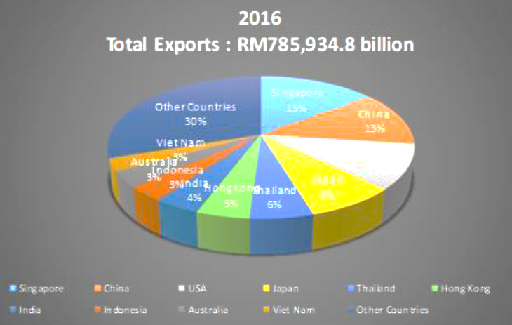

**Figure 1: Malaysia’s total exports**

**Source:** Department of Statistics, Malaysia, 2017

Globalization impacts all industries and nations. Lack of adaptability leaves us behind. It also benefits ourselves, our business, and our nations. Every country is globalizing. Companies are expanding abroad via trade and investment to succeed in the 21st century. Powerful nations export more than they import. This gives them an edge over weaker nations. Globalization reduces trade and investment gaps, but may also be impacted by economic factors, politics, social instability, and natural calamities. By competing with other nations, we may benefit from their experience and use it as a competitive advantage. Globalization strengthens nations and commerce sustains their economies.

According to Giddens (1990), globalization is “the intensification of worldwide social relations that link distinct localities in such a way that local happenings are shaped by events occurring miles away.” Globalization is also linked to economic integration and liberalism, with investment, labor, technology, culture, information, and a borderless world. Globalization encompasses fast environmental changes that need dramatic interventions and acts.

1. **Malaysia’s Total Import Based on Country in 2016**

This segment will expound upon the realm of international commerce, which Malaysia intends to import goods into in the near future, specifically in 2016.

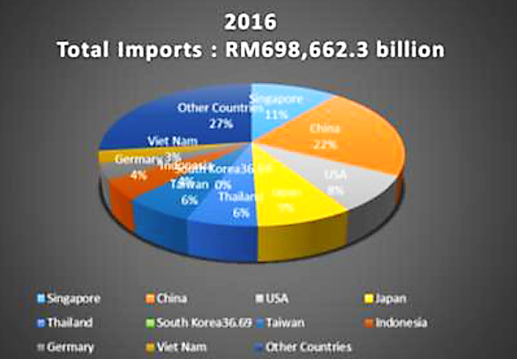

**Figure 2: Malaysia‟s total imports**

**Source:** Department of Statistics, Malaysia, 2017

One country's population import products and services from another. Residents include businesses and government. Airline hand baggage may import. Companies develop worldwide via imports and exports (Department of Statistics, Malaysia, 2017). Malaysia's 2016 foreign imports are graphed. International imports were RM698,662.30 in 2016. Imports rose 2.30 percent to RM15725.20 in 2016.

Malaysia buys from Singapore, China, the US, Japan, Thailand, Germany, Vietnam, Indonesia, Australia, and South Korea. In 2016, imports grew 2.30 percent (RM15731.20). China supplied 22% of Malaysian imports in 2016. It cost RM153705.71. A new agreement was signed during the 27th ASEAN Summit in Kuala Lumpur on November 21, 2016. Due to trade and economic trends, ASEAN economic cooperation, particularly between Malaysia and China, should be strengthened and simplified. It entails rewriting the Trade in Goods, Services, Investment, and Economic and Technical Cooperation agreement. 11 percent, RM76852.85, were imported. Next, 9% of total imports came from Japan since ASEAN and Japan pledged to increase their trade and investment flows by 2022 and acknowledged the AJCEP's significance in strengthening and boosting economic integration. The US followed with RM55,892.98 and rose 1% owing to Malaysia's pursuit of four free trade agreements, including MEUFTA and MEEPA. Thailand and Taiwan followed at 6% (RM41,919.74), Germany and Indonesia at 4% (RM27,946.49), and Vietnam at 3% (RM20,959.87). Foreign imports made for 27% of 2016 imports at RM188638.82.

In 2016, China imported the most at RM153,705.71, after RM122,928.68 in 2014. Data reveals a 25.04% rise, or RM30777.03, between 2014 and 2015. Vietnam imported the least in 2014 (RM13, 658.74) and 2016 (RM20, 959.87). It increased 53.45%, or RM7301.13, between 2014 and 2016.

1. **The Trend for Malaysia’s Trade Balance from 1990 to 2016**

This segment examines Malaysia's trade balance over an extended period of time, from 1990 to 2016, in order to assess the influence of globalization on the country's foreign trade.

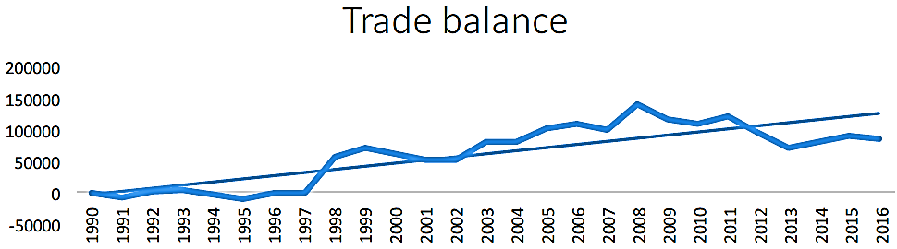

**Figure 3: Trade balance from 1990-2016**

**Source:** Department of Statistics, Malaysia, 2017

Trade balance 1990–2016 is graphed. Trade balance compares imports and exports. Positive trade balances suggest surpluses, whereas negative ones imply deficits. Trade balances change from 1990 to 2016. Some trade balances were favorable, while 1991, 1994, and 1995 were negative. The highest and lowest were 2008 and 1995. Foreign trade has bolstered Malaysia's GDP since 1998. Malaysia has consistently had trade surpluses owing to increased electrical and electronic exports. The US, Singapore, Hong Kong, Japan, and Taiwan had the greatest trade surpluses and deficits with China and Taiwan in 2015.

Malaysia's exports and imports expanded consistently in 2016 despite trade balance shifts. Malaysia utilized agreements, trade, and diplomatic connections with China, a major market, the US, which will assist us with the monetary unit, Japan, which manufactures chips, iron, steel, and circuit boards, and the other three important trading partners. Exports exceeded imports in 2016, improving the trade balance.

**Conclusion**

Globalization may affect everyone. Globalization is possible, but it need not be worldwide. Know how far globalization has come. Quantifying and explaining our focus on economic globalization are also included.

Technology improvements from market-based systems, domestic politics, and economic stability encouraged globalization. As globalists capitalize on opportunities and decrease costs, globalization processes create new or changed governance structures. Globalization will be autonomous and governance institutions will be reliant. New governance dynamics may alter globalization accord and extent.

Globalization may enhance markets, something any economy should want. An efficient market balances buyers' and sellers' desire to pay and sell. We lower costs by outsourcing or buying from a cheap overseas source, boosting demand and affordability. A company may produce more money to boost salaries or grow activities without decreasing expenses.

Globalization will generate many manufacturers competing for economies. Competence boosts product and service quality, benefiting consumers. When expanding globally, companies create new norms. Consumers have more alternatives. Competition for market share pushes enterprises to improve their goods and services or provide value. Customers benefit from our high-quality, sometimes cheaper products.

Globalization accelerates foreign direct investment, enhancing international trade, technology transfer, industrial restructuring, and firm growth. Globalization encourages competition, which stimulates technical advancement, particularly foreign direct investment, which improves process efficiency and economic productivity.

Globalization helps large companies achieve economies of scale and decrease prices, encouraging economic growth and wealth equality. Many Malaysians think globalization has degraded their standards of living, whereas hundreds of millions have jobs, businesses, and can support their families. Malaysians take clean water, shelter, and food for granted. Despite our poverty, we live well and cannot afford luxury. Globalization may have stopped you from buying a new TV, but it fed countless developing nation families.

Finally, the new international system's globalization is a major factor in nation-state fate. Economic, political, environmental, social, cultural, security, health, and other factors. This article examines worldwide economic "globalization". Though coined in the 1980s, the idea is traditional and interpreted variably. Governments, scholars, and activists see globalization as positive or detrimental due to these different views.

**References**

1. Abdullah, A. A. & Islam, R. (2013). Balanced Scored Evaluating of British Tobacco in Malaysia. Journal of Applied Sciences Research, 9(5): 3301-3310.
2. Abidin, I. S. Z., Haseeb, M. & Islam, R. (2016b). Regional Integration of the Association of Southeast Asian Nations Economic Community: An Analysis of Malaysia – Association of Southeast Asian Nations Exports. International Journal of Economics and Financial Issues, 6(2): 646-652.
3. Abidin, I. S. Z., Haseeb, M., Chiat, L. W. & Islam, R. (2016a). Determinants of Malaysia – BRICS Trade Linkages: Gravity Model Approach. Investment Management and Financial Innovation, 13(2): 1-10.
4. Alam, F., Siwar, C., Talib, B. & Islam, R. (2011). Impacts on International Migration and Remittances Growth. American Journal of Environmental Sciences, 7(1): 20-25, 2011. ISSN: 1553-345X.
5. Al-Homayan, A. M., Shamsudin, F. M. Subramaniam, C. & Islam, R. (2013). Relationship among Job Demand- Resources, Job Stress, Organizational Support and Nurses‟ Job Performance. Australian Journal of Basic and Applied Sciences, 7(9): 294-308.
6. ALNasser, A., Yusoff, R. Z. & Islam, R. (2013c). Relationship between Hard Total Quality Management Practices and Organizational Performance in Municipalities. American Journal of Applied Sciences,10(10): 1214-1223.
7. Al-Nasser, M., Islam, R. Abidin, I. S. Z., Azam, M. & Prabhakar, A. C. (2015). Analysis of E-service Quality through Online Shopping. Research Journal of Business Management, 9(3): 422-442.
8. Al-Nasser, M., Yusoff, R. Z., Islam, R. & AL Nasser, A. (2013a). Cultural Differences Identification and Its Effect on E- service Quality Perception. American Journal of Economics and Business Administration, 5(2): 65-74.
9. Al-Nasser, M., Yusoff, R. Z., Islam, R. & AL Nasser, A. (2013b). E-service Quality and its Effect on Consumers‟ Perceptions Trust. American Journal of Economics and Business Administration, 5(2): 47-55.
10. Al-Nasser, M., Yusoff, R. Z., Islam, R., Abidin, I. S. Z. & Samsudin, S. (2016a). Mediating Effect of E-service Quality Perceptions on Attitude and Trust toward Online Shopping. International Business Management, 10(3): 228-240.
11. Al-Nasser, M., Yusoff, R. Z., Islam, R., Abidin, I. S. Z., Othman, Z. & Khan, S. J. M. (2016b). Moderating Impact of Risk on the Relationship between E-service Quality and Trust. Research journal of Applied Sciences, 11(2): 44-53.
12. Alshammari, S. D. & Islam, R.(2014). Export Performance Relationship among Malaysian Exporters. Advances in Environmental Biology, 8(7): 2287-2300.
13. Boudreaux, D. J. (2008). Globalization. London: Greenwood Press. 156p.
14. Chandran, R. (2006). International Business. Jaico Publishing House; 2nd revised edition edition, 396p. Cuterela, S. (2012). Supplement Trim IV. Globalization: Definition, Process and Concepts, 137-146.
15. Czinkota, M. R., Ronkainen, I. A. & Moffett, M. H. (2011). International Business. United States of America: Courier- Kendallville, Inc. 288p.
16. Friedman, M. (1970). International Business Ethics: Focus on China. 257p. Springer Link.
17. Hamilton, L. & Webster, P. (2015). The International Business Environment. Third Edition. Oxford University Press. 567p.
18. Incekara, A. and Savrul, M. (2012). International Conference on Eurasian Economies. The Effect of Globalization on Foreign Trade and Investment in Eurasian Countries, 23-30. Manas University Press.
19. Islam R. & Al-Homayan, A. M. (2013). Impacts of Job Resources on Nurses‟ Performance Working in Public Sector Hospitals. American Journal of Applied Sciences, 10(10): 1224-1233.
20. Islam, R. & Abdullah, A. A. (2013). Marketing Implications of Consumer Behavior for Supermarket in Kedah, Malaysia. Australian Journal of Basic and Applied Sciences, 7(6): 479-485, 2013.