**DESIGN, FABRICATION AND CALIBRATION OF A SOLID MANURE INJECTOR**

*2Osadare T., 1Agbetoye, L.A.S., 1Soyoye, B.O., 1Ewetumo, T. and 1Olabiyi, J.A.

1Department of Agricultural and Environmental Engineering, Federal University of Technology, Akure, Nigeria.

2Department of Agricultural and Bio-Environmental Engineering, The Federal Polytechnic, Ado-Ekiti, Nigeria.

*Corresponding Author: [topeosadare@yahoo.com](mailto:topeosadare@yahoo.com)

**Abstract**

The labour-intensive nature of spreading solid manure manually is a time-consuming and costly process. It also leads to uneven distribution of manure and environmental concern due to ammonia volatilization and odour emissions, thus, there is need to make available an equipment to be used to inject solid manure to address these challenges. A solid manure injector was developed to place solid manure uniformly beneath the soil surface and completely covering the manure to reduce ammonia volatilization and odour emissions. The machine consists of the main frame, hopper, pulverizer, conveyor, furrow opener, and furrow coverer. The drive shaft directly on the wheel controls the pulverizer shaft and conveyor shaft via a chain and sprocket mechanism. The speed at which the pulverizer and conveyor operates are synchronized with the speed at the wheels. The Solid manure injector was calibrated in the laboratory by rotating the wheels at 28, 54 and 70 rpm respectively while regulating the rate of delivery with the help of an opening at the bottom of the hopper at varying feed gate openings of 6 cm, 12 cm and 18 cm. The machine was tested for three different moisture levels: 13%, 21% and 31% respectively. Laboratory tests indicate a highest discharge rate of 470.98 kg/h at 70 rpm, 18 cm feed gate opening and 13% moisture content. Further analysis indicated that all the main factors and their interactions significantly influenced discharge rate.

**Keywords:** Solid manure, solid manure injector, calibration, ammonia volatilization, odour emission

**1. INTRODUCTION**

Manure is a valuable resource for crop production, improving soil structure, and enhancing water retention (Adugna, 2016). However, mismanagement can harm water quality (Yu *et al.,* 2019). There are two main types of manure: liquid and solid. Liquid manure, easier to handle, has high moisture content but poses environmental risks, including runoff, which can lead to nutrient pollution in nearby water bodies (Khoshnevisan *et al.,* 2021). Solid manure, with more dry matter, presents challenges in application, particularly due to the labour-intensive, uneven distribution processes that traditional methods often involve (Ayilara *et al.*, 2020). Surface application of solid manure raises concerns about ammonia volatilization and odour emissions (Khoshnevisan *et al.,* 2021). To address these issues, the development of a solid manure injector offers a more efficient solution. This equipment injects manure directly into the soil, reducing nutrient loss and improving uptake by crops. Benefits include minimized ammonia volatilization, reduced odour, and a lower risk of nutrient runoff, contributing to more sustainable farming practices. Solid manure is typically spread using equipment like rear-discharge or side-discharge spreaders (Sathiamurthi *et al.,* 2020), which distribute it across fields before tilling it into the soil. Tractor-drawn or truck-mounted spreaders are commonly used for this process (Korra *et al.,* 2020). Additionally, injection systems, which place manure directly into the soil, help reduce nutrient loss and improve placement (Webb *et al.,* 2012). These systems use tools like discs or shovels to create furrows in the soil, allowing manure to be injected below the surface, preventing runoff and nutrient volatilization, thereby enhancing environmental sustainability and agricultural efficiency. Adgidzi *et al.* (2007) developed a manure spreader with key components including a hopper, frame, power transmission unit, spreading mechanism, and wheels. Powered by a 45 kW tractor, the spreader uses an agitator with 23 spikes to distribute composted cow dung, achieving a discharge efficiency of 86% and a field capacity of 0.6 ha/h. Field tests showed an application rate of 5.9 t/ha and an operating width of 1.096 meters. Ademosun et al. (2014) developed liquid manure injection equipment designed for adaptability, low draught force, and effectiveness in varying soil and crop residue conditions. The equipment, featuring two sweeps and a 350-liter tank, was tested in sandy loam soil at different depths and speeds. Results showed that soil disturbance and draught forces increased with injection depth, with specific draught forces ranging from 2.68 to 9.87 kN per tool.

**2. MATERIALS AND METHODS**

**2.1 Description of the Solid Manure Injector**

The solid manure injector in Figures 1 and 2 was developed at the Department of Agricultural and Environmental Engineering, Federal University of Technology, Akure, Nigeria. The features of the solid manure injector include frame, hopper, pulverizer, conveyor, delivery tube, furrow opener, furrow coverer, transport wheels and instrumentation system.

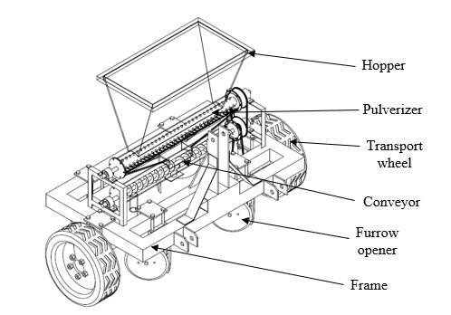

Figure 1: Annotated isometric drawing of the solid manure injector

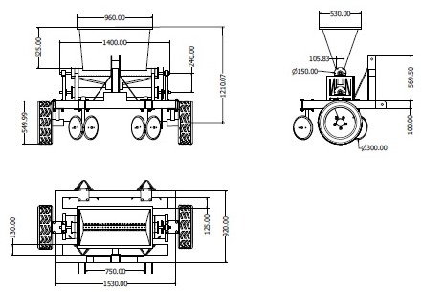

Figure 2: Orthographic drawing of the Solid manure injector

1. **Frame:** The frame was made of 50 mm × 50 mm mild steel square pipes for rigidity, measuring 1500 mm in length and 800 mm in width.
2. **Hopper:** The frame supports a trapezoidal hopper, which gradually feeds manure into the pulverizer through a slanted design that aligns with the manure's angle of repose. The hopper's top base measures 1200 mm × 800 mm, while the bottom base is 1200 mm × 200 mm, and it's made from 4 mm thick steel.
3. **Pulverizer:** The pulverizer, which is 1000 mm long and 100 mm in diameter, breaks down manure into smaller particles before they are conveyed.
4. **Conveyor:** The conveyor, a two-directional auger type with a diameter of 400 mm, transports the pulverized manure to two delivery tubes located below the conveyor. The delivery tubes are made from rectangular hollow pipe mild steel, each measuring 400 mm in length.
5. **Furrow openers and coverers:** Furrow openers of the adjustable double-disc type cut and displace soil for easy manure injection, with discs measuring 300 mm in diameter and beveled at the lower edge to facilitate cutting. A furrow coverer of the same double-disc type, also made of mild steel, follows to cover the injected manure.
6. **Transport wheels:** The injector is equipped with rubber transport wheels, 400 mm in diameter, which help transmit power to the pulverizer and conveyor via a chain and sprocket system.

**2.2 Design Considerations**

The design of the manure spreader is based on the following considerations:

1. The solid manure injector is simple in design with the use of locally available materials for the fabrication of the component parts.
2. The ease of fabrication of the component parts with simple joinery methods.
3. The hopper is designed to accommodate a large manure and reduce refill frequency
4. Rigidity of the frame to withstand weight, stress, and potential impacts during operation.

**2.3 Design Calculations of Machine Components**

The following design calculations were carried out for the machine components:

1. **Determination of the volume of hopper**

Volume of hopper was calculated using equation 1

Volume of the hopper $=1/3h$ $\left(A_{1}+B_{2}+\sqrt{A_{1}+B_{2}}\right)$ (1)

where, $h$ is height of the hopper; $A_{1}$ is Area of lower base; $A_{2}$ is Area of upper base

The volume of hopper determination is determined as 0.336 $m^{3}$

1. **Determination of weight of main frame material**

The weight of the main frame material is determined using equations 2 – 5:

$A_{MFM}=5\left[{L_{1}}^{2}-{l_{1}}^{2}\right]+2\left[{L_{2}}^{2}-{l_{2}}^{2}\right]$ (2)

$V_{MFM}=A_{MFM}×L_{MFM}$ (3)

$M_{MFM}=V_{MFM}×ρ_{MFM}$ (4)

$W_{MFM}=M_{MFM}×g$ (5)

where, $L_{1}$ is length of outer square of longer side; $l_{1}$ is length of inner square of longer side; $L_{2}$ is length of outer square of shorter side; $l_{2}$ is length of inner square of shorter side; $A_{MFM}$ is area of main frame material; $V_{MFM}$ is volume of main frame material; $M_{MFM}$ is mass of main frame material; $ρ_{MFM}$ is density of main frame material; $W_{MFM}$ is weight of main frame material

The weight of main frame material is determined as 1358 $N$.

1. **Determination of manure weight in the hopper**

The weight of the manure in the hopper was determined using equations 6 and 7:

$M_{m}=$ $ρ_{m}×V_{h}$ (6)

$W_{m}=$ $M_{m}×g$ (7)

where, $M_{m}$ is mass of manure filled to the hopper brim ($kg$); $V_{h}$ is volume of hopper ($m^{3}$); $ρ_{m}$ is bulk density of manure (${kgm}^{-3})$.

Manure weight in the hopper is determined as 87.36 $kg$

1. **Determination of capacity of screw conveyor**

The capacity of the screw conveyor was determined using equation 8 (Gbabo and Andrew, 2015):

$Q=60×π/4×D^{2}×S×N× ∝ ×ρ×C$ (8)

where; $Q$ is screw capacity ($kg/h$); $D$ is screw diameter ($m$); $S$ is screw pitch ($m$); $N$ is screw speed in rpm; $∝$ is loading ratio (loading ratio for not free flowing material is $0.15 mm$; $ρ$ is material density ($kg/m^{3}$; $C$ is inclination correction factor

The capacity of screw conveyor is determined as 441 $kg/h$

1. **Determination of the shaft diameter**

The shaft, made of mild steel, was designed using the ASME code equation to account for bending and torsional moments, along with shock and fatigue factors.

The diameter of the shaft was determined using equation 9:

$d^{3}=\frac{16}{πS_{s}}\sqrt{(k_{b}M_{b})^{2}+(k_{t}M_{t})^{2}}$ (9)

where, $d$ is diameter of the shaft ($m$); $M_{b}$ is Bending moment ($Nm$); $M_{t}$ is Torsional moment ($Nm$); $k_{b}$ is combined shock and fatigue factor applied to bending moment; $k_{t}$ is combined shock and fatigue factor applied to torsional moment; $S_{s}$ is allowable stress $=$ 40 –2 (for shaft with key way)

A shaft diameter of 30 mm was obtained

**2.4 Fabrication of the Machine**

The solid manure injector was fabricated at the Federal University of Technology, Akure, using mild steel for all components except the rubber wheels. The hopper was made from 3 mm thick steel, while the main frame, supporting all components, used mild steel square pipes measuring 1200 mm in length and 800 mm in width. The pulverizer, consisting of a 20 mm diameter metal rod welded onto a 1000 mm cylindrical pipe, was positioned beneath the hopper. A two-directional conveyor, 1000 mm in length and 400 mm in diameter, was fabricated to transport manure. The adjustable furrow opener and coverer were created using 600 mm diameter, 3 mm thick steel discs. The drive shaft controls both the pulverizer and conveyor through a chain and sprocket system, synchronized with the wheel speed for efficient operation.

**2.5 Calibration of the Solid Manure Injector**

The solid manure injector (Figure 4) was calibrated in a laboratory by raising the machine, allowing the ground wheel to rotate freely. Manure was collected from the delivery tubes as the wheel was rotated at speeds of 28, 54, and 70 rpm, corresponding to field operation speeds. The collected manure was then weighed using an electronic balance. This procedure was repeated using different feed gate openings (6 cm, 12 cm, and 18 cm) and manure samples with moisture levels of 13%, 21%, and 31%, which are typical for manure application equipment, in order to evaluate the machine’s manure discharge rate.

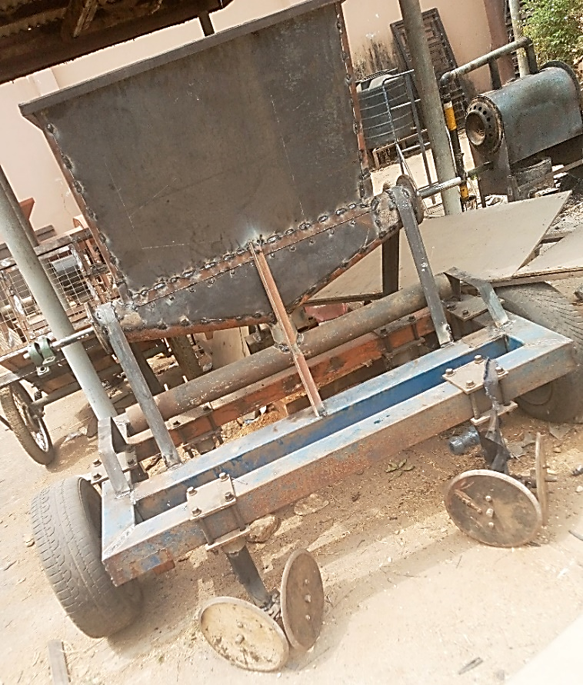

Figure 4: Fabricated solid manure injector

**3. RESULTS AND DISCUSSION**

**3.1 Main and Interactive Effects between Speed, Feed Gate Openings and Moisture Content on Discharge Rate**

Table 1 illustrates how discharge rate is influenced by different moisture contents, speeds and feed gate openings. ANOVA results show that all main effects (MC, FG, S) and their interactions (MC × FG, MC × S, FG × S) significantly affect the discharge rate (p < 0.001 for all factors and interactions). These findings are consistent with material flow dynamics reported by Singh *et al.* (2018) and Agidi (2019). The significant interactions indicate that the impact of each factor depends on the levels of the other factors.

The highest average discharge rate (470.98 kg/h) was achieved with 13% manure moisture content, an 18 cm feed gate opening, and a wheel speed of 70 rpm. This rate is significantly higher than all other treatment combinations but lower than the 1368 kg/h reported by Singh and Singh (2014) and the 2988 kg/h reported by Jain and Lawrence (2015). Both of these higher discharge rates were obtained using farmyard manure spreaders, which can handle larger volumes and distribute manure over a wider area, resulting in higher output. In general, combinations of lower moisture content, larger feed gate openings, and higher speeds tend to produce higher discharge rates.

**Table 1**: Average values of discharge rates (kg/h) at different moisture content, speed and feed gate openings

|  |  |  |  |  |
| --- | --- | --- | --- | --- |
| **Moisture Content (%) (MC)** | **Speed (rpm) (S)** | **Feed gate opening (cm) (FG)** | | |
|  |  | **6 cm** | **12 cm** | **18 cm** |
| 13 | 28 | 54.93v | 120.74q | 177.07l |
|  | 54 | 105.83s | 221.01j | 333.09d |
|  | 70 | 137.23o | 305.49e | 470.98a |
| 21 | 28 | 49.26w | 108.67r | 159.36m |
|  | 54 | 95.25t | 198.91k | 299.78f |
|  | 70 | 123.51p | 274.94g | 423.88b |
| 31 | 28 | 43.78x | 96.59t | 141.65n |
|  | 54 | 84.67u | 176.81l | 266.48h |
|  | 70 | 109.78r | 244.39i | 376.78c |
| **ANOVA** |  | **Discharge rate** | |  |
|  | MC | < 0.001 |  |  |
|  | FG | < 0.001 |  |  |
|  | S | < 0.001 |  |  |
|  | MC $×$ FG | < 0.001 |  |  |
|  | MC $×$ S | < 0.001 |  |  |
|  | FG $×$ S | < 0.001 |  |  |
|  | MC $×$ FG $×$ S | < 0.001 |  |  |

Different letters indicate significant difference at p < 0.001

**3.2 Effect of Speed on Discharge Rate at varying Moisture Contents**

Figure 5 shows the effect of speed (rpm) on the discharge rate (kg/h) of a solid manure injector at varying moisture contents.

The discharge rate increases with increase in speed. As the speed increases from 28 rpm to 70 rpm, the discharge rate rises. This suggests that faster speeds allow for greater material flow, resulting in higher discharge rates. Higher speeds provide more kinetic energy, which helps to overcome the friction and gravitational forces acting on the manure, allowing it to be discharged more quickly (Dun *et al.,* 2024). This observation is in line with the findings of Niu *et al.* (2023), who noted that increasing the auger shaft speed in a Soil-fertilizer application machine produces larger centrifugal forces, facilitating faster material discharge. Zakari *et al.* (2022) also reported that increasing the shaft speed in a tractor-operated solid manure spreader significantly boosted the flow of manure.

**3.3 Effect of Feed Gate Openings on Discharge Rate at varying Speeds**

The **feed gate opening** has a significant impact on the discharge rate (Figure 6). As the opening widens from 6 cm to 18 cm, the discharge rate increases notably. This is because a larger opening allows more manure to be dispensed per unit of time, leading to higher throughput. This finding aligns with basic material flow principles, where reducing restrictions allows for greater material flow. Research by Suleiman *et al.* (2022) supports this trend, showing that widening a gate from 15 cm to 45 cm increased the discharge rate from 1070 kg/h to 3938 kg/h in a tractor-powered solid manure spreader. Similarly, Bello et al. (2022) found that increasing the aperture from 10 cm to 20 cm in a spinning disc manure spreader resulted in a discharge rate increase from 604.8 kg/h to 1002 kg/h.

**3.4 Effect of Moisture Contents on Discharge Rate at varying Speeds**

Figure 7 shows the effect of moisture content on discharge rate at varying speeds. As moisture content increases from 13% to 31%, the discharge rate decreases. This indicates that manure with higher moisture content becomes more difficult to flow through the injector. The higher moisture content increases stickiness and cohesion between particles, making it more resistant to movement, which reduces flowability and ultimately lowers the discharge rate. Similar trends have been observed by Singh et al. (2018), who reported that drier materials experience less resistance and clogging in manure spreaders, improving flow efficiency.

**CONCLUSION**

The solid manure injector was designed and fabricated by the Department of Agricultural and Environmental Engineering at the Federal University of Technology, Akure. The machine consists of essential components, including a hopper for manure storage, a pulverizer to break down the manure, a conveyor for transporting the material to the delivery tubes, and a furrow opener and coverer to bury the manure in the soil. Laboratory tests (calibration) were conducted by rotating the wheels at speeds of 28, 54, and 70 rpm, using manure with moisture levels of 13%, 21%, and 31% (dry basis). The highest discharge rate of 470.98 kg/h was achieved at a speed of 70 rpm, an 18 cm feed gate opening, and 13% moisture content. The study found that all main factors—moisture content, feed gate opening, and speed—had a significant impact on discharge rate (p < 0.001).

The results demonstrated that increasing speed and widening the feed gate openings consistently improved the discharge rate of manure, with 13% moisture content being optimal for maximum flow. Based on these findings, it is recommended that when operating the solid manure injector in the field, adjustments to speed, feed gate opening, and moisture content should be made to optimize discharge rate and meet application needs. This study highlights the importance of calibrating these factors to achieve efficient manure application and enhanced machine performance in real field conditions.

**REFERENCES**

Ademosun, O. C.; Akande, L.; Manuwa, S. and Ewetumo, T. (2014). Development of Liquid Animal Manure Injector Equipment with Instrumentation for Draught Measurement of Tillage Tools. *Journal of Agricultural Engineering and Technology*, 22(1), 9-18.

Adgidzi, D.; Balami, A. A. and Bashir, M. (2007). Development of a Manure Spreader. *Arid Zone Journal of Engineering*, *5*, 37–44.

Adugna, G. (2016). A review on impact of compost on soil properties, water use and crop productivity. *Academic Research Journal of Agricultural Science and Research*, 4(3), 93-104.

Agidi, G., Gana, I. M., and Usman, H. (2020). Development of an indented cylinder metering device for a tractor drawn manure spreader. *IOP Conference Series: Earth and Environmental Science,* 445(1), 61-69).

Ayilara, M. S.; Olanrewaju, O. S.; Babalola, O. O. and Odeyemi, O. (2020). Waste management through composting: Challenges and potentials. *Sustainability*, 12(11), 44-56.

Bello, R.S, Saliu, M.O, Nebo, E.U, and Ayodele, A.A. (2022). Development and performance evaluation of a tractor mounted spinning disc manure spreader.*International Journal of Scientific and Technology Research*, 5(3), 1002–1014.

Dun, G., Sheng, Q., Sun, H., Ji, X., Yu, Z., Wang, H., and Li, H. (2024). Design Optimization and Experimentation of Triple-Head Gradually Reducing Spiral Precision Fertilizer Apparatus. *Processes*, *12*(9), 19-28.

Gbabo, A. and Andrew, N. E. (2015). The Physical, Proximate and Ultimate Analysis of Rice Husk Briquettes Produced from a Vibratory Block Mould Briquetting Machine. *International Journal of Innovative Science, Engineering and Technology,* 2(5), 814-822.

Jain, A. K., and Lawrence, A. K. A. [(2015)](https://edgeservices.bing.com/edgesvc/chat?udsframed=1&form=SHORUN&clientscopes=chat,noheader,udsedgeshop,channelstable,ntpquery,devtoolsapi,udsinwin10,udsdlpconsent,udsfrontload,cspgrd,&shellsig=9a92cac4be250c26b7a3c88964a8586b152eae50&setlang=en-US&lightschemeovr=1&udsps=0&udspp=0#sjevt%7CDiscover.Chat.SydneyClickPageCitation%7Cadpclick%7C0%7C1fba2ec6-2a54-4a8f-b36d-7f50542f588e). [Field evaluation of manual spreading of farm yard manure](https://edgeservices.bing.com/edgesvc/chat?udsframed=1&form=SHORUN&clientscopes=chat,noheader,udsedgeshop,channelstable,ntpquery,devtoolsapi,udsinwin10,udsdlpconsent,udsfrontload,cspgrd,&shellsig=9a92cac4be250c26b7a3c88964a8586b152eae50&setlang=en-US&lightschemeovr=1&udsps=0&udspp=0#sjevt%7CDiscover.Chat.SydneyClickPageCitation%7Cadpclick%7C1%7C1fba2ec6-2a54-4a8f-b36d-7f50542f588e). [*New Agriculturist,* 26(1), 159-161](https://edgeservices.bing.com/edgesvc/chat?udsframed=1&form=SHORUN&clientscopes=chat,noheader,udsedgeshop,channelstable,ntpquery,devtoolsapi,udsinwin10,udsdlpconsent,udsfrontload,cspgrd,&shellsig=9a92cac4be250c26b7a3c88964a8586b152eae50&setlang=en-US&lightschemeovr=1&udsps=0&udspp=0#sjevt%7CDiscover.Chat.SydneyClickPageCitation%7Cadpclick%7C3%7C1fba2ec6-2a54-4a8f-b36d-7f50542f588e).

Khoshnevisan, B.; Duan, N.; Tsapekos, P.; Awasthi, M. K.; Liu, Z.; Mohammadi, A. and Liu, H. (2021). A critical review on livestock manure biorefinery technologies: Sustainability, challenges, and future perspectives. *Renewable and Sustainable Energy Reviews*, *13(5)*, 11-33.

Korra, S. N., Sudarshan, E., Venkatesulu, S., Kumar, P. P., and Yadav, B. P. (2020). Portable manure dispenser machine. *IOP Conference Series: Materials Science and Engineering,* 981(2), 22-26.

Niu, Y., Zhang, J., Qi, J., Meng, H., Peng, H., and Li, J. (2023). Design and Test of Soil–Fertilizer Collision Mixing and Mulching Device for Manure Deep Application Machine. *Agriculture*, *13*(3), 7-15.

Sathiamurthi, P.; Anaamalaai, A. S.; Ahamed Buhari, M. R.; Anburaja, A. and Thahasin, M. A. (2020). Design and fabrication of manure spreader. *International Journal of Scientific and Technology Research*, *9*(3), 5134–5136.

Singh, G., Shamsuddin, M. R., and Lim, S. W. (2018). Characterization of chicken manure from manjung region. *IOP conference series: materials science and engineering,* 458(1), 12-24.

Singh, R. C., and Singh, C. D. (2014). Design and development of an animal drawn farmyard manure spreader. *African Journal of Agricultural Research,.* 9(44), 3245-3250.

Suleiman, M.L., Muhammad, U.S., Zakari, S. and Saleh, A. (2022). Development and Performance Evaluation of a Tractor Powered Solid Manure Spreader. *UNIOSUN Journal of Engineering and Environmental Sciences*, 4(1), 64 – 74.

Webb, J.; Pain, B.; Bittman, S. and Morgan, J. (2012). The impacts of manure application methods on emissions of ammonia, nitrous oxide and on crop response-A review. *Agriculture, Ecosystems and Environment*, *137*(1–2), 39–46.

Yu, C.; Huang, X.; Chen, H.; Godfray, H. C. J.; Wright, J. S.; Hall, J. W. and Taylor, J. (2019). Managing nitrogen to restore water quality in China. *Nature*, *567*(7749), 516-520.

Zakari, S., Suleiman, M. L., Muhammad, U. S., and Saleh, A. (2022). Effects of disc speed and height of flow mechanism of a solid manure spreader on uniformity of spreading and swath width. *Journal of Applied Sciences and Environmental Management*, *26*(1), 109-113.