**Design of Analog to Digital Converters Employing SDM Structure with NTF Estimation**

Neetu Khande1, Prof. Deepak Sharma2

**Abstract: ADCs are critical for the operation of digital circuits. This paper details the design and implementation of adaptive noise-cancelling filters utilizing MASH ADCs. The process of recursive or pipelined noise shaping in ADCs has been demonstrated to attain faster speeds, even when utilizing oversampling over the Nyquist rate with recursive encoding. The diverse parameters influencing the design and efficacy of the MASH ADCs utilized in filter design have been examined. The stability of higher-order sigma-delta modulators has been examined to develop an improved methodology for their design. Fluctuations in the SNR have been demonstrated using alterations in the Over Sampling Rate.**

***Keywords***: ***Adaptive Filter Design, MASH ADCs, Over Sampling Rate, Signal to Noise Ratio, Dynamic Range, Quantization Noise.***

**I. INTRODUCTION**

Adaptive filter design finds its applications in several fields of signal processing such as speech processing, analog to digital conversion, image processing etc. The very essence of adaptive filtering rests on the principle that the noise conditions faced by signals can vary. Adaptive filter adjust their coefficients to minimize an error signal and can be realized as finite impulse response (FIR), infinite impulse response (IIR), lattice and transform domain filter. Although real world signals are analog, it is often desirable to convert them into the digital domain using an analog to digital converter (ADC). Signal processing in the digital domain is useful in digital storage, biomedical applications, and industrial applications - from instrumentation to communication. Sigma Delta Modulators achieve a high degree of insensitivity to analog circuit imperfections, thus making them a good choice to realize embedded analog-to-digital interfaces. Application based and sophisticated design techniques demand Radio Frequency Identification Techniques which find its application in object tracking, etc. Sigma Delta ADC is high resolution ADC and acts as a major building block in RFID applications. [1] As per the sampling frequency, ADC is classified into two categories: Nyquist ADCs and Sigma- Delta ADCs. Nyquist ADCs have a lower effective number of bits due to process variation and mismatching [2]. One technique, Sigma Delta modulation, which is based on the combination of oversampling and quantization error shaping techniques, has become quite popular for achieving high resolution and high accuracy. [3] One significant advantage of the method is that analog signals are converted using only a 1-bit ADC and analog signal processing circuits having a precision that is usually much less than the resolution of the overall converter. Using sigma-delta A/D methods, high resolution can be obtained for only a low to medium signal bandwidths. The Oversampling behavior of the Sigma Delta Modulator restricts the bandwidth which can be overcome by using higher order architecture.

The Signal to Noise Ratio of Sigma Delta Modulator is dependent upon the number of bits of quantizer and is independent of amplitude of input signal. The N - bit quantizer has 2 levels and separated by V LSB. The amplitude of full scale sine wave input is 2 N-1 V LSB. Peak to peak value is given by 2 N V LSB Mean Square Value of the Signal is given by:

**S=(2N-1VLSB)2/2 (1)**

Mean squared Noise is given by the expression:

**N=V2LSB/12 (2)**

Therefore,

Signal to Noise Ratio (SNR) is given by:

**[(2N-1VLSB)2/2]/[V2LSB/12] (3)**

which reduces into

**SNR=*1*22N (4)**

Also,

**SNR=6.02N+1.76dB (5)**

**II. SYSTEM DESIGN**

The basic structure of an adaptive noise filter can be implemented using the sigma delta modulation. A delta-sigma converter uses many samples from the modulator to produce a stream of l-bit codes. The delta- sigma ADC accomplishes this task by using an input- signal quantizer running at a high sample rate. The delta-sigma modulator takes an input and produces a stream of digital values same as other quantizers that represents the voltage of the input. The delta-sigma modulators are of two types the time and the frequency domain. An adaptive filter always has an error feedback loop often called the Sigma Delta Modulator. The modulator in Fig. l illustrates a first order sigma-delta modulator. It comprises of an integrator, a 1-bit quantizer, and a 1-bit DAC. The integrator ramps the input signals up and down. The integrator acts as the noise shaping circuit which shifts the noise from pass band to stop band. The output of the integrator is given to the comparator and then the comparator output is fed back through a 1-bit DAC to the Summing circuit. Oversampling is the process of taking more samples per second than required on the basis of the Nyquist- Shannon criterion. By changing the sampling rate the signal power and total quantization noise power is not affected. Therefore, the signal to quantization noise ratio is not changed.

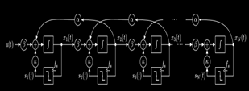

***Fig.1 Cascaded ADC Structure***

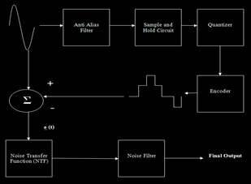

***Fig.2 Structure of NTF Based ADC***

However, the quantization noise is spread over a larger frequency range, which reduces the spectral density of the quantization noise. The quantization noise power is reduced by 3 dB for every doubling of the oversampling ratio and the signal to quantization noise ratio is improved accordingly if the original Nyquist band is considered only. The oversampling ratio also affects the signal to noise ratio. If oversampling is increased, the signal to noise ratio is also increased exponentially.

**III. PARAMETERS FOR ADAPTIVE FILTERING**

1. **OVER SAMPLING RATIO:**

When a significantly sampling frequency in a signal higher than the twice of bandwidth of digital samples known as Over sampling p, defined as

**P = fs / 2B (1)**

Where fs is the sampling frequency, B is the bandwidth or highest frequency of the signal, the nyquist rate is 2B.[2]

The theoretical limit of the SNR of Associate in Nursing ADC activity is predicated on the quantisation noise owing to the quantisation error inherent within the analog-to-digital conversion method once there's no oversampling and averaging. Since the quantisation error depends on the quantity of bits of resolution of the ADC the simplest case SNR is calculated as a perform of the Effective range of Bits

**SNR= (6.02*ENOB) - 1.767 (2)**

for the Effective number of bits , using the measured SNDR

**ENOB = SNDR - 1.76 dB / 6.02dB/bit (3)**

Effective number of bits (ENOB) is simply the signal to noise-and-distortion ratio expressed in bits rather than decibels by solving the ideal SNR" equation [7] In the presentation of measured results, ENOB is identical to SNDR, with a change in the scaling of the vertical axis.

**QUANTIZATION AND QUANTIZATION ERROR**

It is bound by [-A/2 to +A/2] where A represents the amplitude of the analog signal.

Qe(Max) = Δ/2

Here Δ represents the step size.

1. **NOISE SHAPING:**

The noise transfer function can be given by:

**NTF (z) = (1 - z-1) L (4)**

Where L denotes the order of filter

1. DYNAMIC RANGE:

Dynamic range is the parameter exhibiting the variation of the signal in the time domain. It is mathematically given by:

**A-(-A) = 2A (5)**

1. FIGURE-OF-MERIT:

The figure of merit is the inverse of the signal to noise ratio and is given by

**FOM = 1/ SNR (6)**

Comparison of the power efficiency of two AD converters that achieve identical signal conversion specifications, i.e. have the same sampling rate and realize the same SNR for every input signal, is an easy task; the one with the lowest power consumption is the best. Although the FoM of combining weight, (6) is wide used, it cannot be accustomed build honest comparisons between low resolution and high resolution AD converters. once the resolution of associate ADC is inflated, some extent is reached wherever thermal noise is limiting the SNR, so as to scale back the impact of the noise by three sound unit, capacitances have to be compelled to be doubled to extend the amount of effective bits by one, a six sound unit reduction of the noise is needed, which implies an element four increase in capacitance. Since power scales linearly with the quantity of capacitance to charge, the facility will increase with an element four. Thus, the FoM can become a minimum of an element a pair of worse once the ENOB is inflated by one.

The Error minimization gradient computed by the LMS algorithm is given by:

$\min{E\left[z^{2}\right]=E\left[s^{2}\right]+\min{E[{\left(n_{0}-y\right)}^{2}]}}$**(7)**

**EXPERIMENTAL RESULTS**

The system has been designed on Matlab 2018a.

This section will deal with the comparative analysis of fourth order Sigma Delta Modulator with respect to different topologies for parameters like signal to noise ratio and effective number of bits.

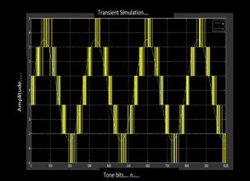

***Fig.3 Time Domain Simulation Of Fourth Order Sigma Delta Modulator With CIBF Architecture***

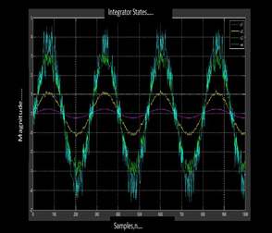

***Fig.4 Integrator States Of Fourth Order Sigma Delta Modulator With CIBF Architecture***

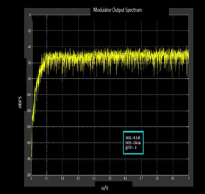

***Fig.5 Frequency Domain Simulation Of Fourth Order Sigma Delta Modulator With CIBF Architecture***

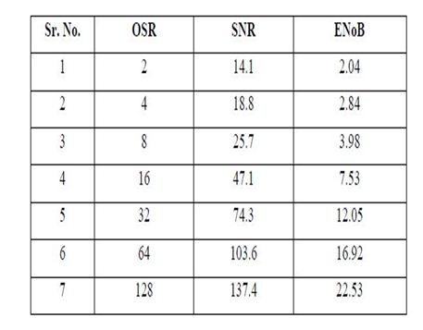

***Table.1 Analysis Of Fourth Order Sigma Delta Modulator For Signal To Noise Ratio And Effective Number Of Bits***.

Thus the aforesaid discussions along with the relevant waveforms and tables are self explanatory for the performance of higher order sigma delta modulators. The above comparative analysis concludes that parameters affecting the performance of Sigma Delta Modulator like Signal to Noise Ratio and Effective Number of Bits increases with increase in Over Sampling Ratio. Also, with the increase in order of modulator and quantization level, high SNR can be achieved at low OSR value. But with the increase of order, the modulator becomes unstable and also, maximum usable input signal amplitude decreases.

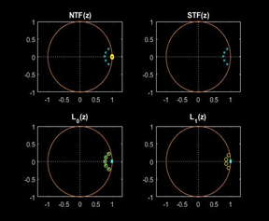

***Fig.6 Stability Analysis of 5th Order Filter***

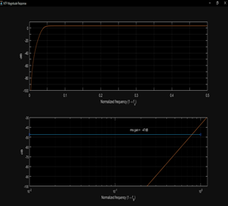

***Fig.7 Stability Analysis of 5th Order Filter***

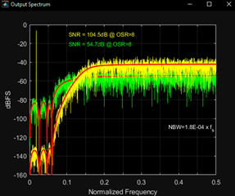

***Fig.8 Stability Analysis of 5th Order Filter***

The stability can be achieved for high order Sigma Delta Modulator by keeping the gain of Noise Transfer Function to be low. So, low order Sigma Delta Modulator with high OSR can be used for application.

By the use of uniform quantizer, the performance of Sigma Delta Modulator increases drastically. Stability issues can be resolved by using multibit quantizers. But the designing of multibit quantizer is complex. Also its implementation in chip is quite cumbersome, with respect to large scale integration technologies.

The stability of loop filter depends upon number of factors like maximum input signal range, position of poles of Noise Transfer Function in unit circle, gain value of the loop filter etc. So, by considering all the above parameters as per the application, the Sigma Delta Modulator of specific architecture with required order can be used. If the bandwidth requirement is modest, then conventional model of Sigma Delta Modulator of low order can be used. The Analog to Digital Converters required for audio signals which are having higher bandwidth can use Sigma Delta Modulator of higher order.

The take away of the results and discussions can be stated as follows:

The take away of the results and discussions can be stated as follows:

1) Conventional ADC design doesn’t have as much noise immunity as SDM based ADC design. Hence SDM based ADCs have higher accuracy.

2) Increasing the oversampling ratio (OSR) reduces the noise and hence increases the Signal to Noise Ratio

3) One stage of SDM may not suffice to render high SNR in the digitized form of the original signal. Hence it is necessary to implement a multi level SDM based ADC. Increasing the number of order of the SDM leads to reduced stability in the filter based implementation of the system.

**CONCLUSION**

**This study analyzes lower and higher order MASH ADCs in conjunction with the LMS algorithm, focusing on Signal to Noise Ratio and Effective Number of Bits. The noise shaping characteristic of the Sigma Delta Modulator has rendered it favorable in applications requiring a high Signal to Noise Ratio. The notable characteristic of noise shaping displaces noise into the out-of-band range, hence diminishing the necessity for a sharply cutoff anti-aliasing filter. As the oversampling ratio increases, the Signal-to-Noise Ratio also improves. Elevated SNR levels can be attained with reduced OSR by employing higher-order modulators. However, when the quantity of integrators in the modulator rises, this influences the positioning of the poles of the Noise Transfer Function, potentially rendering the loop filter unstable. The results and conclusions indicate that the sigma delta scheme is an efficient method for designing Adaptive Filters, producing minimal Quantization Noise due to the inherent noise shaping concept in the suggested technique.**

**REFRENCES**

1. F. Feyling, H. Malmberg, C. Wulff, H. -. A. Loeliger and T. Ytterdal, "High-level Comparison of Control-Bounded A/D Converters and Continuous- Time Sigma-Delta Modulators, Submitted to Special Issue on IEEE Transactions on Circuits and Systems, September, 2022, pp.1-5.
2. S Oh, Y Oh, J Lee, K Kim, S Lee, J Kim, "A 80dB DR 6MHz Bandwidth Pipelined Noise-Shaping SAR ADC with 1–2 MASH structure," 2020 IEEE Custom Integrated Circuits Conference (CICC), 2020, pp. 1-4
3. M. Danesh and A. Sanyal, "Fully Digital 1-1 MASH VCO-Based ADC Architecture," 2019 IEEE 62nd International Midwest Symposium on Circuits and Systems (MWSCAS), 2019, pp. 501-504
4. P Payandehnia, H Mirzaie, H Maghami, J Muhlestein, “Fully passive third-order noise shaping SAR ADC”, Electronics Letters, IET Journal 2017
5. Rudolf Ritter, John G. Kauffman, Joachim Becker, Maurits Ortmanns, “A 10 MHz Bandwidth, 70 dB SNDR Continuous Time Delta-Sigma Modulator With Digitally Improved Reconfigurable Blocker Rejection”, IEEE 2016
6. S Tao, A Rusu, “A power-efficient continuous-time incremental sigma-delta adc for neural recording systems”, IEEE 2015
7. Angsuman Roy and Jacob Baker, “A Passive 2nd-Order Sigma-Delta Modulator for Low-Power Analog-to-Digital Conversion”, IEEE 2014
8. L Hernandez, E Gutierrez, “Analytical evaluation of VCO-ADC quantization noise spectrum using pulse frequency modulation”, IEEE 2014
9. M De Bock, X Xing, L Weyten, G Gielen, “Calibration of DAC Mismatch Errors in ADCs Based on a Sine-Wave Measurement”, IEEE 2013
10. HC Tsai, CL Lo, CY Ho, YH Lin, “A 64-fJ/Conv.-Step Continuous-Time Modulator in 40-nm CMOS Using Asynchronous SAR Quantizer and Digital Truncator”, IEEE 2013
11. V Srinivasan, V Wang, P Satarzadeh, “A 20mW 61dB SNDR (60MHz BW) 1b 3rd-order continuous-time delta-sigma modulator clocked at 6GHz in 45nm CMOS”, IEEE 2012
12. B Jacob, MR Baiju, “Vector-quantized space-vector-based spread spectrum modulation scheme for multilevel inverters using the principle of oversampling ADC”, IEEE 2012
13. Yingqi Qian Changchun Zhang a, Zhongchao Liu, Leilei Liu, YurongLuan,Yuming Fang and Yufeng Guo,“ A High-Performance Sigma-Delta Modulator in 0.18pm CMOS Technology” International Journal, Applied Mechanics and Materials Vols. 519-520 (2014) pp 1085-1088, February 2014
14. FanWenjie,LvQiuye,HeChong,YinLiang,LiuXiaowei, “Architectural Design and Simulation of A Fourth-Order Sigma-Delta Modulator , International Journal, Key Engineering Materials Vols. 609-610 (2014) pp 723-727 , April 2014
15. Hetal Panchal, “Design and Simulation of Sigma Delta ADC Using VHDL AMS” , International Journal of Engineering Development and Research , Volume 2, Issue 1 ,pp no.548-551, 2014
16. Liu Liang, Chen Song , He Chong, Yin Liang, Liu Xiaowei“Design of Third-order Single loop Full Feed-forward Sigma Delta Modulator”, International Journal, Key Engineering Materials Vols. 609-610 (2014) pp 1176-1180, April 2014
17. RaminZanbaghi, Pavan Kumar Hanumolu “An 80-dB DR, 7.2-MHz Bandwidth Single OpampBiquad Based CT Modulator Dissipating 13.7-mW ”, IEEE Journal of Solid-State Circuits, Vol. 48, No. 2, pp 1 -15, February 2013
18. Jiandong Cheng, Guoyong Shi, and Ailin Zhang, “A Fast SNR Estimation Method for Sigma-Delta Modulator Design” , TENCON 2013, IEEE Conference, 22nd -25th October ,pp 1-4, 2013
19. Philip M. Chopp and Anas A. Hamoui, “A 1-V 13-mWSingle-Path Frequency-Translating AZ Modulator With 55-dB SNDR and 4-MHz Bandwidth at 225 MHz” , IEEE Journal of Solid-State Circuits, Vol. 48, No. 2, pp 1-14 February 2013
20. HisatoFujisaka , Takeshi Kamio, Chang-Jun Ahn, Masahiro Sakamoto, and Kazuhisa Haeiwa “Sorter-Based Arithmetic Circuits for Sigma-Delta Domain Signal Processing—Part I: Addition, Approximate Transcendental Functions, and Log-Domain Operations”, IEEE Transactions On Circuits and Systems—I: REGULAR PAPERS, Vol. 59, No. 9, ,pp no. 1952-1965, September 2012