Antinutritional Factors and Digestibility Challenges in Aquafeeds: A Review
Vishal¹, Shalu²
¹Guru Angad Dev Veterinary and Animal Sciences University, Ludhiana, Punjab-141004
²Central Institute of Fisheries Education, Mumbai, Maharashtra- 400061
Corresponding Email:
l2022f05m@gadvasu.in (Vishal); Shalusharma9080@gmail.com (Shalu)

Introduction
Feed plays a pivotal role in modern aquaculture as it caters to the nutrient needs of the farmed fish in order to meet their energy and growth requirements. With aquaculture growing faster than any other food producing industry, the global demand for quality feeds has increased tremendously over the last decade. On the other hand, issues related to sustainability have arisen related to the utilization of fishmeal and fish oil as functional ingredients as they are obtained from fish caught in the wild and the biomass has not been growing significantly while overfishing is widespread. Because of this, the aquaculture industry has moved towards vegetarian and other non-marine feed ingredients to lessen the reliance on ocean based feedstocks and increase sustainability in the industry.
The growing trend of using non mariculture feed components especially soybean meal, corn gluten and other land based crops helps alleviate the concerns of sustainability but brings forth other issues that need to be dealt with. Ingredients in such feed have anti-nutritional factors (ANFs) in them including saponins, tannins and non-starch polysaccharides which can negatively impact nutrient bioavailability and fish health. Hence such issues of digestibility need to be resolved in order to ensure optimal performance in fish and have minimum negative consequences on the environment. As a result, this paper attempts to examine the effects of anti-nutritional factors on the digestibility of aquafeeds and to suggest measures in order to reduce such factors and achieve feeds which are both nutritious and environmentally conscious.
The increased usage of more sustainable feed alternatives highlights the importance of using microbial biomass, algae, and insect proteins. These novel elements could be added to plant-based ingredients to assist strike a balance between growing concerns about environmental sustainability and the nutrient needs of various fish species. Furthermore, new processing technologies and feed formulations will be required to improve the digestibility of plant-based feeds and aid to the long-term development of aquaculture systems.
Antinutritional Factors (ANFs) in Aquafeeds:
These chemicals, found in legumes such as soybean meal, interact with digestive enzymes like trypsin, reducing protein utilization. Heat treatment is a popular approach for deactivating them. Some key types of ANFs include:
- Protease Inhibitors: Phytic acid binds important minerals like calcium, iron, and zinc, lowering their bioavailability. High-phytate diets can reduce growth, although treatments such as phytase enzyme supplementation and fermentation enhance digestibility.
- Phytates: Tannins, found in oilseeds and grains, bind to proteins and enzymes, limiting protein digestion. Dehulling, fermentation, and chemical treatments can reduce their impact.
- Tannins: Tannins, found in oilseeds and grains, bind to proteins and enzymes, limiting protein digestion. Dehulling, fermentation, and chemical treatments can reduce their impact.
- Lectins: Found in beans, lectins attach to cell membranes and harm the gut lining, reducing nutrient absorption. Moist heat or autoclaving diminishes their existence.
- Saponins: Legumes include saponins, which influence membrane permeability and can injure fish gills when present in large numbers. These are frequently neutralized using aqueous extraction or irradiation procedures.

Mechanisms of Action of Antinutritional Factors (ANFs)
- Inhibition of Digestive Enzymes: Protease inhibitors, such as trypsin inhibitors, prevent enzymes such as trypsin and amylase from breaking down proteins and starches. This inhibition reduces food availability, affecting fish development and metabolism.
- Nutrient Binding: Phytates bind to important minerals such as calcium and phosphorus, rendering them insoluble and unavailable for absorption. This can induce mineral shortages and disrupt the skeletal growth of fish.
- Alteration of Gut Permeability and Microbiota: Saponins alter intestinal membrane integrity, resulting in increased gut permeability. This can allow toxins to enter the gut and disrupt the balance of bacteria, affecting digestion and immunological function.
- Impact on Protein, Lipid, and Mineral Absorption: Tannins and lectins impede protein and lipid digestion by creating insoluble complexes, lowering nutritional bioavailability and affecting energy metabolism. This cumulative effect may cause growth retardation in aquaculture animals.
Impact of Antinutritional Factors (ANFs) on Fish Health and Growth
- Reduced Feed Intake and Efficiency:
ANFs, such as tannins and saponins, reduce feed palatability and digestibility, resulting in lower intake. This reduces feed conversion efficiency, slowing growth rates and jeopardizing aquaculture productivity.
.
- Growth Suppression and Poor Nutrient Utilization:
Phytates and protease inhibitors can affect the digestion of vital nutrients such as proteins and minerals, resulting in stunted growth. Fish fed high quantities of plant-based diets containing these ANFs frequently display lesser weight gain than those fed fishmeal-based diets.
- Effects on Immune Response and Stress Tolerance:
ANFs also have an effect on fish immunity by modifying the gut microbiome and decreasing micronutrient uptake. This reduces fish's tolerance to diseases and stresses, making them more susceptible to infections and environmental problems.
- Impact on Gut Health and Microbial Balance:
ANFs, such as lectins, damage the intestinal epithelium, resulting in gut inflammation. They also affect the bacteria composition in the digestive tract, which can further impact nutritional absorption and immunological function.

Digestibility Challenges in Plant-based Aquafeeds
- Low Digestibility of Alternative Ingredients
Plant-based components frequently contain fibers, resistant starches, and other indigestible carbohydrates, which can lower overall digestibility in aquafeeds. For example, fibers make up the majority of the meal yet are poorly digested by fish, resulting in decreased nutritional absorption and efficiency.
- Protein Digestibility Issues
Many plant-based proteins lack a comprehensive amino acid profile when compared to fishmeal, resulting in poor amino acid balance. This can reduce fish growth and nutrient use. Certain ingredients, such as distillers dried grains with solubles (DDGS), have been shown to require synthetic amino acid supplementation for adequate fish growth.
- Fatty Acid Imbalance
Plant-based aquafeeds frequently have low quantities of omega-3 fatty acids, which are essential for fish health and development. This imbalance can have an impact on the fish's nutritional quality, causing problems with growth and overall health. Research suggests that microalgae and other sources could help rectify this imbalance by delivering necessary fatty acids.

Advances in Digestibility Improvement Techniques
- Use of Enzyme Cocktails for Complex Plant-Based Diets: The use of enzyme cocktails in aquafeeds can greatly improve the digestion of complicated plant-based nutrients. These enzyme mixes are intended to break down various components of plant materials, such as fibers and resistant starches, thereby increasing nutrient availability. The enzymes can also target specific antinutritional factors (ANFs) in these substances, improving overall feed efficiency and fish development performance.
- Coating Technologies to Protect Ingredients from ANFs: Coating technologies have emerged as a means of protecting sensitive nutrients from the harmful effects of ANFs. These methods improve bioavailability by encapsulating feed ingredients with protective coverings, preventing ANFs from interacting with vital nutrients. This method is very useful in maintaining nutritional integrity during the digestion process and decreasing the impact of ANFs.
- Microencapsulation of Nutrients for Better Bioavailability:
Microencapsulation techniques improve the stability and bioavailability of critical elements in aquafeeds. This approach encapsulates nutrients in a protective matrix, allowing for regulated release during digestion. Microencapsulation can also preserve nutrients against degradation by ANFs and severe digestive conditions, ensuring that fish get the most nutritional value from their meal.
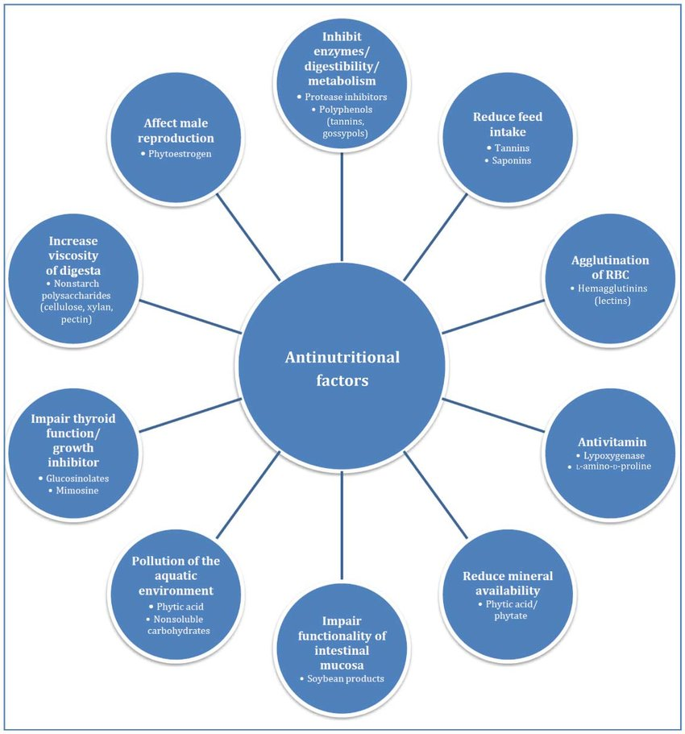
1: Effects of Plant-Derived Antinutritional Factors.

Case Studies and Experimental Evidence
Examples of Successful Inclusion of Plant-Based Feed Ingredients with Mitigated ANF Effects
Several studies have shown that plant-based components can be successfully incorporated into aquafeeds while reducing the influence of antinutritional factors. For example, studies demonstrate that employing fermented soybean meal can reduce the deleterious impacts of ANFs, improving nutrient digestibility and total fish growth.
Research Findings on Enzyme and Fermentation Effectiveness in Improving Digestibility
Experiments show that both enzymatic treatments and fermentation processes can effectively improve the digestibility of plant-based feed. Enzymes including amylases and proteases have been proven to improve nutrient digestion, whereas fermentation can reduce ANF levels, making important nutrients more available.
- Fermented Plant-Based Ingredients: One study found that fermented soybean meal mixed with probiotics boosted growth performance in fish such as largemouth bass (Micropterus salmoides) when incorporated at up to 30% of the diet. This fermentation procedure improved nutrient digestibility and feed efficiency, resulting in greater overall health and growth rates than non-fermented controls.
- Combination of Plant Proteins: enegalese sole (Solea senegalensis) growth performance and nutrient utilization were not impaired by a diet including 75% plant protein sources (soybean meal, peas, corn gluten, and wheat).This shows that well-balanced plant protein combinations can be employed efficiently without endangering the fish's health.
- Use of Enzyme Additives: Enzymatic treatments have been shown to improve the digestibility of plant-based diets. For example, the use of exogenous enzymes like as phytase has showed promise in improving phosphorus availability and overall nutritional digestibility in diets high in plant components.
- Microencapsulation Techniques: Microencapsulation of nutrients has emerged as a viable method for increasing nutritional bioavailability. This approach protects sensitive nutrients from destruction and enhances their absorption in the fish gut.

Environmental Implications of ANFs in Aquafeeds
Antinutritional factors (ANFs) in aquafeeds can cause substantial environmental issues due to their effects on nutrient digestion and fish health.
- Increased Nutrient Excretion Due to Poor Digestibility: The presence of ANFs frequently causes lower nutritional absorption, which leads to higher excretion of undigested nutrients into the aquatic environment. This can worsen the nitrogen load in nearby waters, raising ecological concerns.
- Eutrophication Risks from Undigested Nutrients: Excessive nutrient release, particularly nitrogen and phosphorus, can contribute to eutrophication, which is the excessive growth of algae in water bodies. This can cause hypoxic conditions (low oxygen levels), which are harmful to aquatic life.
- Potential for Eco-Friendly Solutions Through Feed Optimization: Addressing the issue of ANFs through feed formulation modification can help to reduce their negative environmental impact. Strategies such as improving ingredient quality, employing enzyme additions, and increasing digestibility can all help to reduce nutrient excretion and its environmental consequences. Sustainable feed techniques are critical to minimizing the ecological footprint of aquaculture.
Future Directions and Research Gaps in Aquafeeds
The aquaculture sector is increasingly recognizing the importance of novel feed additives and creative component sources in improving sustainability and nutritional quality. Research has identified numerous crucial areas for future improvement:
- Need for Novel Feed Additives and Enzyme Formulations: There is a rising emphasis on creating particular enzyme formulations that can successfully eliminate antinutritional factors (ANFs) in plant-based diets. This comprises enzyme mixtures that are intended to break down complex carbohydrates and improve the digestibility of alternative protein sources.
- Exploration of Emerging Ingredients: Ingredients like as bug meal and algae are being investigated for their potential as sustainable replacements to standard feed sources such as fishmeal. Insect meal, particularly from species such as black soldier flies and mealworms, has showed potential in overcoming nutritional barriers and could be used in aquafeeds within the next five years. Algae's low environmental effect and capacity to convert CO₂ into biomass provide a complimentary nutritional profile to fishmeal.
- Integration of Nutritional Genomics: The application of nutritional genomics can result in species-specific feed solutions that optimize nutrient absorption and improve fish growth performance. Research in this sector may pave the way for personalized diets that maximize the health and growth potential of various aquaculture species.

Conclusion:
In conclusion, antinutritional factors (ANFs) and the accompanying digestibility issues provide significant impediments to the successful use of plant-based aquafeeds in aquaculture. These factors can have a negative impact on fish health, growth performance, and overall feed efficiency. Despite the potential benefits of adding alternative ingredients, such as legumes and other plant sources, the existence of ANFs needs continued research and novel techniques to reduce their effects.
The future of aquaculture depends on developing effective techniques to improve feed quality and sustainability. Continued research into innovative feed additives, the examination of emerging ingredients such as insect meal and algae, and the incorporation of nutritional genomics are critical for developing tailored feed solutions that fulfill the unique needs of distinct aquaculture species. As the industry evolves, collaboration among researchers, industry stakeholders, and regulatory agencies will be important in resolving current issues and guaranteeing a sustainable aquaculture future.

References:
- Aqua IMPACT (2024). "The transition to plant-based raw materials in fish feeds." Aqua IMPACT Project.
- MDPI (2019). "The Sustainability Conundrum of Fishmeal Substitution by Plant Ingredients." Sustainability, 11(4). MDPI (2023).
- "Fishmeal and Fish Oil Replacement in Aquaculture."
- Francis, G., Makkar, H.P.S., & Becker, K. (2001). "Antinutritional factors present in plant-derived alternate fish feed ingredients and their effects in fish." Aquaculture, 199(3-4), 197-227. Link to study
- Kumar, V., Makkar, H.P.S., & Becker, K. (2011). "Detoxified Jatropha curcas kernel meal as a dietary protein source: Growth performance, nutrient utilization, and blood metabolic profile of Nile tilapia." Aquaculture Nutrition, 17(4), 462-471.
- Hardy, R. W. (2010). "Utilization of plant proteins in fish diets: Effects of global demand and supplies of fishmeal." Aquaculture Research, 41(5), 770-776.
- Storebakken, T. & Refstie, S. (2001). "Soy products as fat and protein sources in fish feeds for intensive aquaculture." Aquaculture, 190(3), 357-367.
- ResearchGate. "Antinutritional factors and their biological impact in aquafeeds."
- Francis, G., Makkar, H. P. S., & Becker, K. (2001). "Antinutritional factors present in plant-derived alternate fish feed ingredients and their effects in fish." Aquaculture, 199(3-4), 197-227.
- Kumar, V., Sinha, A. K., Makkar, H. P. S., de Boeck, G., & Becker, K. (2012). "Phytate and phytase in fish nutrition." Journal of Animal Physiology and Animal Nutrition, 96(3), 335-364.
- Frontiers. (2023). "A review on anti-nutritional factors: unraveling the natural gateways to human health." Frontiers.
- SpringerLink. "Role of anti-nutritional factors in aquafeed formulations." Springer.
- Lopez Nadal, A., et al. (2020). "Feed, Microbiota, and Gut Immunity: Using the Zebrafish Model to Understand Fish Health." Frontiers in Immunology, 11, 114. Link
- Sinha, A. K., et al. (2011). "Effects of antinutritional factors in plant-based aquafeeds on fish performance: A review." Animal Feed Science and Technology, 170(3-4), 157-179.
- Thaher, M. I. A., Quadir, M. A., Khan, S., Mahata, C., & Al Jabri, H. (2021). Nutrients and Energy Digestibility of Microalgal Biomass for Fish Feed Applications. Sustainability, 13(23), 13211.
- Harnessing the power of resistant starch: a narrative review of its health impact and processing challenges. (2023). Frontiers.
- Digestibility challenges in aquafeeds using plant ingredients. (2022). University of Minnesota.
- Podvolotskaya, A., Son, O., & Tekutyeva, L. (2024). Exploring Sustainable Aquafeed Alternatives with a Specific Focus on the Ensilaging Technology of Fish Waste. Fermentation, 10(5), 258.
- Hossain, M. B., et al. (2024). The Role of Functional Feed Additives in Enhancing Aquaculture Sustainability. MDPI, 10(5), 258.
- Aquafeed.com. (2018). The Importance of Digestibility Enhancers in Current Aquafeed Formulations.
- Podvolotskaya, A., Son, O., & Tekutyeva, L. (2024). Exploring Sustainable Aquafeed Alternatives with a Specific Focus on the Ensilaging Technology of Fish Waste. Fermentation, 10(5), 258.
- Hossain, M. B., et al. (2024). The Role of Functional Feed Additives in Enhancing Aquaculture Sustainability. MDPI, 10(5), 258.
- Aquafeed.com. (2018). The Importance of Digestibility Enhancers in Current Aquafeed Formulations.
- Oliva-Teles, A., & Gonçalves, P. (2020). Alternative Feed Ingredients and their Functional Properties in Aquaculture. Frontiers in Marine Science.
- Van Hemert, N., et al. (2020). Fermentation in aquafeed processing: Achieving sustainability in feeds. Aquaculture Research.
- Hu, Y., & Wang, W. (2022). Nutritional Assessment of Plant-Based Ingredients in Aquafeeds. Journal of Animal Science and Biotechnology.
- Tacon, A. G. J., & Forster, I. P. (2003). Aquaculture. Environmental implications of nutrient inputs and effluents in aquaculture. Aquaculture, 226(1-4), 181-189. Food and Agriculture Organization. (2018). The state of world fisheries and aquaculture 2018—meeting the sustainable development goals.
- World Aquaculture Society. (2020). The key role of functional aquafeeds to achieve a more sustainable aquaculture.
- Valente, L. M. P., et al. (2016). Dietary Protein Sources and Their Effects on Fish Growth Performance. International Journal of Fisheries and Aquatic Studies.
- Bonaldo, A., et al. (2011). Mixtures of Plant Protein Diets and Their Effects on Growth and Nutrient Utilization in Fish. International Journal of Fisheries and Aquatic Studies.
- Yu, Y., et al. (2014). Effects of Fermented Plant-Based Diets on Growth Performance and Nutrient Digestibility in Fish. Journal of Aquaculture Research & Development.
- Sørensen, M., et al. (2023). The Role of Functional Feed Additives in Enhancing Aquaculture Sustainability. MDPI.
- García, G. C., et al. (2023). Case Studies on the Utilization of Plant-Based Ingredients in Aquafeeds: A Review. Journal of Fisheries Research
- Fitzsimmons, K. (2023). Novel alternatives take lead as future fishmeal replacement. Feed Mill of the Future.
- Chen, L. (2023). Nine promising novel aquafeed ingredients.
- Francis, G., Makkar, H. P. S., & Becker, K. (2001). "Antinutritional factors present in plant-derived alternate fish feed ingredients and their effects in fish." Aquaculture, 199(3-4), 197-227.
- Thaher, M. I. A., et al. (2021). "Nutrients and Energy Digestibility of Microalgal Biomass for Fish Feed Applications." Sustainability, 13(23), 13211.

