**Spatial Differential and Socio-Economic correlates of Hypertension among women in Karnataka, India.**

**Author**

Indrakant Behera

Department of Geography, Central University of Karnataka,

Karnataka- 585311, India

Email: [beheraindrakant@gmail.com](mailto:beheraindrakant@gmail.com)

Corresponding author: [beheraindrakant@gmail.com](mailto:beheraindrakant@gmail.com)

**Statement & Declaration**

**Ethical Approval:** Not Applicable

**Availability of Supporting Data:** Not Applicable

**Funding**: The authors declare that no funds, grants or any other support were received during this research.

**Competing Interests:** The authors declare no competing interest.

**Data Availability:** All the datasets used are publicly available on the internet with open access and it has been reported in this manuscript.

**Author Contribution:** The author has contributed to conceptualising the research, working with the methodology, using software and visualising the result, writing the original draft and further reviewing and editing it. The author has read and approved the final manuscript.

**Consent to publish:** The Author has agreed with the content and gave explicit content to submit.

**Ethical responsibilities of authors**: The author has read, understood, and complied as applicable with the statement on “Ethical responsibilities of Authors” as found n the Instructions for Authors.

**Acknowledgement:** The author would like to acknowledge the National Family Health Survey (NFHS) for providing valuable data that was integral to this research. Additionally, the author extends gratitude to the Central University of Karnataka for offering the platform and support necessary to carry out this research work.

**SPATIAL DIFFERENTIAL AND SOCIO-ECONOMIC CORRELATES OF HYPERTENSION AMONG WOMEN IN KARNATAKA, INDIA.**

**ABSTRACT**

This study examines the prevalence of hypertension among women in Karnataka, India, distinguishing between urban and rural populations. Utilizing data from the National Family Health Survey 5 (NFHS 5), which includes detailed demographic and health indicators, we analyzed a sample of 30,455 women. A multi-stage stratified sampling design ensured robust representation across both settings. Statistical analyses, including Pearson’s chi-square tests, revealed significant associations between hypertension prevalence and various factors such as age, marital status, drinking habits, history of terminated pregnancies, religious affiliation, caste, economic status, and residence. Findings indicate higher hypertension rates in urban areas (3.4%) compared to rural areas (2.7%), with notable variations across districts. Hotspot analysis identified Haveri and Dharwad as key areas with elevated hypertension prevalence. The results highlight the need for targeted healthcare interventions and region-specific strategies to address the disparities in hypertension prevalence among women in Karnataka

***Keywords:*** *Hypertension, NFHS – 5, Women, Karnataka, Correlation, Significance, Chi-squared test.*

**1. INTRODUCTION**

The world's biggest cause of cardiovascular illnesses and mortality is hypertension or increased blood pressure. Both in developed and emerging nations, such as India, hypertension is a serious public health issue.

Throughout its clinical course, hypertension is quiet and typically asymptomatic. The disease has been dubbed the "Silent Killer" by the World Health Organisation because, despite its seemingly asymptomatic exterior, it does significant harm to the body through "Target Organ" destruction. (Rajat & GD, 2019). High blood pressure, or hypertension, is defined by standard criteria as a systolic blood pressure of approximately 140 mmHg and a diastolic blood pressure of approximately 90 mmHg. Individuals who possess specific physical characteristics or lead certain lifestyle choices may be more susceptible to high blood pressure, which increases the risk of stroke, cardiovascular illnesses, and other health hazards. (Ponnaganti et al., 2018).

In the stage of sociodemographic and epidemiological change, hypertension is a significant public health concern that can result in several consequences that raise morbidity and death rates. There is an epidemic-like rise in the prevalence of hypertension in the Indian population. (Gupta et al., 1996). India has a significant public health issue with hypertension, which causes 1.1 million deaths a year (uncertainty index: 0.9-1.3 million). 10.8% of all fatalities and 4.6% of all disability-adjusted life years (DALYs) in the nation are thought to be caused by it (Gupta R & Yusuf S, 2021).

Elevated blood pressure, or hypertension, is still a major global public health concern, especially for women states that hypertension has become a major health concern in India impacting a significant section of the populace, particularly women in Karnataka (Ghosh and Kumar, 2019). There is an impact of socioeconomic disparities on chronic illnesses like diabetes and hypertension among women in Karnataka, which requires research on the spatial and socioeconomic factors impacting hypertension among women in Karnataka (Bansode et al., 2021). Studies by (Kumar & Misra, 2021) and (Gupta et al.,2012) have emphasised the incidence and gender-specific variations in hypertension, highlighting its appropriateness for investigating the complex socio-economic factors impacting women's health in Karnataka.

Using data from the National Family Health Survey 5 (NFHS-5) and other socioeconomic datasets that significantly influence the prevalence of hypertension, this study aims to investigate the intricate relationship between socioeconomic factors and spatial disparities that lead to hypertension in women in Karnataka. A thorough picture of the disease's distribution and interactions can be obtained by integrating spatial and socioeconomic factors into research on women's hypertension in Karnataka.

**2. LITERATURE REVIEW**

Hypertension, a serious health issue poses a serious threat to the women in Karnataka. To develop successful intervention measures, it is essential to comprehend its socio-economic groundwork and spatial distribution. This review summarises a wide range of research to shed light on the frequency, contributing variables, and geographic distribution of hypertension in women in Karnataka.

**2.1 Regional Prevalence**

After conducting a thorough investigation in rural Dakshina Kannada, Gupta et al., (2016) found that women living in these remote areas had frighteningly high prevalence rates of hypertension. Their results demonstrated a significant burden, highlighting the critical need for targeted healthcare initiatives in rural areas to reduce the incidence of hypertension. Similarly, Veientlena & Prabu, (2018) research in the Udupi district revealed that women, especially those living in coastal areas, frequently suffer from hypertension. These results highlighted the seriousness of the issue in coastal regions, emphasising the need for quick action to stop the rising prevalence rates. According to Rajat & GD, (2019), hypertension is a common health problem in Karnataka and was found to be present in a variety of regional groups.

**2.2 Socio-economic Correlates**

Bansode et al., (2021) emphasised the importance of having stable finances in managing diseases, they outlined the income-related risk factors for diabetes and hypertension among women in Karnataka. According to Datta & Haider, (2022), young adult women are more likely to develop hypertension when they have lower levels of education as a result of child marriage in India. Drviveksinha & Kachhawa, (2017) demonstrated how the prevalence of hypertension differed in Hapur's (Uttar Pradesh) rural and urban populations, pointing to a variety of lifestyle factors that may influence the occurrence of the disease. R. & R., (2016), examined the prevalence of hypertension in rural Mandya, Karnataka highlighting inequities and restricted access to healthcare. In Dharwad, Kurjogi et al., (2021) carried out a study that highlighted occupational factors that contribute to the prevalence of hypertension.

In Coastal Andhra Pradesh, Ponnaganti et al., (2018) investigated environmental factors that impact rural people, with a focus on their contribution to the prevalence of hypertension.

**2.3 Geographical Distribution**

Kim & Park, (2018) examined 64,473 people in seven locations across Seoul, South Korea, showing how regional (healthcare availability, environment) and individual (age, income) factors interact to affect the prevalence of hypertension. Geographic differences were identified by Rao et al., (2013)'s quantitative analysis of the prevalence of high blood pressure in Coastal Karnataka.

**2.4 Gender-specific Perspectives**

To address the distinct risk factors that are common among women, Kumar & Misra, (2021) highlighted the sex-based disparities in the prevalence of hypertension in India and argued for gender-specific healthcare treatments. In Zhejiang Province, China, Xu et al., (2016) looked at gender differences in the prevalence of hypertension in the middle-aged and older population. Their findings made clear the necessity for gender-sensitive health strategies to alleviate inequities.

**2.5 Healthcare Access and Interventions**

Evaluations of healthcare access carried out by Gupta A. et al., (2016) revealed obstacles that impacted women faced when seeking diagnosis, treatment, and preventive measures. Proposing customised intervention techniques, Bansode et al., (2021) and Kurjogi et al., (2021) emphasised community-based programmes and focused healthcare activities to address the impact of hypertension on women's health.

The revised literature indicates that women in Karnataka suffer from a significant prevalence of hypertension, which is closely related to socioeconomic variables, urbanisation, and regional differences. The interactions between these variables and how they affect the prevalence of hypertension in different parts of Karnataka, however, remain largely unexplained. Certain studies don't fully examine the socioeconomic factors and how they specifically affect the incidence of hypertension in a range of groups.

In addition to offering insightful information on several aspects of hypertension prevalence and correlates among women in Karnataka, the literature also highlights trends related to gender-specific patterns, socioeconomic impacts, and regional differences. Yet further in-depth research covering a wider range of socio-economic issues and various geographic contexts is still required. We also know less about the precise socio-economic factors that directly affect the prevalence of hypertension in women in various regions of Karnataka because some researches do not thoroughly analyse and investigate these factors.

This study is important because it directly influences the creation of public health policies, going beyond scholarly research. Policymakers can develop healthcare interventions tailored to unique contexts that lower the prevalence of hypertension in women with the help of the insights gathered from this thorough review. This research helps policymakers and healthcare professionals to adopt more focused and effective interventions, which could lead to better health outcomes for women in Karnataka by illuminating the socioeconomic variables and spatial inequities.

**3. METHODOLOGY**

**3.1 Study Area**

This study looks into the prevalence of hypertension in women living in Karnataka, India, both urban and rural. It seeks to thoroughly evaluate the prevalence of hypertension in women across the state's urban and rural areas, taking into account socioeconomic and environmental circumstances.

**3.2 Data Source**

With a focus on Karnataka, India, this study makes use of data from the National Family Health Survey 5 (NFHS 5). The Government of India's Ministry of Health and Family Welfare undertook the nationally representative NFHS 5 survey to gather detailed data on demographic and health indicators.

Under the direction of the Ministry of Health and Family Welfare (MoHFW), the International Institute of Population Sciences (IIPS), Mumbai, led the conduct of this multi-round, large-scale survey. It offers crucial data on the number of households and housing characteristics, the respondents' basic demographic and socioeconomic characteristics, fertility, family planning, infant and child mortality, maternal and child health, anaemia and nutrition, morbidity and health care, HIV/AIDS and other adult health issues, women's empowerment, and domestic violence at the national, state, and local levels in India. (Kumar & Misra, 2021)

**3.3 Sampling Procedure**

A multi-stage stratified sampling design was implemented by NFHS 5 in Karnataka to guarantee participation from both rural and urban areas. There were 30,455 people in the sample size for Karnataka in NFHS 5. There were 8,962 participants from urban areas and 21,493 individuals from rural regions in this sample.

**3.4 Outcome Variable**

The percentage of women in Karnataka with high blood pressure is represented by the outcome variable in this study, "Hypertension Prevalence Among Women." It acts as the main focal point and illustrates the prevalence rate of hypertension in the female population under study. This binary variable is essential for understanding the health burden and directing targeted interventions for improved healthcare outcomes among women in Karnataka. It separates women identified as having hypertension (coded as 1) based on standardised blood pressure measurements or self-reported diagnoses from those without hypertension (coded as 0).

**3.5 Predictor Variable**

Many different demographic, socioeconomic, and lifestyle factors are predictive factors for the study of hypertension prevalence among women in Karnataka. To evaluate age-related trends, demographic variables comprise mean age computations in addition to age groups classified as 15–24, 25–39, and 40–49. Several socio-economic factors provide insights into the socio-cultural contexts shaping the prevalence of hypertension. These factors include employment status ('Currently Working: No/Yes'), marital status ('Married: Yes/No'), religious affiliation ('Hindu/Muslim/Other'), caste stratification ('SC/ST/OBC/No Caste/Unrecognized'), economic status ('W1/W2/W3/W4/W5'), and urban versus rural residence. Incorporating personal health practices into the evaluation framework, lifestyle factors include drinking habits ('Yes/No') and a history of aborted pregnancies ('Yes/No').

**3.6 Statistical Approach**

The statistical analyses were mostly carried out with the help of SPSS (Statistical Package for the Social Sciences), a reliable programme that is widely used for a variety of statistical tests and analyses. In this study, Pearson’s chi-square test was used to examine the association between several demographic and socioeconomic characteristics and the prevalence of hypertension among women in Karnataka, India.

Several categorical variables, including age groups, marital status, economic position, religious affiliations, drinking patterns, and residential (rural/urban) status, were examined as part of the analysis.

**4. RESULTS**

A comprehensive analysis of prevalence of hypertension among women in Karnataka was carried out by examining various demographic and socio- economic factors. To investigate the relationship between these factors and the prevalence of hypertension, chi-squared tests and descriptive statistics were utilised.

The sample consisted of females from different demographic backgrounds in Karnataka, India. With an average age of about 31.34 years, women were primarily spread in the age ranges of 25–39 (30.6%) and 40–49 (40.2%). Of them, a sizable percentage (71.8%) were married. Furthermore, the majority (91.7%) had not experienced a pregnancy termination, and virtually all (99.6%) reported having no drinking problem. Hindus constituted the majority of the religious affiliation (86%), while the distribution of castes indicated a notable presence of Other Backward Classes (OBC - 57%). In terms of economy, W3 (wealth quintile 3 - 32.1%) had the most participation.

The sample covered both rural (70.6%) and urban (29.4%) regions of Karnataka geographically. Significantly, the chi-square test (p > 0.05) revealed that the status of "Currently Working" was not significant, with 94.32% of respondents not working. (Table 1).

Age Group, Marital Status, Drinking Habits, Terminated Pregnancy, Religious Status, Caste, Economic Status, and Residence all demonstrated statistically significant associations (p < 0.05) with hypertension prevalence, indicating their potential influence on the condition among women in the region. Except, the status of “Currently Working” which showed statistically insignificant. (Table 2)

The findings show that the prevalence of hypertension rises in tandem with women's advancing years. In the 15–24 age group, the prevalence of hypertension was 0.60 percent; however, in the 40–49 age group, the prevalence rises to 5.705 percent. The presence of hypertension was significantly correlated with marital status. Compared to married women (1.6%), the proportion of single women (3.4%) was higher. There were notable variations in the prevalence of hypertension between women who reported drinking (6.7%) and those who did not (2.9%).

The frequency of hypertension was greater in women with aborted pregnancies (4.8%) than in those without (2.7%). Based on their religious affiliation, Hindu women made up 2.7% of the population, Muslims 4.1%, and other religious groupings 1.9%. With SC (2.5%), ST (2.6%), OBC (3.1%), and no caste affiliation (3.2%) displaying different percentages, different castes had varying prevalence rates. The highest-classified economic position (W5) had the greatest prevalence of hypertension at 3.6%, The prevalence of hypertension was found to be slightly greater in urban areas (3.4%) as opposed to rural areas (2.7%). (Table 2).

|  |  |  |  |  |  |  |
| --- | --- | --- | --- | --- | --- | --- |
| **Table 1: BACKGROUND CHARACTERISTICS OF SAMPLE WOMAN** | | | | | | |
| **BACKGROUND CHARACTERISTICS** | | | | **TOTAL SAMPLES (N)** | **PERCENT (%)** | |
| **AGE GROUP** | | | |  |  | |
| 15-24 | | | | 8886 | 29.2 | |
| 25-39 | | | | 9325 | 30.6 | |
| 40-49 | | | | 12244 | 40.2 | |
| Mean | | | | 31.34 |  | |
| **CURRENTLY WORKING** | | | |  |  | |
| NO | | | | 28726 | 94.32 | |
| YES | | | | 1729 | 5.68 | |
| **MARITAL STATUS** | | | |  |  | |
| YES | | | | 21855 | 71.8 | |
| NO | | | | 8600 | 28.2 | |
| **DRINKING HABITS** | | | |  |  | |
| YES | | | | 120 | 0.4 | |
| NO | | | | 30335 | 99.6 | |
| **EVER HAD TERMINATED PREGNANCY** | | | |  |  | |
| YES | | | | 2514 | 8.3 | |
| NO | | | | 27941 | 91.7 | |
| **RELIGIOUS STATUS** | | | |  |  | |
| HINDU | | | | 26199 | 86 | |
| MUSLIM | | | | 3742 | 12.3 | |
| OTHER | | | | 514 | 1.7 | |
| **CASTE** | | | |  |  | |
| SC | | | | 6416 | 21.1 | |
| ST | | | | 3356 | 11 | |
| OBC | | | | 17351 | 57 | |
| NO CASTE | | | | 2047 | 6.7 | |
| UNRECOGNISED | | | | 1285 | 4.2 | |
| **ECONOMIC STATUS** | | | |  |  | |
| W1 | | | | 2333 | 7.7 | |
| W2 | | | | 6205 | 20.4 | |
| W3 | | | | 9770 | 32.1 | |
| W4 | | | | 8120 | 26.7 | |
| W5 | | | | 4027 | 13.2 | |
| **RESIDENCE** | | | |  |  | |
| URBAN | | | | 8962 | 29.4 | |
| RURAL | | | | 21493 | 70.6 | |
| **TABLE 2: PREVALENCE OF HYPERTENSION AMONG WOMEN IN KARNATAKA, INDIA (2019-20) BY SOCIAL AND DEMOGRAPHIC SURVEY** | | | | | | | |
|  |
| **BACKGROUND CHARACTERISTICS** | **HYPERTENSION** | | **CHI-SQUARED TEST (P-VALUE)** | | | **SAMPLE (N)** | |  |
| **PREVALENCE (%)** | **N** |  |
| **AGE GROUP** |  |  | p <0.05 = Significant | | |  | |  |
| 15-24 | 0.60% | 53 |  | | | 8886 | |  |
| 25-39 | 1.50% | 139 |  | | | 9325 | |  |
| 40-49 | 5.70% | 692 |  | | | 12244 | |  |
| **CURRENTLY WORKING** |  |  | p >0.05 = Not Significant | | |  | |  |
| NO | 2.9% | 834 |  | | | 28726 | |  |
| YES | 2.9% | 50 |  | | | 1729 | |  |
| **MARIATAL STATUS** |  |  | p <0.05 = Significant | | |  | |  |
| YES | 1.6% | 138 |  | | | 8600 | |  |
| NO | 3.4% | 746 |  | | | 21855 | |  |
| **DRINKING HABITS** |  |  | p <0.05 = Significant | | |  | |  |
| NO | 2.9% | 876 |  | | | 30335 | |  |
| YES | 6.7% | 8 |  | | | 120 | |  |
| **EVER HAD TERMINATED PREGNANCY** |  |  | p <0.05 = Significant | | |  | |  |
| NO | 2.7% | 764 |  | | | 27941 | |  |
| YES | 4.8% | 120 |  | | | 2514 | |  |
| **RELIGIOUS STATUS** |  |  | p <0.05 = Significant | | |  | |  |
| HINDU | 2.7% | 720 |  | | | 26199 | |  |
| MUSLIM | 4.1% | 154 |  | | | 3742 | |  |
| OTHER | 1.9% | 10 |  | | | 514 | |  |
| **CASTE** |  |  | p <0.05 = Significant | | |  | |  |
| SC | 2.5% | 159 |  | | | 6416 | |  |
| ST | 2.6% | 86 |  | | | 3356 | |  |
| OBC | 3.1% | 531 |  | | | 17351 | |  |
| NO CASTE | 3.2% | 108 |  | | | 3332 | |  |
| UNRECOGNISED |  |  |  | | |  | |  |
| **ECONOMIC STSTUS** |  |  | p <0.05 = Significant | | |  | |  |
| W1 | 2.4% | 57 |  | | | 2333 | |  |
| W2 | 2.3% | 142 |  | | | 6205 | |  |
| W3 | 2.7% | 266 |  | | | 9770 | |  |
| W4 | 3.4% | 274 |  | | | 8120 | |  |
| W5 | 3.6% | 145 |  | | | 4027 | |  |
| **RESIDENCE** |  |  | p <0.05 = Significant | | |  | |  |
| URBAN | 3.4% | 308 |  | | | 8962 | |  |
| RURAL | 2.7% | 576 |  | | | 21493 | |  |

|  |  |  |  |  |  |  |  |  |  |  |  |
| --- | --- | --- | --- | --- | --- | --- | --- | --- | --- | --- | --- |
| **TABLE 3: PREVALENCE OF HYPERTENSION AMONG WOMEN IN RURAL, URBAN, AND TOTAL DISTRICTS OF KARNATAKA, INDIA** | | | | | | | | | | | |
|  |
| **S. NO.** | **DISTRICTS** | **URBAN** | | | **RURAL** | | | **TOTAL** | | | |  |
|  |
| **HYPERTENSION** | | **SAMPLE (N)** | **HYPERTENSION** | | **SAMPLE (N)** | **HYPERTENSION** | | **SAMPLE (N)** |  | |
| **PREVALENCE (%)** | **N** | **PREVALENCE (%)** | **N** | **PREVALENCE (%)** | **N** |  | |
| 1 | Bagalkot | 3.3% | 12 | 364 | 2.5% | 19 | 774 | 2.7% | 31 | 1131 |  | |
| 2 | Bangalore Rural | 3.8% | 9 | 235 | 2.4% | 17 | 721 | 2.7% | 26 | 956 |  | |
| 3 | Bangalore Urban | 3.6% | 27 | 754 | 2.3% | 2 | 86 | 3.5% | 29 | 840 |  | |
| 4 | Belgaum | 2.1% | 6 | 289 | 2.4% | 21 | 858 | 2.4% | 27 | 1147 |  | |
| 5 | Bellary | 3.2% | 14 | 439 | 2.0% | 13 | 664 | 2.4% | 27 | 1103 |  | |
| 6 | Bidar | 2.5% | 8 | 317 | 2.0% | 17 | 864 | 2.1% | 25 | 1181 |  | |
| 7 | Bijapur | 2.3% | 6 | 263 | 3.6% | 30 | 828 | 3.3% | 36 | 1091 |  | |
| 8 | Chamarajanagar | 2.2% | 4 | 186 | 1.9% | 15 | 771 | 2.0% | 19 | 957 |  | |
| 9 | Chikkaballapura | 2.0% | 4 | 205 | 1.8% | 12 | 676 | 1.8% | 16 | 881 |  | |
| 10 | Chikmagalur | 7.1% | 15 | 212 | 2.9% | 21 | 733 | 3.8% | 36 | 945 |  | |
| 11 | Chitradurga | 2.2% | 4 | 185 | 2.5% | 19 | 768 | 2.4% | 23 | 953 |  | |
| 12 | Dakshina Kannada | 3.0% | 13 | 437 | 1.1% | 6 | 550 | 1.9% | 19 | 987 |  | |
| 13 | Davanagere | 2.1% | 7 | 334 | 3.8% | 24 | 639 | 3.2% | 31 | 973 |  | |
| 14 | Dharwad | 6.6% | 34 | 519 | 3.2% | 17 | 532 | 4.9% | 51 | 1051 |  | |
| 15 | Gadag | 2.8% | 11 | 393 | 3.0% | 22 | 743 | 2.9% | 33 | 1136 |  | |
| 16 | Gulbarga | 4.5% | 18 | 404 | 3.5% | 26 | 743 | 3.8% | 44 | 1147 |  | |
| 17 | Hassan | 3.4% | 8 | 233 | 2.1% | 16 | 746 | 2.5% | 24 | 979 |  | |
| 18 | Haveri | 4.8% | 11 | 231 | 4.2% | 35 | 829 | 4.3% | 46 | 1060 |  | |
| 19 | Kodagu | 3.4% | 4 | 117 | 3.6% | 28 | 768 | 3.6% | 32 | 885 |  | |
| 20 | Kolar | 3.1% | 9 | 295 | 2.3% | 16 | 695 | 2.5% | 25 | 990 |  | |
| 21 | Koppal | 1.2% | 2 | 171 | 2.6% | 22 | 846 | 2.4% | 24 | 1017 |  | |
| 22 | Mandya | 7.2% | 10 | 138 | 2.3% | 16 | 706 | 3.1% | 26 | 844 |  | |
| 23 | Mysore | 2.2% | 8 | 358 | 2.5% | 15 | 593 | 2.4% | 23 | 951 |  | |
| 24 | Raichur | 3.3% | 10 | 303 | 1.9% | 17 | 874 | 2.3% | 27 | 1177 |  | |
| 25 | Ramanagara | 2.3% | 5 | 220 | 4.0% | 24 | 594 | 3.6% | 29 | 814 |  | |
| 26 | Shimoga | 6.3% | 23 | 363 | 3.0% | 20 | 670 | 4.2% | 43 | 1033 |  | |
| 27 | Tumkur | 2.2% | 4 | 183 | 1.2% | 9 | 729 | 1.4% | 13 | 912 |  | |
| 28 | Udupi | 4.4% | 12 | 273 | 3.7% | 29 | 792 | 3.8% | 41 | 1065 |  | |
| 29 | Uttara Kannada | 2.7% | 8 | 293 | 3.5% | 25 | 707 | 3.3% | 33 | 1000 |  | |
| 30 | Yadgir | .8% | 2 | 248 | 2.3% | 23 | 994 | 2.0% | 25 | 1242 |  | |

There are considerable geographical differences in the prevalence of hypertension among women in different districts of Karnataka, India. The data illustrates that rates differ among urban districts. With prevalence rates of 7.2% and 7.1%, respectively, Mandya and Chikmagalur stand out, while Koppal has the lowest rate at 1.2% (Figure 2). Relatively higher rates are also shown by Bangalore Urban and Udupi, with 3.6% and 4.4%, respectively. (Table 3).

There is some variation in the prevalence in rural areas. With 4.9% and 4.3% respectively, Dharwad and Haveri have higher percentages, whereas Yadgir has the lowest incidence (0.8%) (Figure 3). All things considered; rural regions generally appear to have somewhat lower prevalence in comparison to urban areas. (Table 3).

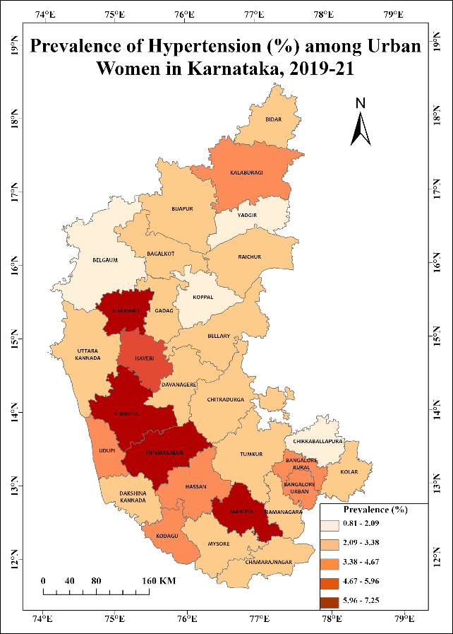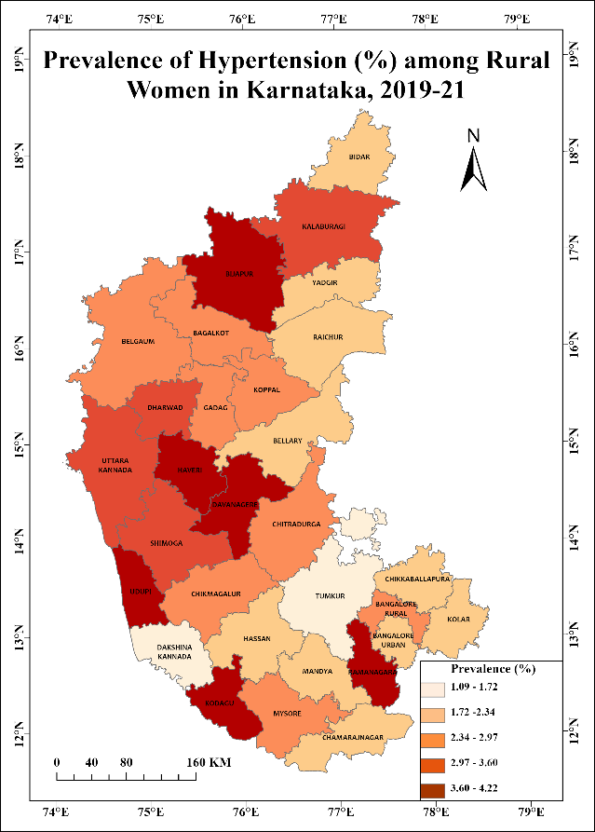

Figure 1: Urban Karnataka Figure 2: Rural Karnataka

[Figure 1 illustrates the Prevalence of Hypertension among Women in Urban Areas of Karnataka, whereas Figure 2 illustrates the Prevalence of Hypertension among Women in Rural Areas of Karnataka India. The varying shades indicate the different levels of hypertension prevalence across the districts, with darker shades representing higher rates]

All of the data combined, from both urban and rural areas, show enduring differences. At 3.1% and 3.8%, respectively, Mandya and Chikmagalur still have higher rates, whereas Yadgir's prevalence is still lower at 2.0% (Figure 3). To address the different prevalence rates among districts, region-specific interventions and healthcare methods are required, as seen by the overall combined prevalence's minor deviation from individual urban and rural averages (Table 3).

Haveri and Dharwad districts were shown to be significant hotspots for hypertension prevalence among women in Karnataka, with a 95% confidence interval, according to the study, which used the Hotspot Analysis (Getis-Ord Gi*) in ArcGIS Pro 3.2.0 statistic for hotspot analysis. Furthermore, with a 90% confidence level, Gadag became a hotspot (Figure 4).

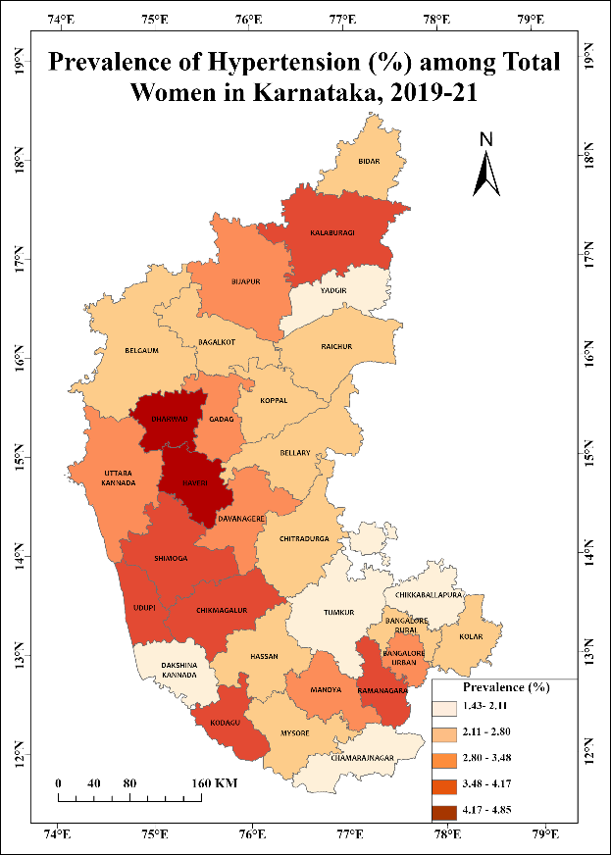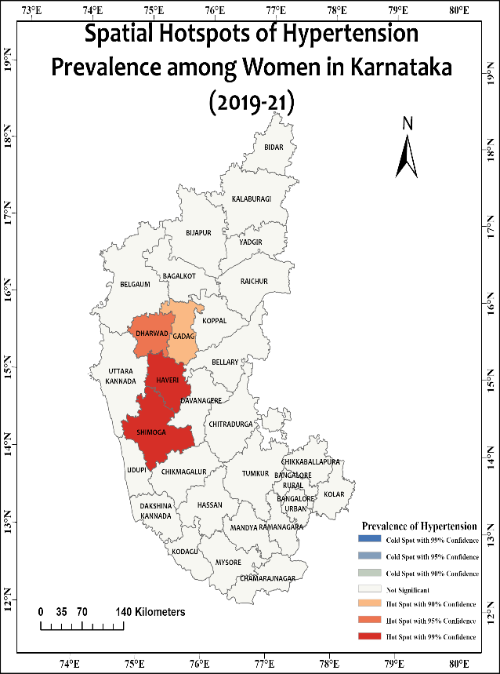

Figure 3: Total Karnataka Figure 4: Result of Hotspot Analysis

[Figure 3 illustrates the Prevalence of Hypertension among Women in Karnataka, whereas Figure 4 provides a visual depiction of districts identified as hotspots for hypertension prevalence among women in rural Karnataka, India.]

According to the spatial clustering of these data, some districts may have higher prevalence rates than their surrounding areas. This suggests that these districts should be the focus of more research or focused interventions.

**DISCUSSIONS:**

Significant correlations between socioeconomic and demographic characteristics were found in the study on the prevalence of hypertension in women in Karnataka, India. Age groups demonstrated a noteworthy correlation, demonstrating an increase in the prevalence of hypertension with increasing age, in line with documented patterns. In the same way, the prevalence of hypertension showed strong correlations with marital status, drinking patterns, history of abortions, caste, religion, economic position, and place of residence. The variable 'currently working' did not show any significant link because of missing data, indicating that the occurrence of hypertension among women in Karnataka may not be primarily influenced by one's occupation or that part of survey has to be done again with better accuracy.

The study revealed significant variations in hypertension prevalence among women across rural and urban regions of Karnataka. Urban areas exhibited a higher prevalence compared to rural districts, underscoring the need for tailored healthcare strategies. The district-level analysis identified hotspots like Haveri and Dharwad with higher prevalence rates, emphasizing the importance of targeted interventions.

Addressing these regional differences is vital to implement context-specific healthcare initiatives and ensure equitable access to health services for women across diverse districts in Karnataka (Figure 5).

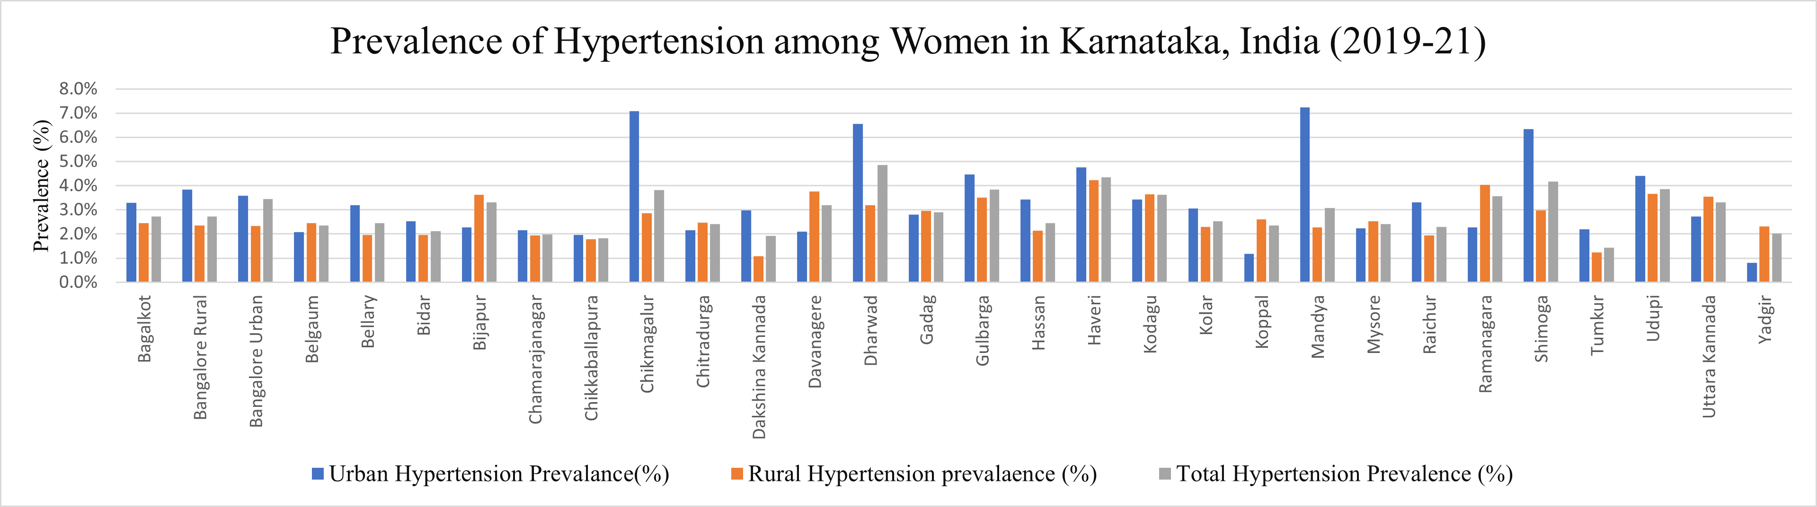

Figure 5: Graphical Representation of the prevalence of Hypertension among women in Karnataka

It is difficult to determine a causal relationship between demographic characteristics and hypertension because of the cross-sectional methodology. Moreover, the study predominantly focuses on women, potentially overlooking gender-specific aspects of hypertension prevalence. The results may not be as generalizable to a larger population due to the restricted regional scope, which is limited to Karnataka, India.

Although the focus of this research is women in Karnataka, there are similarities with other studies on women's health across other regions, highlighting the need for healthcare measures that are relevant to the region and specifically designed to address prevailing health inequities. Despite these similarities, this study adds new perspectives by combining hotspot analysis and rural-urban disparities. This improves our understanding of the geographic variations in the prevalence of hypertension among women in Karnataka and may lead to a deeper understanding of public health interventions and policy formulation.

**CONCLUSION**

According to this research, there is a significant correlation between women's hypertension in Karnataka and a range of sociodemographic factors. The findings highlight the pressing necessity for focused healthcare interventions and policy measures intended to lower the prevalence and cost of hypertension in this population. This work establishes a solid framework for well-informed public health decisions and emphasises the significance of ongoing investigations into lifestyle changes and their possible effects on morbidity and mortality from hypertension. Promoting additional thorough research would open the door for customised interventions and policy development, which will ultimately help to lessen the burden of hypertension on Karnataka's female population.

**REFERENCES**

Bansode, B., Marbaniang, S. P., & Prasad, J. B. (2021). Risk factors of diabetes and hypertension among women in Karnataka. *Diabetes and Metabolic Syndrome: Clinical Research and Reviews*, *15*(4). <https://doi.org/10.1016/j.dsx.2021.05.012>

Datta, B. K., & Haider, M. R. (2022). Child marriage and health disparities in adulthood: the differential risk of untreated hypertension among young adult women in India. *Clinical Hypertension*, *28*(1). <https://doi.org/10.1186/s40885-022-00213-6>

Drviveksinha, Drviveksinha, & Kachhawa, P. (2017). Screening of risk factors of hypertension among urban and rural populations of District-Hapur. *IOSR Journal of Dental and Medical Sciences, 16*(6), 21-25. <https://doi.org/10.9790/0853-1606142125>

Ghosh, S., & Kumar, M. (2019). Prevalence and associated risk factors of hypertension among persons aged 15-49 in India: A cross-sectional study. *BMJ Open*, *9*(12). <https://doi.org/10.1136/bmjopen-2019-029714>

Gupta, A., Brahmbhatt, K., KS, P., & Halappanavar, A. (2016). Prevalence and correlates of hypertension in the rural community of Dakshina Kannada, Karnataka, India. *International Journal of Medical Science and Public Health*, *5*(2), 241. <https://doi.org/10.5455/ijmsph.2016.0707201554>

Gupta, R., al-Odat, N. A., & Gupta, V. P. (1996). Hypertension epidemiology in India: Meta-analysis of 50-year prevalence rates and blood pressure trends. Journal of Human Hypertension, 10(7), 465-472. PMID: 8880561

Gupta, R., Pandey, R. M., Misra, A., Agrawal, A., Misra, P., Dey, S., Rao, S., Menon, V. U., Kamalamma, N., Vasantha Devi, K. P., Revathi, K., Vikram, N. K., Sharma, V., & Guptha, S. (2012). High prevalence and low awareness, treatment and control of hypertension in Asian Indian women. *Journal of Human Hypertension*, *26*(10), 585–593. <https://doi.org/10.1038/jhh.2011.79>

Gupta, R., & Yusuf, S. (2014). Towards better hypertension management in India. Indian Journal of Medical Research, 139, 657-660. Retrieved from [http://www.ijmr.org.in](http://www.ijmr.org.in/)

Kim, M. J., & Park, N. H. (2018). Analysis of spatial distribution of hypertension prevalence and its related factors based on the model of social determinants of health. *Journal of Korean Academy of Community Health Nursing*, *29*(4), 414–428. <https://doi.org/10.12799/jkachn.2018.29.4.414>

Kumar, K., & Misra, S. (2021). Sex differences in prevalence and risk factors of hypertension in India: Evidence from the National Family Health Survey-4. In *PLoS ONE* (Vol. 16, Issue 4 April). Public Library of Science. <https://doi.org/10.1371/journal.pone.0247956>

Kurjogi, M. M., Vanti, G. L., & Kaulgud, R. S. (2021). Prevalence of hypertension and its associated risk factors in Dharwad population: A cross-sectional study. *Indian Heart Journal*, *73*(6), 751–753. <https://doi.org/10.1016/j.ihj.2021.10.006>

Office of the Registrar General. (2013). Registrar General of India report on medical certification of cause of death 2013. New Delhi, India: Office of the Registrar General

Ponnaganti, S. C., Undavalli, V. K., Sayyad, A. P., Narni, H., & Muthe, A. (2018). Prevalence of hypertension and its associated risk factors in the rural field practice area of a tertiary care teaching hospital of Coastal Andhra Pradesh, India. *International Journal of Research in Medical Sciences*, *6*(5), 1747. <https://doi.org/10.18203/2320-6012.ijrms20181772>

R., A., & R., H. (2016). The prevalence of hypertension and its associated risk factors among adults in rural Mandya, Karnataka, India. *International Journal of Community Medicine and Public Health*, 2369–2372. <https://doi.org/10.18203/2394-6040.ijcmph20162819>

Rajat, S., & GD, B. (2019). STUDY TO DETERMINE RISK FACTORS ASSOCIATED WITH HYPERTENSION IN URBAN POPULATION OF BHOPAL (MP) INDIA. *International Journal of Medical and Biomedical Studies*, *3*(5). <https://doi.org/10.32553/ijmbs.v3i5.260>

Rao, C. R., Kamath, V. G., Shetty, A., & Kamath, A. (2013). High Blood Pressure Prevalence and Significant Correlates: A Quantitative Analysis from Coastal Karnataka, India. *ISRN Preventive Medicine*, *2013*, 1–6. <https://doi.org/10.5402/2013/574973>

S K, M., & T B, S. (2014). A STUDY ON PREVALENCE OF HYPERTENSION AND ITS RISK FACTORS AMONG URBAN ADULT POPULATION OF SHIMOGA. *Journal of Evolution of Medical and Dental Sciences*, *3*(18), 4876–4880. <https://doi.org/10.14260/jemds/2014/2527>

S, S., & M S, K. sumadevi. (2015). BLOOD PRESSURE VALUES AMONG PRIMI AND MULTIGRAVIDA WOMEN IN A RURAL POPULATION OF KARNATAKA STATE. *Journal of Evolution of Medical and Dental Sciences*, *4*(23), 3920–3924. <https://doi.org/10.14260/jemds/2015/565>

Uddin, J., Acharya, S., Valles, J., Baker, E. H., & Keith, V. M. (2020). Caste Differences in Hypertension Among Women in India: Diminishing Health Returns to Socioeconomic Status for Lower Caste Groups. *Journal of Racial and Ethnic Health Disparities*, *7*(5), 987–995. <https://doi.org/10.1007/s40615-020-00723-9>

Veientlena, S., & Prabu, P. (2018). Prevalence of hypertension and determination of its risk factors in korangrapady, udupi district, coastal Karnataka, India. *Asian Journal of Pharmaceutical and Clinical Research*, *11*(6), 517–521. <https://doi.org/10.22159/ajpcr.2018.v11i6.24727>

Virk, A., Samdarshi, N., Saini, P., Mohapatra, A., Sahoo, S., & Goel, S. (2022). Prevalence and determinants of hypertension and associated comorbidities in non-pregnant women of reproductive age group (15–49 years): Evidence from National Family Health Survey (NFHS-4), India. *Journal of Family Medicine and Primary Care*, *11*(9), 5865. <https://doi.org/10.4103/jfmpc.jfmpc_162_22>

Xu, L., Lai, D., & Fang, Y. (2016). Spatial analysis of gender variation in the prevalence of hypertension among the middle-aged and elderly population in Zhejiang Province, China. *BMC Public Health*, *16*(1). <https://doi.org/10.1186/s12889-016-3121-y>