Optimizing Decision-Making in Business Intelligence Through RFM Analysis

# Arfan A, Dakshak Jagdeesh, Srinivasan S

*B.Tech – Computer Science Engineering, SRM Institute of Science and Technology Vadapalani Campus,*

*Chennai, India*

# [aa0981@srmist.edu.in,](mailto:aa0981@srmist.edu.in) [dj2596@srmist.edu.in,](mailto:dj2596@srmist.edu.in) [ss5523@srmist.edu.in](mailto:ss5523@srmist.edu.in)

***Abstract*—The use of data analytics in business intelligence (BI) has become essential for improving the efficacy of decision- making in enterprises. Building on the groundwork established by the base article ”Enhancing Business Intelligence and Decision Making Through Big Data Analytics,” this research explores the relationship between business analytics and successful decision- making. The study looks at how information processing capacity is enhanced by business analytics in a data-driven environment, which eventually results in more efficient decision-making.**

***Index Terms*—Business Intelligence, RFM Analysis, Decision Making, Clustering**

1. INTRODUCTION

Business Intelligence (BI) systems play a crucial role in transforming data into actionable insights. However, opti- mizing these systems to improve decision-making remains a challenge for many organizations. RFM (Recency, Frequency, Monetary) analysis offers a powerful solution by segment- ing customers based on their purchasing behavior, helping businesses identify key customer groups and improve their strategies.

This paper investigates how RFM analysis can be used to enhance BI systems. By evaluating customer behavior through RFM scoring, businesses can develop more targeted marketing campaigns and improve resource allocation. A case study is presented to demonstrate the practical application of RFM in driving data-driven decisions and achieving better business outcomes.

1. METHODOLOGY
2. *Database*

This is the source of customer transaction data. It stores raw data such as transaction history, customer demographics, purchase amounts, and more. The data from this database will be extracted for further processing.

1. *Data-Driven Environment*

Feature Engineering: This step involves creating new features or modifying existing ones from raw data to improve the predictive power of the model. In RFM analysis, features such as recency, frequency, and monetary value are derived from the transaction data.

Identify applicable funding agency here. If none, delete this.

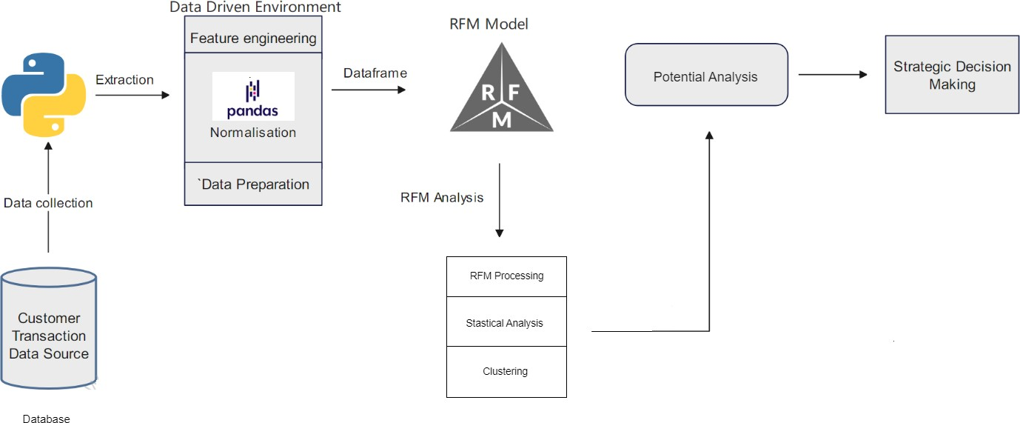

Fig. 1. Project Architecture Diagram

Normalization: Data normalization ensures that different scales or ranges of data are standardized. This is important in clustering algorithms to ensure that no variable dominates due to its scale.

Data Preparation: This module handles cleaning, formatting, and organizing the data for analysis. It may involve handling missing values, encoding categorical variables, and ensuring that data is consistent and ready for RFM analysis.

1. *RFM Model*

**Statistical Analysis:** In this step, statistical methods are applied to analyze customer behavior based on RFM metrics. Descriptive statistics may help summarize and visualize the distribution of customer segments.

**RFM Processing:** This is the core step where RFM scores (recency, frequency, and monetary value) are calculated for each customer. These scores help classify customers into different categories based on their behavior.

**Clustering:** After generating the RFM scores, customers are grouped into clusters based on their similarities. Clustering techniques like K-means can be used to segment customers into groups (e.g., high-value, inactive, etc.) to allow targeted strategies.

1. *Potential Analysis*

This module identifies business opportunities based on the clustered data. It can uncover customer segments with high potential for upselling, cross-selling, or those at risk of churn. The insights from this analysis guide strategic decision- making.

1. *Decision Making*

The final step where the insights from the RFM analysis and potential analysis are utilized to make informed business decisions. This could involve tailoring marketing campaigns, optimizing resources, or designing customer retention strate- gies.

1. DATA COLLECTION AND PREPARATION FOR ANALYSIS
2. *Data Sources*

The dataset for this study was provided by a safety equip- ment company and consists of comprehensive customer trans- action records.Key variables include the customer ID, which acts as a unique identifier for each customer; the city, which indicates the customer’s location; the product, which details the kind of safety equipment purchased; the price per unit, which indicates the cost of each item; the units sold, which indicate the quantity purchased; and the total sales, which records the total amount of money made from each transaction.

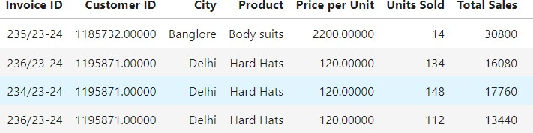

Fig. 2. Example of a figure caption.

1. *Data Cleaning and Transformation*

The dataset was meticulously cleaned and transformed before analysis. Incomplete entries were either removed or im- putted in order to rectify missing values in customer IDs, trans- action dates, or amounts. When necessary, outliers—such as transaction amounts that were abnormally high or low—were examined and eliminated. We eliminated duplicate items to avoid distorted data. Next, the three crucial RFM analysis variables—Recency, Frequency, and Monetary Value—were computed. Frequency was defined as the total number of transactions, monetary value as the total spending, and recency as the time elapsed since the customer’s most recent purchase. In order to standardize these factors for efficient clustering, the data was finally standardized.

1. DATA ANALYSIS AND VISUALIZATION
2. *RFM Analysis*

The RFM analysis was conducted to segment customers based on their transactional behavior using the three compo- nents:

* + Recency (R): The number of days since the customer’s last purchase.
  + Frequency (F): The total number of purchases made.
  + Monetary (M): The total spending amount by each cus- tomer.

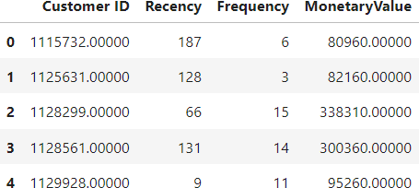

Fig. 3. Example of a figure caption.

This methodology enabled customer segmentation into groups such as high-value, loyal, at-risk, and inactive cus- tomers. For the purposes of this study, customers were as- signed scores for each component based on quantiles, allowing a structured classification of customer behavior.

1. *Visualization of RFM Metrics*

Several visualizations were created to illustrate the distribu- tion of customer behaviors across the RFM dimensions:

* + Recency Distribution: The distribution of recency re- vealed that most customers had made purchases within the last [X] days, suggesting strong recent engagement. However, a significant tail in the distribution indicated a subset of customers who had not made purchases in an extended period, highlighting potential churn risks .

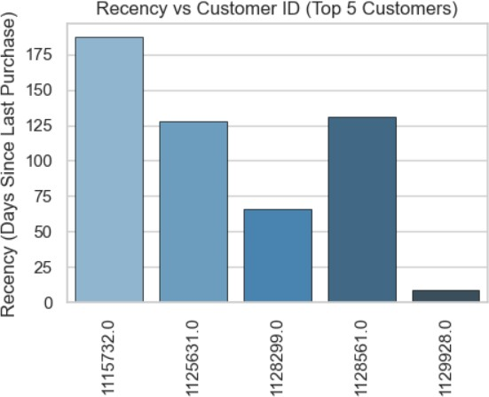

Fig. 4. Example of a figure caption.

* + Frequency Distribution: The frequency distribution showed that while the majority of customers had only made a small number of purchases, there was a distinct subset of highly frequent buyers. This subset represents a core group of loyal customers who have consistently engaged with the company over time.

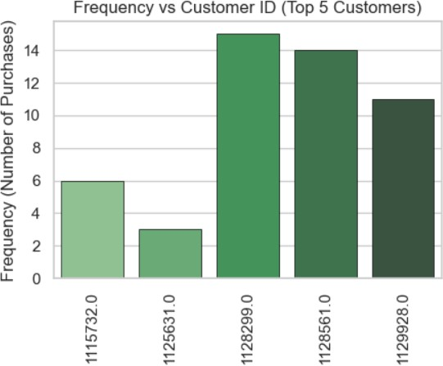

Fig. 5. Example of a figure caption.

* + Monetary Distribution: The monetary distribution was skewed, with a small proportion of customers contribut- ing a disproportionately large share of total revenue. This aligns with the Pareto principle (80/20 rule), where a minority of customers are responsible for the majority of sales.

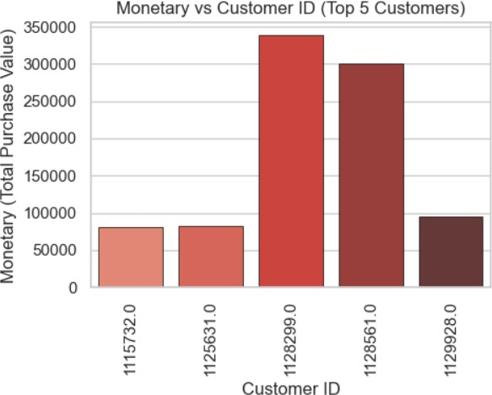

Fig. 6. Example of a figure caption.

These visualizations not only revealed the disparities be- tween different customer segments but also provided a clear direction for prioritizing high-value customers and developing strategies for re-engagement of less active segments.

1. *Clustering*

The final stage of the analysis, customers were segmented into distinct clusters based on their RFM scores. Using clus- tering techniques, such as K-means, customers with similar

recency, frequency, and monetary values were grouped to- gether. Each cluster represents a specific customer segment, enabling the application of tailored strategies. For example, high-value customers with frequent and recent purchases can be targeted with loyalty programs, while customers with low frequency and monetary values might benefit from re- engagement campaigns. These targeted strategies allow the company to optimize marketing efforts, improve customer retention, and enhance overall business performance.

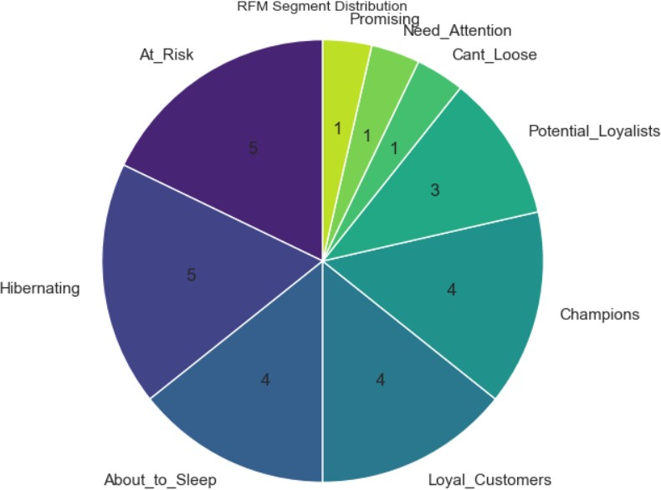

Fig. 7. Example of a figure caption.

1. LITERATURE SURVEY

Numerous studies have demonstrated the ability of big data, analytics, and AI-driven insights to enhance managerial decision-making and optimize corporate operations. Big data is essential for improving decision-making. [1] demonstrates how business intelligence is enhanced by real-time data processing, resulting in better decision-making. This is consistent with the study’s use of RFM analysis to maximize consumer segmentation.

Moreover, the quality of big data analytics has a large impact on business performance, as [2] investigates. This study investigates the relationship between business outcomes and data quality, including timeliness and correctness. This bolsters the notion that actionable customer insights from high-quality data can enhance decision-making in RFM research.

[3] demonstrates how decision-makers are influenced by real-time business intelligence since it provides deeper insights into consumer behavior. This is similar to the RFM analysis in this study, which makes use of customer information to guide sales and marketing plans.

In [4], a path model connecting business analytics with efficient decision-making is developed. This elucidates the re- lationship between the two. It talks about how decision-making effectiveness is improved by structured analytics models, such as RFM, which provide quantifiable data. This aids companies in strengthening retention tactics and giving priority to high- value clients.

[5] highlights the noteworthy contribution of artificial in- telligence (AI) in enabling decision support systems and business analytics. In a similar vein, RFM analysis sets the stage for possible AI integration in consumer engagement and segmentation..

In the end, the study backs the use of AI, real-time intelli- gence, and data analytics in decision-making. These guidelines are followed in this study’s RFM analysis, which enhances consumer segmentation and business results.

1. CONCLUSION

This study shows how segmenting clients based on their purchase patterns and assessing recency, frequency, and mone- tary value using RFM analysis can maximize decision-making. The identification of critical customer segments, including high-value, loyal, and at-risk clients, allowed companies to better target their marketing efforts, increase client retention, and boost revenues. RFM analysis facilitates better decision- making by offering useful insights into customer interaction trends. This is consistent with previous studies on the value of data analytics for increased operational effectiveness and corporate expansion. In the future, research may focus on utilizing AI to automate and improve customer segmentation, resulting in even more accurate real-time decision-making.

1. FUTURE WORK AND IMPROVEMENTS

Although RFM analysis is used in this study to segment customers in an effective way, there are a few areas where further research could improve its use. The use of AI and machine learning to automate and continuously update RFM ratings is one area that might use development. This would enable more precise targeting techniques based on anticipated customer behavior. Furthermore, the integration of variables such as online interactions and client preferences may yield a more refined comprehension of customer groupings, hence enabling customized marketing strategies.

Another area of investigation is the creation of a dynamic RFM model, which allows companies to adapt to changes in customer behavior by updating ratings in real time based on ongoing transactions. Deeper insights into overall customer involvement and loyalty may also be obtained by extending the research to include multi-channel data, including both online and offline sources.

Lastly, using longitudinal research to look at how customer habits change over time may be able to help forecast long-term value and provide guidance for proactive engagement tactics aimed at retention.

REFERENCES

1. Author(s), ”Enhancing Business Intelligence and Decision-Making Through Big Data Analytics,” IEEE, Nov. 3, 2023.
2. Author(s), ”Attribute of Big Data Analytics Quality Affecting Business Performance ,” IEEE, Dec 2023.
3. Author(s), ”The impact of real-time business intelligence and advanced analytics on the behaviour of business decision makers,” IEEE, Jan 2018.
4. Author(s), ”Linking Business Analytics to Decision Making Effective- ness: A Path Model Analysis,” IEEE, Jun 2015.
5. Author(s), ”Insightful Business Analytics Using Artificial Intelligence - A Decision Support System for E-Businesses,” IEEE, Nov 2021.
6. Author(s), ”Business Intelligence using Data Mining techniques and Business Analytics,” IEEE, Nov 2016.
7. Author(s), ”Data-driven management using Business Analytics: the case study of data sets for new business in tourism,” IEEE, Jun 2022.
8. Author(s), ”IoT and HR Analytics: Leveraging Data for Informed HR Decision-Making and Strategic Planning,” IEEE, Oct 2023.