**SEASONAL VARIATION OF GASEOUS POLLUTANTS AND SUSPENDED PARTICULATE MATTER IN THE DARUSSALAM AREA**

**Maino Uddin Shadin1, Md. Hasib Mahmud2, Md. Shahriar Rahman Naeem Patwary3,**

**Safayet Jahan4**

1Department of Civil Engineering, Faculty of Engineering, Ahsanullah University of Science & Technology, Dhaka, Bangladesh

2Department of Civil Engineering, Faculty of Engineering, Ahsanullah University of Science & Technology, Dhaka, Bangladesh

3Department of Civil Engineering, Faculty of Engineering, Ahsanullah University of Science & Technology, Dhaka, Bangladesh

4Department of Civil Engineering, Faculty of Engineering, Ahsanullah University of Science & Technology, Dhaka, Bangladesh

ABSTRACT

Through the analysis and comparison of meteorological data and seasonal fluctuations in air pollutants, this study investigated the quality of the air in Dhaka. All around the nation, there is a lot of rainfall during the rainy season. Rivers, canals, marshes, and low-lying regions around Dhaka city are now under water. Compared to the dry season, the wind speed is stronger during this period. Rain removes pollutants from the air, particularly particle matter. As a result, there are fewer PM2.5 and PM10 pollutants than during the dry season. For the last five years, from January 2016 to December 2020, Darussalam's air pollution concentrations and seasonal variations have been recorded. Owing to time and resource limitations, an evaluation of Dhaka's air quality has been conducted using secondary data gathered by the Department of Environment (DoE), the Bangladesh Agricultural Research Council (BARC), the Continuous Air Monitoring Station (CAMS), the Air Quality Management Project (AQMP), and various government agencies and institutions as well as published research studies. The main pollutants' daily emissions as well as the contributions of exhaust emissions from the various cars operating in Dhaka will be measured. To evaluate the health impacts and establish relationships, the survey will be conducted among those most impacted by roadside pollution, particularly traffic police officers. To illustrate variations in air pollution and meteorological data, the Pearson correlation coefficient test was created using Origin Pro and shown statistical analysis in SPSS. The majority of air pollutant concentrations were shown to have a negative connection with temperature, precipitation, and relative humidity, according to the correlation metrics. Although particulate matter (PM2.5 and PM10) has a strong negative association with temperature and relative humidity, it has a positive correlation with other gaseous pollutants (SO2, NO2, CO, and O3). Pollutants and temperature often have a negative relationship. To make decisions about control strategies to preserve Dhaka's atmospheric environment and take appropriate action to reduce health hazards for the most endangered group exposed to air pollution, this study will give environmentalists, urban planners, traffic engineering practitioners, and policymakers the right management and technological tools.

**keywords:** PM2.5, Temperature, Department of Environment (DoE), Continuous Air Monitoring Station (CAMS), Air Quality Management Project (AQMP), Air Pollution.

1. INTRODUCTION

Among the world's most polluted cities is Dhaka. The main issues include noise pollution, soil contamination, river pollution, and air pollution, among other types of pollution. However, the most concerning issue of our day is air pollution. According to a combined World Bank and Bangladeshi government environmental report, the economic losses of deterioration amount to around 4.3% of GDP, with pollution in urban areas contributing almost one-fourth of that amount. The World Bank analysis estimates that Dhaka's air pollution-related fatalities and illnesses cost the city between $200 and $800 million annually [1]. Material, infrastructural, and ecological degradation are additional effects of air pollution. Consequently, Dhaka and Bangladesh's sustainable growth is hindered by air pollution.

As a country in Asia, Bangladesh is seeing yearly declines in air quality due to population expansion and fast urbanization. Headaches, eye irritation, wheezing, horrible odor, infections, acute respiratory, etc., are frightening symptoms of air pollution that Dhaka residents are increasingly experiencing as a result of the city's rapid urbanization. Degradation of the environment occurred as a result of unplanned industrialization in big cities such as Dhaka. Air pollutants such as PM2.5, PM10, SO2, NO2, O3, CO, and a host of others are growing due to all these human-made causes [2]. Particulate matter has a negative impact on human health. To put it simply, air pollution occurs when certain pollutants are present in the air at concentrations far higher than their normal ambient levels, having a discernible impact on living things, plants, and materials.

According to the World Health Organisation and the American Medical Association, "Air pollution is the excessive concentration of foreign matter in the air which adversely affects the well-being of the individual or causes damage to property." The following are the main categories into which the Environmental Protection Agency (EPA) has placed the causes of air pollution: Vehicles, such as ships, aircraft, trains, and cars, Combustion of fuel in fixed-location sources, such as utilities, Processes used in industry, such as those that produce steel, textiles, and paper, Methods for disposing of solid waste, such as sanitary landfills, incineration, and open burning, General procedures, such as washing up after using pesticide [3].

With an average yearly PM2.5 concentration of 82 µg/m3 due to various pollution sources, the Dhaka region is regarded as one of the world's most polluted cities [4]. According to World Health Organisation (WHO) research on outdoor air pollution, Dhaka ranked third among megacities with an estimated population of 14 million or more as concerns pollution [5]. Unplanned urbanization, industrialization, and motorization are to blame for Dhaka's pollution level spike. Brick kiln operations cause the majority of the air pollution in Dhaka. Automobiles are the second most prevalent cause of pollution, followed by road dust, fugitive lead, soil dust, biomass combustion, and sea salt. This list is based on estimates that brick kiln activities account for 58% of total fine particulate matter PM2.5 Pollution in Dhaka [6]. The Bangladeshi government prohibited the use of two-stroke vehicles in Dhaka commencing in 2003. Previously, it was considered that two-stroke engines were the most significant cause of traffic pollution in Dhaka, which caused more than half of the PM2.5 emissions [7].

The increasing number of brick kilns, caused by fast industrial expansion and urbanization, is a major contributor to the spread of air pollution in Dhaka, accounting for 58% of the total. There are over 8,000 brick kilns in Bangladesh, both registered and unregistered. In the greater Dhaka area alone, there are roughly 1,000 brick kilns. While wood is used as an additional fuel source, coal is the primary fuel for the brick kilns sector in Bangladesh [8]. The majority of diesel fuel used by heavy-duty vehicles is high-sulfur. The unanticipated development of the roads, flyover, and building has resulted in the accumulation of dust from both the road and dirt. During the dry season, brick kilns in Dhaka are operational, making them a seasonal industry. Brick production peaks between November and March. Long-range transmission of small particles, as well as poor dispersion conditions throughout the winter, may contribute to the higher concentrations during this season. In 2013, the brick kiln industries in Dhaka were responsible for 91.1% of the city's PM10 emissions and 98.3% of its SO2 emissions, with 53,333 tonnes of PM10 and 59,221 tonnes of SO2 being emitted [9]. But this particular source of emissions from brick kilns is only active at certain times of the year; specifically, when the monsoons are in full swing. The transport industry is responsible for about 58.6% of Dhaka's total yearly NOx emissions. Industrial sources account for around 15.7% of total yearly NOx emissions. Renewable energy sources account for 40.5 percent of Dhaka's CO emissions, and fossil fuels account for 27.1 percent. Industrial sources, such as brick kilns, contribute to 16.4 percent [9]. Congestion in the city is caused by a wide variety of motor vehicles, including transport buses, long-distance buses, diesel-powered local passenger vans (called "Laguna" in Dhaka), private cars, passenger cars, commercial vans, run auto-rickshaws, compressed natural gas (CNG) and heavy-duty diesel-powered lorry trucks used to transport garment goods. Although natural gas and petrol are sometimes utilized, high-sulfur diesel is the most common fuel for vehicles. Dhaka's local city buses carry the majority of the city's public transit passengers. One million motor cars were registered in Greater Dhaka in September 2016, according to the Bangladesh Road and Transport Authority (BRTA). On the roadways of Dhaka, there are an additional 400,000 motor vehicles that have not been registered. These cars are a major contributor to environmental pollution since they are decades old and no longer suitable for use [5]. The high levels of CO, NOx, and SOx emitted by these buses are a direct result of their poorly maintained engines, which contribute to the city's heavy traffic pollution. In Dhaka city, the air is mostly polluted by pollutants from factories and cars. The majority of the smoke, dust, gases, fumes, etc. that pollutes the air originates from industrial emission sources, such as the hundreds of ready-made garment factories (RMG), chemical industries, brick kilns, pharmaceutical businesses, and so on. Rising air pollution is a direct result of the ever-increasing number of automobiles on the road in Bangladesh's capital city, which is a direct result of the city's rapidly expanding population and its unchecked urbanization [10].

Two-stroke engine-powered vehicles, such as motorcycles, minitrucks, tempos, baby taxis, and others, are the primary source of air pollution in the capital city of Dhaka, according to recent research from the Bangladesh Department of Environment (DoE) and other pertinent organizations. Subtropical monsoon (summer monsoon) weather is typical in Bangladesh and is defined by higher humidity, hotter temperatures, and more precipitation during certain seasons. When it comes to air pollution exposure, among other aspects, the monsoon is a major differentiator across seasons. Four distinct seasons are recognized by Bangladesh's meteorologists: the pre-monsoon (March-May), monsoon (June–September), post-monsoon (October–November), and winter (December–February) [11]. In Bangladesh, winter is called the dry season because of the low relative humidity, dry soil, and minimal precipitation. Light northwesterly winds blow into Bangladesh throughout the winter. During the pre-monsoon season, the predominant wind direction changes to the southwest, leading to higher wind speeds, relative humidity, and rainfall. Once the monsoons pass, the weather starts to dry up, become windier, and the wind starts to blow from the northeast again [7]. A major climatic factor influencing air pollution levels in Dhaka is the rain that comes during the monsoon season. Pollutants in the air are impacted by a variety of climatic parameters, including temperature, humidity, precipitation, wind speed and direction, mixing height, and many more. These elements influence the processes of emission, dilution, transit, chemical change, and deposition [12]. People living in Dhaka are at risk due to the city's poor air quality. Data suggests that during the dry season, Dhaka's air pollution is particularly severe due to high amounts of particle matter (PM2.5 and PM10). The most common sources of particle pollution, according to source apportionment studies, are motor vehicles and brick kilns, followed by soil dust.

The current research aims to evaluate air contaminants and demonstrate their variability in Dhaka city. The following are among the particular aims of this research: Evaluation of air contaminants and pollution emissions in the Darussalam district of Dhaka, Creating concentrations of various pollutants, including gaseous pollutants and particle matter, and determining correlations between air pollutants in Dhaka city; estimating meteorological factors necessary for air quality; and finding seasonal fluctuation characteristics From January 2016 through December 2020, analyze the air pollution concentration and how it varies with the seasons in Darussalam.

1. METHODOLOGY

In order to back up the Bangladeshi government's National Ambient Air Quality Standards (BNAAQS) of 65 ug/m3 for PM2.5 and 150 μg/m3 for PM10, the country's Department of Environment (DoE) has instituted monitoring programs (Department of Environment, 2016). The Darussalam continuous air monitoring site is situated just 100-120 meters from Dhaka City's main thoroughfare, Mirpur Road, making it a traffic hotspot among the three Dhaka metro area CAMS (Sangshad Bhaban, Sher-e-Bangla Nagar, Firmgate, and Darus-Salam) shown in Figure 1. Furthermore, Darussalam station is situated close to three important long-distance bus terminals—"Technical," "Kallyanpur," and "Gabtoli"—that serve as entrance points to Dhaka City from the country's northern regions. It is also situated downwind of another congested area known as "Farmgate." As a result, compared to other monitoring stations, Darussalam CAMS is likely to have greater amounts of O3 and NO3.

**Table 1:**1 An Overview of the Air Monitoring System:

|  |  |  |  |
| --- | --- | --- | --- |
| **City** | **Location** | **Lat/Lon** | **Monitoring Capacity** |
| Dhaka | Darus-salam | 23.78N 90.36E | PM10, PM2.5, CO, SO2, NOx and O3 with meteorological parameters. (Wind speed, Temperature, Relative humidity, Rainfall) |

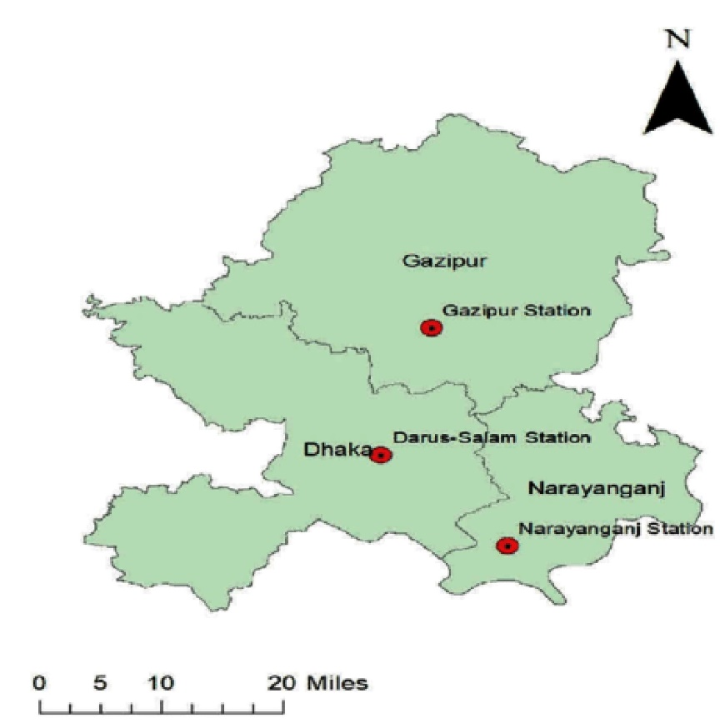**Fig 1:** Dhaka and the surrounding metropolitan area's continuous air monitoring stations' locations (shown with red dots).

**2.1 Air pollution and Meteorological data**

From 2016 to 2020, the DoE/CASE Project in Bangladesh collected data on the daily concentrations of gaseous pollutants and particulate matter in the Dhaka Metropolitan area. For several types of standards air pollutants, the Bangladesh Department of Environment (DoE) developed the Bangladesh National Ambient Air Quality Standards (BNAAQS) in 2005.These pollutants include particulate matter (PM2.5 and PM10), sulfur dioxide (SO2), nitrogen oxides (NO2), carbon monoxide (CO), temperature, relative humidity, precipitation, and wind speed (Table 1). Using a combination of online gas sensors and beta gauge monitors, Dhaka's continuous air monitoring stations determine the concentration of gaseous pollutants (like SO2, NO2, CO, and O3) and particulate matter (PM2.5 and PM10) on an hourly basis. When it comes to temporal data coverage, only the Darussalam station out of three in the Dhaka City region offers acceptable results (>90%). This study does not use the remaining two stations' data since their temporal coverage is very poor (<50%). The Department of Environment is the source for the meteorological data used in this research, which includes temperature, humidity, and precipitation.

1. Data Analysis Method

The main objective of this project is to develop a model that can accurately forecast pollution levels in Dhaka city from 2016 to 2020 by studying the impact of the seasons on pollution levels. All of the measured characteristics, including air contaminants and meteorological variables (temperature, relative humidity, and rainfall), were analyzed using a parametric test Pearson correlation coefficient.

**3.1 Pearson Correlation Coefficient**

This project's overarching goal is to research the effect of the seasons on pollution levels in Dhaka city and create a model that can reliably predict these levels from 2016 to 2020. The use of a parametric test Pearson correlation coefficient allowed for the analysis of all the recorded attributes, including air pollutants and meteorological factors (temperature, relative humidity, and rainfall).

$$r=\frac{n(\sum{xy)-(\sum{x)(\sum{y)}}}}{\sqrt{\left[n\sum{x^{2}-{(\sum{x)}}^{2}}\right]\left[n\sum{y^{2}-{(\sum{y)}}^{2}}\right]}}$$

Where,

$r$ = Pearson correlation coefficient

$x$ = Values in the first set of data

$y$ = Values in the second set of data

$n$ = Total number of values

Using yearly and seasonal averages of pollution concentration, this study examines the fluctuations in concentration at the Darussalam area from 2016 to 2020 to apply spatial interpolation to the distributions of pollutant concentrations. The link between all the observed factors, including air contaminants and meteorological variables (temperature, relative humidity, and rainfall), may be better understood with the use of the Pearson correlation coefficient. The data is divided into four separate seasons: winter (December–February), pre-monsoon (March–May), monsoon (June–September), and post-monsoon (October–November). This allows us to examine the influence of the seasons on pollution concentration.

**3.2 Data Processing**

The air quality in Dhaka is monitored hourly by continuous air monitoring stations that record data on gaseous contaminants, particulate matter, and atmospheric conditions. Hourly concentration data from 2016 to 2020 has been given by the Department of Environmental (DoE). The data was translated from hourly to monthly for the analysis step. Due to the possibility of data corruption or human mistakes in recording values, missing values are a prevalent problem in many real-world datasets. Since some data was missing at random over a lengthy period of time, interpolation and mean imputation cannot be used to replace the values. After the missing values are eliminated, the remaining numbers are used to calculate the average.

1. RESULT AND DISCUSSION

Statistical analysis was conducted to calculate the yearly and seasonal categories' means, standard deviations, variances, and standard errors using IBM SPSS Statistics 22 software.

**Table 2:** The average ± standard error concentration of air pollutants in the Darussalam region from 2016 to 2020, both annually and seasonally.

|  |  |  |  |  |  |  |
| --- | --- | --- | --- | --- | --- | --- |
| Area | Pollutants | Annual | Winter * | Pre-monsoon | Monsoon | Post-monsoon |
| Darus salam | PM2.5 (µg/m3) | 87.11± 7.50 | 173.23 ± 5.65 | 73.09 ± 7.46 | 32.64± 1.26 | 87.85 ± 9.84 |
| PM10 (µg/m3) | 151.42 ±11.68 | 269.58 ±10.95 | 153.90 ± 16.96 | 62.79 ± 3.29 | 147.70 ± 17.04 |
| SO2 (ppb) | 10.10 ± 1.19 | 17.40 ± 1.95 | 13.81 ± 2.26 | 4.08 ± 1.32 | 4.78 ± 1.11 |
| NO2 (ppb) | 19.80 ± 2.01 | 29.98 ± 3.46 | 18.24 ± 4.63 | 10.26 ± 1.06 | 24.63 ± 5.61 |
| CO (ppm) | 2.14 ± 0.19 | 3.29 ± 0.54 | 1.97 ± 0.26 | 1.66 ± 0.25 | 2.08 ± 0.42 |
| O3 (8hr) (ppb) | 5.59 ± 0.72 | 9.71 ± 1.84 | 6.42 ± 1.15 | 2.09 ± 0.29 | 5.39 ± 1.13 |

Notes: *There is a substantial difference between the monsoon and wintertime pollution concentrations.

**4.1 Particulate matter (PM2.5 and PM10)**

Specifically, particulate elements represent a health risk to residents of Dhaka and the rest of Bangladesh. On a global scale, it is also one of the most harmful pollutants. Table 2 shows that across all seasons, with the exception of the monsoon, the average PM2.5 concentrations at the Darussalam monitoring site were higher than the Bangladesh National Ambient Air Quality Standards, which are 65 µg/m3for PM2.5 and 150 µg/m3for PM10.

**Fig 2:** Column chart for monthly average concentration of PM2.5 pollutant (µg/m3) from January 2016 to December 2020 timeline.

**Fig 3:** Column chart for monthly average concentration of PM10 pollutant (µg/m3) from January 2016 to December 2020 timeline.

At Darussalam station, the average ± SE values of PM2.5 and PM10 over the study period were 87.11 ± 7.50 ug/m3 and 151.42 ±11.68 ug/m3, respectively. At the Darussalam continuous air monitoring station, there is a strong seasonal pattern. The winter season has the highest concentrations of PM2.5 and PM10, which are comparable to BNAAQS. The Darussalam location showed statistically significant variations in PM pollution concentration between the winter and monsoon seasons. In the winter, the average ± SE (standard error) concentration of PM2.5 was 173.23 ± 5.65 ug/m3 compared to 32.64 ± 1.26 ug/m3 during the monsoon season, and in the winter, the average ± SE concentration of PM10 was 269.58 ±10.95 ug/m3 compared to 62.79 ± 3.29 ug/m3 at the Darussalam location. Reduced mixing layer height, thermal inversion, and increased emissions from brick kiln industries are some of the reasons why particulate matter (PM) levels tend to be higher in the winter. During the winter in Bangladesh, you may expect mild temperatures, minimal precipitation, moderate wind speeds, and low relative humidity. As a result of resuspended road dust and soil dust, PM concentrations were greater in the winter.

**Seasonal variation of PM2.5 and PM10 in the Darussalam area**

Both the 2019 and 2020 PM2.5 and PM10 emission levels vary significantly from month to month, as seen in Figures 4 and 5. The PM2.5 line is green, while the PM10 line is blue. Both particulate matter and total particle emissions climb throughout the dry season, as shown clearly by the line graph, which indicates that they begin to rise in November and peak in January and February.

**Fig 4:** Seasonal Variation of PM2.5 and PM10 in 2019.

**Fig 5:** Seasonal Variation of PM2.5 and PM10 in 2020.

A lot of rain falls on the nation while it's raining. During this period, low-lying regions around Dhaka city, as well as rivers, canals, and marshes, are inundated. The wind speed is greater during this period compared to the dry season. When it rains, it washes away air pollutants, particularly particulate particles. Pollutant levels of PM2.5 and PM10 are much lower than during the dry season. The opposite is true during the winter when local urban activity and low relative humidity provide ideal circumstances for the production of transboundary aerosols. Due to the lack of precipitation and the clear sky, the air cleansing processes are hindered, leading to an elevated aerosol loading. Aerosols would include both coarse and small particles, with the former coming from mechanical processes in conjunction with urban activity and the latter from precursors and turbulence. The residence duration of fine particles is much longer than that of coarse aerosols. Hence, throughout the winter season, both PM10 and PM2.5 levels remain high (table 2). Also, during winter, there are a lot of morning and evening temperature inversions, which decrease the amount of air that can be used to dilute pollutants. So, even when emissions don't vary, the concentration of pollutants in a city with an inversion layer is higher.

Consequently, levels of PM10 and PM2.5 begin to rise in the winter. Because Dhaka city was under complete lockdown from March to May of 2020, the PM concentration was lower than in 2019. Up to partial lockdown, the PM concentration was likewise at its lowest. Dhaka City's PM2.5 and PM10 emissions dropped significantly because of the lockdown, which reduced transit activity, and closed offices, schools, and all kinds of industrial activities. However, the situation deteriorates once more during the dry season because of the abrupt opening of industries and an increase in cars. In 2020, the PM number shows a higher concentration compared to winter 2019.

**4.2 Sulfur dioxide (SO2)**

The colorless gas SO2 has a strong smell. Fossil fuel combustion is a major source of SO2 emissions in the atmosphere, particularly in nearby brick kilns where significant SO2 emissions are mostly caused by coal burning [9]. About 3000 parts per million of sulfur are present in the diesel fuel used in Bangladeshi mobile sources [7]. Therefore, using diesel fuels with a high sulfur concentration in automobiles and power plants is the other major human-caused source. The concentration of SO2 was less important than that of PM. The majority of the year's SO2 concentration throughout the research period was within BNAAQS (140 ppb 24-hr average for SO2). At Darussalam, no SO2 BNAAQS limit exceedances were discovered (Fig 6).

**Fig 6:** Column chart for monthly average concentration of SO2 pollutant (ppb) from January 2016 to December 2020 timeline.

During the research period, the regional homogeneity and low annual SO2 mean ± SE concentrations are shown in Table. Table 1 shows that similar to particulate matters, SO2 concentration varied significantly throughout the year in Darussalam locations. The greatest values were recorded in winter (17.40 ± 1.95 ppb), in contrast to the other seasons. As a seasonal industry, brick manufacturing, drying, and fire are all halted by rain in Bangladesh, hence brick kilns may only operate during the dry season. Consequently, the monsoon season is not a time to conduct the brick-producing activity; rather, it is November through June. There are hundreds of textile factories all around Dhaka City. The Dhaka metro region is significantly affected by SO2 emissions because of the frequent movement of large diesel-fuel lorry trucks used for textile product transportation. The majority of these vehicles run on high-sulfur diesel fuel.

**4.3 Nitrogen dioxide (NO2)**

Nitrogen dioxide pollution in heavily populated places, such as Dhaka, is often caused by emissions from motor vehicles. Power plants, metal refineries, and other types of industrial and food processing facilities might potentially play a role. A high temperature is required for the nitrogen-oxygen reaction to create NO when coal, oil, and fuel oils are burned in electric power plants and in cars, respectively.

**Fig 7:** Column chart for monthly average concentration of NO2 pollutant (ppb) from January 2016 to December 2020 timeline

Throughout the research period, a notable seasonal shift was identified, with the winter season recording the greatest concentration at 29.98 ± 3.46 ppb and the monsoon season recording the lowest concentration at 10.26 ± 1.06 ppb. No notable change in NO2 concentrations was seen in the other two seasons; in the pre-monsoon season, it was 18.24 ± 4.63 ppb, and in the post-monsoon season, it was 24.63 ± 5.61 ppb (Figure 7 and Table 1). The noticeable variation in NO2 levels between the winter and monsoon seasons. No 24-hour average BNAAQS level for NO2 concentration is available in Bangladesh, as seen in figure 7. Data from the Darussalam station shows that yearly NO2 readings did not above the U.S. NAAQS limit (24-hour average 100 ppb for NO2) from 2016 to 2020, suggesting that particulate matter pollution is more prevalent in Dhaka than NO2 pollution.

**4.4 Carbon monoxide (CO)**

In Dhaka, CO emissions mostly come from vehicles (cars, trucks, etc.) and power plants (oil, coal, etc.) that burn fossil fuels. Polluted air makes it harder for oxygen to reach vital organs via the bloodstream.

**Fig 8:** Column chart for monthly average concentration of CO pollutant (ppm) from 2016 to 2020 combined five years CO monthly concentration data into one year monthly average concentration in average per month.

**Fig 9:** Line chart for monthly average concentration of CO pollutant (ppm) from January 2016 to December 2020 timeline.

Some months' worth of data on the average monthly concentration of CO pollutants for the last five years is missing. Accordingly, we drew a column chart and averaged the monthly concentrations of CO pollutants across five years to get a single yearly average. Using data collected from the Department of Environment between 2016 and 2020, Figure 8 displayed the chronology of the monthly average concentration of CO pollutants. For the most of the year, the SO2 concentration was within the acceptable range according to BNAAQS (35 ppm CO 24-hour average), and the results showed that the CO value dropped dramatically, falling within the established range. Throughout the research period, the CO content at the Darussalam station averaged 2.14 ± 0.19 ppm. There was a noticeable change in concentration throughout the year, with the highest recorded in the winter at 29.98 ± 3.46 ppb and the lowest at 10.26 ± 1.06 ppm, as shown in Table 1. Rising CO emissions in Dhaka City are caused by a combination of factors, including lax emission control legislation, the continued use of outdated and inefficient cars on city streets, the use of solid fuels in home cooking, and the use of coal in brick kiln businesses.

**4.5 Ozone (O3)**

Ozone, a secondary pollutant, is formed when sunlight reacts chemically with nitrogen oxides (NOx) and volatile organic compounds (VOCs) emitted by many sources, including vehicles, power plants, refineries, boilers, and others (Guo 2012). The data for the monthly average concentrations of O3 were gathered from January 2016 to December 2020, and as shown in Figure 4.9, the concentrations of O3 declined significantly [13].

**Fig 10**: Column chart for monthly average concentration of O3 pollutant (ppb) from January 2016 to December 2020 timeline.

Over the research period in the Darussalam region, the average ± SE ozone O3 concentrations were 5.59 ± 0.72 parts per billion. The national air quality limit for O3 in Bangladesh is 80 ppb (8-hour average), with a maximum concentration of 23.72 ppb recorded at the Darussalam location, which was within the standard value range. Table 1 demonstrated that the O3 concentration at Darussalam sites varied significantly with the seasons, with the winter season having the maximum concentration (9.71 ± 1.84 ppb).

4.6 Correlation between gaseous pollutants and meteorological data in various season

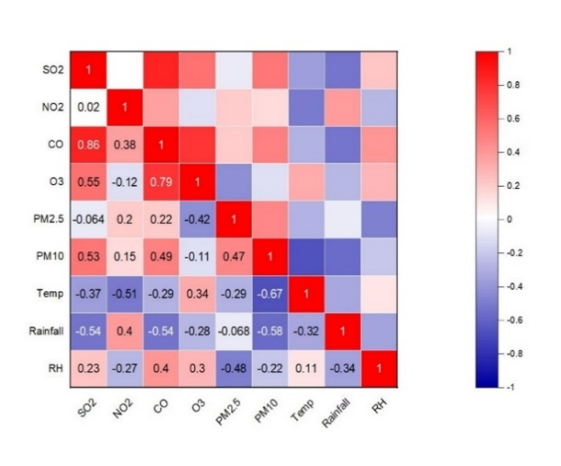

Winter

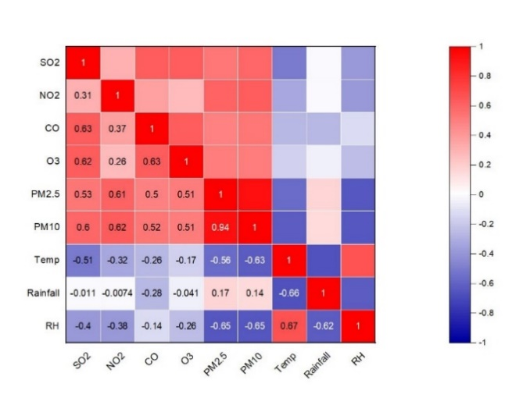

Annual

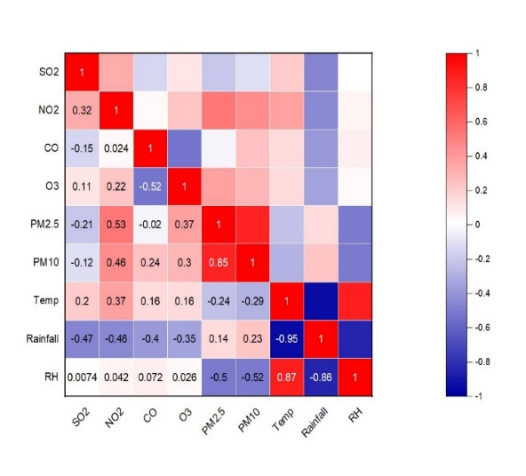

Pre-monsoon

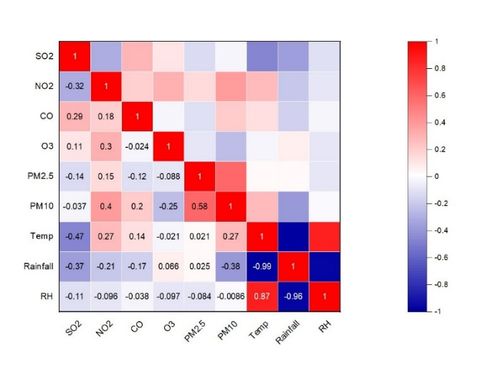

Monsoon

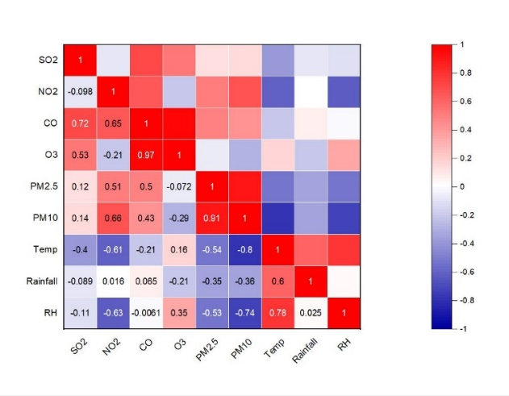

Post-monsoon

**Figure 11**: Correlation matrix by season for air pollutants and weather variables over the study period in Dhaka City (Darussalam site).

Each table column in Figure 11 displays the correlation between two variables. Correlation matrices are used for data summarisation, input into more advanced research, and diagnostics in advanced analysis. We used correlation analysis to probe the link between Dhaka city's air pollution levels and weather conditions, using monthly average data from the Darussalam station (2016–2020). The yearly data shows that there is a negative correlation between gaseous pollutants and climatic factors such as relative humidity, rainfall, and temperature. Although particulate matter (PM2.5 and PM10) has a substantially negative relationship with temperature and relative humidity, it has a positive and high link with other gaseous pollutants (SO2, NO2, CO, O3). It follows that high temperatures promote both the upward movement of heated air over the ground and the dispersion of pollutants, as the two variables have a negative correlation. Additionally, the finding demonstrates that as weather conditions deteriorate, the concentration of pollutants increases. Since the relationships between SO2 and NO2 are so weak in the winter and after the monsoon, it's safe to assume that their respective origins are distinct (industrial vs. transportation). From December through February, the winter months, most pollutants are negatively correlated with temperature and rainfall. As the temperature drops and the rainfall percentage drops, the association weakens. Region and season may have a role in the variation of PM concentrations. Typically, PM10 and PM2.5 seasonal variations tend to peak in the winter. However, it's important to note that different regions have different seasonal variations according to meteorological circumstances. As the rate of chemical reactions in the atmosphere increases with increasing temperature, there is a positive association between temperature and the gaseous pollutants. When compared to other seasons, the monsoon season's matrix is unique. There is a decreased relationship between temperature, rainfall, humidity and PM2.5 during the monsoon season (June–September). Monsoon season has a weak link due to the rain's moist scavenging impact on PM2.5. The absence of a strong relationship between SO2 and PM2.5 -0.14 and PM10 -0.037 during that period further suggests that the brick kilns were not operating. The average maximum temperature decreases as rainfall increases, and this negative relationship is most during the monsoon season (r=-0.99). Enhanced emissivity as a result of soil moisture depletion and its impact on surface temperature magnitude. A high relative humidity increases the likelihood of cloud formation and precipitation in the event of a temperature decrease (r=-0.96) because more moisture is present in the air. After the monsoons, the post-monsoon season shows a -0.35 and -0.36 connection between PM2.5 and PM10 and rainfall, a -0.53 and -0.74 correlation between PM2.5 and PM10 and relative humidity, and a -0.54, -0.8 correlation between PM2.5 and PM10 and temperature. Therefore, it is clear that PM has a very unfavorable relationship with weather reports.

1. CONCLUSION

The main objective of the study was to ascertain the function of air pollutants and how they affect our lives. The study aims to predict Dhaka's ambient particulate matter concentration using air quality models. The physical landscape of Dhaka has transformed over the last several decades due to rapid urbanization and population increase. All types of motorized vehicle emissions have been gradually worsening the city's air quality. Aircraft, railway engines, uncontrolled emissions from the Tejgaon industrial area, uncontrolled emissions from the tannery industries in Hazaribagh, brickfields surrounding Dhaka city, power plants, open burning incineration, negligent solid waste disposal, impromptu construction projects, excavation, etc. are additional sources. Darussalam, which is essentially a traffic hotspot, was the study area. The most concerning air pollutant, based on our study of pollutant concentrations with Bangladesh NAAQS restrictions, is particulate matter (PM2.5 and PM10). It often beats the Bangladesh NAAQS during the dry months. Various seasonal patterns have diverse outcomes due to the monsoon's importance to our nation. Ambient PM2.5 and PM10 concentrations in the city exceed safe levels during the dry season, which begins in November and continues until March. Still, they do not live up to expectations all the way through the wet season (April–October). While the investigation was underway, gaseous pollutants reported much fewer exceedances. Accurately detecting the concentration of pollutants is a major function of meteorology. All year round, temperature and relative humidity were shown to have a negative connection with PM2.5, PM10, SO2, NO2, CO, and O3 according to studies that correlated air pollutants with weather variables. Consequently, it seems that higher temperatures may limit pollution. Rainfall and PM demonstrated a negative link when PM levels rose during the dry season. This is because winter perception is often low.

**Recommendation**

Both urban and semi-urban regions should have more Continuous Air Monitoring Stations (CAMS). The public is required to have consistent access to CAMS data via an online portal. It is also imperative that the Department of Environment (DoE) implement AQI predictions and a warning mechanism. The primary function of air pollution early warning systems is to alert the relevant authorities when the air quality approaches the threshold for early warning. In a comprehensive pollution warning system, the pollutants, resources, and territory of influence are covered.   
In addition, future research on air pollution and its effects in Dhaka city should include the following suggestions:

* All of the brick kilns' production levels should be taken into account in the modeling studies. Future modeling studies may take into account the impact of additional sources, such as cement factories, power plants, open burning, traffic dust, and so on.
* Vehicle attribute data, emission factors, and other variables useful for estimating vehicle emissions in Dhaka may be gleaned from regularly performed surveys.
* It is possible to conduct comprehensive epidemiological investigations in Bangladesh to find the right coefficient of linked mortality/morbidity health consequences due to air pollution.
* Air quality models might benefit from site-specific estimations of deposition factors, such as wet and dry deposition rates.
* The study's findings might be compared using other dispersion models.

1. References
2. Open Knowledge Repository. (2006). Bangladesh Country Environmental Analysis. Retrieved from http://hdl.handle.net/10986/33925
3. World Bank Group. (2022, December 4). High Air Pollution Level is Creating Physical and Mental Health Hazards in Bangladesh: World Bank. *World Bank*. Retrieved from <https://www.worldbank.org>
4. US. (2019). Air Quality | Air Quality Planning & Standards | US EPA. Retrieved from Epa.gov website: https://www3.epa.gov/airquality/cleanair.html
5. State of Global Air. (2017). A SPECIAL REPORT ON GLOBAL EXPOSURE TO AIR POLLUTION AND ITS DISEASE BURDEN. *State of Global Air*. Health Effects Institute. Retrieved from https://www.stateofglobalair.org/sites/default/files/soga_2017_report.pdf
6. Rahman, M. M., Mahamud, S., & Thurston, G. D. (2018). Recent spatial gradients and time trends in Dhaka, Bangladesh, air pollution and their human health implications. *Journal of the Air & Waste Management Association*, *69*(4), 478–501. https://doi.org/10.1080/10962247.2018.1548388
7. Begum, B. A., S. K. B. Eugene Kim, and P. K. Hopke. 2004. Investigation of sources of atmospheric aerosol at urban and semi-urban areas in Bangladesh. *Atmospheric Environment*, 38 (19):3025–38. <https://doi.org/10.1016/j.atmosenv.2004.02.042>
8. Begum, B., M. Nasiruddin, S. Randal, B. Sivertsen, and P. Hopke (2014). Identification and apportionment of sources from air particulate matter at urban environments in Bangladesh. *Br. J Appl. Sci. Technol*. 4 (27):3930-55. Doi: [10.9734/BJAST/2014/11247](https://doi.org/10.9734/BJAST/2014/11247)
9. Tusher, T. R., Ashraf, Z., & Akter, S. (2019). Health effects of brick kiln operations: A study on largest brick kiln cluster in Bangladesh. *South East Asia Journal of Public Health*, *8*(1), 32–36. https://doi.org/10.3329/seajph.v8i1.42270
10. Randall, S., B. Sivertsen, S. S. Ahammad, N. D. Cruz, and V. T. Dam. 2015. Emissions Inventory for Dhaka and Chittagong of Pollutants PM10, PM2.5, NOx, SOx, and CO.

http://bapman.nilu.no/LinkClick.aspx?fileticket=Wq46eRdToUA%3D&tabid=3331& mid=7822&language=en-US.

1. Khuda, K. E. (2020). Air pollution in the capital city of Bangladesh: its causes and impacts on human health. *Pollution*, *6*(4), 737–750. https://doi.org/10.22059/poll.2020.300588.775
2. Salam, A., H. Bauer, K. Kassin, S. M. Ullah, and H. Puxbaum 2003. Aerosol chemical characteristics of a Mega-City in Southeast Asia (Dhaka-Bangladesh). *Atmospheric. Environment,* 37 (18):2517–28. Doi: 10.1016/S1352-2310(03)00135-3.
3. Kinney, P. L. (2008). Climate change, air quality, and human health. *American Journal of Preventive Medicine*, *35*(5), 459–467. https://doi.org/10.1016/j.amepre.2008.08.025
4. Guo, D., Su, Y., Shi, C., Xu, J., & Powell, A. M. (2015). Double core of ozone valley over the Tibetan Plateau and its possible mechanisms. *Journal of Atmospheric and Solar-Terrestrial Physics*, *130–131*, 127–131. https://doi.org/10.1016/j.jastp.2015.05.018