**A REVIEW ON IN DETAIL OF FORMULATION AND EVALUATION OF MULTIPURPOSE HERBAL CREAM**

**Abhijeet Kastode 1, Ajit Tuwar 2, Megha Salve 3**

Shivajirao Pawar College of Pharmacy Pachegaon, Maharashtra

**Abstract**

Herbal creams have gained popularity due to their natural ingredients and potential therapeutic benefits. This review aims to summarize the current state of knowledge on the formulation and evaluation of multipurpose herbal creams. A comprehensive literature search was conducted to identify relevant studies on herbal cream formulations, their stability, and biological activities. The review highlights the commonly used herbal extracts, bases, and preservatives in cream formulations, as well as the various evaluation methods employed to assess their physical, chemical, and biological properties. The findings suggest that multipurpose herbal creams exhibit antimicrobial, anti-inflammatory, antioxidant, and wound-healing activities, making them suitable for various skin applications. However, the review also identifies gaps in the existing literature, including the need for standardized formulation and evaluation protocols, as well as clinical studies to confirm efficacy and safety. This review provides a foundation for future research and development of effective and safe multipurpose herbal creams.

**INTRODUCTION**

The demand for herbal cosmetics is increasing due to their high-quality properties and minimal side effects. Herbal formulations provide essential nutrients and moisture to the skin, making them a popular choice. The herbal cream is a water-in-oil emulsion, and its natural ingredients - turmeric, papaya, aloe-vera, tulsi, and neem - were selected for their individual properties. Aloe-vera moisturizes and reduces acne, while turmeric imparts a golden radiance and offers anti-inflammatory and antiseptic properties. Neem treats various skin diseases, tulsi promotes wound healing and adds glow, and papaya provides anti-wrinkle and anti-inflammatory benefits.

Our goal is to develop a multipurpose herbal cream that moisturizes, reduces acne and skin irritation, and addresses dry skin, wrinkles, and rashes. Cosmetic products, including face creams, soften and cleanse the skin. The Ayurvedic system has long utilized herbal plants and extracts to treat various diseases. Emulsions, like our water-in-oil cream, prevent phase separation using surfactants. Adding active ingredients with specific cosmetic effects enhances the formulation. Antioxidants, in particular, offer advantages in cosmetic emulsion preparation.

Skin creams protect against environmental conditions and provide a soothing effect. Various types of creams exist, but many contain synthetic polymers, emulsifiers, and other agents. There is a growing need to replace these toxic synthetic agents with natural alternatives. Poly herbal cosmetic formulations are gaining recognition worldwide for their purity, protection, and effectiveness.

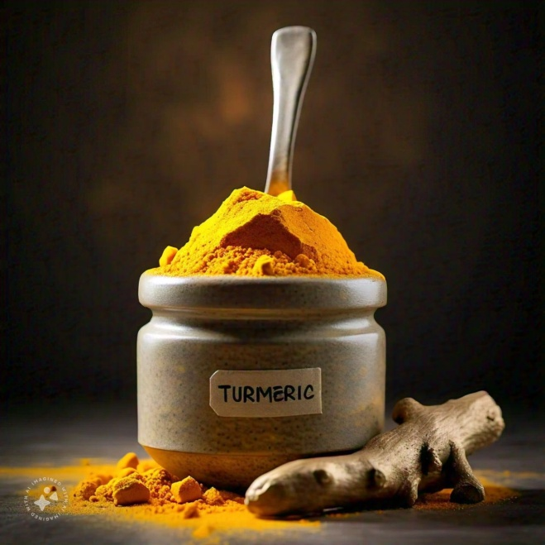

Fig.1 Turmeric

**Benefits of turmeric in health**

• Natural anti-inflammatory compound

• Improve heart health and prevent against alzheimer’s and cancer

• Powerful antioxidant

• Treat and prevent diabetes

• Improve skin health

• Treats depression

• Cures acne

• Reduce dark circles

• Could help psoriasis eczema

• Clears the skin

• Helps wound healing

• Promotes weight loss

• Protect your body from free radicals

• Anti-microbial agent

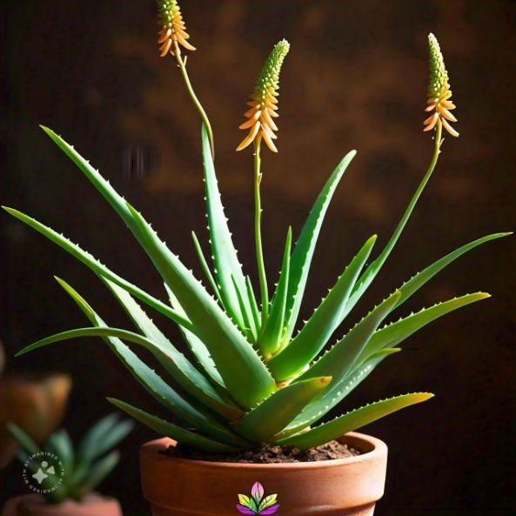

Fig.2 Aloe-vera

**Benefits of aloe-vera for face**

• Its anti-inflammatory properties can reduce pain, swelling, and soreness of wounds or injuries

• It has a cooling effect on rashes or sunburns

• It supports the production and release of collagen

• Help in keeping your face health and gives you a natural shine

• Aloe-vera is rich in moisturizing properties it helps in removing dead cells

• Prevent or reduce wrinkles and dark spots of your face

• Moisturizes dry skin

• Soothes irritated skin

• Remove sign of ageing

• Fights acne and blemishes

• Remove dark circles and puffiness

• Relieves eczema and psoriasis

• Eliminates dead skin cells

• Treat sunburn

• Bring a natural glow to the skin

• Hydrated the skin with essential

• Prevents premature aging

• Reduce stretch marks

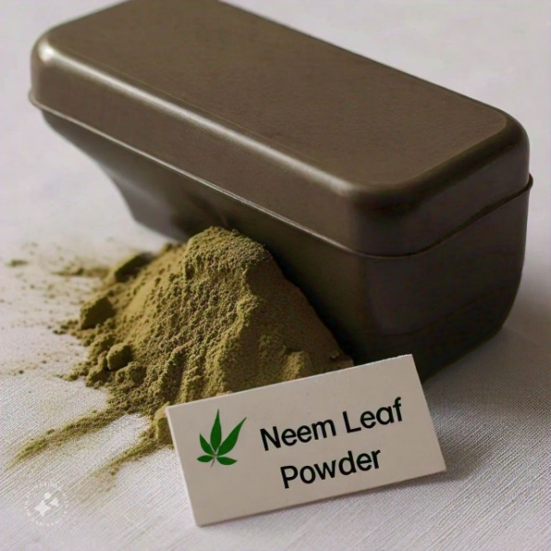

Fig.3 Neem leaf powder

**Benefits of neem leaf powder**

• Acts as a shield against dandruff

• It can be used for both face and hair

• Treat dry scalp making it smooth and shiny

• Increase radiance and produce ageing effect

• Increase blood circulation

• Help to treat ulcers

• Keep the skin healthy and glowing

• Neem has anti-bacterial properties which get rid of pimples

• Neem lightens and blurs the scars left behind by acne

• Neem is anti-inflammatory in nature with fatty acids and glycosides

• Neem is rich in anti-oxidant and vitamin E that reduce wrinkles

• Fatty acids and vitamin E in neem nourish the skin

• Help soothe eczema

• Treat acne

• Prevent skin infection

• Gives even skin tone

• Offers anti-ageing benefits

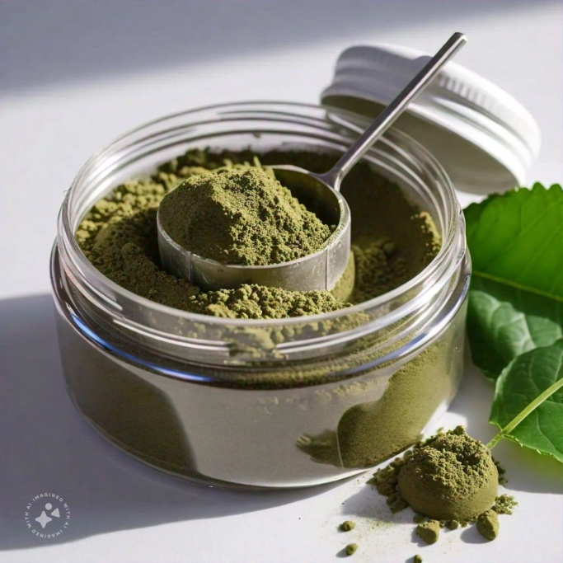

Fig.4 Tulsi leaf powder

**Benefits of tulsi leaf powder**

• Natural immunity booster

• Reduce stress and blood pressure

• Good for skin health

• Useful in kidney stone

• Fight acne

• Supports healthy skin aging

• Soothes skin condition like eczema

• Great for healing skin problem

• Good source of vitamin K

• Super beneficial for skin

• Helping anti-aging

• Control blood glucose level

• Prevent kidney stone

• Reduce stress

• Prevent acne

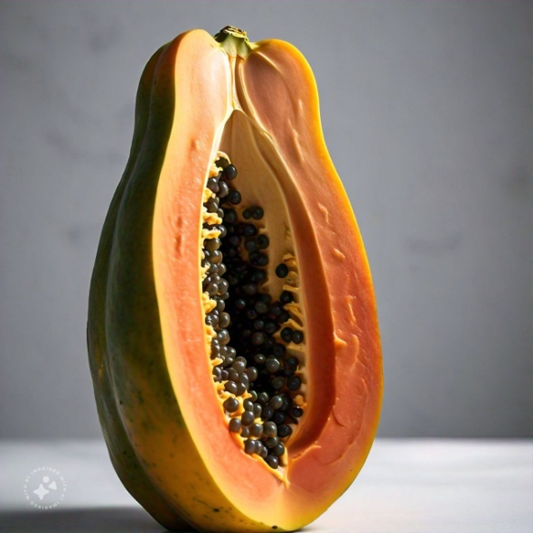

Fig.5 Papaya

**Benefits of papaya for skin**

• It used to the winkle reduction

• It is used to the enzyme action

• It used to the anti-inflammatory properties

• Control acne

• Remove dead skin cells

• Improve skin stone

• Soothes irritated skin

• Hydrates dry skin

• Help weight loss

• Supporting skin health

• Skin and healing

• Boosts your immunity

• Full of anti-oxidants, vitamin and minerals

• Protect eye sight

• Helps treat hypertension

• Anti-aging properties

• Cures skin infection

• Prevents wrinkles

• Treat morning sickness

**MATERIALS AND METHODS**

**Collection of plants material :**

The collection of live plant specimens from the wild, also known as plant hunting, has been occurring for centuries. Herbaria are essential for preserving plant samples and their associated data for scientific purposes. The process of collecting plant specimens involves careful consideration of factors such as the plant's life cycle, environmental conditions, and the time of year. This ensures that the collected specimens are of high quality and suitable for research and study.

In the context of our study, the collected plant specimens (turmeric, papaya, aloe-vera, tulsi, and neem) were carefully selected and processed to extract their active ingredients. These ingredients were then used to formulate a multipurpose herbal cream with various benefits, including moisturizing, acne reduction, and anti-inflammatory properties.

By utilizing plant specimens from a local botanical garden and following proper collection and processing procedures, we aimed to create a high-quality herbal cream that leverages the therapeutic properties of these natural ingredients.

Turmeric, papaya, aloe-vera, tulsi, and neem were sourced from a local botanical garden. Regardless of the type of crude drug or collection area, it's essential to collect drugs when they contain the maximum concentration of active ingredients. Environmental conditions and skilled labor are also considered during collection, especially on a commercial scale. Fruits are collected based on the part used, either ripe or half-ripe but fully grown. Rhizomes are collected when they have stored ample reserve food material and contain the maximum chemical constituents. Opium and papaya latices are collected after latex coagulation.

Plant collecting, or acquiring plant specimens for research, cultivation, or hobby, is an ancient practice dating back over 5,000 years. Collected plants are often dried and pressed to preserve quality, and may end up in botanical gardens, private gardens, or herbaria. Herbaria are collections of preserved plant samples and associated data for scientific purposes. They provide biological materials for researchers, reference points for documenting scientific names, and vouchers for use in herbaria world -wide. Plant samples in herbaria typically include a reference sheet with information about the plant and collection details. This organized system allows horticulturists and researchers to access information about a particular plant and add new information to existing plant sample files.

**Methods of preparation:**

**Slab method:**

The components are mixed until a uniform preparation is attained. One small scale, as in extemporaneous compounding, other will use an ointment mill. If components of an ointment react with metal hard rubber spatula may be used. Put this cream on the slab and add few drops of distilled water if necessary and mix the cream in a geometric manner on the slab to give a smooth texture to the cream and to mix all the ingredients properly. This method is called as slab technique or extemporaneous method of preparation of cream

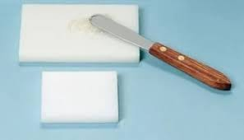

Fig.6

**Herbal ingredients used with their roles**

|  |  |  |
| --- | --- | --- |
| Sr. No | Ingredient | Role |
| 1 | Turmeric | Glow your skin and antiseptic, anti- inflammatory |
| 2 | Ripe papaya | Anti- wrinkle, cleansing, enzymes action, anti- inflammatory |
| 3 | Aloe-vera | Anti-ageing, reduce acne and pimples |
| 4 | Tulsi | Antibacterial, add glow to the face |
| 5 | Neem | skin dryness promote wound healing |
| 6 | Bees wax | Emulsifying agent |
| 7 | Liquid paraffin | Lubricating agent |
| 8 | Borax | Alkaline agent |
| 9 | Methyl paraben | Preservative |
| 10 | Distilled water | Vehicle |
| 11 | Rose oil | Fragrance |

Table:1

**Extraction process**

**1.Preparation of turmeric extract:**

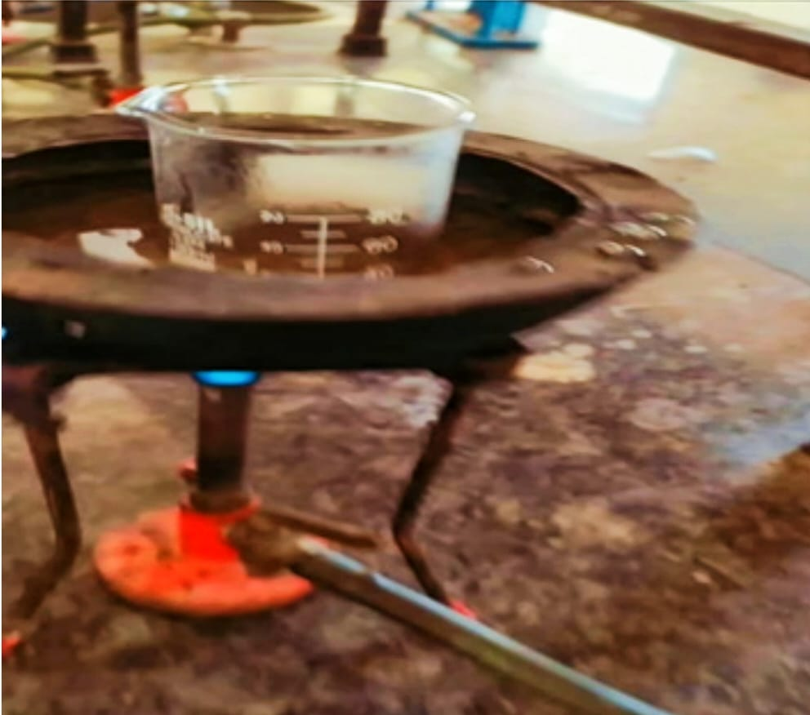

Take 1 g turmeric powder in 10 ml distilled water and shaken in 250 ml volumetric flask heated in water bath at 80°C to 100°C for 5 to 10 minutes. Then filtered it and it and turmeric extract is obtained

**2.Preparation of aloe-vera extract:**



Collect mature and fresh aloe-vera leaf from plant and washed it with distilled water. Dried it is hot air oven. Leaf dissected longitudinally by sterile knife. The semi-solid aloe-vera is collected. Remove fibers and impurities form it. Aloe-vera extract is obtained

**3.Preparation of neem extract:**



Collect fresh neem leaves and wash it with distilled water. Dried it in hot air oven and then powdered take 5 gm neem powder in 20 ml Dimethyl sulfoxide at 100°C for 5 to 10 minutes. Then filter it by filter paper and clear solution is obtained

**4.Preparation of tulsi extract:**



Tulsi leaves were collected and washed with distilled water and dried hot air oven. Then after proper drying, the leaves were powdered. Then 1 gm tulsi leaf powder+10 ml Dimethyl sulfoxide was taken in a volumetric flask. Then the solution was heated on water bath at 80°C to 100°C for 5 to 10 minutes then filtered the solution use by filter paper and clear extract of tulsi leaves

**5.Preparation of ripe papaya extracts (papaya oil):**



To make the papaya oil, take a tablespoon of every finely cut, ripe but firm organic papaya, pieces in a bowl. Add in 2 tablespoon of any unrefined oil of your choice now take the bowl and place it over a pan of gently simmering water. The top bowl with the oil should not touch the water in the bottom bowl and the flame should be on the lowest possible setting the entire time we’re making the oil. Continue cooking like this for 30 minutes using double boiler method will help preserve to top up with water every 10 minutes. After 30 minutes remove the top bowl and strain out the oil. Now you make the papaya oil is obtained

**Formulation of Cream:**

In a borosilicate glass beaker, heat the liquid paraffin and beeswax to 75°C, maintaining this temperature for the oil phase. In a separate beaker, dissolve borax and methyl paraben in distilled water at 75°C using a water bath. Stir the solution with a glass rod until all solid particles are fully dissolved, creating the aqueous phase.

Gradually add the heated aqueous phase to the heated oily phase, continuously stirring with a glass rod (Ashara K, et al., 2013). Following the mixing of both phases, immediately incorporate aloe-vera extract, neem extract, tulsi extract, and turmeric extract, along with ripe papaya, and continue mixing until a smooth cream forms.

Once the cream is formed, add rose oil for fragrance. Transfer the cream to a slab and add a few drops of distilled water if necessary. Mix the cream in a geometric pattern on the slab to achieve a smooth texture and ensure thorough incorporation of all ingredients. This method is known as the slab technique or extemporaneous method of cream preparation."

**Formulation table:**

|  |  |  |  |  |
| --- | --- | --- | --- | --- |
| Sr. No. | Ingredient | Formulation 1 | Formulation 2 | Formulation  3 |
| 1 | Turmeric extract | 2.7ml | 1.42 ml | 1.67 ml |
| 2 | Ripe papaya | 2.7 ml | 1.67 ml | 1.42 ml |
| 3 | Aloe-vera extract | 2.8 ml | 1.47 ml | 1.67 ml |
| 4 | Tulsi extract | 1.7 ml | 1 ml | 1 ml |
| 5 | Neem extract | 0.9 ml | 0.28 ml | 0.67 ml |
| 6 | Bee-wax | 5.45 ml | 4.97 ml | 5.36 ml |
| 7 | Liquid paraffin | 18.1 ml | 21.32 ml | 20.1 ml |
| 8 | Borax | 0.36gm | 0.56gm | 20.1gm |

Table:2

**Result & Physical parameter:**

In this test color, odor, texture, and state of cream are observed

|  |  |  |  |  |
| --- | --- | --- | --- | --- |
| Sr.No. | Parameters | Formulation  1 | Formulation  2 | Formulation  3 |
| 1 | Color | Faint Yellow | Faint Yellow | Faint Yellow |
| 2 | Odor | Pleasant | Pleasant | Pleasant |
| 3 | Texture | Smooth | Smooth | Smooth |
| 4 | State | Semi-solid | Semi-solid | Semi-solid |

Table:3

**Irritancy:** Mark the area (1 cm2 ) on the left hand dorsal surface. Then the cream was applied to the area and the time noted. After interval up to 24 hr. it is checked for irritant effect, erythema and edema if any than reported

|  |  |  |  |  |
| --- | --- | --- | --- | --- |
| Sr.No. | Formulation | Irritant effect | Erythema | Edema |
| 1 | Formulation 1 | Nil | Nil | Nil |
| 2 | Formulation 2 | Nil | Nil | Nil |
| 3 | Formulation 3 | Nil | Nil | Nil |

Table:4

**Wash ability:** Wash ability test was carried out by applying a small amount of cream on the hand and then washing it with help of tap water. All three formulations were easily washable.

|  |  |  |
| --- | --- | --- |
| Sr. No. | Formulation | Wash ability |
| 1 | Formulation 1 | Easily washable |
| 2 | Formulation 2 | Easily washable |
| 3 | Formulation 3 | Easily washable |

Table:5

**Phase separation**: Prepared cream is kept in tightly closed container at room temperature away from sunlight and observed for 24 hours for phase

|  |  |  |
| --- | --- | --- |
| Sr. No. | Formulation | Phase separation |
| 1 | Formulation 1 | No Phase Separation |
| 2 | Formulation 2 | No Phase Separation |
| 3 | Formulation 3 | No Phase Separation |

Table: 6

**pH**: Take 0.5 g of cream and dispersed it in 50 ml distilled water. Then check it’s pH by using digital pH meter

|  |  |  |
| --- | --- | --- |
| Sr. No | Formulation | pH |
| 1 | Formulation 1 | 7.98 |
| 2 | Formulation 2 | 7.94 |
| 3 | Formulation 3 | 7.96 |

Table: 7

**Spreadability:** Spreadability is carried out for all three formulations that is, F1C, F2C and F3C. The less time take for the separation of both the slide better the spreadability. Therefore according to statement F2C had better spreadability

|  |  |  |  |
| --- | --- | --- | --- |
| Sr. No | Formulation | Time (sec) | Spreadability |
| 1 | Formulation 1 | 7 | 2.14 |
| 2 | Formulation 2 | 5 | 3 |
| 3 | Formulation 3 | 6 | 2.5 |

Table : 8

**Conclusion:**

The formulated cream, comprising turmeric, papaya, aloe-vera, neem, and tulsi, exhibited a multipurpose effect, with each herbal ingredient demonstrating significant activities. Stability studies revealed that formulations F1C, F2C, and F3C remained stable at room temperature and were safe for skin application. Among these, F2C emerged as the superior formulation.

This study highlights the potential of herbal extracts in cosmetic applications, which have gained immense popularity in personal care. Bioactive ingredients in cosmetics influence skin's biological functions and provide essential nutrients for healthy skin. The prepared formulation demonstrated excellent spreadability, no phase separation, and consistent texture throughout the study period.

The herbal cream exhibited optimal properties, nutritional value, and minimal chemical content, protecting the skin from various issues. The simple preparation method and ingredients used make the cream economical. As a herbal cosmetic formulation, it offers a safe and protective barrier for the skin. Various tests confirmed the cream's topical applicability in shielding the skin from damage.

The preference for natural remedies stems from their perceived safety and fewer side effects compared to synthetic alternatives. Future research will investigate the synergistic effects of the formulation."

**Reference :**

1.Somnath S Davkhar* , Aarti S Bhandari, Sanjivani A Akolkar. A multifaceted review journal in the field of pharmacy23-28

2. Mali AS, Karekar P, Yadav AV. Formulation and evaluation of multipurpose herbal cream. Int J Sci Res. 2015; 4(11): 1495-1497.

3. Christaki EV, Florou-Paneri PC. Aloe vera: A plant for many uses. J Food Agric Environ. 2010; 8(2): 245-249.

4. <https://en.wikipedia.org/wiki/turmeric>

5. Dhyani A, Chander V, Singh N. Formulation and evaluation of multipurpose herbal cream. J drug deliv ther. 2019; 9(2): 341-343.

6. <https://en.wikipedia.org/wiki/aloe-vera>

7. <https://en.wikipedia.org/wiki/tulsileaf>

8. <https://en.wikipedia.org/wiki/neamleaf>

9. <https://en.wikipedia.org/wiki/papayafruit>

10. Bhowmik D, Chiranjib YJ, Tripathi KK, Kumar KS. Herbal remedies of Azadirachta indica and its medicinal application. J Chem Pharm Res. 2010; 2(1): 62-72.

11. Rignall A. ICHQ1A (R2) stability testing of new drug substance and product and ICHQ1C stability testing of new dosage forms. ICH quality guidelines: An implementation guide. 2017.

12. <https://en.wikipedia.org/wiki/cream>

13. <https://en.wikipedia.org/wiki/herbalcream>

14. <https://en.wikipedia.org/wiki/parameterofcream>

15. <https://en.wikipedia.org/wiki/parameterofherbalcream>