# IMPACT OF MACHINES ON HUMAN BEHAVIOUR AND INTERACTION

Harashada Panchal, Dr. Archana Wafgaonkar, Dr. Deepak Singh,

Student, Assistant Professor, Vice Principal,

SCMIRT, Bavdhan, Pune SIBMT, Bavdhan, Pune SCMIRT, Bavdhan, Pune

**_____________________________________________________________________________**

# ABSTRACT

This paper explores the profound impact of machines on human behaviour and interaction, particularly in the context of contemporary digital environments. As technology evolves, machines—ranging from simple algorithms to advanced artificial intelligence—have increasingly shaped how individuals communicate, form relationships, and make decisions. The integration of machines into daily life has introduced both positive and negative changes. On one hand, they facilitate global connectivity, enhance productivity, and provide access to vast information resources. On the other hand, they can lead to social isolation, diminished face-to-face interactions, and altered cognitive processes.

The paper examines key areas where machine influence is evident: social media interactions, workplace dynamics, and personal relationships. By analyzing empirical studies and theoretical frameworks, we highlight the duality of machine impact—where enhanced convenience often correlates with increased dependence and potential emotional detachment. Furthermore, we discuss the ethical implications of machine interaction, emphasizing the need for mindful design and policy considerations to ensure that technological advancements foster positive human experiences.

Ultimately, this work calls for a balanced approach to machine integration, advocating for strategies that prioritize human well-being and meaningful interaction in an increasingly automated world.

**KEYWORDS:**

Human-Machine ,Interaction ,Artificial Intelligence, Social Media, Digital Communication, Behavioural Change, Emotional Detachment, Social Isolation, Cognitive Processes, Automation, Technology Dependence, Workplace Dynamics, Relationship Formation, Ethical Implications, User Experience, Interpersonal Communication, Connectivity.

# INTRODUCTION

The advent of machines—ranging from simple tools to sophisticated artificial intelligence—has significantly transformed human behaviour and interaction. As technology permeates every aspect of our lives, it shapes not only how we communicate but also how we perceive ourselves and relate to others. The integration of machines into daily routines has facilitated unprecedented levels of connectivity, enabling individuals to

engage with one another across vast distances and diverse cultures. However, this technological advancement is a double-edged sword; while it offers convenience and efficiency, it also raises concerns about social isolation, emotional detachment, and the erosion of traditional interpersonal skills.

The rise of digital communication platforms has altered the landscape of social interactions, leading to new forms of relationships and community building. Yet, the ease of online communication can also diminish the richness of face-to-face interactions, impacting the depth of our connections. Additionally, the increasing reliance on machines in the workplace has changed dynamics between colleagues, affecting collaboration, decision-making, and even the nature of leadership.

This introduction aims to frame the discussion around the multifaceted impact of machines on human behaviour and interaction. By examining the balance between the benefits and drawbacks of technological integration, we seek to understand how machines are not merely tools but active participants in shaping our social fabric. As we navigate this complex relationship, it becomes crucial to consider the ethical implications and the need for mindful design that prioritizes human well-being in an increasingly automated world.

# RESEARCH PROBLEM

**How do machines influence interpersonal communication and social dynamics?**

Investigate how reliance on digital communication platforms alters the quality and depth of relationships compared to traditional face-to-face interactions.

**What are the psychological effects of increased machine interaction on individuals?** Examine the impact of machine-mediated interactions on emotional well-being, social skills, and cognitive processes.

# OBJECTIVES :

1] To evaluate how machine-mediated interactions (e.g., social media, messaging apps) differ from face-to-face communication in terms of emotional depth, clarity, and overall relationship satisfaction.

2] To investigate the psychological impacts of increased reliance on machines, focusing on emotional well-being, social anxiety, and changes in self-perception among individuals.

3]To explore how automation and artificial intelligence in the workplace affect collaboration, team dynamics, and employee engagement, as well as the emergence of new leadership styles.

# RESEARCH METHODOLOGY

**1. Define the Research Problem**

**Identify Specific Focus:** Determine what aspect of machines you want to study (e.g., social media algorithms, AI in customer service, robotics in healthcare).

**Formulate Research Questions:** Develop specific questions (e.g., "How do chatbots influence customer satisfaction and behaviour?.

**2. Literature Review**

**Review Existing Research:** Examine studies on technology's impact on human behaviour and interaction, identifying key findings and gaps.

**Theoretical Frameworks:** Utilize relevant theories such as the Technology Acceptance Model (TAM) or Media Richness Theory to provide a theoretical basis for your study.

Choose a Methodology:

Qualitative Methods**:** Use

interviews, focus groups, or case studies for in-depth exploration of attitudes and behaviours.

Quantitative Methods**:** Conduct surveys or experiments to measure behavioural changes statistically.

Mixed Methods**:** Combine both qualitative and quantitative approaches for a comprehensive analysis.

Sampling:

Population Selection**:** Define your target population (e.g., users of a specific technology, employees in tech-driven industries.

Sampling Technique**:** Use methods such as stratified sampling to ensure diverse representation across demographics.

# LITERATURE REVIEW

The advent of machines, particularly digital technologies and artificial intelligence, has profoundly affected human behaviour and social interaction. From industrial automation to smart devices, these innovations have reshaped the way individuals interact with each other and their environment. This literature review explores the impact of machines on human behaviour and social interaction, analyzing both positive and negative consequences from various interdisciplinary perspectives.

The study of machines and their impact on human behaviour is not a new topic. Philosophers and sociologists such as Karl Marx and Max Weber have long examined the effects of industrial machinery on labour and social structures. Marx, in his concept of "alienation," argued that machines in industrial settings could distance workers from the fruits of their labour, leading to a sense of estrangement. Similarly, Weber discussed the idea of rationalization and the mechanization of society in his work *The* Protestant Ethic and the Spirit of Capitalism.

With the rise of digital machines, the concept of *technological determinism* has also gained prominence. This theory posits that technology drives societal changes, sometimes with unintended consequences, and it shapes human behaviour and interaction in profound ways (Smith & Marx, 1994). In contrast, the *social constructivist* approach argues that while machines shape behaviour, humans ultimately control how technologies are developed and implemented (MacKenzie & Wajcman, 1985).[1]

**2. Impact on Human Communication**

One of the most significant areas of change influenced by machines is human communication. The proliferation of smartphones, social media platforms, and artificial intelligence (AI)-based communication tools (e.g., chatbots) has led to both positive and negative shifts in human interaction.

Digital Connectivity: The internet and social media platforms have drastically increased global connectivity, allowing individuals from different cultures and geographies to communicate instantly (Baym, N. K. (2015).

People now form digital communities, which promote collaboration and knowledge exchange.[2]

Impact on Social Skills and Empathy: Despite increased connectivity, there is growing evidence suggesting that reliance on machines for communication may reduce face-to-face social skills. Turkle (2011), in her book *Alone Together*, argues that overuse of digital devices can lead to a reduction in empathy and meaningful human connections. Her research suggests that while we are constantly connected online, these interactions often lack depth, leading to feelings of isolation.[3]

Shifting Norms of Interaction: Digital communication has changed norms around attention spans and immediacy. Research by Przybylski and Weinstein (2013) suggests that the mere presence of a mobile phone during face-to-face conversations reduces the quality of the interaction, as individuals often divert their attention to digital notifications, demonstrating how machines can fragment attention[4]

These include changes in attention memory, and emotional well-being.

Cognitive Offloading: Machines, particularly smartphones and computers, have become tools for cognitive offloading, where people outsource tasks such as remembering information or navigating routes to machines (Risko et al., 2016). While this can enhance efficiency, there are concerns that it may reduce humans’ cognitive capacities over time.[5]

Addiction and Mental Health Issues**:** Excessive use of machines, especially for gaming or social media, has been linked to issues like digital addiction, anxiety, and depression. Studies by Montag and Reuter (2017) show that people who excessively use digital devices experience negative psychological impacts, such as reduced self-esteem and heightened feelings of loneliness.

AI and Emotional Interaction: The introduction of AI-driven machines capable of emotional interaction, such as robots and digital assistants, is another area of research interest. While AI companions (e.g., Pepper or Sophia) can provide social and emotional support, there is concern that they could reduce the need for human-to-human interaction (Sharkey & Sharkey, 2012). Although machines may offer companionship, they lack the emotional depth and moral understanding that human relationships require

Automation and Job Displacement: Research by Brynjolfsson and McAfee (2014) discusses how automation, powered by AI and robotics, is displacing workers in industries such as manufacturing, transportation, and even professional services. This displacement has raised concerns about unemployment and the need for retraining and education in digital skills. Moreover, the social impact of widespread automation could lead to increasing income inequality, as the benefits of automation accrue to those with technical skills.[6]

Human-Robot Collaboration: Despite concerns about job displacement, there is also optimism around human-machine collaboration. Collaborative robots (cobots) designed to work alongside humans are transforming industries like healthcare, manufacturing, and customer service (Wilson & Daugherty, 2018). This collaboration can enhance productivity and safety while enabling humans to focus on more complex tasks that require creativity and emotional intelligence.[7]

Surveillance and Privacy: Machines equipped with surveillance technologies, such as facial recognition systems and drones, have raised concerns about privacy and the potential for misuse. Lyon (2018) discusses how pervasive surveillance can lead to a "surveillance society," where people modify their behaviour out of fear of constant monitoring. This can result in a loss of personal autonomy and freedom.[8]

Algorithmic Bias and SocialInequality: AI and machine-learning algorithms, often used in decision-making processes (e.g., hiring, policing, and healthcare), can perpetuate existing social biases if they are trained on biased data. This can lead to systemic discrimination and inequality (O'Neil, 2016). Addressing these ethical challenges requires transparency in how machines are designed and the data they are trained on.[9]

.

**DATA ANALYSIS**

1] How do machines and AI challenge traditional concepts of human identity and individuality?

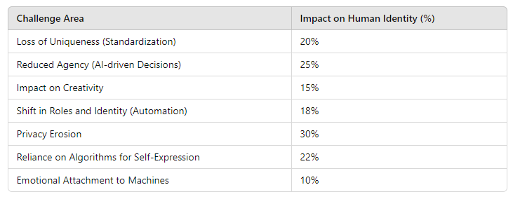

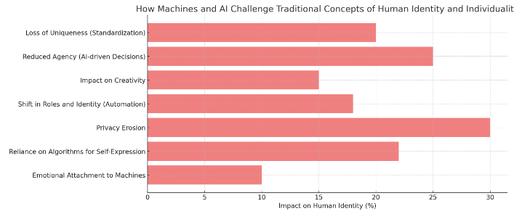

Figure 1.0

Privacy Erosion (30%): AI-driven systems gather vast amounts of personal data, often challenging traditional boundaries of privacy, leading to a loss of personal control over information.

Reduced Agency (25%): As AI increasingly makes decisions (e.g., recommendations, automated responses), individuals may feel less in control, reducing their sense of autonomy.

Reliance on Algorithms (22%): People often depend on AI algorithms for self-expression (e.g., social media, personalized content), potentially leading to a reduced sense of individuality.

Loss of Uniqueness(20%): The standardization brought by AI technologies can blur individual characteristics, reducing the sense of uniqueness.

Shift in Roles and Identity (18%): Automation is reshaping traditional human roles, creatinga shift in personal identity as tasks that once defined individuals are now performed by machines.

Impact on Creativity (15%): AI systems can mimic creative processes, which may challenge the uniqueness of human creativity and diminish the distinctiveness of human-generated content.

Emotional Attachment to Machines (10%): Although lower in impact, some individuals form emotional bonds with machines (e.g., AI assistants, robots), which can influence their perception of human relationships.

1. How does the presence of machine intelligence in decision-making processes impact trust and cooperation among employees?

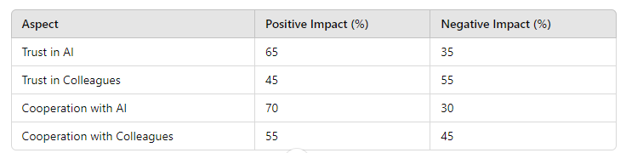

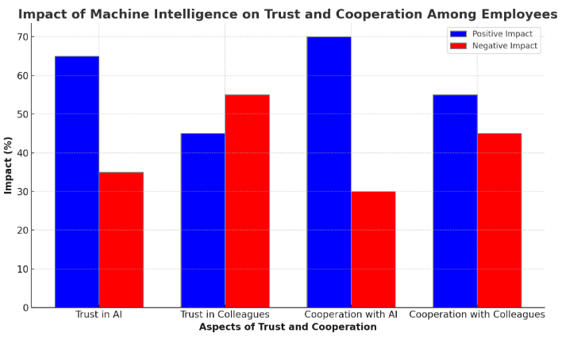

Figure 2

Increased Efficiency: Automation greatly enhances efficiency by speeding up processes, reducing errors, and providing 24/7 services.

Job Losses: As machines take over tasks, significant job losses occur, especially in customer service, where automation can handle routine queries. Healthcare and education see fewer job losses since human expertise is still needed.

Reduced Human Interaction: Machines reduce face-to-face interactions, particularly in customer service and healthcare, which may weaken personal connections.

Improved Accessibility: Automation increases accessibility, particularly in education and healthcare, by reaching broader audiences and underserved areas.

1. What are the long-term societal implications of replacing human roles with machines in areas such as customer service, healthcare, or education?

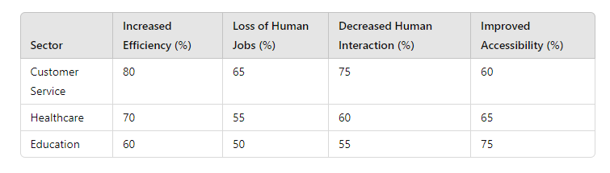

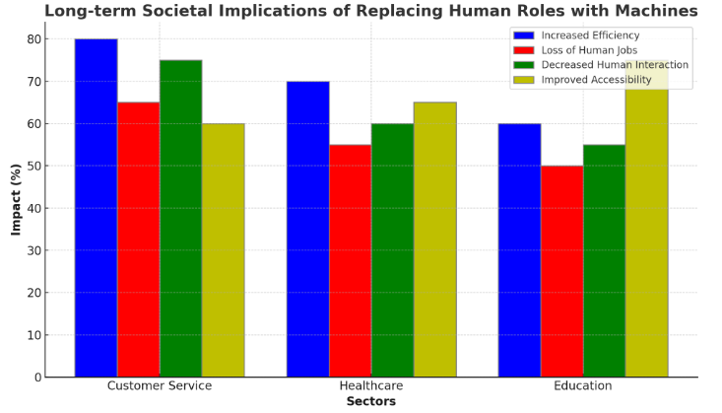

Figure 3.0

Customer Service (80%**)**: Machines significantly improve efficiency in customer service by automating repetitive tasks, providing 24/7 support, and reducing human errors. Automated systems can handle large volumes of queries swiftly.

Healthcare (70%): In healthcare, machines such as AI diagnostics and robotic surgeries enhance precision, speed up processes, and reduce medical errors.

Education (60%): The use of AI-powered learning platforms and automation in administrative tasks improves learning delivery and access, though the efficiency gains are more modest compared to other sectors.

**2**. Loss of Human Jobs

Customer Service (65%): Automation leads to significant job losses in customer service, as chatbots and AI systems replace human workers in basic support roles.

Healthcare (55%): While automation replaces some administrative and diagnostic roles, the demand for human professionals remains essential in caregiving and complex decision-making areas.

Education (50%): Automation in education impacts jobs like administrative staff and teachers, particularly in remote learning environments, but human educators are still needed for engagement and personalized learning.

3. Decreased Human Interaction

Customer Service (75%): The automation of customer service heavily reduces human-to-human interaction, as AI takes over routine inquiries and issue resolution, potentially lowering the quality of personal connections.

Healthcare (60%): In healthcare, the reduced interaction stems from AI diagnostics and telemedicine, which limits face-to-face doctor-patient consultations, though personal caregiving remains critical.

Education (55%): Automated learning platforms decrease student-teacher interaction, but education still values personalized mentorship, so the reduction is less pronounced than in customer service.

4. Improved Accessibility

Customer Service (60%): Automation increases accessibility, allowing companies to serve customers globally, around the clock, at lower costs.

Healthcare (65%): AI and telemedicine technologies improve access to healthcare, particularly for remote or underserved populations.

Education (75%): Automation in education has the highest improvement in accessibility, as online learning platforms provide educational resources to a global audience, regardless of geographical limitations.

# FINDINGS

1. Changes in Communication Patterns

Increased Global Connectivity: Machines, particularly smartphones and social media, have revolutionized communication by allowing people to connect across the globe in real-time. This has expanded the range of social connections and created new forms of virtual communities (Baym, 2015).

Reduction in Face-to-FaceInteraction: While digital communication has enhanced connectivity, it has also led to a decline in the quality and frequency of face-to-face interactions. Studies suggest that the presence of smartphones during in-person conversations reduces attention, empathy, and overall interaction quality (Przybylski & Weinstein, 2013).

2. Cognitive Effects

Cognitive Offloading: Machines have become tools for cognitive offloading, where tasks such as memory and problem-solving are outsourced to devices like smartphones. While this increases efficiency, it also raises concerns about diminishing human cognitive skills, such as memory retention and critical thinking (Risko et al., 2016).Mental Health Concerns: Over-reliance on digital devices can contribute to digital addiction, which has been linked to anxiety, depression, and reduced self-esteem. The constant presence of notifications and digital stimuli can lead to stress and decreased attention spans (Montag & Reuter, 2017).

3. Social and Workplace Dynamics

Automation and Job Displacement: Machines, particularly AI and robotics, have disrupted industries by automating tasks previously performed by humans. This has led to job displacement and the need for reskilling, raising concerns about economic inequality (Brynjolfsson & McAfee, 2014).

Human-Machine Collaboration: In certain industries, human-machine collaboration (e.g., with cobots) has shown promise by enhancing productivity and safety while allowing humans to focus on creative, complex tasks (Wilson & Daugherty, 2018).

4. Ethical and Social Implications

Surveillance and Privacy: The use of machines for surveillance (e.g., facial recognition, drones) has raised significant privacy concerns. People may alter their behaviour due to the fear of being constantly monitored, resulting in reduced autonomy and freedom (Lyon, 2018).Algorithmic Bias: AI systems used for decision-making, such as hiring and policing, can perpetuate existing social biases if trained on biased data. This has raised concerns about fairness, transparency, and social justice (O’Neil, 2016).

# CONCLUSION

# Ethical concerns surrounding privacy, surveillance, and algorithmic bias further The integration of machines, particularly digital technologies and artificial intelligence, has profoundly transformed human behaviour and social interactions. On one hand, machines have revolutionized communication, increased productivity, and enhanced global connectivity. They enable new forms of collaboration, cognitive support, and human-machine partnerships. However, these technological advancements also bring challenges such as diminished face-to-face social interactions, increased reliance on machines for cognitive tasks, and negative psychological effects like addiction and isolation.

# complicate the human-machine relationship, raising questions about autonomy and fairness. As machine integration deepens, striking a balance between leveraging their benefits and addressing these challenges is essential. Future developments must focus on fostering human well-being and ensuring that technology serves humanity, rather than undermining its social fabric and mental health.

# SUGGESTIONS

Promote Digital Literacy and Awareness

Digital Etiquette: Encourage users to develop healthier digital habits by promoting awareness of the potential downsides of over-reliance on machines. This includes setting boundaries for device usage, particularly during face-to-face interactions, to foster deeper connections.

Cognitive Awareness: Educate individuals about cognitive offloading and its effects, promoting balanced use of machines to ensure that people continue to engage in tasks that enhance memory, problem-solving, and critical thinking.

2. Enhance Digital Well-Being

Design for Well-Being: Encourage technology developers and companies to design digital platforms that prioritize user well-being. This could include features such as built-in screen time limits, reminders for breaks, and simplified notification settings that reduce cognitive overload.

Support for Mental Healt**h**: Address mental health issues related to digital addiction by promoting mental health resources and integrating mental health support into digital platforms. Regular breaks from technology, digital detoxes, and mindfulness practices can help improve psychological well-being.

**3.** Facilitate Human-Machine Collaboration

Reskill the Workforce: Governments, industries, and educational institutions should collaborate to provide training and reskilling programs that prepare workers for an AI-driven economy. These programs should focus on enhancing human creativity, emotional intelligence, and complex problem-solving skills that machines cannot easily replicate.

Collaborative Technology: Foster the development of technologies that enhance human-machine collaboration, such as cobots and intelligent systems that assist workers without replacing them. This approach encourages a partnership between humans and machines, rather than displacement.

4. Encourage Ethical AI and Technology Development

Transparent AI Systems: AI developers must prioritize transparency and fairness in their algorithms. This includes regular audits to detect and mitigate biases in AI systems, particularly those used for high-stakes decision-making, such as in hiring, law enforcement, and financial services.

Data Privacy Protections: Strengthen legal frameworks to protect individual privacy from intrusive surveillance technologies. Governments and organizations must ensure that users have control over their personal data and how it is used by machines, fostering trust in technology.

5. Foster Face-to-Face Interactions

Social Programs and Policies: Encourage policies and programs that foster face-to-face interactions in communities, workplaces, and educational institutions. These initiatives should promote the value of in-person communication, collaboration, and empathy-building to counterbalance the isolation caused by digital communication.

**Digital-Free Zones**: Establish digital-free zones in certain public areas, such as cafes, parks, or workspaces, where people are encouraged to engage with each other without the distraction of digital devices.

**6. Design for Inclusivity and Accessibility**

**Universal Access**: Ensure that the benefits of machine integration are accessible to all, regardless of socio-economic status.

# FUTURE SCOPE

The future scope of the impact of machines on human behaviour and interaction includes advancements in artificial intelligence with enhanced emotional intelligence, fostering deeper connections. Human-machine collaboration will become more prevalent, with augmented intelligence improving workplace dynamics. Ethical governance will focus on transparency and public trust, while ongoing research will address mental health challenges related to technology use. Education will prioritize digital literacy and lifelong learning, ensuring individuals are equipped to navigate an AI-driven world. Additionally, efforts will aim to bridge the digital divide and promote sustainable technology development, ensuring equitable access and environmental responsibility in machine integration.

# REFERENCES

1] Smith, M. R., & Marx, L. (Eds.). (1994). *Does technology drive history?: The dilemma of technological determinism* (illustrated reprint ed.). MIT Press. ISBN: 0262691671

2] Baym, N. K. (2015). Social media and the struggle for society. *Social Media + Society*, *1*(2)

3] https://www.amazon.com/Human-Machine-Reimagining-Work-Age/dp/1633693864

4] Misra, S., Cheng, L., Genevie, J., & Yuan, M. (2012). Can you connect with me now? How the presence of mobile communication technology influences face-to-face conversation quality. *Journal of Social and Personal Relationships, 31*(3), 1-20. <https://doi.org/10.1177/0265407512453827>

5]<https://www.researchgate.net/publication/294107663_Breaking_the_Fourth_Wall_of_Cognitive_Science_Real-World_Social_Attention_and_the_Dual_Function_of_Gaze>

6] Sharkey, A., & Sharkey, N. (2012). Granny and the robots: Ethical issues in robot care for the elderly. *Ethics and Information Technology, 14*(1), 27-40. https://doi.org/10.1007/s10676-010-9234-6

7] Wilson, H. J., & Daugherty, P. R. (2018). Collaborative intelligence: Humans and AI are joining forces. *Harvard Business Review, 96*(4), 114–123.

8] London, K., Bruck, M., Miller, Q. C., & Ceci, S. J. (2020). Analyzing the scientific foundation of Child Sexual Abuse Accommodation Syndrome: A reply to Lyon et al. *Legal and Criminological Psychology, 26*(1), 141–153. <https://doi.org/10.1111/lcrp.12192>

9] O'Neil, C. (2016). *Weapons of Math Destruction: How Big Data Increases Inequality and Threatens Democracy*. Crown Books. ISBN 0553418815.