# THE ROLE OF AI IN DAY TO DAY LIFE AND BUSINESS

Divya Sawant, Dr. Archana Wafgaonkar, Dr. Deepak Singh,

Student, Assistant Professor, Vice Principal,

SCMIRT, Bavdhan, Pune SCMIRT, Bavdhan, Pune SCMIRT, Bavdhan, Pune

**_____________________________________________________________________________**

# ABSTRACT

Artificial Intelligence (AI) is increasingly integrated into daily life, transforming the way people interact with technology, information, and each other. AI technologies—ranging from machine learning and natural language processing to computer vision—power a wide array of applications, making tasks more efficient, personalized, and automated. AI is present in virtual assistants (like Siri and Alexa), smart home devices, recommendation systems (such as Netflix and Amazon), and even healthcare and finance, where it aids in diagnostics, fraud detection, and personalized services. In transportation, AI is crucial for advancements like self-driving cars and intelligent traffic management systems. In communication, AI enhances experiences through chatbots, predictive text, and real-time language translation.

While AI's growing role in everyday life offers convenience and innovation, it also raises concerns about data privacy, job displacement, and ethical considerations regarding decision-making processes and biases in AI algorithms. Balancing AI's benefits with these challenges is crucial as it continues to shape the future of daily human activities and societal systems.

**KEYWORDS:**

Artificial Intelligence (AI), Machine Learning, Natural Language Processing (NLP),Virtual Assistants, Smart Home Devices, Recommendation Systems, Healthcare AI, Financial AI, Self-driving Cars, Intelligent Traffic, Management, Chatbots, Predictive Text, Real-time Language Translation, Data Privacy

**INTRODUCTION**

Artificial Intelligence (AI) is no longer a futuristic concept confined to science fiction; it has become an integral part of everyday life. From personal assistants like Siri and Alexa to recommendation engines on platforms such as Netflix and Amazon, AI-driven technologies are seamlessly embedded into the fabric of modern society. AI systems are designed to mimic human cognitive functions such as learning, reasoning, and problem-solving, making them powerful tools for enhancing convenience, efficiency, and personalization**.**The widespread adoption of AI is transforming how individuals interact with technology and shaping various industries, including healthcare, education, transportation, and entertainment. AI algorithms optimize navigation in traffic systems, help diagnose diseases, and offer personalized learning experiences. Additionally, AI-powered automation is changing the nature of work, contributing to greater productivity but also raising concerns about job displacement and the ethical use of AI technologies.As AI continues to evolve, it raises critical questions about privacy, security, ethics, and the broader implications of its influence on society. While AI offers immense potential for improving quality of life, it also requires careful consideration of its risks and challenges. This research explores the multifaceted role of AI in everyday life, examining both the opportunities it creates and the dilemmas it presents. Through this examination, the study aims to provide a comprehensive understanding of AI’s pervasive influence and its implications for the future.

**RESEARCH PROBLEM**

Which teaching approach will be more effective : Online, Traditional or Hybrid Learning?

The rise of e-learning is transforming the educational landscape and raising inquiries about the effectiveness of online education versus traditional education. Despite the flexibility and resource access e-learning provides, it comes with challenges like requiring self-motivation and digital skills. Traditional education has advantages such as face-to-face connection and an organized atmosphere, but it is limited by predetermined schedules and geographical restrictions. The primary concerns are evaluating how these two methods affect student outcomes, such grades, engagement, and satisfaction, and investigating if combining traditional and online learning could result in a more thorough and efficient teaching strategy

**OBJECTIVES**

1. To compare how e-learning and traditional learning impact students' performance.
2. To compare the level of engagement and motivation of students towards e-learning and traditional classroom learning.
3. To determine students’ satisfaction levels on e-learning and comparison to traditional learning.
4. To examine the pros and cons of e-learning and traditional classroom learning.
5. To identify the efficiency of the hybrid model combining aspects of online and traditional learning to improve student achievement.

# RESEARCH METHODOLOGY

This study employs a mixed-methods approach, combining both qualitative and quantitative research methods to explore the role of Artificial Intelligence (AI) in everyday life. The methodology is designed to provide a comprehensive analysis of AI's applications, impacts, and challenges across various domains.

**Quantitative Data Collection:**

Survey: A structured online survey will be administered to a broad demographic of participants to assess public awareness, perceptions, and attitudes toward AI technologies in their daily lives. Questions will cover aspects such as the types of AI applications used, frequency of use, perceived benefits, concerns regarding privacy and security, and overall trust in AI systems.

Statistical Analysis: Collected data will be analyzed using statistical software to identify patterns and correlations between demographic factors (age, gender, profession, etc.) and attitudes toward AI adoption. This will help quantify the extent to which AI has been integrated into daily life and its perceived impact.

**Qualitative Data Collection:**

Interviews: In-depth, semi-structured interviews will be conducted with AI experts, industry professionals, and users of AI technologies. These interviews will focus on personal experiences, challenges faced in AI adoption, ethical concerns, and future expectations of AI’s role in daily life.

**Case Studies**: Selected case studies of AI applications in sectors such as healthcare, education, transportation, and entertainment will be examined to illustrate how AI is transforming these fields. The case studies will explore the practical benefits, limitations, and societal impacts of AI adoption in real-world settings.

# LITERATURE REVIEW

. The role of Artificial Intelligence (AI) in everyday life has garnered increasing attention from researchers across a wide range of disciplines. AI’s rapid integration into daily routines is driven by advances in machine learning, natural language processing, and robotics, enabling systems to perform tasks that once required human intelligence. This literature review explores existing research on AI’s impact on various sectors, its benefits and challenges, and the ethical concerns associated with its growing presence.

AI in Personal and Domestic Setting**s**

AI has become an integral part of modern domestic life, with smart devices, virtual assistants (e.g., Siri, Alexa, Google Assistant), and Internet of Things (IoT) systems increasingly common in households. According to **Guzman and Lewis (2020)**, [1]virtual assistants enhance convenience by automating tasks like scheduling, controlling smart home systems, and providing information. These systems are built on natural language processing (NLP), which allows users to interact with technology in a human-like manner. However, privacy concerns have been raised, particularly regarding data collection and the potential for surveillance through smart devices **(Zuboff, 2019)** [2]

Additionally, AI-driven home appliances, such as robotic vacuum cleaners and smart refrigerators, illustrate how AI is transforming mundane tasks. Studies by **Strengers et al. (2021)** [3] suggest that such devices help improve household efficiency and provide personalized services based on user preferences. However, critics argue that over-reliance on AI systems may lead to decreased cognitive engagement and a loss of practical skills (Carr, 2011).

AI in Healthcare

One of the most significant areas of AI impact is healthcare. AI is being utilized for diagnosing diseases, analyzing medical images, and predicting patient outcomes. **Topol (2019)**[4] highlights the potential of AI to revolutionize healthcare by improving diagnostic accuracy and reducing human error. AI-powered tools, such as IBM’s Watson Health and Google’s DeepMind, are examples of AI systems that assist doctors in decision-making, offering recommendations based on vast amounts of medical data **(Jiang et al., 2017).[**5]

However, AI in healthcare is not without its challenges. The accuracy of AI systems depends on the quality and diversity of data they are trained on, and issues related to bias in AI algorithms have been documented. According to **Obermeyer and Mullainathan (2019)**,[6] AI algorithms in healthcare risk perpetuating health disparities if the data used to train them is not representative of all population groups. Ethical concerns also arise regarding patient consent and the ownership of sensitive medical data.

AI in Transportation

The transportation industry has seen a growing adoption of AI technologies, particularly in the development of autonomous vehicles (AVs). According to **Litman (2020)**,[7] self-driving cars are expected to reduce traffic accidents, decrease fuel consumption, and improve urban mobility. Autonomous driving systems, such as those developed by Tesla, rely on machine learning algorithms to process sensory data and make real-time driving decisions.

Despite these advancements, researchers such as **Goodall (2016)** [8] point out significant ethical dilemmas concerning AVs, particularly regarding decision-making in life-threatening scenarios (e.g., the “trolley problem”). Additionally, legal and regulatory frameworks for AVs are still in their infancy, raising questions about liability and safety standards **(Lin, 2016). [**9]

AI in Entertainment and Media

AI has also significantly impacted the entertainment and media sectors. Recommendation algorithms used by streaming platforms like Netflix and Spotify enhance user experience by personalizing content based on viewing and listening habits. According to **Gomez-Uribe and Hunt (2015)**,[10] these algorithms are responsible for driving user engagement and customer satisfaction by suggesting content that aligns with individual preferences.

beliefs and preferences, a phenomenon often associated with recommendation systems on platforms like YouTube and Facebook.

Ethical and Societal Impacts of AI

.**Bostrom and Yudkowsky (2014)**[11] emphasize that AI, particularly in advanced forms, may pose existential risks if not carefully regulated. Additionally, AI systems’ ability to replace human labor has generated significant debate about the future of work. **Brynjolfsson and McAfee (2014) [**12**]**  argue that while AI can enhance productivity, it also risks displacing jobs, particularly in sectors such as manufacturing, retail, and logistics.

Privacy concerns are central to discussions about AI’s societal impact. **Zuboff (2019)** [14]introduces the concept of "surveillance capitalism,"

wherein tech companies collect vast amounts of personal data for profit, often without users’ explicit consent. This has raised questions about AI's role in eroding personal privacy and autonomy.

AI Governance and Policy

Governance and regulation of AI technologies are essential to addressing the ethical concerns associated with their use. **Floridi et al. (2018)**

[15] argue that the development of clear ethical guidelines for AI is critical to ensure its responsible deployment. International organizations, such as the European Union, have proposed frameworks for regulating AI, focusing on transparency, accountability, and preventing bias in AI algorithms. Despite these efforts, the fast-paced evolution of AI poses challenges for regulators in keeping policies up to date.

**DATA ANALYSIS**

1] How does the increasing use of AI in everyday life impact job displacement and creation in various sectors?

TABLE: Impact of AI on job displacement and creation in various sectors

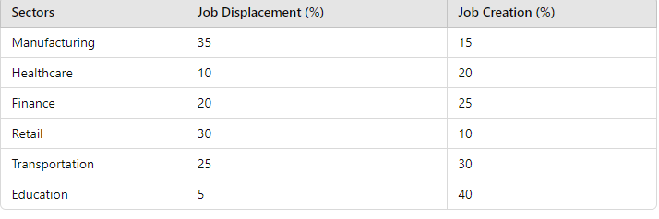

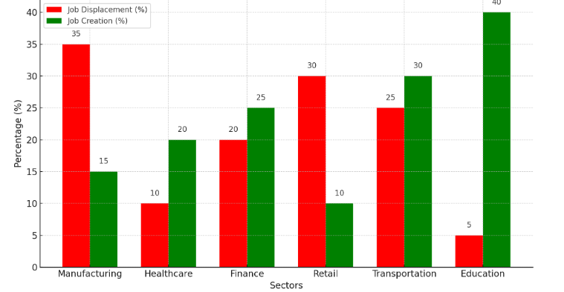

Figure 1.0

**Job Displacement:** The manufacturing sector shows the highest percentage of job displacement at 35%, followed by retail (30%) and transportation (25%). This indicates that automation and AI technologies are significantly affecting jobs in these fields.

**Job Creation:** In contrast, the education sector shows the highest potential for job creation at 40%, followed by transportation (30%) and finance (25%). This suggests that while some sectors may experience job losses, others may see growth due to the emergence of new roles related to AI technologies

1. How has the introduction of AI technologies changed individuals’ daily routines and tasks (e.g., shopping, communication, transportation)?

TABLE: Impact of AI Technologies on Daily Routines and Tasks



. 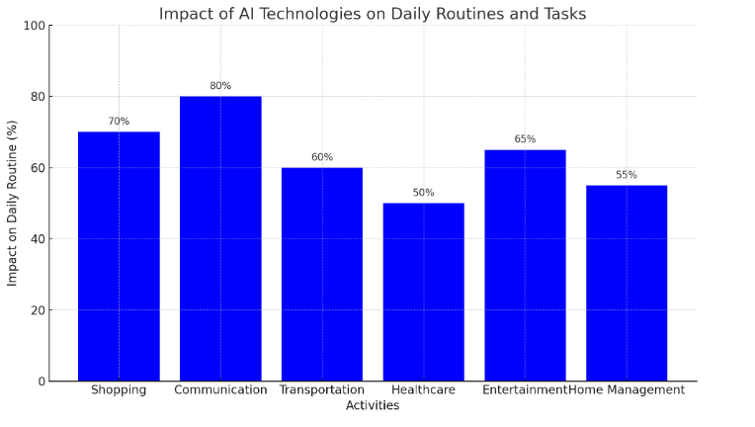

Figure 2.0

**Communication** shows the highest impact on daily routines at **80%**, reflecting the significant role of AI in enhancing communication methods (e.g., chatbots, virtual assistants).

**Shopping** follows closely with **70%**, indicating that AI-driven recommendation systems and online shopping platforms have transformed consumer behaviors.

**Transportation** and **Entertainment** also demonstrate substantial impacts at **60%** and **65%**, respectively, due to advancements in ride-sharing apps and streaming services.

**Healthcare** and **Home Management** show lower but still significant impacts at **50%** and **55%**, highlighting AI’s role in managing health data and smart home technologies

3.How do machines and AI challenge traditional concepts of human identity and individuality?

TABLE: How Machine and AI Challenge Traditional Concepts of Human Identity and individualty

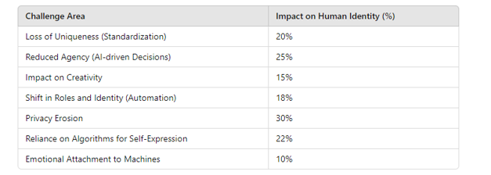

Figure 3.0

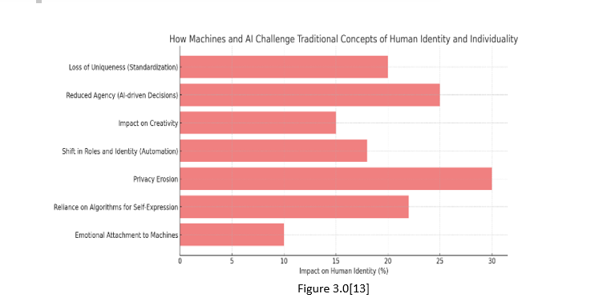

**Privacy Erosion (30%)**: AI-driven systems gather vast amounts of personal data, often challenging traditional boundaries of privacy, leading to a loss of personal control over information.**Reduced Agency (25%)**: As AI increasingly makes decisions (e.g., recommendations, automated responses), individuals may feel less in control, reducing their sense of autonomy. **Reliance on Algorithms (22%)**: People often depend on AI algorithms for self-expression (e.g., social media, personalized content), potentially leading to a reduced sense of individuality.**Loss of Uniqueness (20%)**: The standardization brought by AI technologies can blur individual characteristics, reducing the sense of uniqueness.**Shift in Roles and Identity (18%)**: Automation is reshaping traditional human roles, creating a shift in personal identity as tasks that once defined individuals are now performed by machines. **Impact on Creativity (15%)**: AI systems can mimic creative processes, which may challenge the uniqueness of human creativity and diminish the distinctiveness of human-generated content. **Emotional Attachment to Machines (10%)**: Although lower in impact, some individuals form emotional bonds with machines (e.g., AI assistants, robots), which can influence their perception of human relationships.

# FINDINGS

Widespread Integration of AI in Everyday Life:

AI technologies have become integral to many aspects of daily life, spanning personal, professional, and public domains. Virtual assistants, smart home devices, and AI-driven apps are widely adopted for convenience and efficiency, with users relying on AI for tasks such as scheduling, shopping, navigation, and entertainment. The increasing presence of AI in routine activities demonstrates the seamless integration of these technologies into modern lifestyles.

2. Enhanced Personalization and User Experience**:**

One of the key benefits of AI is its ability to offer personalized experiences. Recommendation algorithms on platforms like Netflix, YouTube, and Amazon significantly improve user satisfaction by tailoring content and product suggestions to individual preferences. AI systems learn from user behavior, making interactions more relevant and efficient. This personalization, however, is accompanied by concerns about data privacy and the creation of filter bubbles that limit exposure to diverse content.

3. Improved Efficiency and Automation in Various Sectors:

AI has made significant strides in improving efficiency across several sectors:

**Healthcare**: AI-powered diagnostic tools and predictive analytics enhance the accuracy of diagnoses, optimize treatment plans, and improve patient outcomes.

**Transportation**: Autonomous vehicles and AI-based traffic management systems reduce congestion, enhance safety, and lower fuel consumption.

**Retail and Customer Service**: AI-driven chatbots, inventory management, and personalized marketing improve customer service and operational efficiency.

# CONCLUSION

The integration of Artificial Intelligence (AI) into everyday life marks a significant milestone in technological advancement, fundamentally transforming how individuals interact with the world around them. From enhancing personal convenience through virtual assistants to revolutionizing industries such as healthcare and transportation, AI is reshaping daily routines and experiences. The benefits of AI are substantial, with improved efficiency, personalized services, and enhanced decision-making capabilities at the forefront.

However, the rapid proliferation of AI technologies also raises important challenges and ethical dilemmas that must be addressed. Privacy concerns, the potential for algorithmic bias, and the impact of automation on employment are pressing issues that require careful consideration and proactive governance. As individuals and societies navigate these complexities, fostering a responsible approach to AI development and deployment is critical.

To maximize the benefits of AI while minimizing its risks, it is essential to establish robust regulatory frameworks that prioritize transparency, accountability, and ethical standards. Public engagement and education about AI technologies will also play a vital role in building trust and understanding among users. By fostering a collaborative dialogue between technologists, policymakers, and the public, we can ensure that AI serves as a tool for enhancing human life and addressing societal challenges.

In conclusion, the role of AI in everyday life presents a dual narrative of opportunity and challenge. As we embrace the transformative potential of AI, it is imperative to remain vigilant and committed to ethical practices, equitable access, and the responsible use of technology. This balanced approach will help shape a future where AI not only improves daily life but also aligns with our collective values and aspirations.

.

# SUGGESTIONS

Enhancing Public Awareness and Education**:**

Develop educational programs and workshops aimed at increasing public understanding of AI technologies. This could help demystify AI, making individuals more informed users and encouraging responsible engagement with AI systems.

Create resources that explain how AI works, its applications, and its limitations, fostering a more informed public discourse around AI.

Promoting Ethical AI Development:

Encourage collaboration between technologists, ethicists, and policymakers to establish clear ethical guidelines for AI development and deployment. This would help address issues of bias, accountability, and transparency in AI systems.

Advocate for the incorporation of ethical considerations into the design process of AI technologies to ensure they align with societal values and human rights.

Implementing Robust Regulatory Frameworks**:**

Governments should establish regulatory frameworks that govern the use of AI in various sectors, ensuring data protection, privacy rights, and algorithmic accountability.

Consider international cooperation on AI regulation to address cross-border challenges and ensure consistent standards for AI deployment globally.

Fostering Inclusivity in AI Development**:**

Promote diversity in AI development teams to ensure a variety of perspectives and experiences are represented. This can help mitigate bias in AI algorithms and create more equitable AI systems.

Engage underrepresented communities in discussions about AI technologies to ensure their needs and concerns are addressed.

# FUTURE SCOPE

Integration with Augmented and Virtual Reality:

Enhanced User Interfaces**:** AI will play a crucial role in creating immersive experiences in augmented reality (AR) and virtual reality (VR) environments. This integration will transform how people interact with digital content, enhancing gaming, education, and training applications.

AI-Driven Simulations**:** In fields such as healthcare and education, AI could power realistic simulations for training purposes, allowing users to practice skills in a safe and controlled environment.

Smart Cities and Infrastructure:

Urban Planning**:** AI will contribute to the development of smart cities through improved urban planning, traffic management, and resource allocation. AI-driven analytics will help optimize energy usage, reduce waste, and improve public transportation systems.

Sustainable Development**:** Future AI applications will focus on sustainability, using data analytics to address environmental challenges such as climate change, resource depletion, and pollution.

AI in Healthcare Innovations**:**

Predictive Healthcare**:** AI will advance predictive analytics in healthcare, enabling early disease detection and personalized treatment plans based on genetic and lifestyle factors.

**Telemedicine:** The growth of telemedicine will be further supported by AI, allowing for remote monitoring, diagnosis, and treatment of patients through intelligent systems that analyze health data in real time.

.**REFERENCES**

1.Guzman, A. L., & Lewis, S. C. (2020). Artificial intelligence and communication: A Human–Machine Communication research agenda. *New Media & Society, 22*(1), 70–86. <https://doi.org/10.1177/1461444819858691>

2.Bongiovi, J. R. (2019). *The Age of Surveillance Capitalism: The Fight for a Human Future at the New Frontier of Power* [Review of the book *The Age of Surveillance Capitalism: The Fight for a Human Future at the New Frontier of Power* by S. Zuboff]. *Social Forces, 98*(2),<https://doi.org/10.1093/sf/soz037>

3.Liu, C. (2023). More-than-human practices of making and unmaking the smart home: A socioemotional investigation. *Emotion, Space and Society****, 46*, 100982.** <https://doi.org/10.1016/j.emospa.2023.100982>

4. Topol, E. J. (2019). High-performance medicine: The convergence of human and artificial intelligence. *Nature Medicine, 25*(1), 44–56. <https://doi.org/10.1038/s41591-018-0300-7>

5. Jiang, Y., Wang, W., Xie, Q., Liu, N., Liu, L., Wang, D., Zhang, X., Yang, C., Chen, X., & Wang, E. (2017). Plants transfer lipids to sustain colonization by mutualistic mycorrhizal and parasitic fungi. *Science, 356*(6343), 1172–1175. <https://doi.org/10.1126/science.aam9970>

6. Obermeyer, Z., Powers, B., Vogeli, C., & Mullainathan, S. (2019). Dissecting racial bias in an algorithm used to manage the health of populations. *Science, 366*(6464), 447–453. <https://doi.org/10.1126/science.aax2342>

7. Litman, T. (2020). *Autonomous vehicle implementation predictions: Implications for transport planning*. Victoria Transport Policy Institute. Retrieved from <https://www.vtpi.org>

8. Goodall, J. S. (2016). Technology and school–home communication. *Learning, Media and Technology, 41*(2), 118–131. <https://doi.org/10.1080/22040552.2016.1227252>

9. Lin, A. (2016). *Language across the curriculum & CLIL in English as an additional language (EAL) contexts*. Springer. <https://doi.org/10.1007/978-981-10-1802-2>

10. Gomez-Uribe, C. A., & Hunt, N. (2015). The Netflix recommender system: Algorithms, business value, and innovation. *ACM Transactions on Management Information Systems (TMIS), 6*(4), Article 13, 1–19. <https://doi.org/10.1145/2843948>

11. Bostrom, N., & Yudkowsky, E. (2014). The ethics of artificial intelligence. In *Artificial Intelligence* (pp. 316–334). Cambridge University Press. <https://doi.org/10.1017/CBO9781139046855.020>

12. Brynjolfsson, E., & McAfee, A. (2014). *The second machine age: Work, progress, and prosperity in a time of brilliant technologies*. Taylor & Francis. <https://doi.org/10.1080/14697688.2014.946440>

13. Bongiovi, J. R. (2019). *The Age of Surveillance Capitalism: The Fight for a Human Future at the New Frontier of Power* [Review of the book *The Age of Surveillance Capitalism: The Fight for a Human Future at the New Frontier of Power* by S. Zuboff]. *Social Forces, 98*(2),<https://doi.org/10.1093/sf/soz037>

14 Floridi, L., Cowls, J., Beltrametti, M., Chatila, R., Chazerand, P., Dignum, V., Luetge, C., Madelin, R., Pagallo, U., Rossi, F., & others. (2018). AI4People—An ethical framework for a good AI society: Opportunities, risks, principles, and recommendations. *Minds and Machines, 28*(4), 689–707. <https://doi.org/10.1007/s11023-018-9482-5>