CENTRALISED MONITORING SYSTEM FOR STREETLIGHT FAULT DETECTION AND LOCATION TRACKING

1. Dr. Swaleha M Attar, Associate Professor, Dr. J. J. Magdum college of Engineering, Jaysingpur
2. Vishal B Dhaygude , Research Student
3. .Parth R. Thorwat , Research Student
4. Shamis H. Shaikh, Research Student
5. Sainath A. Karawade, Research Student

# ABSTRACT –

Addressing the challenges posed by the absence of a centralized monitoring system for streetlight maintenance, this study highlights the inefficiency in fault identification and repair process. With lineman investing valuable time in manual fault detection and diagnosis, coupled with the lack of precise fault location information, the maintenance process is further hindered. To overcome these obstacles, this research advocates real time fault detection, precise identification of fault types, and accurate tracing of faulty streetlight locations.

**Keywords:** centralized monitoring system, streetlight maintenance, fault identification, accurate tracing, etc.

# INTRODUCTION –

Street lighting is essential for urban infrastructure, ensuring public safety, visibility, and security for residents and commuters. However, the maintenance and monitoring of

streetlights can be a demanding task for municipal authorities. Traditional methods rely on manual inspections, which are inefficient and expensive. To address these challenges, a

centralized monitoring system for detecting streetlight faults and tracking their locations is necessary.

This system utilizes modern technology and data-driven solutions to streamline street lighting maintenance and management. It offers an intelligent, automated approach to detect faults and accurately locate them. This allows for a more efficient response to outages, reduces energy

consumption, and improves the overall urban quality of life.

# BLOCK DIAGRAM –

The proposed block diagram comprises of Node MCU, LDR sensors and Relay.

## Summary of Workflow:

* 1. **Light Detection:** The **Sensor** detects light (or its absence) from the streetlight.
  2. **Data Processing:** The **NodeMCU** processes this data to determine if the streetlight is functioning properly.

## Action Triggering:

* + - If a problem is detected, the NodeMCU might activate the **Relay** to attempt to correct the issue by turning the light on or off.
    - Simultaneously, the NodeMCU sends an alert to a **Mobile** device.
  1. **Notification:** The **Mobile** device receives an **SMS** with details about the light status and the specific streetlight (e.g., "L1 Lamp").

This system allows for remote monitoring and control of streetlights, with real-time alerts sent to maintenance personnel if a fault is detected.

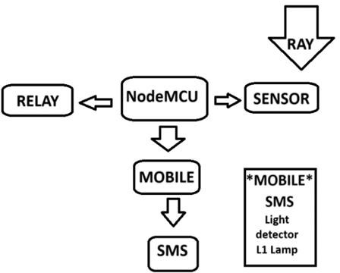

# COMPONENTS –

* 1. **Node MCU –**

Node MCU is a open-source LUA based firmware created For the ESP8266 wifi chip.

The data received from the NodeMCUs can be displayed on a centralized dashboard, showing the status and location of all streetlights in the system. The dashboard can highlight faulty lights and provide information for maintenance scheduling.

**Alerts and Notifications:** The system can be configured to send automatic alerts via SMS, email, or a mobile app to the maintenance team whenever a fault is detected.

## LDR sensor –

LDRs are modest light sensing gadgets moreover known as photoresistors. An LDR is a resistor that alters its resistance depends on the brightness of the light it receives.

## GPRS 900 –

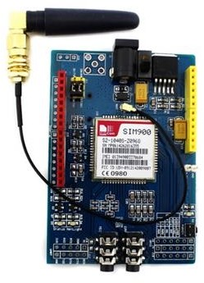SIM900A GSM module is a dual-band-GSM/GPRS engine

that works on frequencies EGSM 900MHz and DCS 1800 MHz (OTHER OPTIONS –

1. We can hardcore the coordinates
2. We can give the direct connection of the government landline

/BSNL connection)

## PIR motion sensor (optional) –

In out prototype we haven’t used PIR motion sensor

But we can be using it in near future and its use is as follows:

* If it has Dim light then there is no car
* If it has Bright light then consider car is passing
* If there is No light then there might be fault in the lamp

## Software –

Blynk IOT platform – it will send the message with the location and fault type.

Integrating Blynk into the centralized monitoring system for streetlight fault detection and location tracking enhances the project's functionality by providing real-time monitoring, remote control,

efficient data management, and robust notification systems. Blynk's user-friendly interface and

scalability make it an ideal choice for deploying and managing IoT solutions, ensuring that streetlights operate efficiently and that maintenance teams are promptly informed of any issues, thereby improving public safety and reducing operational costs

# CONCLUSION –

A centralized monitoring system for streetlight fault detection and location tracking is an innovative and efficient solution that significantly enhances the management and maintenance of streetlighting infrastructure. By integrating NodeMCU with sensors and communication modules, the system

enables real-time monitoring, quick fault detection, and precise location tracking of faulty streetlights.

This not only ensures timely repairs and reduced downtime but also optimizes energy usage and reduces operational costs. The ability to remotely manage and control streetlights contributes to

smarter cities, improving public safety and ensuring that streetlights operate efficiently with minimal manual intervention. Overall, such a system represents a critical step forward in the modernization

and automation of urban infrastructure.

# REFERENCES –

1. https://chat.openai.com/
2. https://blynk.io/
3. https://www.arduino.cc/en/Guide/Environment
4. https://en.wikipedia.org/wiki/Passive_infrared_sensor

https://ai.thestempedia.com/docs/evive/evive-tutorials/what-is-ldr-photoresistor/