**Deep Learning for Brain Tumor Recognition in MRI Imaging**

**Shinde P.S1, Dhaigude N.B2**

1Assistant Professor , Department of Electronics, SPCOE&T Someshwarnagar, Baramati, Maharashtra, India

2Assistant Professor , Department of E&TC, SVPM COE Malegaon(BK), Baramati, Maharashtra, India

**ABSTRACT**

The diagnosis of brain tumors is a critical challenge in medical imaging, requiring precise determination of the location, orientation, and area of abnormal tissues. This paper proposes an efficient automated classification technique for brain MRI using deep learning algorithms. We conduct a literature survey on existing techniques, explore suitable datasets, and implement preprocessing techniques to prepare data for analysis. The paper employs a thresholding technique for tumor detection and implements algorithms to classify MRI scans into categories: Glioma, Meningioma, and No Tumor. Finally, the performance of the classifiers is evaluated and validated.

**Keywords:** Brain Tumor Detection, Deep Learning, MRI, Classification, Thresholding.

**1. INTRODUCTION**

Brain tumors are among the most critical medical conditions requiring prompt diagnosis and treatment. Early detection is crucial for effective management and improved patient outcomes. Magnetic Resonance Imaging (MRI) is a non-invasive imaging technique that provides high-resolution images of brain structures, making it a preferred method for diagnosing brain tumors. The detection and classification of brain tumors play a significant role in medical diagnostics, impacting treatment decisions and patient outcomes. With the increasing volume of MRI scans necessitating the development of automated techniques, deep learning—a subset of machine learning—has shown promise in image classification tasks. By leveraging vast datasets and advanced algorithms, deep learning can automate the diagnosis process, enhance accuracy, and reduce the workload on healthcare professionals.

**2. Background Theory**

**2.1 Brain Tumors**

Brain tumors can be classified into primary and secondary tumors. Primary tumors originate in the brain, while secondary tumors spread from other body parts. Common types of brain tumors include Gliomas, Meningiomas, and Pituitary adenomas. Diagnosing these tumors at an early stage is crucial for improving survival rates and treatment outcomes.

**2.2 Importance of Brain Tumor Diagnosis**

The diagnosis of brain tumors is critical due to their potential impact on a patient's health and quality of life. Effective diagnosis enables timely treatment interventions, which can be life-saving. The complexities involved in brain tumor diagnosis arise from various factors, including the tumor type, location, and growth characteristics. MRI is the preferred imaging modality as it provides high-resolution images of soft tissues, facilitating the detection of subtle abnormalities.

**2.3 Challenges in Manual Detection**

Manual analysis of MRI scans is subject to human error and variability in interpretation. Radiologists may overlook subtle signs of tumors due to the complexity of brain structures and the need for specialized knowledge. Additionally, the increasing volume of imaging data necessitates automated solutions that can assist clinicians in improving diagnostic accuracy and efficiency.

**2.4 Deep Learning in Medical Imaging**

Deep learning, a subset of machine learning, has shown remarkable success in image classification tasks due to its ability to automatically learn features from raw data. Convolutional Neural Networks (CNNs) are particularly effective in processing image data because they can capture spatial hierarchies and patterns through convolutional layers. The layers learn progressively more complex features, enabling the model to classify images based on high-level abstractions.

**3. Literature Survey on Detection Techniques**

A comprehensive literature survey on brain tumor detection should encompass various techniques, including:

**3.1** **Traditional Image Processing**: Techniques such as edge detection, region growing, and morphological operations have been used to identify tumor boundaries, but they often rely on manual input and are limited in handling noise and variability.

**3.2** **Machine Learning Approaches**: Earlier studies employed classical machine learning algorithms (e.g., SVM, Random Forest) for tumor classification based on extracted features. However, these approaches often require manual feature extraction, which can be subjective and prone to bias.

**3.3 Deep Learning Approaches**: Recent advancements involve using CNNs, which have demonstrated superior performance due to their end-to-end learning capability. Other architectures like U-Net for segmentation and transfer learning with pre-trained models (e.g., VGG, ResNet) have also shown promise.

**4. Dataset Exploration and Selection**

The choice of dataset significantly impacts the performance of deep learning models. Factors to consider when selecting a dataset include:

**4.1** **Diversity**: A dataset should encompass a variety of tumor types (Glioma, Meningioma, etc.) and grades to ensure robust model performance.

**4.2 Quality and Quantity**: High-quality, annotated images with a sufficient number of samples are necessary to train the models effectively.

4.3 **Availability**: Public datasets like the BRATS dataset provide a rich source of annotated MRI scans, facilitating research and development in this area.

**5. Image Pre-processing Techniques**

Pre-processing is crucial for improving the quality of the input data and enhancing model performance. Common pre-processing steps include:

**5.1** **Normalization**: Scaling pixel values to a standard range (e.g., 0 to 1) helps in stabilizing the learning process.

**5.2** **Resize**: Standardizing image dimensions (e.g., 256x256 pixels) ensures consistent input sizes for the model.

**5.3** **Enhancement**: Techniques such as histogram equalization can improve contrast and highlight relevant features, making tumors more discernible.

**6. Thresholding Techniques for Tumor Detection**

Thresholding is a simple yet effective technique for segmenting regions of interest in medical images. It involves converting grayscale images to binary images by selecting a threshold value. Pixels above the threshold are classified as tumor regions, while others are considered background. This method can be combined with morphological operations to refine segmentation results.

**7. Classification Algorithms**

**7.1Convolutional Neural Networks (CNNs)**: CNNs consist of convolutional layers, pooling layers, and fully connected layers. Each layer learns different levels of abstraction, enabling the model to identify complex patterns in the images.

**7.2CNN-Support Vector Machine (SVM)**: The combination of CNN for feature extraction and SVM for classification leverages the strengths of both approaches, enhancing classification accuracy by effectively separating feature spaces.

**7.3Densenet201**: This architecture introduces dense connections between layers, allowing for better gradient flow and efficient feature reuse. The model's depth and structure contribute to its high accuracy in classification tasks.

To validate and verify the performance of the classification algorithms, various metrics are essential: Accuracy: The proportion of correctly classified instances over the total instances. Precision: The ratio of true positive predictions to the total positive predictions, indicating the accuracy of the positive class. Recall (Sensitivity): The ratio of true positive predictions to the total actual positives, reflecting the model's ability to identify positive cases.F1 Score: The harmonic mean of precision and recall, providing a balance between the two metrics. Receiver Operating Characteristic (ROC) Curve and AUC: Used to assess the trade-off between sensitivity and specificity across different thresholds.

**8Result:**

**8.1.1 CNN Brats Dataset:**

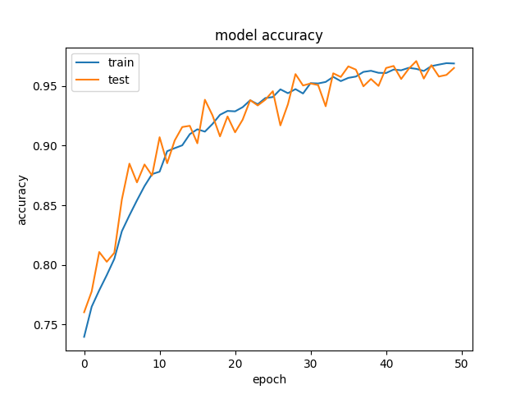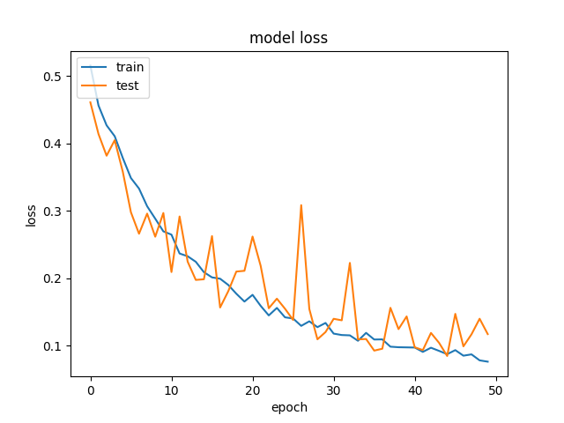

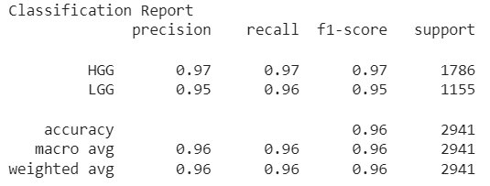 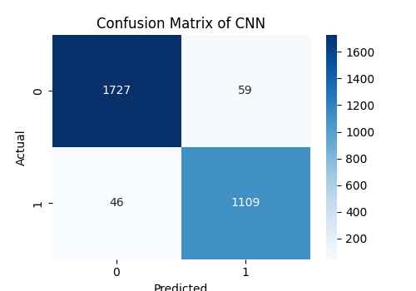

**8.1.2Brats Dataset** :**CNN-SVM**

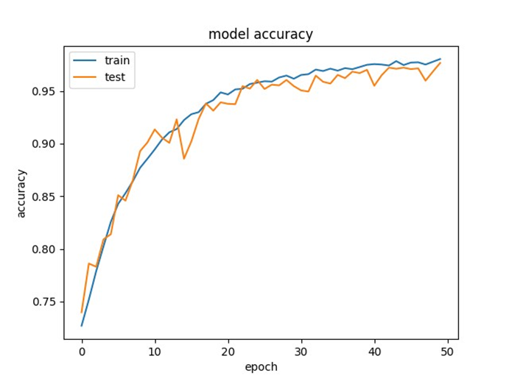 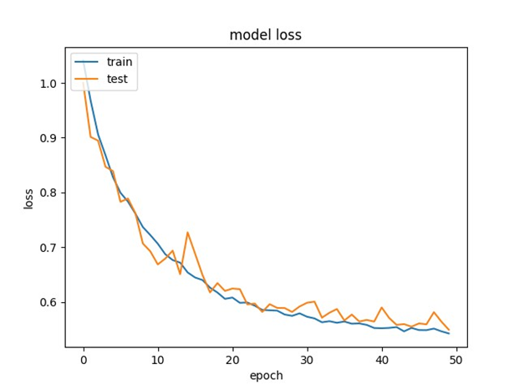

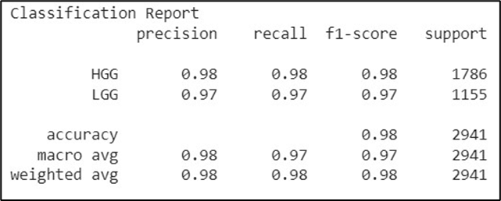 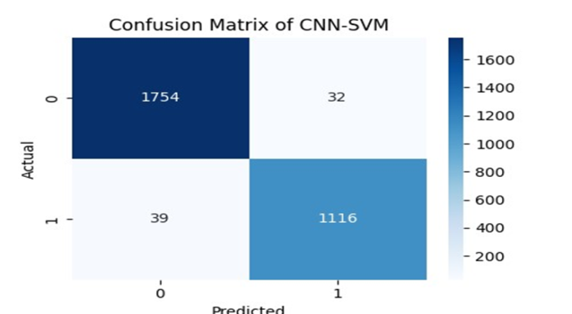

**8.1.3 Brats Dataset :Densenet201**

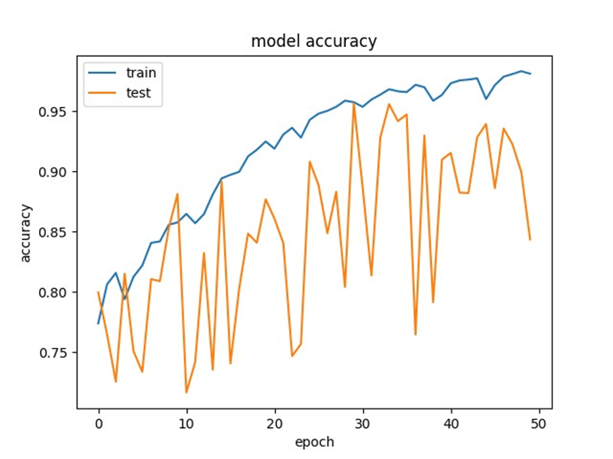 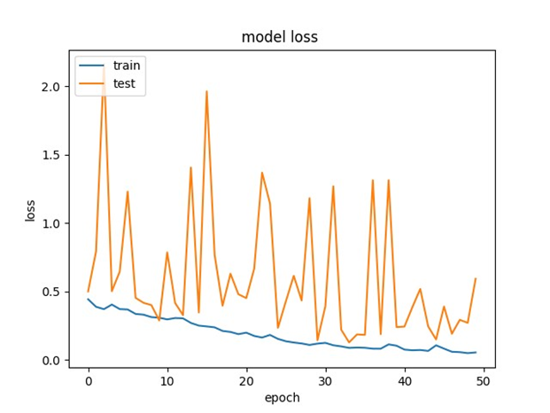

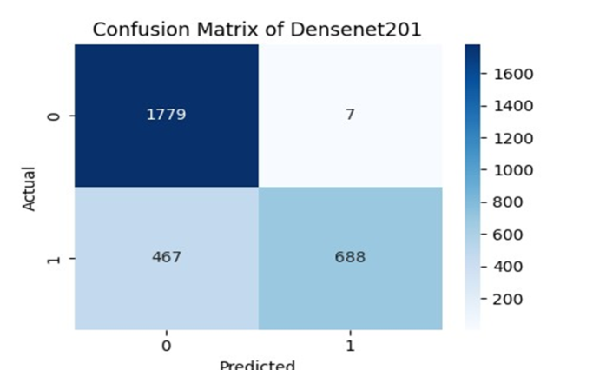 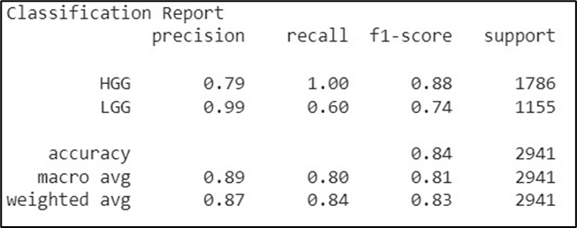

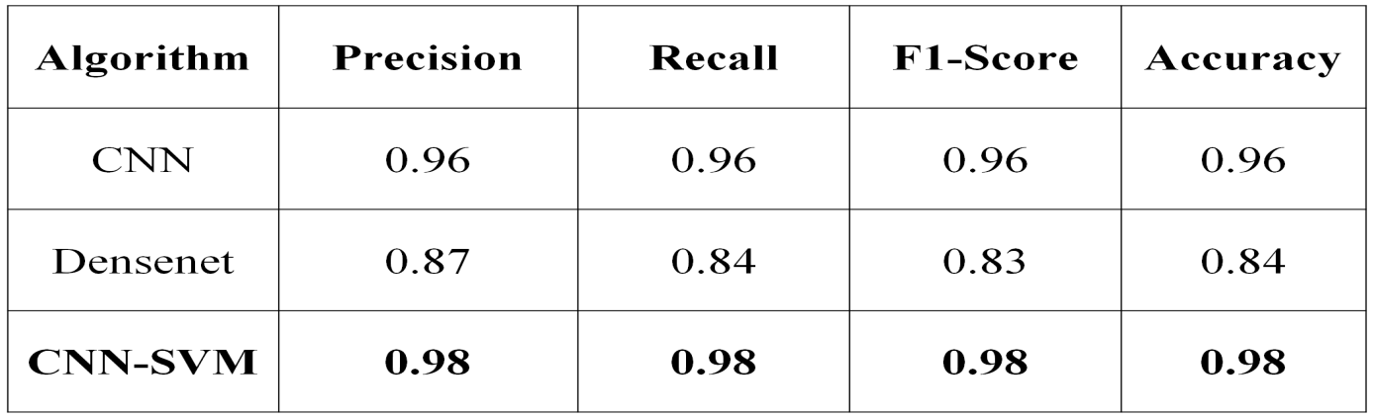

**Table 1: Comparative analysis of different classifiers on the Brats Dataset**

The BRATS dataset, due to its complexity, favors deep learning models like CNN and DenseNet, which can automatically extract and learn from intricate patterns in MRI data. Traditional models like SVM, RF, CNN struggle to match their performance, particularly when it comes to image segmentation tasks that require a deep understanding of spatial hierarchies.

**8.2.1Sartaj Dataset :CNN**

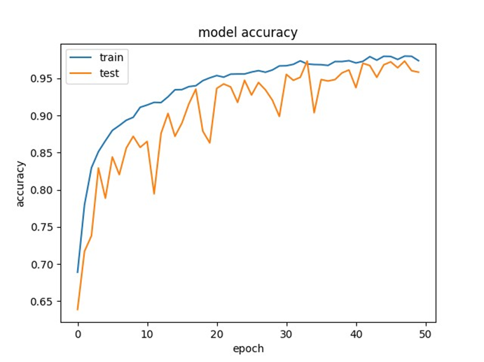 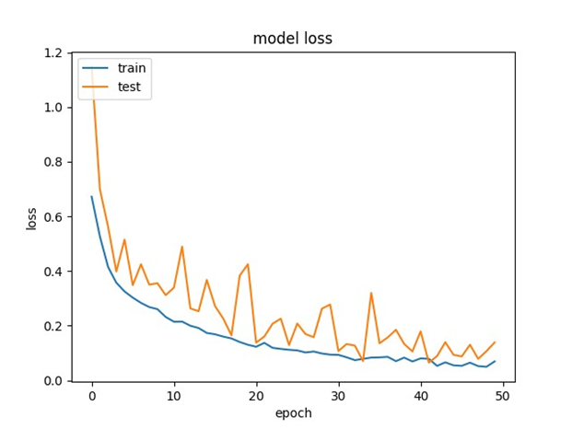

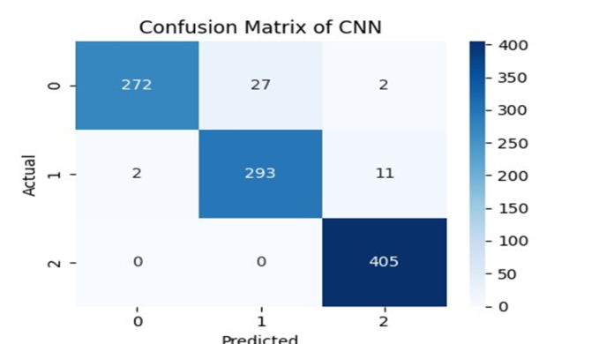 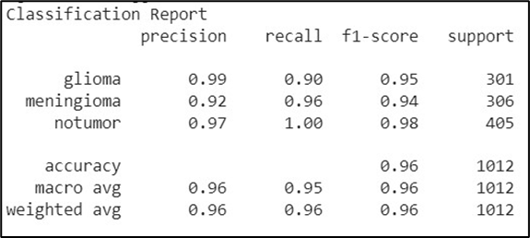

**8.2.2 Sartaj Dataset -CNN-SVM**

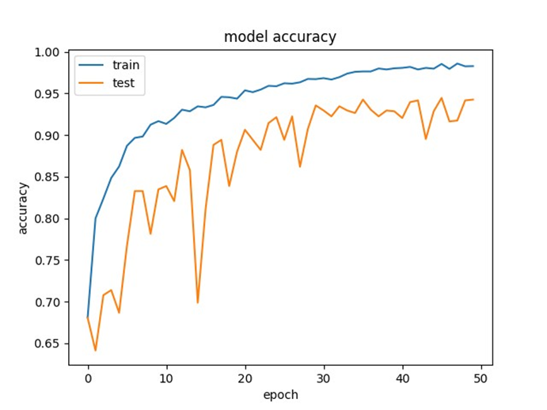 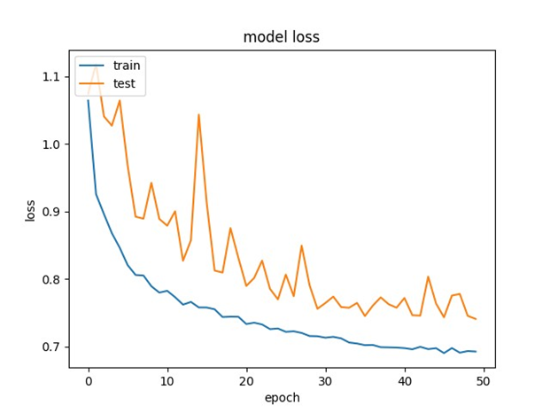

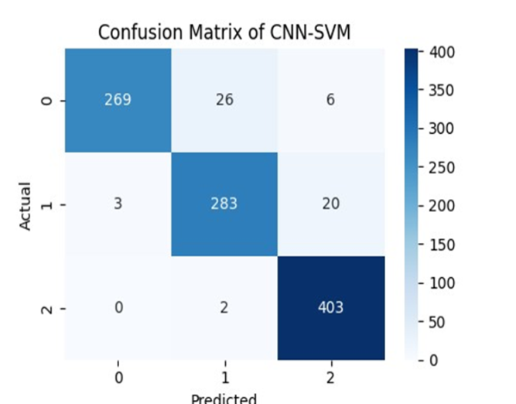 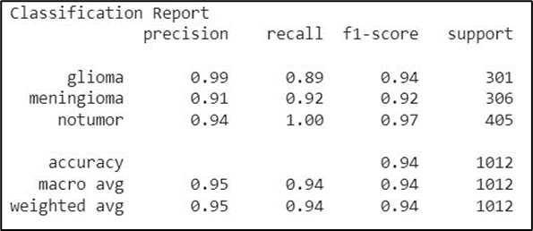

**8.2.3 Sartaj Dataset :Densenet201**

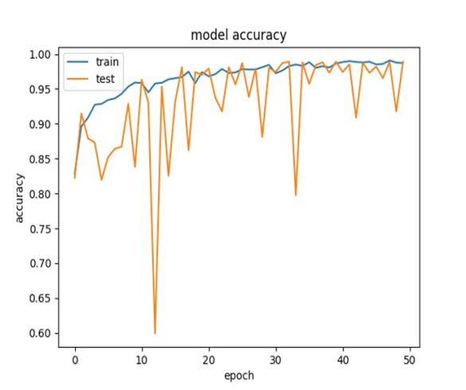 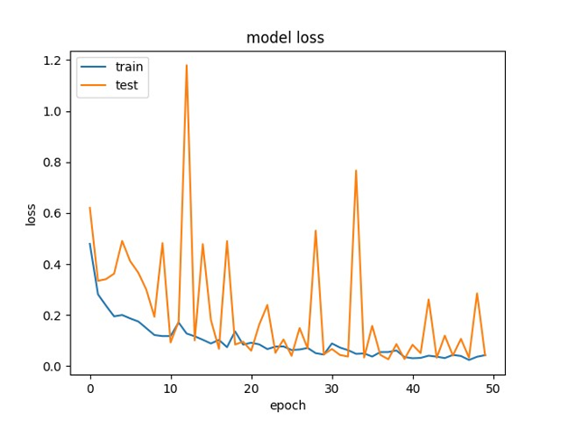

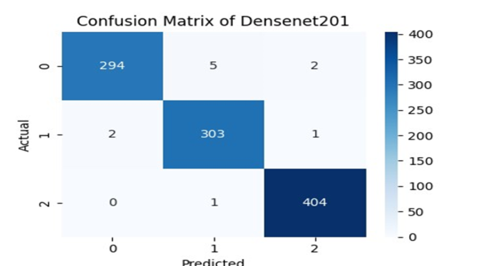 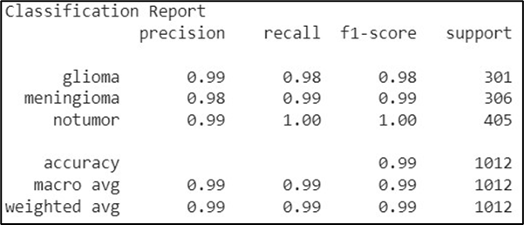

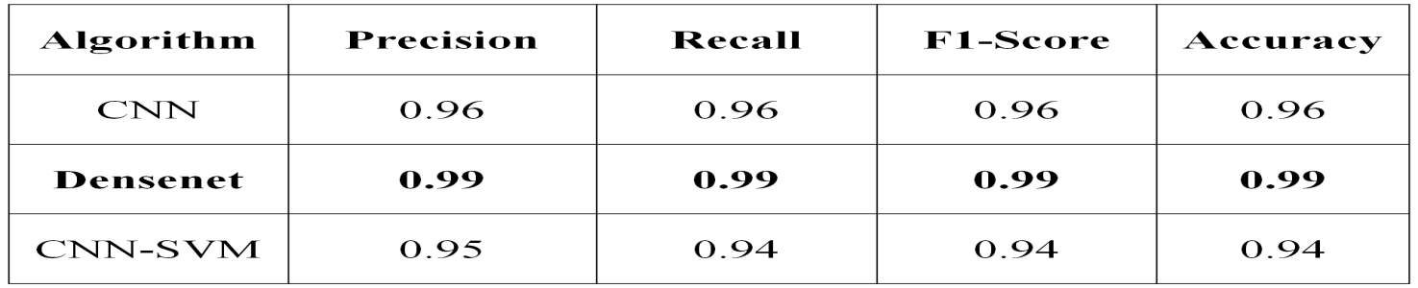

**Table 2: Comparative analysis of different classifiers on the Sartaj Dataset**

On the Sartaj dataset, traditional classifiers like Logistic Regression, Random Forest, and SVM performed exceptionally well, achieving high accuracy and F1-scores. These models are well-suited for structured data and exhibit strong generalization. Deep learning models, though not explicitly mentioned, may not be necessary for simpler datasets like Sartaj, where traditional machine learning models can perform competitively with far less computational complexity.

**9.Conclusion**

This study developed an automated system for classifying brain MRI scans into Glioma, Meningioma, and No Tumor categories. Utilizing CNN, CNN-SVM, and Densenet201 algorithms, the system achieved a maximum accuracy of 0.98 with the CNN-SVM model for distinguishing High-Grade Gliomas (HGG) from Low-Grade Gliomas (LGG), while Densenet201 attained an accuracy of 0.99 for HGG-LGG classification. These results highlight the effectiveness of deep learning techniques in enhancing diagnostic accuracy and support their potential integration into clinical practice for improved brain tumor detection and diagnosis.

**10.Refrences**

1. M. Aggarwal et al., “An early detection and segmentation of brain tumor using deep neural network,” BMC Med Inform Decis. Mak, vol. 23, no. 78, 2023.
2. P. P. Malla et al., “Classification of tumor in brain MR images using deep convolutional neural network and global average pooling,” Processes, vol. 11, no. 3, 2023.
3. S. Krishnapriya et al., “Pre-trained deep learning models for brain MRI image classification,” Front Hum Neurosci., vol. 17, 2023.
4. S. R. Sowrirajan et al., “MRI brain tumor classification using a hybrid VGG16-NADE model,” Brazilian Archives of Biology and Technology, vol. 66, 2023.
5. M. O. Khairandish et al., “A hybrid CNN-SVM threshold segmentation approach for tumor detection and classification of MRI brain Images,” IRBM, vol. 43, 2022.
6. C. Someswararao, R. S. Shankar, S. V. Appaji and V. Gupta, “Brain tumor detection model from MR images using convolutional neural network,” in Proc. 2020 International Conference on System, Computation, Automation and Networking (ICSCAN), Pondicherry, India, 2020