**EXPERIMENTAL STUDY ON STRENGTH AND DURABILITY PROPERTIES OF BIO-SELF-CURED CONCRETE**

**V. Santhana Lakshmi1, A. Yogeshwaran2**

1Department of Civil Engineering, Meenakshi Sundararajan Engineering College, Chennai, Tamil Nadu, India

2Department of Civil Engineering, Meenakshi Sundararajan Engineering College, Chennai, Tamil Nadu, India

**ABSTRACT**

High performance concrete is not only characterized by its high strength, workability, and durability but also by its smartness in performance without human care since the first day. If the concrete can cure on its own without external curing without compromising its strength and durability, then it is said to be high performance self-curing concrete. In this paper, an attempt is made on the performance study of internally cured concrete using biomaterials, namely Spinacea Oleracea and Calatropis gigantea as self-curing agents, and it is compared with the performance of concrete with existing self-cure chemical, namely superplasticizer. The present paper focuses on workability, strength, and durability study on M20. The optimum dosage of Spinacea Oleracea, Calatropis gigantea, and superplasticizer was taken as 0.6%, 0.24%, and 0.3% by weight of cement from the earlier research studies. From the slump tests performed, it was found that there is a minimum variation between conventional concrete and self-cured concrete. The strength activity index is determined by keeping compressive strength of conventionally cured concrete for 28 days as unity and observed that, for self-cured concrete, it is more than 1 after 28days.

**Keywords:** Spinacea Oleracea, Calatropis gigantea, Self-cure chemical and Superplasticizer.

1. **INTRODUCTION**

Concrete is a versatile, man-made material extensively used in construction due to its ability to be molded into various shapes and forms, offering high durability and strength. Comprised mainly of Portland cement, water, and aggregate, concrete plays a critical role in infrastructure development, from buildings and bridges to roads and dams. However, the quest for more sustainable and high-performance concrete has prompted the use of various admixtures and alternative materials to enhance its properties. One emerging challenge in modern concrete technology is ensuring proper curing to prevent autogenous shrinkage and early-age cracking, especially in High-Performance Concrete (HPC).

The development of self-curing concrete is a notable advancement aimed at addressing the limitations of traditional curing methods. The scarcity of water, combined with the chemical shrinkage associated with cement hydration, can lead to empty pores within the cement paste, causing internal stresses and shrinkage cracks. Internal curing seeks to mitigate this by providing a continuous supply of moisture, thus maintaining the concrete’s internal relative humidity and reducing shrinkage.

In recent years, innovative methods have emerged to incorporate internal curing agents such as lightweight aggregates, water-absorbent polymers, and wood-derived materials. However, these materials often present challenges related to strength and consistency. To overcome these drawbacks, this study explores the use of bio-materials like Spinacea Oleracea (spinach) and Calotropis gigantea as partial replacements for cement. These biomaterials have been found to enhance the curing process, promoting better hydration, improving compressive strength, and increasing durability while reducing early-age cracking.

Additionally, superplasticizers—polymers that act as dispersants—are employed to improve workability and strength without increasing water content. In this paper, we examine the potential of Spinacea Oleracea and Calotropis gigantea to serve as effective internal curing agents, comparing their performance to traditional materials and investigating their effect on the overall durability of high-performance concrete.

1. **AIM OF THE PROJECT**

In High Performance Concrete (HPC), mineral admixtures increase the demand for curing water. Without adequate water, autogenous deformation and early-age cracking may occur due to chemical shrinkage during cement hydration. This creates empty pores, lowering internal humidity and leading to shrinkage. To prevent moisture loss, which is crucial for strength development, and to reduce issues like plastic shrinkage, self-curing concrete is used. Internal curing methods like lightweight aggregates, water-absorbent polymers, and wood-derived materials help, but lightweight aggregates can reduce strength and cause performance variability.

1. **RESEARCH GAP**

An exhaustive report was experienced by gathering a wide scope of research articles. By directing a comprehensive literature survey, it was identified that huge experimentation has been done on basic properties of concrete by adding self-curing chemical admixtures. In spite of the fact that there has been broad work done on the mechanical properties of self-curing concrete with the assistance of moulds however there was no relevant research regards to the strength durability of bio-self-cured concrete. To utilize self-curing concrete, it is necessary to survey the behavior of the concrete in terms of strength and durability. This territory has not yet been investigated.

1. **SCOPE OF THE PROJECT**

In this project, the materials were carefully tested to assess their suitability for use in concrete. The concrete mixture was prepared by incorporating superplasticizer, *Spinacea oleracea*, and *Calotropis gigantea* as partial replacements for cement. The resulting mix was then cast into iron molds to form concrete cubes. These cubes were subjected to a curing period and tested at intervals of 7, 14, and 28 days. After each curing period, the cubes were carefully detached from the molds and tested using a compressive strength testing machine to determine their compressive strength at each stage. The results were compared with those of nominal mix concrete cubes to evaluate the effectiveness of the biomaterials and superplasticizer in enhancing the strength and durability of the concrete over time.

1. **SCOPE FOR FUTURE RESEARCH**

Despite a broad assessment has been done in the basic properties of concrete. Future research is important to comprehend the advancement in durability of concrete and also to study the different properties of reinforced concrete structures.

1. **LITERATUREREVIEW**

**Azhagarsamy S and Sundararaman S,** studied about compressive and split tensile strength of M25 grade concrete mix for 0.5%,1%,1.5% and 2% PEG-400 at the age of 3,7 and28 days. The result for 0.5% PEG-400 the compressive

strength showed an increasing of 18.76, 32.6 and 44.5N/mm2, by using of 1% and 1.5% of PEG-400 the maximum value obtained at the end of 28 days for 1% and 1.5% was47.8 and 43.1 N/mm2, 2% of PEG-400 showed a decreasing trend in the compressive strength at the end of 3,7 and 28days the compressive strength observed at the end of 28daysfor 2% of PEG-400 is 38.3N/mm2, split tensile strength at the end of 3,7 and 28 days for 0.5% PEG-400 showed the increasing value of 1.76, 2.84 and 5.09 N/mm2, result for tensile strength for adding 1% and 1.5% PEG-400 in 28days was 5.16 and 4.72 N/mm 2, with 2% showed decreasing trend in the split ensile strength at the end of 3,7 and 28 days; for 2% in 28days was 4.35 N/mm2.

**R. Malathy,** in this paper, an attempt is made on the performance study of internally cured concrete using biomaterials, namely Spinaceaoleracea and Calatropis gigantea as self-curing agents, and it is compared with the performance of concrete with existing self-cure chemical, namely polyethylene glycol. The present paper focuses on workability, strength, and durability study on M20, M30, and M40 grade concretes replacing 30% of fly ash for cement. The performance study of concretes in aggressive environment like acid attack, sea water attack, and chloride attack was made, and the results are positive and encouraging in bio-self cured concretes which are eco-friendly, cost effective, and high-performance materials.

**M.Priya, S.Ranjitha, R.TamilElakkiya,**  in this investigated on self-curing concrete by adding of super absorbent polymer, PEG admixtures with 2%,4% and 6% of wood

powder. Obtained result for 2% and 4% of wood powder compare to conventional concrete was found low compressive strength but 6% of wood powder compare to

conventional concrete is high compressive strength.

**Dr.Sundararaman, S. and Azhagarsamy, S.,** in their studies in M20 grade of concert they added 0.5%, 1%,1.5%and2% ofPEG-600 as admixture at the age of 3,7and28days, it found that for compressive strength of 37.77MPa and split tensile

strength 12.88MPa for 1% of PEG-600 was obtained at the end of 28 days and this result was very comparable to compressive and split ensile strength.

**Magda I. Mousa, Mohamed G. Mahdy, Ahmed H. AbdelReheem, Akram Z. Yehia,** investigated about physical properties of self-curing concrete. The first used type is presoaked lightweight aggregate with different percentage of 10%, 15% and 20% of volume of sand, second used type is a chemical agent of polyethylene glycol with different percentage of 1%,2% and 3% weight of cement. Three cement content 300, 400, and 500 kg/m3. Three different water cement ratios 0.5, 0.4 and 0.3 and two magnitudes of silica fume as pozzolanice additive 0.0% and 15% of cement weight, at different ages up to 28days. Result show that use of PEG improves the physical properties of concrete. 15% oflight weight aggregate was effective while 20% saturated light weight aggregate was effective for permeability and mass loss but adversely volumetric water absorption. PEG was more effective than light weight aggregate. In all cases2% PEG and 15% light weight aggregate were optimum values. Higher cement content or lower water cement ratio had more effective results and adding silica fume into concrete increase all physical properties.

**M.Vidhya, S. Gobhiga and K. Rubini,** in this paper investigated the fresh and hardened properties of concrete by adding 15% silica fume instead of cement, extract fromCalotropis Gigantea and Cypress tree bark. Calotropis Gigantea started from 0.2% to 0.4% with gradual increase of0.1%. 15% extract water of cypress bark used instead of mixing water. Good result from 0.4% Calotropis Gigantea, 15% and Cypress tree bark and 15% silica fume at the age of7day and 28days is greater than the conventional concrete.**RiyazAhmaed. K, Pradeep Kumar. A, DuraiPriyadarshini, Kalaivani. K, KingstaBeautin. M,** in this paper used sodium lingo-sulphonate as self-curing agent with different percentage of (0.5%, 1%, 1.5%, 2%, 2.5%, 3%) for7, 14,28days and tested for compressive strength and split tensile strength, the mix designed for M20 grade of concrete. By comparing with conventional concrete, the best result for compressive strength with adding 0.5% of sodium ligno-sulphonate was 6.25% increased and for split tensile strength 2.5% increased.

1. **MIX PROPORTION**

**Table 1.** Mix proportion details

|  |  |  |
| --- | --- | --- |
| **PROPORTION** | **CONVENTIONAL (M20 MIX)** | **0.6%, 0.24%,0.3% REPLACEMENT OF SPINACEA OLERACEA, CALATROPIS GIGANTEA, SUPERPLASTICIZER RESPECTIVELY** |
| Cement (30%replacement with fly ash)  (kg) | 4.2 | 4.15 |
| M-sand(kg) | 6.3 | 6.3 |
| Coarse aggregate (kg) | 12.6 | 12.6 |
| Water(kg) | 2.1 | 2 |
| Spinacea Oleracea (kg) | - | 0.25 |
| Calatropis gigantea (kg) | - | 0.10 |
| Superplasticizer(kg) | - | 0.12 |

1. **PROCESS OF MANUFACTURING OF CONCRETE CUBES**

**8.1 Mixing**

**8.1.1 Conventional Concrete (9 cubes)**  
For M20 grade concrete (1:1.5:3), 8400g of cement, 6300g of coarse aggregate, and 12600g of M-sand are mixed. A water-cement ratio of 0.5 is maintained, and water is added to the dry mix to achieve a slump of 90-100mm.

**8.1.2 0.6%, 0.24%, 0.3% Replacement of Spinacea oleracea, Calotropis gigantea, Superplasticizer (9 cubes)**  
For M20 grade concrete (1:1.5:3), 4200g of cement, 12600g of coarse aggregate, and 8400g of M-sand are used, along with 0.25kg of *Spinacea oleracea*, 0.10kg of *Calotropis gigantea* milk, and 0.12kg of superplasticizer. A water-cement ratio of 0.5 is followed, and water is added to reach a workable slump of 90-100mm.

**8.2 Casting of Concrete**  
Concrete is placed in greased steel moulds (15x15x15cm) in 3 layers, compacted with a tamping rod (25 times per layer). Mould removal is done carefully to avoid damaging the cubes.

**8.3 Curing of Concrete Cubes**  
Curing starts after moisture evaporation. IS 456-2000 recommends a curing period of at least 7 days for OPC and 10-14 days for concrete with mineral admixtures or in hot, dry weather.

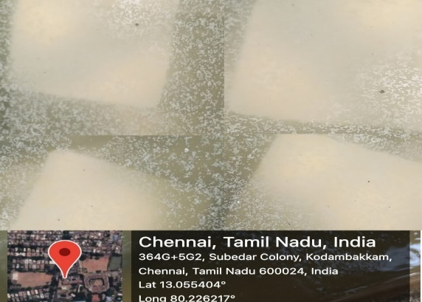

**Figure 1:** Casting and curing of concrete cubes

1. **TESTING OF CONCRETE MOULDS**

**9.1 Workability Test (Slump Cone Test - Fresh State)**  
A truncated cone-shaped mould is used with 200mm base diameter, 100mm top diameter, and 300mm height. About 6 liters of concrete is required. The cone is placed on a moistened base plate, filled with concrete, and leveled. The cone is then lifted, allowing the concrete to spread. The slump flow is measured by averaging two perpendicular diameters.

**9.1.1 Conventional Concrete Mix**  
M20 concrete mix (1:1.5:3) is prepared by mixing cement, sand, and coarse aggregate. Water is added gradually, and the mix is poured into oiled moulds. After 24 hours, the specimens are demoulded and cured, with workability tested via slump test.

**9.1.2 Modified Concrete Mix**  
Similar to conventional mixing, but with partial replacement of cement by *Spinacea oleracea* (0.6%), *Calotropis gigantea* milk (0.24%), and superplasticizer (0.3%). The mix is prepared, placed into moulds, and cured after 24 hours.

**9.2 Testing of Concrete in CTM (Hardened State)**

**9.2.1 Conventional Concrete**  
The concrete cube is placed in the testing machine between the upper and lower bearing blocks. After zeroing the load indicator, load is applied continuously until failure. The maximum load and failure type are recorded.

**9.2.2 Modified Concrete**  
The same procedure is followed for modified concrete (with partial replacement of cement by *Spinacea oleracea*, *Calotropis gigantea*, and superplasticizer). The load is applied until failure, and the maximum load and type of failure are noted.

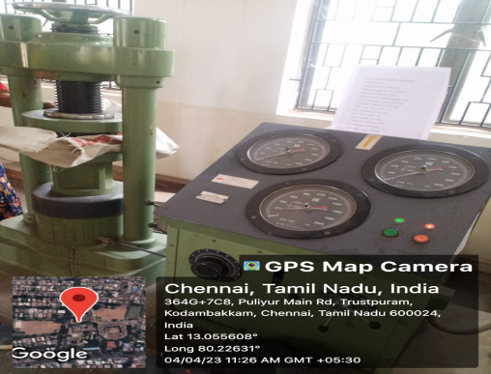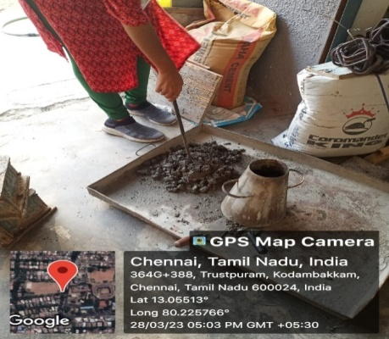

**Figure 2:** Testing of concrete cubes

1. **RESULTS**

# **10.1 CONVENTIONAL M20 MIX**

**10.1.1** **Compressive Strength at 7days**

compression strength

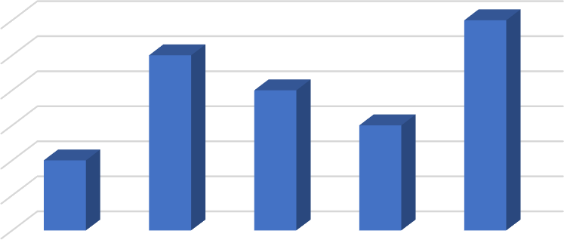

COMPRESSIVE STRENGTH (N/mm2)

Conventional concrete at 7days

14.9

14.9

14.8

14.7

14.8

14.7

14.6

14.6

14.5

14.4

14.3

14.5

SAMPLE-1 SAMPLE-2 SAMPLE-3 SAMPLE-4 SAMPLE-5

samples

**Chart 1:** Compressive Strength of Conventional M20 Mix at 7days

**10.1.2 Compressive Strength at 28days**

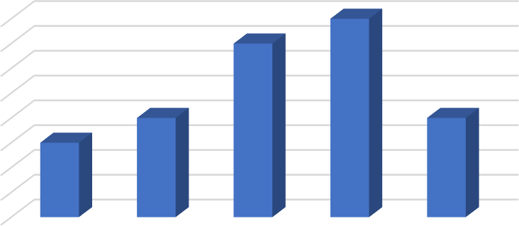

COMPRESSIVE STRENGTH(N/mm2)

Conventional concrete at 28days

20

SAMPLE-1 SAMPLE-2 SAMPLE-3 SAMPLE-4 SAMPLE-5

samples

Compression strength

|  |  |  |  |  |
| --- | --- | --- | --- | --- |
| 20 |  |  | 19.9 |  |
| 19.9 |  |  |  |
| 19.8 |  |  |  |
| 19.7 |  | 19.6 |  | 19.6 |
| 19.6 | 19.5 |  | | |
| 19.5 |  |
| 19.4 |  |
| 19.3 |  |
| 19.2 |  |

**Chart 2:** Compressive Strength of Conventional M20 Mix at 28days

**10.2 10%PARTIALLY REPLACED CONCRETE M20 MIX**

**10.2.1 Compressive Strength at 7days**

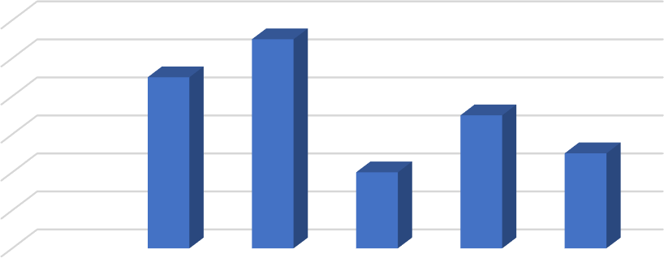

COMPRESSIVE STRENGTH(N/mm^2)

10% replaced concrete at 7days

15.6

15.5

15.4

15.2

15

14.8

15.3

15.1

14.9

14.8

14.6

14.4

SAMPLE-1 SAMPLE-2 SAMPLE-3 SAMPLE-4 SAMPLE-5

samples

Compression strength

**Chart 3:** Compressive Strength of 10% Replaced Concrete M20 Mix at 7days

# **10.2.2 Compressive Strength at 28days**

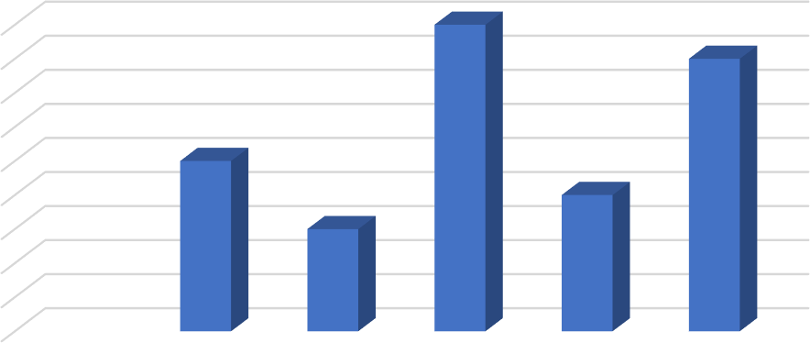

COMPRESSIVE STRENGTH(N/mm^2)

10% replaced concrete at 28days

21.1

21

20.9

20.8

SAMPLE-1 SAMPLE-2 SAMPLE-3 SAMPLE-4 SAMPLE-5

samples

Compression strength

|  |  |  |  |  |  |
| --- | --- | --- | --- | --- | --- |
|  | | | 21.7 |  | |
| 21.7 |  |  |  |  | 21.6 |
| 21.6 |  |  |  |  |  |
| 21.5 |  |  |  |  |  |
| 21.4 | 21.3 |  |  |  |  |
| 21.3 |  |  |  | 21.2 |  |
| 21.2 |  | 21.1 |  |  |  |
|  |  |  |  |  |  |

**Chart 4:** Compressive Strength 10% of Replaced Concrete M20 Mix at 28days

**10.3 15%PARTIALLY REPLACED CONCRETE M20 MIX**

**10.3.1 Compressive Strength at 7days**

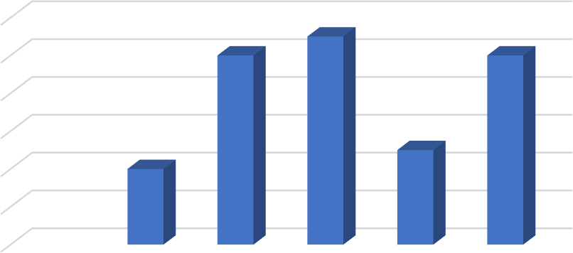

COMPRESSION STRENGTH(N/mm2)

15%replaced concrete at7 days

16

15.8

15.6

15.4

15.2

15

14.8

SAMPLE-1 SAMPLE-2 SAMPLE-3 SAMPLE-4 SAMPLE-5

Samples

Compression strength

**Chart 5:** Compressive Strength of 15% Replaced Concrete M20 Mix at 7days

**10.3.2 Compressive Strength at 28days**

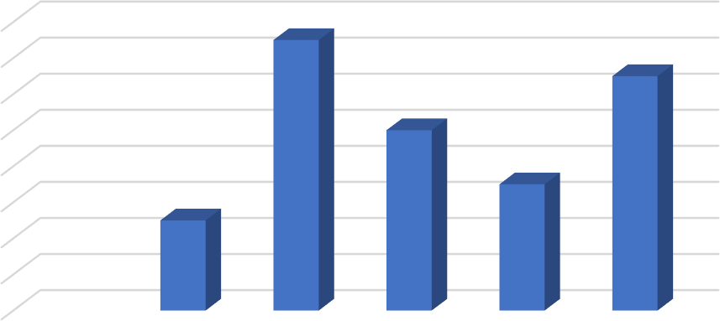

COMPRESSION STRENGTH(N/mm^2)

15% replaced concrete at 28days

22.6

22.4

22.2

22

21.8

21.6

21.4

21.2

21

22.5

22.3

22

21.7

21.5

SAMPLE-1 SAMPLE-2 SAMPLE-3 SAMPLE -4 SAMPLE-5

samples

Compression strength

**Chart 6:** Compressive Strength of 15% Replaced Concrete M20 Mix at 28days

1. **CONCLUSION**

From the workability and strength studies, it is revealed that there is a presence of OH ions in the self-curing concrete. This helps in the effective hydration resulting in better durability properties. Workability of concrete was tested and we can infer that the concrete is medium workable which can be used for the flat slabs with normal reinforcement. The cement is replaced with Spinacea oleracea, calatropis gigantea and superplasticizer partially for about 0.6%, 0.24%, 0.3% respectively in the conventional concrete and the graphical representation of compressive strength of concretes were analyzed.

Use of bio-materials increases the compressive strength of the concrete. There placement of bio-materials (industrial and building waste) for cement decreases the water cement ratio. It is concluded that the vegetative materials added as internal curing agents perform better workability, strength, and durability characteristics in fly ash-based concrete of grade M20 and such biomaterials as internal curing agents can be used for RCC works, pavements, water tanks, pre-stressed concrete structures without curing with fly ash to achieve long term strength with high performance.

1. **REFERENCES**
2. Azhagarsamy S and Sundararaman S, “A Study on Strength and Durability of Self Curing Concrete Using Polyethylene Glycol-400”, international journal of civil engineering and concrete structure, Vol. 1, No. 2, July 2016, ISSN 2455-7714
3. R. Malathy, “Experimental Study on Strength and Durability Properties of Bio-Self-Cured Fly Ash Based Concrete under Aggressive Environments”, World Academy of Science, Engineering and Technology International Journal of Structural and Construction Engineering Vol:11, No:3, 2017
4. M.Priya, S.Ranjitha, R.TamilElakkiya, “self-curing”, international journal seventh sense research group,ICCREST2016,E-ISSN:2348-8352
5. Dr.Sundararaman, S. and Azhagarsamy, S., “Experimental Investigation on Strength Properties of Self Curing Concrete Using Polyethylene Glycol-600”, international journal of current research , vol.8, june 2016, issue 06,pp.33296-33298
6. Magda I. Mousa, Mohamed G. Mahdy, Ahmed H. AbdelReheem, Akram Z. Yehia, “Physical Properties of Self-Curing Concrete (SCUC)”, housing and building national researchcenter, 18-may-2014.
7. M.Vidhya, S. Gobhiga and K. Rubini, “Experimental Study on Self Curing Concrete Using Biomaterials as Admixture”, international journal of engineering research and modern education, ISSN:2555-4200, April-2017
8. RiyazAhmaed. K, Pradeep Kumar. A, DuraiPriyadarshini, Kalaivani. K, KingstaBeautin. M, “Experimental Study on Self Curing Concrete Using Sodium Lignosulphonate”, international journal of emerging technologies and engineering, vol2 issue4, ISSN 2348-8050, April-2015