**Thermal Analysis of Carbon based Piston Using FEA**

**Mr.Sohan Dhurwey and Prof. Ganesh Singh Chauhan\***

*Lakshmi Narain College of Technology(RIT) IndoreM.P.   
[sohandhurwey11@gmail.com](mailto:sohandhurwey11@gmail.com); [ganesh.lnct11@gmail.com](mailto:ganesh.lnct11@gmail.com);

**Abstract**

The piston is a critical component of internal combustion engines, and its thermal performance significantly impacts the engine's overall efficiency and durability. This study focuses on the thermal analysis of a piston made from various materials using Finite Element Analysis (FEA). By simulating the thermal behavior under engine operating conditions, the research evaluates the impact of material selection on thermal stress, deformation, and heat dissipation. Graphite and structural steel are considered for comparison, with graphite emerging as the superior material.

**Keywords**: Thermal analysis, Finite Element Analysis (FEA), piston materials, thermal stress.

**INTRODUCTION**

Finding the normal stresses and thermal stresses using a speculative IC engine piston with various materials is the aim of this investigation. The materials that were taken into consideration for the study were structural steel, cast iron, and aluminum alloys. Although structural steel is the most widely used material in engineering, it has some limits, therefore in order to get around them, we utilized an alternate material from the perspective of design and analysis.

Our research, as covered in the literature review, further demonstrates that traditional materials are unable to keep up with the rapidly evolving automobile viewpoints. Thus, it is critical to find a substitute in order to meet the constantly evolving requirements.

Cast iron, cast aluminum, forged aluminum, cast steel and forged steel . Are the materials that I.C. engines most frequently use for their pistons. Cast iron pistons are utilized for piston speeds less than 6 m/s, and aluminum alloy pistons are used for highly rated engines operating at greater piston speeds.

**Aims and Objectives of the present work**

The following are the current investigation's goals and objectives:

* Choose the material for the pistons of an internal combustion engine and use numerical computing to confirm the analytical conclusions.
* Finding the Von-mises stresses on the piston head and examining the stress brought on by gas pressure.
* Assessing the thermal strains on the piston head as a result of temperature variations between the piston's center and edge.
* Using graphite as a novel piston material and experimenting with various piston materials to achieve the best possible result.
* Validation of CAE software as a useful tool for IC engine piston modeling and thermal analysis.

**Using Carbon as material for piston IC Engines:**

Pistons for internal combustion engines require highly-developed materials.

Owing to their specific qualities, carbon materials designed for this purpose provide an alternative to conventional materials, enable extraordinary processes, and significantly boost performance in automotive engineering.

**Integration of CAE Software**

These CAE tools are often used in conjunction with specialized CAE software packages to facilitate problem solving and engineering component design. A difficult issue is the unification of the tools or the data exchange between them. An appropriate systemized database is required in order to properly integrate these systems. The different data is incorporated into and retrieved from CAE tools. Should the CAE software be private and data access difficult, programming transfers may be necessary, but at the expense of functionality and interaction.

The example of CAE design is the landing gear system of an aircraft. The first step in defining the issue is to compile a list of performance requirements. Specialized programs can assist the logical design process at a higher level by estimating the landing gear's size based on predetermined weights and deflections.

**Working of Finite Element Analysis**

The material and structural characteristics that specify how the structure will behave under specific loading conditions are programmed into Finite Element Analysis (FEA). The material is determined by the expected stress levels in a certain location. The fracture point of previously tested material, intricate details, and the affected high stressed locations are examples of points of interest. The mesh will function in the expanded system similarly to a spider web net, with each node having a web of vectors and each neighboring node having a mesh element. Numerous components were created by this network of vectors carrying the objects' material attributes.

A wide range of objective functions (variables within the system) are available for variation:

* Mass and volume, temperature variation
* Strain energy, stress strain
* Dynamic Force and displacement, velocity and acceleration calculation.

Each FEA program comes with the following elements as given below:

* Rod elements, Beam elements
* Plate/Shell/Composite elements
* Shear panel

Many FEA programs are equipped by multiple materials within the structure such as given below:

* Isotropic, identical throughout
* Orthotropic, identical at 90 degrees
* General anisotropic, different throughout

**Modeling of Piston**

A complete Finite Element Analysis consists of three stages:

**Pre-Processing-**

**Part module-** First of the piston is created in part module.

**Property module-**CATIA has built-in system of units. Some common systems of consistent units are shown in Table 5

|  |  |  |  |  |
| --- | --- | --- | --- | --- |
| **Variable** | **SI** | **SI (mm)** | **US Unit (ft)** | **US Unit (inch)** |
| **Length** | M | Mm | ft. | in. |
| **Force** | N | N | Lbf | Lbf |
| **Mass** | Kg | tonne (103 kg) | Slug | lbf s2 /in |
| **Time** | Sec | Sec | Sec | Sec |
| **Stress** | Pa (N/m2 ) | MPa (N/mm2 ) | lbf/ft2 psi | (lbf/in2 ) |
| **Energy** | J | mJ (10-3 J) in | Ftlbf | Lbf |
| **Density** | kg/m3 | tonne/mm3 | slug/ft3 | lbf s2 /in4 |

**Table 1:-Some common systems of units**

We are using the SI (mm) system of units for this investigation. The following are the mechanical qualities of the materials used, all of which have an elastic nature.

**Post-processing with CATIA/CAE-**

When creating graphics, You may use the Visualization module to examine the analysis's results once the process has finished successfully. From the menu that opens, choose Results to open the Visualization module. CATIA/CAE shows a quick visualization of the model and accesses the output database according to the job. To aid in understanding and result analysis, CATIA displays stress zones and maximum to lowest deformation in various colors.

**Modeling Procedure:**

Figure 2 shows the flow process chart of the IC engine piston regarding the modeling procedure.

In order to solve the problem, a uniform gas pressure is applied after the geometric parameters are determined with reference to the numerical and empirical equations that are stated in a way that allows it to move solely in an axial direction. With the same program, a parabolic octree-tetrahedron element with an element size of two is selected out of the four nodes that were picked. In the CATIA generative workbench, the spring material's properties are finally examined.

**Numerical Analysis: Calculated Parameters for Piston:**

|  |  |  |
| --- | --- | --- |
| S. NO. | Parameter | Size in mm |
| 1 | Length of piston | 42 |
| 2 | Cylinder Bore | 53 |
| 3 | Axial thickness of ring | 1.181 |
| 4 | Radial thickness of ring | 1.688 |
| 5 | Maximum thickness of barrel | 8.178 |
| 6 | Width of the outer ring land | 1.266 |
| 7 | Width of the top land | 8.018 |
| 8 | Length of skirt | 31.8 |
| 9 | Piston pin Diameter | 15.9 |

**Table 2: Calculated Parameters for Piston**

3D Model

Input file for analysis

Post-processing (result visualisation)

Output file

Simulation of Piston

Pre-processing in CATIA software

**Fig.2:- Modeling Process of IC engine piston**

**Piston Calculation:**

1. $η_{mech }$ = $\frac{BP}{IP}$

IP = $\frac{BP}{0.8}$ = $\frac{5.5}{0.8}$ =6.875 KW

Where: η= Mechanical efficiency

IP = Indicated Power

BP= Break power

1. IP = $\frac{P×L×A×n}{ 60}$

Pme = 1.244 MPa

Pmax = 10 x P = 12.44 MPa

Where: P= pressure in MPa

L= Length of piston in mm

A= Area of piston in mm^2

1. Thickness of piston head

tH= D $\sqrt{\frac{3 Pmax}{16σt}}$

tH = 9.28

empirical formula

tn= 0.032D + 1.5 = 3.19 mm

[ Mf = 45.493 kg/kws]

$$\left[tn= \frac{[C×HCV×m×BP]×{10}^{6}}{12.56×150×75×3600}\right]$$

1. Piston rings:-
2. Radial thickness

t1 = D

Pw = 0.025-0.042 N/mm2

σt = 85-110 MPa for cast iron rings

t1 = 1.688mm

1. Axial Thickness

t2 = 0.7 t1 to t2= ( = 1.181mm

Where: D = Diameter of Bore in mm

1. Width of top land and Ring land
2. Width of top land

b1 = tH to 1.2 tH = 8.018mm

Width of ring land

b2  = 0.75 t1  to t2 = 1.266mm

1. Piston Barrel
2. Thickness of piston Barrel at top end

t3  = 0.03 D + b + 4.5mm

t3 = 0.0353 + 2.088 + 4.5 = 8.178mm

1. Thickness of piston Barrel at open end

t4 = (0.25 t3  to 0.35 t3 ) = 2.022 mm

1. Length of skirt

LS  = (0.6 D to 0.8 D) = 31.8mm

1. Length of piston pin in on rod bushing

l1  = 45% of piston dia. = 23.85

1. Piston pin dia.

dp = (0.28 D + 0.038 D)

= 14.9mm

Centre of pin should be 0.02 D to 0.04 D above piston skirt

* Heat flow through piston head

H = 12.56 × tH× (Tc– TE ) KJ/sec

H = 744.368 KJ/sec

Where: Tc = temperature at the center of piston head in ºC

TE = temperature at the edges of the piston head in ºC

**FEA Analysis**

FEA analysis is integrated into FEA software like CATIA, ANSYS, and ABAQUS. Modeling may be used to regularize personal verification. Verification of linear analysis is typically less complicated than verification of non-linear analysis through the use of classical equations to determine the solutions

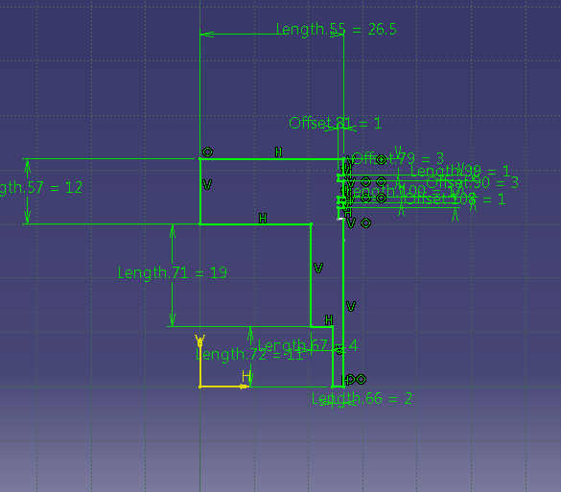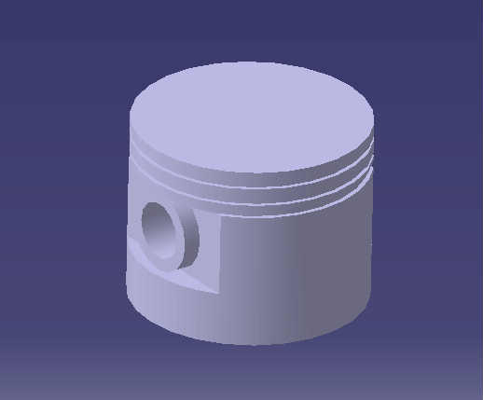

**Fig 3CATIA V5 Section of piston Fig 4 CATIA V5 3D Model of piston**

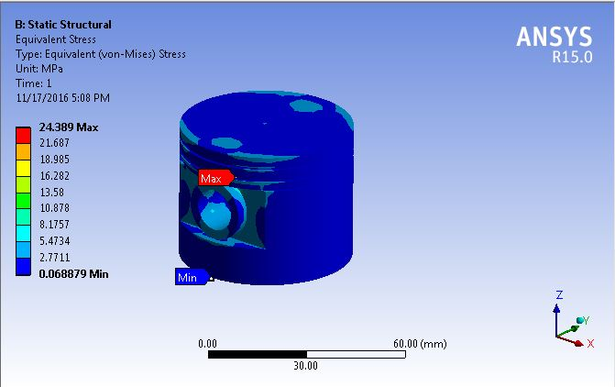

**Figure 5. Von Mises Stress in Graphite Piston**

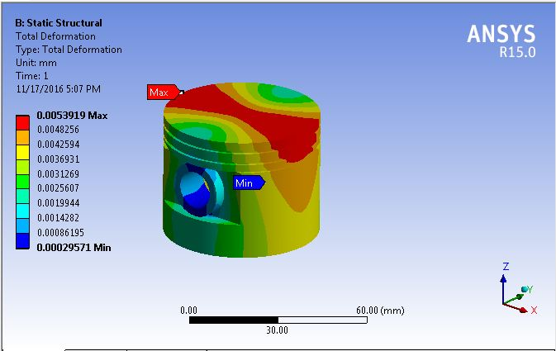

**Figure 6: Total Displacement in Graphite Piston**

**Results:**

In order to determine the impact of a material change on the piston's performance, this study examines one of the engine's components, the piston, using two distinct production materials. The maximal equivalent stress for graphite is 24.389 MPa and for structural steel is 24.428 MPa, according to research. The thermal analysis yields a maximum heat flow of 1.9288 W/mm for structural steel and 1.462 W/mm for graphite.. The following results were found by applying the calculations:

**Table 2: Effect of Thermal Stresses and Equivalent Stress on Piston Performance using Different Piston Materials**

|  |  |  |  |
| --- | --- | --- | --- |
| **S. No** | **Piston Material** | **Structural Steel** | **Graphite** |
| **1.** | Maximum Thermal Range (ºC) | 22.012-280 ºC | 22.019-280 ºC |
| **2.** | Maximum Heat Flux (W/mm) | 1.9288 W/mm | 1.462 W/mm |
| **3.** | Maximum Equivalent Stress (N/m2) | 24.428 MPa | 24.389 MPa |
| **4.** | Maximum Deformation (mm) | 0.00074929 mm | 0.0053919 mm |

As the table and results shows that when utilizing graphite as the piston material, the maximum heat flux, maximum deformation, and equivalent stress are all at their lowest, and that when using structural steel as the piston material, the maximum values of all variables are greater than when using graphite.

Thus, based on the data, we can conclude that the piston's maximum thermal stress and maximum deformation may be expressed as

**Structural Steel > Graphite**

**Conclusion**

* To enhance comprehension and analysis of the outcome, the CATIA program offers distinct deformation and stress zones. CATIA has produced better results and required less work to solve the complicated computation..
* The performance of the piston is enhanced by the use of graphite as the piston material.
* The meshing element comprising triangular and quadrilateral nodes with least mesh size works better and delivers desired output.
* Since graphite has demonstrated less thermal stress and deformation and better thermal behavior than structural steel, it should be utilized to construct the piston.
* The weight has been reduced and high mechanical strength may be obtained at low temperatures by substituting graphite for the piston material.

**REFERENCES**

1. Yaohui Lu, Xing Zhang, Penglin Xiang, Dawei Dong – “Analysis of Thermal Temperature Fields and Thermal Stress under Steady Temperature field of Diesel Engine Piston” , Southwest Jiaotong University, Chengdu Sichuan 610031, China, 2016.
2. V G Cioată, I Kiss, V Alexa and S ARațiu – “Mechanical and thermal analysis of the internal combustion engine piston using Ansys” International Conference on Applied Sciences (ICAS2016).
3. C. Kirner, J. Halbhuber, B. Uhlig, A. Oliva, S. Graf, G. Wachtmeister- “Experimental and simulative research advances in the piston assembly of an internal combustion engine” Preprint submitted to Tribology International March 17, 2016.
4. Dilip Kumar Sonar, MadhuraChattopadhyay – “Theoretical Analysis of Stress and Design of Piston Head using CATIA & ANSYS” International Journal of Engineering Science Invention ISSN (Online): 2319 – 6734, ISSN (Print): 2319 – 6726: June 2015.
5. NunnaDurgaPrasanth ,Dr.BVenkataraman – “EXPERIMENTAL INVESTIGATION AND ANALYSIS OF PISTON BY USING HYBRID METAL MATRIX” [Nunna, 4(3): March, 2015] ISSN: 2277-9655 Scientific Journal Impact Factor: 3.449 (ISRA), Impact Factor: 2.114.
6. Kethavath Vishal, Dinesh Bajaj, A.Sai Kumar –“ Design and Structural Analysis of Composite Piston” Volume No: 2 (2015), Issue No: 10 (October) October 2015.
7. M.Srinadh , K. RajasekharaBabu – “Static and Thermal Analysis of Piston and Piston Rings” August 2015, Volume 3, Issue 8, ISSN 2349-4476.
8. Abino John, Jenson T Mathew- “Design and Analysis of Piston by SiC Composite Material” IJIRST –International Journal for Innovative Research in Science & Technology| Volume 1 | Issue 12 | May 2015.
9. Vaishali R. Nimbarte , Prof. S.D. Khamankar – “STRESS ANALYSIS OF PISTON USING PRESSURE LOAD AND THERMAL LOAD” Volume 3, Issue 8, August 2015.
10. G.Anusha ,Ramlakshmi , K Mohan Krishna, P.Prem Kumar –“ Modeling and Analysis of Piston Design through Pro/E & ANSYS” © 2015, IRJET ISO 9001:2008 Certified Journal.
11. Claudia Lenauer n , Christian Tomastik, Thomas Wopelka, Martin Jech- “Piston ring wear and cylinder liner tribofilm in tribotests with lubricants artificially altered with ethanol combustion products” C. Lenauer et al. / Tribology International 2014.