**Bibliometric Analysis of Internet of Things (IOT) Research Data on the Scopus Database withVOSviewer**

Gaurav D. Saxena

Assistant Professor, Department of Computer Science and Applications, City Premier College, Nagpur

Email: gauravsaxena711@gmail.com

Parmod

Research Scholar, Department of Computer Science and Engineering, Chaudhary Devi Lal University, Sirsa, Haryana, India

E-mail: Parmod94843@gmail.com

**ABSTRACT :**

Internet of things is a trending topic for several decades, but it has only recently become a popular topic in the world of technology. Internet of things is used in all the fields like biology, physics, etc. Internet of things (IOT) is described as an object or thing which is used to connect various others IOT devices on the internet. These object is a combination of sensors, actuators, processors, software, and other things. Scopus is one of the biggest research databases. It publishes high-quality research papers from all over the world so we are choosing to analyze the research data from the Scopus database. Scopus provides a graphical view of research data. We are also using VOSviewer for graphical analysis of the relationship between various terms.

The purpose of this research is to analyze the research data and relationships between various terms of internet of things (IOT) using the Scopus database and VOSviewer. The data for analysis is collected from the Scopus database and we are using VOSviewer to draw relationships. We are collecting data using a keyword like ( ( internet AND of  AND  things ) OR ( IOT ) OR ( web AND of  AND  things ) OR ( industrial AND IOT ) OR ( smart AND device ) OR ( wireless AND devices)")" etc. In this research, we are analyzing research data according to country, subject, keyword, year, name of the journal, type of paper, and many other contexts. In this, we are also reviewing 10 highly cited research papers and 10 newly published research papers according to the open/free availability. This research can be used for referencing, discussing, and also for choosing research areas for new researchers.

**KEYWORD:** Internet of Things, IOT, Bibliometric Analysis, VOS viewer, Scopus, wireless devices,

**INTRODUCTION:**The purpose of this research was to systematically explore the development of the literature and to clarify its history and future potential. Using advanced metric literature techniques, we've built a database of major studies based on the searches of the Scopus database‘s data. The resulting total number of 330439 documents was analyzed using co-citation and co-appearance measures. The previous is an older Bibliometric technique that identifies common occurrences of scientific disciplines and keywords. The latter is preferred. [4] Bibliometric Analysis is the process of analyzing or previously published research papers based on various properties, databases, and other factors. The Internet of Things (IOT) There is no unique definition available for the Internet of Things that is acceptable by the world community of users [1] "The Internet of Things (IOT) is the network of physical objects, devices, vehicles, buildings, and other items which are embedded with electronics, software, sensors, and network connectivity, which enables these objects to collect and exchange data." [2] IOT is an emerging and very useful concept in the world of technology[3]. Scopus is a database containing a list of journals that fulfill specific conditions. It continuously adds or removes journals from time to time. [5] VOSviewer is a software which draws relationships between various terms. It has 3 types of diagram, named network visualization, overlay vitalization, and density visualization .[6]

**LITERATURE REVIEW :** we are reviewing various previous published paper . in those paper we find that almost every author only analysis the some part of Internet of things (IOT) or one or two application of Internet of things (IOT) or some devices of Internet of things (IOT) .we are analyzing complete documents related to internet of things. RejebA,et al. conduct the Bibliometric analysis of internet of things and agriculture document among 827 papers of 2948 authors of Scopus database. [7] RejebA,et al. conduct the Bibliometric analysis of internet of things and **smart cities** document among 1802 papers of Scopus database.[8] Kumar S, et al. conduct the Bibliometric analysis of internet of things and tourism document among more than 1000 papers were published between 2009 to 2019 in web of science database.[9] Márquez CL, et al. conduct the Bibliometric analysis of internet of things and Lean Manufacturing document among more than 1000 papers were published Web of Science (WoS) and Scopus, from 2010 until 2021.[10]

**METHODOLOGY :**Our study includes all articles and papers published in various journals indexed in the Scopus database from the start of 2022. It includes all papers that are accepted and published. We retrieve data from the Scopus database and also retrieve various charts. All my data is fetched from the Scopus website on September 14, 2012. We are downloading .csv files of all research data available in the Scopus database according to my requirements. We are using Scopus and VOSviewer to display various charts and diagrams. We are installing VOSviewer . My research includes various stages defined below.

1. **Choose the study topic:** In the first step, we choose "Bibliometric."We selected "Bibliometric Analysis of Internet of Things (IOT) Research Data" as my research topic.
2. **Select the tools to find research article data:** In this, we select Scopus as the database to find research article data. We selected Scopus because Scopus publishes high quality research articles. And it continuously updates their database. It covers all the worldwide articles. We selected Scopus and VOSviewer to draw various charts and interrelationships. Normal charts are automatically available in Scopus. We use VOSviewer for drawing interrelationships. VOSviewer provides high quality interrelationship charts. It is also free of charge. It provides various options to draw a chart.
3. **Select the search keyword:** In the third step, I selected the keyword to search in Scopus document search. In Scopus document search, I enter TITLE-ABS-KEY-AUTH ((internet AND of AND things) OR (IOT) OR (web AND of AND things) OR (industrial AND IOT) OR (smart AND device) OR (wireless AND devices)).
4. **Download all text data and Bibliometric data on articles:** In the fourth step, we download a .csv file of all text data and Bibliometric data on articles.
5. **Draw and fetch charts**: in the fifth step, we fetch all charts related to our Bibliometric analysis from Scopus document search. And we draw interrelationships between various terms.
6. **Analysis of BibliometricAnalysis** : In this step, we analyze the Bibliometric Analysis research data.
7. **Download research papers:** In this step, we will download 10 highly cited papers and 10 most recent papers based on availability.
8. **Review the paper** : In the last step, we review this downloaded paper.

**RESULT AND DISCUSSION: Publication Data Search Results from Scopus :** There are 330439 research papers published in Scopus on the topic "TITLE-ABS-KEY-AUTH ( ( internet AND of  AND  things ) OR ( IOT ) OR ( web AND of  AND  things ) OR ( industrial AND IOT ) OR ( smart AND device ) OR ( wireless AND devices)")"

1. **20 newly accepted or published papers:**Table 1. presents 20 newly accepted or published papers in Scopus related to the internet of things. There are very few citations for these articles because they are the latest articles. There are 13 articles: 5 review papers, 1 conference paper, and 1 conference review. All papers are accepted by Scopus indexed journals and will be published in 2023.

**Table 1. 20 newly accepted or published papers on Internet of things**

|  |  |  |  |  |  |
| --- | --- | --- | --- | --- | --- |
| **Sr.No.** | **Authors** | **Title** | **Year** | **Cited by** | **Document Type** |
|  | Wang Z., Dong J. | Design of Dance Data Management System Based on Computer-Aided Technology Under the Background of Internet of Things | 2023 |  | Article |
|  | Maatoug A., Belalem G., Mahmoudi S. | A location-based fog computing optimization of energy management in smart buildings: DEVS modeling and design of connected objects | 2023 |  | Article |
|  | Kirar M.K. | IOT Based Remote Monitoring, Control, and Protection of Irrigation Water Pumping System | 2023 |  | Article |
|  | Wang X., Jiang P., Baker T., Li T., Zhu L. | Enabling privacy and leakage resistance for dynamic blockchain-based access control systems | 2023 |  | Article |
|  | Fernandes J.M., Silva J.S., Rodrigues A., Boavida F. | A Survey of Approaches to Unobtrusive Sensing of Humans | 2023 |  | Review |
|  | Bang A.O., Rao U.P., Kaliyar P., Conti M. | Assessment of Routing Attacks and Mitigation Techniques with RPL Control Messages: A Survey | 2023 | 1 | Review |
|  | Ghosh S., Chatterjee A., Chatterjee D. | Extraction of statistical features for type-2 fuzzy NILM with IOT enabled control in a smart home | 2023 |  | Article |
|  | Wang C., Guo R., Yu H., Hu Y., Liu C., Deng C. | Task offloading in cloud-edge collaboration-based cyber physical machine tool | 2023 |  | Article |
|  | Jiang X., Sun A., Sun Y., Luo H., Guizani M. | A Trust-Based Hierarchical Consensus Mechanism for Consortium Blockchain in Smart Grid | 2023 |  | Article |
|  | Shi B., Zhang X., Li W., Liang N., Hu X., Xiao J., Wang D., Zou X., Shi J. | An intrinsic dual-emitting fluorescence sensing toward tetracycline with self-calibration model based on luminescent lanthanide-functionalized metal-organic frameworks | 2023 |  | Article |
|  | Tian K., Hu D., Wei Q., Fu Q., Deng H. | Recent progress on multifunctional electromagnetic interference shielding polymer composites | 2023 |  | Article |
|  | Abdelbasset W.K., Savina S.V., Mavaluru D., Shichiyakh R.A., Bokov D.O., Mustafa Y.F. | Smartphone based aptasensors as intelligent biodevice for food contamination detection in food and soil samples: Recent advances | 2023 |  | Review |
|  | Macagno J., Gerlero G.S., Satuf M.L., Berli C.L.A. | Field-deployable aptasensor with automated analysis of stain patterns for the detection of chlorpyrifos in water | 2023 |  | Article |
|  | Liu X., Gao R., Han L., Kan C., Xu J. | A smartphone readout device for portable and sensitive estimation of Hg2+ via coumarin-modified paper | 2023 |  | Article |
|  | Liao Z., Ai J., Liu S., Zhang Y., Liu S. | Blockchain-based mobile crowdsourcing model with task security and task assignment | 2023 |  | Article |
|  | Mu Y., Wang C., Xu Y.-B., Du X.-X., Pan Q.-Y., Zhang H.-Y., Zhu Y.-J. | Time-coordinated SPAD-based receiver for high-speed optical wireless communication | 2023 |  | Article |
|  | Dao N.-N. | Internet of wearable things: Advancements and benefits from 6G technologies | 2023 |  | Review |
|  | Indrawan B., Alzamora D.G., Rahmatullah M.S., Wikarta A. | Facial Recognition-Based Automatic Door Security System Integrated with Internet of Things for Smart Home Actualization | 2023 |  | Conference Paper |
|  | [No author name available] | 5th International Conference on Mechanical Engineering, ICOME 2021 | 2023 |  | Conference Review |
|  | Tang J., Lu X., Xiang Y., Shi C., Gu J. | Blockchain search engine: Its current research status and future prospect in Internet of Things network | 2023 |  | Review |

[11][12][13][14][15][16][17][18][19][20][21][22][23][24][25][26][27][28][29][30]

1. **Table 2. presents the 20 most highly cited papers:** Table 2. presents the 20 most highly cited papers in Scopus related to the internet of things. There are very few citations for these articles because they are the latest articles. There are 11 articles, 4 review papers, 4 conference papers, and a book. All papers are accepted by Scopus indexed journals and these are published in various years. The "Wireless sensor networks: A survey" published in 2002 is cited the highest number of times, 13197, and is written by Akyildiz I.F., Su W., Sankarasubramaniam Y., Cayirci E.. The average number of citations for these 20 papers is 5206.75.

**Table 2. 20 highly cited papers on Internet of things**

|  |  |  |  |  |  |
| --- | --- | --- | --- | --- | --- |
| **Sr. No** | **Authors** | **Title** | **Year** | **Cited by** | **Document Type** |
|  | Akyildiz I.F., Su W., Sankarasubramaniam Y., Cayirci E. | Wireless sensor networks: A survey | 2002 | 13197 | Article |
|  | Atzori L., Iera A., Morabito G. | The Internet of Things: A survey | 2010 | 9746 | Article |
|  | Goldsmith A. | Wireless communications | 2005 | 8869 | Book |
|  | Gubbi J., Buyya R., Marusic S., Palaniswami M. | Internet of Things (IOT): A vision, architectural elements, and future directions | 2013 | 7468 | Article |
|  | BahlParamvir, PadmanabhanVenkata N. | RADAR: An in-building RF-based user location and tracking system | 2000 | 6940 | Conference Paper |
|  | Rappaport T.S., Sun S., Mayzus R., Zhao H., Azar Y., Wang K., Wong G.N., Schulz J.K., Samimi M., Gutierrez F. | Millimeter wave mobile communications for 5G cellular: It will work! | 2013 | 5054 | Article |
|  | Revell L.J. | phytools: An R package for phylogenetic comparative biology (and other things) | 2012 | 4667 | Article |
|  | Al-Fuqaha A., Guizani M., Mohammadi M., Aledhari M., Ayyash M. | Internet of Things: A Survey on Enabling Technologies, Protocols, and Applications | 2015 | 4654 | Article |
|  | Stuart M.A.C., Huck W.T.S., Genzer J., Müller M., Ober C., Stamm M., Sukhorukov G.B., Szleifer I., Tsukruk V.V., Urban M., Winnik F., Zauscher S., Luzinov I., Minko S. | Emerging applications of stimuli-responsive polymer materials | 2010 | 4392 | Review |
|  | Kurs A., Karalis A., Moffatt R., Joannopoulos J.D., Fisher P., Soljačić M. | Wireless power transfer via strongly coupled magnetic resonances | 2007 | 4338 | Article |
|  | Bonomi F., Milito R., Zhu J., Addepalli S. | Fog computing and its role in the internet of things | 2012 | 4146 | Conference Paper |
|  | Ye W., Heidemann J., Estrin D. | An energy-efficient MAC protocol for wireless sensor networks | 2002 | 4095 | Conference Paper |
|  | Jacobson V. | Congestion avoidance and control | 1988 | 3949 | Conference Paper |
|  | Zanella A., Bui N., Castellani A., Vangelista L., Zorzi M. | Internet of things for smart cities | 2014 | 3708 | Article |
|  | Shi W., Cao J., Zhang Q., Li Y., Xu L. | Edge Computing: Vision and Challenges | 2016 | 3682 | Article |
|  | Kim D.-H., Lu N., Ma R., Kim Y.-S., Kim R.-H., Wang S., Wu J., Won S.M., Tao H., Islam A., Yu K.J., Kim T.-I., Chowdhury R., Ying M., Xu L., Li M., Chung H.-J., Keum H., McCormick M., Liu P., Zhang Y.-W., Omenetto F.G., Huang Y., Coleman T., Rogers J.A. | Epidermal electronics | 2011 | 3282 | Article |
|  | Schubert E.F., Kim J.K. | Solid-state light sources getting smart | 2005 | 3134 | Review |
|  | Xu L.D., He W., Li S. | Internet of things in industries: A survey | 2014 | 3121 | Review |
|  | Bulusu N., Heidemann J., Estrin D. | GPS-less low-cost outdoor localization for very small devices | 2000 | 2891 | Article |
|  | Palomares V., Serras P., Villaluenga I., Hueso K.B., Carretero-González J., Rojo T. | Na-ion batteries, recent advances and present challenges to become low cost energy storage systems | 2012 | 2802 | Review |

[31][32][33][34][35][36][37][38][39][40][41][42][43][44][45][46][47][48][49][50]

1. **Documents by Subject Area** : Figure 1. represents the subject-wise papers published/accepted in Scopus indexed journals . There are two subjects: engineering and science. 32.1% of the paper is related to computer science, 26.5% to engineering disciplines, and the rest is related to other subjects.

**Table 3. Documents by Subject Area**

|  |  |
| --- | --- |
| **Subject-area** | **Documents** |
| Computer Science | 213417 |
| Engineering | 175919 |
| Mathematics | 45364 |
| Physics and Astronomy | 45326 |
| Materials Science | 34941 |
| Decision Sciences | 24726 |
| Energy | 20696 |
| Social Sciences | 20427 |
| Medicine | 17062 |
| Chemistry | 12052 |
| Others | 54743 |

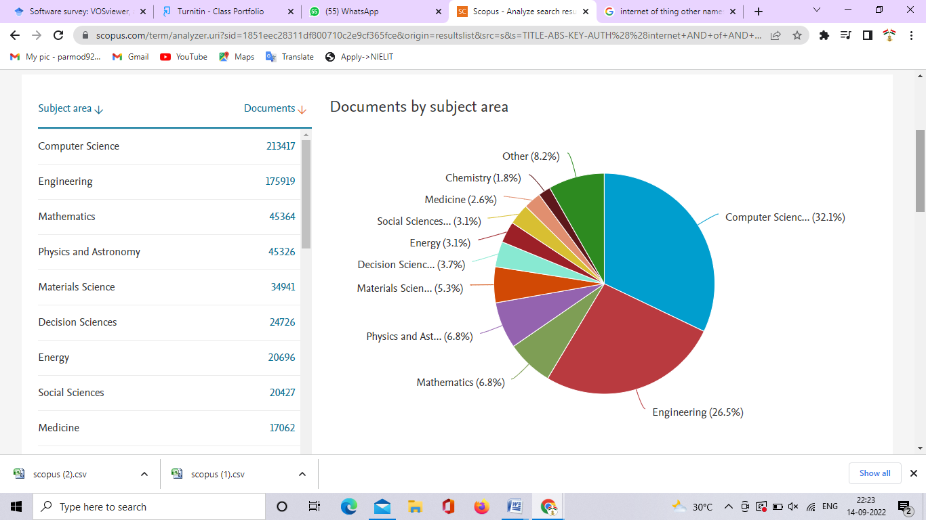

**Fig. 1. Documents by Subject Area**

1. **Documents by Author:** Figure 2. represent the 10 author who published highest paper in Scopus indexed journals . The Guizani, M published 344 papers and Rodrigues, J.J.P.C published .340.

**Table 4. Documents by Author:**

|  |  |
| --- | --- |
| **Author** | **Documents** |
| Guizani, M. | 344 |
| Rodrigues, J.J.P.C. | 340 |
| Kumar, N. | 290 |
| Han, Z. | 270 |
| Benini, L. | 227 |
| Choo, K.K.R. | 225 |
| Niyato, D. | 207 |
| Al-Turjman, F. | 202 |
| Leung, V.C.M. | 198 |
| Lloret, J. | 190 |

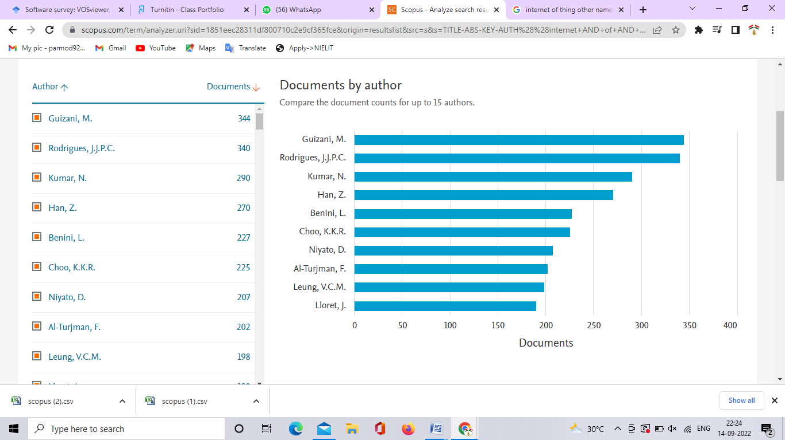

**Fig. 2. Documents by Author**

1. **Documents per year by sources:** Figure 3 represents documents per year by sources in Scopus indexed journals. This figure represents papers published from 1976 to the present by various sources such as Lecture Notes In Computer Science Including Subseries Lecture Notes In Artificial Intelligence And Lecture Notes In Bioinformatics (7865), IEEE Access (5038), ACM International Conference Proceeding Series (4812), IEEE Internet Of Things Journal (4592), and Proceedings Of SPIE, The International Society For Optical Engineering (4230).

**Table 5. Documents per year by sources**

|  |  |
| --- | --- |
| **Source** | **Documents** |
| Lecture Notes In Computer Science Including Subseries Lecture Notes In Artificial Intelligence And Lecture Notes In Bioinformatics | 7865 |
| IEEE Access | 5038 |
| ACM International Conference Proceeding Series | 4812 |
| IEEE Internet Of Things Journal | 4592 |
| Proceedings Of SPIE The International Society For Optical Engineering | 4230 |

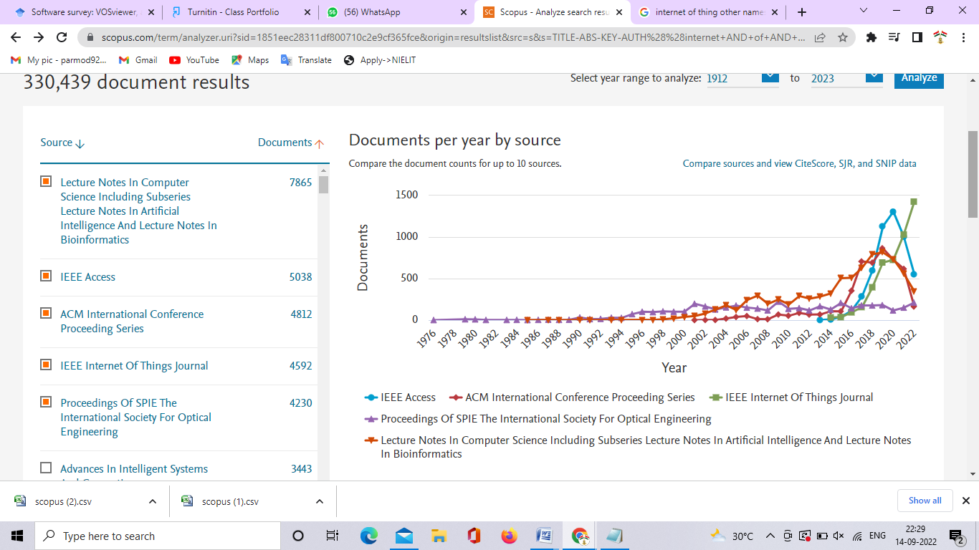

**Fig. 3. Documents per year by sources**

1. **Document / paper by affiliation:** Figure 4 . represent various document / paper by affiliation , the highest number of documents of affiliated by Chinese Academy of Sciences and Ministry of Education China .the 3775 documents are affiliated by Chinese Academy of Sciences and 3144 documents are affiliated by Ministry of Education China.

**Table 6. Document / paper by affiliation**

|  |  |
| --- | --- |
| **Affiliation** | **Documents** |
| Chinese Academy of Sciences | 3775 |
| Ministry of Education China | 3144 |
| Beijing University of Posts and Telecommunications | 2792 |
| Tsinghua University | 2464 |
| CNRS Centre National de la RechercheScientifique | 1952 |
| University of Electronic Science and Technology of China | 1888 |
| Georgia Institute of Technology | 1864 |
| Shanghai Jiao Tong University | 1677 |
| Nanyang Technological University | 1573 |
| Xidian University | 1481 |

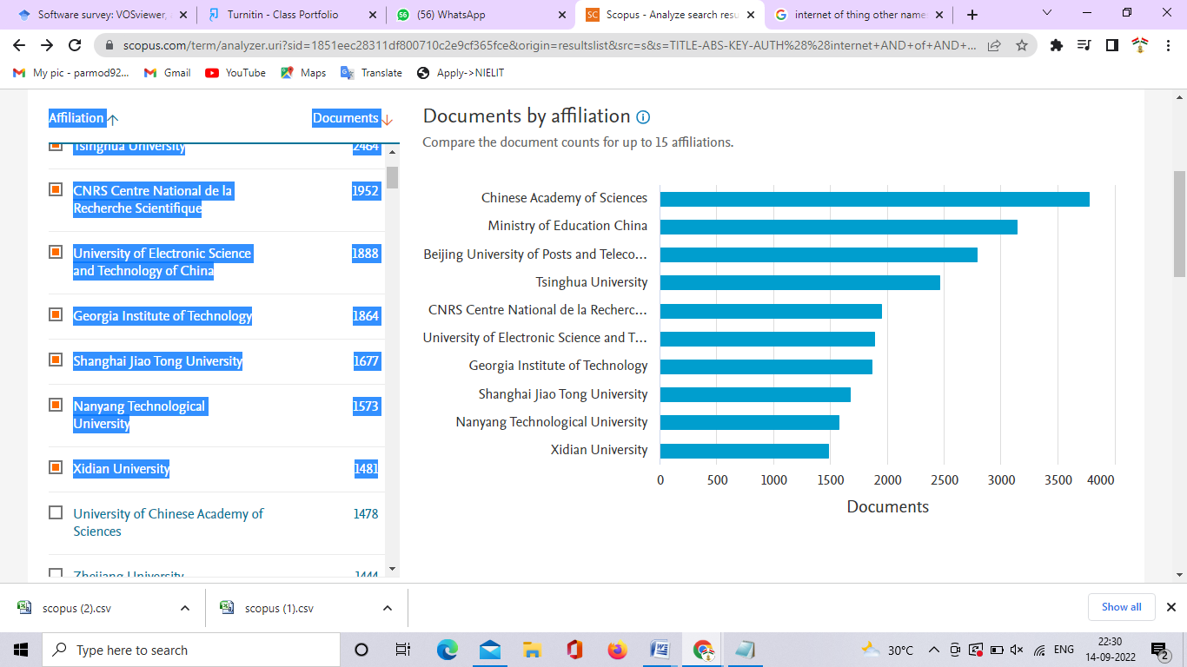

**Fig. 4. Document / paper by affiliation**

1. **Document published /accepted for publication for various years 1912 to current:** Figure 5 .represent various document published /accepted for publication for various years 1912 to current. Highest documents are published in 2021 but more than 30000 document are published / accepted for publication till now. Documents publishing are increasing year to year. In 21th century research on internet of things are increase rapidly.

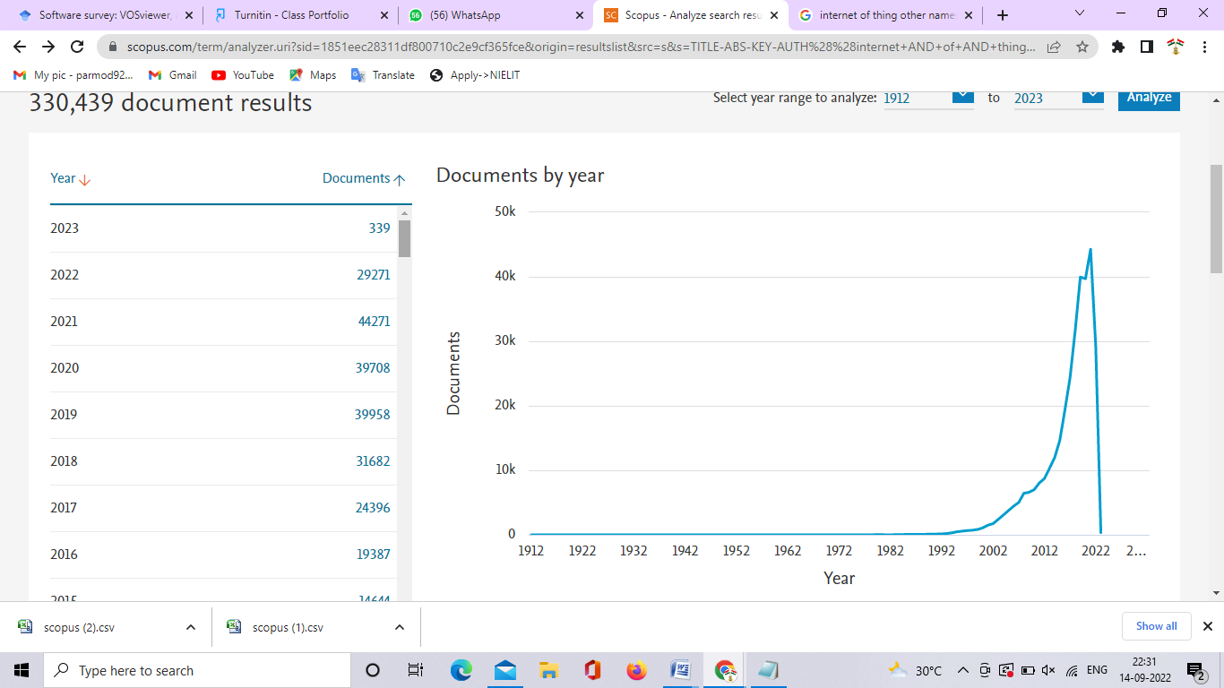

**Fig. 5. Document published /accepted for publication for various years 1912 to current.**

1. **Documents published or accepted for publication for various years from 2003 to the present. :**Figure 6 represents various documents published or accepted for publication for various years from 2003 to the present. The topic " internet of things" has become very popular in 2016 . Currently, "the internet of things"  is the hottest topic for research.

**Table 7. Documents published or accepted for publication for various years from 2003 to the present.**

|  |  |
| --- | --- |
| **Year** | **Documents** |
| 2023 | 339 |
| 2022 | 29271 |
| 2021 | 44271 |
| 2020 | 39708 |
| 2019 | 39958 |
| 2018 | 31682 |
| 2017 | 24396 |
| 2016 | 19387 |
| 2015 | 14644 |
| 2014 | 11987 |
| 2013 | 10328 |
| 2012 | 8717 |
| 2011 | 8038 |
| 2010 | 6990 |
| 2009 | 6593 |
| 2008 | 6441 |
| 2007 | 5018 |
| 2006 | 4440 |
| 2005 | 3759 |
| 2004 | 3066 |
| 2003 | 2394 |

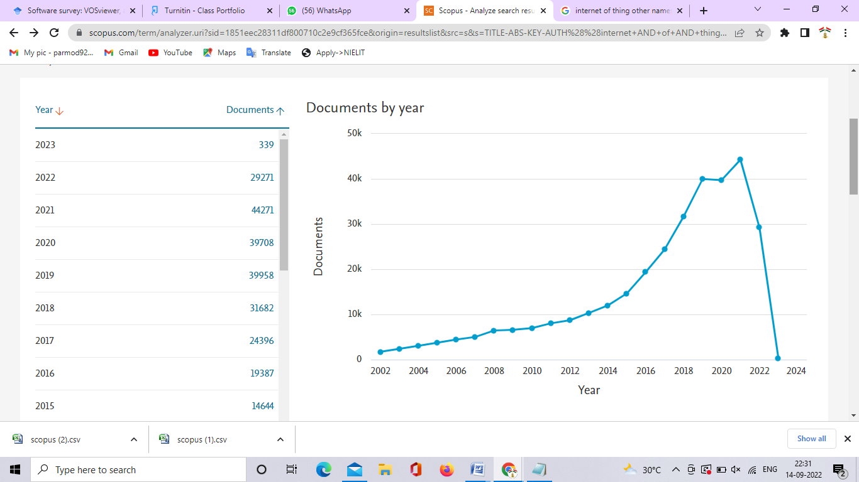

**Fig..6. Documents published or accepted for publication for various years from 2003 to the present.**

1. **Documents by types** : Figure 7 represents the different types of documents that have been published or accepted for publication in Scopus up to September 2022. This includes articles, book chapters, reviews, conference reviews, editorials, books, surveys, notes, letters, and other types of documents.

**Table 8. Documents by types :**

|  |  |
| --- | --- |
| **Document type** | **Documents** |
| Conference Paper | 170593 |
| Article | 121443 |
| Book Chapter | 10606 |
| Review | 9424 |
| Conference Review | 6615 |
| Editorial | 1264 |
| Book | 1193 |
| Short Survey | 817 |
| Note | 550 |
| Letter | 202 |
| Others | 451 |

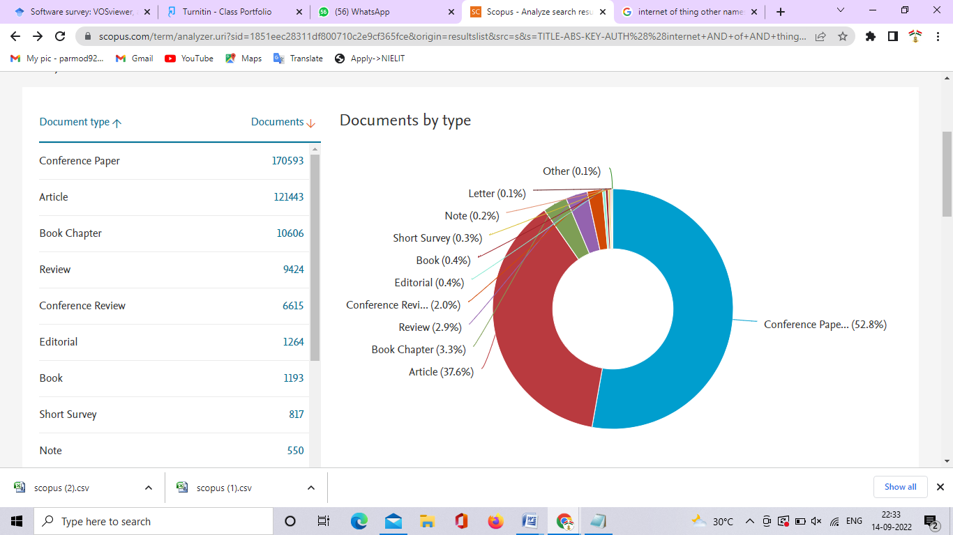

**Fig. 7. Documents by types**

1. **Documents by Country:** Figure 8. represents documents published or accepted for publication by various countries. China and the United States have the highest number of documents. The 60436 documents were published or submitted for publication by China, and 51720 60436 documents were published or submitted for publication by the United States. India has 39687 documents published or accepted for publication in journals indexed in Scopus.

**Table 9: Documents by Country:**

|  |  |
| --- | --- |
| **Country/Territory** | **Documents** |
| China | 60436 |
| United States | 51720 |
| India | 39687 |
| South Korea | 17407 |
| United Kingdom | 16618 |
| Italy | 15116 |
| Germany | 14475 |
| Japan | 11946 |
| France | 10028 |
| Canada | 9981 |

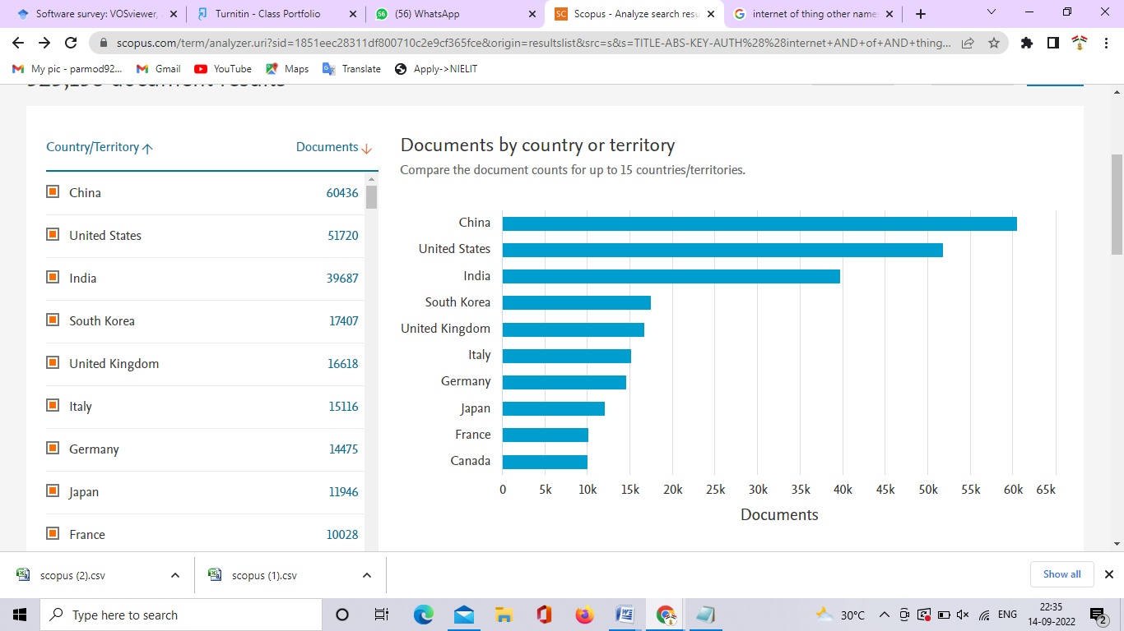

**Fig.8. Documents by Country:**

1. **Documents by a funding sponsor:** Figure 9. represents documents by a funding sponsor in various journals indexed in Scopus. The National Natural Science Foundation of China is sponsoring 20677 documents and the National Science Foundation is sponsoring 7668.

**Table 10. Documents by a funding sponsor**

|  |  |
| --- | --- |
| **Funding sponsor** | **Documents** |
| National Natural Science Foundation of China | 20677 |
| National Science Foundation | 7668 |
| European Commission | 5283 |
| National Research Foundation of Korea | 4629 |
| Horizon 2020 Framework Programme | 4514 |
| National Key Research and Development Program of China | 3734 |
| Fundamental Research Funds for the Central Universities | 3694 |
| Ministry of Science, ICT and Future Planning | 2817 |
| European Regional Development Fund | 2510 |
| Engineering and Physical Sciences Research Council | 2290 |

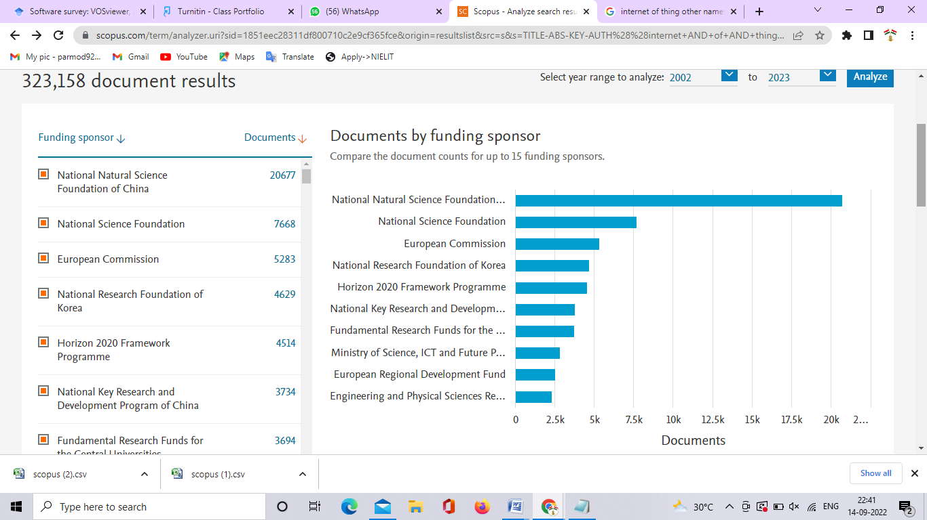

**Fig.9. Documents by a funding sponsor**

We selected 2000 highly cited papers for interrelationship analysis or various properties of documents. We are now analyzing various interrelationships using VOSviewer.

1. **Co-authorship analysis according to authors** : we analyses co-authorship after applying these conditions The unit of analysis : Authors, The counting method is full counting. The minimum number of documents for an author is 10 and The minimum number of citations for an author is 5000. We got 27 authors that met the threshold . Research associated with  internet of things supported network visualization is split into 7 clusters and there are 410 links between these items . Cluster 1 was assigned the red color, which contained 6 items; Cluster 2 was assigned the green color, which contained 5 items; Cluster 3 was assigned the blue color, which contained 4 items; Cluster 4 was assigned the yellow color, which contained 4 items; Cluster 5 was assigned the violet color, which contained 3 items; Cluster 6 was assigned the sky-blue color, which contained 3 items; and Cluster 7 was assigned the orange color, which contained 2 items.

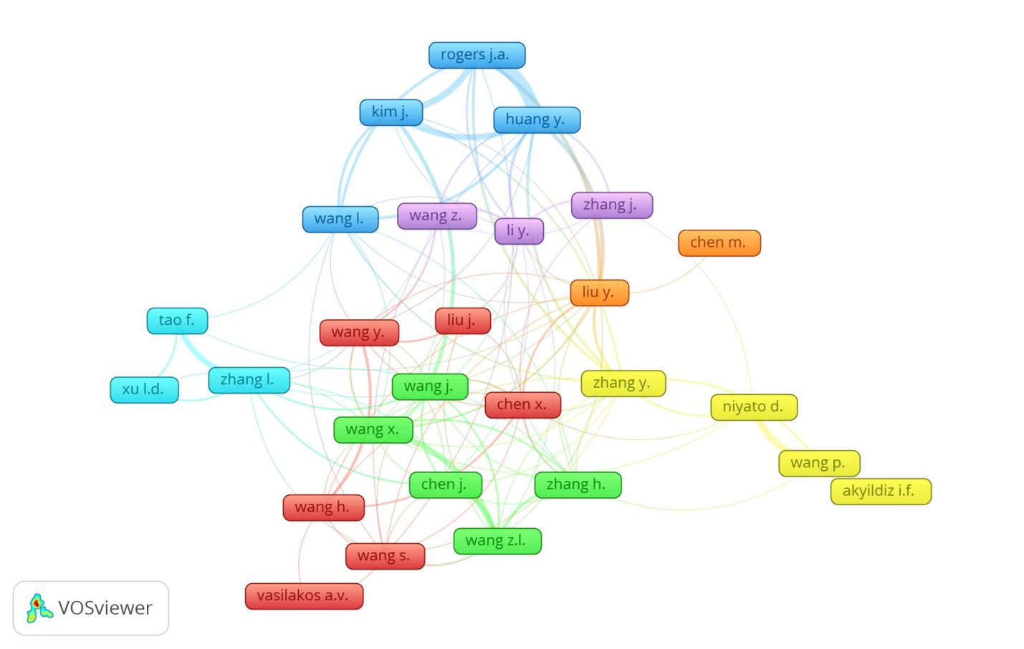

**Fig. 10. Co-authorship analysis according to authors**

1. **Co-authorship analysis according to country** : we analyses co-authorship after applying these conditions Country is the unit of analysis. The counting method is full counting. The minimum number of documents for an author is 5 and The minimum number of citations for an author: 0. We got 45 authors that met the threshold . Research associated with internet of things supported network visualization is split into 7 clusters and there are 3360 links between these items . Cluster 1 was assigned the red color, which contained 15 items; Cluster 2 was assigned the green color, which contained 12 items; Cluster 3 was assigned the blue color, which contained 5 items; Cluster 4 was assigned the yellow color, which contained 5 items; Cluster 6 was assigned the sky-blue color, which contained 3 items; and Cluster 7 was assigned the orange color, which contained 1 item.

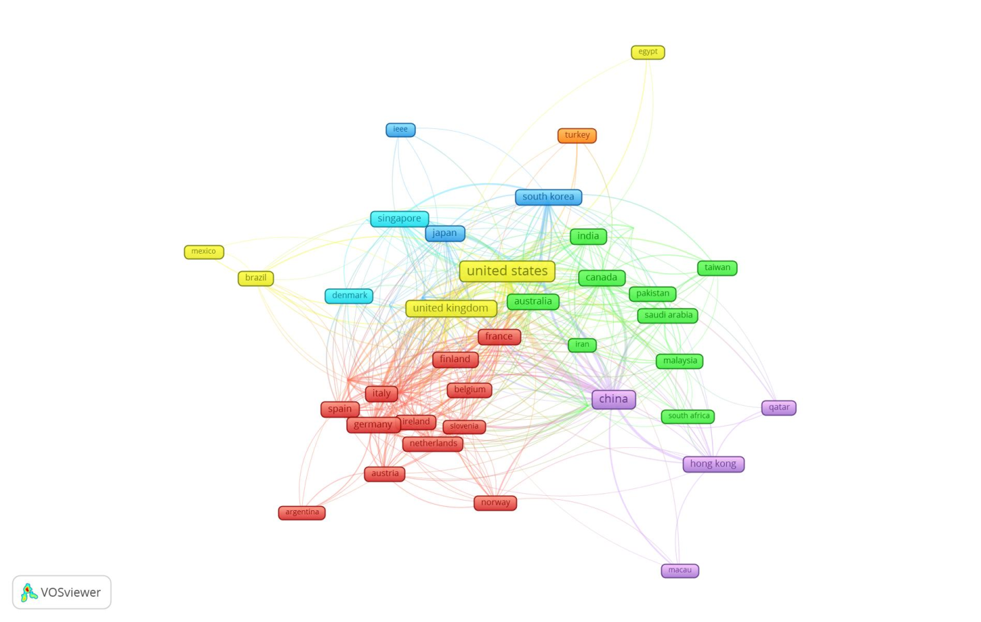

**Fig.11. Co-authorship analysis according to country :**

1. **Co-occurrence analysis for all keywords:** After applying these conditions, we analyses Co-occurrence. unit of analysis for all keywords, The counting method is full counting. The minimum number of occurrences of a keyword is 50 . We got 54 keywords that meet the threshold . Research associated with internet of things supported network visualization is split into 3 clusters. Cluster 1 is colored red and contains 23 items: artificial intelligence, automation, big data, block chain, cloud computing, digital storage, distributed computer systems, edge computing, embedded systems, fog computing, health care, industry 4.0, intelligent buildings, internet, internet of things ,IOT, network architecture, network security, security, surveys, and ubiquitous computing. The green color is assigned to Cluster 2, which contains 17 items that are algorithms, computer simulation, energy efficiency, energy harvesting ,energy utilization, mobile computing, mobile devices, mobile telecommunication systems, network protocols ,optimization, sensor networks, sensors, telecommunication networks, wireless communication, wireless networks, wireless sensor networks, and wireless telecommunication systems. Cluster 3 is colored blue and contains 14 items: articles, chemistry, controlled studies, devices, equipment design, human, humans, male, nanotechnology, priority journal, procedures, reviews, sensors, and wireless communication.

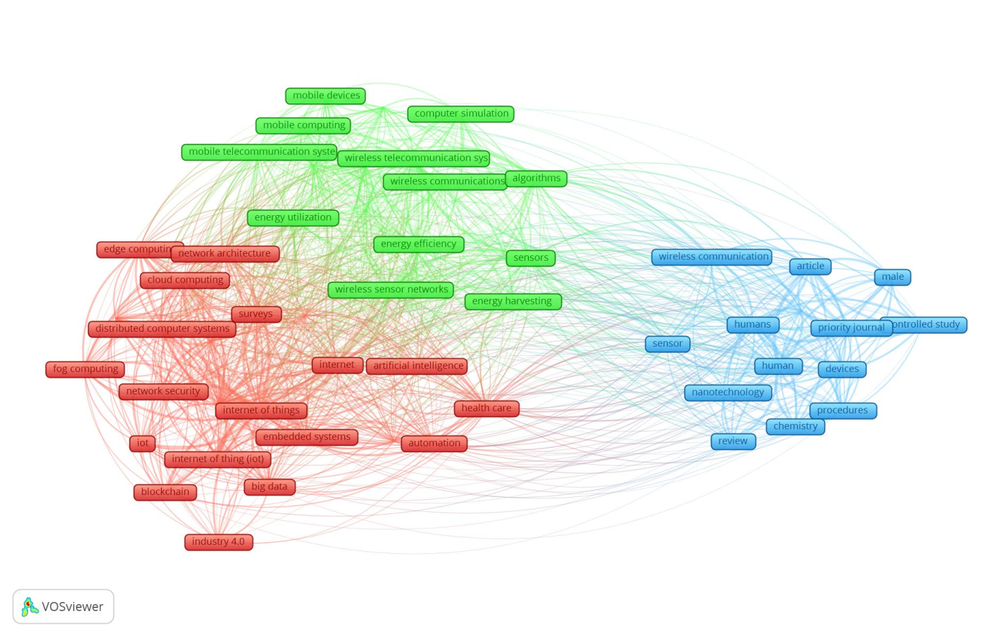

**Fig.12. Co-occurrence analysis for all keywords:**

1. **Authors' keyword co-occurrence analysis:** we analyses Co-occurrence after applying these conditions. Unit of analysis : Authors' keyword, The counting method is full counting. The minimum number of occurrences of a keyword is 10 . We got 58 keywords that meet the threshold . Research associated with internet of things supported network visualization is split into 7 clusters. Cluster 1 was assigned the red color, which contained 16 items; Cluster 2 was assigned the green color, which contained 15 items; Cluster 3 was assigned the blue color, which contained 8 items; Cluster 4 was assigned the yellow color, which contained 6 items; Cluster 5 was assigned the violet color, which contained 5 items; Cluster 6 was assigned the sky-blue color, which contained 5 items; and Cluster 7 was assigned the orange color, which contained 2 items.

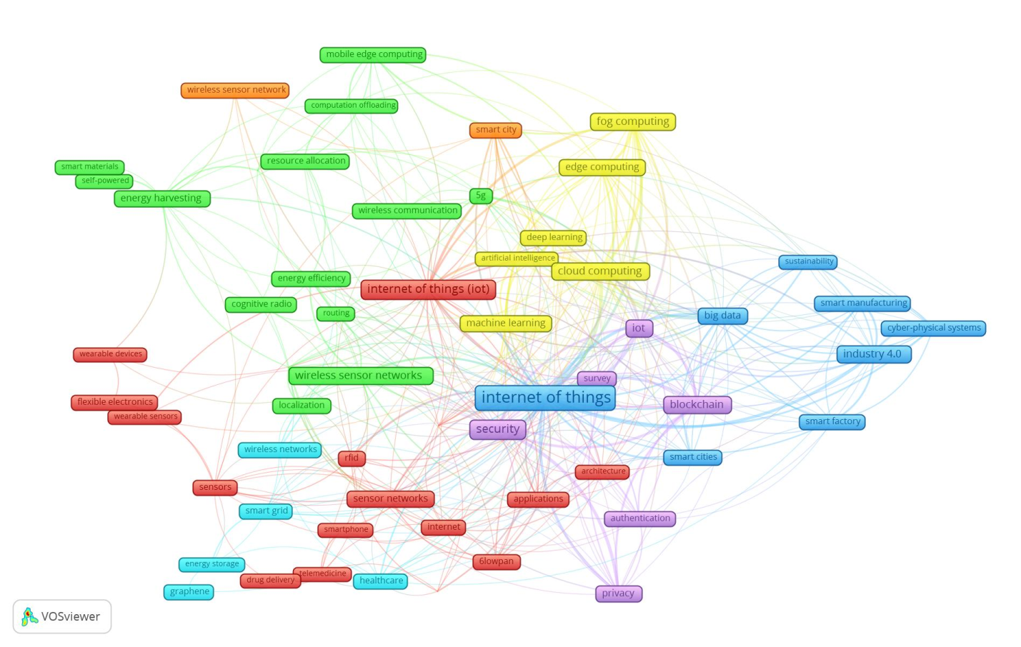

**Fig.13. Authors' keyword co-occurrence analysis:**

1. **Citation analysis by country:** we examine Citation after applying these conditions. Countries are the unit of analysis. The counting method is full counting. The minimum number of documents for a country is 10 and The minimum number of citations for a country is 5000. We have 35 countries that meet that threshold . Research associated with internet of things supported network visualization is split into 5 clusters. Cluster 1 was assigned the red color, which contained 13 items; Cluster 2 was assigned the green color, which contained 13 items; Cluster 3 was assigned the blue color, which contained 7 items; Cluster 4 was assigned the yellow color, which contained 1 item; and Cluster 5 was assigned the violet color, which contained 1 item.

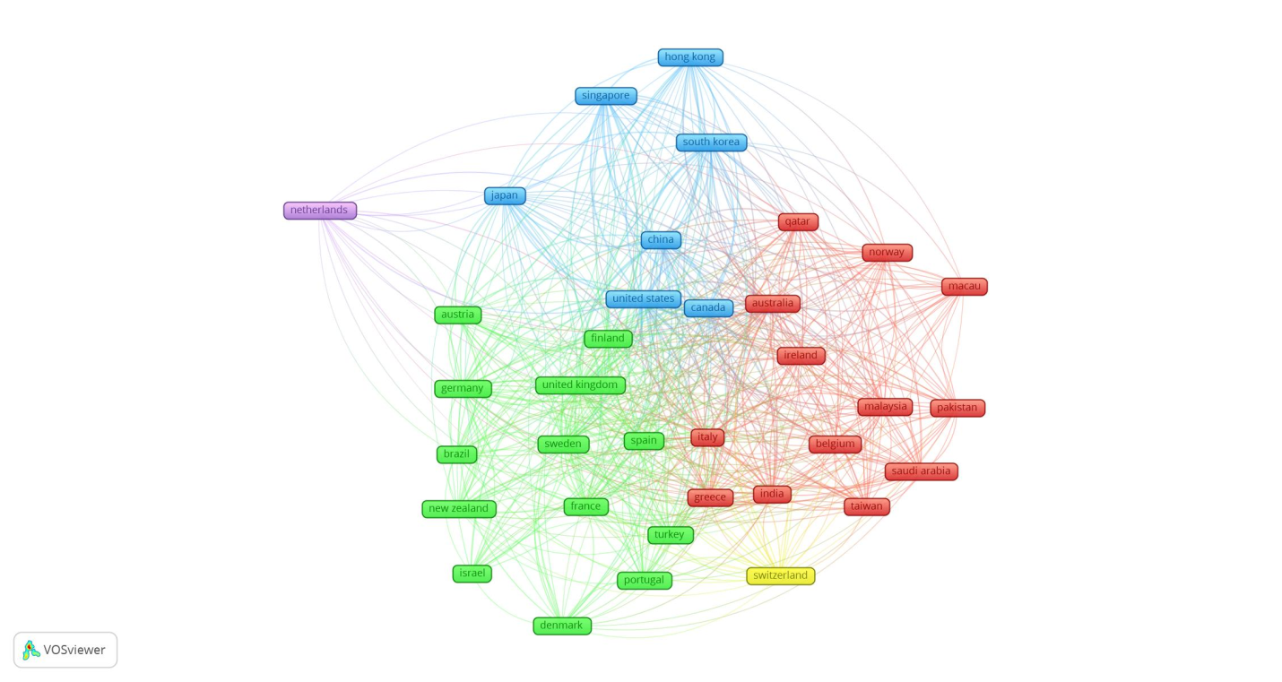

**Fig.14. Citation analysis by country**

**Review of 10 newly published research papers:**

Wang Z., Dong J.(2023) It analyzes the biomechanical properties of dance movement, captured data on dance movement based on rotation, and also finds a relationship between time gravity, fluency, and space. It defines dance movement theoretically and analyzes movement and training methods.[11]

Maatoug A., Belalem G., Mahmoudi S.(2023)Its designs and develop location-based fog computing optimization of energy management in smart buildings named Discrete Event System Specification(DEVS). It designs a new approach with high efficiency and reduces latency.[12]

Kirar M.K. (2023) Its designs and develops an IOT-Based Remote Monitoring, Control, and Protection of Irrigation Water Pumping System using various IOT devices and SIM900 GSM. It is the new model which provides high efficiency. In this, Single phasing is detected and the supply is tripped within 0.15 sec, under voltage protection operated in 0.3 sec, and a 5% unbalance in supply voltage is detected successfully and protection is operated within time.[13]

Wang X., Jiang P., Baker T., Li T., Zhu L.(2023)It design a new model named R-PAC to a simulated Ethereal network to measure its performance. R-PAC provides low cost, high efficiency, and high security.[14]

Fernandes J.M., Silva J.S., Rodrigues A., Boavida F.(2023)In this Unobtrusive Sensing of Humans, research data is presented, and analyzing various approaches. It also finds issues, challenges, and a new field of research in Unobtrusive Sensing.[15]

Bang A.O., Rao U.P., Kaliyar P., Conti M.(2023) It is a survey on RPL based IOT network. It gives a new classification scheme to reduce routing attacks and manage mitigation.[16]

Ghosh S., Chatterjee A., Chatterjee D.(2023) Its designs and develop IOT based type-2 fuzzy system for identifying household appliances using extracted statistical features. It also developed a laboratory-scale prototype system to verify and validate the designed technique or system.[17]

Wang C., Guo R., Yu H., Hu Y., Liu C., Deng C. (2023) It design a new approach named cloud-edge collaboration-based to make effective use of computing resources, processing data from cloud to edge, and provide micro service. The proposed approach is used in performing tool wear monitoring, prediction, and health management.[18]

Jiang X., Sun A., Sun Y., Luo H., Guizani M.(2023) It designs a trust-based hierarchical consensus mechanism (THCM) for a smart grid to improve efficiency and throughput. It also implements a prototype system to evaluate the performance of THCM. The results demonstrate that the consensus efficiency is improved by 19.8%, the throughput is improved by 12.34%, and the storage is reduced by 37.9%.[19]

Liao Z., Ai J., Liu S., Zhang Y., Liu S. (2023) It designs a blockchain-based crowdsourcing model using the DBSCAN algorithm for solving privacy issues and task assignments. It implements a prototype on the Ethereum test network Ropsten. It is experimentally proved that it is useful for mobile users and security systems to ensure privacy and confidently.[25]

**Review of 10 highly cited research papers :**

Akyildiz I.F., Su W., Sankarasubramaniam Y., Cayirci E. (2002) It is based on a wireless sensor network. It defines how to design a sensor network, architecture, protocol of each layer and issues of the sensor network.[31]

Atzori L., Iera A., Morabito G.(2010) It is based on an IOT survey. It defines previous research, various vision of the IOT paradigm, issues related to IOT, and future scope.[32]

Goldsmith A. (2005) It defines introduction, design techniques, tools, the core principle of designing, characteristics, and modulation techniques. It describes with figures and examples.[33]

Gubbi J., Buyya R., Marusic S., Palaniswami M. (2013) It defines the cloud-based IOT system and various technologies to deal with private and public clouds. It presented cloud implementation using the Aneka tool. [34]

BahlParamvir, PadmanabhanVenkata N. (2000) It defines a radar base system to track the user. This research is based on an experiment that shows how to increase the ability of radar to track location.[35]

Rappaport T.S., Sun S., Mayzus R., Zhao H., Azar Y., Wang K., Wong G.N., Schulz J.K., Samimi M., Gutierrez F.(2013) It motivates research on Millimeter-wave cellular systems. It describes the method, hardware for measurement, and result of measurement. [36]

Revell L.J. (2012) It is an R package for phylogenetic comparative biology. It describes the method, and results using examples and also describes a web log. [37]

Al-Fuqaha A., Guizani M., Mohammadi M., Aledhari M., Ayyash M. (2015) It is IOT based survey. It provides an overview, technical details, and used IOT devices It surveys various technologies, protocols, issues, and applications of the Internet of Things. It also concludes various old surveys and review papers.[38]

Stuart M.A.C., Huck W.T.S., Genzer J., Müller M., Ober C., Stamm M., Sukhorukov G.B., Szleifer I., Tsukruk V.V., Urban M., Winnik F., Zauscher S., Luzinov I., Minko S. (2010) It reviews the previous research, advancement, and various challenges in the development of Emerging applications of stimuli-responsive polymer materials.[39]

Kurs A., Karalis A., Moffatt R., Joannopoulos J.D., Fisher P., Soljačić M. (2007) It experimentally proves that nonradiative power transfer up to 8 times the radius of the coils. It gives a new model for power transfer with a 5% experiment result. It gives the suggestion and direction to the practical implementation of Wireless power transfer via strongly coupled magnetic resonances. [40]

**CONCLUSION :** Finally, we can say that the Internet of things (IOT) is a growing field in computer science as well as all other fields like bioscience, physics, biotechnology etc. Almost all developed and developing countries are conducting more research into the Internet of Things (IOT). The number of IOT devices is also increasing day to day at a higher speed. We believe that more research into the Internet of Things (IOT) should be conducted. We can live a simpler life with the help of the Internet of Things (IOT) and also get real-time information or data, which is very helpful for taking decisions. The Internet of things (IOT) is very useful for bioscience because we need real-time data about the environment to take decisions which can protect our lives and the environment.

**REFERENCE:**

[1] Ruchi Parashar1, Abid Khan2, Neha3,"A SURVEY: THE INTERNET OF THINGS",International Journal of Technical Research and Applications e-ISSN: 2320-8163, www.ijtra.com Volume 4, Issue 3 (May-June, 2016), PP. 251-257

[2] Guangwen H., 2008. Application of RFID and Internet of Things in Monitoring and Anticounterfeiting for Products. International Seminar on Business and Information, Wuhan, Hubei, China, Pages: 392- 395

[3] SomayyaMadakam, R. Ramaswamy, SiddharthTripathi,"Internet of Things (IOT): A Literature Review", Journal of Computer and Communications, May 2015, Volume 3, 164-173, http://www.scirp.org/journal/jcc

[4] Kashani ES, Radosevic S, Kiamehr M, Gholizadeh H. The intellectual evolution of the technological catch-up literature: Bibliometric analysis. Research Policy. 2022 Sep 1;51(7):104538.

[5] Burnham JF. Scopus database: a review. Biomedical digital libraries. 2006 Dec;3(1):1-8.

[6] Van Eck N, Waltman L. Software survey: VOSviewer, a computer program for bibliometric mapping. scientometrics. 2010 Aug 1;84(2):523-38.

[7] Rejeb A, Rejeb K, Abdollahi A, Al-Turjman F, Treiblmaier H. The Interplay between the Internet of Things and Agriculture: A Bibliometric Analysis and Research Agenda. Internet of Things. 2022 Jul 18:100580.

[8] Rejeb A, Rejeb K, Simske S, Treiblmaier H, Zailani S. The big picture on the internet of things and the smart city: a review of what we know and what we need to know. Internet of Things. 2022 Aug 1;19:100565.

[9] Kumar S, Saini A, Kumar S, Kumar V. Bibliometric Analysis on Internet of Things (IOT) and Tourism Industry: A Study Based on Scopus Database. South Asian Journal of Tourism and Hospitality. 2022 Jun 13;2(1).

[10] Márquez CL, Avilés JD, Ovalle-Osuna OO, Barragán-Quintero RV. The interrelationship between Lean Manufacturing and Internet of Things: a bibliometric analysis. In2022 IEEE Technology and Engineering Management Conference (TEMSCON EUROPE) 2022 Apr 25 (pp. 135-140). IEEE.

[11] Wang Z, Dong J. Design of Dance Data Management System Based on Computer-Aided Technology Under the Background of Internet of Things. Comput -Aided Des Appl 2023;20(S2):45-55.

[12] Maatoug A, Belalem G, Mahmoudi S. A location-based fog computing optimization of energy management in smart buildings: DEVS modeling and design of connected objects. Front ComputSci 2023;17(2).

[13] Kirar MK. IOT Based Remote Monitoring, Control, and Protection of Irrigation Water Pumping System. J Oper Auto Power Eng 2023;11(1):69-75.

[14] Wang X, Jiang P, Baker T, Li T, Zhu L. Enabling privacy and leakage resistance for dynamic blockchain-based access control systems. Comput Stand Interfaces 2023;84.

[15] Fernandes JM, Silva JS, Rodrigues A, Boavida F. A Survey of Approaches to Unobtrusive Sensing of Humans. ACM ComputSurv 2023;55(2).

[16] Bang AO, Rao UP, Kaliyar P, Conti M. Assessment of Routing Attacks and Mitigation Techniques with RPL Control Messages: A Survey. ACM ComputSurv 2023;55(2).

[17] Ghosh S, Chatterjee A, Chatterjee D. Extraction of statistical features for type-2 fuzzy NILM with IOT enabled control in a smart home. Expert Sys Appl 2023;212.

[18] Wang C, Guo R, Yu H, Hu Y, Liu C, Deng C. Task offloading in cloud-edge collaboration-based cyber physical machine tool. Rob ComputIntegrManuf 2023;79.

[19] Jiang X, Sun A, Sun Y, Luo H, Guizani M. A Trust-Based Hierarchical Consensus Mechanism for Consortium Blockchain in Smart Grid. Tsinghua Sci Tech 2023;28(1):69-81.

[20] Shi B, Zhang X, Li W, Liang N, Hu X, Xiao J, et al. An intrinsic dual-emitting fluorescence sensing toward tetracycline with self-calibration model based on luminescent lanthanide-functionalized metal-organic frameworks. Food Chem 2023;400.

[21] Tian K, Hu D, Wei Q, Fu Q, Deng H. Recent progress on multifunctional electromagnetic interference shielding polymer composites. J Mater SciTechnol 2023;134:106-131.

[22] Abdelbasset WK, Savina SV, Mavaluru D, Shichiyakh RA, Bokov DO, Mustafa YF. Smartphone based aptasensors as intelligent biodevice for food contamination detection in food and soil samples: Recent advances. Talanta 2023;252.

[23] Macagno J, Gerlero GS, Satuf ML, Berli CLA. Field-deployable aptasensor with automated analysis of stain patterns for the detection of chlorpyrifos in water. Talanta 2023;252.

[24] Liu X, Gao R, Han L, Kan C, Xu J. A smartphone readout device for portable and sensitive estimation of Hg2+ via coumarin-modified paper. Talanta 2023;252.

[25] Liao Z, Ai J, Liu S, Zhang Y, Liu S. Blockchain-based mobile crowdsourcing model with task security and task assignment. Expert Sys Appl 2023;211.

[26] Mu Y, Wang C, Xu Y-, Du X-, Pan Q-, Zhang H-, et al. Time-coordinated SPAD-based receiver for high-speed optical wireless communication. Opt Commun 2023;526.

[27] Dao N-. Internet of wearable things: Advancements and benefits from 6G technologies. Future GenerComputSyst 2023;138:172-184.

[28] Indrawan B, Alzamora DG, Rahmatullah MS, Wikarta A. Facial Recognition-Based Automatic Door Security System Integrated with Internet of Things for Smart Home Actualization. Lect Notes MechEng 2023:360-368.

[29] 5th International Conference on Mechanical Engineering, ICOME 2021. Lect Notes MechEng 2023.

[30] Tang J, Lu X, Xiang Y, Shi C, Gu J. Blockchain search engine: Its current research status and future prospect in Internet of Things network. Future GenerComputSyst 2023;138:120-141.

[31] Akyildiz IF, Su W, Sankarasubramaniam Y, Cayirci E. Wireless sensor networks: A survey. Comput Networks 2002;38(4):393-422.

[32] Atzori L, Iera A, Morabito G. The Internet of Things: A survey. Comput Networks 2010;54(15):2787-2805.

[33] Goldsmith A. Wireless communications. Wireless Communications; 2005. p. 1-644.

[34] Gubbi J, Buyya R, Marusic S, Palaniswami M. Internet of Things (IOT): A vision, architectural elements, and future directions. Future GenerComputSyst 2013;29(7):1645-1660.

[35] RADAR: An in-building RF-based user location and tracking system. Proceedings - IEEE INFOCOM; 2000.

[36] Rappaport TS, Sun S, Mayzus R, Zhao H, Azar Y, Wang K, et al. Millimeter wave mobile communications for 5G cellular: It will work! IEEE Access 2013;1:335-349.

[37] Revell LJ. phytools: An R package for phylogenetic comparative biology (and other things). Methods EcolEvol 2012;3(2):217-223.

[38] Al-Fuqaha A, Guizani M, Mohammadi M, Aledhari M, Ayyash M. Internet of Things: A Survey on Enabling Technologies, Protocols, and Applications. IEEE CommunSurv Tutor 2015;17(4):2347-2376.

[39] Stuart MAC, Huck WTS, Genzer J, Müller M, Ober C, Stamm M, et al. Emerging applications of stimuli-responsive polymer materials. Nat Mater 2010;9(2):101-113.

[40] Kurs A, Karalis A, Moffatt R, Joannopoulos JD, Fisher P, Soljačić M. Wireless power transfer via strongly coupled magnetic resonances. Science 2007;317(5834):83-86.

[41] Fog computing and its role in the internet of things. MCC'12 - Proceedings of the 1st ACM Mobile Cloud Computing Workshop; 2012.

[42] An energy-efficient MAC protocol for wireless sensor networks. Proceedings - IEEE INFOCOM; 2002.

[43] Congestion avoidance and control. Symposium Proceedings on Communications Architectures and Protocols, SIGCOMM 1988; 1988.

[44] Zanella A, Bui N, Castellani A, Vangelista L, Zorzi M. Internet of things for smart cities. IEEE Internet Things J 2014;1(1):22-32.

[45] Shi W, Cao J, Zhang Q, Li Y, Xu L. Edge Computing: Vision and Challenges. IEEE Internet Things J 2016;3(5):637-646.

[46] Kim D-, Lu N, Ma R, Kim Y-, Kim R-, Wang S, et al. Epidermal electronics. Science 2011;333(6044):838-843.

[47] Schubert EF, Kim JK. Solid-state light sources getting smart. Science 2005;308(5726):1274-1278.

[48] Xu LD, He W, Li S. Internet of things in industries: A survey. IEEE Trans IndInf 2014;10(4):2233-2243.

[49] Bulusu N, Heidemann J, Estrin D. GPS-less low-cost outdoor localization for very small devices. IEEE PersCommun 2000;7(5):28-34.

[50] Palomares V, Serras P, Villaluenga I, Hueso KB, Carretero-González J, Rojo T. Na-ion batteries, recent advances and present challenges to become low cost energy storage systems. Energy Environ Sci 2012;5(3):5884-5901.