**Comparative Structural Analysis of High-Rise Reinforced Concrete and Composite Edifices Using STAAD.Pro and ETABS**

**Zahid Azam 1,Afzal Khan2**

Millennium institute of technology and science,Bhopal

**Abstract:**  
The study explores the structural performance of high-rise buildings with reinforced concrete (RCC) and composite structures. Analytical methods such as P-Delta, Time History Analysis, and Response Spectrum Analysis are used to compare structural behaviors under different loading conditions. Software tools STAAD.Pro V8i and ETABS are employed to model 20-storey structures, assessing parameters like weight, base shear, and storey drift. Findings indicate that while RCC structures provide stability, composite structures demonstrate superior weight efficiency but may experience higher drift. The results guide the selection of suitable materials for high-rise construction, considering structural safety and economic factors.

**Keywords:**  
High-rise buildings, RCC, Composite structures, STAAD.Pro V8i, ETABS, P-Delta Analysis, Seismic response.

**1. Introduction**

The growing demand for multi-storey buildings worldwide is driven by urbanization and land scarcity. Reinforced concrete and composite structures are commonly used in high-rise construction due to their distinct material properties. This paper aims to compare the structural performance of RCC and composite materials in a 20-storey building scenario, using advanced computational tools for detailed analysis.

**2. Literature Review**

A review of previous research highlights various approaches to designing and analyzing multi-storey buildings. While some studies focus on RCC's strength and durability, others advocate for the lightweight and flexible nature of composite materials. The use of STAAD.Pro V8i and ETABS for structural analysis has been validated in prior works, providing the foundation for this comparative study.

**2.1 Analysis Techniques for Structural Design**

* **Deshmukh, D.R. et al. (2016):** Studied the design of a G+19 RCC building using STAAD.Pro, demonstrating that STAAD.Pro is effective for analyzing complex structures. Their findings support the use of software for handling the intricacies of multi-storey building design.
* **Ramya, D. (2015):** Conducted a comparative study on G+10 multi-storey buildings using STAAD.Pro and ETABS. The research provided insights into the accuracy of these tools, revealing that ETABS yielded more precise results in dynamic analysis.
* **Wagh, S.A. et al. (2014):** Examined RCC and composite structures of varying heights (G+12, G+16, G+20, G+24), comparing their performance. Their analysis indicated that composite structures could significantly reduce construction costs and time due to material efficiency.

**2.2 Seismic Analysis and Structural Safety**

* **Beigi, H.A. et al. (2015):** Investigated the effects of seismic retrofit on soft-story buildings, emphasizing the importance of structural modifications for enhanced safety. The study's findings on soft-story vulnerability are relevant for comparing the seismic performance of RCC and composite buildings.
* **Patil, A.S. et al. (2013):** Performed time history analysis on RCC buildings under various earthquake intensities using SAP2000. Their research demonstrated the critical impact of earthquake intensity on structural response, emphasizing the need for accurate seismic analysis tools.
* **Zhai, C.H. et al. (2015):** Explored the impact of mainshock-aftershock sequences on RCC buildings, finding that sequential loading can increase lateral displacement by up to 30%. This work underscores the necessity of considering multiple seismic events in structural design.

**2.3 Comparative Analysis of RCC and Composite Structures**

* **Jani, K. and Patel, P.V. (2013):** Analyzed the diagrid structural system for high-rise steel buildings using ETABS, noting that lateral load resistance was largely managed by diagrid columns. Their approach can inform the comparative analysis of lateral load resistance in RCC versus composite structures.
* **Nassani, D.E. (2014):** Studied vibration periods in steel structures and found that software tools such as STAAD.Pro provide quicker and more accurate results compared to conventional methods. These findings are crucial for understanding the benefits of software-based structural analysis in multi-storey building design.

**3. Methodology**

**3.1 Structural Model Description**

Two 20-storey models were developed: one RCC and one composite, designed using STAAD.Pro V8i and ETABS. The RCC structure utilizes M25 grade concrete and Fe415 grade steel, while the composite structure combines steel and concrete elements.

**3.2 Analysis Techniques**

* **P-Delta Analysis:** Evaluates structural stability by considering secondary moments due to axial displacements.
* **Time History Analysis:** Assesses dynamic response under realistic seismic loading using historical earthquake data.
* **Response Spectrum Analysis:** Calculates maximum structural response for varying frequencies, as per IS1893:2002 guidelines.

**3.3 Design Parameters**

* **Material Properties:** M25 concrete, Fe415 steel for RCC; structural steel sections for composite.
* **Loading Conditions:** Live load of 2 kN/m², wind load as per IS 875, and seismic load per IS 1893:2002.
* **Dimensions:** Floor height of 4 m, total building height of 80 m, varying floor plans (32m x 32m up to 44m x 44m).

|  |  |  |
| --- | --- | --- |
| **S.NO** | **PARTICULARS** | **DIMENSION/VALUE/SIZE** |
| 1 | PLAN(Upto5floors) | 32m*32m |
| 2 | PLAN(Upto15floors) | 40m*40m |
| 3 | PLAN(Upto20floors) | 44m*44m |
| 4 | FLOORHEIGHT | 4m |
| 5 | COLUMNSIZE | .60m*.60m |
| 6 | BEAMSIZE | .40m*.40m |
| 7 | FOUNDATIONDEPTH | 10m |
| 8 | TYPE OFSOIL | HARD |
| 9 | ZONETYPE | 3 |
| 10 | GRADEOFCONCRETE | M25 |
| 11 | GRADEOFSTEEL | Fe415 |

**4. Results and Discussion**

**4.1 Concrete Design and Material Requirements**

The RCC structure required approximately 8688.7 cubic meters of concrete, with higher quantities of reinforcement due to the heavier self-weight compared to the composite structure.

**4.2 P-Delta Analysis Results**

The composite structure exhibited a 0.041667% higher storey drift than the RCC structure, indicating increased flexibility. However, the deflection remained within permissible limits.

**4.3 Time History Analysis**

As time increased, the frequency of the RCC structure decreased. Both models showed significant responses under dynamic loading, with the composite structure displaying slightly larger displacements.

**4.4 Response Spectrum Analysis**

Modal mass participation for both structures exceeded 90%, meeting code requirements. The RCC structure experienced higher base shear than the composite model, suggesting more significant load-bearing capacity.

**4.5 Comparative Analysis**

The composite structure's weight was found to be 94.45% of the RCC structure's weight, indicating a lighter and more efficient design. However, increased drift in the composite model

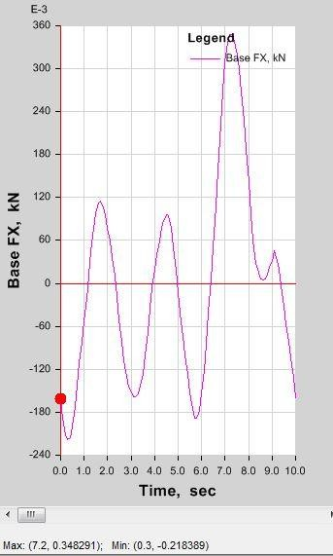may necessitate additional considerations for lateral stability.

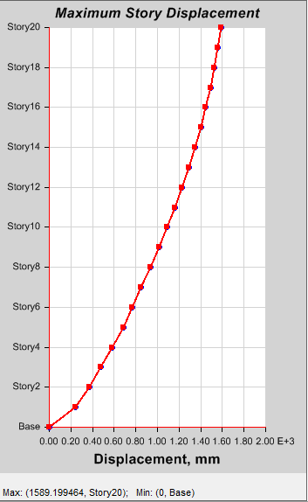

**Fig: 4.1 Response Plot**

**4.6 Economic Considerations**

The cost analysis showed a significant reduction in material costs for composite structures due to the lower weight, which also reduced foundation requirements.

**5. Conclusion**

The comparative analysis revealed that RCC structures offer better resistance to lateral forces due to their higher mass, while composite structures provide a lighter alternative with economic benefits. The choice between these materials should consider project-specific requirements, such as seismic activity and cost constraints.  
Future research should focus on hybrid structural systems to optimize the advantages of both RCC and composite materials.

**References**

1. Beigi, H.A., et al. "Factors influencing the repair costs of soft-story RC frame buildings." *Engineering Structures*, 2015.
2. Cherifi, F., et al. "Seismic Vulnerability of Reinforced Concrete Structures in Tizi-Ouzou City (Algeria)." *Procedia Engineering*, 2015.
3. Deshmukh, D.R., et al. "Comparative Analysis and Design of Multistorey Buildings Using STAAD.Pro." *International Journal of Engineering Research and Applications*, 2016.
4. IS 456:2000. "Code of Practice for Plain and Reinforced Concrete."
5. IS 1893:2002. "Criteria for Earthquake Resistant Design of Structures."
6. IS 875:1987. "Code of Practice for Design Loads (Other Than Earthquake) for Buildings and Structures."
7. Jani, K., and Patel, P.V. "Analysis and design of diagrid structural system for high rise steel buildings." *Procedia Engineering*, 2013.
8. Muljati, I., et al. "Performance of Force Based Design Versus Direct Displacement Based Design in Predicting Seismic Demands." *Procedia Engineering*, 2015.
9. Nassani, D.E. "A Simple Model for Calculating the Fundamental Period of Vibration in Steel Structures." *APCBEE Procedia*, 2014.
10. Patel, K., and Thakkar, S. "Analysis of CFT, RCC and STEEL buildings subjected to lateral loading." *Procedia Engineering*, 2013.
11. Ramya, D. "Comparative Study on Design and Analysis of Multistoreyed Building (G+10) by STAAD.Pro and ETABS." *International Journal of Engineering Sciences & Research Technology*, 2015.
12. Wagh, S.A., et al. "Comparative Study on Analysis of Multi-storey Buildings Using STAAD.Pro and ETABS." *International Journal of Engineering Research and Applications*, 2014.