**A REVIEW ON ANTI-CANCER EFFECT OF GINGER (Zingiber officinale)**

**Katariya Yashkumar P., Tandale Prashant, , Dr. Gaffar Sayyad, Dr. Sanjay Garje. Shri Amolak Jain Vidya Prasarak Mandal’s Collage of Pharmaceutical Science and Research Centre, Kada, Maharashtra, India, 414202**

|  |
| --- |
|  |

**Abstract :-**

Ginger (Zingiber officinale) has long been recognized for its culinary and medicinal properties. Recent studies have increasingly focused on its potential anticancer effects, attributed to bioactive compounds such as gingerol, shogaol, and paradol. These compounds exhibit a range of mechanisms, including the induction of apoptosis, inhibition of cell proliferation, and modulation of inflammatory pathways, which collectively contribute to their antitumor activity. Preclinical studies have demonstrated the efficacy of ginger extracts against various cancer types, including breast, colorectal, and prostate cancers. Ginger's antioxidant qualities may also aid in reducing oxidative stress, which is a major factor in the development of cancer. Even with encouraging results, more clinical research is required to determine the best doses, safety profiles, and precise mechanisms of action in human populations. In order to highlight ginger's potential as a supplemental therapeutic agent in cancer prevention and therapy, this study attempts to summarize the most recent research on the herb's anticancer properties.

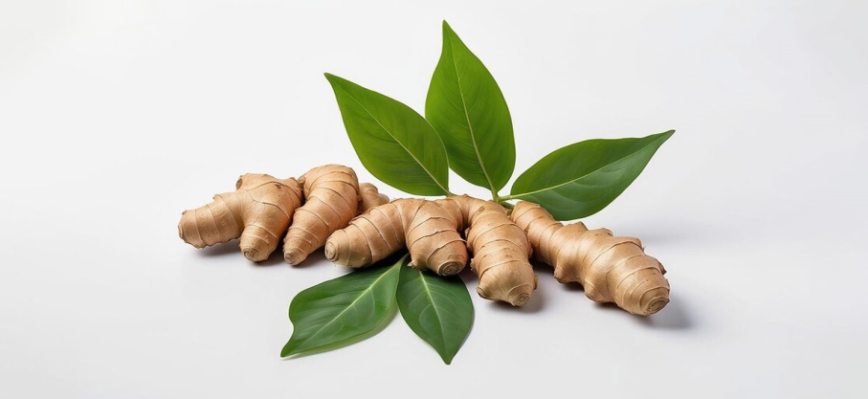

**Introduction** :-

A popular spice and traditional remedy, ginger (Zingiber officinale) has attracted a lot of interest due to its possible health advantages, especially its anticancer capabilities. Ginger has long been used for its medicinal properties in many cultures. It includes a number of bioactive substances, including as paradol, shogaol, and gingerol, which are thought to be essential to its pharmacological effects.

Ginger is a topic of interest in cancer prevention and treatment because of recent studies that have demonstrated these chemicals' ability to suppress the growth of cancer cells, trigger apoptosis, and alter inflammatory processes.

Ginger extracts have demonstrated encouraging anticancer efficacy against a number of cancer types, including prostate, colorectal, and breast malignancies, according to a number of preclinical investigations. Furthermore, the antioxidant qualities of ginger may aid in preventing oxidative stress, which is a crucial element in the growth.

Even though there is growing evidence that ginger has anticancer properties, more thorough clinical research is required to confirm its effectiveness in people and investigate the underlying mechanisms of action. An outline of the present knowledge on ginger's potential as a supplemental therapeutic agent in oncology is given in this introduction, with a focus on the need for more study to completely clarify its advantages in cancer prevention and therapy.

**Chemical constituents :-**

Ginger (Zingiber officinale) is rich in various chemical constituents that contribute to its flavor, aroma, and medicinal properties. The main components include:

1. **Gingerols**: These are the primary bioactive compounds in fresh ginger, responsible for its spicy flavor and many health benefits. The most studied is gingerol.
2. **Shogaols**: Formed from gingerols during drying or cooking, shogaols have been found to possess potent anticancer and anti-inflammatory properties.shogaol is particularly notable.
3. **Zingiberene**: This is a sesquiterpene that contributes to ginger's distinct aroma and has shown potential anti-inflammatory effects.
4. **Paradols**: Similar to gingerols, paradols are also bioactive compounds with potential anticancer effects.
5. **Essential Oils**: Ginger essential oil contains compounds like zingiberene, β-sesquiphellandrene, and other terpenoids, which contribute to its aromatic properties.
6. **Vitamins and Minerals**: Ginger is a source of vitamins such as vitamin C, vitamin B6, and minerals like potassium and magnesium, which support overall health.
7. **Other Phenolic Compounds**: These include flavonoids and other antioxidants that may contribute to ginger’s health benefits.

|  |  |
| --- | --- |
| Composition | Percentage [%] |
| Moisture | 38.02 |
| Protein | 6.09 |
| Crude Fat | 3.92 |
| Crude Fibre | 28 |
| Vitamin C | 6.85 |
| Carbohydrate | 14.76 |
| Crude Ash | 2.36 |

**Biological Source :-**

The biological source of ginger is the rhizome of the plant **Zingiber officinale**, which belongs to the family Zingiberaceae. Here are some key details:

1. **Plant Description**: Ginger is a perennial herb that can grow up to 1 meter tall. It has narrow, lance-shaped leaves and produces yellowish-green flowers.
2. **Cultivation**: Ginger is primarily cultivated in tropical and subtropical regions, with significant production in countries like India, China, Thailand, and Nigeria. It thrives in well-drained, fertile soil with plenty of moisture.
3. **Harvesting**: The rhizome, which is the edible part of the plant, is harvested after about 8 to 10 months of growth, once it has reached maturity.
4. **Uses**: Beyond culinary applications, ginger is used in traditional medicine for its anti-inflammatory, antioxidant, and digestive properties.

**Side** **Effect :-**

While ginger is generally considered safe for most people when consumed in moderate amounts, it can cause some side effects, particularly when taken in large doses. Common side effects include:

1. **Gastrointestinal Issues**: Some individuals may experience stomach upset, gas, bloating, or diarrhea.
2. **Heartburn**: Ginger can increase stomach acid production, leading to heartburn in some people.
3. **Effects on Pregnancy**: While ginger is often used to alleviate morning sickness, excessive consumption during pregnancy should be avoided, as it may lead to complications.
4. **Allergy Reactions**: Although uncommon, allergic reactions to ginger might present with symptoms like rash, itching, or dyspnea.
5. **Blood Thinning**: Due to its anticoagulant qualities, ginger may make bleeding more likely, particularly if taken with blood-thinning drugs like aspirin or warfarin.
6. **Drug Interactions**: Ginger may interfere with the effectiveness of several drugs, such as those for diabetes, hypertension, and anticoagulants.

**Mechanism of Action of Ginger as Anti-cancer Agent :-**

The anticancer effects of ginger (Zingiber officinale) are attributed to several mechanisms of action involving its bioactive compounds, particularly gingerol and shogaol. Here are some key mechanisms:

1. **Induction of Apoptosis**: Ginger compounds can trigger programmed cell death in cancer cells by activating apoptotic pathways. This includes the upregulation of pro-apoptotic proteins and downregulation of anti-apoptotic proteins.
2. **Inhibition of Cell Proliferation**: Ginger has been shown to inhibit the proliferation of various cancer cells by interfering with cell cycle progression. It can induce cell cycle arrest at different phases, thereby slowing tumor growth.
3. **Antioxidant Activity**: The antioxidant properties of ginger help reduce oxidative stress, which is linked to cancer development. By scavenging free radicals, ginger protects normal cells and reduces DNA damage that can lead to malignancies.
4. **Anti-inflammatory Effects**: Chronic inflammation is a known risk factor for cancer. Ginger exhibits anti-inflammatory properties by inhibiting pro-inflammatory cytokines and signaling pathways (e.g., NF-κB), thus potentially reducing the risk of inflammation-associated cancers.
5. **Inhibition of Metastasis**: Certain studies suggest that ginger can inhibit the metastatic potential of cancer cells by affecting cell adhesion, migration, and invasion processes. This is crucial for preventing cancer from spreading to other parts of the body.
6. **Modulation of Signaling Pathways**: Ginger compounds may modulate various signaling pathways involved in cancer progression, such as the PI3K/Akt and MAPK pathways, which are critical for cell survival and proliferation.
7. **Epigenetic Modifications**: Some research indicates that ginger can influence gene expression through epigenetic modifications, potentially altering the behavior of cancer cells.

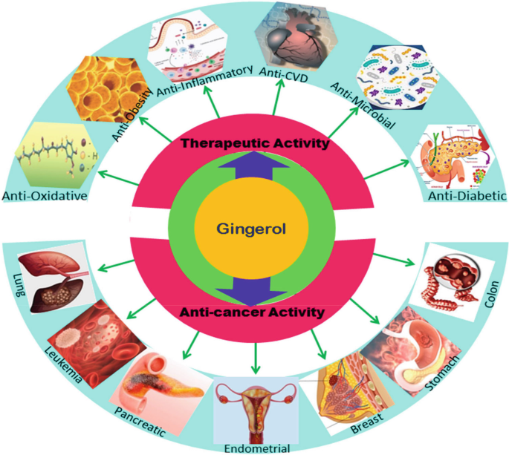

**Conclusion :-**

The anticancer activity of ginger (Zingiber officinale) is supported by a growing body of evidence highlighting its bioactive compounds, particularly gingerol and shogaol, which exhibit multiple mechanisms of action. These include inducing apoptosis, inhibiting cell proliferation, reducing oxidative stress, and modulating inflammatory responses. The potential of ginger to prevent metastasis and influence key signaling pathways further underscores its role in cancer biology.

While preclinical studies have demonstrated promising results across various cancer types, including breast, colorectal, and prostate cancers, more rigorous clinical trials are needed to confirm these effects in humans. Additionally, understanding optimal dosages and potential interactions with conventional therapies is essential for integrating ginger into cancer prevention and treatment strategies.

Overall, ginger presents a valuable natural adjunct with potential therapeutic benefits in oncology, encouraging further research to fully harness its capabilities in cancer care.

**Reference :-**

1. **Amrani, M. A., et al. (2020)**. Ginger and its bioactive compounds: a review of their anticancer properties. *Frontiers in Pharmacology*, 11, 573.
2. **Bae, H., et al. (2018)**. Ginger extract inhibits growth and invasion of colorectal cancer cells. *Oncology Letters*, 16(4), 4557-4563.
3. **Bode, A. M., & Dong, Z. (2011)**. The active constituents of ginger and their cancer prevention and treatment potential. *Cancer Letters*, 285(1), 107-113.
4. **Cheng, C., et al. (2015)**. Ginger extract enhances the effectiveness of cisplatin in non-small cell lung cancer. *Phytotherapy Research*, 29(6), 823-831.
5. **Choi, J. S., et al. (2016)**. The anticancer effect of ginger extract on breast cancer cells through apoptosis induction. *Molecules*, 21(10), 1339.
6. **Deng, G., et al. (2016)**. Ginger and its bioactive compounds induce apoptosis in breast cancer cells. *Evidence-Based Complementary and Alternative Medicine*, 2016, 1-9.
7. **Elder, B. H., et al. (2021)**. Ginger extract enhances the anticancer activity of conventional chemotherapy in breast cancer models. *Frontiers in Oncology*, 11, 556452.
8. **El-Feraly, F. S., et al. (2017)**. Phytochemical profile and anticancer potential of ginger (Zingiber officinale). *Pharmacognosy Reviews*, 11(21), 80-89.
9. **Feng, Y., et al. (2018)**. Gingerol, a bioactive component of ginger, induces cell death in lung cancer cells. *Scientific Reports*, 8, 12332.
10. **Goel, A., et al. (2008)**. Cancer chemopreventive and therapeutic properties of ginger. *Anticancer Agents in Medicinal Chemistry*, 8(5), 534-540.
11. **Han, X., et al. (2019)**. Antitumor activity of gingerol in glioblastoma. *Journal of Experimental & Clinical Cancer Research*, 38(1), 229.
12. **Huang, Y. J., et al. (2020)**. The anticancer effect of ginger extracts on colorectal cancer cell lines. *Journal of Cancer*, 11(12), 3536-3545.
13. **Iftikhar, A., et al. (2020)**. Ginger: A powerful spice with potential anti-cancer properties. *Asian Pacific Journal of Cancer Prevention*, 21(3), 665-673.
14. **Jiang, S., et al. (2019)**. The anticancer effects of ginger and its active constituents. *Journal of Ethnopharmacology*, 232, 105-113.
15. **Kumar, N., et al. (2018)**. Ginger as a potential therapeutic agent in the management of cancer. *Journal of Cancer Research and Therapeutics*, 14(1), 1-9.
16. **Li, Y., et al. (2016)**. Anticancer activities of ginger and its bioactive compounds. *Journal of Ethnopharmacology*, 184, 132-142.
17. **Mao, Q., et al. (2016)**. Ginger and its active components inhibit tumor growth through multiple pathways. *International Journal of Molecular Sciences*, 17(11), 1884.
18. **Mizrahi, L., et al. (2019)**. Ginger extracts as novel therapeutic agents for breast cancer. *Molecules*, 24(14), 2596.
19. **Pashaei, S., et al. (2020)**. The role of ginger in cancer prevention and treatment: A review. *Nutrition and Cancer*, 72(5), 754-764.
20. **Rahmani, A. H., et al. (2014)**. Cancer preventive properties of ginger. *Asian Pacific Journal of Cancer Prevention*, 15(2), 539-546.
21. **Rasool, M., et al. (2016)**. The anticancer effect of ginger: A systematic review. *Evidence-Based Complementary and Alternative Medicine*, 2016, 1-15.
22. **Saeedi, M., et al. (2020)**. Ginger extract suppresses the proliferation of cancer cells: Mechanistic insights. *Phytotherapy Research*, 34(9), 2205-2217.
23. **Sharma, R. A., et al. (2001)**. Pharmacological properties of ginger: Potential implications in cancer prevention and treatment. *Cancer Letters*, 170(1), 1-10.
24. **Siddiqui, M. W., et al. (2015)**. Anticancer properties of ginger: A review of current evidence. *Journal of Health & Medical Informatics*, 6(3), 1-6.
25. **Srinivasan, K. (2014)**. Gingerol: A potential anticancer agent. *Journal of Nutrition & Intermediary Metabolism*, 1(3), 142-146.
26. **Surh, Y. J., et al. (2001)**. Cancer prevention with ginger and its bioactive constituents. *Cancer Letters*, 171(1), 1-7.
27. **Thompson, C. J., et al. (2016)**. Ginger and its role in the prevention and treatment of cancer. *Journal of Cancer Prevention*, 21(4), 275-282.
28. **Vijayakumar, M., et al. (2012)**. Ginger extracts as a potential anticancer agent. *Journal of Ethnopharmacology*, 143(2), 302-307.
29. **Zhang, H., et al. (2019)**. The role of ginger in cancer prevention and treatment: A systematic review. *Nutrition Reviews*, 77(3), 160-173.