**WEALTH FROM WASTE : BANANA FIBER**

**ABSTRACT :**

Banana fiber, a by-product of banana fruit production, has long been overlooked as a valuable resource. However, its unique properties make it an attractive sustainable alternative to synthetic materials. This article explores the characteristics, benefits, and applications of banana fiber from textiles and paper products to composites, and bioplastics. We examine the environmental advantages of using banana fiber, including its biodegradability, low lignin content and high cellulose content. Additionally, we discuss the challenges and opportunities for scaling up banana fiber production and processing. As the world seeks innovative solutions to reduce waste and promote sustainability, banana fiber emerges as a promising material for a greener future.

**KEY POINTS :**

Spinning, Banana silk, Banana cotton, Weaving, Bunching

**INTRODUCTION :**

Banana fiber, a byproduct of the banana fruit, has long been considered in the fruit's production cycle. However, this versatile and sustainable resource has been gaining attention in recent years for its remarkable properties and potential applications. With its high strength, durability, and eco-friendly credentials, banana fiber is being explored as a viable alternative to synthetic materials in a range of industries, from textiles and paper production to construction and bio composites Banana fiber mostly used in making handicrafts, and home decorative. Composite material of banana fiber used in building boards. During the research it was found that paper made out of this fiber has a long life of over 100 years as it is the strongest of the long fiber over other natural fibers which can be folded 3000 times. It can be used as currency and valuable documents. As the world shifts towards a more circular economy and seeks innovative solutions to reduce waste and minimize environmental impact, the humble banana fiber is emerging as a hidden gem with vast potential for sustainable development.

**WHEN, WHERE, AND HOW ?**

According to archaeologists, the banana was first domesticated in the Kuk valley of New Guinea around 8000 BCE. Though this is the first known location of banana domestication, other spontaneous domestication projects may have occurred, throughout Southeast Asia and the South Pacific.

Historically banana stems had been used as source e of fiber with the earliest evidence dating to the 18th century But its popularity faded after other convenient fibers such as cotton and silk were made popular. For centuries, banana fiber textiles were made in Japan and Nepali

In Japan, banana fibers were a prized substitute for silk and were traditionally woven into ceremonial garments for the wealthy in both Nepal and Japan, the outermost sheaths of the banana plant were used for making cloth that was not intended for articles of clothing. Coarser banana cloth was used for place mats, floor mats, and sunshades.

Initially people in Japan and Nepal realized that except for the fruit, the complete banana tree is out and thrown away as a waste. After exploring the tree, they figured out that the stalk can be used to make strong ropes. Eventually, they discovered other uses of banana fiber. Today, Banana fiber is used all over the world for multiple purposes. Commercial value of the fiber has increased over the years. Transforming the waste into, a usage fabric and other products is a great achievement.

**WHAT IS BANANA FIBER?**

Banana fiber is made from bananas - not from the soft and mushy product you eat, but the inner and outer pins filled with fiber. Like jute or hemp that produces a fibrous stem section, banana stems and their peels have fibers that can be converted into textile products. Although this practice has been there for several centuries, it has only recently caught the eye of the modern textile industry.

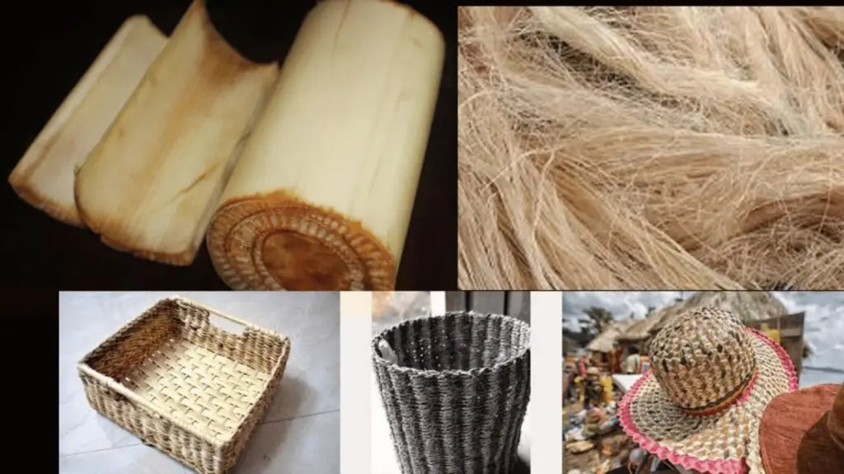

**CHARACTERISTICS OF BANANA FIBER :**

Banana fiber has its own physical and chemical characteristics and many other properties that make it a fine quality fiber.

i) Appearance of banana fiber is similar to that of bamboo fiber and ramie fiber, but its fineness and spinnability is better than the two.

ii) The chemical composition of banana fiber is cellulose, hemicellulose, and lignin

iii) It is highly strong fiber and light in weight.

iv) It has small elongation and has a somewhat shiny appearance depending upon the extraction and spinning process.

v) It has a strong moisture absorption quality. It absorbs as well as releases moisture very fast.

vi) It is bio-degradable and has no negative effect on the environment and thus can be categorized as eco-friendly fiber.

vii) Its average fineness is 2400 Nm.

viii) It can be spun through almost all the methods of spinning including ring spinning, open-end spinning, bast fiber spinning, and semi-worsted spinning among others.

**COMPOSITION OF BANANA FIBER :**

|  |
| --- |
| Tenacity 29.98 g/denier |
| Fineness 17.15% |
| Moisture Regain 13.00% |
| Elongation 6.54% |
| Alco-ben extractives 1.70% |
| Total cellulose 81.80% |
| Alpha cellulose 61.50% |
| Residual Gum 41.96% |
| Lignin 15.00% |

**PROPERTIES :**

**1. Strength:**

Banana fiber is strong and durable, making it suitable for various textile and industrial applications.

**2. Biodegradability:**

It is biodegradable and environmentally friendly, meaning it decomposes naturally in the environment.

**3. Moisture Absorption:**

Banana fibers have high moisture absorption capacity, making it breathable and comfortable to wear.

**4. Anti-bacterial:**

It has natural anti-bacterial properties that make it ideal for medical and hygiene applications.

**5. Elasticity:**

Banana fiber has good elasticity, which gives it a natural stretchiness and makes it ideal for use in clothing.

**6. Light weight:**

These fibers are lightweight, making it easy to handle and work with in various applications.

**7. Softness**:

Banana fiber is soft and comfortable making it suitable for use in clothing & home textiles.

**HOW IS IT MADE ?**

The following are a few steps involved the process of making banana fabric :

**Step 1: Separation**

First, the fibers from the banana stems and peels are separated from their non-usable components. Various techniques are used to attain these fibers which involve soaking the peels in a chemical substance or water to soften and separate the fibers.

**Step 2: Drying and Bunching**

Once the fibers are separated, they are bunched together and left to dry. After this step, the outer and inner fibers are kept together, as it is hard to separate them when they are wet.

**Step 3: Grouping**

Once the fibers are dry, it is separated into various groups based on quality. Group A contains the best fabrics and is used for silk applications. Some manufacturers only have two groups, whereas others produce different grades of banana fiber.

**Step 4: Spinning and Weaving**

Finally, the separated fibers are spun into yarn. It is dyed, treated, and then woven into accessories, clothes, decor items, or industrial products. This process was Partier handmade, making it harder to process on a larger scale. It is where machines come in.

Using machines for producing banana fiber has many advantages.

* It helps reduce intense and heavy labor work.
* Machines ensure 50 times more production compared to the manual process.
* It is economical and user-friendly.
* It is safe to operate and needs less maintenance cost.
* It can produce up to 30 kg of banana fiber per day.
* It gives you consistent and quality fiber in terms of softness, length, color and strength.

**TYPES OF BANANA FIBER :**

**1. Outer peel banana fiber :**

This coarse and rough fiber has been used for centuries in industrial applications. It is also perfect for ropes, mats & thick outerwear and garments.

**2. Inner peel banana fiber :**

This banana fabric is super soft, just like silk. It is reasonably delicate and is very expensive to produce.

**3. Banana silk :**

This fabric is not a banana fiber and silk mixture. It is just another term for inner peel banana fiber, which is similar to the properties of silk.

**4. Banana cotton:**

The high-grade fabric from the outer banana peel is also called banana cotton. It has a texture like cotton, and the two have many other similarities.

**ADVANTAGES OF USING BANANA FIBER :**

While there are numerous benefits of using banana fiber, here are its three main advantages.

1. **Low impact on soil health:**

Unlike cottons, which need tilling to re-fertilize the soil, banana trees regrow in the same place. It also does not require additional water, land or fertilizers, and the roots are strong enough to hold the soil in place, thus preventing landslides. Its low energy, low water consumption, and chemical-free fiber production has minimal impact.

1. **Non-Toxic:**

Banana fibers do not use or need genetically modified crops. Thus, they provide a sustainable livelihood for the farmers. Banana fabrics also do not contain dyes, so no chemicals can contaminate the local water supplies. It is safe for the wearer and does not cause any irritation or allergies.

1. **No wastage:**

Banana fiber is made from parts of the banana tree and banana peel that is discarded if not put to use. Creating something valuable from anything that otherwise goes to waste makes banana fiber one of the best alternatives to several other synthetic and natural fibers.

**APPLICATIONS OF BANANA FIBERS :**

Banana fiber has a wide range of applications.

**1. Textile industry:** Banana fibers are commonly used in the textiles industry to produce clothing accessories, and home textiles. The fiber's softness, elasticity, and moisture absorption properties make it ideal for use in clothing and bedding products. It is also commonly used to make table runners, placemats, and other decorative textiles.

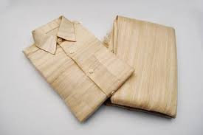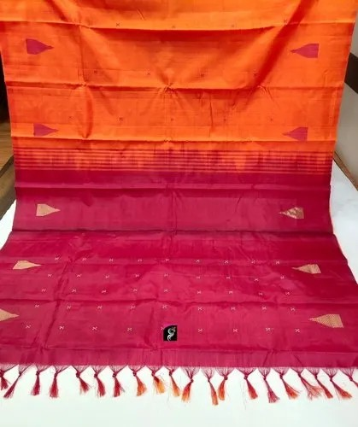

**2. Industrial Applications:** These fibers are often used in industrial applications due to its strength and durability. It is commonly used to reinforce concrete, to make ropes, twines and mats and as a raw material in the production paper.

**3. Agriculture:** It is used in agriculture to make mulch and as a natural alternative to synthetic fibers. It helps to regulate soil temperature and moisture, promoting healthy plant growth.

**4.Medical Applications:** It has natural antibacterial properties, making it ideal for use in medical and hygiene applications. It is commonly used to make surgical masks, gowns, and other medical textiles.

**5. Automotive Industry:** Banana fiber is used in the automotive industry as a lightweight and sustainable alternative to synthetic fibers in the production of car parts and components.

**6. Packaging:** They are used in the packaging materials. It is also used to make bags, boxes and other types of packaging products.

**7. Art and crafts:** Banana fibers are also used in art and craft projects, due to its natural beauty and texture. It is commonly used to make baskets, coasters, and other decorative items.

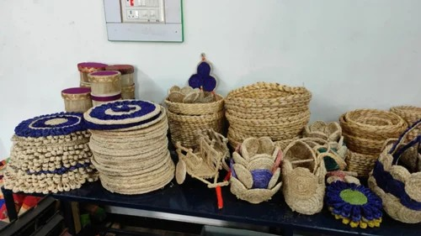

**CONCLUSION :**

In conclusion, banana fiber is a versatile and sustainable natural resource with a wide range of applications. From textiles and paper production to composite materials and biomedical uses, banana fiber has shown great potential as a renewable alternative to synthetic materials. Its unique properties, such as high tensile strength, durability, and biodegradability make it an attractive option for various industries. Furthermore, the use of banana fiber can contribute to reducing waste and promoting sustainable agriculture practices. As research and development continue to explore new applications and improve processing methods, banana fiber is poised to become an increasingly important player in the global push towards a more sustainable future.