STUDY OF MEDICINAL PLANTS USED TO TREAT DIFFERENT SKIN AILMENTS BY KAIBARTA COMMUNITY IN A SEMI-URBAN VILLAGE OF TINSUKIA DISTRICT, ASSAM

BY

# NIKITA DAS

**Masters Of Science, Department Of Zoology Sikkim Central University, Gangtok**

Abstract:

Skin, which serves as the body's primary defense, is composed of specialized cells and three distinct layers viz; the outermost epidermis, middle dermis and the innermost hypodermis, each having important functions in the body. Skin diseases are prevalent among both humans and animals. From neonatal to elderly people, skin diseases are very common and cause

harm.

The present ethnobotanical survey was carried out to document the use of plant-based

remedies to treat different skin diseases by the people belonging to the Kaibarta community

residing in Kaptanchuck Gaon, a semi-urban Village of the Tinsukia district of Assam, North- East India.

The study documents and highlights 32 Phyto species having different medicinal values

belonging to 26 different families. Among these 32 key plant species, 44% are herbs, 34% are trees and the remaining 22% are shrubs. These plant species are used for treating various skin ailments such as abscess, vitiligo, leprosy, urticaria, eczema, skin burn and many other skin diseases. Different plant components including leaf extracts, seed oils or barks are used for

the treatment of these diseases.

The use of plants for treating skin diseases is gaining more popularity with time since they have minimal side effects and numerous advantages for the skin.

Keywords: Medicinal plants, Skin diseases, Scheduled caste, Kaptanchuck Gaon, Tinsukia District.

# INTRODUCTION:

Skin which serves as the body's primary defense, is composed of specialized cells and three distinct layers viz; the outermost epidermis, middle dermis and the innermost hypodermis, each having crucial functions in the body. Its primary function is to protect the human body from harmful external contact with pathogens. Skin diseases are prevalent among both humans and animals. From neonatal to elderly people, skin diseases are very common and can be detrimental. Various skin infections such as viral infection, bacterial infection, rashes,

and pigment disorders are some common skin diseases in humans (Tamuli and Ghosal, 2017).

Medicinal plants are the backbone of traditional medicine. The use of plant-based remedies plays an important role in the treatment of certain diseases. Over 3.3. billion people in less developed countries use plant-based medicine on a regular basis. According to the World

Health Organization (WHO), nearly 80% of the global population frequently utilizes

traditional herbal medicines for the treatment of various diseases (Topno and Sinha, 2018).

Traditionally used plant-based natural medicines are gaining more popularity with time since they have minimal side effects and numerous advantages. Moreover, these medicines are less expensive and more acceptable due to a long history of use.

Assam, located in the North Eastern region of India, is one of the most significant

biodiversity hotspots in the world. Many tribes and ethnic communities within the state uphold their tradition despite facing economic challenges. The major ethnic and tribal communities living in the state are Lushai, Karbi, Chorei, Dimasa, Rhabha, Jayantia,

Sonowal-Kachari, Deori, Moran, Motok Mishing, Ahom, Kaibarta community and tea tribes (Buragohain, 2011). Each and every tribe and community have tremendous faith and belief in their unique practices of Indigenous traditional phytomedicinal knowledge in healing various ailments.

The Kaibarta community is one of the oldest inhabitants of Assam. This community ranks as the second largest community out of the sixteen scheduled castes of Assam. Similar to the other ethnic communities, the Kaibarta community also has a very deep and rich cultural heritage and holds unique traditional knowledge on the application of plant-based remedies for common human diseases ( Das and Duarah, 2024).

Several ethnobotanical studies have been conducted in various ethnic communities around the globe, including Assam. However, the traditional knowledge of healing practices by the

Kaibarta Community from Assam is limited. Furthermore, disease-specific ethnomedicinal research is particularly lacking in this community from Assam.

Considering the aforementioned, the present study was undertaken to document, highlight and evaluate the rich Indigenous knowledge of the Kaibarta Community of Kaptanchuck Gaon, a semi-urban village from the Tinsukia District of Assam.

The primary objective of this study is to explore the application of Phyto-remedies in combating frequently occurring skin ailments by the people of the Kaibarta community residing in the study area. These important ethnobotanical findings would provide fundamental information for future phytochemical research.

# MATERIALS AND METHODS:

* 1. Study area:

Tinsukia District is situated in the North-Eastern part of Assam between 27.25º N to 27.30º N latitude and 94.50º E to 95º E longitudes. It is located at 116 meters (380 feet) elevation above sea level. This district is bounded by Dibrugarh and Dhemaji in the West and North-

West and it also shares an international border with Myanmar in the South. The total area of the district is 3790 sq. km. and is characterized by a subtropical climate with an average

minimum temperature of 8.5ºC and a maximum temperature of about 33.4º C. Similarly, the area receives an average rainfall of about 2768 mm per annum with a relative humidity of

about 78% (Bora and Meitei, 2014). The total population of the district according to the 2011 census is 1,327,929 inhabitants with a 70.92 % literacy rate. The majority of the people in the district are farmers and agricultural workers. Although rice farming occupies a significant portion of the district’s traditional agricultural practices, the residents of the district also

cultivate a notable number of other cultivations such as tea, ginger and orange. ()

Hijuguri Kaptanchuck Gaon which is a semi- urban village located in the Tinsukia district has an area coverage of 167.52 hectares. This village mostly has Paddy Field along with a variety of other crop cultivations such as vegetables, pulses, fruits, etc. This small village is a home to diverse ethnic communities including Ahom, Muttok, Kaibarta and Tea tribes. The rural folks more particularly those belonging to these mentioned communities have a long history of utilizing plants for medicinal purposes. Despite the existence of a rich history of ethnomedicinal practices, only a few pieces of literature are available.

* 1. Data collecting method:

Field trips were undertaken in the study area that is Kaptanchuck Gaon, a semi urban village in the Tinsukia district of Assam. The survey was conducted from October 2023 to May 2024. The data collection was carried out by interviewing respondents (healers, practitioners and elderly people) of the village. The respondents were people belonging to the Kaibarta community and particularly either traditional healers themselves or they have a tradition of healing in their families and had knowledge of medicinal plants for said purposes (Saikia et al., 2006).

For collecting the information from the respondents, a structured information form was

prepared including questions such as the type of herbal cure known to them for skin diseases, the use of plants and their parts, the modes of administration etc. The information was

collected in the local language (Assamese language).

* 1. Collection and identification of medicinal plants:

The acquired data were cross-checked with available local literatures. The identification was done with the help of the books mentioned below (Kalita et al., 2015) and photographs were also captured in cases where identification was not feasible, and subsequently identified using various resources such as plantnet.org.

1. Kirtikar, K.R., Basu, B.D. (1951)
2. Kanjilal, U.N., Kanjilal, P.C., De, R.N., Das, A. (1991)
3. Sharma, U.K., (2004)

# RESULT AND DISCUSSION:

The use of 32 ethnomedicinal plant species belonging to 26 different families was recorded to be used by traditional healers in the treatment of skin diseases. Among these 26 families, Rutaceae (3 species), Euphorbiaceae (2 species), Poaceae (2 species), Fabaceae (2 species), and Zingiberaceae (2 species) were predominant and the remaining families with single species were recorded (Figure 1). It was observed that different plant parts were used to treat different skin diseases, among which leaves were the dominant part used with 41% (Figure 4). Out of these 32 phytomedicinal species, herbs were abundant with 44% followed by 34% of trees and the remaining 22% were shrubs.

For each of the plant species the data were tabulated (Table:1) to include the botanical name, family, vernacular name in Assamese, plant habit, plant parts used, plants used against diseases and mode of administration were recorded.

The result of the present study provides evidence that medicinal plants still play a vital role in the primary health care of the Kaibarta community, mostly in rural or semi-urban villages of the Tinsukia district of Assam.

3.5

3

2.5

2

1.5

1

0.5

0

FAMILY

NO. OF SPECIES

Figure 1: Familywise classification of ethnomedicinal plants used to treat various skin ailments

Alliaceae

Anacardiaceae Aocynaceae Apiaceae Arecaceae Asphodelaceae Asteraceae Caesalpiniaceae Combretaceae Crassulacease Euphorbiaceae

Fabaceae Lamiaceae Leguminosae

Liliaceae Lytraceae Malvaceae Meliaceae Mimosaceae

Poaceae Rosaceae Rutaceae Sapindaceae Solanaceae Thymelaeaxeae

Zingiberaceae



**Tree 34%**

**Herb**

**44%**

**Shrub 22%**

Herb

Shrub Tree

Figure 2: Percentages of different habits of the phytomedicinal species used



Seed Rhizome

Fruit Bulb

Wood

0

2

4

6

8

10

12

14

**NO. OF SPECIES**

**PARTS USED**

Figure 3: Number of medicinal plant species and their parts used

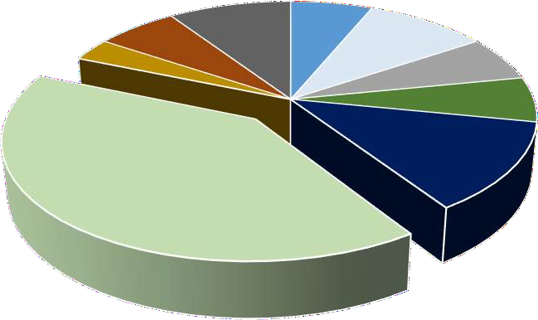

Roots Rhizome6%

3%

Seed 9%

Wood

6% Bark

10%

Bulb 6%

Flower 6%

Fruit 13%

Leaves 41%

Wood

Bark Bulb Flower Fruit Leaves Rhizome Roots Seed

Figure 4: Percentages of plant parts used to treat skin ailments

Table 1: Medicinal plants used for healing various skin ailments by the Kaibarta Community of Kaptanchuck Gaon in Tinsukia District of Assam

|  |  |  |  |  |  |  |
| --- | --- | --- | --- | --- | --- | --- |
| **Sl.**  **No** | **Scientific name** | **Common**  **name** | **Family** | **Habit** | **Parts**  **used** | **Skin Ailments** |
|  |  |  |  |  |  | Abscess, vitiligo, |
|  | *Aegle marmelos (L.)* |  |  |  |  | redness, itching, skin |
| 1 | *Corr.* | Bel | Rutaceae | Tree | Leaves | rashes |
| 2 | *Allium cepa L.* | Piyaj | Liliaceae | Herb | Bulb | Pediculosis |
| 3 | *Allium sativum L.* | Naharu | Alliaceae | herb | Bulb | Urticaria |
| 4 | *Aloe barbadensis Mill.* | Saalkuwori | Asphodelaceae | Herb | leaves | Skin Burn, Eczema |
|  | *Alstonia scholaris (L.) R.* |  |  |  |  |  |
| 5 | *Br.* | Satiyana | Aocynaceae | Tree | Bark | Toe crack |
|  | *Aquilaria agallocha* |  |  |  |  |  |
| 6 | *Roxb* | Agaru | Thymelaeaxeae | Tree | wood | Leprosy |
|  |  |  |  |  |  | Eczema, prevent |
|  | *Azadirachta indica A.* |  |  |  | seeds, | acne, ringworm, |
| 7 | *Juss.* | Neem | Meliaceae | Tree | leaves | itching |
|  | *Bryophyllum pimmatum* | Dupar |  |  |  |  |
| 8 | *(Lam.) Kurz* | Tenga | Crassulacease | Herb | Leaves | Abscess |
| 9 | *Cassia fistula L.* | sunaru | Caesalpiniaceae | Tree | Leaves | Ringworm, skin burn |
|  | *Centella asiatica (L.)* |  |  |  |  |  |
| 10 | *Urb.* | Manimuni | Apiaceae | Herb | Leaves | Carbuncles, Abscess |
| 11 | *Citrus limon (L.) Burm.* | Gulnemu | Rutaceae | Shrub | Fruit | Dry skin, Pimples |
|  |  |  |  |  |  | Eczema, skin |
|  |  |  |  |  |  | brightening, treats |
|  | *Citrus odorata (Westeer)* |  |  |  |  | dark spots on knees |
| 12 | *Tanaka* | Nemu | Rutaceae | Herb | Fruit | and elbows |
|  |  |  |  |  |  | Leprosy and other |
| 13 | *Clitoria ternatea L.* | Aparajita | Fabaceae | Herb | Leaves | skin problems |

1. *Cocos nucifera L.* Narikol Arecaceae Tree Fruit
2. *Curcuma longa L.* Haladhi Zingiberaceae Herb Rhizome

Scabies, smooth skin, reduce acne and wrinkles Urticaria, Ringworm, Scabies, Dry Skin

*Cymbopogon nardus (L.)*

1. *Rendle* Chitranala Poaceae Herb

*Cynodon dactylon (L.)*

leaves &

stem Pediculosis

1. *Pers.* Dubari bon Poaceae Herb Leaves Urticaria

Eczema, reduced

1. *Datura Stramonium L.* Dhatura Solanaceae Herb Roots

Mahabhring

wrinkle, dark circles Pediculosis, reduce

1. *Eclipta erecta L.*

araj Asteraceae Herb Leaves

acne

Shiny hair, prevents

1. *Hibiscus-rosa-sinensis L.* Jaba Malvaceae Shurb Flower skin ageing
2. *Jatropha curcas L.* Bongali era Euphorbiaceae Shrub Seed Skin Burn

Wrinkled skin, Burning sensation in

1. *Lawsonia inermis L.* Jetuka Lytraceae Shrub Leaves
2. *Mangifera indica L.* Aam Anacardiaceae Tree Fruit

Leaves, whole

feet and palm Wrinkled skin, sunburn

1. *Mimosa pudica L.* Lajukilota Mimosaceae Herb

plant Eczema Urticaria, blackheads and treats premature

1. *Ocimum sanctum L.* Tulasi Lamiaceae Shrub Leaves
2. *Phaseolus mungo L.* Maatimah Fabaceae Shrub Seeds

aging

for shiny and beautiful hair, reduce pimples

1. *Phyllanthus emblica L.* Amlokhi Euphorbiaceae Tree Bark Scabies, dry skin

*Pterocarpus santalinus*

1. *Blanco.* Chandan Leguminosae tree Wood
2. *Rosa rosa* Gulap Rosaceae Shrub Flower

*Saphindus mukorossi*

Prickly heat, acne, eczema

smooth skin, Abscess on eyes, prevents appearance of scar

1. *Gaertn.* Manisaal Sapindaceae Tree Seed cover Dandruff

*Terminalia arjuna*

1. *(Roxb.)W.&A.* Arjun Combretaceae Tree Bark

*Zingiber officinale*

Acne, Burns and wounds

1. *Roscoe.* Moran aada Zingiberaceae Herb Roots Urticaria

Mode of Administration of all the 32 Phyto-medicinal species are mentioned bellow:

* 1. *Aegle marmelos (L.) Corr.* – Paste of leaves is applies on the affected area to cure abscesses and the fruit juice is used in curing vitiligo and skin rashes.
  2. *Allium cepa L.* – the juice is applied on the affected area.
  3. *Allium sativum L. –* the pieces are taken to cure urticaria.
  4. *Aloe barbadensis Mill.* – leaf pulp is applied on burns and to treat Eczema.
  5. *Alstonia scholaris (L.) R. Br. –* the extract of gum from the bark is directly applied on toes to treat toe cracks.
  6. *Aquilaria agallocha Roxb –* the extracted oil from the plant is applied on the infected skin.
  7. *Azadirachta indica A. Juss. -* leaf paste is applied with Kapoor and coconut oil in infected areas to prevent itching in the skin, leaf paste is also mixed with turmeric powder and applied on the infected areas to treat pimples and ringworm.
  8. *Bryophyllum pimmatum (Lam.) Kurz –* paste prepared from the leaves is applied on the boils
  9. *Cassia fistula L. –* crushed leaves are applied to the infected areas.
  10. *Centella asiatica (L.) Urb. –* crushed leaves are directly applied to the skin.
  11. *Citrus limon (L.) Burm. –* the juice extract is mixed with honey and applied on skin for healing pimple and juice is also orally taken for treating dry skin.
  12. *Citrus odorata (Westeer) Tanaka –* fruit juice is applied directly on the skin.
  13. *Clitoria ternatea L. –* leaves paste is directly applied to the infected areas.
  14. *Cocos nucifera L. –* the extracted oil is mixed with citrus lemon juice for treating scabies. The oil can be directly applied to the skin to treat other problems such as rashes, acne, ringworm etc.
  15. *Curcuma longa L. –* crushed rhizome is directly applied on infected skin. Juice is mixed with milk and taken orally to treat scabies.
  16. *Cymbopogon nardus (L.) Rendle –* the extracted oil is mixed with mixed with coconut oil and applied on the head to treat pediculosis.
  17. *Cynodon dactylon (L.) Pers. –* the grass/leaves are crushed and the paste is applied directly on the skin.
  18. *Datura Stramonium L. –* the leaves paste is applied to the infected area.
  19. *Eclipta erecta L. –* the crushed leaves are applied on the head.
  20. *Hibiscus-rosa-sinensis L. –* the flowers are crushed and applied directly on hair.
  21. *Jatropha curcas L. –* leaves extract is mixed with egg yolk and applied on burns.
  22. *Lawsonia inermis L. –* the crushed paste of leaves is applied on the affected areas such as palm, nails and toes.
  23. *Mangifera indica L. –* raw fruit pulp is boiled or roasted and applied on the sun burn.
  24. *Mimosa pudica L. –* paste of leaves or whole plant is applied on infected areas.
  25. *Ocimum sanctum L. –* leaves paste is used on the infected areas.
  26. *Phaseolus mungo L. –* the paste prepared from crushed seeds is applied to hair.
  27. *Phyllanthus emblica L. –* dried bark powder is boiled with coconut oil and applied externally on infected areas to treat scabies.
  28. *Pterocarpus santalinus Blanco –* the powder is soaked in water and the paste is applied on the infected areas.
  29. *Rosa rosa –* the flower paste is applied on infection, and the rose water is poured on the eyes and also applied on the face.
  30. *Saphindus mukorossi Gaertn. –* the seed covers are generally used for washing hair and it prevent dandruff in hair.
  31. *Terminalia arjuna (Roxb.) W.&A. –* the paste prepared from the bark is applied on burns, acne and infected areas.
  32. *Zingiber officinale Roscoe. –* the extracted root juice is mixed with old molasses and taken orally for the treatment of urticaria.

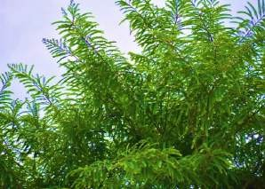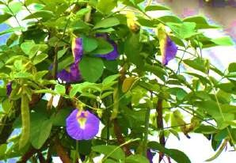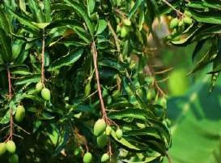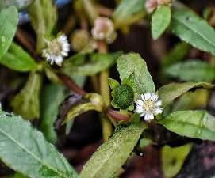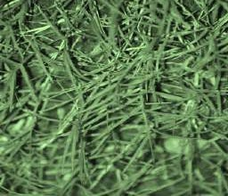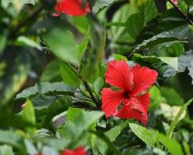

*Phyllanthus emblica L*

*Clitoria ternatea L*

*Mangifera indica L.*

*Eclipta erecta L.*

*Cynodon dactylon (L.) Pers.*

*Hibiscus-rosa-sinensis L.*

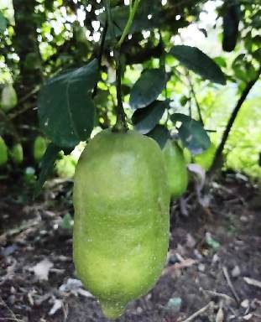 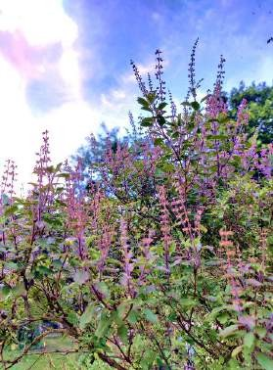 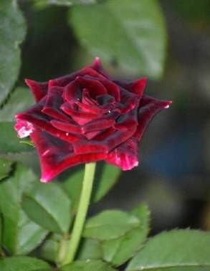

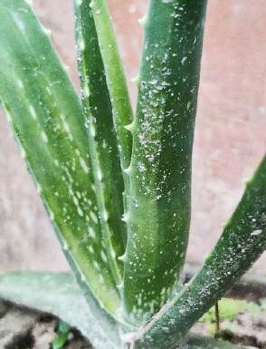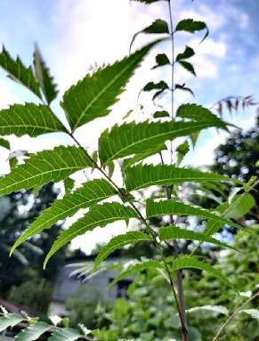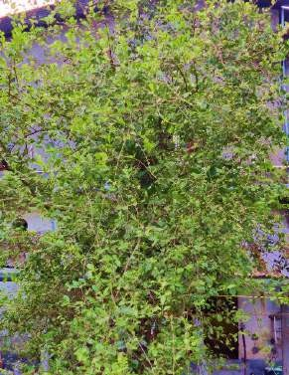

*Citrus odorata (Westeer) Tanaka*

*Ocimum sanctum L.*

*Rosa rosa*

*Aloe barbadensis Mill.*

*Azadirachta indica A. Juss.*

*Lawsonia inermis L.*

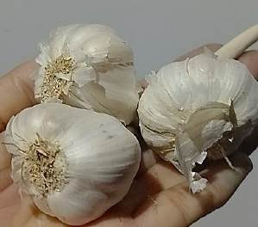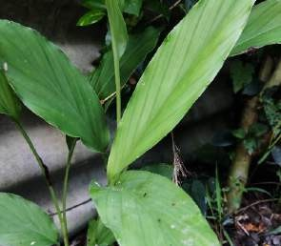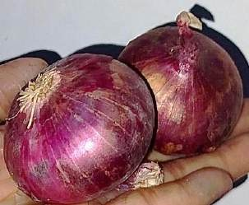

*Allium sativum L.*

*Curcuma longa L.*

*Allium cepa L.*

# CONCLUSION:

Ethnomedicinal plants possess great potential in the treatment of different kinds of skin

diseases. In villages with limited access to modern medicinal facilities, traditional healers play a significant role by using ethnomedicines for the treatment of a wide range of common human ailments including skin diseases.

The people belonging to the Kaibarta community in the research site of Kaptanchuck Gaon, Tinsukia District of Assam mostly rely on medicinal plants for the treatment of different skin diseases. Based on the findings from the present study, the use of a total of 32 medicinal plant species suggests that the diversity of the medicinal flora in this region is quite high and has

great potential to treat a wide range of skin diseases.

Hence, conserving the ethnomedicinal plants and the indigenous knowledge of plants used in traditional healthcare holds great significance. It is necessary to spread awareness among

individuals from the ethnic and tribal communities about the worth of their indigenous

knowledge and help the society to preserve these traditional methods of treatment through effective identification and documentation of plant species.

# REFERENCES:

Bora, A. and Meitei, L.R. 2014. Butterfly Fauna (Order: Lepidoptera) in five major tea gardens of Sivasagar District, Assam, India. *Biological Forum-An International Journal*. Vol. 6, 2:7-15.

Buragohain, J., and Konwar, B.K. (2007). Ethnomedicinal plants used in skin diseases by some Indo-Mongoloid communities of Asa. *Asian Journal of Experimental Sciences*, 21(2),281-288.

Das, A.M., Kumar, R., Athar, M., Rawat, D.S., Kumar, M., Khan, M.A. (2013). Ethno Medicinal study of threatened plants of Sonitpur district in Assam, North East India.

*International journal of pharmacy*, 4(1),146-149.

Das, K., & Duarah, P. (2024). Ethnobotanical knowledge of the Kaibarta community of the Upper Brahmaputra Valley zone of Assam. *Plant Science Today.*

Gogoi, M., Barooah, M. S., & Dutta, M. (2019). Use of medicinal plants in traditional health care practices by tribes of Dhemaji district, Assam, India. *International Journal of Herbal Medicine*, 7(5), 01–06.

Kanjilal, U.N., Kanjilal, De, R.N., Das, A. A Flora of Assam. Vol. III Allied Book Centre: 1991.

Kirtikar, K.R., Basu, B.D. Indian Medicinal Plants: Vol. 4: Lalit Mohan Basu Publication, Allahabad: 1951.

Saikia, A. P., Ryakala, V. K., Sharma, P., Goswami, P., & Bora, U. (2006). Ethnobotany of medicinal plants used by Assamese people for various skin ailments and cosmetics. *Journal of Ethnopharmacology*, 106(2), 149–157.

Sharma, U.K. Medicinal Plants of Assam. M/s Bishen Singh Mahendra Pal Singh; First Edition: 2004.

Tamuli, P., & Ghosal, A. (2017). Ethnomedicinal plants used by major ethnic groups of Assam (India) for curing skin diseases. *International Journal of Herbal Medicine*, 5(4), 140–144.

Topno, S. C., & Sinha, M. R. (2018). Study of medicinal plants used to heal skin diseases by tribes of west Singhbhum district of Jharkhand (India). *Journal of Pharmacognosy and Phytochemistry*, 7(1), 371–376.

AUTHOR DETAILS-

NAME- Miss Nikita Das

DESIGNATION- Masters of Science

AFFILIATION- Sikkim Central University, Department of Zoology

EMAIL ID- nitunikita1903@gmail.com

CONTACT NO- 8638576559/9954326926

POSTAL ADDRESS- C/O Ganesh Das, Hijuguri Kaptanchuck Gaon, P.O. + P.S. Hijuguri, Tinsukia, Assam

STREET ADDRESS: Hijuguri Kaptanchuck Gaon, Heuj Path, Near KTM Bike Dealers, Tinsukia, Assam

CITY: Tinsukia

STATE: ASSAM

PIN- 786192(ASSAM)