**Eulophia herbacea used for health benefits. (Orchidaceae)**

**“ Amarkand ”**

**Author Name :- *Vaishnavi Babasaheb Pawar.**

**Co-author Name :- 1.Nirmal Sakshi Kailas.**

**2.Rahinj Pradeep Dattatray.**

**Research scholar :- B.Pharmacy**

**Guidance :- Prof.Shubham Sabale.**

**College Name :-Ashvin college of pharmacy, manchi hill**

**Abstract :-**

In India, the term "Amarkand" is commonly used for around 30 different plant species belonging to genus Eulophia (Orchidaceae). This single local name Amarkand to different taxonomical species creates uncertainty about its ethnomedical and nutritional claims. In the present article, we have reviewed available literature regarding ethnopharmacology, phytochemistry, taxonomy, nutritional, and pharmacological studies of different Amarkand species. The literature was searched using Google Scholar, PubMed, Scopus, and Web of Science databases. Some textbooks and reference books were also used to collect information about traditional and ethno pharmacological records. Amarkand species have been used as a remedy for the treatment of various diseases such as diarrhea, stomach pain, rheumatoid arthritis, cancer, asthma, bronchitis, sexual impotency, tuberculosis, and so on. Nutritionally, Amarkand is considered as an excellent food for children and convalescents. Recent studies confirm antioxidant, anti-inflammatory, anti-diarrheal, and so forth activities to Amarkand species. These species are reported to possess various phytoconstituents such as flavonoids, terpenoids, and penetrance derivatives. The present review will help to understand overall ethnopharmacology, nutritional aspects, and taxonomy of Amarkand species.

**Keywords** :- Amarkand, ethnobotanical uses, pharmacology, phytochemistry.

**INTRODUCTION :-**

Traditional medicines with therapeutic utility have been used since antiquity and are still contributing a significant role in the primary health-care system. It is estimated that 70-80% of the world’s population relies on traditional herbal medicines for their primary health care [1]. Parallel to traditional medicines, several ethnobotanical medicinal plants have also been validated for their therapeutic efficacy with the help of modern scientific tests. Some of these ethnobotanical plants are receiving merits as both food and medicine [2], and Amarkand is one of the best examples of this.

The word S Is composed of two different words “Amar” means immortal and “kand” stands for tubers. The word Amarkand is commonly used for 30 closely related plant species from genus Eulophia (Orchidaceae) and for one species from the genus Dioscorea (Dioscorea bulbifera, family: Dioscorea). Since ancient times, Amarkand is believed to be an excellent health-promoting agent. Rhizomes/tubers of Amarkand are routinely consumed by the tribal parts of India as food as well as a therapeutic entity for better health and longevity [2-3]. In Ayurvedic medicine, Amarkand is generally prescribed as expectorant, anabolic, tonic, diuretic, astringent, digestive, and soft purgative [4]. Moreover, the usefulness of these species for the treatment of ear discharge, blood clotting, joint edema, and debility has also been highlighted in some ancient texts [4]. However, this single local name, Amarkand to different taxonomical species creates confusion about its ethnomedical and nutritional claims. In the present article, we have reviewed the available literature regarding ancient therapeutic claims and recent chemical and pharmacological studies about Indian Eulophia species so as to link their ethnobotanical applications with recent scientific advances.

**Distribution** :-

Genus Eulophia is highly diverse, occurs in a wide range of habitats, and belongs to family Orchidaceae. This plant produces two shacks, reproductive and vegetative, firm their underground tuners. The genus Eulophia has a wide distribution and comprises aver 230 species, which are widespread from tropical and Southern Africa, Madagascar and from nootropics to throughout tropical and subtropical parts of Asia and Australia. Among these, one species occurs in tropical America. In India, this genus is particularly distributed in tropical Himalaya and Deccan peninsula region. There are altuent 723 records under Eulophia in Interactional Plant Name Index. However, 500 arm synonym and many of them are ornamental [5]Web of Science and Scopus pus showed about 247 and d5f documents, respectively, under the keyword “Eulophia” till October 2015.

Amend 25 species are recorded from all over India, out of these, 20 species have medicinal importance. The medicinal properties of these species are documented in Table 1 [6-10]Eulophia species are used for several therapeutic passages in different parts of Irudia [11], Amarkand is the most prevailing name to all Eulophia species in India, however, these species are also known by several vernacular names ach as Balakımıd, Manakamad Mumpatak, Amrite (Sanskrit), Amarkand. Salem (1 lindi), Andhra (Bengali), Solar (Galati), Amarkand, and Silliman (Marathi)

**Morphology :-**

The Species under genus Eulophia are terrestrial herbs, autotrophic, or rarely heteromorphic [Figure La]. Parenting organs may be pseudo bulbs or tuber like. These pseudo bulbs are subterranean or born above ground, corm like, tuberous or rhizomatous, usually with several nodes and slender or thick fibrous roots at the base. Eulophia develops a chain of underground tubers [Figure 1b1. Leaves appear at or after an thesis, which are thin but tough, narrow, and grass like or lanceolate and plicate and are one to many, basal and having petiole-like leaf base, sometimes overlapping and forming a pseudo stem. Some species lack green leaves and are saprophytic. The inflorescence is erect, lateral, racemase or rarely pediculate, laxly to sub-densely many flowered or occasionally reduced to a solitary flower. Eulophia species are mostly identified by their flowers. Two types of flowers occur within Eulophia. In the first type, the sepals and petals are similar in size, shape, and color while in the other, sepals are smaller than petals and often recurved. In both types, the lip extends into a spur which can be very diverse in shape [12.16].

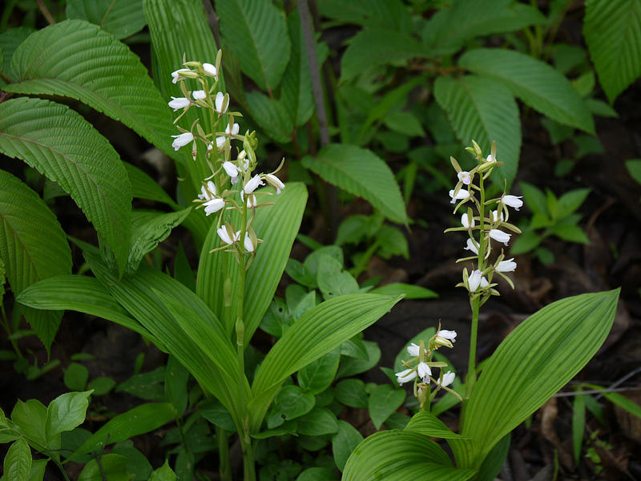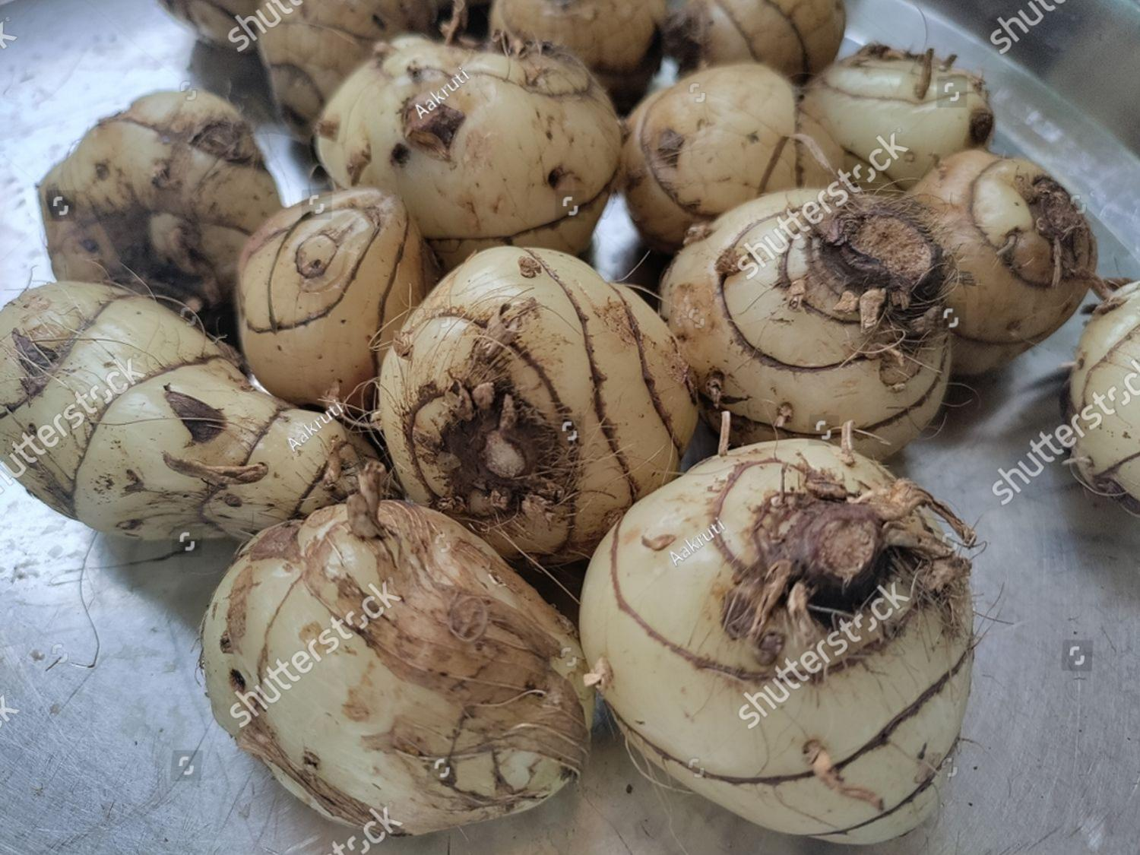

**ANATOMICAL STUDIES :-**

There are Intragenic classification of Eulophia R. Br. Ex Lindl. Was carried out based on methods of taxonomy, particularly the examination of generative and vegetative characters, followed by their comparison based on the data obtained from molecular studies and scanning electron microscopy [6]. Study on Eulophia Andamanese’s Rich. F. found that 0.1% colchicine is effective to induce mutations to increase flower size [17]. E. gamine Lindl, was also studied for its unique storage structure of the rhizome, brief juvenile stage, in vitro flowering and automatous mating system, which explains its strong colonization ability [18]. An anatomical study has been carried out on Eulophia alta to investigate the pollination biology, breeding system, nectar production, and floral scent composition of the plant. This study clearly showed that flowers of E. alta were self-compatible, partially automatous and effectively pollinated by five bee species. The nectar sugar content was reported to be highest on the third day after flower opening. Floral fragrance analyzes revealed 42 compounds, of which monoterpenes and benzoids are predominant [19]. Studies on symbiotic and symbiotic seed germination of the same plant revealed that the symbiotic seed culture is a more efficient way of propagation [20]. An optimized method was devised for asymbiotic in vitro seed germination, seedling development, and field establishment of Eulophia nude[22.25] , a similar study was carried out with E culling [27].

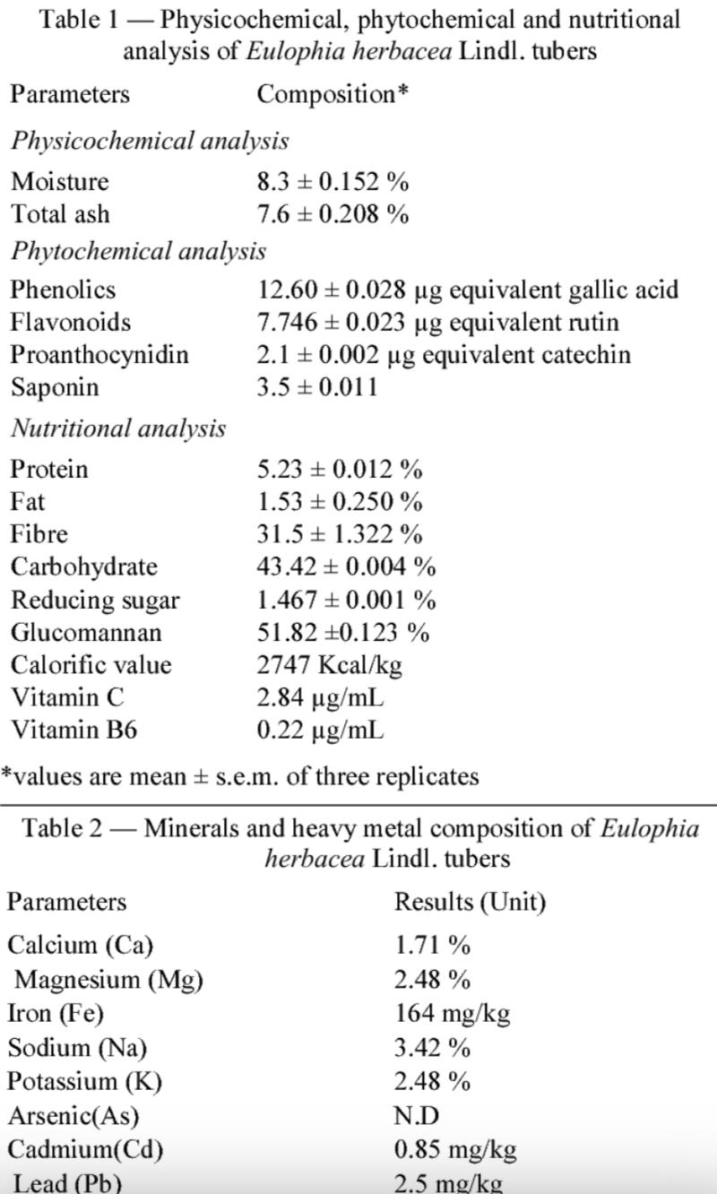 **Nutritional Studies:-**

**PHYTOCHEMISTRY**:-

The Medicinal plants produce thousands of patho-physiologically active principles that have been exploited over the years in the treatment of various ailments [29]. The qualitative and quantitative estimation of the phytochemical constituents of the medicinal plant is considered to be an important step in the herbal drug standardization [30].

Metabolic extracts of tubers of E. epidendrea (JKoen) Schltr. Showed the presence of several classes of phytochemicals such as flavonoids, reducing sugars, cyanogenic glycosides terpenoids, and tannins [31]. Thin-layer chromatography (TLC) studies of the isolated fractions from leaves and tubers indicated the presence of flavonoids, sterols, and terpenoids [Table 3] [571]

Bhandari et al. [32] have detected the presence of phenanthrene nodal (2, 7- dihydroxy-3, 4-dimethoxyphenanthrene) in the fresh tubers of E. node Lindl. In the subsequent study, another six phenanthrene derivatives were also isolated from the same plant tubers [Table 2] [24]. Among these derivatives, the therapeutic potential was largely attributed to 9, 10-dihydro-2, 5- dimethoxyphenanthrene-1, 7-diol. Kshirsagar er al. [33] validated the ethnobotanical rejuvenating claim of E. orchestra Lindl. By studying its antioxidant activity. Two radical scavenging molecules were isolated from dichloromethane and ethyl acetate extracts of tubers of E. orchestra Lindl.

**TRADITIONAL AND ETHNOBOTANICAL USES :-**

In Ayurvedic medicine, Amarkand is generally prescribed as expectorant, anabolic, tonic, diuretic, astringent, digestive, and soft purgative, and also recommended for the treatment of ear discharge, blood clotting, joint edema, and debility [5]. In addition, it is also considered as a general tonic to promote strength and alleviates all the three “doshas” [34]. These are also used in stomatitis, purulent cough; and in the heart problems, dyscrasia, and scrofulous diseases of the neck; bronchitis, blood diseases, and as a vermifuge [35].

Different Eulophia species have been extensively used in the traditional system of medicines in many countries [36,37]. In India, several ethnopharmacological uses/application have been reported for different species of Eulophia in different parts of the country.

**RECENT PHARMACOLOGICAL STUDIES :-**

Pharmacology is the science of drug action on biological systems. Pharmacological characters can provide a better understanding of active principles in plants and their mode of action. Pharmacological trials are needed to investigate the unexploited potential of plants.

Tubers of E. campestris Wall. Are well known for its binding properties [23]. Ghule et al. [38] pointed out that large quantity of mucilage from tubers of this plant is used as binding agent in tablet formulation. This mucilage produces a sticky film of hydration on the surface of prepared tablets, which ultimately reduces drug release rate. Thick jelly of this mucilage is also reported to be highly nutritious [39]. Glycation inhibitory activity of sales (E. campestris Wall.) extract was assessed by trichloroacetic acid treatment. In this study, the formation of glycated products/AGEs was decreased at the highest concentration of salep, i.c., at 25 mg/ml [10]. Mucilage isolated from tubers of E. herbacea Lindl. Has a potential as a suspending agent. It has a low rate of sedimentation, high viscosity, weak acidic pH and is easily re-dispersible. Thus, it can also be used as pharmaceutical adjuvant [40].

Methanol extract of tubers of E. epidendrea (JKoen) Schltr could significantly inhibit castor oil-induced diarrhea in rats, which was assessed by reduction in the frequency of defecation and the wetness of the fecal droppings compared to untreated control rats. The extract also significantly inhibited intestinal fluid accumulation (enteropooling). In addition, the extract appears to act on all parts of the intestine. Thus, it inhibited the propulsive movement of the intestinal contents in the charcoal meal treated model. These finding suggested that the methanol extract of the tubers of E. epidendrea (JKoen) Schltr may have an anti- diarrheal effect. This study validates the use of this plant as a non-specific anti-Diarrheal agent in folk medicine [41].

The crude drug in the powder form prepared from tubers of E. nude Lindl. Has aphrodisiac potential [42]. Phenanthrene compounds, such as 1- phenanthrenecarboxylic acid, 1, 2, 3, 4, 4a, 9, 10, 10a-octahydro-1, 4a-dimethyl-. Methyl ester, were isolated from Eulophia herbacea were found to have anticancer potential [43]. Pure compounds such as phenanthrene derivative, 9, 10-dihydro-2, 5-dimethoxyphenanthrene-1, 7-diol isolated from fresh tubers of E. nude Lindl. Showed good anti-proliferative activity against human breast cancer cell lines MCF-7 and MDA-MB-231 at concentration of 1000 µg/ml [44] The same compound was isolated from tubers of E. ochreata Lindl. In the pure form and was analyzed for its anti-inflammatory activity using cell line and carrageenan-induced rat paw edema model. The compound inhibited the release of several pro-inflammatory mediators, particularly cytokines and could be a promising anti-inflammatory agent [45].

Similarly, anti-inflammatory and antioxidant activities were attributed to the methanolic extract of tubers of E. ochreata Lindl [25]. Moreover, different solvent extracts of this tuber were found to have potent antibacterial activity against Bacillus subtilis, Staphylococcus Aureus, and Escherichia coli [46]- Tubers are also reported to have promising antioxidant, antiglycation, and alpha- amylase inhibitory activity and may have potential in the treatment and management of the Type II diabetes [47]. Recently, we have studied seven Amarkand species for its phytochemical profile, polyphenolic content, and free radical scavenging activity and found that D. bulbifera and E. ochreata had the highest antioxidant potential [46.48]. Similarly, tubers of E. ochreata and bulbils of D. bulbifera have shown a high anti-fatigue potential among different Amarkand species [48]. Among different Eulophia species. E, ochreata has the highest score for biological activities [34].

**Conclusion :-**

The conclusions for Eulophia herbacea include :-

1. Antioxidant potential :- Eulophia herbacea is a rich source of secondary metabolites, including flavonoids and phenols, and has strong antioxidant potential.
2. Antimicrobial and anthelmintic activity :-Eulophia herbacea can be a safe and alternative remedy for treating bacterial, fungal, and helminthic infections.
3. Phytochemical synthesis of silver nanoparticles The tuber extract of Eulophia herbacea can be used to synthesize silver nanoparticles that have antibacterial and antifungal activity.
4. Traditional medicinal plant :- Eulophia herbacea is a traditional medicinal plant that is used by tribes to treat a variety of diseases.

**Reference :-**

1. World Health Organization. Media Centre Fact Sheet No. 134. Traditional Medicines. [Last Access on 2015 Nov]. Available from: http://www.who.int/mediacentre/factsheets/fs134/en/2008.
2. Jagtap SD, Deokule SS, Bhosle SV. Some unique ethnomedicinal uses of plants used by the Korku tribe of Amravati district of Maharashtra, India. J Ethnopharmacol. 2006;107:463-9. [PubMed] [Google Scholar]
3. Jagtap SD, Deokule SS. Pawar PK, Harsulkar AM. Traditional ethnomedicinal knowledge confined to the Pawra tribe of Satpura Hills, Maharashtra, India. Ethnobot Lealf. 2009;13:98- 115. [Google Scholar]
4. Vaidya B. Nighantu Adarsha. Varanasi, India: Sarva Seva Sangha; 2004. [Google Scholar]
5. Cieslicka D. The problems of infrageneric classification of Eulophia R Br. Ex Lindl. (Orchidaceae, Cymbidiinae). Biodiv Res Conserv 2006:3:210-2.
6. Thomas P, Newman M, Svengsuksa B, Ketphanh S. A Review of Cites Appendices I and II Plant Species from Lao PDR. A Report for IUCN: 2006.
7. Rao AN. Orchids flora of North East India – An upto date analysis.
8. Suryanrayana B. Rao AS. Orchids and Epiphytes on veligonda hills-Eastern ghats. EPTRI-ENVIS News Lett 2005:11:1-12.Bull Arunachal Forest Res 2007:23:6-38,
9. Prasad YD, Chandra CR, Kumar L, Singh B. Effect of Salep (Eulophiacampestris) on glycation of IgG in vitro condition. Int Res J Pharm 2012:3:194-6.
10. Medhi RP, Chakrabarti S. Traditional knowledge of NE people on conservation of wild orchids. J Tradit Knowl 2009;8:11-6 12. Singh A. Duggal S. Medicinal orchids: An overview. Ethnobot Lealf 2009:13:351-63.
11. Jagtap SD, Deokule SS, Bhosle SV. Ethnobotanical uses of endemic and RET plants by Pawra tribe of Nandurbar district, Maharashtra. Indian J Tradit Knowl 2008;7:311-5.
12. Kshirsagar RD, Kanekar YB, Jagtap SD. Upadhyay SN. Rao R. Bhujbal SP, et al. Phenanthrenes of Eulophia ochreata Lindl. Int J Green Pharm 2010:4:147-52
13. Cieslicka D. The problems of infrageneric classification of Eulophia R. Br. Ex Lindl. (Orchidaceae, Cymbidiinae) Biodiv Res Conserv. 2006,3:210-2. [Google Scholar]
14. Thomas P, Newman M. Svengsuksa B, Ketphanh S. A Review of Cites Appendices I and II Plant Species from Lao PDR. A Report for IUCN, 2006 Gooele Scholar]
15. Rao AN. Orchids flora of North East India – An upto date analysis. Bull Arunachal Forest Res. 2007:23:6-38. [Google Scholar]
16. Suryanrayana B, Rao AS. Orchids and Epiphytes on veligonda hills – Eastern ghats. EPTRI-ENVIS News Lett. 2005:11:1-12. [Google Scholar]
17. Prasad YD, Chandra CR, Kumar L., Singh B. Effect of Salep (Eulophia campestris) on glycation of IgG in vitro condition. Int Res J Pharm. 2012:3:194-6. [Google Scholarا 11. Medhi RP, Chakrabarti S. Traditional knowledge of NE people on conservation of wildorchids. J Tradit Knowl. 2009;8:11-6. [Google Scholar]
18. Singh A, Duggal S. Medicinal orchids: An overview. Ethnobot Lealf, 2009:13:351-63. [Google Scholar]
19. Jagtap SD, Deokule SS, Bhosle SV. Ethnobotanical uses of endermic and RET plants by Pawra tribe of Nandurbar district, Maharashtra. Indian J Tradit Knowl. 2008:7:311-5. [Google Scholar]
20. Kshirsagar RD, Kanekar YB, Jagtap SD, Upadhyay SN, Rao R, Bhujbal SP. Et al. Phenanthrenes of Eulophia ochreata Lindl. Int J Green Pharm. 2010;4:147-52. [Google Scholar]
21. Xinqi C, Cribb PJ, Gale SW. Flora of China. Beijing: Science Press: 2009. Pp. 253-8. [Google Scholar] .
22. Semeung S. Chinachit W. Effects of colchicine on in vitro cultured plantlets of Eulophia andamanensis Rehh.f. Khon Kaen Agric J. 2008:36. [Google Scholar]
23. 17. Chang C, Hu W, Chen YC, Su YL., Chiu YT. In vitro flowering and mating system of Eulophia graminea Lindl. Botl Stud. 2010:51:357-62. [Google Scholar]
24. Jurgens A, Bosch SR, Webber SC, Win T, Frame D, Gottsberger G. Pollination biology of Eulophia alta (Orchidaceae) in Amazonia: Effects of pollinator composition on reproductive success in different populations. Ann Bol, 2009;104:897-912. [PMC free article] [PubMed] Google Scholar
25. Johnson T. Stewart S, Dutra D, Kane M. Richardson L.. Asymbiotic and symbiotic seed germination of Eulophia alta (Orchidaceae)-preliminary evidence for the symhiotic culture advantage. Plant Cell Tissue Organ Cult. 2007:90:313-23. [Google Scholar]
26. Nanekar V. Shriram V. Kumar V, Kavi Kishor PB. An Endangered Medicinal Orchid. Vol. 84. The Proceedings of the National Academy of Sciences, India, Section B: Physical Sciences: 2014, Asymbiotic in vitro seed germination and seedling development of Eulophia nuda Lindl; pp. 837-46. [Google Scholar]
27. Decruse SW, Reny N. Shylajakumari S. Krishnan PN. In vitro propagation and field establishment of Eulophia cullenii (Wight) Bl a critically endangered orchid of Western Ghats, India through culture of seeds and axenic seedling-derived rhizomes In vitro. Cell Dev Biol Plant. 2013:49:520-8. [Google Scholar]
28. https://www.semanticscholar.org/paper/Chemical-analysis%2C-nutritional-content-and-property-Tatiya-Kalaskar/c9619874515f617ccd278b6bfd7fe739a97dab0c/figure/0
29. Adebajo AO. Adewumi CO, Essain EE. Anti-Infective Agents of Higher Plants, International Symposion of Medicinal Plants. Sth ed. Nigeria: University of Ile, 1983. Pp. 152-8. [Google Scholar]
30. Kokate CK. Practical Pharmacognosy. New Delhi: Vallabh Prakashan Publication, 1994. Pp. 107-13. [Google Scholar]
31. Maridass M. Hussain MI, Raju G. Phytochemical survey of orchids in the Tirunelveli hills of South India. Ethnobot Leulf, 2008:12:705-12. [Google Scholar]
32. Maridass M, Ramesh U. Investigation of phytochemical constituents from Eulophia epidendraea. Int J Biol Technol. 2010;1:1-7. [Google Scholar]
33. Bhandari SR, Kapadi AII, Mujumdar PL, Joardar M. Shoolery IN. Nudol, a phenananthrene of orchids Eulophia auda Eria carmata and Eria stricta. Phytochemistry. 1985:24:801-4. (Google Scholar)
34. Hossain MM. Therapeutic orchids: Traditional uses and recent advances – An overview,Fitoterapia, 2011:82:102 40. [PubMed] [Google Scholar]
35. Dhiman AN. Ayurvedic Drugs Plants. New Delhi: Daya Publishing House: 2006.[Google Scholar]
36. Martin GJ. Ethnobotany: A Conservation Manual, London: Chapman and Hall, 1995.Google Scholar]
37. Behera D, Rath CC, Mohapatra U. Medicinal orchids in India and their conservation: A review. Floricult Ornament Biotechnol. 2013:7:53-9. [Google Scholar]59. Ghule BV, Darwhekar GD. Jain DK, Yeole PG. Evaluation of binding properties of Eulophia campestris Wall. Mucilage. Indian J Pharm Sci. 2006;68:566-9. [Google Scholar]
38. Ghule BV, Darwhekar GD. Jain DK, Yeole PG. Evaluation of binding properties of Eulophia campestris Wall. Mucilage. Indian J Pharm Sci. 2006;68:566-9. [Google Scholar]
39. Nadkarni KM. Indian Materia Medica. 2nd ed. L. Mumbai: Popular Prakashan: 1998. P.519. [Google Scholar]
40. Bharat MR, Kawatikwar PS. Sanghavi RS, Patil PP, Salunke PA, Kapure SV. Evaluation of Eulophia herbacen tubers mucilage as an innovative suspending agent. J Pharm Res. 2012:5:321-3. [Google Scholar
41. Maridass M. Anti diarrhoeal activity of rare orchid Eulophia epidendraea (Retz.). Fisher, Nat Pharm Technol. 2011;1:5-10. [Google Scholar)
42. Jagdale SP. Shimpi S. Chachad D. Pharmacological studies of Salep J Herb Med Toxicol. 2009;3:153-6. [Google Scholarl
43. Tatiya AU, Bari N. Surana SJ, Kalaskar MG. Effect of bioassay guided isolation of 1- phenanthrene carboxylic acid from Eulophia herbacea Lindl. Tubers on human cancer cell lines. Res J Phytochem. 2014:8:155-61. [Google Scholarl
44. Datla P, Kalluri MD, Basha K. Bellary A, Kshirsagar R. Kanetkar Y, et al. 9, 10-Dihydro-2.3-dimethoxyphenanthrene-1, 7-diol, from Eulophia ochreata inhibits inflammatory signalling mediated by toll-like receptors. Br J Pharmacol. 2010;160:1158-70. [PMC free article) (PubMal) (Gevels Scholar)
45. Devkar S, Jagtap SD, Kale Y, Kasote D. Antibacterial activity of Eulophia ochreata L. tubers. J Herb Med Toxicol. 2009;3:31-3. [Google Scholar]
46. Narkhede AN, Nirmal PS, Tupe RS, Kulkarni OP, Harsulkar AM, Jagtap SD. In vitro antioxidant, antiglycation and a Amylase inhibitory potential of Eulophia ochreata L Pharm Res. 2012;5:2532-7. [Google Scholar]
47. Narkhede AN, Jagtap SD. Screening of Amarkand species with respect to their polyphenolic content and free radical quenching potential. Int J Pharm Bio Sci. 2015;6:1123-33. [Google Scholar]
48. Narkhede AN, Jagtap SD, Nirmal PS, Giramkar SA, Nagarkar BE, Kulkarni OP, et al. Anti-fatigue effect of Amarkand on endurance exercise capacity in rats. BMC Compl Altern Med. 2016:16:23-7. [PMC free article] [PubMed] [Google Scholar]