**ELECTRIC VEHICLES: REVOLUTIONIZING THE FUTURE OF TRANSPORTATION**

**P.Preetha Vaishnavi,Dr.V.Jane Varamani Sulekha**

Department of Information Technology,Fatima College, TamilNadu,Madurai

Department of Information Technology,Fatima College, TamilNadu,Madurai

**ABSTRACT**

Electric vehicles (EVs) are at the forefront of transforming the transportation landscape, driven by advancements in technology, environmental concerns, and shifting consumer preferences. As global efforts to combat climate change intensify, EVs offer a sustainable alternative to traditional internal combustion engine vehicles by significantly reducing greenhouse gas emissions and reliance on fossil fuels. This revolution is supported by innovations in battery technology, which enhance performance and range while decreasing costs. Additionally, the expansion of charging infrastructure and government incentives are facilitating greater adoption among consumers. As automakers pivot towards electric mobility, the future of transportation is increasingly characterized by smart, connected, and eco-friendly solutions, promising not only to reshape urban environments but also to drive economic growth and create new job opportunities in emerging industries. This abstract highlights the pivotal role of electric vehicles in achieving a cleaner, more efficient, and sustainable future for transportation.

**Keywords-** Electric vehicles (EVs),Transportation revolution,Sustainability

# 1. INTRODUCTION

The advent of electric vehicles (EVs) marks a pivotal shift in the future of transportation, redefining how we think about mobility in an era increasingly focused on sustainability and environmental stewardship. As concerns about climate change intensify and the detrimental effects of fossil fuel consumption become more evident, EVs present a viable solution to reduce greenhouse gas emissions and lessen our dependence on non-renewable resources.

Technological advancements have driven significant improvements in battery efficiency, charging infrastructure, and vehicle performance, making electric cars not only more accessible but also more appealing to consumers. Major automotive manufacturers are investing heavily in electric mobility, introducing a diverse range of models that cater to various needs and preferences. Additionally, supportive government policies and incentives are further accelerating the transition to electric transportation.

Beyond environmental benefits, the rise of EVs is set to transform urban landscapes, enhance energy security, and create new economic opportunities in manufacturing, infrastructure development, and technology sectors. This transformation signals a shift towards smarter, cleaner, and more efficient transportation systems, promising a future where electric vehicles play a central role in reshaping our cities and lifestyles. As we stand on the brink of this revolution, the integration of electric vehicles into everyday life represents not just a technological advancement, but a crucial step toward a more sustainable and resilient future.

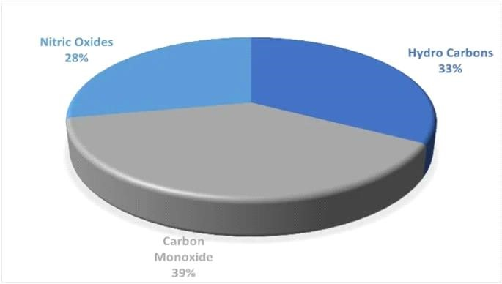

# 2. METHODOLOGY

Methodology for Researching Electric Vehicles

1. Define Objectives

Primary Objective: To assess the impact of electric vehicles on the future of transportation. Secondary Objectives:

Analyze environmental benefits.

Evaluate economic implications.

Examine technological advancements.

Study consumer adoption trends.

1. Literature Review

Conduct a comprehensive review of existing research, articles, and reports related to EVs.

Identify key themes such as environmental impact, technological innovations, infrastructure development, and policy frameworks.

1. Data Collection

* Quantitative Data:
* Collect statistical data on EV sales, market share, and growth projections from industry reports.
* Analyze data on emissions reductions and energy consumption.
* Qualitative Data:
* Conduct interviews or focus groups with stakeholders (manufacturers, consumers, policymakers).
* Gather insights from case studies of cities or regions that have successfully integrated EVs.

4. Analysis Framework

* Use a mixed-methods approach:
* Quantitative Analysis: Utilize statistical tools to analyze numerical data, focusing on trends and correlations.
* Qualitative Analysis: Employ thematic analysis to interpret qualitative data, identifying key narratives and sentiments regarding EV adoption.

5. Impact Assessment

* Evaluate the potential impacts of EVs on:
* Environmental Sustainability: Assess reductions in greenhouse gas emissions and urban air quality improvements.
* Economic Factors: Analyze job creation in the EV sector and effects on the oil industry.
* Technological Innovation: Examine advancements in battery technology, charging infrastructure, and autonomous driving features.
* Social Change: Investigate shifts in consumer behavior and public perceptions of transportation.

6. Policy Analysis

* Review current policies and incentives promoting EV adoption (tax credits, subsidies, charging infrastructure development).
* Analyze potential barriers to adoption, such as range anxiety and charging accessibility.

7. Case Studies

* Select diverse case studies (e.g., countries or cities leading in EV adoption) to illustrate successful strategies and challenges.
* Compare and contrast the approaches taken by different regions.

8. Synthesis and Recommendations

* Synthesize findings to present a comprehensive view of the future of transportation with EVs.
* Provide actionable recommendations for stakeholders (governments, manufacturers, consumers) to facilitate EV adoption and maximize benefits.

9. Conclusion

* Summarize key insights and implications for the future of transportation.
* Highlight the significance of continued research and innovation in the EV sector. • Timeline and Budget
* Timeline: Outline a timeline for each phase of the research (literature review, data collection, analysis, etc.).
* Budget: Estimate costs for data acquisition, surveys, interviews, and any necessary tools or software.
* Dissemination of Findings
* Plan to publish findings in academic journals, industry reports, and presentations at conferences to share insights with a broader audience.
* This methodology will help in comprehensively understanding how electric vehicles can revolutionize transportation and their broader implications for society and the environmen.

# 3. ENERGY MANAGRMENT STRATEGIES USED IN EVs

Energy management strategies (EMSs) are crucial for systems with multiple energy sources as they control power distribution within powertrains, impacting vehicle performance, efficiency, and component longevity (Sabri et al. 2016). While research on EMSs for PHEVs is limited compared to HEVs, some EMSs developed for HEVs can also be utilized in PHEVs. Therefore, this section initially introduces EMSs commonly employed in HEVs before discussing their potential adaptation for PHEVs. EMSs for HEVs are broadly classified into two main categories, as shown in Fig. 4: ruled-based strategies and optimization-based strategies.

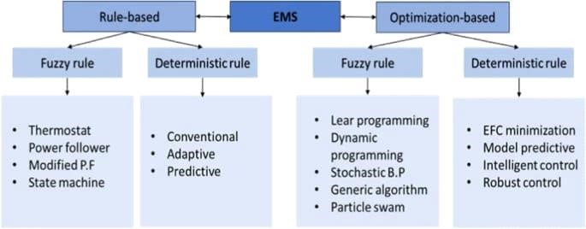

# 4. CHARGING METHODS

Besides autonomy, another important aspect of electric vehicles (EVs) is the charging process. For EVs to be truly successful, users need to be able to charge their vehicles quickly and easily. There are three primary charging methods: battery exchange, wireless charging, and conductive charging. Conductive charging can be further divided into pantograph charging and overnight charging as illustrated.

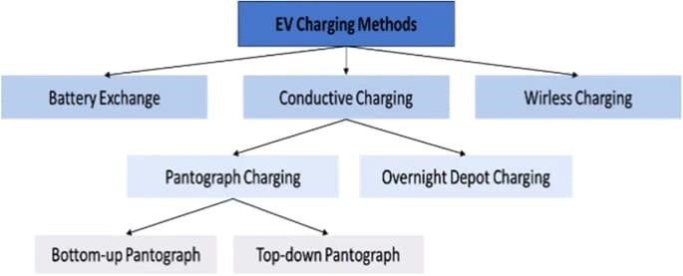

## (a) Battery swap station

Battery swap stations for electric vehicles (EVs) are an innovative solution aimed at addressing range anxiety and reducing charging times. Here's a breakdown of how they work, their benefits, and challenges:

How Battery Swap Stations Work

Infrastructure: Stations are equipped with automated systems that can quickly remove a depleted battery from a vehicle and replace it with a fully charged one.

Standardization: For battery swapping to be effective, a standardized battery design across different vehicle models is often necessary. Some companies focus on specific vehicle types or brands.

Process:

The driver arrives at the station and parks the vehicle.

The station identifies the vehicle type and retrieves a compatible battery.

An automated or semi-automated system handles the battery removal and replacement, typically taking only a few minutes.

Benefits

Reduced Downtime: Swapping a battery can be done in under 10 minutes, significantly quicker than traditional charging methods.

Extended Range: Drivers can travel longer distances without worrying about finding charging stations.

Battery Lifecycle Management: Stations can monitor battery health and performance, ensuring optimal charging conditions and lifespan.

Convenience: Users can easily replace batteries as needed, making EV ownership more appealing, especially for those who use their vehicles for long trips or in commercial application

## (b) Wireless power transfer station

Wireless power transfer (WPT) for electric vehicles (EVs) is an innovative technology that allows for the charging of EVs without the need for physical connections. This method utilizes electromagnetic fields to transfer energy from a power source to a vehicle. Here's a breakdown of how it works, its benefits, and considerations:

How It Works

Inductive Coupling: WPT systems primarily use inductive coupling, where an alternating current (AC) is passed through a coil at the charging station, creating a magnetic field. A second coil in the vehicle captures this magnetic field and converts it back into electrical energy.

Alignment: Proper alignment between the transmitter (charging station) and receiver (vehicle) is crucial for efficient energy transfer. Some systems use automated positioning technology to enhance alignment.

Power Transfer: The efficiency of the transfer typically varies from 85% to 95%, depending on the design and alignment.

Benefits

Convenience: Eliminates the hassle of plugging in cables, making charging easier and more user-friendly.

Safety: Reduces the risk of electrical hazards and wear and tear on charging ports.

Weather Resistant: No exposed electrical connections mean less vulnerability to adverse weather conditions.

Dynamic Charging: Future advancements may enable charging while driving, reducing downtime and extending range.

## (c) Conductive charging station

A conductive charging station for electric vehicles (EVs) uses a physical connection—typically a plug and socket—to transfer electrical energy from the charging station to the vehicle. Here are some key aspects to consider: Components of a Conductive Charging Station Charging Unit:

AC Chargers: Typically Level 1 (120V) or Level 2 (240V) chargers suitable for home and public use.

DC Fast Chargers: Provide rapid charging, using direct current to charge EVs much faster than AC chargers.

Connector Types:

Type 1 (J1772): Common in North America for AC charging.

Type 2 (Mennekes): Common in Europe for AC charging.

CCS (Combined Charging System): Combines AC and DC charging; widely used for fast charging. CHAdeMO: A fast charging standard used primarily by Nissan and Mitsubishi.

Power Supply:

Sufficient capacity to support the charging station's output. This may involve connecting to the grid or using renewable energy sources.

Safety Features:

Overcurrent protection, ground fault detection, and thermal management to prevent overheating.

User Interface:

Display for charging status, payment processing, and user instruction.

# 5. TRANSPORTATION WITH EV, S

* **Transportation is economical with EV,s** :
* Absolutely, electric vehicles (EVs) offer several economic advantages when it comes to transportation:
* Lower Fuel Costs: Electricity is generally cheaper than gasoline or diesel, which can lead to significant savings on fuel over time.
* Reduced Maintenance Costs: EVs have fewer moving parts than traditional combustion engines, which means lower maintenance costs. For example, they don’t require oil changes and have fewer components that can wear out.
* Government Incentives: Many governments offer tax credits, rebates, and other incentives to encourage EV adoption, making the initial purchase more affordable.
* Long-term Savings: While the upfront cost of an EV can be higher, the total cost of ownership (including fuel and maintenance) is often lower over the vehicle's lifespan.
* Resale Value: As the market for EVs grows, many are retaining or increasing their resale value, especially as demand rises for more sustainable transportation options.
* Energy Independence: Using domestically generated electricity for transportation can reduce reliance on imported oil, which can have positive economic implications at a national level.
* Environmental Benefits: While not strictly economic, the reduction in emissions can lead to lower healthcare costs and less environmental damage, which can translate into economic savings for communities.
* Overall, transitioning to electric vehicles can be a smart financial move for both individuals and society at large.
* Reducing transportation cost :
* You can reduce transportation costs with electric vehicles by focusing on several key areas:
* Lower Fuel Costs: EVs typically have lower energy costs per mile compared to gasoline or diesel.
* Reduced Maintenance: EVs have fewer moving parts, resulting in lower maintenance expenses over time.
* Government Incentives: Utilize tax credits and rebates to offset initial purchase costs.
* Optimized Routes: Use technology to plan efficient routes, reducing travel time and energy consumption.
* Charging Strategies: Charge during off-peak hours to take advantage of lower electricity rates.
* Fleet Integration: Incorporate EVs into your fleet to balance costs and enhance sustainability.

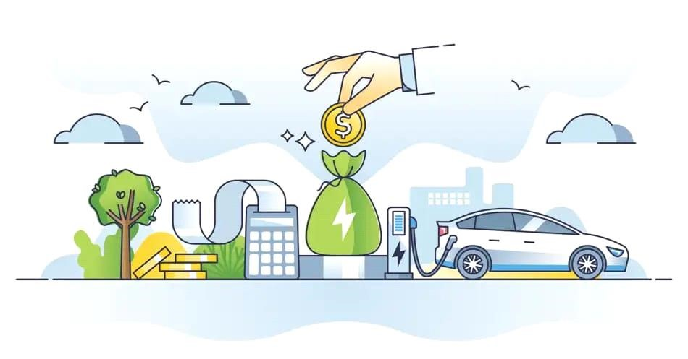

# 6. EV, S ARE HELPFUL IN VARIOUS SECTORS

Electric vehicles (EVs) are transforming the transportation of materials across various sectors due to their efficiency, environmental benefits, and technological advancements. Here’s how they are making an impact:

## 1. Freight and Logistics

Reduced Operating Costs: EVs typically have lower fuel and maintenance costs compared to diesel trucks, which helps companies save money.

Lower Emissions: Electric freight vehicles significantly reduce greenhouse gas emissions, helping logistics companies meet sustainability goals.

Urban Delivery: Electric vans are ideal for urban areas, reducing noise and air pollution while allowing for easier access to city centers.

## 2. Construction and Heavy Machinery

Zero Emissions on Site: Electric construction vehicles, such as excavators and forklifts, minimize air pollution and improve working conditions on job sites.

Operational Efficiency: Electric machinery often has fewer moving parts, leading to lower maintenance requirements and higher reliability.

Regulatory Compliance: Many regions have stricter emissions regulations, and electric machinery helps companies comply with these standards.

**3. Public Transportation** Buses and Trams: Electric buses reduce emissions and noise in urban environments, making public transport more appealing and sustainable.

Infrastructure Development: Investment in EV public transport encourages the development of charging infrastructure, which can benefit other electric vehicles.

## 4. Agriculture

Electric Tractors: These are becoming popular for their lower operational costs and reduced emissions, helping farmers operate more sustainably.

Logistics for Produce: Electric vehicles can be used for transporting goods from farms to markets, reducing carbon footprints.

## 5. Retail and E-commerce

Last-Mile Delivery: Companies are increasingly using electric vans for last-mile deliveries, which helps reduce emissions and meet consumer demand for greener options.

Fleet Management: Electric delivery fleets can be optimized for efficiency and routing, improving service and reducing costs.

## 6. Waste Management

Electric Garbage Trucks: Many municipalities are transitioning to electric waste collection vehicles, which lower noise levels and reduce emissions in residential areas.

Sustainable Practices: Electric vehicles help waste management companies enhance their sustainability initiatives.

## 7. Emergency Services

First Response Vehicles: Electric ambulances and fire trucks can provide quieter operations and reduce emissions in urban environments, which is critical during emergencies.

Rapid Deployment: Many electric emergency vehicles can be equipped with advanced technology for efficient dispatch and communication.

# 7. CONCLUSION AND PROSPECTIVES

In conclusion, electric vehicles have become an increasingly popular alternative to traditional gas-powered cars. In this comprehensive review, we examined various types of EVs, charging methods, and the associated issues and challenges for some types. We also explored various energy generation systems and energy management strategies that are used to power and optimize electric vehicles.

Additionally, we discussed the application of machine learning techniques in electric vehicle battery management, range optimization, and energy consumption prediction. Overall, the use of machine learning in electric vehicles has shown promising results in improving their efficiency, performance, and sustainability.

However, there are still several challenges that need to be addressed, such as battery degradation, data privacy, and ethical considerations in the development and deployment of machine learning algorithms for electric vehicles.

Further study and invention is needed to overcome these challenges and accelerate the adoption of EVs as a clean and sustainable transportation solution for the future. We finish by outlining our perspective on the field that requires further research and development to ensure that these ML algorithms can provide accurate and reliable results to EVs, and to make an influence on the optimization and management of EVs.

# 8. REFERENCES

1. Sovacool, B. K., & Hirsh, R. F. (2009). Beyond Batteries: An Examination of the Benefits and Barriers to Plug-in Hybrid Electric Vehicles (PHEVs) and a Vehicle-to-Grid (V2G) Transition. Energy Policy, 37(3), 1095-1103.
2. Analyzes the potential benefits of PHEVs and the challenges associated with integrating them into the power grid.
3. Breetz, H. L., Mildenberger, M., & Stokes, L. C. (2018). The Political Logics of Clean Energy Transitions. Business and Politics, 20(4), 663-692.
4. Explores the political factors influencing the transition to clean energy, including the adoption of electric vehicles.
5. Wang, N., & Sperling, D. (2008). A National Plug-in Hybrid Electric Vehicle Program: PEV Benefits, Costs, and Impacts. Environmental Science & Technology, 42(17), 6554-6560.
6. Evaluates the nationwide implementation of plug-in hybrid electric vehicles, focusing on environmental and economic impacts.
7. Zhang, Y., Mi, C. C., & Yang, L. (2013). Effect of Electric Vehicles on Energy Consumption and Greenhouse Gas Emissions in China: A Scenario Analysis. Renewable and Sustainable Energy Reviews, 21, 203-211.
8. Assesses how the adoption of electric vehicles could influence energy consumption and greenhouse gas emissions in China.
9. Tran, M., Banister, D., Bishop, J. D. K., & McCulloch, M. D. (2011). Prospects for Plug-In Hybrid Electric Vehicles in the UK. Energy Policy, 39(2), 789-799.
10. Explores the potential market penetration and environmental benefits of plug-in hybrid electric vehicles in the UK.