**Performance Analysis of Bit Coupled code for Recursive Decoder Structure for VLSI Applications**

1Rahul Kushwah, 2Prof. Deepak Sharma

1M.Tech Scholar, 2Assistant Professor

1,2Dept. of ECE, LNCT(Bhopal) Indore Campus, Indore

**Abstract: Implementing error detection of system on chip (SoC) is a challenge for VLSI applications. One way to look at turbo codes is as a type of parallel convolution code that achieves low BER in the waterfall area of the error, even for low SR values. In this article, we show how to use turbo codes. The recursive convolution encode is utilized in this paper's technique since the receiving end's decoding converges well. To make the bit stream random or permuted, block interleaving has been employed. In addition, puncturing has been incorporated to produce codes at higher rates than the standard r=1/3 encoder. Turbo codes with a higher rate can be generated with this. The last step in the decoding process is the usage of soft input-soft output decoding. The bit error rate has been used to measure the system's performance, which outperforms existing work in the domain.**

**Keywords:Very Large Scale Integration (VLSI), System on Chip (SOC), Turbo Codes, cascaded code blocks, recursive decoding, puncturing, bit error rate.**

**I. INTRODUCTION**

Turbo codes, introduced in the early 1990s, revolutionized the field of error correction in digital communications by approaching the Shannon limit, which defines the maximum rate at which data can be transmitted over a channel with a specified noise level without error. The implementation of turbo codes in Very Large Scale Integration (VLSI) applications has garnered significant interest due to their ability to enhance data reliability in communication systems. This essay explores the application of turbo codes in VLSI, discussing their advantages, design considerations, and challenges.Channel capacity is mathematically given by:

$TR≤Channel Capacity$ (1)

Here,

TR represents transmission rate through the channel.The Shannon’s limit is BER of almost 10-5(ideally 0)for $\frac{E_{b}}{N_{0}}$ = 0 dB for binary modulation. [11].

The turbo codes can be thought of as a parallel concatenation of Convolutional codes. The structure of the turbo encoder and decoder in a communication system is shown in the figure below.

Outer Encoder

Inner

Encoder

Channel

Inner Decoder

Outer Decoder

**Super Channel**

**Fig.1 The Turbo Encoder-Decoder in a channel**

The turbo encoding can be thought of as a two-step process comprising of the inner encoder and the outer encoder.[3] The inner encoder, channel and outer encoder is often termed as the super channel. The block diagram of the turbo encoder is shown below.

(π)

Enc2

Enc1

I

P2

P2

I

**Fig.2Turbo Code Encoding Mechanism [11]**

The encoder inputs and outputs are:

Input: I

Outputs: I, P1, P2

Here,

I represents the information bits

P1 represents the Parity bit 1

P2 represents the parity bit 2

The interleaver is denoted by π

Turbo codes should look like random codes and the interleaver introduces the randomness. However, too much randomness can create a lot of decoding complexity. On the flipside, if the randomness is too low, i.e. there is too much structure in the code, then the code doesn’t remain random at all.

**II. TURBO ENCODING**

The blocks in the turbo encoding part are:

1) Encoder 1

2) Encoder 2

3) Interleaver (π)

The information bit I is fed directly to one encoder and it’s interleaved version is fed to the other encoder. The outputs of encoder 1, encoder 2 and he original information bit are fed to the channel. Often the output of encoder 1 is called parity bit 1, and the output of encoder 2 is called parity bit 2.If both the encoder structures are same, then such codes are called symmetric codes and they generally exhibit good convergence.

**Encoder Structure:**

The encoder structure is extremely critical for turbo code design. The encoder structure is a recursive feedback encoding mechanism. It results in large inter code distance in the trellis structure. The conventional turbo code or the systematic turbo encoder has one input and 3 outputs and hence has a coder rate of

$r=\frac{1}{3}$ (2)

The recursive encoding structure can be understood as:

$$\frac{1}{1+D}$$

$$\frac{1}{1+D}$$

**π**

**Fig. 3 Internal Encoder Structure**

The recursive structure at the encoder is used in the form of the system response of $1+D$

Generally, recursive encoder design renders better intercede distance. Moreover, the parallel concatenation is better than serial concatenation since parallel concatenation based codes terminating easily.

Considering the response of the encoder block as G(D), and the input as U(D)=1,we get:

$U\left(D\right)=1$ (3)

$G\left(D\right)=\frac{1}{1+D}$ (4)

Then, the output of the encoder1 will be:

$V\left(D\right)=1+D+D^{2}+…$ (5)

If the interleaver system function is given by

$π=1+D^{n-1}$ (6)

Then, the input to encoder 2 will be,

$V\left(D\right)=1+D^{n-1}$ (7)

Thus the interleaver spreads out the 1s in the input bit stream and feeds to encoder 2.This results in code word with large weights at the output.[7] This can be illustrated as:

Let the original information sequence be:

110000000000000

Then the interleaved bit sequence will be

1000000000000001

It can be seen that the bit 1 is spread out temporally in the code word.

The most common interleaver structure used is the block interleaver. It this structure, the interleaver is fed row-wise and data is read column wise and vice-versa.

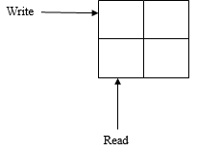

**Fig.4 Block Interleaver structure**

**IV PUNCTURING**

Puncturing is a technique of generating codes of higher rate. In this technique, some of the bits are not transmitted at every time slot. The following table illustrates the concept.[8]

|  |  |  |  |
| --- | --- | --- | --- |
| **Bit** | Tx (Y/N) | Tx (Y/N) | Tx (Y/N) |
| **I** | Y | Y | Y |
| **P1** | Y | N | Y |
| **P2** | N | Y | N |
|  | Time=t1 | Time=t2 | Time=t3 |

At t1, I and P1 are transmitted

At t2, I and P2 are transmitted

At t3, I and P1 are transmitted

Thus the $r=\frac{1}{3}$ code is converted to a $r=\frac{1}{2}$ code. Hence, by puncturing, higher rate codes are obtained. The receiver assumes that for the non-transmitted bit, there exists equal probability for 0/1 transmission i.e.

$P\left(0\right)=P(1)$ (8)

**V NOISY CHANNEL DESIGN**

The channel assumed in this approach is the Gaussian channel with the frequency domain Power Spectral density of noise being constant.[10] Mathematically,

$N\left(f\right)=k∀f$ (9)

Here,

N stands for noise

k is a constant

f stands for frequency.

The time domain nature of the noise is random and resembles a random signal which is a function of time.

**VI. TURBO DECODING**

The turbo decoding mechanism is shown below.

Dec 1

π

Dπ

π

Dec 2

I

**Xk**

**Y1k**

**Y2k**

APP

Decoded Sequence

**Fig.5 Structure of Turbo Decoder [11]**

The turbo decoding mechanism uses two decoders working in synchronism in a recursive fashion.[5]Three inputs to both the decoders are the information bit X and the parity bit Y1 and Y2, all of which come from the channel. The second decoder receives an interleaved version of the parity bit Y2 so as to retain the sequence of the data stream. [9] The input 4 is the apriori information of the bit that the other decoder thinks the bit to be. Hence, decoder 1 sends the estimation of a bit along with its probability to decoder 2 and the same process is repeated by decoder 2 and data is sent to decoder 1. Thus, in place of decoding the bit at one go, the decoder tries to decoder encoder 1 first followed by decoding encoder 2. The decoding is carried on recursively and stopped on setting a conditions on iterations. The final verdict about the information bit I is taken from the decoder 2 after computing the a posteriori probability (APP) using the following relations.

$\max^{*}\left(x,y\right)=ln⁡(e^{x}+e^{y})$ (9)

$$or$$

$\max^{*}\left(x,y\right)$ = $\max\left(x,y\right)+ln⁡(1+e^{-\left|x-y\right|})$

(10)

Here, x and y denote the probabilities of the bit being 0 or 1. Finally a hard decision output i.e. hard quantized output in the form of 1 or 0 is received.

**VII SIMULATION AND RESULTS**

The results obtained are plotted below. The system has been simulate using the statistical and HDL coder toolboxes in MATLAB.

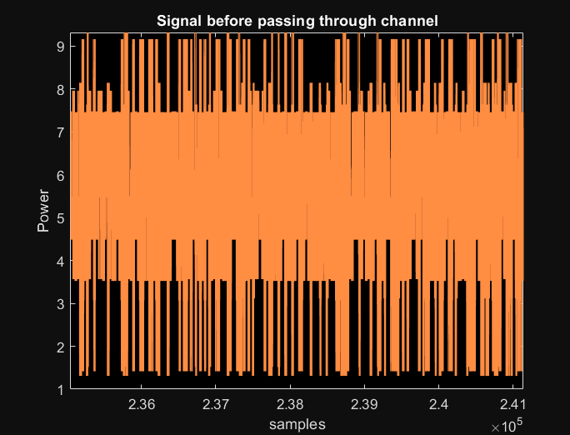

**Fig.6 Original Signal before passing through channel**

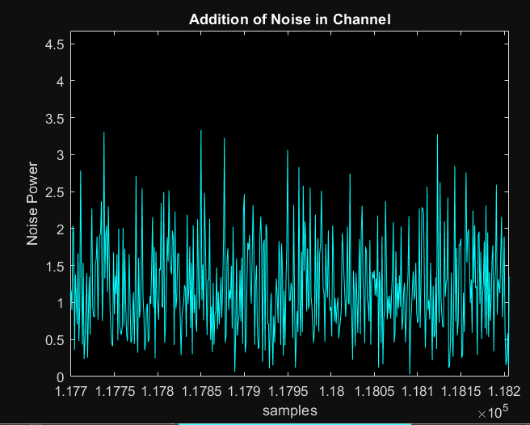

**Fig.7 Addition of Noise in Channel**

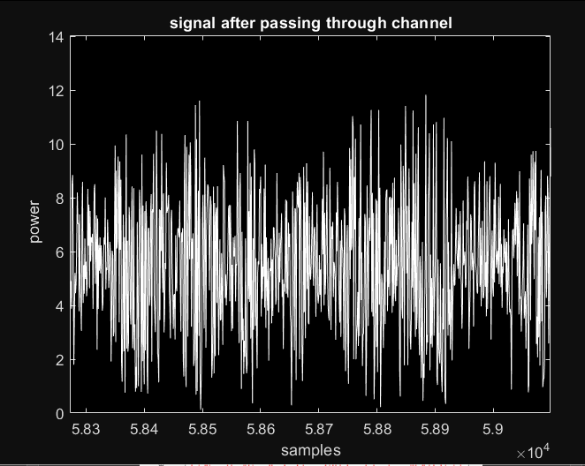

**Fig.8 Signal after addition of noise**

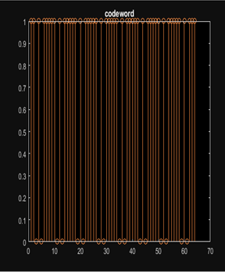

**Fig.9 Codeword Generation**

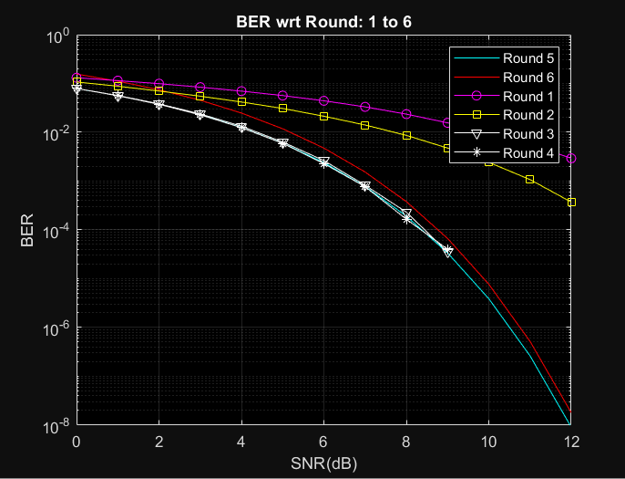

**Fig.10 BER performance of system**

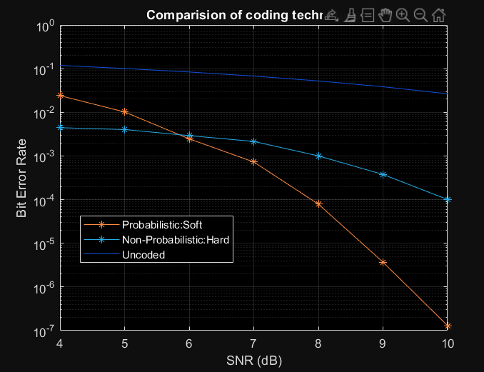

**Fig.11 Comparative BER Analysis for Un-coded, Hard and Soft Decoding Structures**

**Conclusion:**

**Turbo codes offer a powerful solution for error correction in digital communications, and their implementation in VLSI technology enhances the reliability and efficiency of communication systems. While challenges such as high computational complexity and power consumption must be addressed, the advantages of turbo codes, including their exceptional error correction capability and suitability for high-speed applications, make them a valuable tool in modern VLSI designs. As technology advances, the application of turbo codes in VLSI is expected to expand, driving further improvements in the performance and reliability of communication systems.It can be concluded from previous discussions that turbo codes are effective in attaining low BER in the approaching the Shannon’s limit. The system has been simulated on MATLAB. The results obtained and the related mathematical formulations that the proposed technique achieves**

**References**

[1] X. Wu, M. Qiu and J. Yuan, "Partially Information Coupled Duo-Binary Turbo Codes," 2020 IEEE International Symposium on Information Theory (ISIT), 2020, pp. 461-466

[2] Chaofan Chen , Li Li, Li Wang, Shuai Wang 1, Xiangming Li 1, George K. Karagiannidis, “Noncoherent Detection With Polar Codes”, IEEE 2018.

[3] SaeedehMoloudi, Michael Lentmaier, AlexandreGraelliAmat, “Spatially Coupled Turbo-Like Codes”, IEEE 2017.

[4] SuihuaCai, Nina Lin, and Xiao Ma, “Block Markov Superposition Transmission of BCH Codes with Iterative Erasures-and-Errors Decoders”, IEEE 2017.

[5] S. Moloudi, M. Lentmaier and A. Amat, “Spatially coupled Turbo-like codes,” IEEE Trans. Inf. Theory, vol. 63, no. 10, pp. 6199–6215, Oct. 2017.

[6] M. Zhu, D. G. M. MitChell, M. Lentmaier, D. J. Costello and B. Bai, “Braided convolutional codes with sliding window decoding,” IEEE Trans. Comm., vol. 65, no. 9, pp. 3645 – 3658, May 2017.

[7] Gianluigi Liva, Lorenzo Gaudio, Tudor Ninacs and Thomas Jerkovits, “Code Design for Short Blocks: A Survey”, IEEE 2016.

[8] ErdalArıkan, Daniel J. Costello, Jr., JoergKliewer, Michael Lentmaier, Paul Siegel, RuedigerUrbanke, Michael Pursley, “Guest Editorial Recent Advances in Capacity Approaching Codes”, IEEE 2016.

[9] Boulat A. Bash, Dennis Goeckel, SaikatGuha, Don Towsley, “Hiding Information in Noise: Fundamental Limits of Covert Wireless Communication”, IEEE 2015.

[10] Zunaira Babar, Soon Xin Ng and Lajos Hanzo, “EXIT-Chart Aided Near-Capacity Quantum Turbo Code Design”, IEEE 2015.

[11] Michael Lentmaiery, SaeedehMoloudiy, and Alexandre GraelliAmat, “Braided Convolutional Codes – A Class of Spatially Coupled Turbo-Like Codes”, IEEE 2014.

[12] Tsung-Yi Chen, KasraVakilinia, DariushDivsalar, and Richard D. Wesel, “Protograph-Based Raptor-Like LDPC Codes”, IEEE 2014.

[13] A. Amat S. Moloudi and M. Lentmaier, “Spatially coupled Turbo codes: Principles and ﬁnite length performance,” IEEE 11th ISWCS, pp. 883– 887, 2014.

[14] T. Breddermann and V. Peter, “Rate-compatible insertion convolutional Turbo codes: Analysis and application to LTE,” IEEE Trans. Wireless Comm., vol. 13, no. 3, pp. 1356–1366, Mar. 2014.

[15] K Niu, K Chen, JR Lin, “Beyond turbo codes: Rate-compatible punctured polar codes”, IEEE 2013

[16] MM Wilde, MH Hsieh, Z Babar, “Entanglement-assisted quantum turbo codes”, IEEE 2013

[17] G Liva, E Paolini, B Matuz, S Scalise, “Short turbo codes over high order fields”, IEEE 2013

[18] K Anwar, T Matsumoto, “Accumulator-assisted distributed turbo codes for relay systems exploiting source-relay correlation”, IEEE 2012