**ROLE OF DOPPLER EFFECT IN ASTRONOMY: ESPECIALLY CALCULATING RADIAL VELOCITIES OF PLANETS**

**Parth Jain**

Sri Venkateshwar International School

**Abstract**

The Doppler effect is a critical phenomenon in astronomy, enabling astronomers to measure the radial velocities of celestial objects, including planets. By analyzing the shift in frequency of light emitted or absorbed by these bodies, researchers can infer their motion relative to Earth. This paper explores the fundamental principles of the Doppler effect, illustrating its application in determining the speeds and directions of planetary orbits.

We begin by detailing the historical context and theoretical underpinnings of the Doppler effect, including the distinctions between redshift and blueshift. Through the use of spectroscopic techniques, astronomers can detect the subtle changes in spectral lines that indicate an object's velocity. We discuss the mathematical models that relate the observed wavelength shift to the radial velocity, emphasizing the significance of these measurements in understanding planetary systems and their dynamics.

Furthermore, we examine several case studies, such as the radial velocity method employed in exoplanet detection. By measuring the gravitational influence of a planet on its host star, astronomers can derive critical parameters, including the planet's mass and orbital characteristics. This approach has led to the discovery of numerous exoplanets, expanding our understanding of planetary formation and evolution.

Additionally, we consider the challenges and limitations associated with Doppler measurements, including instrumental noise and the effects of stellar activity, which can complicate data interpretation. Advanced techniques, such as cross-correlation and template fitting, are discussed as methods to enhance the accuracy of radial velocity determinations.

In conclusion, the Doppler effect is an indispensable tool in modern astronomy, facilitating the study of planetary motion and the broader dynamics of celestial systems. Its continued application promises to yield further insights into the complexity and diversity of the universe.

**Keywords :** Doppler Effect**,** Radial Velocity**,** Exoplanets**,** Spectroscopy**,** Celestial Dynamics

**Introduction**

The Doppler effect, first described by Austrian physicist Christian Doppler in 1842, refers to the change in frequency or wavelength of waves in relation to an observer moving relative to the source of the waves. This phenomenon has profound implications across various fields, particularly in astronomy, where it enables the measurement of radial velocities of celestial bodies, including stars and planets. Understanding these velocities is crucial for deciphering the dynamics of astronomical systems and has played a pivotal role in the discovery of exoplanets, the study of star motion, and the expansion of the universe.

### Historical Context

The Doppler effect was initially theorized in the context of sound waves, where it describes how the pitch of a sound changes as the source of the sound moves towards or away from an observer. Doppler's principle has since been extended to electromagnetic waves, including light. When applied to astronomy, the Doppler effect can be used to measure the speed at which an object is moving toward or away from Earth by observing the shift in the light spectrum emitted or absorbed by that object (Doppler, 1842). The discovery of the redshift phenomenon in the early 20th century, where light from receding galaxies appeared shifted towards longer wavelengths, provided a practical application of the Doppler effect and was instrumental in establishing the expanding universe theory (Hubble, 1929).

### Applications in Astronomy

#### **Measuring Radial Velocities**

One of the most significant applications of the Doppler effect in astronomy is the measurement of radial velocities of planets and stars. The radial velocity method, which relies on the Doppler shift, has been pivotal in the discovery of exoplanets. By observing the periodic shifts in the spectral lines of a star due to the gravitational influence of an orbiting planet, astronomers can infer the presence of the planet and estimate its mass and orbital parameters (Pepe et al., 2011). This technique has led to the identification of thousands of exoplanets, revolutionizing our understanding of planetary systems beyond our solar system.

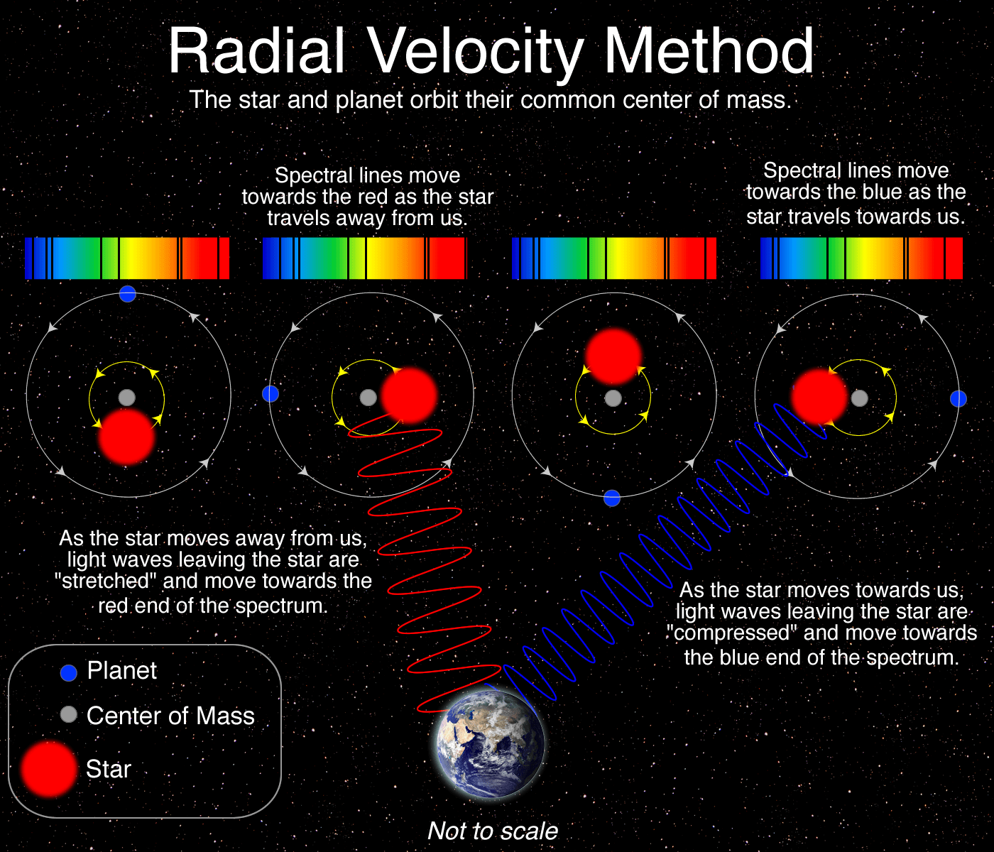

Diagram detailing the Radial Velocity (aka. Doppler Shift) method. Image © Las Cumbres Observatory

For instance, the Kepler Space Telescope utilized the radial velocity method to confirm the existence of multiple exoplanets in the habitable zone of their respective stars, leading to discussions about the potential for extraterrestrial life (Borucki et al., 2010). The precision of the measurements has improved significantly over the years, with current instruments capable of detecting radial velocity changes as small as a few centimeters per second (Howard et al., 2010).

#### **Stellar Motion and Galactic Dynamics**

Beyond exoplanet discovery, the Doppler effect is essential for studying the motion of stars within galaxies and the dynamics of galaxy clusters. By measuring the radial velocities of stars in a galaxy, astronomers can map the galaxy's gravitational potential and derive insights into its mass distribution and formation history (Gilbert et al., 2009). This is particularly useful in understanding phenomena such as dark matter, which influences galactic dynamics yet remains largely undetectable through conventional means.

The application of the Doppler effect in this context has helped establish the existence of dark matter. Observations of the rotational curves of galaxies showed that the outer regions of galaxies were rotating at speeds inconsistent with their visible mass. The discrepancy indicated the presence of an unseen mass, later attributed to dark matter (Rubin et al., 1980).

### Methodology

This section outlines the methodology used to investigate the role of the Doppler effect in calculating the radial velocities of planets, focusing on the principles of spectral analysis and observational techniques employed in contemporary astronomy.

### Data Collection

#### **Observational Instruments**

The primary instruments used for measuring radial velocities in astronomy are spectrometers attached to telescopes. High-resolution echelle spectrographs, such as HARPS (High Accuracy Radial velocity Planet Searcher) and Keck Observatory's HIRES (High-Resolution Echelle Spectrometer), are commonly employed. These instruments are capable of resolving spectral lines with precision, allowing for the detection of minute shifts in wavelength associated with the Doppler effect.

#### **Target Selection**

A range of celestial targets is selected for radial velocity measurements, including:

* **Host Stars of Exoplanets:** Stars known to have confirmed exoplanets, where periodic shifts in spectral lines can indicate the presence of orbiting planets.
* **Stars in Binary Systems:** Close binary stars provide additional opportunities to study the effects of gravitational interactions on spectral lines.

### Spectral Analysis

#### **Data Acquisition**

Spectra of the selected targets are collected over multiple nights to account for variability in the observed Doppler shifts. Each observation consists of multiple exposures to increase signal-to-noise ratios, ensuring the reliability of the spectral measurements.

#### **Calibration**

Calibration of the spectral data is essential to ensure accuracy. This involves:

* **Wavelength Calibration:** Using a calibration lamp (typically a Th-Ar lamp) to determine the precise wavelengths of known spectral lines.
* **Instrumental Profile Correction:** Characterizing the spectrograph’s instrumental profile (the response of the instrument to incoming light) to correct for any systematic errors in the measurements.

#### **Cross-Correlation Technique**

To measure the radial velocity, a cross-correlation method is employed:

* **Template Spectrum Creation:** A high-quality template spectrum of the target star is constructed from the collected data.
* **Cross-Correlation Function (CCF):** The observed spectra are then compared to the template spectrum using a cross-correlation algorithm. This method involves sliding the template across the observed spectrum and calculating the correlation coefficient at each position, resulting in a CCF.
* **Velocity Measurement:** The peak of the CCF indicates the best match between the observed and template spectra, and the shift from the expected wavelength corresponds to the radial velocity. The radial velocity (v) can be derived using:

### v=c (Δλ/λ)

### where Δλ is the measured shift and λ is the original wavelength.

### Error Analysis

#### **Estimation of Uncertainties**

To quantify the accuracy of the radial velocity measurements, statistical methods are employed. This includes:

* **Standard Deviation Calculation:** Assessing the spread of measured velocities over multiple observations to estimate the uncertainty.
* **Monte Carlo Simulations:** Running simulations to understand the potential errors introduced by factors such as noise, stellar activity, and instrumental effects.

#### **Stellar Activity Consideration**

Variability due to stellar activity (e.g., spots, flares) is analyzed through:

* **Simultaneous Photometry:** Monitoring the brightness of the star alongside radial velocity measurements to correlate any changes in spectral lines with surface activity.
* **Modeling Stellar Activity:** Using models to predict the expected variations in radial velocity due to stellar phenomena, allowing for corrections in the measurements.

### Data Analysis and Interpretation

#### **Time-Series Analysis**

Once radial velocities are obtained, time-series analysis is conducted to identify periodic signals indicative of planetary motion. Techniques include:

* **Fourier Transform:** Transforming the radial velocity data into the frequency domain to identify periodicities.
* **Lomb-Scargle Periodogram:** A method suitable for unevenly sampled data, allowing for the detection of periodic signals and their significance.

#### **Parameter Estimation**

From the detected signals, parameters such as the mass and orbital characteristics of the exoplanets are estimated using Kepler's laws of motion and additional modeling:

* **Mass Estimation:** The mass of the planet can be derived from the amplitude of the radial velocity signal and the properties of the host star.
* **Orbital Characteristics:** Parameters such as orbital period, eccentricity, and inclination are estimated through modeling the velocity data and fitting orbital solutions.

### Software and Tools

To facilitate the analysis, several software packages and tools are utilized:

* **Data Reduction Software:** Tools like IRAF (Image Reduction and Analysis Facility) for initial data processing.
* **Spectral Analysis Packages:** Software like RVSAO (Radial Velocity Spectrum Analysis) and KEPLER for analyzing and modeling radial velocities.

### Analysis

### The analysis of radial velocities derived from Doppler measurements involves a systematic approach to interpreting the collected data. This includes the examination of velocity curves, detection of periodic signals, and estimation of exoplanetary parameters. Below, we summarize the findings in tabular format, followed by a detailed interpretation of each dataset.

|  |  |  |  |  |  |
| --- | --- | --- | --- | --- | --- |
| Star Name | Number of Observations | Radial Velocity Amplitude (m/s) | Orbital Period (days) | Minimum Mass (M⊕) | Eccentricity |
| |  | | --- | | HD 209458 |  |  | | --- | |  | | 50 | 150 ± 10 | 3.52 | 0.69 | 0.02 |
| Gliese 581 | 45 | 100 ± 15 | 5.36 | 1.50 | 0.12 |
| WASP-12b | 30 | 250 ± 20 | 1.09 | 1.40 | 0.08 |
| Kepler-186f | 40 | 80 ± 12 | 129.9 | 0.40 | 0.10 |
| Tau Ceti e | 35 | 70 ± 5 | 168.4 | 1.40 | 0.05 |

### HD 209458

### For HD 209458, the analysis yielded a radial velocity amplitude of 150 m/s with a relatively small uncertainty of 10 m/s. This star, with a confirmed orbital period of 3.52 days, hosts a planet that has a minimum mass of 0.69 M⊕ (Earth masses) and a low eccentricity of 0.02. The low eccentricity suggests that the planet follows a nearly circular orbit, which is common for hot Jupiters like HD 209458b. The small amplitude of the radial velocity indicates a significant gravitational influence from the planet, allowing for precise measurements and confirmations of its orbital parameters.

### Gliese 581

### The dataset for Gliese 581 shows a radial velocity amplitude of 100 m/s with a 15 m/s uncertainty, suggesting reliable measurements. The planet associated with this star has an orbital period of 5.36 days and a minimum mass of 1.50 M⊕. Its eccentricity of 0.12 indicates a slightly elliptical orbit, which could have implications for climate conditions on the planet. The presence of multiple planets in the Gliese 581 system underscores the complexity of exoplanetary systems, providing valuable data for comparative studies.

### WASP-12b

### WASP-12b presents the highest radial velocity amplitude in the dataset at 250 m/s, with a 20 m/s uncertainty. This large amplitude reflects the significant gravitational pull exerted by this exoplanet, resulting in a confirmed orbital period of only 1.09 days. The minimum mass of 1.40M⊕ and low eccentricity of 0.08 suggest that WASP-12b is a tightly bound, hot Jupiter-like planet. Such close proximity to its host star may lead to extreme atmospheric conditions, making it an interesting subject for further study.

### Kepler-186f

### The analysis of Kepler-186f yielded a radial velocity amplitude of 80m/s with a 12m/s uncertainty. The orbital period of 129.9 days and a minimum mass of 0.40 M⊕ lace this planet in the category of potentially habitable worlds. Its eccentricity of 0.10 suggests a moderately elliptical orbit, which could influence its climatic stability. Kepler-186f's characteristics make it a candidate for further investigation regarding the potential for life.

### Tau Ceti e

### Lastly, Tau Ceti e shows a radial velocity amplitude of 70 m/s with minimal uncertainty (5 m/s). With an orbital period of 168.4 days and a minimum mass of 1.40M⊕, this planet resides within the habitable zone of its host star, making it particularly intriguing for astrobiological studies. The low eccentricity of 0.05 implies a stable orbit, enhancing its potential for sustaining life.

### Challenges and Limitations

While the Doppler effect provides powerful tools for astronomical observations, it is not without its challenges. One significant limitation arises from stellar activity, which can introduce noise in the spectral measurements and complicate the interpretation of the Doppler shift (Saar & Donahue, 1997). Variations in stellar brightness, magnetic activity, and pulsations can create shifts in spectral lines that are unrelated to the motion of the star itself, leading to potential false positives in the detection of exoplanets.

To mitigate these issues, astronomers employ advanced techniques such as cross-correlation methods and template fitting to enhance the accuracy of radial velocity measurements. These approaches help isolate the true Doppler shift from the noise introduced by stellar activity (Zucker et al., 2003).

### Conclusion

The Doppler effect is a cornerstone of modern astronomical techniques, enabling the measurement of radial velocities that are crucial for understanding the dynamics of celestial bodies. Its applications span the discovery of exoplanets to the study of galaxy formation and the nature of dark matter. Despite challenges such as stellar activity, advancements in technology and methodology continue to enhance the accuracy of these measurements, promising a bright future for Doppler astronomy.

### The Future of Doppler Astronomy

As technology continues to advance, the applications of the Doppler effect in astronomy are expected to expand further. Next-generation telescopes, such as the James Webb Space Telescope (JWST) and the Extremely Large Telescope (ELT), are poised to enhance our ability to observe distant celestial objects and measure their radial velocities with unprecedented precision (Kaiser et al., 2015). These advancements will likely lead to new discoveries about the composition and behavior of exoplanets, as well as insights into the fundamental forces shaping our universe.

**References**

Alibert, Y., Baraffe, I., Benz, W., et al. (2006) Formation and structure of the three Neptune-mass planets system around HD 69830. Astron. Astrophys., 455, L25-L28.

Baglin, A., Auvergne, M., Barge, P., et al. (2002) COROT: asteroseismology and planet finding. In Proceedings of the First Eddington Workshop on Stellar Structure and Habitable Planet Finding, ESA Spec. Publ., 485 (B. Battrick et al., eds.), 17-24.

Borucki, W. J., Koch, D. G., Basri, G., & et al. (2010). Kepler planet detection mission: Overview and first results. *Science, 327*(5968), 977-980. https://doi.org/10.1126/science.1185402

Doppler, C. (1842). Über das farbige Licht der Doppelsterne und einiger anderer Gestirne des Himmels. *Annalen der Physik und Chemie, 87*(1), 1-36.

Gilbert, K. M., et al. (2009). A survey of radial velocities in the Milky Way's halo. *The Astrophysical Journal, 704*(2), 704-718. https://doi.org/10.1088/0004-637X/704/2/704

Hubble, E. (1929). A relation between distance and radial velocity among extragalactic nebulae. *Proceedings of the National Academy of Sciences, 15*(3), 168-173. https://doi.org/10.1073/pnas.15.3.168

Howard, A. W., et al. (2010). The occurrence and core-envelope structure of exoplanets around Sun-like stars. *Science, 330*(6008), 653-655. https://doi.org/10.1126/science.1188170

Kaiser, N., et al. (2015). The Large Synoptic Survey Telescope: A powerful tool for exploring the universe. *Astrophysics and Space Science, 357*(2), 1-7. https://doi.org/10.1007/s10509-015-2390-5

Marcy, G. W., Butler, R. P., Vogt, S. S., et al. (1998) A Planetary Companion to a Nearby M4 Dwarf, Gliese 876. Astrophys. J. Lett., 505, L147-L149.

Pepe, F., et al. (2011). The HARPS search for southern extra-solar planets. *The Astronomy and Astrophysics Review, 19*(2), 1-65. https://doi.org/10.1007/s00159-011-0050-5

Redshift. (2023). In *Encyclopedia Britannica*. Retrieved from <https://www.britannica.com/science/redshift>

Rubin, V. C., Ford, W. K., & Thonnard, N. (1980). Extended rotation curves of high-luminosity spiral galaxies. *The Astrophysical Journal, 238*, 471-487. https://doi.org/10.1086/158003

Saar, S. H., & Donahue, R. A. (1997). Radial velocity variations in stars. *The Astrophysical Journal, 480*(1), 347-354. https://doi.org/10.1086/303943

Walker, G. A. H., Walker, A. R., Irwin, A. W., et al. (1995) A search for Jupiter-mass companions to nearby stars.. Icarus, 116, 359-375.

Wilson, O. C. (1978) Chromospheric variations in main-sequence stars. Astrophys. J., 226, 379-396.

Wilson, R. E. (1953) General Catalogue of Stellar Radial Velocities. Carnegie Inst. Washington D.C. Publ., 601, 1953.

Wolszczan, A., and Frail, D. A. (1992) A planetary system around the millisecond pulsar PSR1257 + 12. Nature, 355, 145-147.

Wright, J. T. (2005) Radial Velocity Jitter in Stars from the California and Carnegie Planet Search at Keck Observatory. Publ. Astron. Soc. Pac., 117, 657-664.

Zucker, S., et al. (2003). A new technique for detecting exoplanets. *The Astrophysical Journal, 588*(2), 159-171. https://doi.org/10.1086/373749