Non-Renewable Energy Source

SHIVAM

*Electrical and Electronics Engineering*

*H.I.E.T Shahpur(HPTU)*

Kangra,Himachal Pradesh [Shivamkaundal27042003@gmail.com](mailto:Shivamkaundal27042003@gmail.com)

Nikhil AWASHTHI

*Electrical and Electronics Engineering*

*H.I.E.T Shahpur(HPTU)* Kangra,Himachal Pradesh nikhil@hiet.co.in

***Abstract*—Non-renewable energy sources, including fossil fuels (coal, oil, and natural gas) and nuclear power, play a critical role in the global energy landscape. These sources are characterized by their finite availability and significant environmental impacts. The extraction and consumption of fossil fuels contribute to greenhouse gas emissions, air and water pollution, and climate change, raising concerns about sustainability and public health. Nuclear energy, while low in carbon emissions, poses challenges related to radioactive waste management and safety. As the world faces increasing energy demands and urgent climate goals, the transition to renewable energy sources becomes imperative. This abstract explores the implications of continued reliance on non-renewable energy, the necessity for technological innovation, and the potential pathways toward a more sustainable and resilient energy future *Keywords—Non-renewable energy, Fossil fuel ,Coal, Oil ,Natural gas.***

# INTRODUCTION

Non-renewable energy sources are forms of energy that are finite and cannot be replenished within a human timescale. These sources primarily include fossil fuels—such as coal, oil, and natural gas—as well as nuclear energy, which relies on uranium and other radioactive materials.

Fossil fuels have been the backbone of industrial development, powering economies and providing energy for transportation, heating, and electricity generation. However, their extraction and use are associated with significant environmental concerns, including greenhouse gas emissions, air and water pollution, and habitat destruction.

Nuclear energy, while low in direct carbon emissions, raises concerns about radioactive waste management and the potential for catastrophic accidents. As the global community increasingly recognizes the urgency of addressing climate change, the shift toward more sustainable and renewable energy sources becomes crucial. Balancing energy needs with environmental impact is a key challenge in the transition away from non- renewable resources.

# SUMMARY

* Non-renewable energy sources are natural resources that cannot be replenished within a human timescale once they are depleted. The primary types include:
* **Fossil Fuels:** This category encompasses coal, oil, and natural gas, formed from the remains of ancient plants and animals over millions of years. They are widely used for electricity generation, heating, and powering vehicles, but their combustion releases greenhouse gases, contributing to climate change.
* **Nuclear Energy:** This energy source is derived from nuclear reactions, primarily through the fission of uranium or plutonium. While it produces minimal greenhouse gas emissions during operation, concerns include radioactive waste disposal, potential accidents, and high initial costs for plant construction.
* Non-renewable energy sources are currently dominant in global energy production, but their finite nature, environmental impact, and the urgency of climate action have led to increased interest in transitioning to renewable energy sources like solar, wind, and hydroelectric power.

# TYPES OF NON- RENEWABLE ENERGY

**SOURCES**

Non-renewable energy sources are typically classified into several categories based on their origins and characteristics. Here are the main classifications:

## Fossil Fuels

**Coal:** A solid fossil fuel formed from ancient plant matter, primarily used for electricity generation and industrial processes.

**Oil (Petroleum):** A liquid fossil fuel used for transportation, heating, and as a raw material in various chemical products.

**Natural Gas:** A gaseous fossil fuel primarily composed of methane, used for heating, electricity generation, and as an industrial feedstock.

## Nuclear Energy

**Uranium:** The primary fuel used in nuclear reactors; it undergoes fission to produce heat, which generates electricity.

**Thorium:** An alternative nuclear fuel that can be used in some reactor designs, offering potential safety and sustainability benefits.

## Tar Sands and Oil Shale

**Tar Sands:** Mixtures of sand, clay, water, and a dense form of petroleum called bitumen, which can be extracted and processed into oil.

**Oil Shale:** Sedimentary rock that contains kerogen, a precursor to oil, which can be converted into synthetic oil through heating and processing.

## Peat

An organic material that is an early stage of coal formation, used as a fuel source in some regions, particularly in Europe.

## Hydrocarbons

A broader category that includes all compounds made of hydrogen and carbon, such as methane, ethane, and various liquid fuels derived from fossil sources.

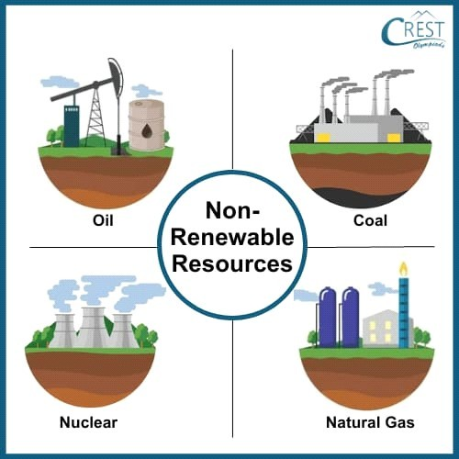

# IMPACTS OF NON- RENEWABLE ENERGY

**SOURCES ON ENVIRONEMENT**

Non-renewable energy sources, such as fossil fuels (coal, oil, and natural gas), have significant environmental impacts:

**Air Pollution:** Burning fossil fuels releases pollutants like sulfur dioxide, nitrogen oxides, and particulate matter, contributing to respiratory problems and smog.

**Greenhouse Gas Emissions:** These sources are major contributors to carbon dioxide emissions, driving climate change and global warming.

**Water Pollution:** Extraction and refining processes can lead to oil spills and runoff of toxic substances, contaminating water sources and harming aquatic life.

**Habitat Destruction:** Mining and drilling operations often disrupt ecosystems, leading to loss of biodiversity and degradation of natural habitats.

**Soil Degradation:** Spills and leaks can contaminate soil, affecting agriculture and local ecosystems.

**Resource Depletion:** Non-renewable resources are finite; their extraction can lead to depletion and increased difficulty in accessing remaining reserves.

**Climate Impact:** The cumulative effects of fossil fuel use contribute to extreme weather events, rising sea levels, and shifting climate patterns.

Transitioning to renewable energy sources can mitigate many of these negative effects and promote a more sustainable environmental future.

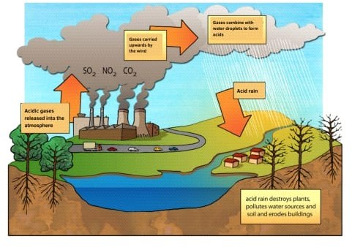

# HOW NON-RENEWABLE SOURCES ARE USEFULL FOR

**US**

Non-renewable energy sources, despite their environmental impacts, offer several advantages that make them useful:

**High Energy Density:** Fossil fuels contain a large amount of energy in a small volume, making them efficient for transportation and power generation.

**Reliability:** Non-renewable sources provide a consistent and stable energy supply, unlike some renewable sources that can be intermittent.

**Infrastructure:** Established infrastructure for extraction, transportation, and use makes non- renewable energy sources readily accessible.

**Economic Growth:** The fossil fuel industry creates jobs and contributes significantly to economies around the world, particularly in regions rich in resources.

**Technological Advancements:** The use of non- renewable energy has driven innovations in extraction, efficiency, and energy storage technologies.

**Energy Security:** Countries with abundant fossil fuel reserves can reduce dependence on foreign energy sources.

**Cost-Effectiveness:** Historically, non-renewable energy has been cheaper to produce and use compared to many renewable options, though this is changing as technology advances.

While these benefits are significant, the long-term sustainability and environmental concerns highlight the importance of transitioning to cleaner energy alternatives.

# ADVANTAGES OF RENEWABLE SOURCES OVER NON-RENEWABLE SOURCES

Renewable energy sources offer several advantages over non-renewable sources:

**Sustainability:** Renewable sources like solar, wind, and hydro are abundant and can be replenished naturally, ensuring a long-term energy supply.

**Lower Environmental Impact:** Renewables produce little to no greenhouse gas emissions during operation, significantly reducing air pollution and contributing to climate change mitigation.

**Biodiversity Preservation:** Renewable energy projects often have a smaller ecological footprint and can coexist with natural habitats, supporting biodiversity.

**Energy Independence:** By harnessing local renewable resources, countries can reduce reliance on imported fuels, enhancing energy security.

**Job Creation:** The renewable energy sector is rapidly growing, creating jobs in manufacturing, installation, and maintenance.

**Technological Innovation:** The renewable energy field is advancing quickly, leading to improvements in efficiency and cost- effectiveness, making it increasingly competitive with non-renewables.

**Resilience:** Distributed renewable energy systems can enhance grid resilience, reducing vulnerability to outages and disasters.

**Economic Benefits:** As technology advances, the costs of renewable energy continue to decline, making it more affordable for consumers and businesses.

Overall, while both energy types have roles in the current energy landscape, the benefits of renewables make them a critical component of a sustainable energy future.

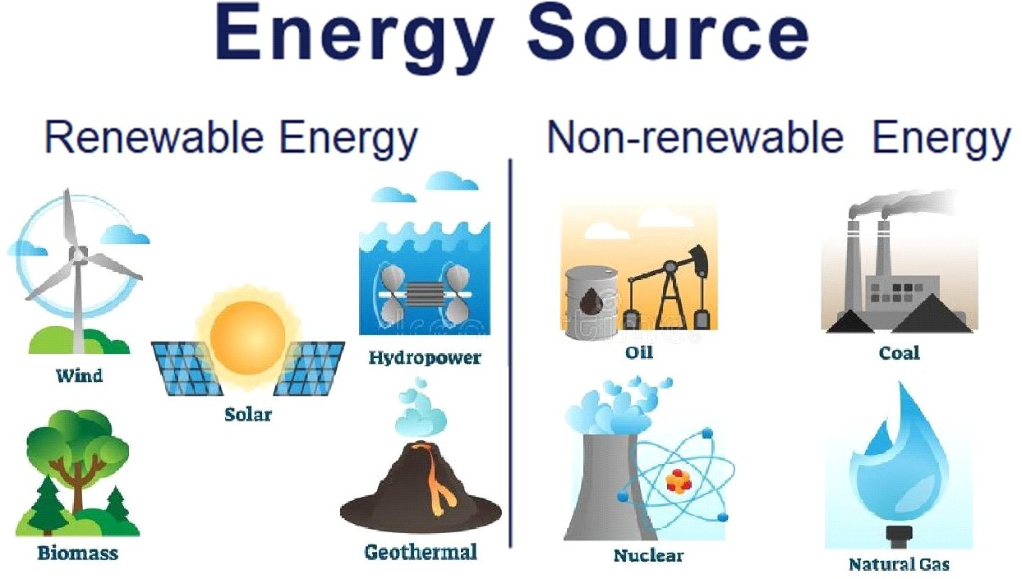

# CONCLUSION

In conclusion, while non-renewable energy sources have played a crucial role in powering industrial growth and modern civilization, their long-term sustainability is increasingly challenged by environmental concerns, resource depletion, and climate change. The reliance on fossil fuels contributes significantly to air and water pollution, greenhouse gas emissions, and habitat destruction. As the world shifts towards a more sustainable energy future, it is essential to recognize the need for a transition to renewable energy sources. This transition not only addresses environmental and health issues but also fosters innovation, job creation, and energy independence, ultimately paving the way for a more resilient and sustainable economy. Balancing the immediate benefits of non- renewable sources with the pressing need for environmental stewardship is critical for the well- being of future generations.

**REFERENCES**

[1]. Hubbert, M. King - "Nuclear Energy and the Fossil Fuels" (1956)

[2]. A foundational work discussing the limits of fossil fuel resources.

[3]. Sorrell, Steve - "Shifting to Low Carbon Energy Systems: A Comparative Analysis of the Global Energy Transition" (2017)

[4]. Provides insights into the impacts of non- renewable energy on climate change.

[5]. World Energy Council - "World Energy Resources" (various years)

[6]. Offers comprehensive data and analysis on global energy resources, including fossil fuels.

[7]. IEA (International Energy Agency) - "World Energy Outlook" (annual reports)

[8]. Key statistics and projections related to non-renewable energy sources.

[9]. BP Statistical Review of World Energy - (annual reports)

[10]. Provides detailed data on global energy production and consumption, including fossil fuels.

[11]. Smil, Vaclav - "Energy Transitions: History, Requirements, Prospects" (2010)

[12]. Discusses historical and future perspectives on energy transitions, including non-renewable sources.

[13]. Meyer, Niels I. - "Non- Renewable Energy Resources: Environmental and Economic Considerations" (2001)