**A Comprehensive Review: Aloe Barbadensis Miller (Aloe Vera)**  
 Katariya Sakshi Manish, Kale Akash D., Sayyed G. A.

Shri Amolak Jain Vidya Prasarak Mandal’s College of Pharmaceutical Science & Research Center, Kada, Maharashtra, India.

**Abstract:**

Aloe Vera (*Aloe barbadensis* Miller) has been widely recognized for its diverse therapeutic and medicinal benefits, including its use in dermatology and gastroenterology. This review provides an in-depth analysis of the taxonomy, botanical characteristics, historical significance, and chemical composition of Aloe Vera, focusing on its polysaccharides, phytochemicals, and secondary metabolites. Furthermore, the pharmacological activities of Aloe Vera are explored, highlighting its anti-inflammatory and antioxidant properties. Aloe Vera’s therapeutic applications for skin health, wound healing, and digestive health are also discussed, showcasing its moisturizing, anti-inflammatory, laxative, and gastroprotective effects. The plant’s bioactive compounds, such as acemannan, aloin, and anthraquinones, are critical in mediating these health benefits. Aloe Vera remains a significant natural remedy in both traditional and modern medicine, offering versatile applications across multiple health conditions.

**Keywords:** Aloe Vera, *Aloe barbadensis* Miller, anti-inflammatory, antioxidant, skin health, wound healing, digestive health, polysaccharides, phytochemicals, anthraquinones

**INTRODUCTION**:

1. Introduction to Aloe Barbadensis Miller

Aloe Barbadensis Miller, commonly known as Aloe Vera, is a visually striking succulent with long, fleshy, lance-shaped leaves that fan out from the center of the plant. Each leaf is thick, smooth, and green, with serrated edges lined by soft teeth. The inner part of the leaves contains a clear, gel-like substance that is highly prized for its medicinal and cosmetic properties.

The plant thrives in arid, desert-like conditions, where it can store water in its leaves, allowing it to survive long periods of drought. This adaptive feature gives Aloe Vera its iconic, fleshy appearance and makes it well-suited to dry climates around the world. When mature, it can also produce a tall stalk bearing tubular, yellow flowers, though the focus remains on the leaves for their numerous uses.

The gel inside Aloe Vera leaves is rich in bioactive compounds such as polysaccharides, vitamins (A, C, E, and B12), enzymes, amino acids, and minerals like calcium, magnesium, and zinc. This potent blend has made Aloe Vera a staple in traditional remedies, especially for skin ailments like burns, wounds, and irritations. Its cooling, soothing qualities make it a natural remedy for sunburns, while its anti-inflammatory properties help reduce swelling and redness.

In addition to topical uses, Aloe Vera has been valued for its internal benefits. The latex, a bitter yellow substance just under the plant's skin, has traditionally been used as a potent laxative. Meanwhile, the gel is known to aid digestion, enhance immune function, and even contribute to improved hydration when consumed in moderation.

Aloe Barbadensis Miller stands as one of nature’s most versatile plants, often found in households for personal care or in gardens for its aesthetic and practical benefits. With its combination of resilience, beauty, and healing properties, it has earned a reputation as the "plant of immortality" in ancient cultures and continues to be a mainstay in modern wellness and skincare industries.

**1.1 Taxonomy and Botanical Characteristics**

**Taxonomy**

Kingdom: Plantae

Clade: Angiosperms

Clade: Monocots

Order: Asparagales

Family: Asphodelaceae

Genus: Aloe

Species: Aloe barbadensis Miller

The species name "barbadensis" is derived from Barbados, where the plant was historically cultivated. The plant was first described by the botanist Philip Miller, hence the species carries his name.

**Botanical Characteristics**

Growth Form: Aloe Barbadensis Miller is a stemless or short-stemmed perennial plant that grows in a rosette pattern. Its leaves are arranged in a spiral, forming a dense, radial cluster that allows the plant to capture sunlight efficiently.

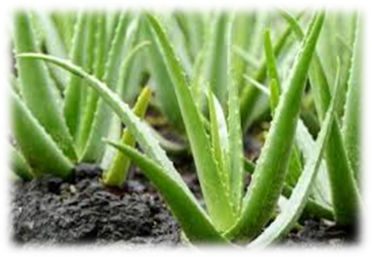

**Fig. 1:** Aloe Vera Leaves

**Leaves:** The leaves are the plant's most distinctive feature. They are:

**Succulent:** Thick and fleshy, storing water to survive arid conditions.

**Shape:** Lance-shaped or sword-like, growing up to 30–50 cm in length and 6–10 cm in width.

**Surface:** The leaf surface is smooth, with a slight waxy coating that helps to reduce water loss.

**Color:** Light green to gray-green, often with white flecks on the upper and lower surfaces of younger plants.

**Edges:** The leaf margins are lined with small, soft, white teeth.

**Internal Structure:** The leaf has three distinct layers—an outer protective rind, a middle latex layer (containing anthraquinones), and an inner gel-rich layer filled with a clear, mucilaginous substance.

**Flowers:** Aloe Vera produces tubular, yellow or sometimes orange flowers on a tall, spike-like inflorescence (up to 90 cm tall). These flowers are arranged densely at the top of the spike and are hermaphroditic, containing both male and female reproductive organs. The flowers are rich in nectar, attracting pollinators like bees and hummingbirds.

**Roots:** Aloe Vera has a fibrous root system that helps anchor the plant and absorb water from the soil. Its root system is relatively shallow, allowing it to thrive in poor, sandy soils.

**Reproductive Method:** The plant reproduces both sexually, through seed production from flowers, and asexually, via offshoots or "pups" that grow at the base of the parent plant. These pups can be separated and replanted, making Aloe Vera easy to propagate.

**Habitat:** Aloe Vera prefers hot, arid environments and is native to the Arabian Peninsula. However, it is now widely cultivated in various parts of the world, including the Mediterranean, Africa, India, and the Americas. The plant can thrive in well-drained, sandy soils and requires minimal water due to its drought-tolerant nature.

**2. Historical and Cultural Significance of Aloe Vera**

Aloe Vera (Aloe Barbadensis Miller) has played a vital role in various cultures and civilizations for over 6,000 years, earning the title of the "plant of immortality" due to its healing properties and ability to thrive in harsh climates. Its rich history is intertwined with traditional medicine, religious rituals, and beauty practices. Below is a look at how different cultures have revered and utilized Aloe Vera throughout history.

**Ancient Egypt**

Aloe Vera was highly prized in ancient Egypt, where it was referred to as the "plant of immortality." It was a staple in Egyptian skincare and beauty routines. Cleopatra, known for her radiant skin, is said to have used Aloe Vera as part of her daily beauty regimen. The Egyptians also valued Aloe Vera for its embalming properties, using its antibacterial and preserving qualities to aid in mummification. Hieroglyphs on ancient temples depict the plant as a symbol of beauty, health, and protection.

**Ancient Greece and Rome**

The ancient Greeks and Romans were also keen users of Aloe Vera for its medicinal properties. Hippocrates, known as the "Father of Medicine," recorded the therapeutic effects of Aloe Vera for treating wounds, burns, and other skin conditions. Greek physicians prescribed Aloe Vera to treat internal ailments such as gastrointestinal disorders and to reduce inflammation. Roman soldiers, particularly under the leadership of Alexander the Great, reportedly used Aloe Vera to treat wounds sustained in battle. Aloe Vera was even transported to the front lines during conquests for its healing powers.

**Traditional Chinese Medicine**

In traditional Chinese medicine (TCM), Aloe Vera has been used for centuries as a cooling herb to treat burns, skin irritations, and constipation. It is known for its ability to balance the body's internal heat and detoxify the system. Aloe Vera gel is still a common ingredient in topical remedies, while the latex is sometimes used in small amounts as a laxative. TCM views Aloe Vera as a healing plant that clears heat, nourishes yin, and moisturizes dryness, aligning with its cooling, hydrating properties.

**Ayurveda in India**

Aloe Vera has long been revered in Ayurveda, the ancient Indian system of natural healing, where it is known as “Ghritkumari”. In Ayurvedic texts, Aloe Vera is mentioned for its numerous health benefits, particularly its ability to support digestion, enhance immunity, and promote skin health. The plant is used as a cooling agent, aiding in the treatment of inflammatory conditions, burns, ulcers, and skin diseases. Aloe Vera juice is also consumed in small amounts for its rejuvenating properties and to balance the body’s doshas (energetic forces).

**The Middle Ages**

During the Middle Ages, Aloe Vera became a significant part of the herbal medicine practiced by monks and herbalists throughout Europe. Its use spread with the expansion of trade routes, and it was commonly used in remedies for skin disorders, digestive issues, and infections. Arab traders brought Aloe Vera to Europe and other parts of the world, where it was quickly integrated into both folk and official medicinal practices.

**The Americas**

Indigenous cultures of Central and South America also used Aloe Vera as a healing plant, particularly for skin conditions, burns, and digestive problems. Spanish explorers, having learned of Aloe Vera’s benefits from the Moors during the Islamic Golden Age, brought the plant to the New World during their expeditions. Aloe Vera thrived in the Americas' arid climates and became an important part of traditional medicinal practices, particularly among the Mayan and Aztec peoples.

**Modern Uses**

Aloe Vera has continued to gain global popularity due to its proven effectiveness in modern medicine, skincare, and wellness. In the 20th century, scientists began studying Aloe Vera more rigorously, confirming many of its traditional uses. Today, Aloe Vera gel is widely used in:

Skincare: For treating sunburns, acne, dry skin, and minor wounds.

Cosmetics: As a hydrating agent in creams, lotions, and moisturizers.

Health products: Aloe Vera juice and supplements are marketed for digestion, detoxification, and immune system support.

**3. Chemical Composition of Aloe Vera**

Aloe Vera (Aloe barbadensis Miller) is renowned for its rich and complex chemical composition, which accounts for its extensive therapeutic properties. The plant's gel and latex contain numerous bioactive compounds that contribute to its medicinal, cosmetic, and pharmaceutical uses. Below is a detailed overview of the key chemical constituents found in Aloe Vera.

**Polysaccharides**

Polysaccharides are one of the most important and abundant components of Aloe Vera, particularly in the clear inner gel. These compounds are primarily responsible for many of the plant’s healing and moisturizing properties. Some of the key polysaccharides include:

Acemannan: A mannose-rich polysaccharide that is largely responsible for Aloe Vera’s wound healing, immune-boosting, and anti-inflammatory properties. It also acts as an emollient, helping to retain moisture in the skin.

Glucomannans: Polysaccharides that have hydrating effects and contribute to skin elasticity.

Pectins, Hemicelluloses, and Cellulose: These contribute to the structural stability and gel consistency of Aloe Vera.

**Anthraquinones and Phenolic Compounds**

Aloe Vera contains a group of phenolic compounds called anthraquinones, which are primarily found in the latex (the yellow sap just beneath the leaf's skin). These compounds have potent laxative effects, antimicrobial properties, and are also known for their role in pain relief. Key anthraquinones include:

Aloin (Barbaloin): Aloin is the primary anthraquinone responsible for Aloe Vera’s purgative (laxative) action. It works by stimulating the bowels and increasing intestinal water secretion.

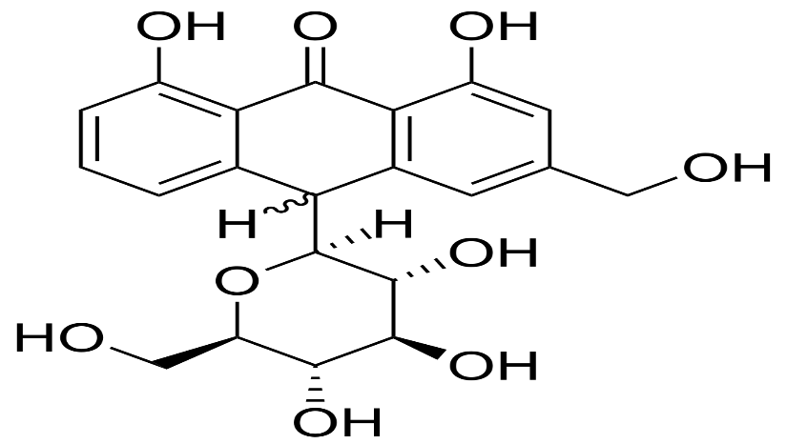

**Fig. 2:** Struture of Aloin

Emodin: A phenolic compound with strong antibacterial, antiviral, and anti-inflammatory effects. It is known to inhibit the growth of certain bacteria and viruses.

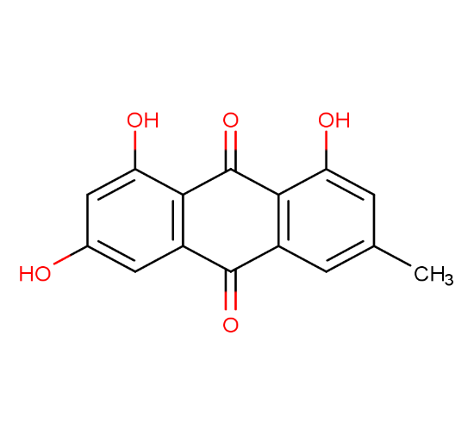

**Fig. 3:** Struture of Emodin

Chrysophanic Acid: Another anthraquinone with antifungal and antibacterial properties, particularly useful in treating skin infections and irritations.

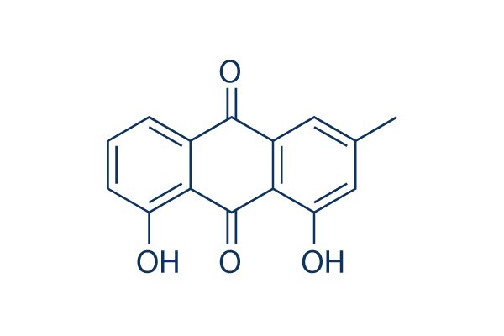

**Fig. 4:** Struture of Chrysophanic Acid

**Vitamins**

Aloe Vera contains an array of vitamins that contribute to its antioxidant and regenerative effects:

Vitamin A (Beta-Carotene): An antioxidant that promotes skin health and supports immune function.

Vitamin C (Ascorbic Acid): A potent antioxidant that helps in collagen synthesis, wound healing, and protection against oxidative stress.

Vitamin E (Tocopherol): Known for its skin-soothing and anti-aging properties, Vitamin E helps protect cells from oxidative damage.

Vitamin B Complex (B1, B2, B6, B12): These vitamins play a crucial role in energy metabolism and maintaining healthy skin, nerves, and blood cells.

**Minerals**

Aloe Vera contains a diverse profile of essential minerals, which play important roles in enzymatic functions, wound healing, and maintaining skin and body health. These include:

Calcium: Vital for cell growth and regeneration, particularly in skin tissues.

Magnesium: Involved in over 300 enzymatic reactions in the body and helps reduce inflammation.

Zinc: Known for its role in wound healing, immune support, and collagen production.

Sodium, Potassium, Copper, Chromium, Manganese, and Iron: All of these trace elements play roles in various biological processes such as maintaining skin integrity, enzyme function, and immune response.

**Enzymes**

Aloe Vera is rich in enzymes, many of which aid in reducing inflammation, speeding up healing, and breaking down sugars and fats. Some notable enzymes include:

Amylase: Helps break down starches into sugars.

Lipase: Assists in the breakdown of fats.

Bradykinase: Known for its anti-inflammatory effects, particularly when applied topically to reduce swelling and redness.

Catalase and Peroxidase: These are antioxidant enzymes that help neutralize free radicals and reduce oxidative stress.

**Amino Acids**

Aloe Vera contains 18 of the 20 essential and non-essential amino acids, which are the building blocks of proteins, necessary for tissue repair and regeneration. Key amino acids in Aloe Vera include:

Lysine: Essential for collagen formation and tissue repair.

Leucine and Isoleucine: Important for tissue healing and immune response.

Serine, Glycine, and Glutamic Acid: These amino acids play roles in hydration and skin elasticity, enhancing the moisturizing effects of Aloe Vera.

**Saponins**

Saponins are glycosides with cleansing and antiseptic properties, found in smaller quantities in Aloe Vera. They contribute to the plant's ability to cleanse wounds, fight infections, and protect against bacteria, fungi, and viruses.

**Sterols**

Sterols are plant-based compounds that exhibit anti-inflammatory and cholesterol-lowering properties. Aloe Vera contains several types of sterols, including:

Campesterol

Beta-sitosterol

Lupeol: This sterol also has analgesic and antimicrobial properties, aiding in pain relief and wound healing.

**Salicylic Acid**

Salicylic acid is a beta-hydroxy acid (BHA) found in Aloe Vera that acts as an exfoliant and anti-inflammatory agent. It helps remove dead skin cells, prevent acne, and soothe skin inflammation, contributing to Aloe Vera's popularity in skincare products.

**Lignin**

Although lignin itself has no direct medicinal properties, it serves as a key component in Aloe Vera’s gel. Lignin allows Aloe Vera to penetrate deeply into the skin, carrying its active ingredients along with it, which enhances its overall effectiveness in topical applications.

**4. Pharmacological Activities of Aloe Vera**

Aloe Vera (Aloe barbadensis Miller) is widely known for its pharmacological properties, which have been validated by both traditional usage and modern scientific research. The plant’s bioactive compounds exhibit a variety of therapeutic effects, making Aloe Vera a valuable resource in medicine and healthcare. Two of the most well-documented pharmacological activities of Aloe Vera are its anti-inflammatory and antioxidant properties.

**4.1. Anti-inflammatory Properties**

Aloe Vera has significant anti-inflammatory effects, making it highly effective in treating a variety of inflammatory conditions, particularly in skin and digestive systems. Its anti-inflammatory action is attributed to several bioactive compounds such as acemannan, salicylic acid, chromones, and anthraquinones. These compounds inhibit the production of inflammatory mediators and reduce the body's inflammatory response.

**Mechanisms of Action**

The anti-inflammatory activity of Aloe Vera is multi-faceted, affecting various biochemical pathways that reduce inflammation:

Inhibition of Pro-inflammatory Enzymes: Aloe Vera inhibits the enzymes cyclooxygenase (COX) and lipoxygenase (LOX), which are responsible for the production of pro-inflammatory molecules such as prostaglandins and leukotrienes. These molecules are mediators in the inflammatory process, contributing to pain, swelling, and redness.

Reduction of Cytokine Production: Aloe Vera reduces the levels of pro-inflammatory cytokines such as interleukin-6 (IL-6), interleukin-1 (IL-1), and tumor necrosis factor-alpha (TNF-α). These cytokines are signaling molecules that regulate the body’s immune response, often amplifying inflammation.

Bradykinase Activity: Aloe Vera contains an enzyme called bradykinase, which is known to reduce swelling and inflammation when applied topically. Bradykinase helps degrade bradykinin, a peptide that causes blood vessels to dilate and results in the classic symptoms of inflammation (swelling, redness, and pain).

Chromones: The chromones found in Aloe Vera, such as aloesin and aloeresin, also contribute to its anti-inflammatory properties. These compounds inhibit the production of reactive oxygen species (ROS) and inflammatory cytokines, reducing inflammation at the cellular level.

Salicylic Acid: Salicylic acid in Aloe Vera acts similarly to aspirin, by blocking the COX enzymes and reducing the production of pro-inflammatory prostaglandins. This action makes Aloe Vera useful in treating minor skin irritations, acne, and inflammatory skin conditions.

**Applications of Anti-inflammatory Properties**

**Topical Use for Skin Conditions:** Aloe Vera is commonly used to treat sunburns, rashes, psoriasis, eczema, and acne. Its ability to reduce redness, swelling, and discomfort makes it a popular choice for soothing irritated skin.

**Wound Healing:** Aloe Vera promotes wound healing by reducing inflammation around injured tissue. It also stimulates the activity of fibroblasts, cells that play a crucial role in tissue repair and collagen production.

**Gastrointestinal Inflammation:** When taken internally, Aloe Vera can help soothe the lining of the digestive tract, reducing inflammation in conditions like gastritis, irritable bowel syndrome (IBS), and ulcerative colitis. Its mucilaginous texture creates a protective coating over inflamed tissues, reducing discomfort.

**4.2. Antioxidant Effects**

Aloe Vera is also rich in antioxidants, which play a crucial role in neutralizing free radicals and protecting the body from oxidative stress. The oxidative process in the body can lead to cellular damage, premature aging, and the development of chronic diseases such as cancer, cardiovascular diseases, and neurodegenerative conditions.

**Key Antioxidants in Aloe Vera**

Vitamins:

Vitamin C (Ascorbic Acid): A potent antioxidant, Vitamin C helps to neutralize free radicals and regenerates other antioxidants within the body. It also contributes to collagen synthesis, aiding in skin repair and wound healing.

Vitamin E (Tocopherol): Another powerful antioxidant, Vitamin E protects cell membranes from oxidative damage and plays a role in skin health, reducing the appearance of scars and wrinkles.

Beta-Carotene (Provitamin A): Beta-carotene is a precursor of Vitamin A, which has antioxidant properties and is vital for maintaining healthy skin and vision.

Phenolic Compounds:

Flavonoids and anthraquinones like aloin and emodin contribute to Aloe Vera’s antioxidant effects. These compounds can scavenge free radicals, reducing oxidative stress and lowering the risk of inflammation-related conditions such as cancer and heart disease.

Enzymes:

Superoxide Dismutase (SOD): This enzyme found in Aloe Vera helps to break down the superoxide radical, a toxic form of oxygen, into less harmful molecules. SOD is one of the body's first lines of defense against oxidative damage.

Catalase and Glutathione Peroxidase: These enzymes help convert harmful peroxides into water and oxygen, preventing cellular damage from oxidative stress.

Polysaccharides:

Polysaccharides like acemannan not only have immune-boosting properties but also act as antioxidants by modulating oxidative stress at the cellular level. They protect cells from damage caused by free radicals and support the overall immune system.

**Mechanisms of Antioxidant Action**

Free Radical Scavenging: Aloe Vera’s antioxidants, including vitamins, flavonoids, and phenolic compounds, neutralize free radicals by donating electrons, which stabilizes these reactive molecules and prevents them from causing damage to cells and tissues.

Inhibition of Lipid Peroxidation: Lipid peroxidation is a process where free radicals attack lipids in cell membranes, leading to cell damage. Aloe Vera’s antioxidants prevent this process, protecting cell membranes and maintaining cellular integrity.

Anti-aging Effects: By reducing oxidative stress, Aloe Vera slows down the aging process of the skin and other tissues. It enhances collagen production, reduces the appearance of fine lines, and improves skin elasticity.

**Applications of Antioxidant Effects**

Skincare and Anti-aging: Aloe Vera’s antioxidant properties make it a popular ingredient in anti-aging skincare products. It helps to prevent skin damage caused by UV radiation and environmental stressors, reducing wrinkles, hyperpigmentation, and loss of skin elasticity.

**Wound Healing:** The antioxidant properties of Aloe Vera also play a role in wound healing by protecting damaged tissues from oxidative stress, accelerating the repair process.

**Prevention of Chronic Diseases:** Regular intake of Aloe Vera (in the form of supplements or juice) may help reduce the risk of diseases associated with oxidative stress, such as cancer, cardiovascular diseases, and neurodegenerative disorders. Its antioxidant components help combat the buildup of free radicals, thus supporting overall health.

**5. Therapeutic and Medicinal Uses of Aloe Vera**

Aloe Vera is widely used for its therapeutic and medicinal benefits across a broad range of health conditions. Its bioactive compounds, including polysaccharides, vitamins, enzymes, and phenolic compounds, make it effective for treating both internal and external health issues. Below are two of the most prominent uses of Aloe Vera in modern healthcare: skin health and wound healing, and digestive health.

5.1. Skin Health and Wound Healing

Aloe Vera’s reputation as a powerful skin healer dates back centuries, and today it remains one of the most popular natural remedies for skin care and wound management. Its ability to accelerate the healing process, soothe skin irritation, and improve overall skin health has made Aloe Vera a staple in dermatological and cosmetic applications.

**Mechanisms of Action in Skin Health**

Moisturizing and Hydration: Aloe Vera gel is rich in polysaccharides like glucomannan and acemannan, which form a protective layer on the skin, locking in moisture and preventing dehydration. These compounds help enhance skin hydration, making Aloe Vera an effective treatment for dry skin conditions.

Collagen Production and Skin Elasticity: Aloe Vera promotes the production of collagen and elastin fibers, which are critical for maintaining skin structure and elasticity. This leads to faster wound healing, improved skin texture, and reduced appearance of fine lines and wrinkles.

Anti-inflammatory Effects: Compounds such as salicylic acid, chromones, and bradykinase in Aloe Vera exhibit potent anti-inflammatory properties. These agents help reduce redness, swelling, and pain, making Aloe Vera particularly useful in treating skin irritations, rashes, and acne.

Antimicrobial and Antiseptic Properties: Aloe Vera contains several bioactive compounds like saponins, lupeol, and anthraquinones that exhibit antibacterial, antiviral, and antifungal properties. This makes Aloe Vera effective in treating minor skin infections, acne, and in preventing the infection of wounds.

**Applications in Wound Healing**

Burns: Aloe Vera is frequently used to treat first- and second-degree burns. Its cooling and moisturizing properties, along with its ability to stimulate cell regeneration, speed up the healing process of burns while reducing pain and discomfort. Aloe Vera also minimizes the risk of scarring.

Cuts and Abrasions: Applying Aloe Vera gel to cuts and abrasions can accelerate wound healing by promoting cell proliferation and collagen synthesis. It also provides a protective barrier that keeps the wound moist, which is essential for optimal healing.

Acne and Acne Scars: Due to its anti-inflammatory and antimicrobial effects, Aloe Vera is commonly used to treat acne. It reduces redness, inflammation, and swelling associated with acne, and helps in fading acne scars by promoting skin regeneration.

Eczema and Psoriasis: Aloe Vera’s hydrating and anti-inflammatory properties make it an effective treatment for eczema and psoriasis, both of which involve dry, itchy, and inflamed skin. Regular application of Aloe Vera can reduce flare-ups and relieve discomfort.

**Cosmetic Use for Skin Health**

Anti-aging: Aloe Vera is frequently included in anti-aging products because of its ability to increase collagen synthesis, improve skin elasticity, and combat oxidative stress. Its antioxidants, such as vitamin C and vitamin E, help to neutralize free radicals that contribute to premature skin aging.

Moisturizers and Sunburn Relief: Aloe Vera’s soothing and hydrating properties make it a popular ingredient in moisturizers and sunburn-relief lotions. It quickly calms inflamed, sunburned skin, reducing redness and discomfort.

**5.2. Digestive Health**

Aloe Vera has a long history of use in promoting digestive health. It is particularly effective in soothing and healing the gastrointestinal tract, making it a popular natural remedy for conditions like irritable bowel syndrome (IBS), acid reflux, and constipation.

**Mechanisms of Action in Digestive Health**

Laxative Effects: Aloe Vera contains anthraquinones, such as aloin and emodin, which have a well-documented laxative effect. These compounds stimulate peristalsis (the contraction of the intestinal muscles), increase water content in the intestines, and promote bowel movements, making Aloe Vera an effective natural treatment for constipation.

Gastroprotective Properties: Aloe Vera’s polysaccharides, especially acemannan, form a protective layer on the mucous membranes of the digestive tract. This soothes irritated tissues and helps heal ulcers or erosions in the stomach and intestines. Aloe Vera is particularly useful for managing symptoms of gastritis and acid reflux.

Anti-inflammatory Effects: Just as Aloe Vera reduces inflammation on the skin, it also has anti-inflammatory effects within the digestive tract. These anti-inflammatory properties make Aloe Vera effective in reducing symptoms associated with inflammatory bowel disease (IBD), such as ulcerative colitis and Crohn’s disease.

Gut Health and Microbiota Balance: Aloe Vera has been shown to support the growth of healthy bacteria in the gut, such as lactobacillus and bifidobacteria, which are essential for digestive health and immune function. By improving the balance of gut microbiota, Aloe Vera may contribute to overall gastrointestinal well-being.

**Applications in Digestive Health**

Constipation Relief: Aloe Vera’s natural laxative properties are useful for treating occasional constipation. Aloe latex (the yellow substance just beneath the leaf’s surface) contains aloin, which stimulates bowel movements. However, due to its potency, Aloe Vera laxatives should be used with caution and not over a long period of time to avoid dependency.

Acid Reflux and Heartburn: Aloe Vera juice is often used to relieve symptoms of acid reflux and heartburn. Its soothing effect on the esophagus and its ability to reduce inflammation help mitigate the burning sensation caused by excess stomach acid.

Irritable Bowel Syndrome (IBS): Aloe Vera may provide relief for people suffering from IBS by reducing symptoms such as bloating, pain, and irregular bowel movements. Its anti-inflammatory and gut-soothing properties help in calming the digestive system and restoring normal bowel function.

Ulcers and Gastritis: Aloe Vera’s gastroprotective properties make it beneficial for treating gastric ulcers. It can reduce inflammation, enhance the healing of ulcerated tissues, and protect the stomach lining from further damage caused by gastric acid.

Detoxification: Aloe Vera juice is often used as a natural detoxifier for the digestive system. It aids in cleansing the colon by promoting bowel movements and removing toxins from the body.

having large parenchyma cells. This is a transparent mucilaginous jelly like material. It contains water (99%), glucomannans, amino acids, lipids, sterols and vitamins. So that, aloevera used as gel for softening skin, hairs.

**Aloevera is uses as juice:** Aloe vera juice is safe to drink every day. But drinking too much of it can cause cramping or diarrhea.This in turn can bring on an electrolyte imbalance.

**References**

Akev N, Can A. Aloe vera and cancer. Turk J Biol. 2016;40(4):1054-1064.

doi:10.3906/biy-1505-101

Boudreau MD, Beland FA. An evaluation of the biological and toxicological properties of Aloe barbadensis (Miller), Aloe vera. J Environ Sci Health C Environ Carcinog Ecotoxicol Rev. 2006;24(1):103-154.

doi:10.1080/10590500600614303

Chithra P, Sajithlal GB, Chandrakasan G. Influence of Aloe vera on collagen characteristics in healing dermal wounds in rats. Mol Cell Biochem. 1998;181(1-2):71-76. doi:10.1023/A:1006826006619

Choi S, Chung MH. A review on the relationship between Aloe vera components and their biologic effects. Semin Integr Med. 2003;1(1):53-62. doi:10.1016/S1543-1150(03)00004-9

Eshun K, He Q. Aloe vera: A valuable ingredient for the food, pharmaceutical and cosmetic industries – A review. Crit Rev Food Sci Nutr. 2004;44(2):91-96. doi:10.1080/10408690490424694

Hamman JH. Composition and applications of Aloe vera leaf gel. Molecules. 2008;13(8):1599-1616. doi:10.3390/molecules13081599

Kaur A, Chauhan A, Nadkarni K. Therapeutic effects of Aloe vera in non-healing diabetic ulcers. Indian J Endocrinol Metab. 2013;17(3):407-410. doi:10.4103/2230-8210.111640

Reynolds T, Dweck AC. Aloe vera leaf gel: A review update. J Ethnopharmacol. 1999;68(1-3):3-37. doi:10.1016/S0378-8741(99)00085-9

Sahu PK, Giri DD, Singh R, et al. Therapeutic and medicinal uses of Aloe vera: A review. Pharmacol Pharm. 2013;4(8):599-610. doi:10.4236/pp.2013.48086

Shelton RM. Aloe vera. Its chemical and therapeutic properties. Int J Dermatol. 1991;30(10):679-683. doi:10.1111/j.1365-4362.1991.tb02607.x

Surjushe A, Vasani R, Saple DG. Aloe vera: A short review. Indian J Dermatol. 2008;53(4):163-166. doi:10.4103/0019-5154.44785

Vogler BK, Ernst E. Aloe vera: A systematic review of its clinical effectiveness. Br J Gen Pract. 1999;49(447):823-828.