# Historical Perspective of Rayadurg Fort: A Key Fort in Vijayanagara Empire

*Dr.Bukkapuram Venkataramana

Academic Consultant, Department of History & Archealogy, Yogi Vemana University, YSR Kadapa (D)-516005

**Abstract**:

The empire's legacy includes monuments spread over South India, the best known of which is the group at Hampi. Different temple building traditions in South and Central India were merged into the Vijayanagara architecture style. This synthesis inspired architectural innovations in the construction of Hindu temples. Efficient administration and vigorous overseas trade brought new technologies to the region such as water management systems for irrigation. The empire's patronage enabled fine arts and literature to reach new heights in Kannada, Telugu, Tamil, and Sanskrit with topics such as astronomy, mathematics, medicine, fiction, musicology, historiography and theater gaining popularity. The classical music of Southern India, Carnatic music, evolved into its current form. The Vijayanagara Empire created an epoch in the history of Southern India that transcended regionalism by promoting Hinduism as a unifying factor. Rayadurgam or Rayadurg Fort or the “King’s Hill Fort” is a medieval fortress built in the town of Rayadurgam in Anantapur district of the Indian province of Andhra Pradesh. It is positioned at a distance of about 2 km from Rayadurgam Bus Station and 99 km from Anantapur. Rayadurgam Fort was built by Junga Nayaka, a chieftain of Vijayanagar Kings. The Battle of Talikota was a bitter battle fought between Rama Rayalu the son in law of King Sri Krishna Deva Raya and Deccan Sultanates. Later the Muslim force was driven out by Koneti Nayaka.

**Introduction:**

**Vijayanagara Empire’s Legacy: Rayadurgam**

**Brief history:**

Rayadurgam Fort is one of Andhra Pradesh’s oldest forts and was built at an altitude of 2727 feet. This fort is accessible through all the means of transportation. The Fort of Rayadurgam is among the principal tourist destinations in the city.

Rayadurg Fort, also known as Ratnagiri Hill Fort, is a historic fort located in the town of Rayadurg in the Anantapur district of Andhra Pradesh, India. Here is some information about Rayadurg Fort:

1. Architecture: Rayadurg Fort is situated atop a granite hill and showcases a blend of Hindu and Islamic architectural styles. The fort complex is spread over a vast area and consists of multiple gateways, fortifications, bastions, palaces, and temples.

2. Historical Significance: Rayadurg Fort has a rich historical significance as it has witnessed the rule of various dynasties. It was originally built by the Vijayanagara Empire in the 16th century and later came under the control of the Marathas, Mughals, and the Nizam of Hyderabad. The fort played a crucial role in the defense and administration of the region.

3. Structures within the Fort: The fort complex houses several structures of historical and architectural importance. Some notable structures include the Konda Reddy Buruju (a tower), the Jami Masjid (a mosque), the Rani Mahal (queen's palace), and the Shiva Temple.

4. Trekking and Panoramic Views: Rayadurg Fort is situated on a hill, offering breathtaking views of the surrounding landscape. The fort is a popular destination for trekkers who enjoy the adventure of climbing the rocky terrain to reach the fort's summit. The trek provides panoramic views of the town and the surrounding countryside.

5. Cultural Significance: The fort is also associated with the local folklore and legends, adding to its cultural significance. It is said to have been a hiding place for the great warrior Tipu Sultan during one of his military campaigns.

6. Annual Jatra: The fort is known for hosting an annual Jatra (fair) called Rayadurg Jatra. The Jatra attracts a large number of devotees who come to pay homage to the local deities and participate in religious and cultural festivities.

Visiting Rayadurg Fort offers a glimpse into the rich history, architectural marvels, and natural beauty of the region. The fort's strategic location, historical significance, and trekking opportunities make it an enticing destination for history enthusiasts, architecture lovers, and adventure seekers.

**Administration of Rayadurgam Fort:**

The Rayadurg Fort played a very significant role throughout the history of the Empire of Vijayanagar. This fort is comprised of numerous layers of the internal forts which made it inaccessible for the attacking enemies. According to historians, Junga Nayaka, the head of Vijayanagar Kings, founded the fort of Rayadurgam. The fort was later conquered by Tipu Sultan and annexed to the Gooty Province. On the hill, beneath which the Rayadurg Town is built, the wrecks of the fortification can still be seen. A portion of the wall of the fort has been collapsed. But the majority of the fortress still stands strong. Four caves with the doors of stone and with the ‘ Siddhas ‘ gravure are situated underneath the slope of the hill. Rayadurgam was originally a stronghold of "Rayadurgam Palegar" who were very turbulent during the Vijayanagara rule. The emperor deputed an officer to drive them out and ruled the place himself and the hill was thus called "Bhupatirayakonda". After the battle of 'Rakshasa Tangadi', the Bedars regained the place, but were again driven out after some time by 'Koneti Nayaka'. His son 'Venkatapathi Nayaka' who had differences with the 'Palegar' of Chittaldurg greatly strengthened the fortifications. Tipucaptured the fort and made it a part of his Gooty

**Temple Culture in Rayadurgam Fort:**

The fortress area includes most of the temples of the village that includes the temples of ‘Hanuman’,’ Narashimhaswamy’ and’ Elamma’. The villagers visit these temples frequently and these are popular among the tourists too. Other temples present in the area are of ‘Prasanna Venkateswara,” Venugopala,” Jambukeswara,” Veerabhadra’ and’ Kanyakaparameswari ‘.Another notable and impressive sight is the statue of Lord Ganesha with ten shoulders or the “Dasabhuja Ganapathi,” carved from a 4 m high monolithic stone. The statue of ‘ Dasabhuja Ganapathi ‘ is the testimony of the beautiful old sculpture art of “Shilpakala.” . These temples are not merely sites of religious worship but also testaments to the unique architecture of the Vijaynagar Empire. You can count on visiting not only the widely popular Rasa Siddha Temple with its numerous meticulous sculptures but also Narasimha Swamy Temple, Prasanna Venkateswara Temple, Elamma Temple, Venugopala Temple, Jambukeswara Temple, Kanyakaparameswari Temple and Veerabhadra Temple. Visiting these sanctums will convey a sense of majesty to you and is an experience worth having.

**Economy of Vijayanagara Empire in Rayadurgam Fort:**

The economy of the empire was largely dependent on agriculture. Sorghum (*jowar*), cotton, and pulse legumes grew in semi-arid regions, while sugarcane, rice, and wheat thrived in rainy areas. Betel leaves, areca (for chewing), and coconut were the principal cash crops, and large-scale cotton production supplied the weaving centers of the empire's vibrant textile industry. Spices such as turmeric, pepper, cardamom, and ginger grew in the remote Malnad hill region and were transported to the city for trade. The empire's capital city was a thriving business centre that included a burgeoning market in large quantities of precious gems and gold. Prolific temple-building provided employment to thousands of masons, sculptors, and other skilled artisans.

**Social Life of People in Rayadurgam Fort**

According to Abdur Razzak, much of the empire was fertile and well cultivated. Most of the growers were tenant farmers and were given the right of part ownership of the land over time. Tax policies encouraging needed produce made distinctions between land use to determine tax levies. For example, the daily market availability of rose petals was important for perfumers, so cultivation of roses received a lower tax assessment. Salt production and the manufacture of salt pans were controlled by similar means. The making of ghee , which was sold as an oil for human consumption and as a fuel for lighting lamps, was profitable. Exports to China intensified and included cotton, spices, jewels, semi-precious stones, ivory, rhino horn, ebony, amber, coral, and aromatic products such as perfumes. Large vessels from China made frequent visits and brought Chinese products to the empire's 300 ports, large and small, on the Arabian Sea and the Bay of Bengal regions on those days. The ports of Mangalore, Honavar, Bhatkal, Barkur, Cochin, Cannanore, Machilipatnam,and Dharmadam  were important for they not only provided secure harbors for traders from Africa, Arabia, Aden, the Red sea, China and Bengal but some also served as ship building centers.

**Rayadurgam: Place of interest**

**Conclusion:**  Constructed by Junga Naik as a medieval fortress to stand guard against the rules who sought to capture Vijayanagar, Rayadurg Fort is the site that singlehandedly characterizes much of the region's tourism. In spite of its age and the unfolding of a brutal military conflict outside its walls, much of the fort has stood the test of time and is therefore perfectly intact. Its architecture is peculiar and comprised of multiple layers of access. Moreover, the fort houses countless temples where you can offer prayers to ancient variants of familiar deities.   
  
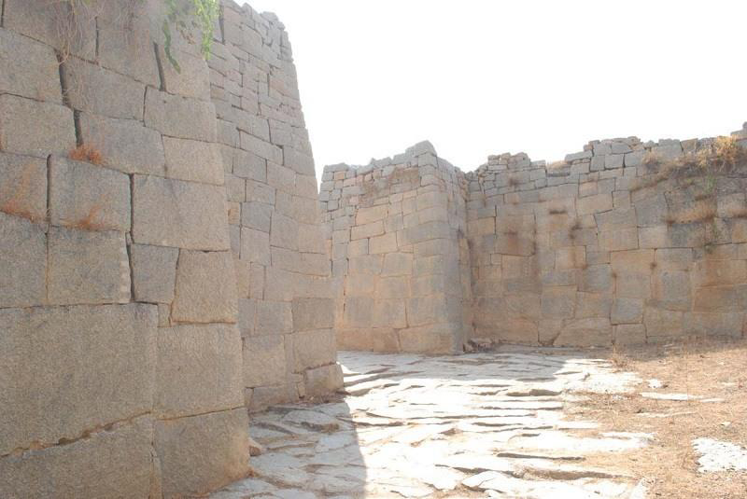

At a distance of 2 km from Rayadurgam Bus Stand, 99 km from Anantapur, 53 km from Bellary, 95 km from Guntakal, 245 km from Kurnool, 449 km from Hyderabad, 571 km from Vijayawada and 265 km from Bangalore, Rayadurgam Fort is a medieval fortress that is situated in Rayadurgam town in Anantapur district of Andhra Pradesh. Though ignored by majority of the historians, it definitely left an indelible mark on history of India by its role during Vijayanagara Empire. A strong fort which was built during Vijayanagara empire is still a silent witness for the forgotten days. A large number of temples built in and around the town also tell lots of stories.

**References**

1. *Bridges, Elizabeth J. (2016). "Vijayanagara Empire". In Dalziel, N.; MacKenzie, J. M. (eds.). The Encyclopedia of Empire. pp. 1–5.*
2. *Babu, Dr.M.Bosu (2018). Material Background to the Vijayanagara Empire (A Study with Special reference To Southern Āndhradēśa From A.D. 1300 To 1500). K.Y.Publications. p. 189.**ISBN**978-9387769427**.*
3. *Ayyangar, Krishnaswami (2019). Sources of Vijayanagar History. Alpha Editions. p. 116.**ISBN**978-9353605902**.*
4. *Dr.B. S. Chandrababu, and Dr.L. Thilagavathi (2009). Woman, Her History and Her Struggle for Emancipation. Bharathi Puthakalayam. p. 266.**ISBN**9788189909970**.*
5. *Mahalingam, T.V (1940).**Administration and Social Life under Vijayanagar**. Madras: University of Madras Historical Series No.15. pp. 255–256.*
6. *From the notes of Duarte Barbosa (**Kamath 2001**, p. 178)*
7. *Wagoner, Phillip B. (November 1996). "Sultan among Hindu Kings: Dress, Titles, and the Islamicization of Hindu Culture at Vijayanagara". The Journal of Asian Studies.****55****(4): 851–880.*
8. *Naik, Reddy, Krishna, Ramajulu (2007). "Impact of endowments on society during the Vijayanagara period: A study of the Rayalaseema region, 1336–1556". Proceedings of the Indian History Congress.****68****: 286–294*
9. *Telagavi, Laxmana. (2009). Vijayanagarada Amara Nayakaru Mattu Palegararu. In Virupakshi Poojarahalli. (Ed.). Charitre Adyayana, Vol. IV, Issue 2. Vidyaranya: Prasaranga, Kannada University, Hampi.*
10. *Venkata Ramanayya, N. (2007). Origin of the City and Empire. New Delhi: Asian Educational Services.*