**AI-QUANTUM SYMBIOSIS: PIONEERING THE FUTURE OF COMPUTING AND FUNDAMENTAL PHYSICS**

**Gurjant Singh1, Nirmal Singh2, Dalbir Singh2**

**1MSc. Botany & PGD in AI in Agriculture, Department of Botanical and Environmental Sciences, Guru Nanak Dev University, Amritsar, Punjab (INDIA)**

**2Student, Department of Computer Sciences, Shaheed Bhai Mewa Singh Senior Secondary Smart School, Lopoke, Amritsar, Punjab**

**Email: 1**[**gurjantaulakh008@gmail.com**](mailto:gurjantaulakh008@gmail.com)**, 2**[**lahoriyanirmal@gmail.com**](mailto:lahoriyanirmal@gmail.com)**, 2**[**dalbirsingh75233@gmail.com**](mailto:3dalbirsingh75233@gmail.com)

**ABSTRACT**

This paper highlights the synergistic relationship between quantum physics and quantum computing (QC) and analyses the revolutionary impact of AI on QC. Superposition and entanglement are the foundations of quantum computing, which provides previously unheard-of computational power. Decoherence and quantum noise are still problems, though. AI’s prowess in pattern recognition, data analysis, and optimisation offers practical answers to these problems. Advances in quantum simulations, material discovery, and state prediction are made possible by key applications such as quantum machine learning (QML), AI-driven quantum error correction, and quantum optimisation. In addition to addressing scalability and data requirements issues, this analysis looks ahead to future developments in quantum cryptography and hybrid AI-quantum systems. AI and quantum technology integration is set to transform a number of industries, representing a huge advancement in computational and scientific advancements.

**Keywords:** Quantum Computing, Artificial Intelligence (AI), Quantum Algorithms, Machine Learning (ML), Quantum Error Correction, Quantum Supremacy, Quantum-AI Integration

**1. INTRODUCTION**

The intersection of Artificial Intelligence (AI) [Fig. 1] and Quantum Computing (QC) [Fig. 2] promises a revolutionary frontier with great promise for improving computational capabilities and furthering scientific research. Superposition and entanglement, two concepts from quantum mechanics, are used in quantum computing to carry out calculations that are more complex than those possible with traditional computers. Artificial intelligence (AI) is a valuable tool for optimising the performance of quantum systems because it can process large datasets and recognise intricate patterns at the same time (Pal, S., et al., 2024; Kak, S., 2007).

This review explores the mutually beneficial link between AI and QC, looking at the ways in which AI methods improve system performance and quantum simulations. To mitigate the impacts of quantum noise and decoherence in quantum systems, for example, artificial intelligence (AI) has been used to optimise quantum circuits and improve quantum error correction techniques (Olaoye, Favour & Potter, Kaledio., 2024). Additionally, AI-driven methods in Quantum Machine Learning (QML) facilitate more effective pattern detection and data analysis in high-dimensional quantum datasets, opening doors for innovations across a range of fields.

This convergence has a wide range of potential applications. For example, in material science, AI can speed up the search for new materials with desired quantum properties (Goswami, Lipichanda et al., 2023); in cryptography, AI algorithms can improve quantum-secure communication protocols (Radanliev, P. 2024). The constraints and difficulties of combining AI with quantum technology are also covered in this review, including the need for big training datasets and scalability concerns.

To put it succinctly, the combination of AI and quantum technology promises to transform many scientific domains and represent a major advancement in computing and scientific research.

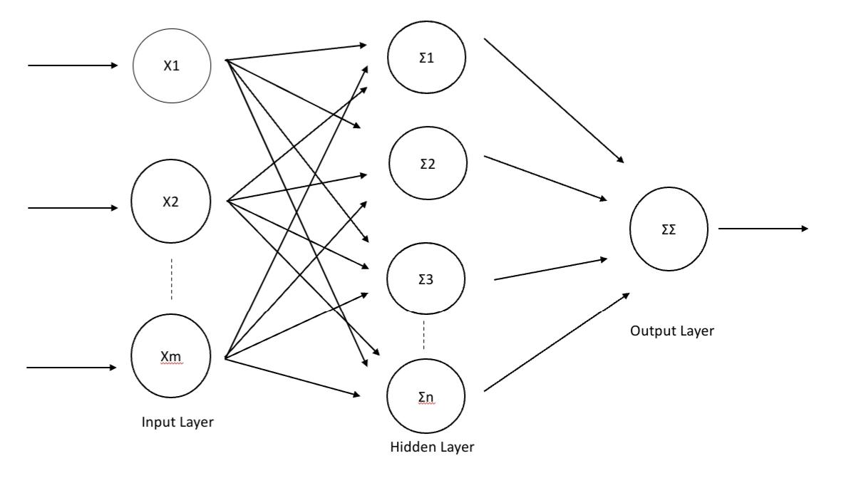

***Fig. 1: Typical Architecture of Artificial Neural Networks System (ANNs)***

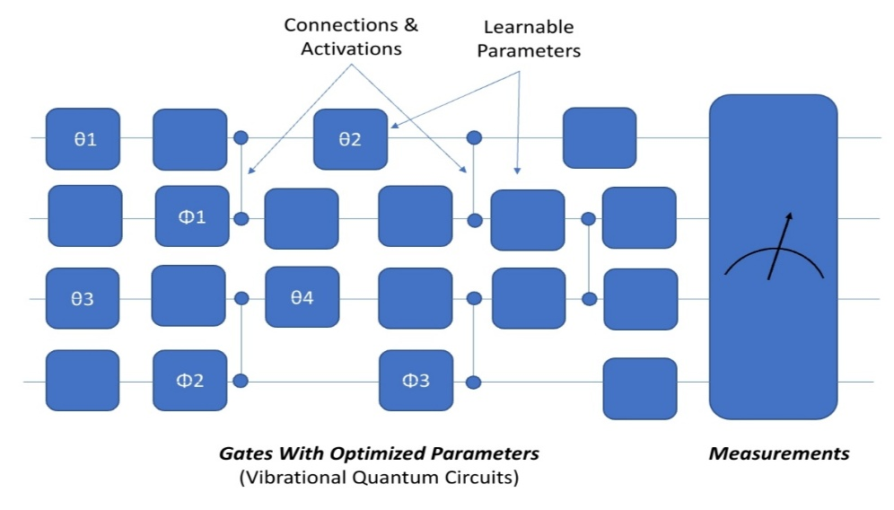

***Fig. 2: Typical Architecture of Quantum Neural Networks System (QNNs)***

**2. LITERATURE REVIEW**

The body of research on the combination of AI and quantum computing in quantum physics and computing shows both great progress and enduring difficulties. The promise of quantum computing is in its ability to use concepts from quantum mechanics, such as entanglement and superposition, to provide processing power well beyond that of classical computers (Aithal, Sreeramana. 2023). Decoherence and quantum noise, for example, continue to be obstacles (Deshmukh, Ananya. 2024). Some of these obstacles have been greatly aided by artificial intelligence (AI), notably machine learning (ML) and deep learning (DL). AI is utilised, for instance, in quantum error correction and quantum algorithm optimisation, which helps to reduce quantum noise and enhances qubit stability (Mafu, Mhlambululi. 2024).

Applications of reinforcement learning (RL) models include qubit calibration and gate optimisation in the management of quantum hardware (Wright, Emily & Sousa, Rogério. (2023). These developments imply that artificial intelligence (AI) is a key factor in raising the effectiveness and performance of quantum systems. Ongoing difficulties are brought to light by constraints such a lack of quantum training data and problems with scalability in quantum models (Rayhan, Abu. 2024).

Moreover, ethical questions about AI-quantum integration have come up, especially with regard to quantum cryptography, indicating the necessity for talks on security and responsible use (Radanliev, P. 2024). All things considered, there is a lot of promise for integrating AI with quantum technologies; however, more study and development are required to overcome its present shortcomings.

**3. MATERIAL & METHODOLOGY:**

The methodology for this review on AI-Quantum symbiosis was focused on analyzing literature from 2010 to 2024. Sources were gathered from reputable databases like PubMed, ScienceDirect, and Google Scholar, as well as specialized journals in quantum computing and artificial intelligence. The selection of papers was guided by a focus on studies that employed AI models—such as machine learning (ML), deep learning (DL), and reinforcement learning (RL)—for quantum computing advancements, particularly those addressing algorithm development, quantum error correction, and hardware optimization.

Quantitative studies with well-documented results, particularly those showcasing improvements in quantum system efficiency, were prioritized. Key performance metrics such as computation speed, accuracy, and resource optimization were used to assess the effectiveness of AI applications in quantum systems. Additionally, papers exploring the challenges of qubit stability, error rates, and scalability were reviewed to provide a balanced view of the current limitations.

The primary focus of the methodology for this review on AI-Quantum symbiosis was the analysis of published works from 2010 to 2024. Reputable databases such as PubMed, ScienceDirect, and Google Scholar were consulted for sources, in addition to specialised journals in artificial intelligence and quantum computing. The selection of papers was based on a concentration on research that used artificial intelligence (AI) models for quantum computing advances, specifically on algorithm development, hardware optimisation, and quantum error correction.

These models included machine learning (ML), deep learning (DL), and reinforcement learning (RL). Prioritisation was given to quantitative investigations with well-documented results, especially those demonstrating increases in quantum system efficiency. Key performance measures, including resource optimisation, computation speed, and accuracy, were employed to evaluate the efficacy of artificial intelligence applications in quantum systems. To present a fair assessment of the existing constraints, publications examining the difficulties with qubit stability, error rates, and scalability were also examined.

A theoretical and experimental study that provided insight into potential future approaches for AI-quantum integration was also taken into consideration in the review. To address the broader ramifications of these breakthroughs, ethical considerations and potential misuse of quantum technologies—particularly in cryptography—were incorporated. This scientific approach guaranteed a thorough review of the field’s advancements and ongoing difficulties. [Fig. 3]

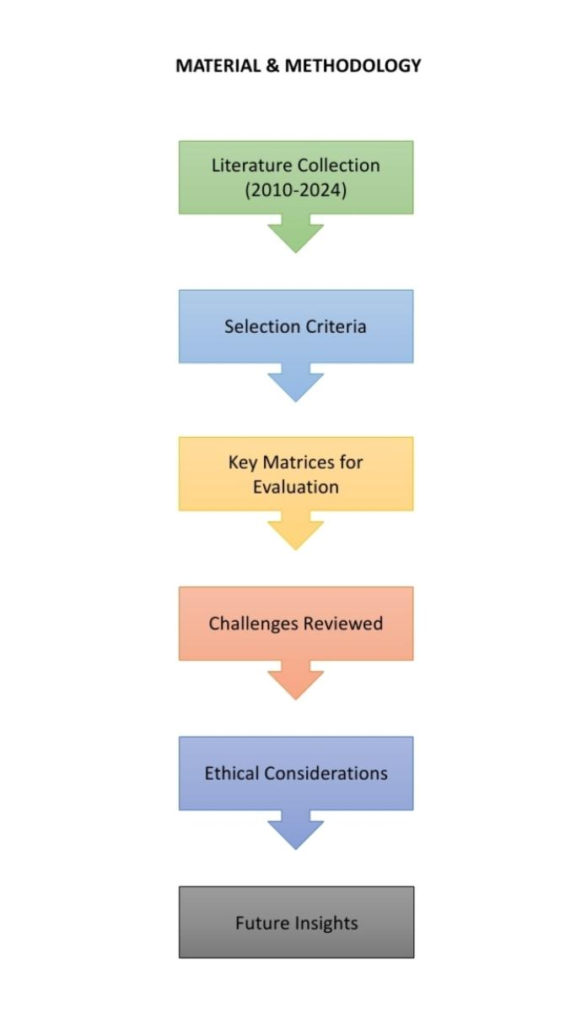Fig. 3: Material & Methodology Outline Employed For This Paper.

**4. FUNDAMENTALS OF QUANTUM COMPUTING**

Classical computing paradigms use bits as the fundamental unit of information, which may be either a 0 or a 1. This is where quantum computing fundamentally differs from them. Quantum bits, or qubits, on the other hand, are used in quantum computers. Qubits use the laws of quantum mechanics to exist in a state of superposition, which allows them to simultaneously represent 0 and 1. Because of this special quality, quantum computers are able to execute intricate calculations at a scale and speed never before possible, solving issues that classical systems would find impossibly difficult (Ray, Ishita. 2011). [Fig.4,5,6]

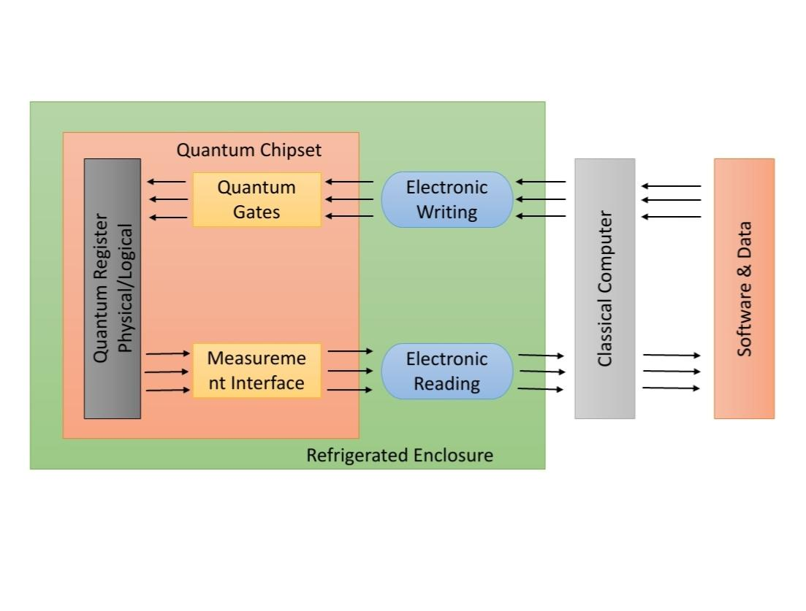

***Fig. 4: Global Architecture of Quantum Computer.***

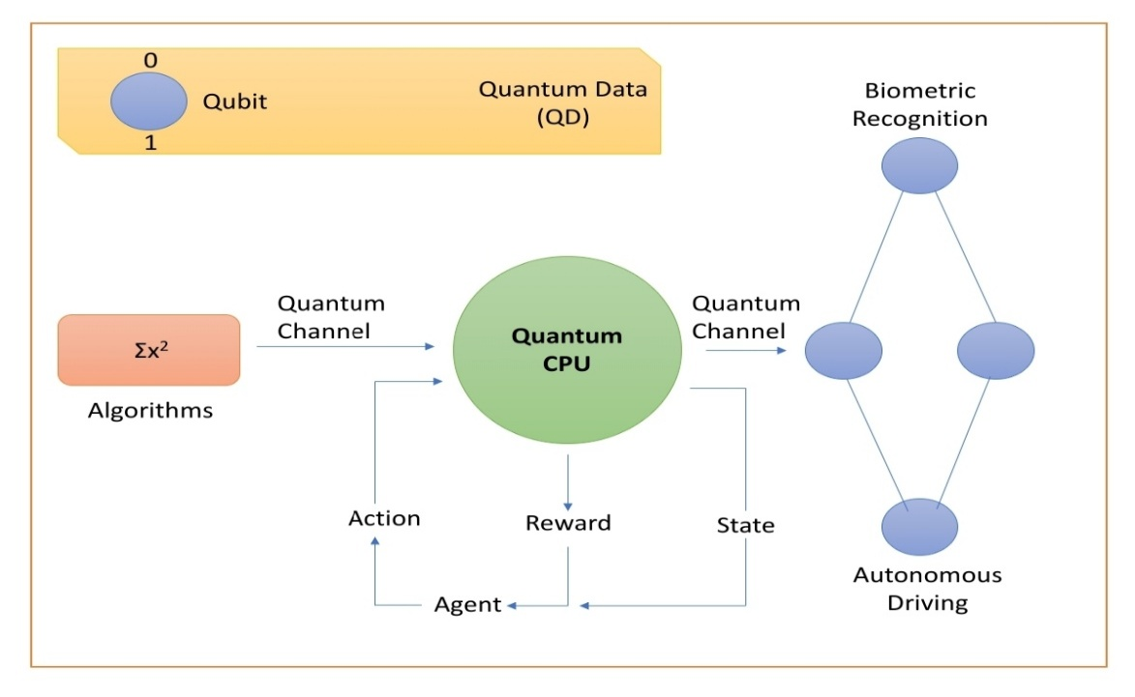

***Fig. 5: Block Diagram/Processing of Quantum Computer***

Quantum entanglement, the phenomenon wherein qubits become interconnected so that the state of one can instantly affect the state of another, regardless of distance, is another important component of quantum computing. According to Jude and Oyo (2024), this connectivity improves computational capacity and makes parallel processing possible, which makes it possible for quantum algorithms to handle problems effectively.

Even with all of its promise, quantum computing still has a number of major obstacles to overcome. Building useful quantum systems is severely hampered by problems like decoherence, which results in the loss of quantum information, and quantum noise, which causes computations to malfunction (Rayhan, Abu. (2024). Additionally, the restricted amount of qubits in present quantum processors makes them incapable of large-scale execution of sophisticated algorithms, which raises concerns about scalability.

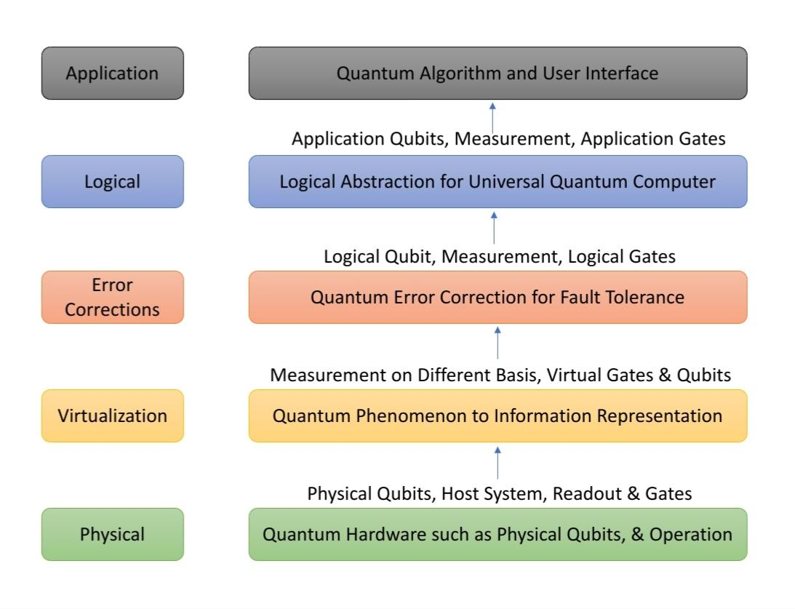

***Fig. 6: Five Layered Architecture of Quantum Computer***

Notable algorithms like Grover’s search optimisation algorithm and Shor’s integer factorisation method were developed as a result of quantum computing. These algorithms have the ability to crack popular encryption systems and revolutionise industries like cryptography. They could also improve database search performance, with far-reaching ramifications for technology and security (Thilagavathy, R., Gayathri, M. 2024). Quantum computing’s continued development will continue to influence how it is used in upcoming technological developments. [Table. 1]

***TABLE. 1 Table Shows the Basic Fundamental Descriptions of Quantum Computing***.

|  |  |  |
| --- | --- | --- |
| SECTION | DESCRIPTION | SOURCES |
| Introduction | Classical computing paradigms use bits as the fundamental unit of information, which may be either a 0 or a 1. This is where quantum computing fundamentally differs from them. | (Ray, Ishita. 2011) |
| Superposition | Superposition, which increases computing capacity by using qubits to concurrently represent 0 and 1. | (Ray, Ishita. 2011) |
| Quantum Entanglement | Quantum entanglement is the concept that qubits are connected and can instantly influence one another across distances. | (Jude, Oyo. 2024) |
| Challenges | Practical quantum systems face obstacles such decoherence, quantum noise, and scaling problems. | (Rayhan, Abu. (2024) |
| Quantum Algorithms | Important algorithms include Grover’s Algorithm for search optimisation and Shor’s Algorithm for integer factorisation. | (Thilagavathy, R., Gayathri, M. 2024) |
| Future Directions | Potential influence on database search effectiveness and cryptography, influencing upcoming technical developments. | (Thilagavathy, R., Gayathri, M. 2024) |

**5. ARTIFICIAL INTELLIGENCE: A KEY ENABLER IN QUANTUM RESEARCH**

More and more artificial intelligence (AI) is being included into different quantum systems to solve problems and improve performance. Mafu, Mhlambululi (2024) states that machine learning (ML) and deep learning (DL) approaches are very useful for training on quantum datasets, allowing the simulation of quantum systems and the prediction of results in quantum experiments. Large amounts of quantum data may be analysed by these AI-driven techniques, which can also extract patterns that human specialists might miss. [Fig. 7]

Quantum error correction is a prominent use of AI in quantum computing. AI systems are able to recognise and reduce noise, which is a major problem that interferes with quantum calculations by reducing the qubit states’ integrity. To improve overall system robustness, for example, reinforcement learning (RL) has been used to optimise quantum error-correcting codes by dynamically adapting to environmental noise (Neumann, N.M.P., et al., 2023)

AI is also essential to the development of effective quantum algorithms. Artificial Intelligence (AI) can assist in identifying algorithms that minimise computation times and resource needs by utilising sophisticated search strategies. This will increase the practicality of quantum computing for real-world applications (Jadhav, Abhishek et al., 2023). For instance, by utilising AI, scientists can investigate the enormous space of potential quantum gate sequences in order to maximise their efficiency and drastically cut down on operational overhead.

Furthermore, reinforcement learning has found use in the control of quantum hardware, namely in the areas of gate optimisation and qubit calibration. RL algorithms can improve the accuracy and dependability of quantum processes by iteratively fine-tuning the control parameters based on input from the system’s performance (O. Shindig et al., 2024).

To put it briefly, by solving problems, streamlining procedures, and facilitating the development of novel quantum algorithms, AI technologies—ML, DL, and RL—are essential to the advancement of quantum computing. Together, these initiatives have the potential to fully realise the potential of quantum systems, resulting in ground-breaking discoveries in a multitude of domains.

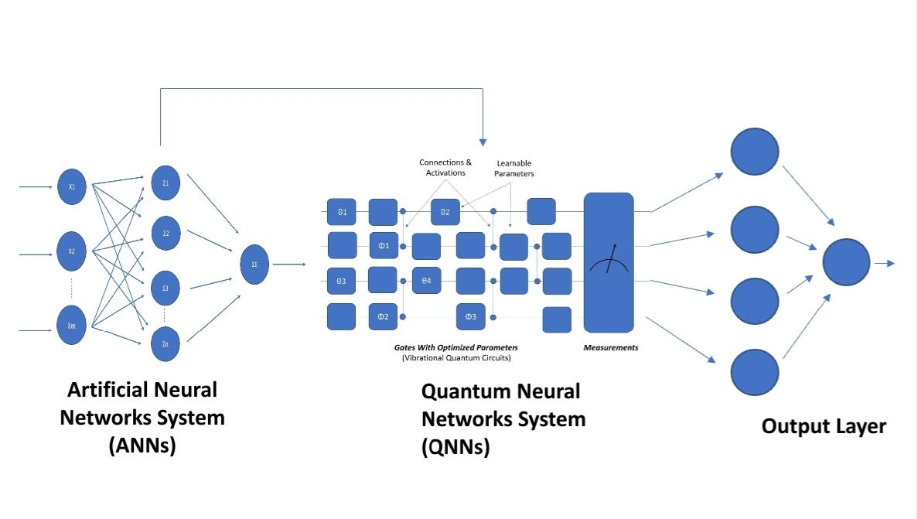

***Fig. 7: Integration of ANNs & QNNs for Enhanced Computing Capabilities***.

**6. APPLICATIONS OF AI IN QUANTUM COMPUTING**

***Quantum Machine Learning (QML)***

When AI and QC are combined, the result is Quantum Machine Learning (QML), in which algorithms are optimised by applying AI models to quantum systems. Quantum circuits for feature selection, classification, and grouping have been designed using AI. Another instance of how AI is used to optimise quantum parameters for high accuracy in activities like quantum chemistry simulations is via variational quantum algorithms, or VQA (Huang, Bing & von Lilienfeld, Anatole. 2021).

***AI-Enhanced Quantum Error Correction***

For quantum computing to be used in real applications, error correction is essential. Algorithms for quantum error correction (QEC) are used to identify and fix quantum mistakes brought on by noise. The fidelity of quantum operations is greatly increased by AI models, which help detect error patterns and optimise QEC protocols by accounting for qubit interactions and ambient factors (Olaoye, Favour & Potter, Kaledio. 2024).

***Quantum Simulations***

The behaviour of quantum systems, such as molecules and intricate physics processes, is modelled via quantum simulations. More precise simulations in quantum chemistry and material science are the result of artificial intelligence (AI) employing neural networks to optimise variational wavefunctions or approximate quantum states (Gardas, Bartlomiej, et al., 2023).

***Quantum Optimization Problems***

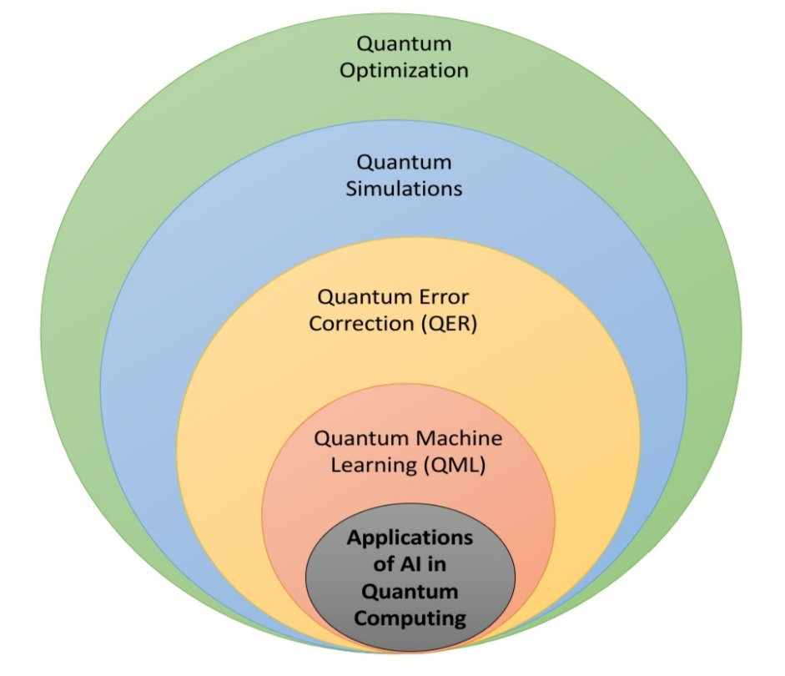Many real-world optimization problems are difficult for classical computers but can be solved efficiently with quantum computers. AI-driven algorithms can enhance Quantum Approximate Optimization Algorithms (QAOA), enabling quantum systems to tackle complex problems in logistics, finance, and cryptography. For example, AI helps in finding optimal qubit configurations for solving optimization problems more efficiently than classical counterparts (Kale, Dattatray. Et al., 2024). [Fig. 8]

***Fig. 8: Applications of AI in Quantum Computing.***

**7. AI IN QUANTUM PHYSICS RESEARCH**

***Quantum State Prediction using AI***

Because of the complexity of quantum processes, predicting the state of a quantum system is one of the most difficult challenges. By using experimental data for training, artificial intelligence can accurately anticipate quantum states. Recurrent neural networks (RNN) and convolutional neural networks (CNN) are two methods that have demonstrated potential for forecasting time-dependent quantum states, which are essential for comprehending quantum dynamics. (Kim, D., Cho, G., and others, 2024). [Fig. 9]

***AI in Quantum Experiments and Data Analysis***

Artificial Intelligence is being utilised more and more in quantum experiments to perform tasks including automating experimental setups, analysing massive quantum datasets, and making real-time modifications to operations. To identify and analyse quantum signals that are too subtle for classical methods, for example, AI models can handle data from quantum sensors (Krenn, Mario, et al., 2023). [Fig. 9]

***AI-Driven Quantum Material Discovery***

AI has expedited the search for novel materials possessing quantum characteristics, including high-temperature superconductors and topological insulators. Researchers can effectively explore the large range of potential material configurations by employing AI-driven optimisation approaches, which can help them find promising candidates for quantum technologies (Stanev, V. et al., 2022). [Fig. 9]

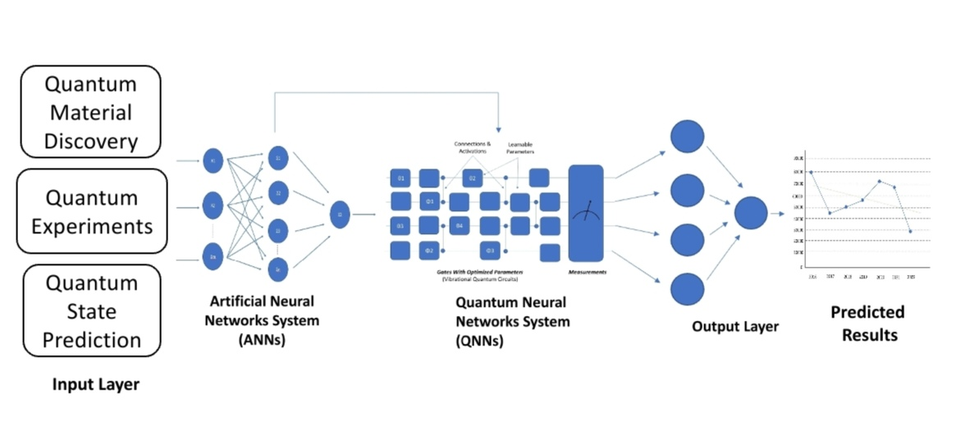

***Fig. 9: Systematic Representation of Working of Integrated ANNs & QNNs in Prediction of Various Physical Experiments.***

**8. CHALLENGES AND LIMITATIONS**

Although promising, the combination of AI and quantum technology has a number of important drawbacks and obstacles. Although quantum algorithms are still in their early phases of development, qubit noise, decoherence, and high error rates are some of the problems that plague current quantum computers, impeding their dependability and efficiency (Rayhan, Abu. 2024). Significant improvements in qubit stability and error correction methods are necessary to achieve quantum supremacy, the state in which quantum computers perform better than their classical counterparts. These issues are still open to debate in the field.

Additionally, the lack of training data from quantum systems frequently presents challenges for AI models, despite their rapid progress. Effective training of AI algorithms is hampered by the peculiarities of quantum data and the difficulties in acquiring it (Cerezo, Marco et al., 2022). Consequently, there may be limitations on the generalisability and applicability of AI techniques in quantum computing.

Crucial elements of the AI-quantum integration process also include ethical considerations. In an increasingly linked digital ecosystem, it is imperative to proactively address concerns regarding data privacy and security, as well as the potential exploitation of quantum cryptography, to avoid unfavourable outcomes (Possati, L.M. 2023). [Fig. 10]

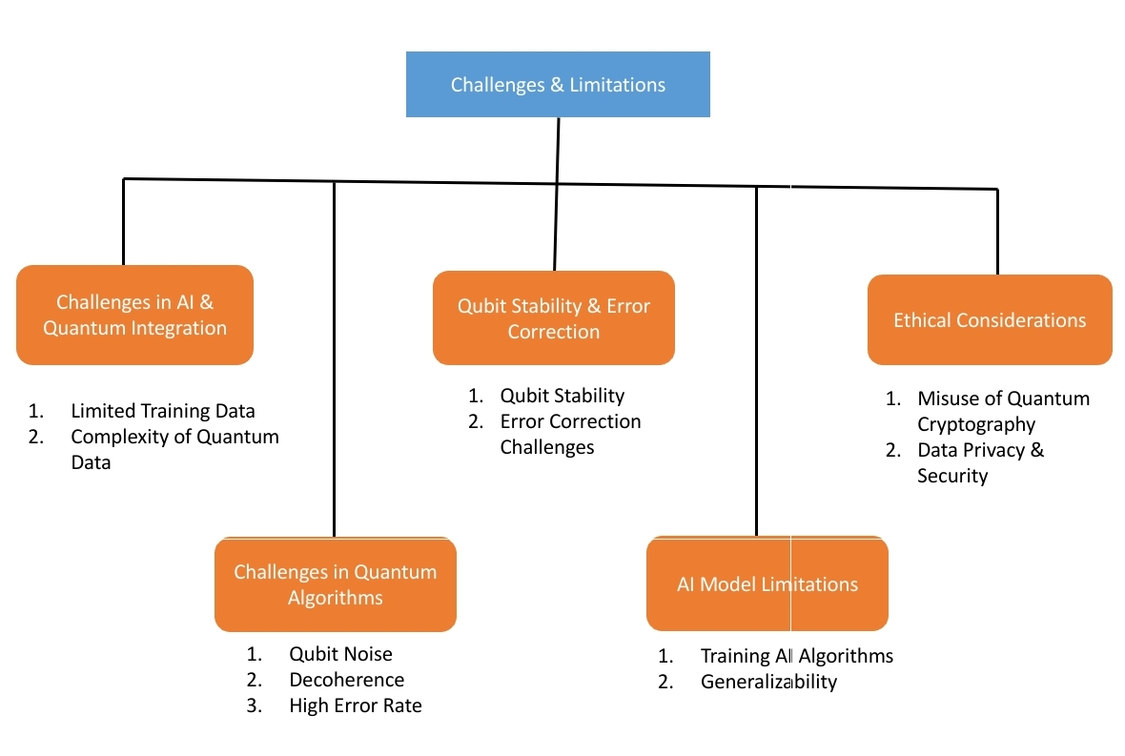

***Fig. 10: Challenges and Limitations of AI and Quantum Technologies.***

**9. FUTURE PROSPECTS**

AI in quantum computing holds great promise for the future, particularly in fields like hardware optimisation and quantum algorithm design. AI-supported quantum algorithms have the potential to completely transform industries like computational modelling and cryptography, resulting in a more effective and safe digital environment. Specifically, advances in quantum cryptography will be crucial in improving cybersecurity by enabling unhackable communication networks. Financial systems, national security, and secure communication networks are all significantly impacted by this (Publication, Research. 2018).

AI-optimized quantum devices have the potential to significantly advance fields like global logistics, economics, and medicine in addition to cryptography. For instance, AI can optimise quantum hardware for optimal performance, enabling more accurate and speedier computations, while quantum computing can aid in drug development by quickly simulating molecular interactions (Solenov, D. et al, 2018). The creation of hybrid algorithms, which use both classical and quantum computing systems, is another exciting avenue for the future. This bridge should be made easier by AI, which could result in more effective solutions that combine the best aspects of both paradigms. In order to usher in a new era of quantum internet, researchers are also exploring the establishment of quantum networks, where AI may play a crucial role in the development of effective routing, node optimisation, and network control mechanisms. AI-quantum synergies are driving these advancements, which will open the door for revolutionary applications in data sciences and computing (Youvan, Douglas, 2024).

**10. CONCLUSION**

AI and quantum computing together constitute a frontier in scientific research and computational power. Together, AI’s enormous dataset processing capacity and sophisticated system optimisation skills and quantum computing’s unmatched computational power open up new possibilities in areas like material science, quantum chemistry, and cryptography. Even though there are still obstacles to overcome, continuous developments in AI and quantum systems are opening the door for a time when quantum technologies will be broadly available, scalable, and useful.

**REFERENCES:**

1. Youvan, Douglas. (2024). Beyond Classical Limits: Forecasting the Capabilities of QuEra’s 3rd Generation Quantum Computer. 10.13140/RG.2.2.31300.81280.
2. Pal, S., Bhattacharya, M., Lee, SS. Et al. Quantum Computing in the Next-Generation Computational Biology Landscape: From Protein Folding to Molecular Dynamics. Mol Biotechnol 66, 163–178 (2024). <https://doi.org/10.1007/s12033-023-00765-4>
3. Kak, S. (2007). Quantum Mechanics and Artificial Intelligence. In: Schuster, A.J. (eds) Intelligent Computing Everywhere. Springer, London. <https://doi.org/10.1007/978-1-84628-943-9_5>
4. Olaoye, Favour & Potter, Kaledio. (2024). QUANTUM ERROR CORRECTION FOR AI APPLICATIONS. Quantum.
5. Goswami, Lipichanda & Deka, Manoj & Roy, Mohendra. (2023). Artificial Intelligence in Material Engineering: A Review on Applications of Artificial Intelligence in Material Engineering. Advanced Engineering Materials. 25. 10.1002/adem.202300104.
6. Radanliev, P. Artificial intelligence and quantum cryptography. J Anal Sci Technol 15, 4 (2024). <https://doi.org/10.1186/s40543-024-00416-6>
7. Aithal, Sreeramana. (2023). Advances and New Research Opportunities in Quantum Computing Technology by Integrating it with Other ICCT Underlying Technologies. International Journal of Case Studies in Business, IT, and Education. 314-358. 10.47992/IJCSBE.2581.6942.0304.
8. Deshmukh, Ananya. (2024). The Role of Quantum Decoherence in Quantum Computing Systems. Journal of Quantum Science and Technology. 1. 37-43. 10.36676/jqst.v1.i2.14.
9. Mafu, Mhlambululi. (2024). Advances in artificial intelligence and machine learning for quantum communication applications. IET Quantum Communication. 5. n/a-n/a. 10.1049/qtc2.12094.
10. Wright, Emily & Sousa, Rogério. (2023). Fast quantum gate design with deep reinforcement learning using real-time feedback on readout signals. 10.48550/arXiv.2305.01169.
11. Rayhan, Abu. (2024). The Quantum Computing Revolution: Challenges and Opportunities. 10.13140/RG.2.2.12467.85283.
12. Radanliev, P. Artificial intelligence and quantum cryptography. J Anal Sci Technol 15, 4 (2024). <https://doi.org/10.1186/s40543-024-00416-6>
13. Ray, Ishita. (2011). Quantum Computing. 10.13140/2.1.1021.7286.
14. Jude, Oyo. (2024). Quantum Entanglement and the Future of Secure Quantum Computing.
15. Rayhan, Abu. (2024). The Quantum Computing Revolution: Challenges and Opportunities. 10.13140/RG.2.2.12467.85283.
16. Thilagavathy, R., Gayathri, M. (2024). The Revolution of Quantum Computing: Analyzing Its Effects on Cryptographic Security and Algorithmic Efficiency. International Journal of Communication Networks and Information Security. 16(4). ISSN: 2073-607X,2076-0930
17. Mafu, Mhlambululi. (2024). Advances in artificial intelligence and machine learning for quantum communication applications. IET Quantum Communication. 5. n/a-n/a. 10.1049/qtc2.12094.
18. Neumann, N.M.P., de Heer, P.B.U.L. & Phillipson, F. Quantum reinforcement learning. Quantum Inf Process 22, 125 (2023). <https://doi.org/10.1007/s11128-023-03867-9>
19. Jadhav, Abhishek & Rasool, Akhtar & Gyanchandani, Manasi. (2023). Quantum Machine Learning: Scope for real-world problems. Procedia Computer Science. 218. 2612-2625. 10.1016/j.procs.2023.01.235.
20. O. Shindi, Q. Yu, P. Girdhar and D. Dong, “Model-Free Quantum Gate Design and Calibration Using Deep Reinforcement Learning” in IEEE Transactions on Artificial Intelligence, vol. 5, no. 01, pp. 346-357, 2024.Doi: 10.1109/TAI.2023.3243187
21. Huang, Bing & von Lilienfeld, Anatole. (2021). Ab Initio Machine Learning in Chemical Compound Space. Chemical Reviews. XXXX. 10.1021/acs.chemrev.0c01303.
22. Olaoye, Favour & Potter, Kaledio. (2024). QUANTUM ERROR CORRECTION FOR AI APPLICATIONS. Quantum.
23. Gardas, Bartlomiej & Rams, Marek & Dziarmaga, Jacek. (2018). Quantum neural networks to simulate many-body quantum systems. Physical Review B. 98. 10.1103/PhysRevB.98.184304.
24. Kale, Dattatray & Nalavade, Jagannath & Hirve, Sumit & Tamboli, Sameer & Randive, Pradnya & Karlekar, Nandkishor. (2024). Quantum Machine Learning Algorithms for Optimization Problems: Theory, Implementation, and Applications. International Journal of Intelligent Systems and Applications in Engineering. Vol. 12 No. 4 (2024). 322-331.
25. Cho, G., Kim, D. Machine learning on quantum experimental data toward solving quantum many-body problems. Nat Commun 15, 7552 (2024). <https://doi.org/10.1038/s41467-024-51932-3>
26. Krenn, Mario & Landgraf, Jonas & Foesel, Thomas & Marquardt, Florian. (2023). Artificial intelligence and machine learning for quantum technologies. Physical Review A. 107. 10.1103/PhysRevA.107.010101.
27. Stanev, V., Choudhary, K., Kusne, A.G. et al. Artificial intelligence for search and discovery of quantum materials. Commun Mater 2, 105 (2021). <https://doi.org/10.1038/s43246-021-00209-z>
28. Rayhan, Abu. (2024). Taming Decoherence: Error Correction Strategies for Robust Quantum Computing. 10.13140/RG.2.2.25282.18882.
29. Cerezo, Marco & Verdon, Guillaume & Huang, Hsin-Yuan & Cincio, Lukasz & Coles, Patrick. (2022). Challenges and opportunities in quantum machine learning. Nature Computational Science. 2. 10.1038/s43588-022-00311-3.
30. Possati, L.M. Ethics of Quantum Computing: an Outline. Philos. Technol. 36, 48 (2023). <https://doi.org/10.1007/s13347-023-00651-6>
31. Publication, Research. (2018). The Future of AI in Quantum Computing. SSRN Electronic Journal. 7. 90-100.
32. Solenov D, Brieler J, Scherrer JF. The Potential of Quantum Computing and Machine Learning to Advance Clinical Research and Change the Practice of Medicine. Mo Med. 2018 Sep-Oct;115(5):463-467. PMID: 30385997; PMCID: PMC6205278.
33. Youvan, Douglas. (2024). The Synergy Between Quantum and Classical Computing. 10.13140/RG.2.2.13355.41761.

**AUTHORS BIOGRAPHY:**

First Author Name: Gurjant Singh

MSc. Botany (Post Graduate Researcher)

Guru Nanak Dev University, Amritsar

Mr. Gurjant Singh is a Post Graduate Researcher of Guru Nanak Dev University, Amritsar specializing in Biological Sciences and AI in Agriculture Specialist. With over 6 years of experience in the field, Mr. Gurjant Singh has authored number of peer-reviewed papers and contributed to significant advancements in Scientific Academia, particularly in Plant, Artificial Intelligence, Pharmaceutical & Food & Nutrition applications. Mr. Gurjant Singh research focuses on integrating AI to optimize chemical reactions, accelerating drug development processes. He holds a MSc. In Botany from Guru Nanak Dev University, Amritsar.



Second Author Name: Nirmal Singh

Higher Secondary Student (Non-Med)

Shaheed Mewa Singh Senior Secondary Smart School, Lopoke, Amritsar

Nirmal Singh is a non-medical student with a keen interest in quantum computing and artificial intelligence. Despite being from a non-medical stream, his passion for technology has driven him to explore AI applications in optimizing quantum systems. With a curiosity for problem-solving, he is eager to contribute to advancements in cryptography and algorithm development.



Third Author Name: Dalbir Singh

High Secondary Student (Non-Med)

Shaheed Mewa Singh Senior Secondary Smart School, Lopoke, Amritsar

Dalbir Singh is a non-medical stream student currently pursuing higher secondary education, showing a remarkable enthusiasm for quantum technologies and artificial intelligence. His focus is on the intersection of AI-driven quantum error correction and optimization, exploring advanced solutions in quantum computing. Eager to learn, he aspire to contribute to groundbreaking developments in quantum algorithms.